**058— FORMANT**

procedure given in the previous chap­ter. The offset and octaves per volt adjustments can also be carried out using the procedure given there. During the offset adjustment P4 should be set to minimum and S3 should be set to the 24 dB position. During the octaves/volt adjustment of P8 the Q control, P4, should be set to maximum, as with the 12 dB VCF.

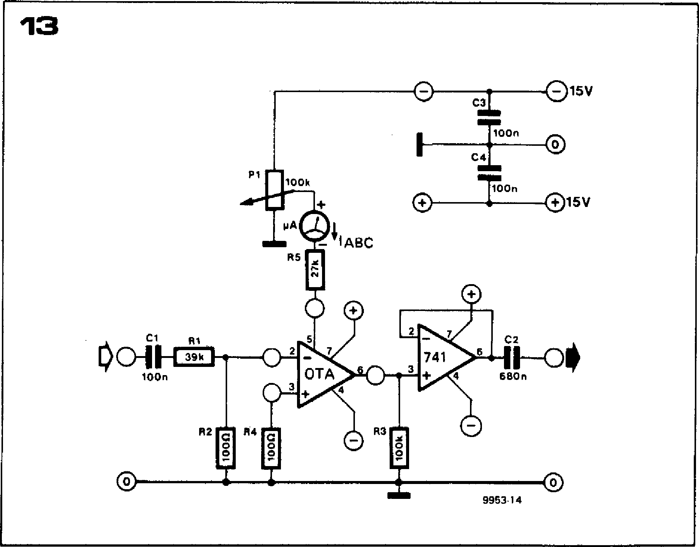

**Using the 24 dB VCF**

**As** can be seen from figure 12, the 24 dB VCF is connected between the 12 dB VCF and the VCA, so that the IOS output of the 12 dB VCF goes to the IC input of the 24 dB VCF instead of to the VCA, whilst the VCA receives its input from the IOS output of the 24 dB VCF. The 24 dB VCF also has inputs from the three VCOs.

In addition to the signal connections the 24 dB VCF must also be provided with supply to the VCF module in accordance with the standard practice for Formant. Provision of control voltage inputs from the ADSR envelope shapers will be discussed later.

For satisfactory operation of the 24 dB VCF the correct setting of the input level is important, even more than in the case of the 12 dB VCF. On the one hand, the input level should not be so large that distortion occurs, but on the other hand it should not be so small that the signal-to-noise ratio is degraded. The 24 dB VCF is designed so that the optimum input level is obtained using three VCOs set to maximum output, with one waveform selected per VCO. If more than three VCOs are in use or more than one output waveform is selected from each VCO then the VCO output levels must be reduced. On the other hand, if only one VCO is used then the signal level may be too low. In

this case it is best to patch the EOS socket of the VCO to the ES input of the VCF, since this input has approxi­mately three times the sensitivity of the hardwired VCO inputs.

The 24 dB VCF is capable of the same basic functions as the 12 dB VCF; driven by the KOV control voltage it will operate as a tracking filter, whilst the ENV and TM inputs allow dynamic modulation of the harmonic content of the VCF output. Due to the greater slope of the 24 **dB** VCF the setting of the ENV level control is more critical than with the 12 dB VCF, but if cor­rectly adjusted then subtle nuances in the tonal character of the output signal are possible.

The question arises as **to which ADSR** envelope shaper should be used to control **the 24 dB VCF, since only** two are built **into the basic** Formant system, and **control the VCA and 12** dB VCF respectively. **Because of** the modular construction **of Formant it** is, of course, perfectly **feasible to build** a third envelope **shaper, which** is the most versatile **arrangement. The** alternatives are to **patch one of the other ADSR outputs to the TM input of the 24 dB VCF, or to hardwire the ENV input of the 24 dB VCF to the output of the envelope shaper that** controls the 12 dB VCF. This latter arrangement is prob­ably preferable, **as it allows the ADSR** signal to be fed to one or both VCFs by suitable adjustment of their ENV controls and also allows the possibility of patching the output of the other envelope shaper into the TM input of either VCF.

**Figure 13. Test circuit for the selection of. OTAs.**

**OTA selection procedure**

Although not absolutely essential, it is well worth selecting OTAs with closely matched transconductance character­istics to ensure that the four filter sections track accurately.

**A** test circuit for the OTAs is given in figure **13.** This should be fed with a sinewave signal of about 2 V peak-to­peak (or 0.7 V measured on an AC voltmeter) from a signal generator or from one of the VCOs. The output should be monitored on a 'scope or AC voltmeter. With a control current of 100 *,uA,* measured on the multimeter in series with R5, the output voltage should be between 0.7 V and 1.3 V peak-to-peak. Without changing the input level or control current the OTAs to be tested should be plugged into the circuit one at a time and the output level for each OTA noted. The four **OTAs** whose output levels are most similar should be used in the VCF. The circuit can also be used to check the linearity of the transconductance v. control current characteristic of **the OTAs, e.g. doubling the** control current **should double the** output of the test circuit **and halving the control** current should halve the output.

**chapter 8**

**resonance filter module**

**In addition to an almost limitless variety of non-natural, wholly 'electronic' sounds, the Formant music synthesiser can, of course, be used to imitate the voicing of conventional (mechanical) musical instruments. The filter module described in this article is designed to allow more realistic simulation of natural musical instruments by providing the fixed bandpass resonances which are an important determining factor in the timbre of mechanical tone generators.**

Although music synthesisers are capable of producing the most `wierd and wonderful' electronic effects, it is a fact that they are frequently employed to imitate the sound of traditional acoustic instruments. Many commercially avail­able synthesisers, for example, are pro­vided with preset facilities for various common instrumental voices, whilst special units such as `string-synthesisers', which are designed solely to reproduce the sound of a string section, are becom­ing increasingly popular.

**FORMANT — 059**

As has already been explained, basic factors influencing the characteristics of a muscial note are pitch, dynamic amplitude, and dynamic harmonic content. As the reader will be aware, pitch and dynamic amplitude charac­teristics are controlled by the VCO (Voltage Controlled Oscillator) and VCA + ADSR (Voltage Controlled Amplifier and Attack - Decay - Sustain -Release) modules in the Formant syn­thesiser, whilst the VCF (Voltage Con­trolled Filter) is used to vary the har­monic content of the signal.

However, in the case of mechanical tone generators, for example brass and wood­wind instruments, an additional con­sideration is the existence of resonant areas in the instrument which possess free vibration periods of their own. These resonances, which are known as ***formants*** (whence the name for the Elektor music synthesiser!) are deter­mined by the shape and mechanical construction of the particular instru­ment (the wooden back and belly of a violin, the pipes of an organ etc.). Unlike the variable pitch of, say, a violin string, they tend to reinforce the same harmonics, whatever the pitch of the note being played. The nature of the formants in an instrument is in fact one of the factors which govern its quality. It should thus be apparent that, in order

to realistically simulate the tonal charac­teristics of traditional instruments, one must be able to tailor the static har­monic content of the note accordingly. What is required is a number of resonant filters with independently variable centre frequency, gain and Q-factor. These features are present already in the state variable VCF of **the Formant;** however, that is only one filter, and more to the point, in this particular application there is no need for the filters to be voltage-controlled, since the filter parameters will be preset to suit whatever musical instrument is being imitated. This explains the reason for the separate manually-controlled reson­ance filter module ***described* in this article.**

**Figure 1. The fundamental frequency range of a number of traditional musical instru­ments, with reference to that of a grand piano. *(From: Elektronik Taschenbuch, Band 1 Ferd. Thimmlers Verlag, Bonn; with kind permission from the publishers.)***

**The uses of resonance filters**

The effect **of resonance filters can best be heard on 'bright' sharp VCO wave­forms which have a high proportion of fairly intense upper harmonics. The effect on vocal sounds can be illustrated by taking a suitable signal with a fre­quency of around 200 Hz, setting the Q of the filter to a mid-value, and varying the centre frequency from mini­mum to maximum.** At first 'dark' sounding tones, largely devoid of higher harmonics will be obtained; as the centre frequency is increased however, one by one the various vowel sounds can be distinguished until, at high centre frequencies, reedy **flute-like sounds are produced. The higher the Q of the filter, the more pronounced the above effects — and vice versa.**

**All bandpass resonances of musical importance lie between roughly 100 and 2000 Hz. Table 1 lists the** main **fixed resonances of** a number of common **musical instruments and also indicates which VCO waveform is best suited to imitate the instrument in question. This table is, of course, merely intended as a rough guide, in the *final*** instance the decision should rest with one's own ears. Unless otherwise indicated, the Q-con­trol should be set to the mid-position. As **a further aid, figure 1 shows the fundamental frequency ranges of vari-**

|  |  |  |  |  |  |  |  |  |  |  |  |  |  |  |  |  |  |  |
| --- | --- | --- | --- | --- | --- | --- | --- | --- | --- | --- | --- | --- | --- | --- | --- | --- | --- | --- |
| percussion | | | I.-- **kettle drum** | | | | | | | | | | | | | | | |
| **—.--.04**  I | | | | | | | | | | | | | | | |
| plucked  string  instruments | | | I 1•II | | | | | | | | | | | | | | | |
| **1 guitar 1**  **la :** ' **1** | | | | | | | | | | | | | | | |
| **bass guitar**  i i | | | | | | | | | | | | | | | |
| woodwind  **instruments** | | | 1 I  piccolo | | | | | | | | | | | | | | | |
| I **I 1**  I **nuts** | | | | | | | | | | | | | | | |
| I **I 1 I I**  **I I S soprano saxophone** | | | | | | | | | | | | | | | |
| **I** e  **I 1 I**  **I clarinet** | | | | | | | | | | | | | | | |
| I I **. i**  **I**  **I 0 1 1 1** | | | | | | | | | | | | | | | |
| **bass saxophone hone M**  **I I 1** | | | | | | | | | | | | | | | |
| 11  1 **bassoon :**  **1 1 t** | | | | | | | | | | | | | | | |
| brass  instruments | | | **I 1 i trumpet 1 I** | | | | | | | | | | | | | | | |
| **I 1 I 1 it I**  **i . , I** | | | | | | | | | | | | | | | |
| **1 It horn firt**  **I i '**  **I+ trombone** | | | | | | | | | | | | | | | |
| I i **i i 1 '**  **I**  ***le* 1. tuba I -1** | | | | | | | | | | | | | | | |
| **1 I . I I I** | | | | | | | | | | | | | | | |
| bowed string  instruments | | | **1 I I I I** | | | | | | | | | | | | | | | |
| **violin** r **• I**  i I I i I  i iri **violin cello** | | | | | | | | | | | | | | | |
| I 1 i **,** 1  . 1 : i i  **double bass** ' i | | | | | | | | | | | | | | | |
| **1.1** Is! i I  I **1** i  **. .**  **I** | | | | | | | | | | | | | | | |
| **vocal** | | | **1**  **I I 1**  **I I I I I a: I** | | | | | | | | | | | | | | | |
| **soprano 1 1**  **i I i I 1 I!** 1 | | | | | | | | | | | | | | | |
| **I 1 1 i alto ri i**  **1 1 11 1 I**  **I I I I I 1 I I**  **I** | | | | | | | | | | | | | | | |
| **14-1--r—,— i tenor ---1.--••••11.1 I i**  **I 1 11 I I I 1 I** | | | | | | | | | | | | | | | |
| **bass —1-11,-1----Isi**  **1 I 11 r4-1-1---1 . o 1 i , II 1 I i**  **1 I I .** | | | | | | | | | | | | | | | | | | |
|  |  |  | | **1 1 t** | **II !** | **..I II 1-1!** | **iliii** | **I! Ill III** | **111** | **111** | **ll I! Ill** | **111 111** | **lli**  **_** | **111** | **MI** | **II!** | **11111 !** |  |

|  |  |  |  |  |  |  |
| --- | --- | --- | --- | --- | --- | --- |
| I c1  **A2**  **27.5 Hz** | **Al**  55.0 Hz | **A  110.0 Hz** | C1 **dl f1** g**1b1 c2 d2**  **a**  **220.0 Hz**  **F.--** octave **_1440.0 Hz** | **C3**  **a2**  **880.0 Hz** | I **c4**  **a3  1760 Hz** | **cs**  **84**  **3520 Hz** |

**9951 -1**

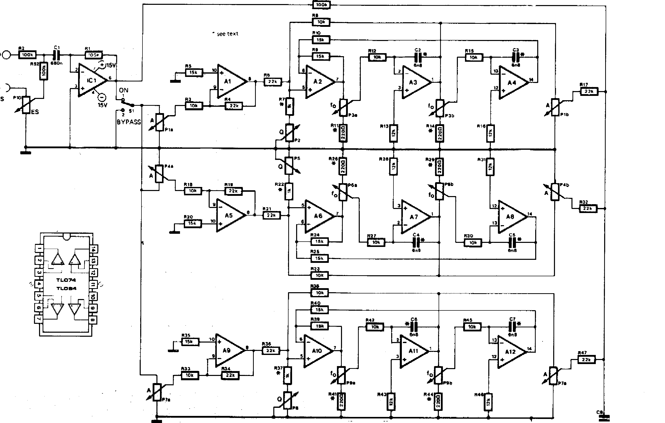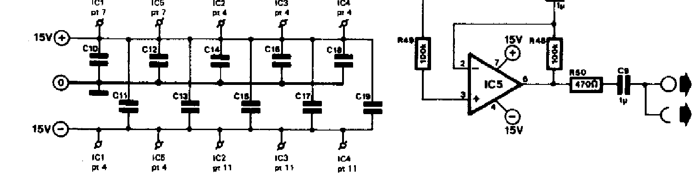**060— FORMANT**

IS

**nSi**

**ICI = LF** 356 MINI DIP

Al . A4 = IC2 = TL 074, TL 084 A5 .. AS = IC3 = TL 074, TL **084** A9 . Al2 = 1C4 = TL 074, TL 084 IC5 = LF 357 MINI DIP

C10 C19 100 *n* P111,113?2,P4a,P46, P5,P7a,P713,P8,P10 =

47 k 50 ki log. P3s,P3b,P6a,P6b,P9a,P9b =

10 k log.

106.

SOS

**9561 4**

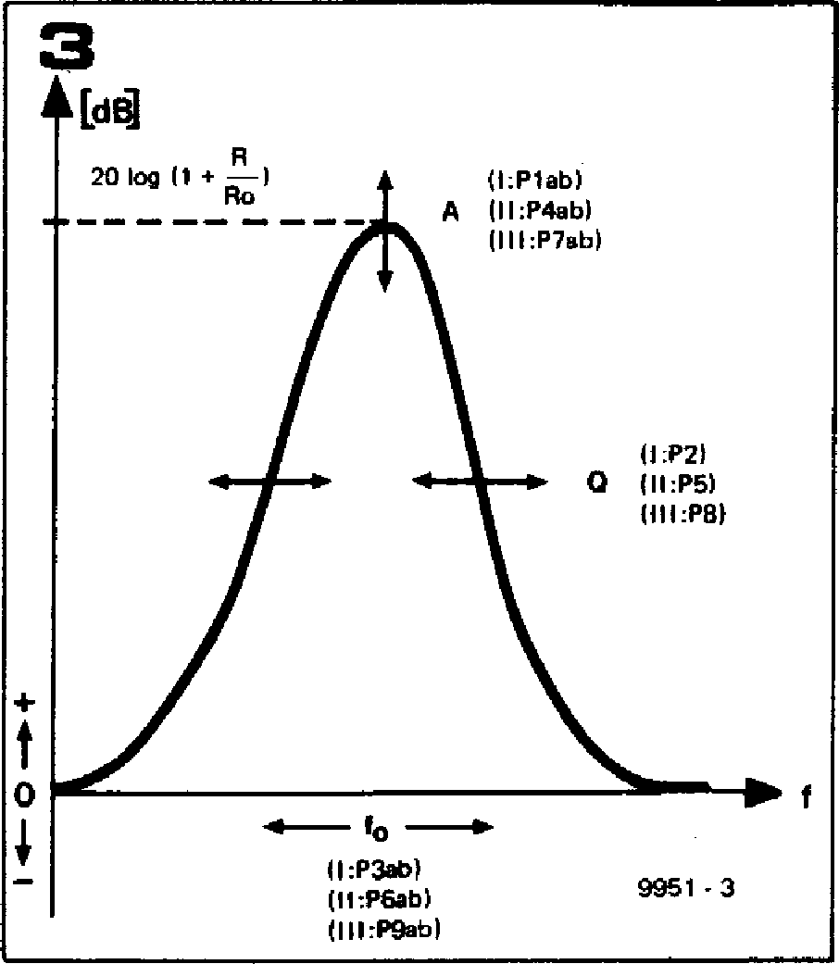

**(I.P1ab) A II I :P4ob)**

(111:P7861

**(1.112) 0 (11:P51**

**IIII:P81**

**.s----- to**

**I I :P3ab) (II:P6ab) (111:P9ab)**

**9951 - 3**

**[dB]**

20 **log (1 + —1**

**Flo**

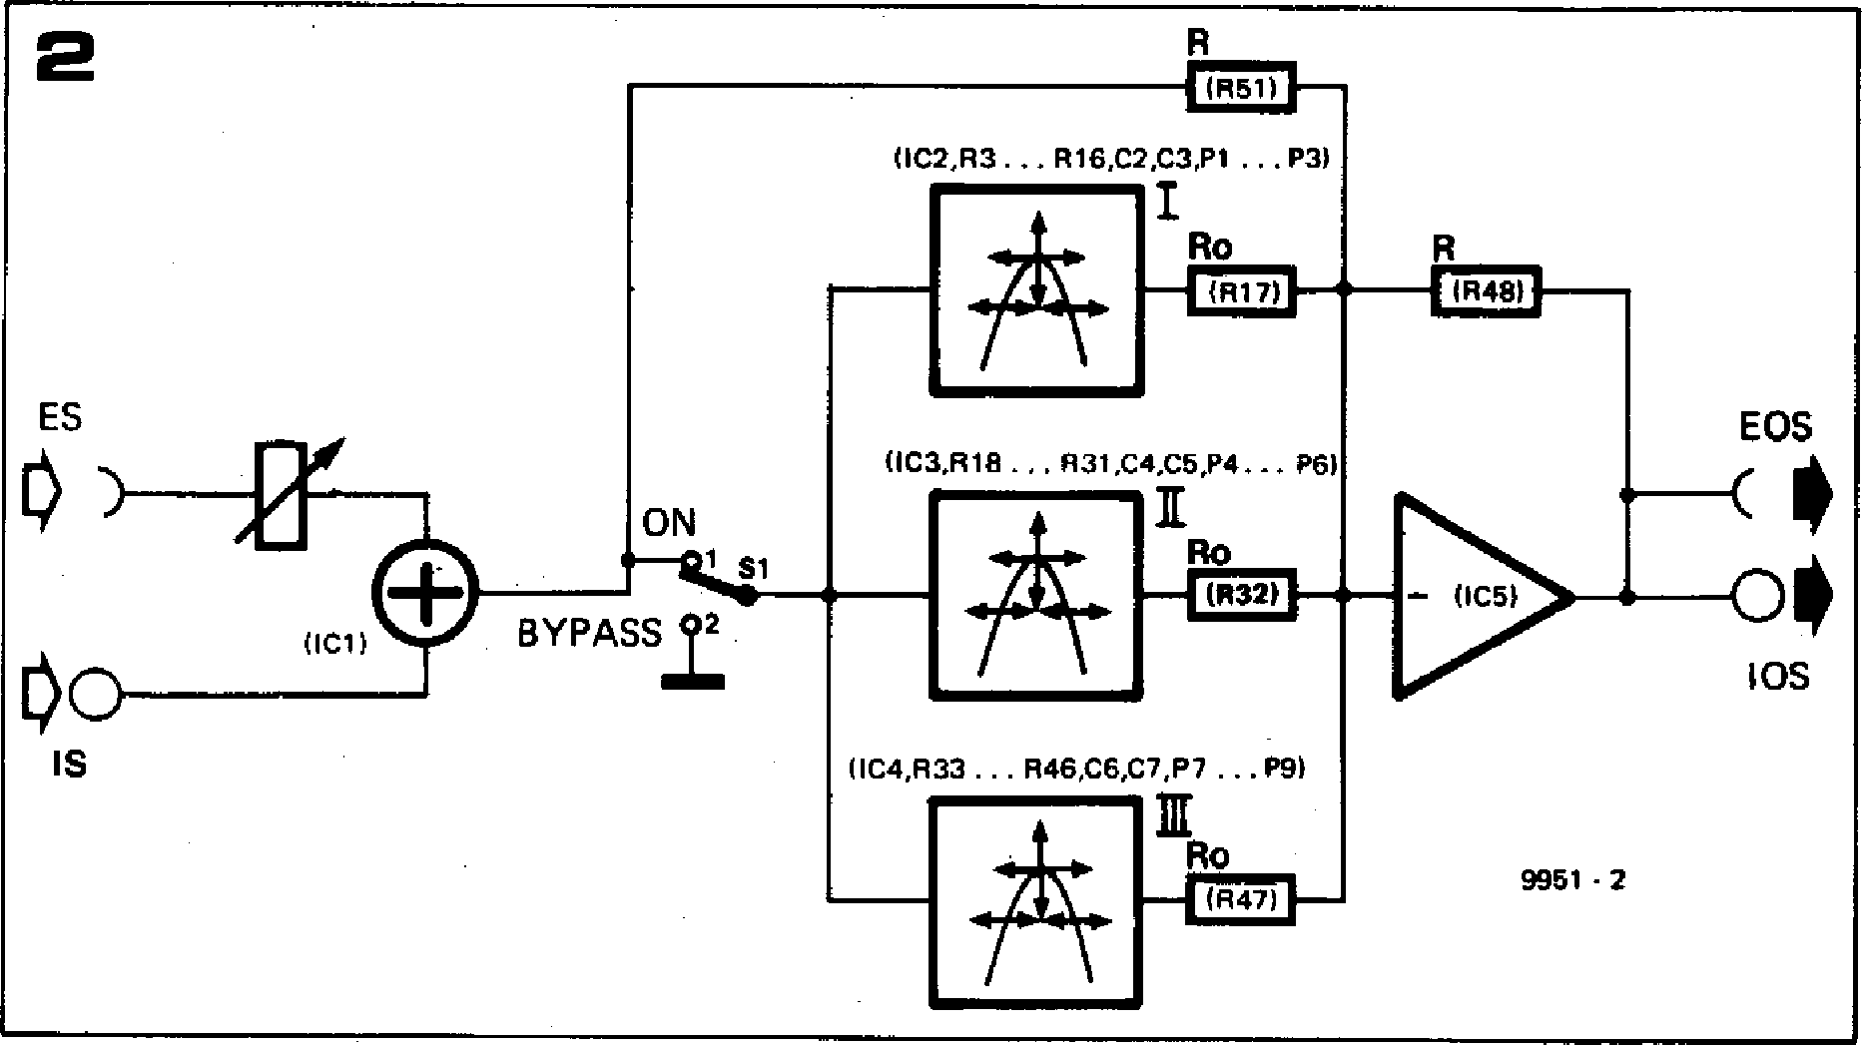

(IC51

**EOS**

**a'**

**'OS**

**9951 - 2**

(IC1)

)

IS

0

**1IC2,R3 R16,C2,C3,P1 ... P3)**

I

R

lily

**ON**

**1IC3,R18 , 1131,C4,C5,P4. P6)**

**1 SI**

**BYPASS/.**

**11C4,R33 R46,C6,C7,P7 ... P9)**

**LIM**

**2**

**ES**

**Figure 2. Block diagram of the resonant filter module. As can be seen, it possesses three independently variable filter sections.**

instrument main resonance at

flute approx. 800 Hz

clarinet 1 . . 2 kHz*

oboe 1300 1700 Hz*

trumpet approx. 1500 Hz

bugle approx. 1000 Hz*

trombone approx. 600 Hz

French horn approx. 400 Hz*

tuba approx. 250 Hz

violin approx. 4000 Hz**

cello approx. 200 Hz**

double bass approx. **100** Hz**

NB:

VCO signal

fairly asym. squarewave sym. squarewave

heavily asym. **squarewave (pulse)**

heavily asym. **squarewave** (pulse)

'spaced' sawtooth sawtooth

'spaced' **sawtooth** sawtooth

**sawtooth**

**'spaced' sawtooth, sawtooth or heavily asym. squarewave (pulse)**

bassoon approx. 440 Hz*

* with, increased Q

** if possible, use several resonant filters (or a **comb filter)**

**Figure 3. The frequency response of one of the three filter sections contained in the resonant filter module. The figure illustrates how the filter parameters can be indepen­dently varied by means of the control poten­tiometers.**

**Figure 4. Detailed circuit diagram of *the* filter module.**

**Figure 5. Track pattern and component lay­out of the filter module p.c.b. (EPS 99511 ).**

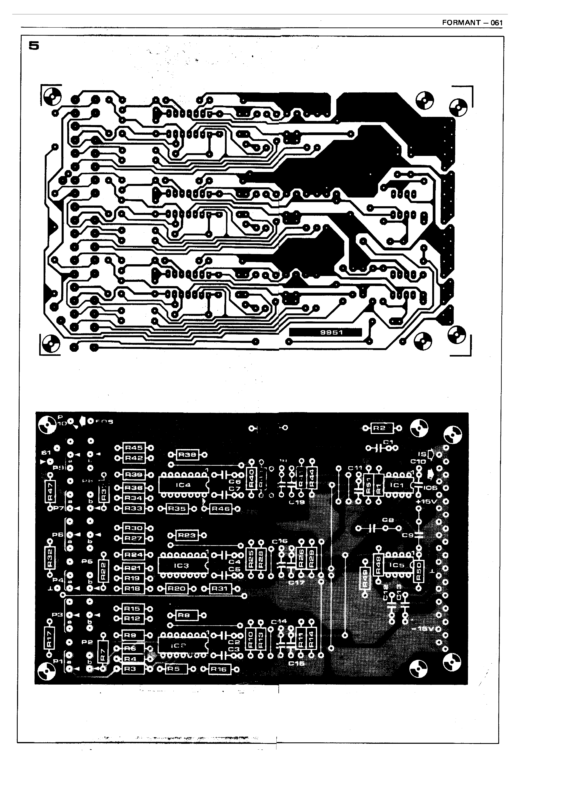

**FORMANT - 061**

**062 — FORMANT**

|  |  |  |  |  |
| --- | --- | --- | --- | --- |
|  |  |  |  |  |
| **Parts list to figure 4 and 5. Resistors:**  **R1,R2,R48,R49,R51,R52 = 100 k R3,R8,R12,R15,R18,R23, R27,R30,R38,R42,R45 = 10 k R4,R6,R17,R19,R21,**  **R32,R34,R36,R47 = 22 k R5, R9,1110,R20,R24,**  **R25,R35,R39,R40 = 15 k R7,R22,R37 = 1 k (see text) R11,R14,R26,R29,**  **R41, R44 = 220 S2 (see text) R13,816,R28,R31,R43,R46 = 12 k**  **R50 = 470 sz,**  **Potentiometers:**  **P1,P4,P7 = 47 k (50 k) logarithmic, stereo, dia 4 mm**  **P2,P5,P8,P10 = 47 k (50 k) logarithmic; dia 4 mm**  **P3,P6,P9 = 10 k logarithmic,**  **stereo; dia 4 mm** |  |  |  |
| **Capacitors (all Siemens MKM, MKH or other polycarbonate/polyester type)**  **Cl = 680 n**  **C2,C3,C4,C5,C6,C7 = 6n8 (see text) C8,C9 = *10.L***  **C10 ... C19 = 100n**  **Semiconductors:**  **IC1 = LF 356 (National Semiconductors), Mini DIP**  **1C2,1C3,IC4 TL 084, TL 074**  **(Texas Instruments)**  **IC5 = LF 357 (National Semiconductors) Mini DIP**  **Miscellaneous:**  **31-way DIN 41617 edge connector or terminal pins**  **Si = miniature SPDT**  **2 miniature sockets 3.5 mm dia.**  **10 x 10 mm collet knobs (with pointer) 1 front panel** |  |  |  |
|  |  |  |
| ous traditional instruments, with refer­ence to a piano keyboard.  **Circuit**  The basic requirements of the filter cir­cuit are, independently variable centre frequency, **Q** and gain. Since the func­tion of the filter is essentially to en­hance a particular band of frequencies (corresponding to the formants of the instrument in question), the circuit is of the boost-only type, i.e. provides selec­tive gain. Without the need to provide a selective cut (below the 0 dB line) the circuit design is considerably simplified. A total of three resonant filters forms an acceptable compromise between the number of settings required for reason­Ebly realistic imitation and the con­straints of space and economy. Of course, it is quite possible to double the rang of control facilities by connecting a second filter module in cascade with the first. |  |  |  |
|  |  |  |
| **Block diagram**  The block diagram of the resonant filter  module is shown in figure 2. The figures |  |  |  |
|  |  |  |

**FORMANT — 063**

**in brackets indicate which components in the final circuit are associated with the different sections of the circuit. Signals can be fed in via the panel-mounted socket (ES) or via the hard­wired input (IS). A portion of the signal is fed direct to the output summing amplifier via R (R51 in the complete circuit) and the input signal is also fed to three bandpass filters whose gain, centre-frequency and Q can all be varied. The outputs of these filters are also summed in 105 via resistors Ro. The output of the filter module will thus consist of a portion of the original input signal plus signals boosted around the centre frequencies of the three filter stages. Two outputs are provided from the filter module, an internal hardwired output (I0S) and an output to a front panel socket (EOS). A bypass switch is provided, which allows the three filter sections to be switched out, in which case only the original signal appears at the output, and the gain is frequency independent, being unity.**

**EOS ES**

**ES**

**P10**

**BYPASS**

**7**

"rimy **=**

**1 t:m1**

**..... .iii."1•119.11 ,,,**

**1**

**41 c..:mir**

**111111EM**

**0 .....‘**

**LIZ INN - Ai :LIMN**

**El 4:**

**Mr**

**:;11 ■**

**ve** fs

**cos**b

|  |  |  |  |
| --- | --- | --- | --- |
| **711. Win MO =mei  11 41 Aim** | | | b |

311

81

**ON**

**fo**

**P9**

0

**P8**

**A**

**P7**

fe

**P5**

**A**

**P4
  
P3**

0

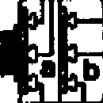

* **=3•**
* **=**
* **= •**
* =I •

•

= = •

* •

•

= •

* =I •
* = •
* **Mal**
* **=I •**

D**.**

**1:13 •
  
I:=1 •**

* =11 •

|  |  |
| --- | --- |
| **P1** | **9951.7** |
|  |  |

**Figure 6. Because of the large number of con­trols, the front-panel for the resonant filter module is clearly different from the other Formant front-panels (EPS 9951-2).**

**Figure 7. Wiring diagram for the components mounted on the front-panel.**

**The amount of boost that can be pro­vided by a filter section relative to the gain obtained in the 'bypass' condition is determined by the gain of the filter sections and the ratio R/Ro. If it is assumed that the filter gain can be varied between zero and one then the maximum amount of boost (in dB) is 20 log (1 + RE—).**

**The frequency response of a filter section is shown in figure 3. The figures in parentheses indicate which controls in the complete circuit vary the differ­ent parameters of the filter.**

**The complete circuit of the • filter module is shown in figure 4. IC1 sums and inverts the two input signals, whilst** the three filter sections are of the state-variable type. The resonant gain of the filters is **set by means of P1, P4 and P7 respectively. One gang of the pots is connected at the input, the other at the output of the filter. This has the effect of improving the dynamic range, since it means reduced noise and less chance of overloading. Finally, there is the inverting summing amplifier round IC5, which also cancels the phase shift intro­duced by ICI.**

**With the values for R and Ro given in the circuit diagram, the maximum gain of the filter is approx. +15 dB. The quality factor, Q, can be varied by P2 (P5, P8) between roughly 0.8 and 5. The centre frequency can be varied between approx. 50 and 2300 Hz, which is more than sufficient for normal use. The frequency range can, however, be modified by altering the value of a number of components; the necessary changes are detailed in the appendix. Maximum Q is obtained for the mini­mum resistance of the Q-potentiometer. The maximum Q can therefore be increased by reducing the value of R7 (R22, R37);** in **this way a Q of between 20 and 30 can easily be obtained. A high Q is useful when processing wave­forms such as squarewaves, which have**

**very steep edges. These tend to set the filters 'ringing' at their resonant fre­quencies, and produce percussive ef­fects. For R7 (R22, R37) = 470**

**a Q of 11.3 is obtained; R7 = 330** n **gives a Q of 15.8, and R7 = 220 12 a Q of 23.4. The higher the Q, the more pronounced the percussive effect.**

**Construction**

**The printed circuit board for the resonant filter module is shown in fig­ure S.**

**As far as the selection of components is concerned, the usual criteria apply. The only difference is that in view of the large number of front-panel con­trols (10 potentiometers) it is strongly recommended that miniature com­ponents (miniature pots with 4 mm diameter spindles) be used. In this way the controls can be arranged in func­tional groups of three to a row.**

**The front panel for the filter module is shown in figure 6, and the details of the wiring for the front-panel controls are illustrated in figure 7. In contrast to the**

**064 — FORMANT**

other Formant modules, the resonant filter module requires no calibration or adjustment procedure. The operation of the circuit can be checked by feeding in a white noise input from the noise module. Varying the three filter par­ameters should produce clearly audible changes in the resulting sound. It will also be apparent that rapid variation of the Q- and fo controls produces effects similar to phasing, thus the filter mod­ule can be used to provide manual phasing.

The scale on each of the fo poten­tiometers on the front panel is calibrated with five nominal frequencies. The three middle settings in particular should be viewed as rough guidelines, since the resistance curve of logarithmic poten­tiometers can exhibit fairly wide toler­ances.

The filter module should be placed between the COM-module and the power amp. However, if one wishes to use the headphone output on the COM­module, the resonant filter module can be connected directly before the latter. **Appendix**

With the component values given in the circuit diagram, the centre frequency of the filters can be varied between roughly 50 and 2300 Hz. To calculate the cor­rect values for higher frequencies than this, the procedure is as follows:

Firstly, the desired maximum frequency of fo can be used to calculate the value of C2 = C3 = C4 = C5 = C6 = C7 = C from the following equation:

16

C —

fo max

where C is in nanofarads and fo in kHz. Secondly the value of resistor R (see figure 2) can be determined on the basis of the desired minimum centre fre­quency fo

16

R — C • fo min

where C is in nanofarads, R is in kR, and fo in kHz

The value of Ro = R11 = R14 = R26 = R29 = R41 = R44 can be calculated from:

10

Ro —

R— 2

where R and Ro are in kfl. These equations can be used to check the values of figure 4.

**chapter 9**

**ADSR**

**The ADSR (Attack-Decay-Sustain­Release) shaper is used to control the VCF and VCA modules and thereby determine the dynamic harmonic structure and dynamic amplitude characteristic of the VCO signals.**

It is often not realised, even by mu­sicians, how much the character **of** an instrument is determined by the dy­namic amplitude and harmonic behaviour, rather than by **the steady-**state harmonic content **of the instru­ment.** If the attack and decay periods of a note are **artificially modified, then** the whole **character of the sound is** altered. An **interesting and amusing** experiment is **to record the sounds of** several **musical instruments, but to** remove **the attack and decay periods by** bringing up **the recording level after the** note starts and fading it down before the note ends. Then ask some **musical** friends to identify the instruments. They will no doubt be amazed how characterless the sound of an instrument becomes when robbed of its particular amplitude envelope.

On the other hand, starting with a single basic waveform such as the triangle out­put of the Formant VCO, a whole range of instrument sounds can be produced simply by varying the amplitude envel­ope, ranging from 'soft' sounds such as flute and some organ voices, to 'hard', percussive sounds such as piano and xylophone.

Envelope control of the harmonic content using the VCF allows even greater variation in the character of the sound.

**Types of envelope curves**

The envelope shaper of the synthesiser must be able to simulate the envelope contour of conventional musical instru­ments when the synthesiser is used in an imitative capacity, and also to produce envelopes that are purely synthetic in character (i.e. not found in sounds produced by normal acoustic methods). Fortunately, there are relatively few types of envelope contour that are musically important, and these are all fairly easy to generate electronically.

**1. Attadchlecay contour**

The simplest type of envelope curve is that consisting only of attack and decay periods. The envelope contour rises to a peak *when* the note is played, and begins to decay immediately the peak is

**passed** (see figure **1). By varying the** attack and decay times a **wide variety** of sounds can be produced.

For example, if a rapid attack and slow decay is applied to the VCA control, then a percussive sound like a piano results. Applied to the VCF in the low-pass mode, the same envelope contour can produce very bright, metallic sounds, depending on the input wave­form.

If the attack period is made long and the decay period short, then applying this to the VCA will produce com­pletely synthetic 'fantasy' sounds simi­lar to those obtained by playing a recording backwards. Applying this type of envelope contour to the VCF can produce sounds similar to those of a brass instrument played staccato.

However, the main use of this type of envelope curve is for the production of percussive sounds such as xylophone, marimba, glockenspiel, bells and gongs, cymbals, and struck or plucked strings **such as guitar,** banjo, harp, other string **instruments** played pizzicato, harpsi­chord, **and of** course, piano.

**2. Attack-sustain-release contour**

**The attack/decay** characteristic pre­viously **described** is typical of instru­ments where the sound is initiated by a short pulse of energy (e.g. by striking or plucking a string), after which the sound dies away since there is no further excitation to sustain it. The envelope contour shown in figure 2 is typical of instruments in which a note is sounded and sustained, such as a pipe organ, woodwind instruments, and bowed string instruments. In a pipe organ the note builds up fairly rapidly after a key is depressed as standing wave modes are established in the pipe, and the note is sustained by virtue of the fact that air is continuously blown into the pipe. When the supply of air stops on releasing the key the note terminates more or less rapidly.

The same basic contour applies to woodwind instruments and to string instruments played with a bow, since the note is here again sustained by blowing or bowing. However, with such instruments much greater expression can be obtained by modulation of the

