**044 — FORMANT**

**chapter 6**

**12 dB VCF**

**This chapter introduces the first of the tone-shaping modules which process the 'raw' output of the VCOs to provide a wide variety of different tone colours and amplitude dynamics. The module presented here is a 12 dB per octave voltage-controlled filter (VCF) which is used to tailor the frequency spectrum of the VCO signal.**

Before looking at the VCF circuit in detail, it is worth examining the ways in which the VCF is used. Four filter functions are available. A lowpass filter with a rolloff of —12 dB per octave above the turnover point, a highpass filter with a rolloff of —12 dB per octave below the turnover point, a band-pass filter with variable Q and minimum slope of —60 dB per octave on either side of the centre frequency, and a notch filter. The turnover point — or centre frequency in the case of the band filters — is the same for all four filter functions, and can be varied by the application of a control voltage.

**Lowpass filter**

The simplest use of the VCF is what might be called static tailoring of a VCO output using the KOV output of the keyboard to control the VCF. Suppose (to give a simple example), it is required to filter out a large proportion of the harmonics of the squarewave signal to produce a flutelike tone. The lowpass function of the VCF would be used and the turnover point would be set so that when a particular key was depressed the desired tone colour was obtained. If a higher note is depressed then the VCO pitch will increase. However, since the KQV output is also applied to the VCF the turnover point of the VCF will increase with the VCO frequency, so that it always remains in the same octave relationship to the VCO fre­quency. The same harmonic structure of the output waveform is thus main­tained, — i.e. the VCF is being used as a tracking filter.

If the VCF is used simply as a tracking filter then the harmonic content of the output remains fixed for the duration of each note. However, dynamic vari­ation of harmonic content during a note is also possible by controlling the VCF from the envelope shaper.

For example, to provide a good imi­tation of a trombone sound the note should initially start off with only a weak harmonic content. As the loudness of the note builds up the harmonic

content **also increases, i.e. the note becomes 'brighter'. Similarly, at the end of the note it is the harmonics which die away first.**

**This is achieved** by using the VCF in the lowpass mode as a tracking filter **with ADSR control, i.e. with inputs from KOV and** from the envelope shaper. When a key is depressed the turnover point is initially determined by **the KOV input, and is set so that the harmonics are filtered out. As the envelope shaper output voltage rises (attack) the turnover frequency of the VCF is increased to pass more of the harmonic content. At the end of the note (decay) the envelope shaper output falls and the turnover frequency of the VCF is reduced to filter out the har­monics once more.**

**These two simple examples relate to the imitative capability of the syn­thesiser, since most people will have a** `feel' for the **sound of conventional** musical **instruments. However, it must** once **again be stressed that the syn­thesiser** is **not limited merely to an** imitative role. It **can also produce** sounds that **are unique to itself, that** do not occur **naturally and are totally `electronic'.**

**Highpass filter**

So far only the use of the lowpass filter has been discussed. The highpass filter **has the** opposite effect to the lowpass filter, i.e. itcan be used to attenuate the fundamentals of notes while retaining the harmonics. This is obviously useful for sounds which have only a weakly developed fundamental or a bright tonal character, such as harpsichord and spinet type sounds, and certain string and brass instruments. When controlled by the envelope shaper the highpass filter can also give an 'ethereal' charac­ter to a sound.

**Bandpass filter**

In addition to the fundamental and harmonic series produced when a particular note of the instrument is sounded, brass and many woodwind instruments exhibit **a number of fixed** bandpass resonances, which are deter­mined by the particular mechanical construction of the instrument. Use of the VCF as a bandpass filter with fixed centre frequency (KOV input switched off), together with a second VCF as lowpass tracking filter, allows these instruments to be more accurately imitated.

**Pedal controlled Wa-Wa**

Using the VCF in the bandpass mode with a fairly high Q-factor, A Wa-Wa effect can be obtained by controlling the VCF with a 0 to 5 V DC supply from a pedal-controlled potentiometer (such Wa-Wa pedals are available commercially or are easily home-made).

**Notch filter**

By sweeping the centre frequency of the

notch filter up **and down the spectrum, either manually using a potentiometer or automatically using a low-frequency oscillator, phaser-type sounds** can be produced. If this is done using a white noise input instead of a VCO then interesting `jet-aircraft' noises can be obtained.

**Design of the VCF**

As **far back as 1965, R.A. Moog designed 24 dB/octave lowpass and highpass filters, and no satisfactory alternative to these was found for several years, although they were periodically 're­invented' by others. It was not until the introduction of a specific type of integrated circuit, the operational trans-conductance amplifier (OTA),** that a **viable alternative became possible.**

**The Formant VCF is developed** from **the two-integrator loop shown in figure L Although a complete** math­ematical **analysis of this circuit is beyond the** scope of this book (those **interested are referred to the bibli­ography), the** basic concept is fairly **simple to grasp.**

**The two-integrator loop can be** con­sidered **as an analogue computer for the solution of a second-order differential equation. If the input resistor R1 and potentiometer PQ are removed, it can be seen that the circuit bears a remark­able resemblance to a quadrature oscillator. In fact, if the loop gain of the circuit is sufficient then it will function as an oscillator — at the fre­quency for which the differential equation solution holds.**

**PQ provides damping so that the circuit does not oscillate, but merely acts as a filter. Highpass, bandpass, and lowpass filter functions are available simul­taneously at outputs (1), (2) and (3) respectively. At the turnover or centre frequency of the filters there is 90° phase shift between the integrator inputs and outputs. Thus between point (1) and point (3) there is 180° phase shift in all. By combining outputs (1)** and (3) using **a voltage follower A4 a notch function can be obtained. Since the two inputs are 180° out of phase at the centre frequency there is a null at the junction of the voltage follower's two input resistors at this frequency. Of course the centre/turnover of this filter is not voltage-controlled, but is fixed by the integrator constants R and C, so to achieve voltage control one of these elements must itself be voltage-controlled. Voltage control of capaci­tance is impractical in this application. Voltage controlled resistors are possible in the form of LED/LDR combinations or FETs, but unfortunately both these methods suffer from disadvantages such as unpredictable performance due to wide tolerances, small control range, poor linearity, and breakthrough of the control signal.**

**An alternative solution can be found by   
re-thinking the basic integrator design.   
The classic op-amp integrator consists**

**FORMANT — 045**

**Figure 1. The two-integrator loop used in the Formant VCF provides 12dB/octave highpass, bandpass and with the addition of A4, a notch filter.**

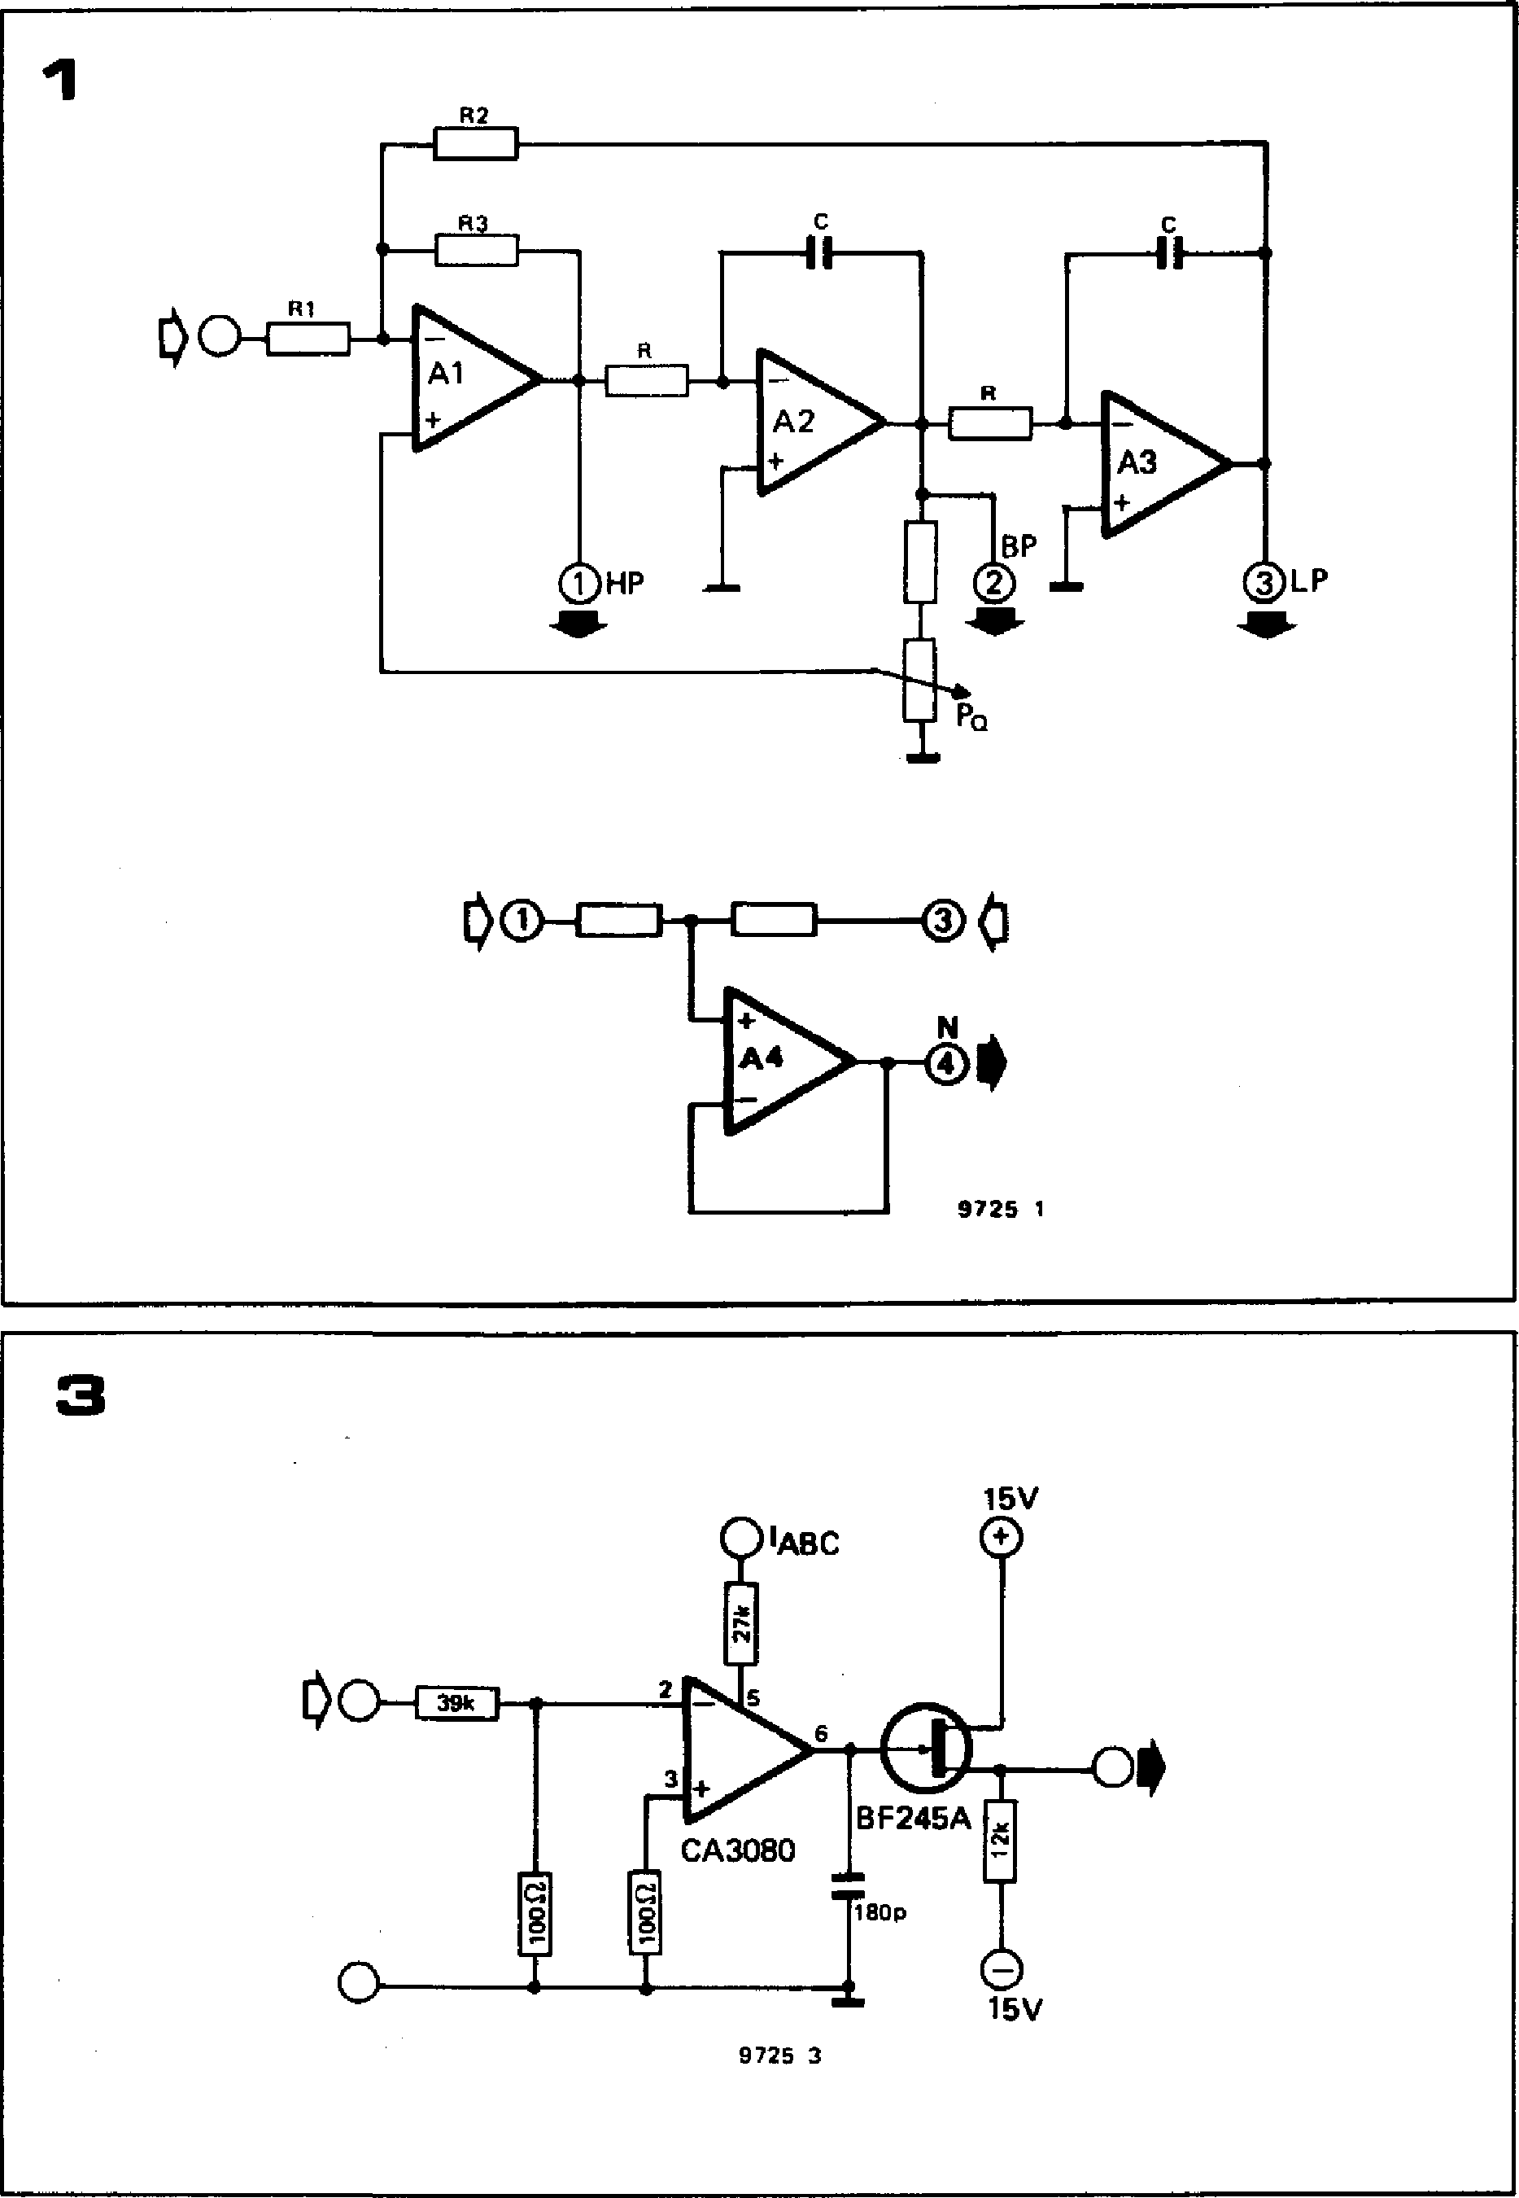

**Hardwired inputs:**

**KOV = Keyboard Output Voltage (from interface receiver).**

**ENV = Envelope shaper control voltage (from ADSR unit).**

**VCO 1, 2, 3 = From VCOs 1, 2 and 3.**

**Front-panel inputs:**

**ECV = External Control Voltage.**

**TM = Tone colour ('Timbre') Modulation input.**

**ES = External Signal, e.g. noise, input.**

**Outputs:**

**VCF/IOS = Internal Output Signal from VCF, (will be hardwired to a VCA).**

**EOS = External Output Signal from VCF (front panel output).**

**Front-panel controls:**

**OCTAVES ENV**

**TM ES**

**OUT ECV/KOV HP**

**BP LP** N

1. **coarse frequency adjustment.**
2. **sets envelope shaper control voltage.**
3. **sets tone colour modulation level.**
4. **sets external signal level.**
5. **0-factor adjustment.**
6. **sets VCF/IOS output level (not EOS1).**

**= S1, selects external or internal control voltage input. = 52, selects high-pass output.**

1. **selects bandpass output.**
2. **selects low-pass output. = S2 + S4, selects notch (band-stop) output.**

**Figure 2. Instead of normal op-amps, OTAs are used in the Formant VCF. The output current change is gm times the input voltage change, but gm can be varied by feeding in a control current IABC-**

**Figure 3. The OTA integrator used in the Formant VCF. The integrator time constant is controlled by the current !ABC. A high im­pedance buffer ensures that all the output current of the OTA flows into the integrator capacitor.**

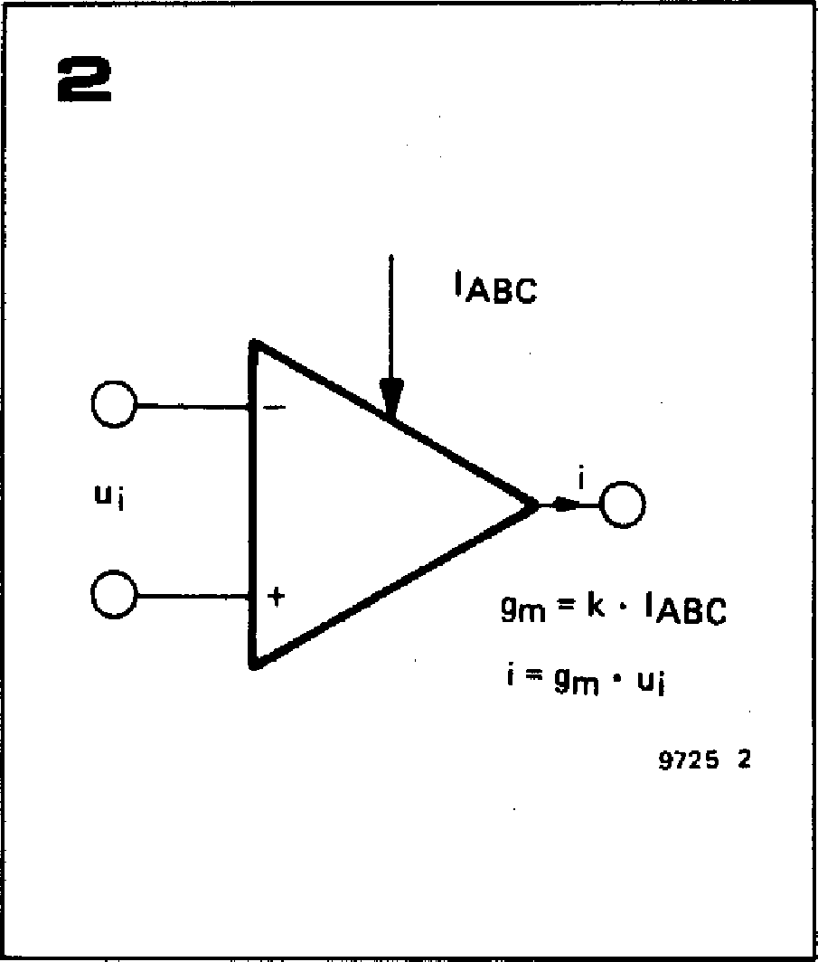

**of a differential-input voltage amplifier with the non-inverting input grounded. An input resistor connected to the inverting input (which is a virtual earth point) converts the input voltage into a proportional current. Since this current cannot flow into the inverting input it must flow into the feedback capacitor, and a voltage appears across the capacitor (and hence at the op-amp output).**

**It is fairly obvious that the op-amp is functioning simply as a voltage-to­current converter, and an equivalent circuit for an integrator would be an amplifier with a voltage-controlled cur­rent output, with a capacitor connected, not in a feedback loop, but between the output and ground. Varying the voltage-current transconductanbe of the amplifier would then effectively vary the 'resistance' constant of the inte­grator.**

**A suitable device exists ready-made in   
the shape of the operational trans-**   
**condunctance amplifier or OTA. This is**

**046 — FORMANT**

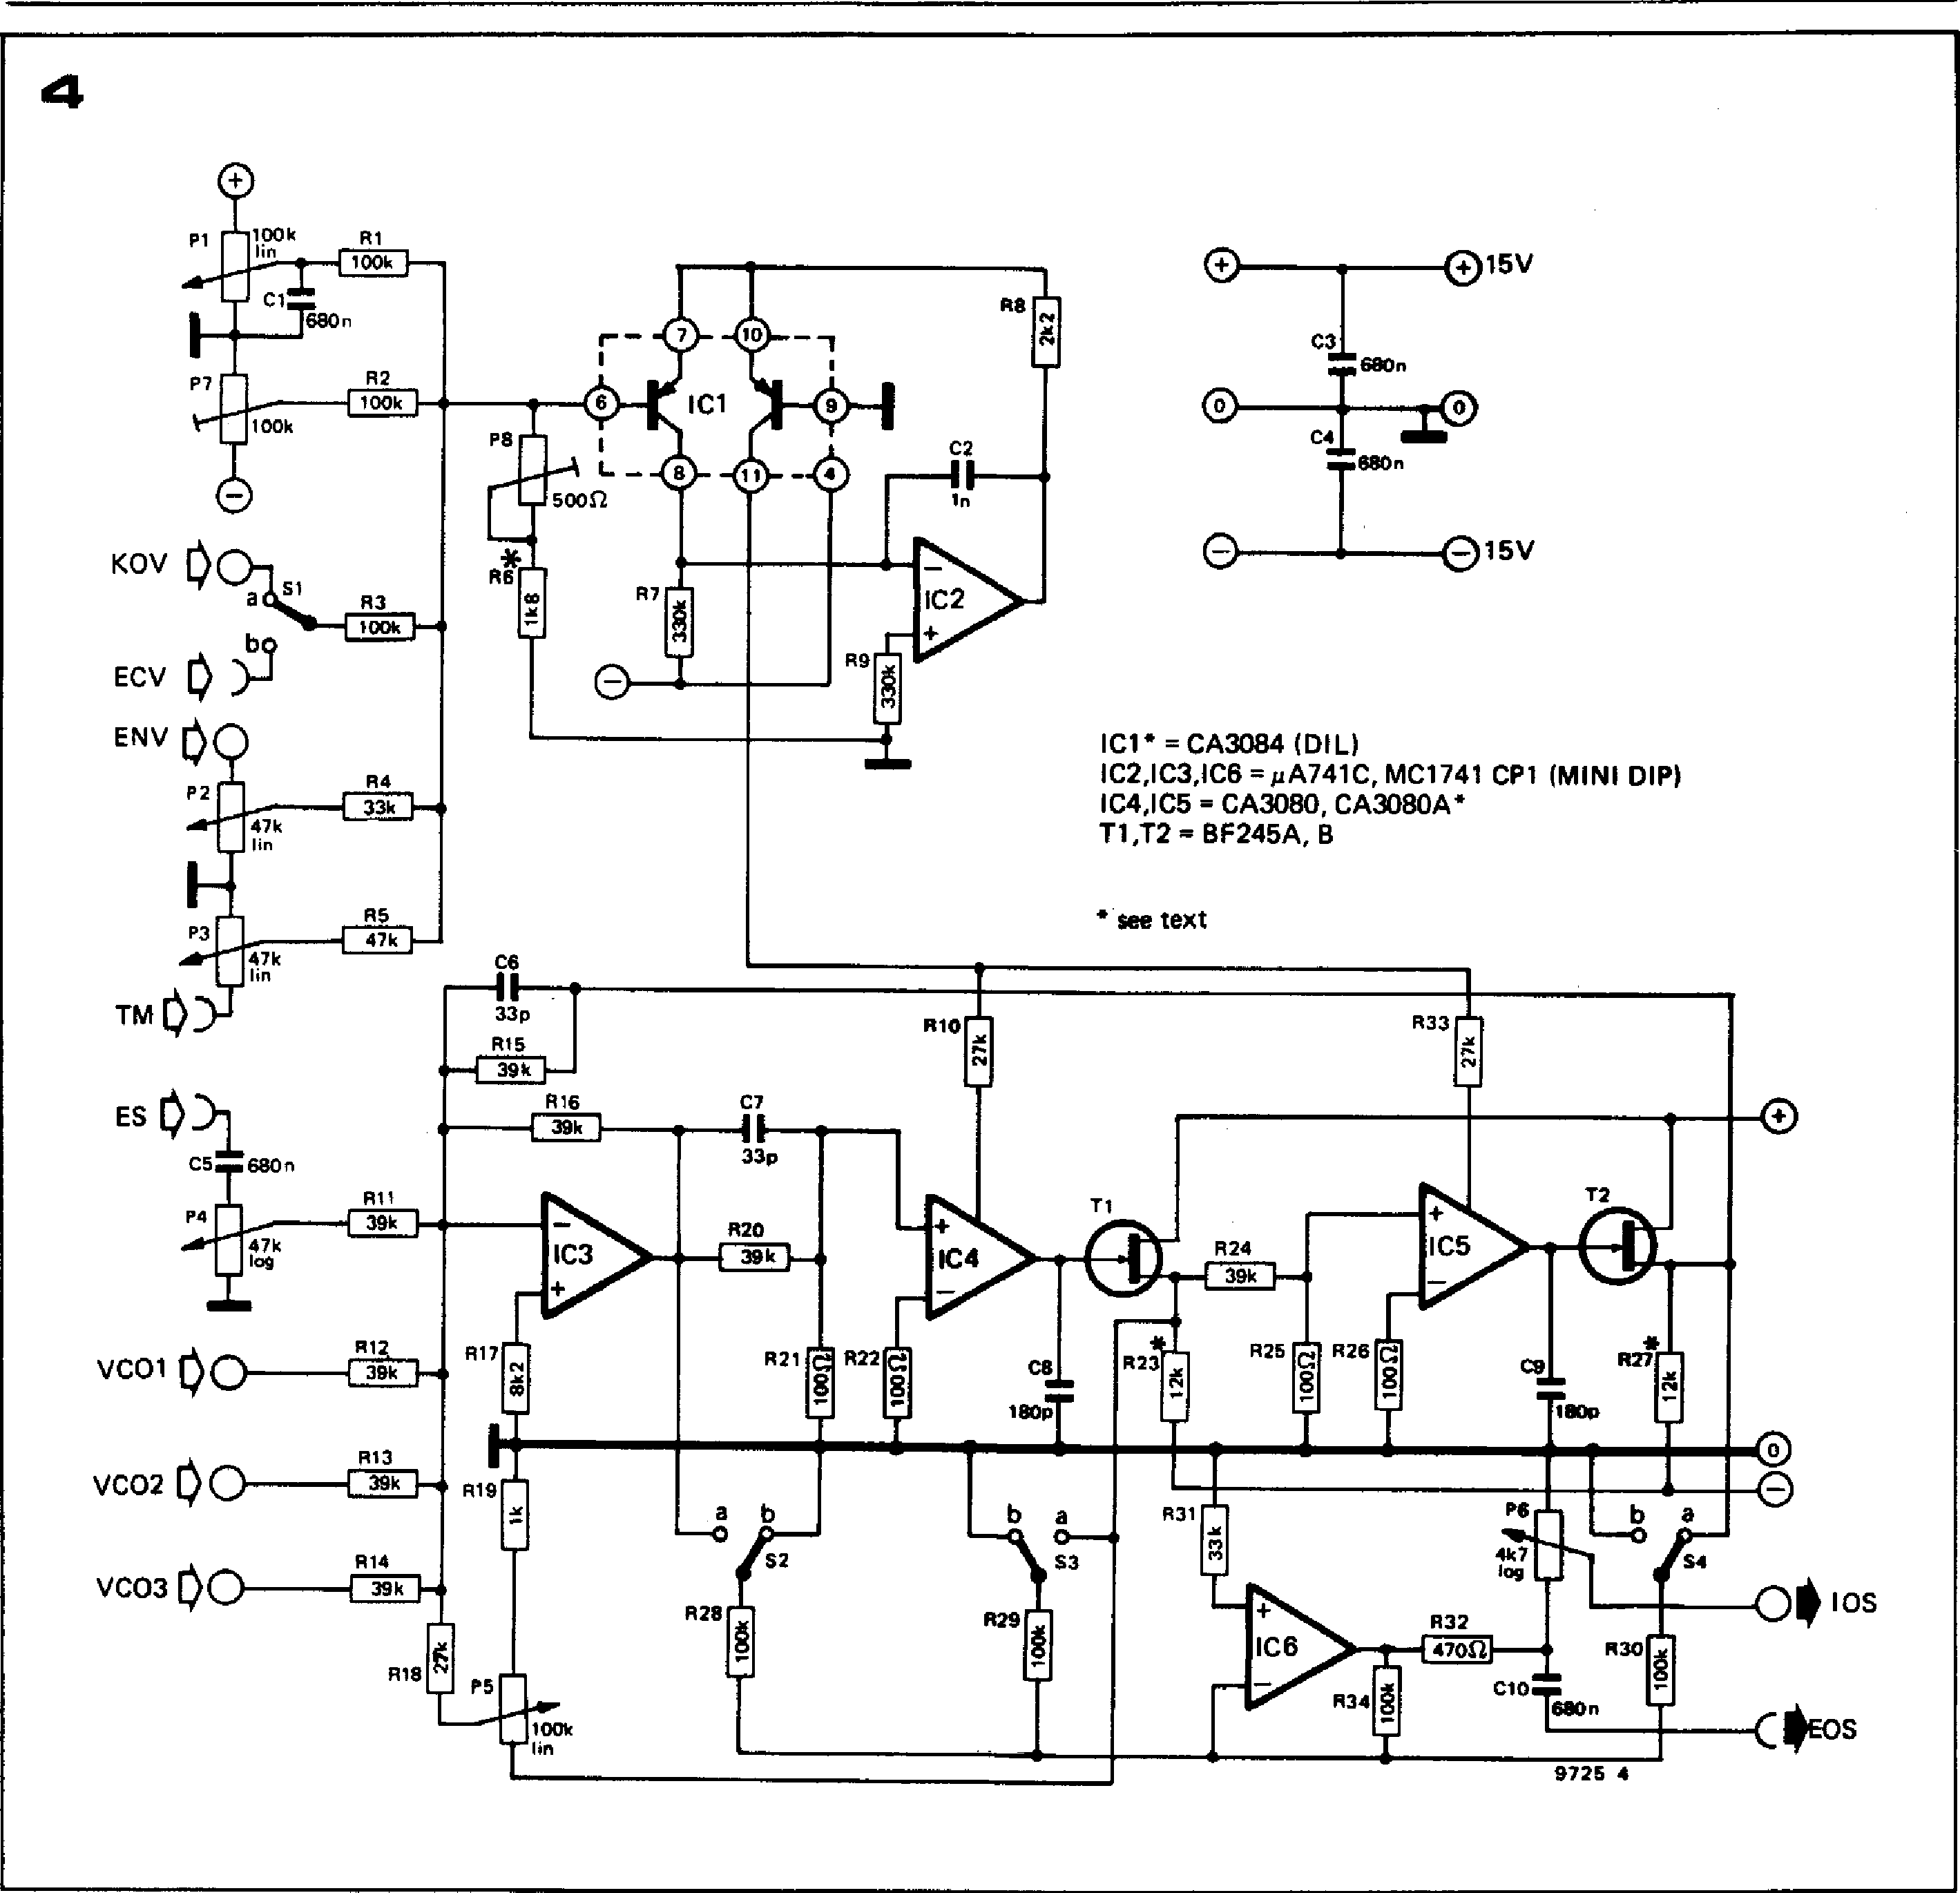

**R33**

R10

**47k**

**lin**

7k

**15V**

**C3**

**680n**

**CI MO**

**680n**

**15V**

**IC1" = CA3084 (DIL)**

**IC2,1C3,IC8 =pA741C, MC1741 CP1 (MINI DIP)**

**I C4,I C5 = CA3080, CA3080A\***

**T1,T2 = BF245A, B**

**41 see text**

**R3**

**100k**

**R4   
33k**

**R5 47k**

**KOV**

**_b9**

**ECV**

**ENV**

**P2**

**33p**

**Rt5**

**p...1 39k I.—**

**R16**

**P4**

**IC3**

**C7**

**I •**

**33p**

**R20   
39k**

**47k log**

**R18**

**VC01**

**VCO2**

**VCO3**

**R12**

**R13**

**R14**

**R17**

**R19**

**R21 CR22**

**8**

b

**52**

**R28**

**100k l'n**

**P5**

**9725 4**

**an amplifier that produces an output current which is proprotional to the input voltage, i.e. i = gm • ui, where i is the output current, ui is the input volt­age and gm is the transconductance. The feature of the OTA which makes it ideal for the VCF is that the trans-conductance gm is determined by a control current ImEtc, thus gm = k • 'ABC, where k is a constant. This is illustrated in figure 2.**

**For the CA 3080 OTA used in the Formant VCF the constant k is 19.2 V-1 at an ambient temperature of 25° C, and so gm = 19.2 x 'ABC mS (milliSiemens = milliamps/volt). This IC is particularly suitable because of the outstanding linearity of its transconduc­tance characteristic over three decades of control current, and because of its relatively small tolerance in the value of 'k' (2:1 for the 3080 and 1.6:1 for the 3080A). However good linearity is achieved only for small input signals, and the input voltage must be attenuated to about ± 10 mV when used in the**

**VCF.**

**Figure 3 shows the circuit of the integrator used in the Formant VCF. The input voltage is attenuated by the potential divider connected to the inverting input, and across the output is connected the 180 p integrating capacitor.**

**To maintain correct operation of the integrator the total output current of the OTA must flow into the integrator capacitor, which means that a buffer stage with a very high input impedance is required on the OTA output to avoid `current-robbing'. A FET connected as a source-follower is used for this purpose. The control current IABC is fed in through a 27 k resistor. The integrator time constant is inversely proprotional to the control current, so the VCF centre/turnover frequency is directly proportional to the control current.**

**Complete circuit of the VCF**

**Figure 4 shows the complete circuit of**

**the VCF. The actual filter circuit has a linear frequency characteristic and is current controlled. It must therefore be preceded by an exponential converter that converts the input control *voltage* into an exponentially related control *current,* so that the VCF tracks with the same 1 octave/V characteristic as the VCOs.**

**The exponential converter occupies the upper portion of the circuit, and is essentially similar to that of the VCOs. However, the control characteristic of the VCF does not need to be so accu­rate as that of the VCO, since a small error will only introduce minor, un­noticeable errors in amplitude response, whereas the same error in the VCO characteristic would cause unacceptable tuning errors.**

**For this reason the VCF exponential converter is provided only with a passive input adder (cf. figure 2a of the last chapter), and temperature stabilisation of the exponentiator is dispensed with, thus saving the cost of a not in-**

**FORMANT — 047**

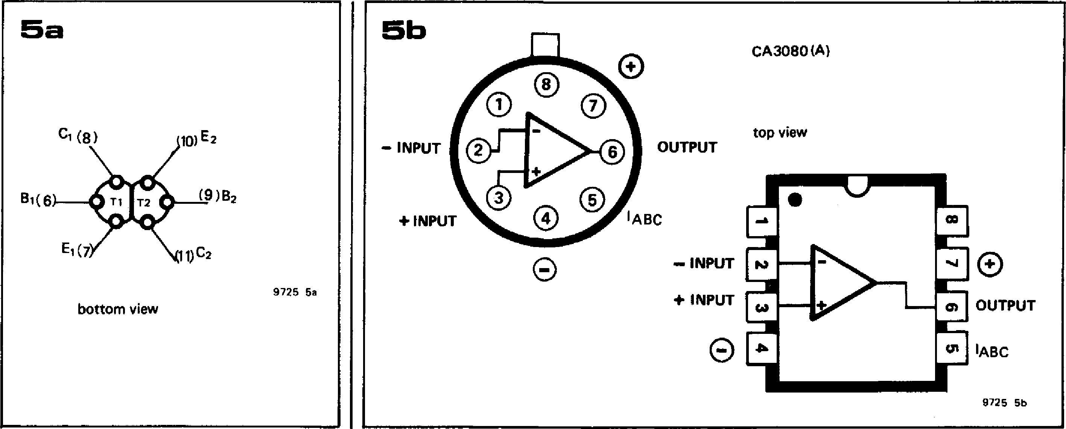

**Figure 4. Complete circuit of the Formant VCF, which consists of a voltage-current exponential converter and a linear current-controlled filter.**

**Figure 5a. Two well-matched PNP transistors may be used in place of IC1 for greater econ­omy. The pin numbers shown correspond to the pinout of IC1.**

**Figure 5b. The CA 3080 is available in two packages. If the TO- package is used the leads must be bent to fit the DIP layout on the p.c.b.**

expensive AtA726 IC. However, tempera­ture compensation is retained in the form of a matched transistor pair. The circuit differs here from the VCO since the exponentiator must source current into the OTAs rather than sinking it as in the VCO, so **PNP** transistors are used.

Since temperature stabilisation is not used, a number of options are open for the choice of the matched transistor pair. Those who have access to a good transistor tester or curve tracer can select a matched pair of any small signal medium gain (`B' spec) transistors such as the BC 179B, BC 159B, BC 557B etc. These are then glued together with epoxy adhesive for good thermal tracking as shown in figure 5a, taking care that there is no electrical contact between the cases if metal-can types are used. (Note that the pin numbers given in figure 5a correspond to the IC pinning in figure 4).

The preferred solution is to use a   
CA 3084 transistor array, which is what

was used in the **prototype, but if this is difficult to obtain then almost any dual** PNP transistor, **such as the Analog** Devices AD 820 . . . **AD 822, Motorola 2N3808 ... 2N3811 or SGS-ATES** BFX 11, **BFX 36, will do.**

Note that **the value shown for R6 ( 1k8)** is correct **when using the CA 3084. If a** dual transistor is used, it is **advisable to reduce the** value of R6 to **1k5.**

The current-controlled filter **consists of IC3, 1C4 and IC5. It will be noted that the integrators 1C4 and IC5. are non-inverting. This does not affect the oper­ation of the circuit, since non-inversion** has the same effect as **the double inver­sion that** takes place in figure **1.** How­ever, **it does ensure that the three out­puts of the filter are in the same sense, whereas in figure 1** the bandpass output is inverted with respect to the other two outputs.

IC6 functions as an output **buffer, and also as a summing amplifier for the high-pass outputs to provide the notch func­tion. By setting S2, S3 or S4 in position `a', highpass, lowpass or bandpass func­tions respectively may be selected. By setting both S2 and S4 in position 'a' the notch function is obtained. Since IC3 is connected as an inverting amplifier and IC6 also inverts, this double inver­sion means that the output signal is non-inverted with respect to the input signals. The overall gain of the VCF (in the passband) is x 1 (OdB).**

**Inputs, controls and outputs**

The exponential converter section is equipped with a coarse octave tuning control P1 (note the absence of a fine control as compared with the VCO) and two presets P7 and P8 to adjust the offset and octave/V characteristic.

KOV and ECV control inputs are pro­vided, as for the VCO. The input for envelope shaper control (ENV) is ad­justable by means of P2. The tone colour modulation input controlled by P3/(TM) is analogous to the FM input of the VCO, i.e. it allows the centre/turnover frequency of the VCF to be modulated. There are four signal inputs, three inter­nally-wired VCO inputs and one external

**signal (ES) input, whose amplitude can be controlled by P4. The Q-factor of the filter is controlled by P5.**

**Switches S2 to S4 select the desired filter type, as has already been described. Two outputs** are provided, an **uncon­trolled output EOS which is brought out to a front-panel socket, and an internal output 10S,** which is **controlled by P6.**

**Construction**

**A printed circuit board and component layout for the VCF** are given in figure 6. The same considerations of component quality apply to the VCF that apply to all parts of the synthesiser. As mentioned earlier, two basic versions of the CA 3080 are available. **The CA 3080A has** better specifications as regards tolerance, and extended temperature range, but the basic CA 3080 is quite adequate (as­suming that the synthesiser is not to be used in Antarctic blizzards).

The CA 3080 is available in two pack­ages, TO- can and mini-DIP, both of which are shown in figure 51). The p.c. board is laid out for the mini-DIP ver­sion, but the TO- version can easily be accomodated by splaying out the leads to conform with the mini-DIP pinning (in fact some TO- package 3080s are supplied with this already done).

The FETs T1 and T2 must be tested as detailed in chapter 3 and their source resistors R23 and R27 selected in accordance with Table 1 of that chapter. A front panel layout for the VCF is given in figure 7, and a wiring diagram for the front-panel mounted components is shown in figure 8.

**Testing and adjustment**

During assembly, it is convenient to use IC sockets so that the current-controlled fiter section of the circuit can be tested independently of the exponential con­verter. To test the CCF, IC1 is removed and a 100k log potentiometer is connec­ted `back-to-front' between ground and -15V (i.e. so that the end of the track approached by clockwise rotation of the wiper is connected to ground).

A multimeter set to the 100 ALA range is

**'MI.- MAMA Pi T**

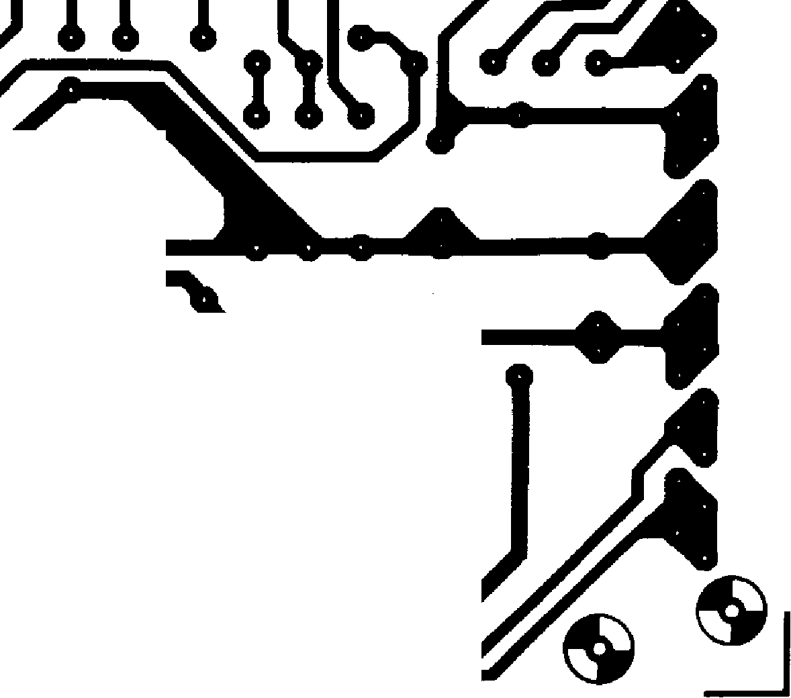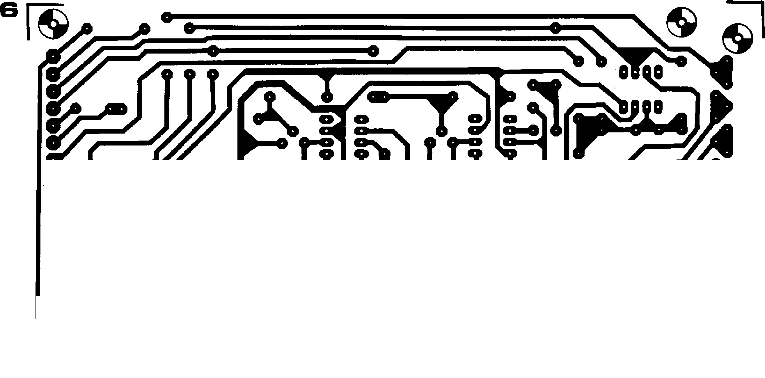7116 )•(7310

rk''°° L

•



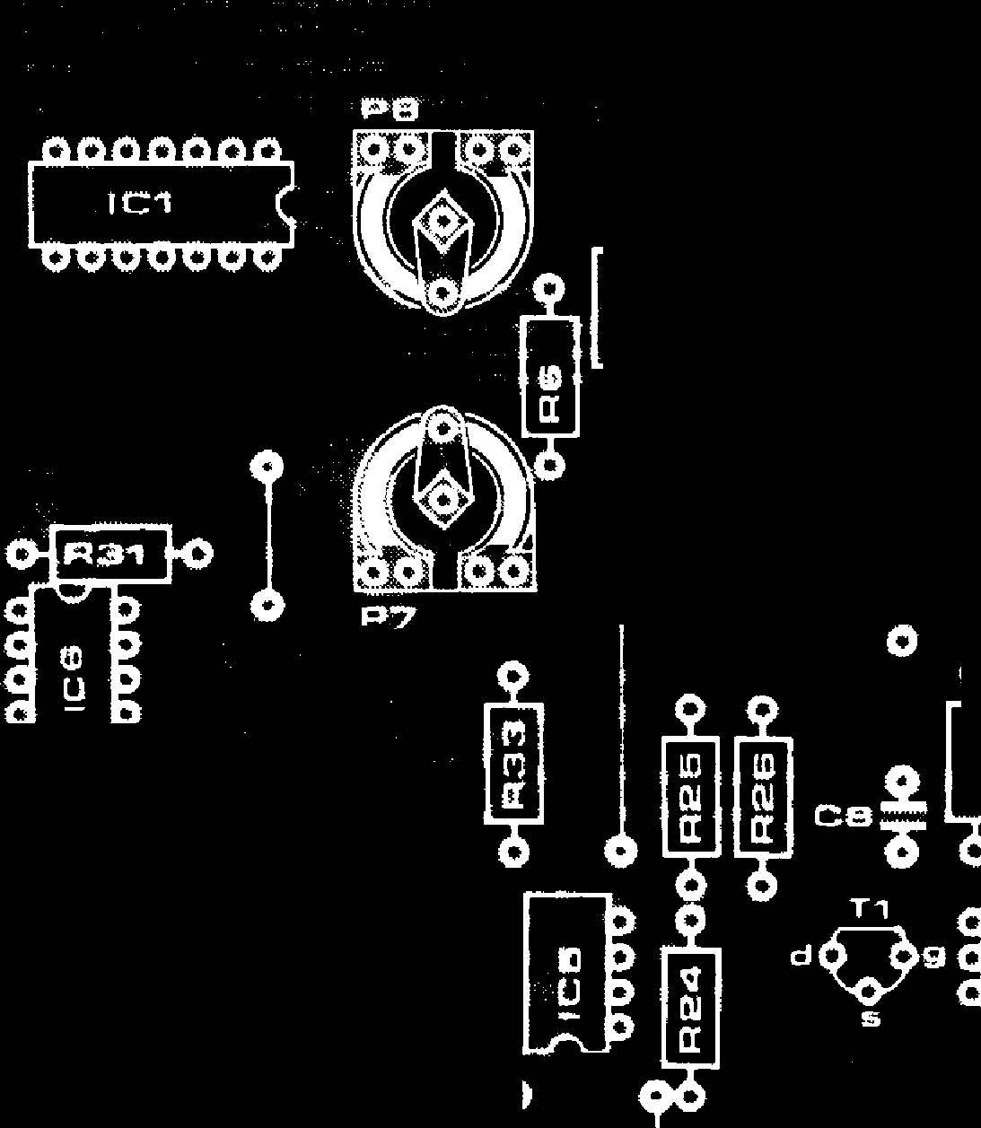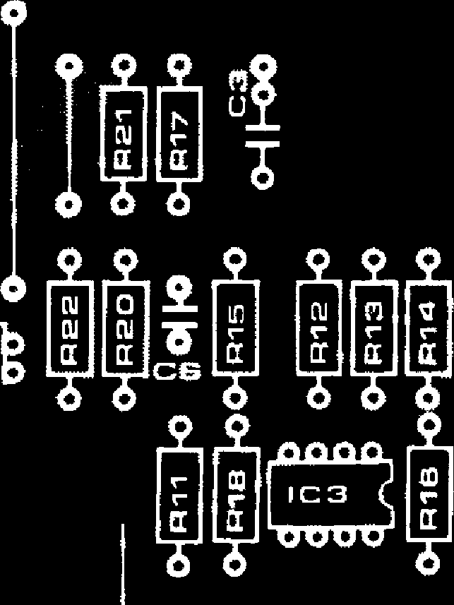

51

**a C°**

**41 OP 3**

**roo RO *tilt"***

**116 -4 0114510**

**0920-{Frallo E co-1142810**

**1210**

**01R3,40**

**a1041**

A.,40°.1 to

ea s

**ti 0**

**Ytp**

**0-i**

a **[0**

0**41 FV0**

Pc•fm-10

**o**

**0**

**4:042**

0

**lisvoo   
0   
mow**

**vco 0**

**300**

**2 0**o

**0**

0

**0**

**L**

**Q!! I CJSQ**

0

0

0

**li [**

**0 4 ,.. I CH R8 fo**

**.0 40.111%6**

**0 0 os301R301.0**

**C94**

**T2 c**

**ciec#9 C**

**C**

**S a**

**K CIV   
ENV**

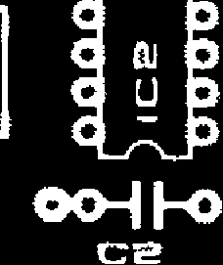

**U D**

**-t.r'sfi 0**

**04 R 473j0 C7**

0

**tr**

**Parts List**

**Resistors:**

**R1, R2, R28, R29,**

**R30, R34 = 100 k**

**R3 = 100 k (1% metal oxide)**

**R4 = 33 k**

**R5 = 47 k**

**R6 = 1k8 (see text)**

**R7, R9 = 330 k**

**R8 = 2k2**

1. **R33 = 27 k**
2. **R12, R13, R14,**

**R15, R16, R20, R24 = 39 k**

**R17 8k2**

**R18 = 22 k**

**R19 = 1 k**

**R21, R22, R25, R26 = 100** SZ   
**R23, R27 = 12 k (nominal value,   
see text)**

**R31 = 33 k**

**R32 = 470 SZ**

**Potentiometers:**

1. **P5 = 100 k lin**
2. **P3 = 47 k (50 k) lin P4 = 47 k (50 k) log**

**P6 = 4k7 (5 k) log**

**Presets:**

**P7 = 100 k**

**P8 = 470 SI (500 SZ)**

**Capacitors:**

**Cl, C3, C4, C5, C10 = 680 n C2 = 1 n**

**C6, C7 = 33 p**

**C8, C9 =180 p**

**Semiconductors:**

**IC1 = CA3084 (DI L) see text.**

**1C2, IC3, IC6 = AA 741 C (Mini DIP),**

**MC1741 CP1 (Mini DIP). IC4, 105 = CA 3080 (A)**

**T1, T2 = BF 245a, b.**

**Miscellaneous:**

**31-way plug (DIN 41617)**

**S1 - S4 = miniature SPDT toggle switch**

|  |  |  |  |  |  |  |
| --- | --- | --- | --- | --- | --- | --- |
|  |  |  |  |  | **FORMANT — 049** | |
|  |  |  |  |  |  |  |
|  | **Figure 6. Printed circuit board and component layout for the VCF. (EPS 9724-1).** |  |  | | | |
|  |  |
| **connected between the wiper of the potentiometer and the junction of R10 and R33, an input signal is provided to the VCF from a sinewave generator or from the VCO, and the Bandpass output is monitored on an oscilloscope. The test then proceeds as follows:**   1. **Set the Q-factor of the filter to maxi­mum (wiper of P5 turned towards R19).** 2. **By means of the 100k log potentio­meter set the control current to 50 ;IA on the meter.** 3. **Slowly increase the generator fre­quency from about 300 Hz to 1500 Hz; somewhere in this range the VCF out­put should peak as its resonant frequency is reached (i.e. there will be a sharp in­crease in output at a particular frequency with a fall-off on each side). Note the frequency at which resonance occurs,** 4. **Increase the control current to 100 ttA and check that resonance now occurs at twice the previously noted frequency.**   **Note. Tests 2 to 4 are intended to check the linearity of the filter frequency v. control current characteristic. The tolerance in the absolute value of filter frequency for a given control current is due to OTA tolerances and is unimport­ant provided linearity is maintained i.e. the filter frequency doubles for each doubling of control current.**   1. **Set the generator to about 50 Hz and check that it is possible to obtain resonance at this frequency by varying the control current with the 100 k potentiometer. Repeat this test at 15 kHz.**   **The exponential converter can now be tested after inserting IC1 and removing IC4 and IC5. A multimeter set to the 100 /IA range is connected from the bottom end of RIO to -15V and the wiper voltage of P1 is monitored with a voltmeter.**  **The test and adjustment now proceed as follows:**  **I. Set P8 to its mid-position, and turn P1 fully anticlockwise so that its wiper voltage is zero. Adjust P7 until the mircroammeter reading is 50 ttA.**   1. **Turn PI clockwise until its wiper voltage is 1V, then adjust P8 until the microammeter reads 100** 2. **Repeat the procedure for 2V, 3V, 4V etc. on the wiper of P1 , checking that the exponentiator output current doubles for every 1V increase.**   **Offset adjustment**  **Now that the two sections of the VCF have been checked, IC4 and IC5 can be re-inserted so that the entire VCF can be checked as a functional unit, as follows:**  **I. A squarewave with 50% duty-cycle at a frequency of about 500 Hz is fed to one of the filter inputs. P1 is turned fully clockwise and P7 is turned anticlockwise. 1 The lowpass output of the VCF is** | |  |
|  | **Figure 7. Front panel *out for ins Val.** | |  |  |
|  |  |  |  |  |

monitored on an oscilloscope, and at this stage should appear at the output without degradation.

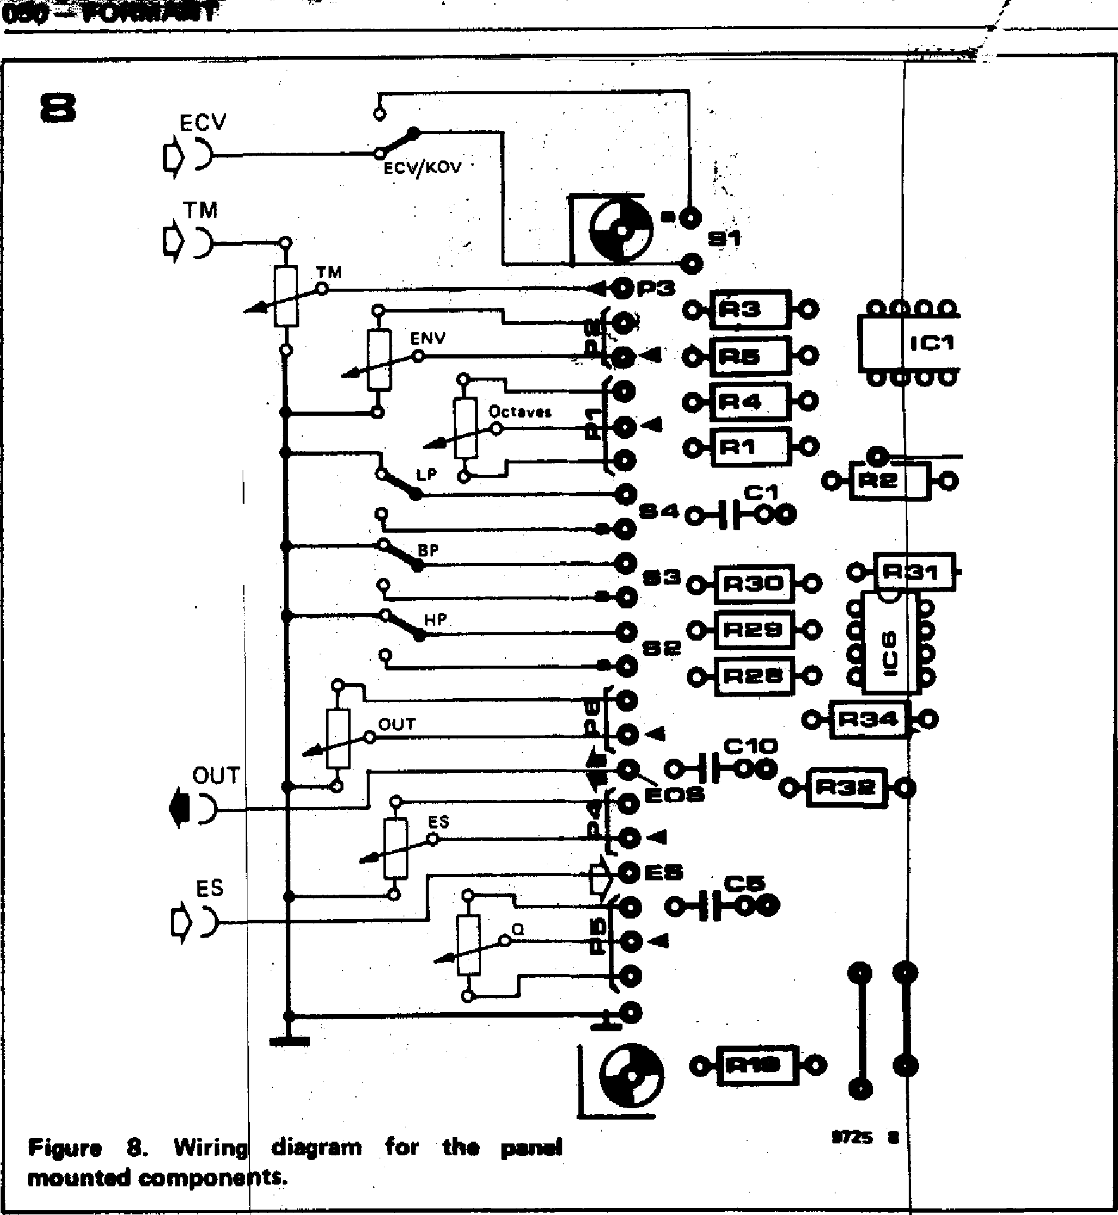

**ECV**

i**)**

**TM**

ECV/KOV •

**060=CONWIPMIT**

T

nn

**ICI**

VV

•

**Os 4 n...1 ala**

**9 •40 —**

**283**

**9**

**%%HP 0**

**9**

**OUT**

**0SE**

**it**

**OUT**

**I)**

ES

**ES**

**Figure 8. Wiring diagram for the**

**mounted components.**

**ms •**

**tput peaks.**

**o further read-the output to one note to**

**may have been nd if necessary in the offset**

**til no further fined.**

***uctance mmable active *gn, September***

***ontrolled***

3. If the wiper of P7 is now turned slowly clockwise the leading edge of the squarewave will start to be rounded off as the turnover point of the filter is reduced. To carry out the offset adjust­ment with P7 its wiper is turned as far clockwise as is possible without signifi­cantly degrading the square waveform (just a slight rounding of the top corner is acceptable, but this adjustment does not have to be particularly precise).

**Octaves/Volt adjustment**

**The** octave/V characteristic of the VCF **can** be adjusted by seeing how well it **tracks** against a previously calibrated VCO. To do this, the KOV input is connected to the VCO and the VCF, **and the sine output of the VCO is connected to the VCF input. The ad­justment procedur is as follows:**

1. **Switch off the main tuning of the keyboard, depress top C of the-keyboard and use the octav s control of the VCO to set its frequenc to about 500 11,z.**
2. **Set the Q cont ol, PS, of the VCF to maximum,** monitOr the bandpasi **-output of the VCF and adjust P1 until the VCF output peaks. As the filter is loaded at high Q-factott necessary to reduce the VCO output• voltage.**

**3**.**. Depress the key two octaves lower and adjust P8 until the V again peaks.**

**4. Depress top C again and if necessary**

readjust P1 so that the o

1. Repeat 3 and 4 until justment is necessary fo peak when changing fro the other..
2. The offset adjustment disturbed, so check this readjust P7 as describe adjustment procedure.
3. Repeat 3 onwards u improvement can be obt

***Bibliography***

1. ***Franco: 'Use transcon amplifiers to make progr filters. — Electronic Des****.* ***13th, 1976.***
2. ***Orr: `Voltagelcurrent­filter.' — Circuit Ideas, Wireless World, November 1976.***

***E. F. Good and F. E. J. Oirling: 'Active filters, 8. The two-integrattor loop, continued' — Wireless World,***

***March 1970.***

***D. P. Colin: 'Electrical d;sign and musical application .of an uncon­ditionally stable combined voltage-controlled filter resonator'. — JAES, December 19th 1971.***

***:. Clayton: 'Experim opeso.sional amplifiers. 4. Intepators.' -- Wireless August 1972.***

***nts with Operational orld,***

***dung der -verstarker — RCA***

***-6668,***

**we**n ***nc***e ***A 308 nd CA 80A. Applicationsschrift ICA****JI* ***1973.***

***U. Tietze Ch. Schenk: instellbares***

***r Schaltungs-***

***technik, p. 350. Springer-Verlag, Berlin, Heidelberg, New York, 1976.***

**chapter 7**

**24 dB VCF**

**Because of the greater range of tonal possibilities they offer,**

**VCFs with an extremely steep slope seem to have a particular appeal for most synthesiser enthusiasts. The design presented here is for a VCF offering a choice of lowpass or highpass functions and a filter slope of 6, 12, 18 or 24 dB per octave.**

**New possibilities**

It should be stated at the outset that the **24 dB VCF is not intended to** replace **the 12 dB design. On the contrary, the two filters are complementary to one another and can be used** in combi­nation **to provide greatly** increased possibilities **for** tailoring the harmonic structure of the sounds produced by **Formant.**

**For example, the 12 dB** VCF can be **used in the bandpass mode together with the steep filtering of the 24 dB VCF to produce selective tone** color­ation. **The two filters can be controlled by the same envelope shaper or** by different envelope shapers, and may be connected in cascade or in parallel. The latter arrangement offers several interesting possibilities. For example, hard, metallic sounds can be produced by applying a short, steep envelope volt­age to the 12 dB VCF and a longer, shallower contour to the 24 dB VCF. If the filter inputs are connected in parallel then interesting effects may be **-obtained by connecting one VCF** out­put to one input of a stereo amplifier and the other VCF output to the other input. This gives rise to a very distinc­tive dynamic amplitude characteristic and stereo imaging, particularly if the two VCFs are controlled by different envelope shapers.

**The audible** differences between the 12 dB VCF and the 24 dB VCF are quite prominent. The 12 dB VCF produces sounds that are distinctly `electronic', which can have **a slightly** fatiguing effect on the listener during extended playing sessions. The sounds **produced** by the 24 dB VCF, on the other hand, are much more 'natural', and can be listened to for extended periods without fatigue. This effect is probably due to the more severe filtering of higher harmonics which the 24 dB VCF provides when used **in the lowpass** mode, since these harmonics tend to make the sound of the 12 dB VCF much more shrill than that of the 24 dB VCF.

The effect of the steeper filter slope of the 24 dB VCF is illustrated in figure 1, which shows **the different outputs from the 12 dB VCF (dotted line) and 24 dB**