monitored on an oscilloscope, and at this stage should appear at the output without degradation.

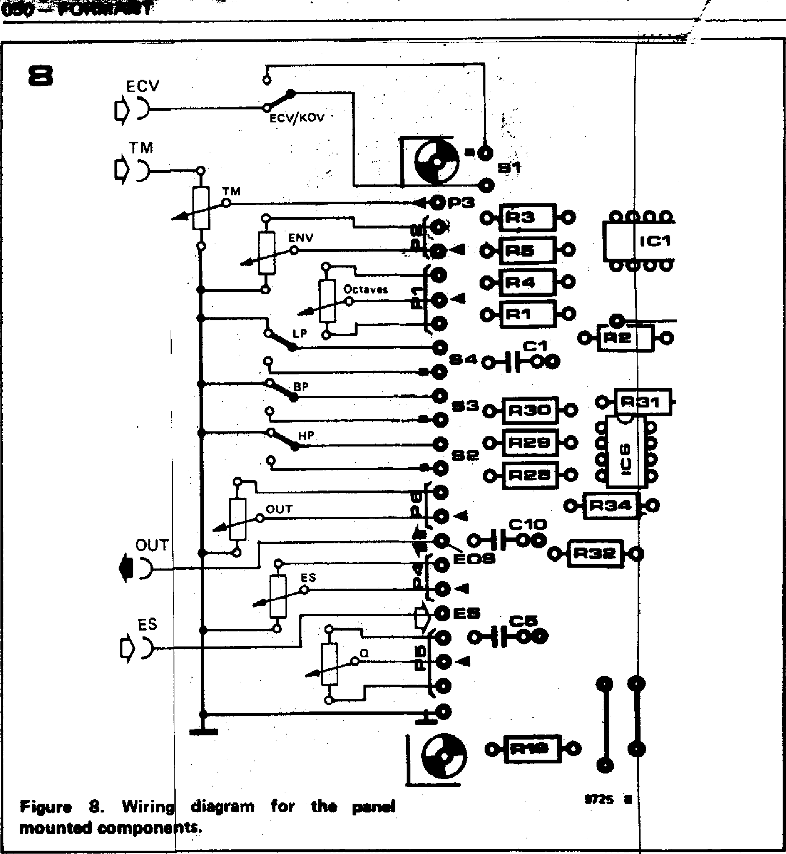

**ECV**

i**)**

**TM**

ECV/KOV •

**060=CONWIPMIT**

T

nn

**ICI**

VV

•

**Os 4 n...1 ala**

**9 •40 —**

**283**

**9**

**%%HP 0**

**9**

**OUT**

**0SE**

**it**

**OUT**

**I)**

ES

**ES**

**Figure 8. Wiring diagram for the**

**mounted components.**

**ms •**

**tput peaks.**

**o further read-the output to one note to**

**may have been nd if necessary in the offset**

**til no further fined.**

***uctance mmable active *gn, September***

***ontrolled***

3. If the wiper of P7 is now turned slowly clockwise the leading edge of the squarewave will start to be rounded off as the turnover point of the filter is reduced. To carry out the offset adjust­ment with P7 its wiper is turned as far clockwise as is possible without signifi­cantly degrading the square waveform (just a slight rounding of the top corner is acceptable, but this adjustment does not have to be particularly precise).

**Octaves/Volt adjustment**

**The** octave/V characteristic of the VCF **can** be adjusted by seeing how well it **tracks** against a previously calibrated VCO. To do this, the KOV input is connected to the VCO and the VCF, **and the sine output of the VCO is connected to the VCF input. The ad­justment procedur is as follows:**

1. **Switch off the main tuning of the keyboard, depress top C of the-keyboard and use the octav s control of the VCO to set its frequenc to about 500 11,z.**
2. **Set the Q cont ol, PS, of the VCF to maximum,** monitOr the bandpasi **-output of the VCF and adjust P1 until the VCF output peaks. As the filter is loaded at high Q-factott necessary to reduce the VCO output• voltage.**

**3**.**. Depress the key two octaves lower and adjust P8 until the V again peaks.**

**4. Depress top C again and if necessary**

readjust P1 so that the o

1. Repeat 3 and 4 until justment is necessary fo peak when changing fro the other..
2. The offset adjustment disturbed, so check this readjust P7 as describe adjustment procedure.
3. Repeat 3 onwards u improvement can be obt

***Bibliography***

1. ***Franco: 'Use transcon amplifiers to make progr filters. — Electronic Des****.* ***13th, 1976.***
2. ***Orr: `Voltagelcurrent­filter.' — Circuit Ideas, Wireless World, November 1976.***

***E. F. Good and F. E. J. Oirling: 'Active filters, 8. The two-integrattor loop, continued' — Wireless World,***

***March 1970.***

***D. P. Colin: 'Electrical d;sign and musical application -of an uncon­ditionally stable combined voltage-controlled filter resonator'. — JAES, December 19th 1971.***

***:. Clayton: 'Experim opeso.sional amplifiers. 4. Intepators.' -- Wireless August 1972.***

***nts with Operational orld,***

***dung der -verstarker — RCA***

***-6668,***

**we**n ***nc***e ***A 308 nd CA 80A. Applicationsschrift ICA****JI* ***1973.***

***U. Tietze Ch. Schenk: instellbares***

***r Schaltungs-***

***technik, p. 350. Springer-Verlag, Berlin, Heidelberg, New York, 1976.***

**chapter 7**

**24 dB VCF**

**Because of the greater range of tonal possibilities they offer,**

**VCFs with an extremely steep slope seem to have a particular appeal for most synthesiser enthusiasts. The design presented here is for a VCF offering a choice of lowpass or highpass functions and a filter slope of 6, 12, 18 or 24 dB per octave.**

**New possibilities**

It should be stated at the outset that the **24 dB VCF is not intended to** replace **the 12 dB design. On the contrary, the two filters are complementary to one another and can be used** in combi­nation **to provide greatly** increased possibilities **for** tailoring the harmonic structure of the sounds produced by **Formant.**

**For example, the 12 dB** VCF can be **used in the bandpass mode together with the steep filtering of the 24 dB VCF to produce selective tone** color­ation. **The two filters can be controlled by the same envelope shaper or** by different envelope shapers, and may be connected in cascade or in parallel. The latter arrangement offers several interesting possibilities. For example, hard, metallic sounds can be produced by applying a short, steep envelope volt­age to the 12 dB VCF and a longer, shallower contour to the 24 dB VCF. If the filter inputs are connected in parallel then interesting effects may be **-obtained by connecting one VCF** out­put to one input of a stereo amplifier and the other VCF output to the other input. This gives rise to a very distinc­tive dynamic amplitude characteristic and stereo imaging, particularly if the two VCFs are controlled by different envelope shapers.

**The audible** differences between the 12 dB VCF and the 24 dB VCF are quite prominent. The 12 dB VCF produces sounds that are distinctly `electronic', which can have **a slightly** fatiguing effect on the listener during extended playing sessions. The sounds **produced** by the 24 dB VCF, on the other hand, are much more 'natural', and can be listened to for extended periods without fatigue. This effect is probably due to the more severe filtering of higher harmonics which the 24 dB VCF provides when used **in the lowpass** mode, since these harmonics tend to make the sound of the 12 dB VCF much more shrill than that of the 24 dB VCF.

The effect of the steeper filter slope of the 24 dB VCF is illustrated in figure 1, which shows **the different outputs from the 12 dB VCF (dotted line) and 24 dB**

**FORMANT — 051**

**Figure 1. This illustrates the difference be­tween the outputs of a 12 dB/octave VCF and a 24 dB/octave VCF having the same turnover frequency, when fed with a sawtooth input. The 24 dB VCF removes practically all the harmonics giving a sinewave output, whereas the original waveshape is still distinguishable at the output of the 12 dB VCF.**

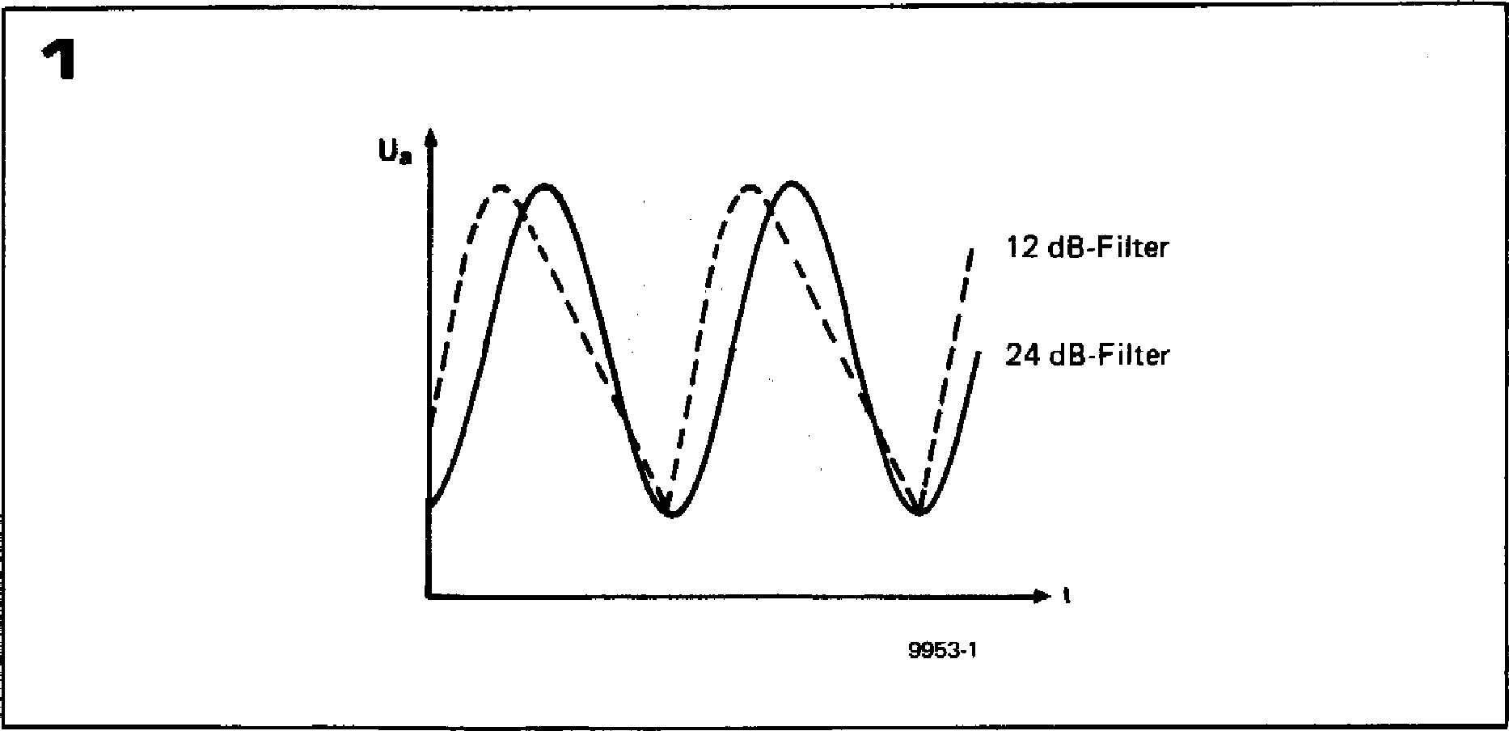

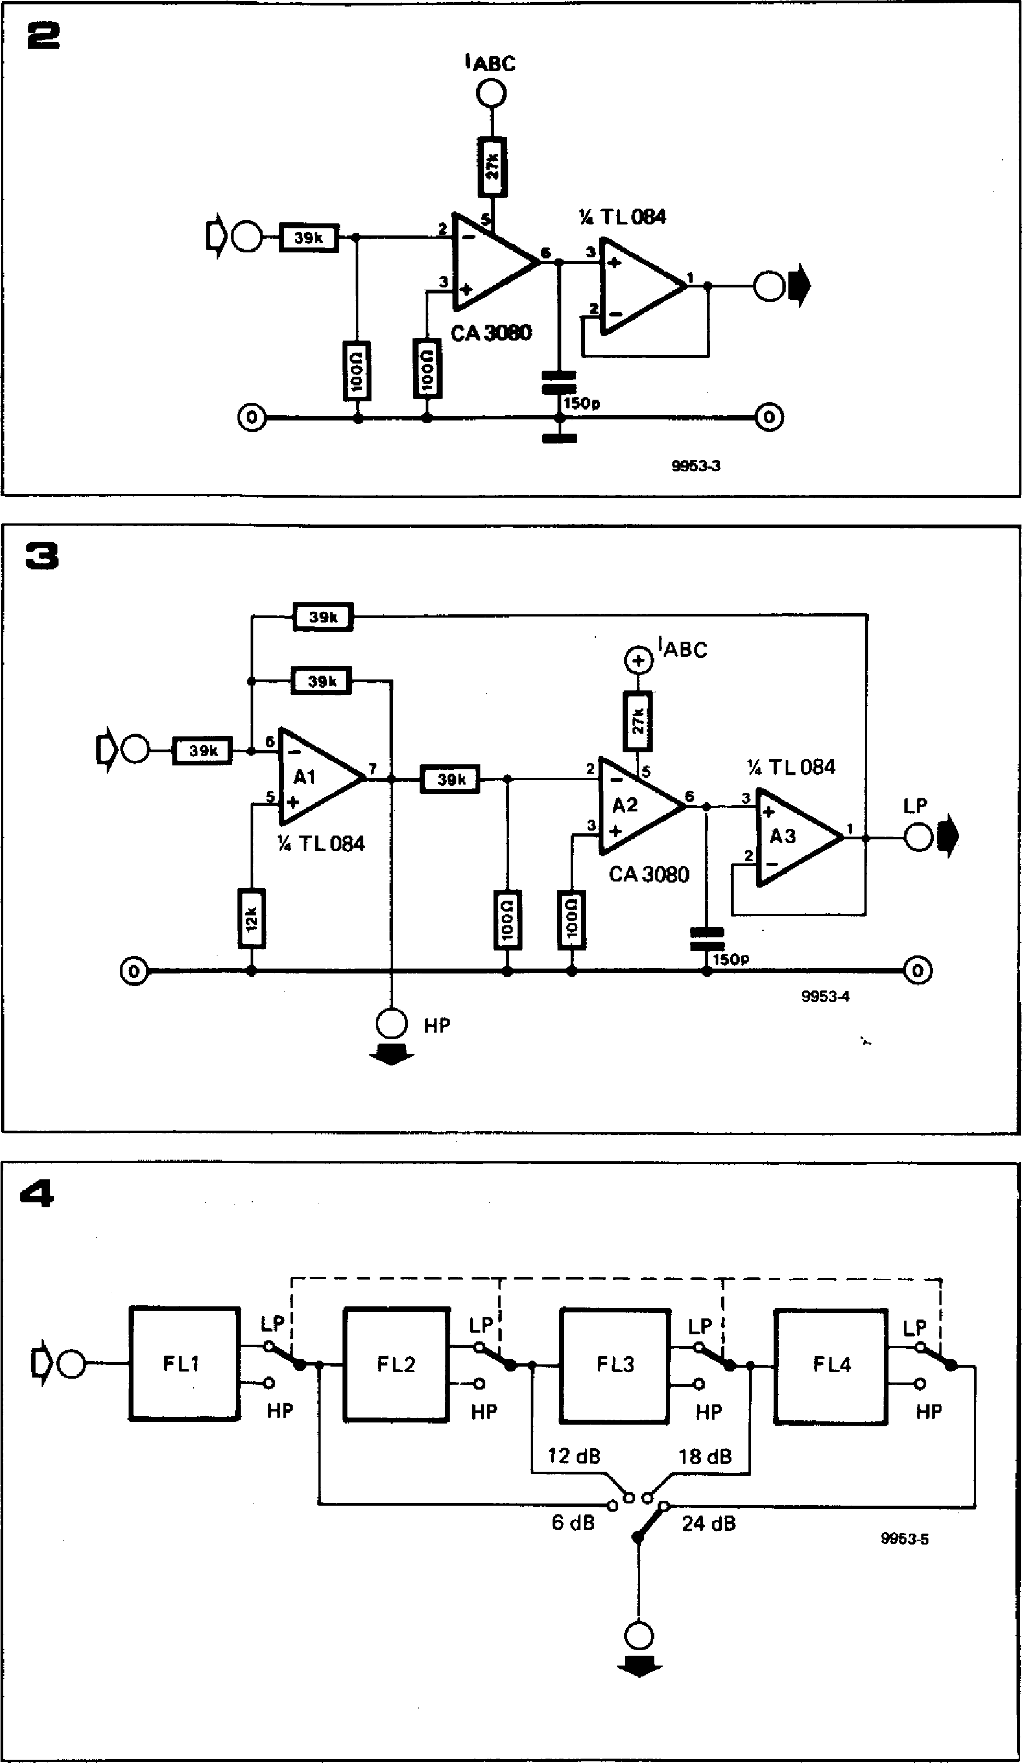

**LP**

**HP**

**LP**

**—040_**

**HP**

**F L4**

**IABC**

•

* **En**

0 0

**CA 3080**

**.11.1**

**9953-3**

**2**

**% TL084**

**3**

00

3

**Al**

**ran**

**TL 084**

**Nam**

**A2**

**3**

0

**IABC**

**3**

+­**A3**

**TL 084**

**CA3080**

**LP**

**00**

O

**9953-4**

**0 HP**

**AP-**

**4**

**-r**

**1 I
  
LPG**

**LP I**

**i —144....._**

**FL3**

**HP HP**

**12dB 18dB**

**6 dB 24 dB**

0

**9953-5**

**FL2**

**FL1**

**Figure 2. The basic filter section of the 24 dB VCF is the same as that of the 12dB VCF, i.e. an OTA integrator followed by a FET op-amp buffer.**

**Figure 3. The highpass function is obtained by connecting the 6 dB lowpass section in the feedback loop of an operational amplifier.**

**Figure 4. To obtain a 24 dB/octave filter, four 6 dB/octave sections are cascaded.**

VCF (continuous line) when fed with a sawtooth waveform. It is apparent that, due to the almost complete removal of the harmonics of the sawtooth, the out­put of the 24 dB VCF is practically a sinewave, whereas the original waveform is still apparent at the output of the 12 dB VCF since the harmonics are only partially removed.

It is clear from the foregoing that a 24 dB VCF greatly extends the musical possibilities of a synthesiser and is virtually a must for the serious user.

**Design of the 24 dB VCF**

The design of the basic filter section shown in figure 2 is very similar to that of the 12 dB VCF, which was described in detail in the previous chapter. How­ever, advantage has been taken of recent developments in FET op-amp techno­logy to simplify the design slightly. As has been explained, the basic filter section is an integrator or 6 dB/octave lowpass section consisting of an OTA driving a capacitor. The voltage/current transconductance (gm) of the OTA can be varied by an external control current and hence, via an exponential volt­age/current converter, from an external control voltage. This control current alters the time constant of the integrator and hence the turnover frequency of the filter section.

**The output current of the OTA must all flow into the capacitor, otherwise the integrator characteristic will be less than ideal. This means that the output of the OTA must be buffered by an amplifier with a high input impedance. In the**

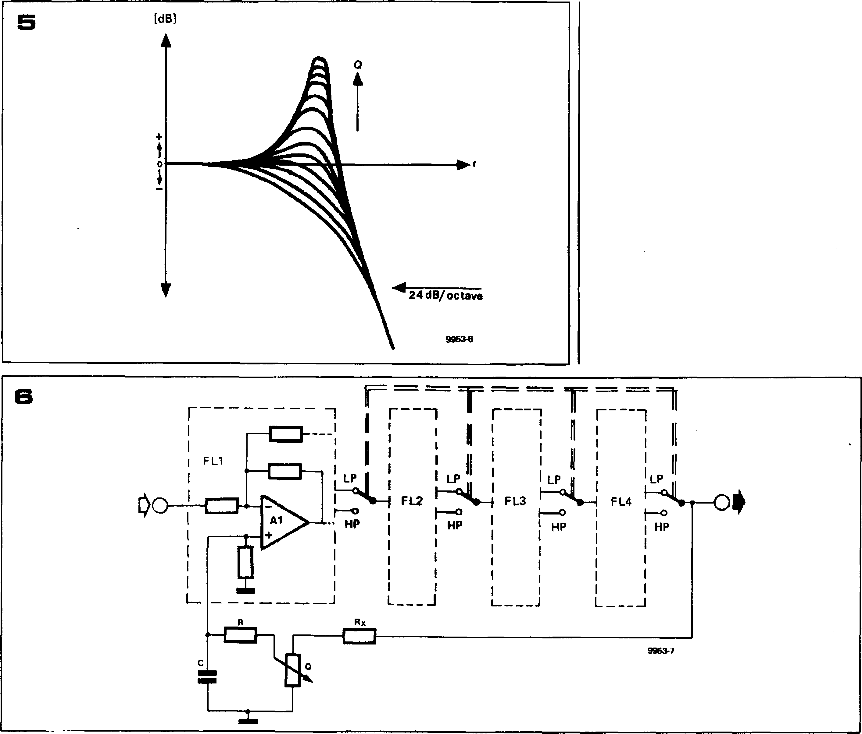**12 dB VCF this was achieved by using a discrete FET source follower and a 741 op-amp. Fortunately, relatively inex­pensive quad FET op-amps such as the Texas TL084 are available. The use of one of these ICs simplifies the design and obviates the need to select FETs, which becomes something of a chore when one considers that the 24 dB VCF uses four integrator stages.**

**062 — FORMANT**

**Figure 5. Positive feedback around theaters filter allows the response to be boosted about the turnover frequency. The degree of boost can be varied by a control.**

**Figure 6. Block diagram of the 24 dB/octave filter, showing how the CI control is incorpor­ated.**

**Figure 7. Complete circuit of the 24 dB VCF. The exponential voltage/current converter is identical to that used in the 12 dB VCF.**

**H igh pass function**

**The highpass mode of the filter is achieved by connecting the 6 dB/octave lowpass section in the negative feedback loop of an operational amplifier, Al , as shown in figure 3. A highpass filter re­sponse is then available at the output of AI whilst a lowpass response is simul­taneously available at the output of A3. Of course, this arrangement gives only a 6 dB/octave slope per section, and in order to obtain a 24 dB/octave filter four filter sections, built according to the circuit of figure 3, must be cascaded as shown in figure 4. Switching at the output of each section allows selection of highpass or lowpass mode, whilst a 4-position switch allows 1, 2, 3, or 4 filter sections to be switched in to give 6-, 12-, 18-, or 24 dB/octave slopes**

**respectively.**

**It is apparent that this arrangement is different from the two-integrator loop or state-variable filter which formed the basis of the 12 dB/octave filter. In the 12 dB/octave filter, lowpass, highpass, bandpass and notch modes were avail­able simultaneously at various points in the circuit, though in fact only one function at a time could be selected at the output.**

**An interesting effect, shown in figure 5, can be obtained with the 24 dB VCF if a feedback loop is connected from the output of the cascaded filters to the non-inverting input of the first stage as illustrated in figure 6. Due to the phase shift around the turnover frequency this causes positive feedback, which boosts the gain of the filter around the turnover frequency as shown in figure 5. The degree of boost is adjustable by means of a 'Q' control. The choice of Rx is important as too much feedback would cause the circuit to oscillate, so the value of Rx is a compromise between stability and a reasonable degree of boost.**

**Complete circuit**

**The complete circuit of the 24 dB VCF**

**is given in figure 7. The exponential converter, constructed around Tl, T2 and IC 1, is identical to that used in the 12 dB VCF and gives the same 1 octave per volt characteristic to the turnover, frequency of the filter. The control volt­age inputs are also the same as for the 12 dB VCF, and are listed in table 1. Since the 24 dB VCF must have the option of being connected in parallel or in cascade with the 12 dB VCF, the input switching arrangements are a little complicated. A9 and A10 form a non-inverting summing amplifier for the three VCO inputs, whilst the output of the 12 dB VCF is fed in via the IS con­nection. With S4 in position 2 the out­put of A10 is disconnected, so the VCO inputs are inhibited. The output of the 12 dB VCF is fed to the input of the 24 dB VCF via S4 and R51, so that the two VCFs are in cascade.**

**With S4 in position 1 the output of A 10 is connected to the inputs of the 24 dB VCF, whilst the output of the 12 dB VCF is routed through AI 1. The output of Al 1 and the output of the 24 dB VCF are added together in the output summing amplifier Al2, i.e. the two VCFs are connected in parallel.**

**The four 6 dB/octave filter sections**

**FORMANT — 053**

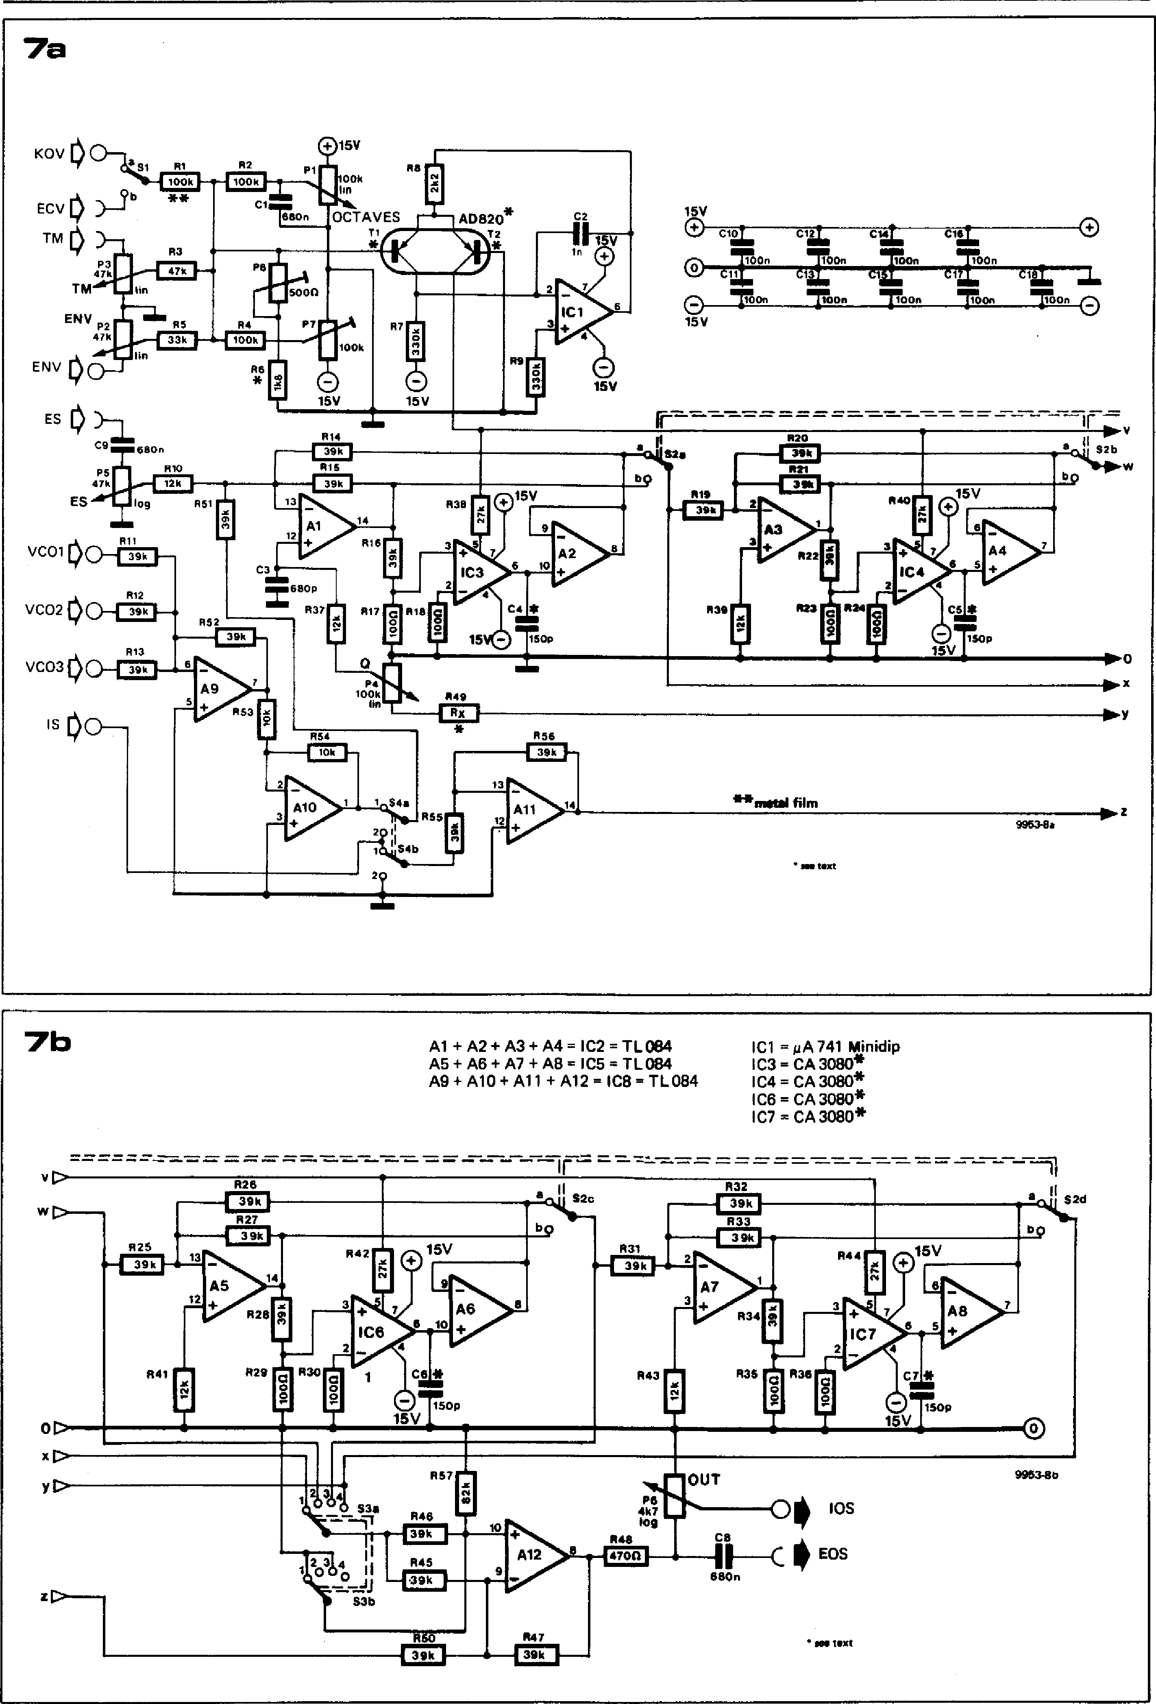

O

**15V**

•

**KOV**

**R8**

**AD820\***

**T2**

*

Ton 0

**15V**

**0 C1 C1 ciL C1**

**0 ctr" CZ" ctliWn Cl20"**

e 740n **TIOn 1.100n TIOOn**

**15V**

**13**

**Al**

**R5**

**LEM**

**ENV P2**

**47k**

lin

•

**ENV 00**

**ES 1)**

**cit" 680"**

**R10**

**P5**

VC01

* **MIX**

R12

**VCO2**

* **EMI**

**R13**

**VCO3**

* **NCI**

0

5

* R53

**R38**

**1C3**

**4**

**R18**

**15**

**9**

**A2**

10

**C4 \***

**1505**

1„54

**2**

**2**

**410**

**7b**

**ICI = *IAA* 741 Minidip**

**IC3 = CA 3080\***

**IC4 = CA 3080\***

**IC6 = CA 3080\***

**IC7 = CA 3080\***

**Al + A2 + A3 + A4 = IC2 = 11.084 A5 + A6 + A7 + A8 = IC5 = TL 084 A9 + A10 +All + Al2 =IC8 =Th084**

**13**

**AS**

**12**

**3**

**+ 7**

**IC6**

**A6**

**6 10**

**C6 \***

**R57**

**53a**

**R46**

**ECM**

**OUT**

**9953-80**

•

**a** S**1 R1 R2**

**Pi,**

**IrZ21**

**\*\***

**ECV }-71)**

**C2**

**In**

C1

**egion OCTAVES**

**T1**

**13**

7a

**Ft5**

**OMR**

**R14**

**R15**

**39k**

**14**

**C3 •**

tats **=680P**

**R37**

**0**

**82a**

bq

**47k**

c)15V

**R52**

**Fry-**

O

**15V**

**P4 100k** lin

R49

**LEE**

*

**R55**

**IS**

**A9**

**\*\*me t& film**

* 444 t•Xt

**2**

**14**

R 5 5

**All**

**9953-6a**

**00k**

**lin**

**R7**

0

**15V**

**TM**

**R3**

**47k**

**P3**

**TM I lin**

**$2 b**

**R21**

**1**

**R40 5V**

**P22**

**5**

0

**III3**

**R19**

**ES 109 R51**

**R11**

**R" 0 Rae**

**R15**

**R17**

**A4**

**CAis**

O

150P

**R54**

**15V**

0

10

== == = - ,-=. - - --- _

ir

**R25**

**9**

**15V**

**en II S2c**

KIM

**15V**

**R42**

O

**R44**

**R32**

**1E11**

**R33**

**2**

**A7**

**R34**

**14**

**R28**

**R29**

**4**

0

**15V**

**150p**

0

**6**

**4**

**cz\***

**150p**

**15V**

**R31**

**EEO**

**A- 8**

**R60**

* tell **text**

**Ell**

V

W

**R27**

**2**

* **7**

**IC7**

**2 3cce0 "'I**

**1 °**

**S3b**

00 **IOS**

**C8**

**EOS**

**680n**

**R25**

**R41**

**R30**

**R43**

**R36**

**R36**

**PS**

**457**

**6:19**

**R48**

**Al2**

**R47**

**ELM**

**R45**

**054 — FORMANT**

comprise Al to AS and 1C3 to 1C7. The four poles of switch S2 select between highpass and lowpass modes, while S3 selects the filter output and hence the slope. The reason that S3 is a two-pole switch may not be immediately appar­ent, but is easily explained. Ignoring the phase shift introduced by the action of the filter, i.e. considering only signals in the filter passband, each filter section inverts the signal fed to it, since Al, A3, A5 and A7 are connected as inverting amplifiers. This means that the outputs of alternate filter sections are either in phase or inverted with respect to the input signal. To ensure that the filter output is in the same phase relationship to the input signal whatever filter slope is selected, S3b is arranged to switch Al2 between the inverting and non-inverting modes to cancel the inversions produced by the filter sections.

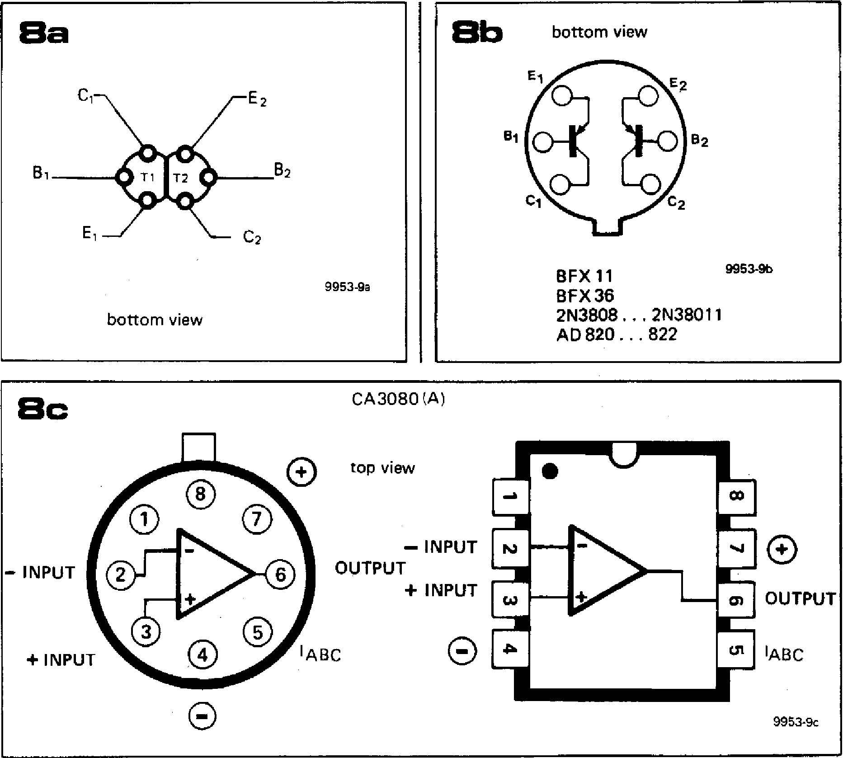

**BFX 11 BFX 36**

**2N3808 2N38011
  
AD 820... 822**

Like the 12 dB VCF, the 24 dB VCF has two outputs, a hardwire output con­nection IOS and an uncommitted out­put, EOS, which is connected to a front panel socket.

**Construction**

As far as the choice of components for the 24 dB VCF goes, the same general comments apply that were made about the 12 dB VCF and the Formant synthesiser in general. All components should be of the highest quality; re­sistors should be 5% carbon film types except where metal oxide or metal film types are specified; capacitors should preferably be polyester, polystyrene or polycarbonate, and must be these types where specified. Semiconductors should be from a reputable manufacturer.

As with the 12 dB VCF the dual transis­tor may be any of the types specified in

**Figure 8. Pinouts for the dual transistors and CA3080.**

**Figure 9. Printed circuit board and component layout for the 24 dB VCF. (EPS 9953-1).**

**Table 1. Summary of the control functions and input/output connections of the 24 dB VCF.**

|  |
| --- |
| **Table 1**   1. **hardwired inputs (not on the front panel) KOV = Keyboard Output Voltage**   **(from interface receiver) ENV = Envelope shaper Control**  **Voltage (from ADSR unit) VCO 1,2,3 = Signals from VCOs 1, 2, 3 IS = Internal signal from the 12 dB**  **VCF**   1. **external inputs (sockets on front panel) ECV = External Control Voltage (for**   **exponential generator of the**  **VCF)**  **TM = Tone Colour Modulation**  **input**  **ES = External Signal (from e.g.**  **noise module)**   1. **outputs**   **IOS = Internal Output Signal (from**  **VCF to VCA)**  **EOS = External Output Signal**  **(socket on front panel)**  **dl controls**  **TM = P3; sets tone colour**  **modulation level**  **ES = P5; sets external signal level**  **ENV = P2; sets envelope shaper**  **control voltage**  **OCTAVES = P1; coarse frequency**  **adjustment**  Q **= P4; sets level of peak boost**  **around turnover frequency OUT = P6; sets lOS output level**  **e) switches**  **ECV/KOV = S1; selects external or internal control voltage input** |

|  |
| --- |
| **Parts list to figures 8 and 10 Resistors:**  **R1 = 100 k metal oxide**  **R2,114 = 100 k**  **R3 = 47 k**  **R5 = 33 k**  **R6 = 1 k8**  **R7,R9 = 330 k**  **R8 = 2k2**  **R10,R37,R39,R41,R43 = 12 k R11 ...R16,R19 ... R22,**  **R25 ... R28,R31 . R34,845,  R46,R47,R50,R51,R52,R55, R56= 39 k**  **R17,R18,R23,R24,R29,R30, R35,R36 = 100 *St***  **R38,R40,R42,R44 = 27 k**  **R48 = 470 St**  **R49 = 100 k (see text)**  **R53,R54 = 10 k**  **R57 = 82 k**  **Potentiometer:**  **P1,P4 = 100 k linear**  **P2,P3 = 47 k (50 k) linear**  **P5 = 47 k (50 k) logarithmic**  **P6 = 4k7 (5 k) logarithmic**  **P7 = 100 k preset**  **P8 = 470** a **(500 St) preset**  **Capacitors:**  **C1,C8,C9 = 680** n  **C2 = 1 n**  **C3 = 680** p **(polystyrene,** not ceramic)  **C4,C5,C6,C7 = 150** p  **(polystyrene, not ceramic) C10 ... C18 = 100 n**  **Semiconductors:**  **IC1 = 741**  **IC2,1C5 = TL 084, TL 074**  **IC8 = TL084, TL 074, LM 324 IC3 . IC6 = CA 3080,**  **CA3080A (MIN I DIP or** TO; **see text)**  **T1 ,T2 = AD 820 . . . 822,**  **2N3808 ... 3811, BFX 11, BFX 36 (see text) or**  **2 x BC 5578**  **Miscellaneous:**  **31-pin DIN 41617 connector or terminal pins**  **S1 = SPDT**  **S2 = 4-pole double throw**  **S3 = 2-pole 4-way; index angle approx. 30°**  **S4 = DPDT**  **4 minature sockets, 3.5 mm dia. 7 13 ... 15 mm collet knobs with pointer (to match existing synthesiser modules).** |

**FORMANT — 055**

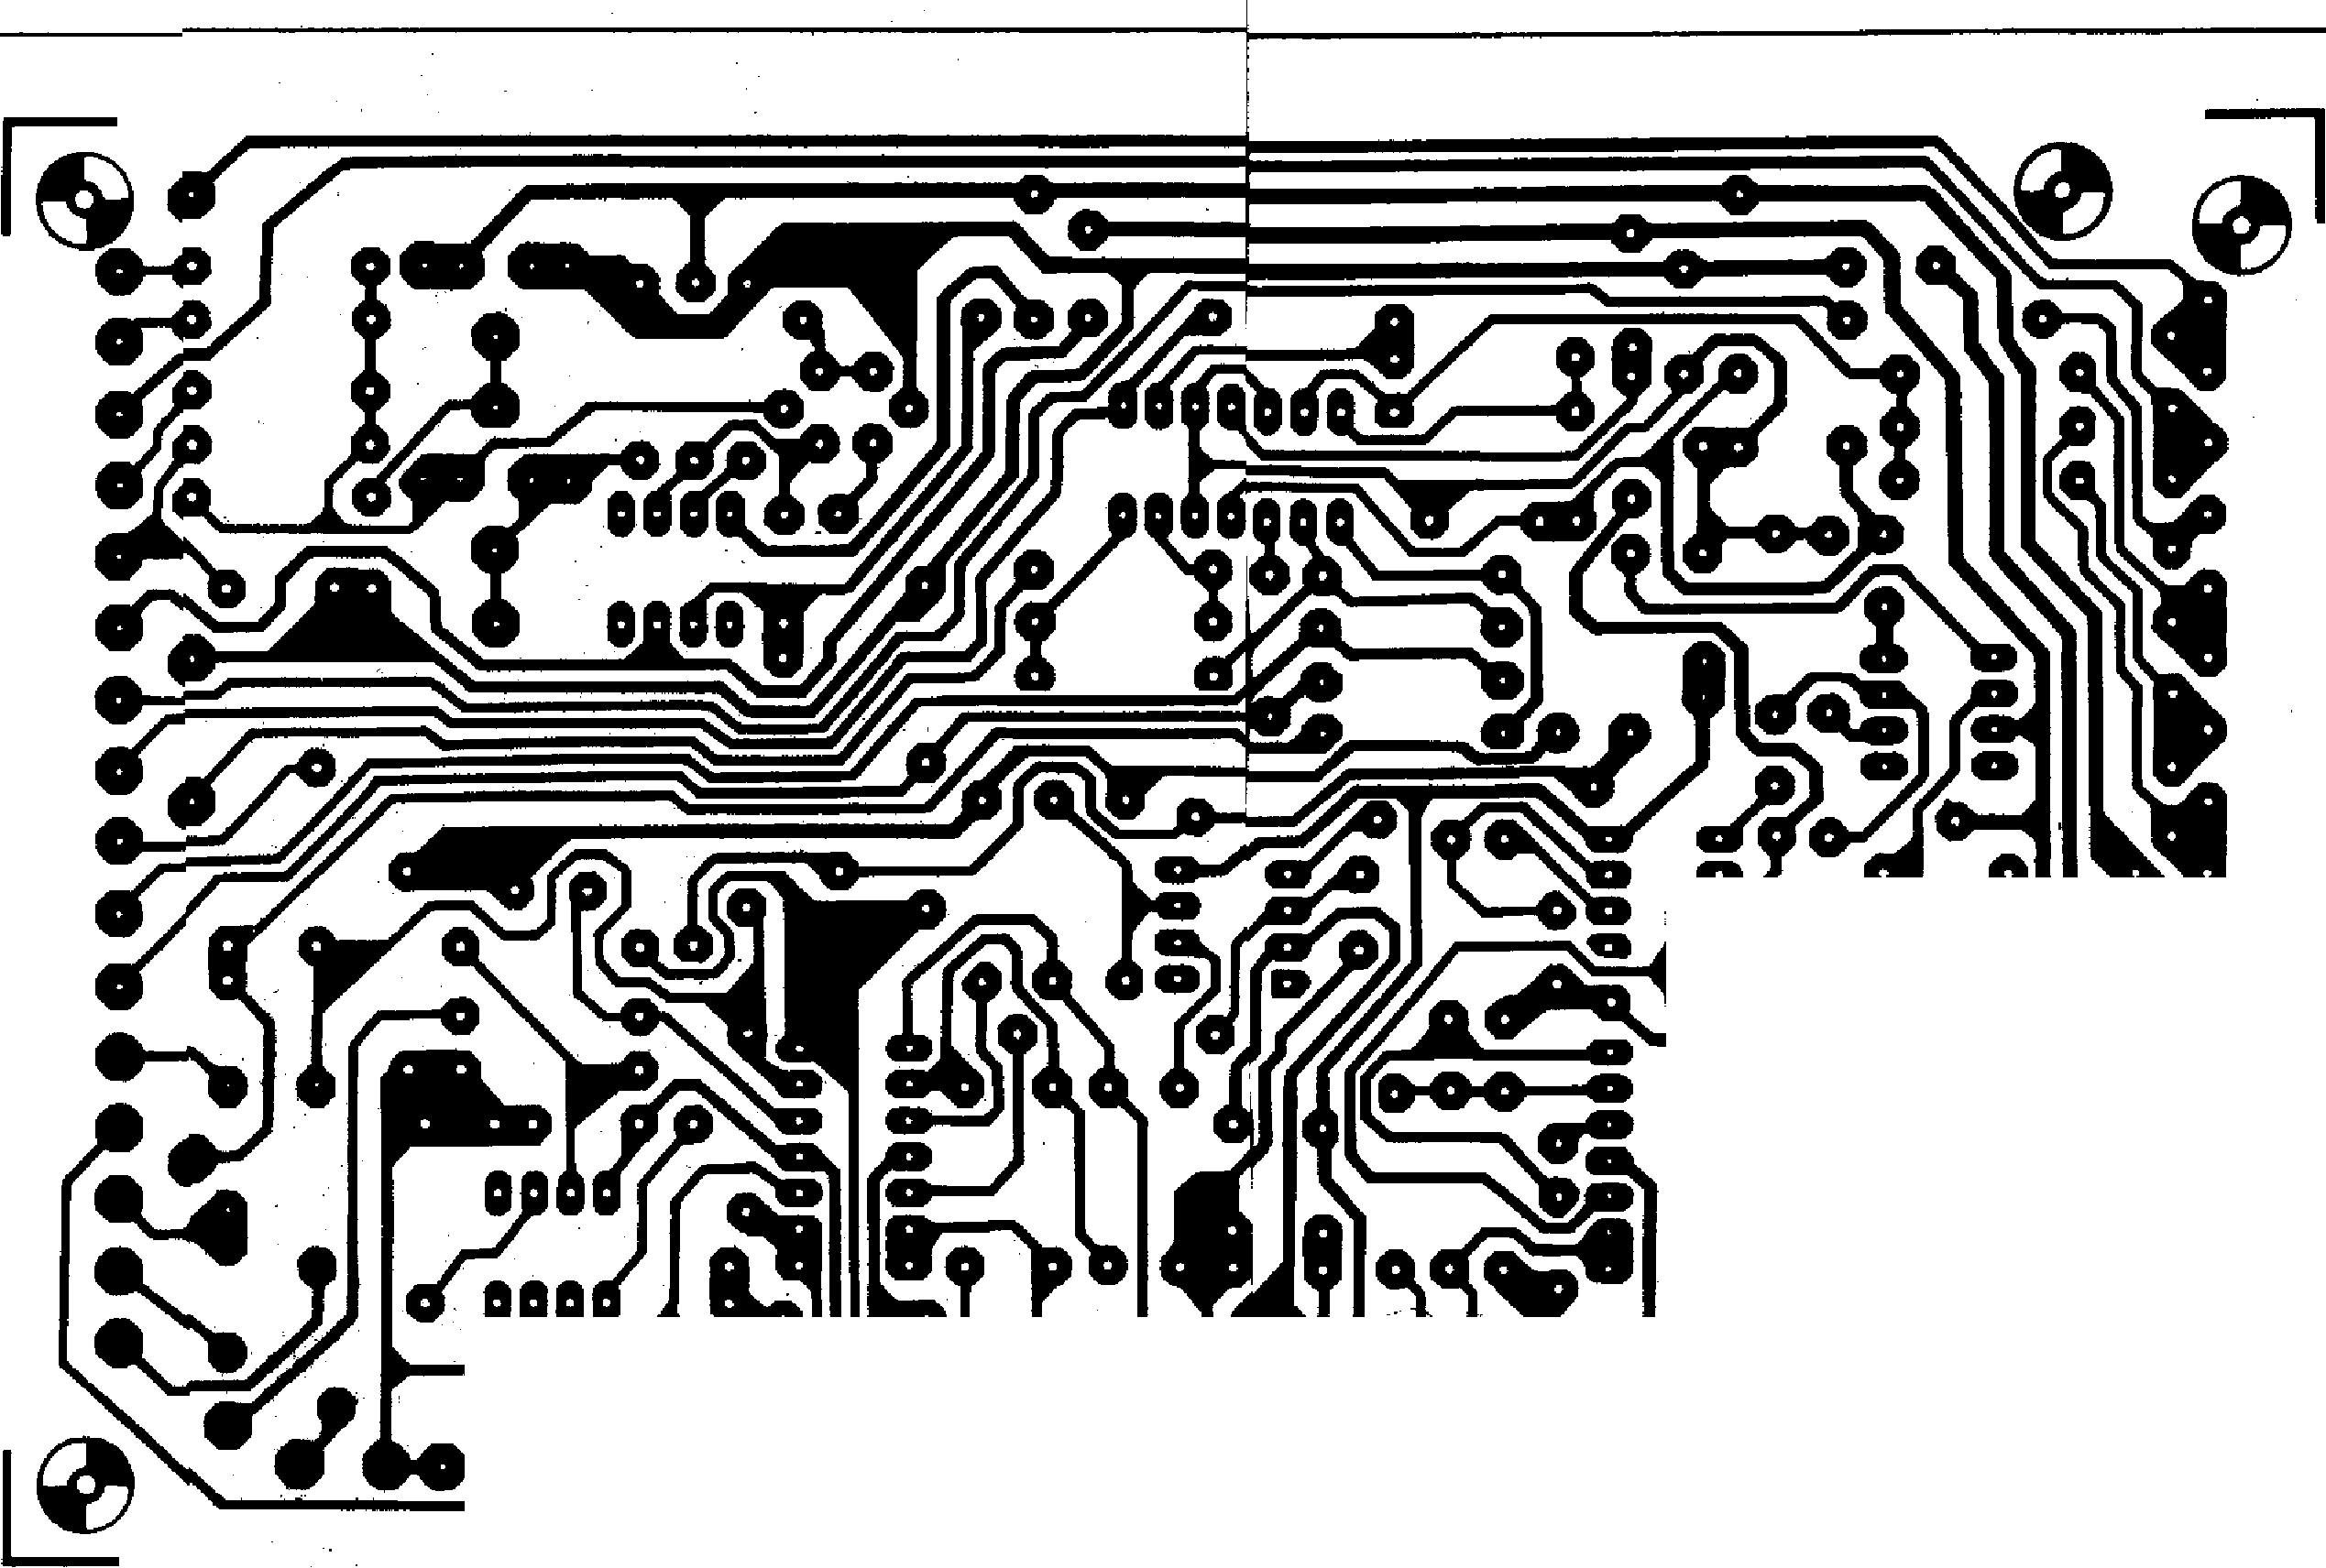**—**

**the parts list, or may be home-made by gluing together two normal transistors, though in this case thermal- ',racking will not be quite so goad. The CA3080 should preferably be in a MINIDIP pack­age to fit the hole spacings on the p.c. board, though the metal can type can be made to fit by splaying the leads. The pinouts for the dual transistors and the CA3080 are given in figure 8.**

**Although not absolutely necessary, it is
  
a good idea to select OTA's with ap-**
  
**proximately the same transconductance,**

**9**

**sib** b **the four sections of the filter will th have almost the ohne turnover fre­quency. The CA30$0 i available in two versions, the standard version, in which the ratio between the maximum and minimum gm is 2:1, a d the CA3080A, in which the spread in m is only 1.6:1. A test circuit and to t procedure for selecting ICs with simil**, **r gm are given at the end of the chapter and it is certainly worthwhile buying a few extra OTAs and selecting the four with the most similar gm. The 'reject' devices are per-**

**fectly acceptable for use in the 12 dB VCF or VCA, and need not be wasted. The other ICs in the circuit should all be TL074 or TL084 quad BIFET op-amps, although for 1C8 it is permissible to use an LM324. Thanks to the use of quad op-amps it is possible to accomo­date the 24 dB VCF on a standard Eurocard-size (160 mm x 100 mm) p.c. board, although the control connections are not all on the front edge of the board. The printed circuit pattern and component layout for this board are**

Wv-i-V)Q11

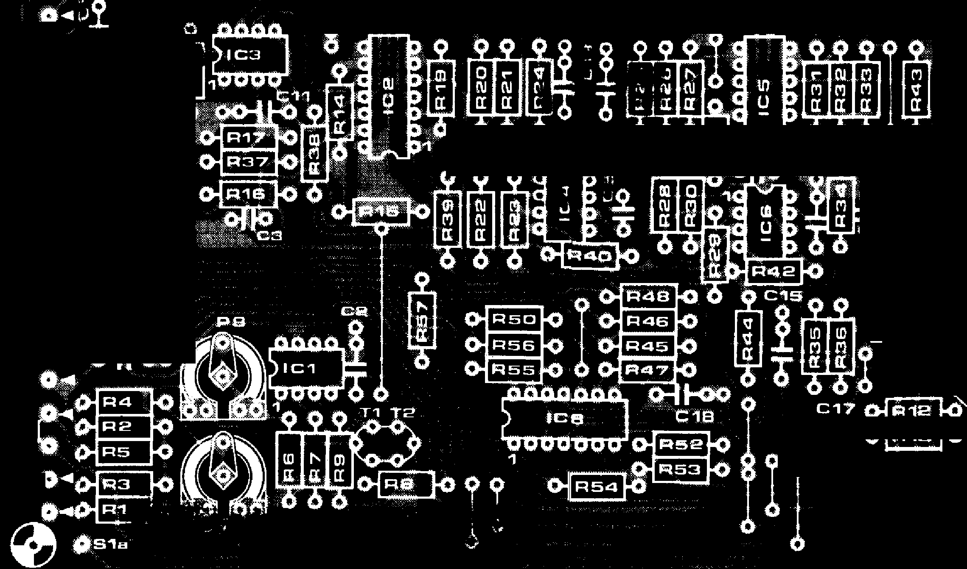***S***

**Seas Seb Q Sec Sod**

**b b b a b**

**0 0 ? 0 OL 0**

**.9.1 co A 0**

**— 40 0 ----HMO**

**176 -00 -**

**.L.**

0

**C7-1 .-151/1"**

**0**

**0**

**4, Is go 2 0**

**0 0**

**10**

**S**

**0 0**

**0**

F.

**0 0**

**0_40 0 V s**



I

**E**NV

**66 0**

**_o**

**0**

**6 0,0**

**0**

***,r r****,*

o 0

**1=1 6 *'air***

**a9**

**ElS1,0-4**

**S3e40.4**

**S4 4b**

**s4811**

**11,1344512/ S4b1 41).L**

**P1**

**P2**

**P3**si

|  |  |
| --- | --- |
| 00-11-0 |  |

**056 — FORMANT**

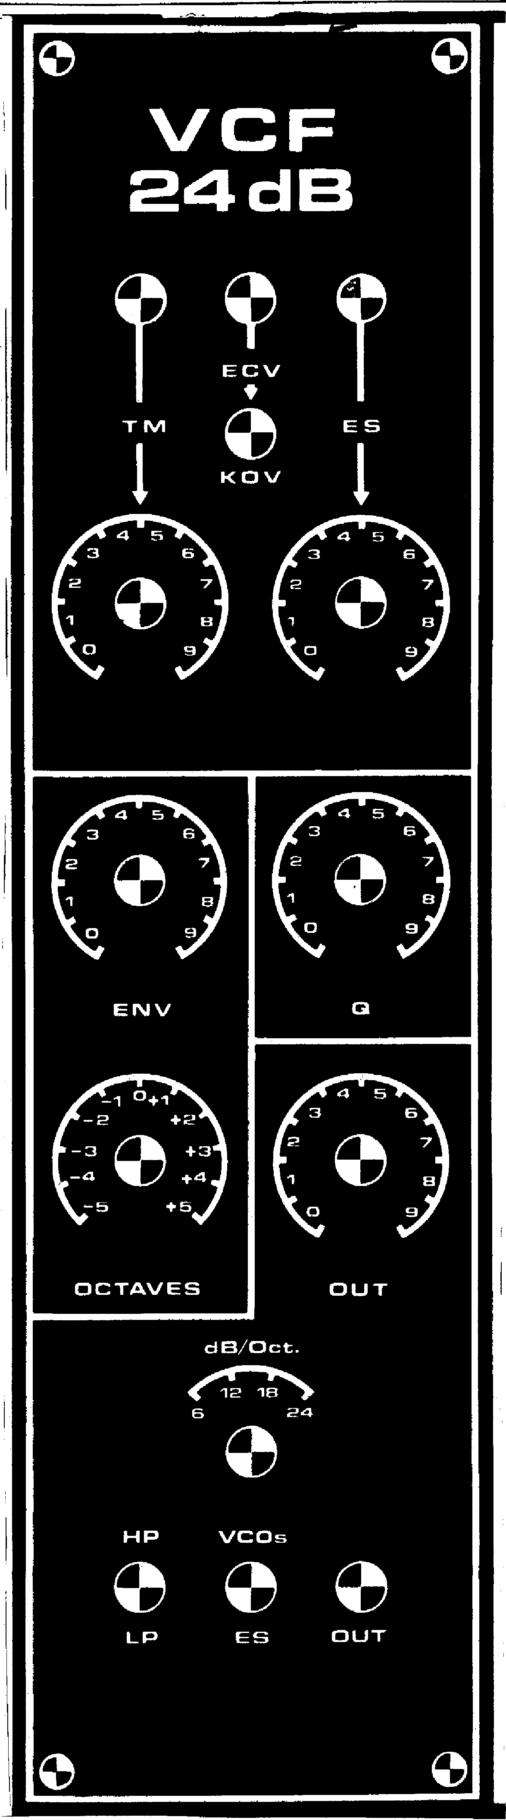

given in figure 9, while a front panel layout is given in figure 10.

**Test and adjustment**

To enable the exponential converter and the filter section to be tested separately they are joined by a wire link which runs across the board from T2 to a point adjacent to R15. This link should be omitted until the VCF has been tested.

To test the filter section it is necessary to provide a temporary control current. This is done by connecting a 100 k log potentiometer between —15 V and ground, with its wiper linked to the junction of R39 and R4 via a multimeter set to the 100 pA DC range. The test then proceeds as follows:

1. Turn the wiper of P4 fully towards ground, select 24 dB slope with **S3** and adjust the control current to 100
2. Feed a sinewave signal into the ES socket and adjust either the sinewave amplitude or P5 for 2.5 V peak-to­peak measured on an oscilloscope at the wiper of PS.
3. Monitor the filter output on the `scope and check the operation of the filter by varying the sinewave frequency and checking that the signal is attenuated above the turn­over frequency in the lowpass mode and below the turnover frequency in the highpass mode.
4. The function of S3 should now be checked. Set S3 to the 6 dB position and S2 to the LP position. Increase the frequency of the input signal until the output of the filter is 6 dB down on (i.e. 50% of) what it was in the passband where the response was level. Now switch to 12 dB, 18 dB and 24 dB and check that the re­sponse is respectively 12, 18 and 24 dB down, i.e. is reduced to 25%, 12.5% and 6.25% of its original value. The exact results of this test will depend upon the matching of the OTAs.
5. Set the Q control, P4, to its maxi­mum value, when the circuit should show no sign of oscillation. If the circuit does oscillate it will be necess­ary to increase the value R49. If it does not oscillate then the Q range can be increased by decreasing R49, taking care that instability does not occur.
6. Finally, the linearity of the turnover frequency v. control current charac­teristic should be checked. Adjust the input frequency until the re­sponse is a convenient number of dB down (say 6 dB). Double the control current then double the input fre­quency and the response should still be **6 dB** down.
7. To check the exponential converter connect a 27 k resistor in series with a **multimeter set to the 100 i.tA range between the collector** of T2 and the —15 V rail. Then follow the test

**FORMANT — 057**

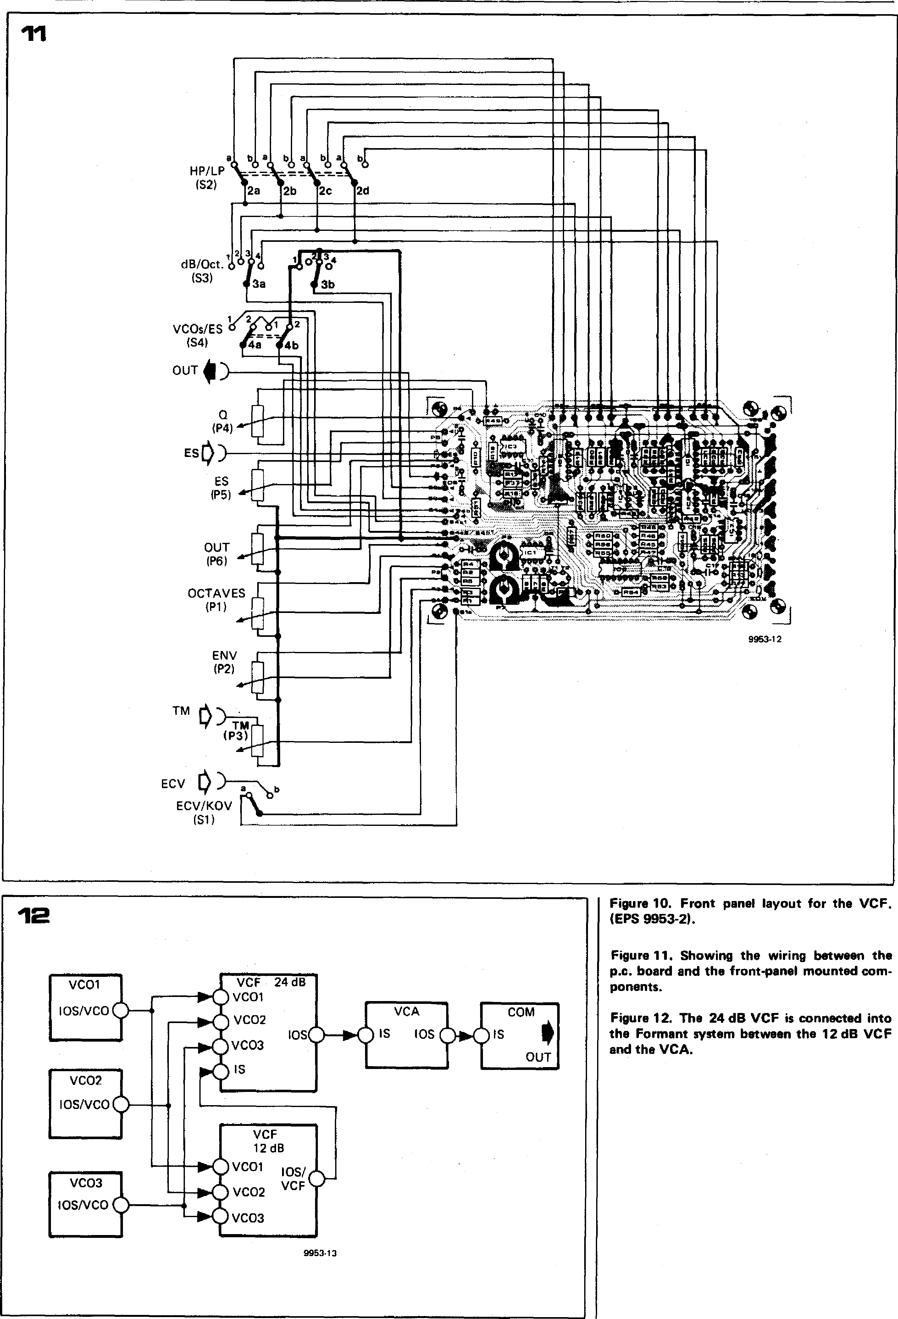

**2d**

**a os a**

**HP/LP**

**(S2) 2a 2b 2c**

**OUT**

**OCTAVES
  
(P1)**

**Figure 10. Front panel layout for the VCF. (EPS 9953-21.**

**Figure 11. Showing the wiring between the p.c. board and the front-panel mounted com­ponents.**

**Figure 12. The 24 dB VCF is connected into the Formant system between the 12 dB VCF and the VCA.**

**VCA
  
IS IOS**

**12**

**9953.13**

**VCF**

**12 dB**

**VC01 IOS/(-N._**

**VCO2 VCF Or**

**COM**

**IS**

**OUT**

**VCF 24 dB VC01**

**VCO2**

**VCO3 IS**

**IOS**

**VCO3**

**VCO3 IOSNCO**

VC01
  
10S/VCO

**VCO2
  
10S/VCO**

**dB/Oct.**

**(S3)**

12134(1

**3a**

**3b**

.

**a 4b**

**eliplinomm**

**MEMO**

**'ffirCE11"=:.**

**•**

woe

**Ulm \**

**VCOs/ES**

**(S4)**

**OUT**

0

**ES )**

**ES**

**9953-12**

**ENV
  
(P2)**

**TM 1:),**

TM

**(133)**

**ECV ) a \I) b**

**ECV/KOV (S1)**

**11**

ONO

as

**1223**

**.crz3, aro**

**61=PI.**

***40***

***10'***

**• MO**

**■4111.,4:;1**