**FORMANT — 029**

**Figure 15. A case containing one 61.! and one 3U rack will accommodate six large and six small Formant modules. It can be useful to add a 2U or 3U bottom panel (using a larger case!), behind which amplifiers etc. can be mounted.**

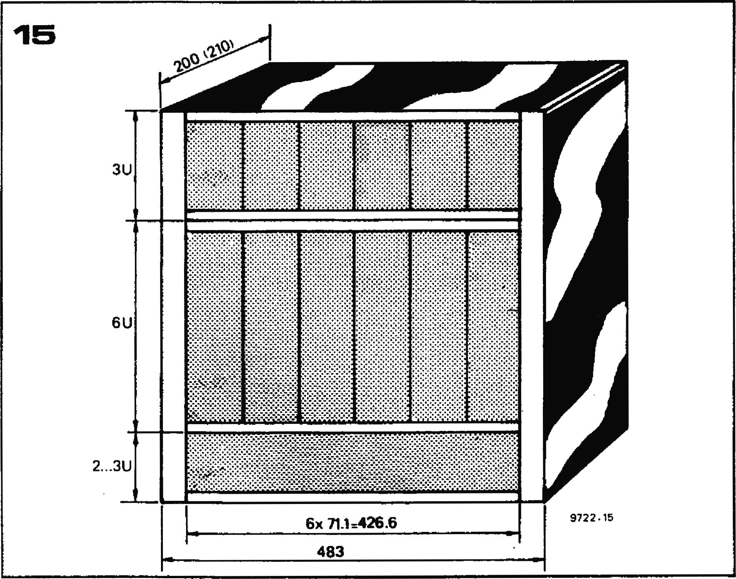

**of at least 1% using a DVM. The overall tuning remains switched off. The KOV output is measured and P6 is adjusted so that alternately depressing keys one octave apart causes the KOV output to change by exactly one volt. The Formant keyboard is now compatible with any synthesiser that uses a stan­dard 1 V/octave keyboard.**

**Finally, the offset compensation should again be checked and readjusted if necessary.**

**Gate delay**

**Accurate adjustment of the gate delay is not possible until the voltage con­trolled modules have been constructed, but an approximate adjustment will suffice until that time. P7 on the inter­face board should be set to about one quarter of its maximum resistance, and P8 on the receiver board should be set to minimum.**

**Modular construction**

**A modular method of construction was chosen because it allowed the greatest flexibility in the final design. Each voltage-controlled circuit is constructed on its own p.c. board which plugs into a socket in the module housing that supplies power, control voltage and gate pulses. Interconnections between modules are made by means of patch cords.**

**The advantage of this system is that the synthesiser can be made as simple or as complex as is required. Provided sufficient space is left in the module housing for additional modules, it is possible to build a playable instrument with just a small number of modules, and to extend it as and when desired. This also means that every instrument can be tailored to the individual con­structor's taste and is not fixed within**

**rigid limits set by the designer. How­ever, for those who require a little more guidance as to the right 'mix' of modules that should be adopted, a suggestion for a 'middle-of-the-road' instrument is given in figure 13. This utilises three VCOs, one 12 dB VCF, one 24 dB VCF, one RFM, one DUAL VCA, two ADSR envelope shapers, one LFO module, one NOISE module and one COM. Some readers may regard the extra (24 dB) VCF and RFM as slight luxuries, and indeed for the beginner or someone with a slightly limited budget, these modules could be initially omitted. However they do considerably enhance the tone-shaping capabilities of the Formant, and for this reason can 'justifiably be included in the 'basic' Formant system.**

**The module printed circuit boards and front panels are compatible with the Eurocard rack system. Two module heights are employed in Formant. A double-height (6U) module is used for the voltage-controlled modules (VCO's, VCA's and VCF's) while a single-height (3U) module is used for the ancillary circuits (envelope, shapers, noise gener­ator etc.).**

**The basic dimensions of the modules are given in figure 14. The Eurocard rack system operates on a card spacing of 5.08 mm (0.2") or multiples thereof. Each Formant module occupies a panel width of approx. 71 mm, so the 426.7 of panel width available will accommo­date six modules. A 6U rack and a 3U rack stacked together will thus accom­modate six large and six small modules, as shown in figure 15. This corresponds exactly to the no. of modules in the `basic' Formant system.**

**Of course some readers, especially those with previous experience of synthesisers, may already have a firm idea of the type of instrument they wish to build, and may like to construct a purpose-**

**built case of wood or some other material. This is quite permissible, as the module housing does not require screening.**

**chapter 4**

**voltage controlled oscillator**

**The voltage controlled oscillators (VCOs) are the heart of any synthesiser. The quality of the VCOs ultimately determines the performance of the synthesiser. For this reason the next two chapters are devoted to their design and construction.**

**The two principal requirements of a synthesiser VCO are stability and good tracking. Stability means that if the control voltage applied to the VCO remains constant, then the frequency of the VCO should also remain constant and not drift. Tracking means that the VCO must follow the prescribed logarithmic I octave/V characteristic as closely as possible. In particular, where several VCOs are used they should all have similar characteristics.**

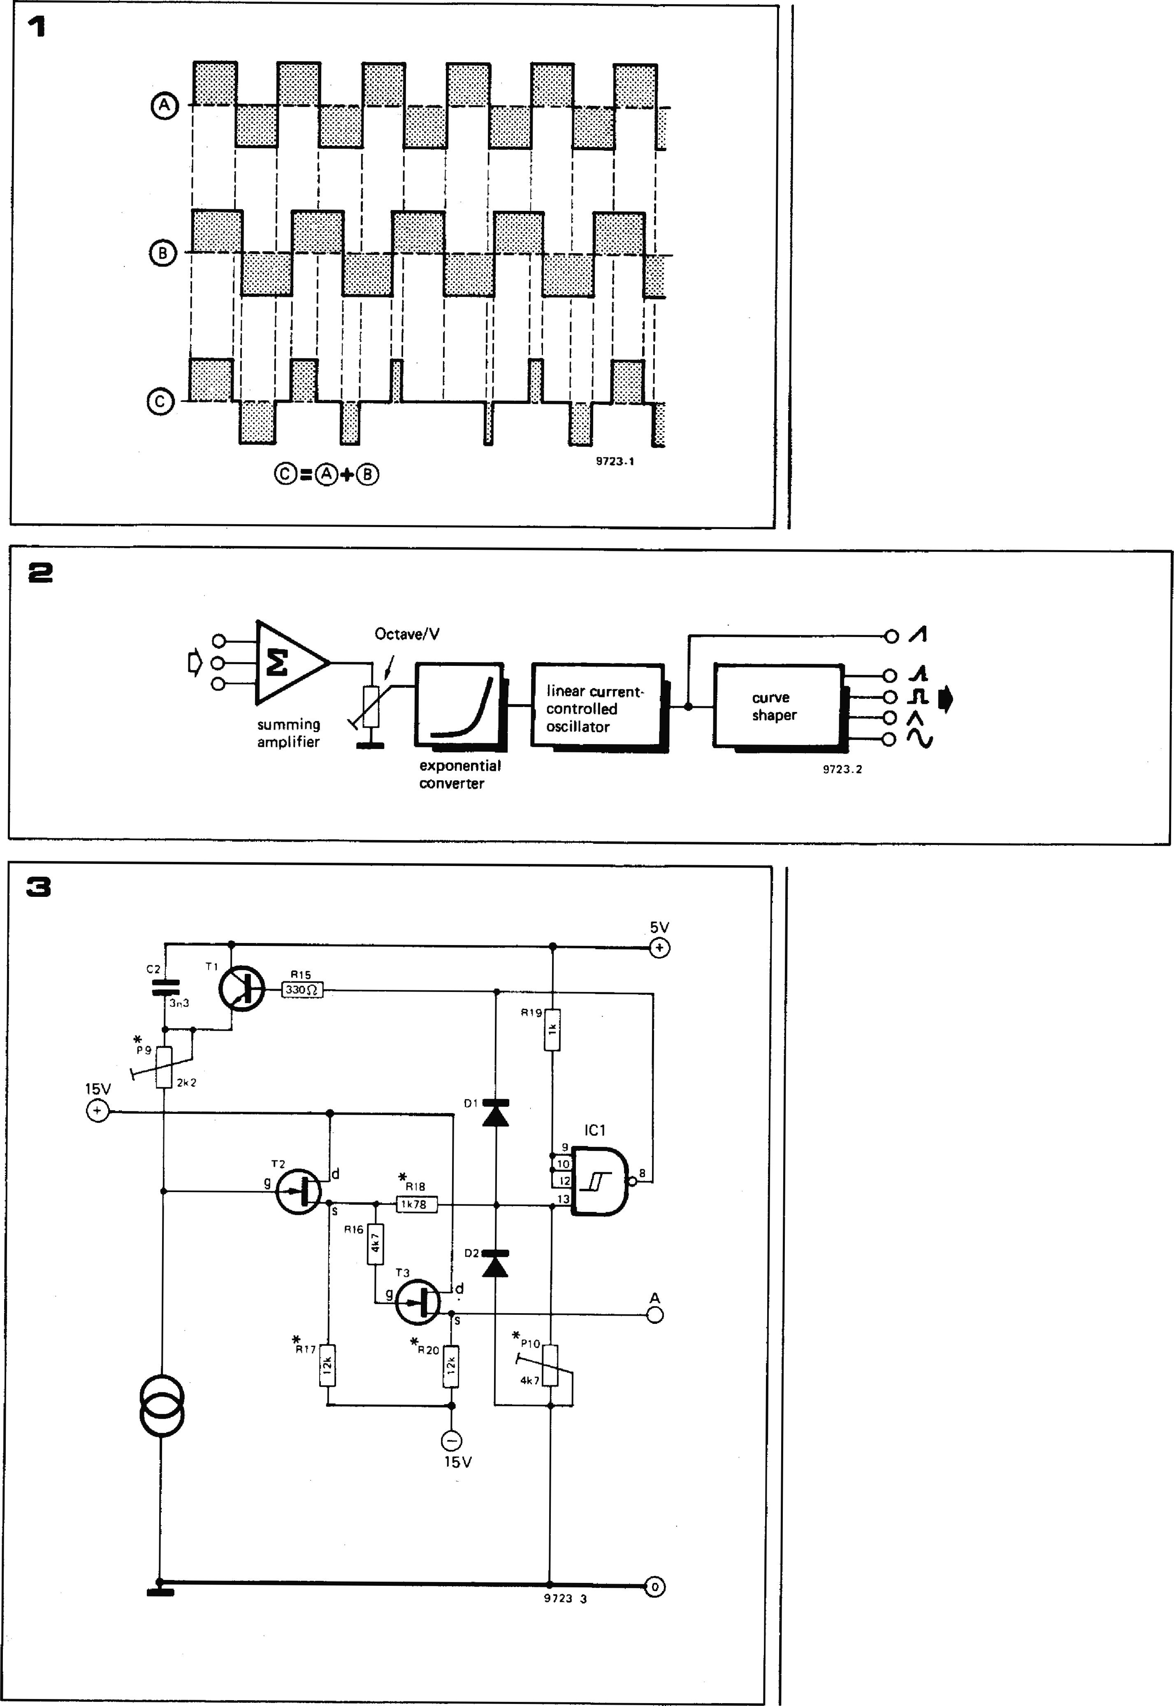**030 — FORMANT**

**These parameters are particularly important in a chording instrument such as the Formant, where a number of VCOs are used simultaneously. In a synthesiser using only one VCO slight drift or deviation from the 1 octave/V characteristic might not be noticed, since the ear is not particularly good at judging absolute frequency, unless a person has 'perfect pitch'. In any chording instrument however, even slight mistuning is immediately apparent due to the formation of beat notes.**

**For example, if two or more VCOs are tuned to the same pitch any slight mistuning is audible as beat notes having a frequency equal to the difference between the two VCO frequencies.**

**Slight mistuning between VCOs is frequently employed deliberately. If the degree of mistuning is slight the beat frequencies are low and beat notes are not audible, but a pleasing chorus or**

**Figure 1. When two notes of almost the same frequency are played together, beat notes are formed which produce a pleasing 'chorus effect.**

**Figure 2. Block diagram of the VCO, which comprises an input summing amplifier, exponential voltage-current converter, linear current controlled oscillator and curve shaper circuits.**

**Figure 3. The linear CCO is the heart of the VCO module. C2 charges linearly to the lower threshold of IC1 before being discharged by T1, thus producing a sawtooth output waveform. The output of the exponential converter, which determines the charging current and hence the CCO frequency, is represented by the current source symbol.**

**Figure 4. Detail of the sawtooth waveform and the output of IC4 at the reset point where T1 is turned on.**

**Figure 5. The exponential relationship be­tween base-emitter voltage and collector current of a bipolar transistor is exploited in the exponential generator.**

|  |  |  |  |  |  |  |  |
| --- | --- | --- | --- | --- | --- | --- | --- |
|  |  |  |  |  |  | **FORMANT — 031** | |
|  |  |  |  |  |  |  |  |
|  |  |  |  |  |  | **linearity or frequency stability of the CCO.**  **The setting of P9 affects the high-frequency linearity of the CCO and is used to set the VCO tracking at high frequencies.**  **Since N-channel FETs are used for the source-follower buffers, the source voltage is always slightly positive with respect to the gate voltage, so that even when the gate of T2 is at zero volts there is always a slight positive voltage on the source. If the source of T2 were connected direct to the input of IC1 it would be possible that the source voltage of T2 (minimum, depending on FET tolerances, typically 1 V) might never fall below the negative threshold of IC1 (typically 0.85 V). For this reason T2 is connected to the input of ICI via a potential divider comprising R18 and P10, the latter being adjusted to ensure that the oscillator starts reliably.**  **The exponential converter**  **The exponential voltage-current**  **converter doubles the output current fed to the CCO, and hence the CCO frequency, for every 1 V increase in control voltage.**  **In common with most such circuits, the exponential converter makes use of the (exponential) collector current versus base-emitter voltage characteristic of a bipolar transistor. Every transistor exhibits this exponential relationship, but not all transistors are suitable for use in exponentiator circuits. The reason is that collector leakage current can cause a deviation from the charac­teristic at low collector currents, and transistor base resistance can cause a deviation at high collector currents. Special transistors for such applications are available, but even these have their limitations due to temperature depen­dence of the collector current. At around room temperature, collector current doubles for a Vbe increase of around 17 mV. However, a tempera­ture increase of around 10°C will also double the collector current, so it is apparent that, unless some form of temperature compensation is employed, even small temperature changes will cause noticeable variations in the pitch of the VCO.**  **There are two methods of reducing the influence of changes in (ambient) temperature, both of which are used in the Formant VCO. The first of these is to use a matched pair of transistors in the exponential converter, one of which is used for temperature compensation. The second method is to keep the chip temperature of the transistors constant. By employing both methods absolute accuracy and stability of the exponen­tial converter are achieved. Temperature stabilisation of the chip may sound like a complicated business, but fortunately a purpose-built IC is available, the pA726. It consists of two matched NPN transistors and also contains a tempera-** | |
|  |  |  | **+5V**  **IC1 output**  **(reset pulse)**  **0** |  | **Block diagram**  **The VCO circuit used in the Formant follows the form proposed first by Robert Moog (figure 2). The VCO input stage consists of a summing amplifier into which a number of control voltages may be fed. A poten­tiometer on its output sets the octaves/volt characteristic of the VCO. The resulting control voltage is fed to an exponential voltage-current converter, the output current of which doubles for every 1 V rise in input voltage. The output of this converter controls a linear current-controlled oscillator,  which produces a sawtooth waveform. Finally, a curve shaper connected to the sawtooth output delivers four further waveforms: spaced sawtooth, squarewave, triangle and sinewave.**  **Oscillator section**  **The CCO is the heart of the VCO circuit, as explained above.**  **The CCO section is shown in figure 3. The output of the exponential voltage-current converter that feeds this section is represented by the current source symbol at the bottom left of the diagram. This current is of course varied by the control voltage applied to the exponential converter.**  **FETs T2 and T3 are connected as source followers; their high input resistance ensures that no significant current is robbed from the current source, even at low currents, as this would spoil the sawtooth linearity and could affect the current-frequency linearity of the CCO. ICI is a Schmitt trigger that senses when the sawtooth voltage has reached a predetermined level.**  **The circuit functions as follows: assume that initially C2 is discharged. The voltage at the gate of T2 will then be nearly +5 V, and since T2 operates as source-follower the voltage at the input of IC1 will be above the positive trigger threshold of this Schmitt trigger, so its output is low and T1 is turned off. As C2 charges from the current source the gate voltage of T2 will fall as the voltage across the capacitor increases. Since C2 is being charged from a constant current source, the voltage across it will increase linearly with time, in accordance with the equation**  **I.t**  **UC2 = .**  **C2**  **When the voltage at the input of ICI has fallen below its negative switching threshold the output of IC1 will go high, which will turn on T1 and discharge C2 until the input voltage of ICI has risen above its positive threshold, when T I will turn off and the whole cycle will repeat. A detail of the IC1 output and input waveforms during the discharge of C2 is shown in figure 4.**  **FET T3 is simply an output buffer stage. As mentioned earlier, the use of two buffer stages in cascade ensures that any load on the output cannot affect the** |
|  |  |  |  |
|  |  | I  ______ **t_ o_ _ I _ __ tTinthreshold**  **i I lower threshold**  **I of 1C1**  **1.--0I reset time 7923_4** | |  |
|  | | | |  |
|  | **phasing effect is obtained, especially if several VCOs are used. This imparts a much more lively character to the sound which contrasts with the sterile sound of fixed phase instruments such as electronic organs based on a -divider system (see figure 1).**  **However, if the VCO frequencies drift apart due to poor stability the beat notes quickly become obtrusive and unpleasant, and ultimately a discord is audible. A similar effect can be noted when the tracking of the VCOs is poor. If a chord is set up at a particular pitch then the musical intervals in the chord should be maintained when the chord is transposed to a different pitch. However, if the tracking of the VCOs is poor this will not be the case and a discord will result.**  **A good test of the VCOs in a synthesiser is thus to tune them together so that no beat notes are audible and check that the tuning is maintained over a period of time and with changes in such par­ameters as supply voltage, temperature etc. The tuning between the VCOs should also be maintained when the pitch is transposed.**  **Any VCO which cannot meet these criteria is useless for a synthesiser, and the design of a suitable synthesiser VCO is necessarily quite complex.** | | |  |

**032 — FORMANT**

**Figure 6. Circuit of the exponential voltage-current converter, which is both temperature stabilised and compensated. IC4 and T1 are respectively parts of the input adder circuit and the CCO.**

**2k2**

**IC4**

**R7**

5

**0 15V**

**In**

**IC2**

3 +

**Tb**

**IC3**

*

**R12** R 1 3

|  |  |
| --- | --- |
| **15V** | **5V** |

**T1**

**OD15R EMI**

**1 \***

**R11 P9**

**2**

**R9**

**C2**

moit

3n3

**• Eim**

**KOV**

8

**P**7**' 200E2**

**8**

**R14**

T.

I

**2**

**IMtNN 9723 6 °**

O

**Figure 7. Complete circuit of the input adder. This will sum input control voltages from the keyboard or ECV socket, DC offset voltages for chording, and AC input signals for fre­quency modulation of the VCO.**

**Figures 8 and 9. The musical quality of a waveform depends on the harmonic content. The harmonic structure of two well-known waveforms is shown: sawtooth (figure 8) and squarewave (figure 9). In order to obtain the widest range of sounds from the Formant VCO, curve shaper circuits are provided that produce four waveforms in addition to the basic sawtooth.**

**Figure 10. Block diagram of the curve shaper. An output adder allows the various waveforms to be fed to the output either individually or in combination.**

**input. P7 allows the input voltage to the exponential converter to be varied between —18.7 and —23.7 mV per volt input, in order to compensate for tolerances in IC3.**

**ture control circuit that maintains a constant chip temperature.**

**The circuit of the exponential converter is given in figure 6. IC4 is not strictly part of the converter but is part of the summing amplifier section. At the operating temperature of the 726 a Vbe increase of between 19 and 23 mV is**

**required for each doubling of collector current, so the 1 V/octave output of the keyboard must be attenuated.**

**IC4 is connected as an inverting amplifier with a gain of —0.0237. Since the KOV input is always positive the output of IC4 will always be negative, and will give an output of —23.7 mV per volt**

**The exponential converter proper comprises IC2 and IC3. The non-inverting input of 1C2 is grounded through R14, so the inverting input should also be at (virtual) earth poten­tial. For this to be the case, a constant current of 15 ,to must flow through R 11, i.e. the collector current of Ta . must be constant at 15 gA. The voltage­to-current conversion can now be explained as follows.**

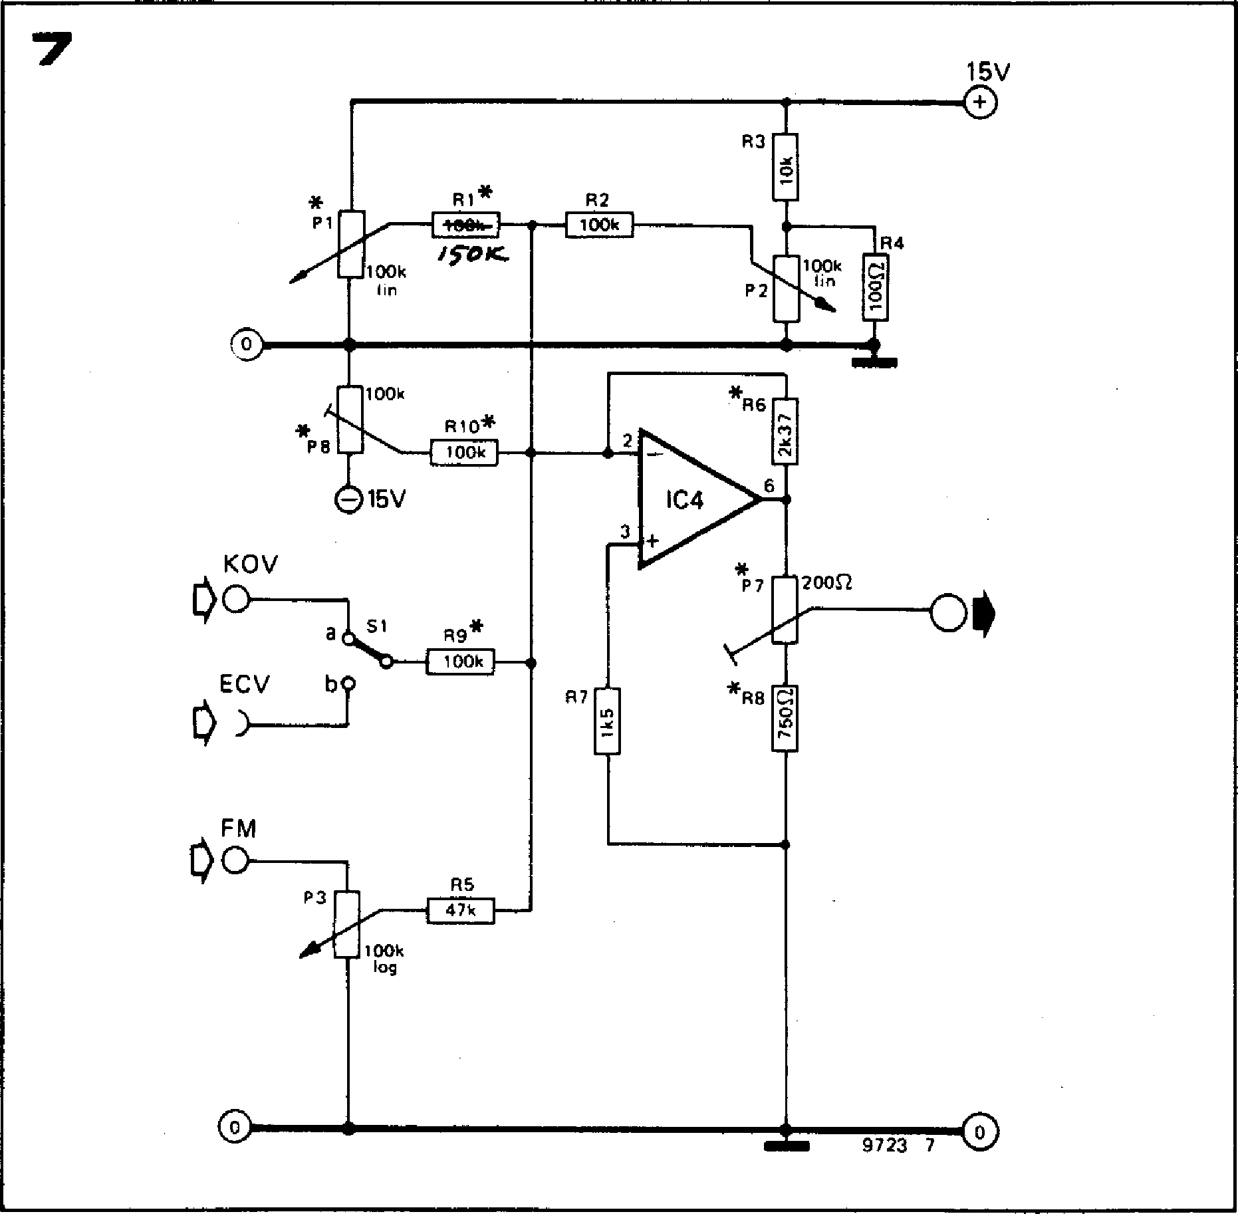

**\*R6**

**7**

15V

**R3**

**R1 R2**

**P1**

**1=5**

**R4**

11=1

100k

c

O

**P2**

**P8**

**R10\***

**L:1**

O

**15V**

**KOV**

O

**) ECV**

**FM**

**a51 R9\***

1 0 0 k

***/5-0/C***

**100k
  
!in**

**\*R8**

**R7**

**R5**

4 7 k

**P3**

**100k
  
log**

9723 7 0

1 0 0 k

**If the input voltage KOV is increased by 1 V then the base voltage of Ta will fall by around 20 mV (depending on the setting of P7). Since the collector current of Ta cannot decrease the output voltage of IC2 must fall in order to reduce the emitter voltage of Ta by 20 mV, maintaining the same base-emitter voltage and thus the same collector current. As the base of Tb is grounded this means that the base-emitter voltage of Tb will fall by 20 mV, and the collector current of Tb will double. The collector of Tb is connected to P9 in the CCO circuit, as shown in the top right hand corner of figure 6.**

**Summing amplifier**

**The summing amplifier, part of which was shown in figure 6, is given in its complete form in figure 7. Point KOV is permanently connected to the 1 V/octave output of the keyboard interface receiver, but the input of the summing amplifier can be switched between this point and an external**

**FORMANT — 033**

**control voltage socket (ECV). Poten­tiometers P1 and P2 give coarse and fine adjustment of a DC offset voltage to transpose the VCO pitch for setting up chords etc. Preset P8 is also provided as an offset control that compensates for the input offset voltage of IC4, and sets the lowest frequency of the VCO (around 15 Hz).**

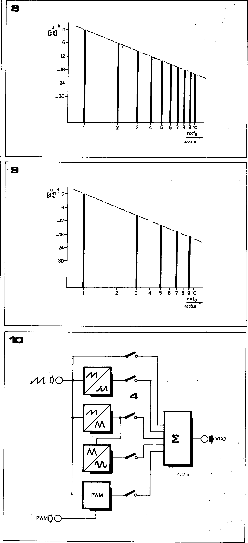

**2 3**

**4 5** 6 **7 8 9 10**

**nxfo**

**9723.8**

u o-D133

**—6— —12— —18— —24— —30—**

**A frequency modulation (FM) input is provided, which can be fed with external (AC) signals to give vibrato effects etc. The modulation depth can be adjusted by P3, the maximum sensitivity being about 2 octaves/V with P3 turned fully clockwise.**

**As previously mentioned, the summing amplifier actually has a gain much less than one, so that the output voltage of 1C4 is reduced to —23.7 mV per volt input.**

**Curve shapers**

**Having ensured that the 'business end' of the VCO design is satisfactory, the design of the curve shaper section — which influences the musical charac­teristics of the VCO — may now be considered. The main processing of the synthesiser waveforms is done by means of voltage-controlled filters (VCFs) which remove certain frequencies from a harmonically rich waveform.**

**The spectra of two well-known har­monically rich waveforms are shown in figures 8 and 9 — the sawtooth, which contains all the odd and even harmonics of the fundamental, and the squarewave, which contains only the odd harmonics. However, this approach does have its limitations if only one waveform is provided at the VCO output. Using as an example the two waveforms just mentioned; no amount of filtering will generate the even harmonics necessary to turn a squarewave into a sawtooth, and it would be very difficult to filter out all the even harmonics from a sawtooth to make a squarewave. It is thus obviously useful to have several different waveforms available at the VCO output.**

**A block diagram of the curve shaper is shown in figure 10. The sawtooth output of the VCO is fed to curve shaper circuits, which produce respectively spaced sawtooth, triangle, sine and square waveforms. The pulse width of the squarewave may be modulated by an external control signal, as will be explained in the description of this part of the circuit.**

**The five waveforms may be selected by means of switches to be fed, either singly or in combination, into a summing amplifier.**

**Musical properties of the waveforms**

**Each of the waveforms available at the VCO output has its own musical character, which is useful for particular applications. An unfiltered squarewave**

**034 — FORMANT**

**Figure 11. Circuit of the spaced sawtooth converter. This clips the sawtooth waveform, passing only the peaks.**

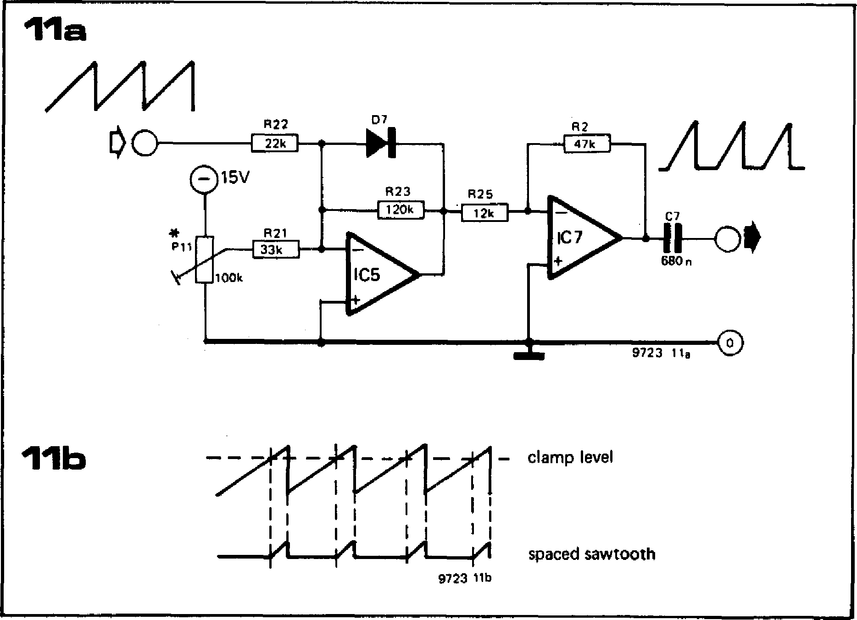

**D7**

**R22**

**MEM**

**R21**

**R25**

**MEM**

**11b**

— clamp level

**411**

**100k**

**9723 1 to**

spaced sawtooth

**11a**

//V

**AAA**

**c1-00 690 n**

15V

P11

**9723 116**

**R2**

**CEO**

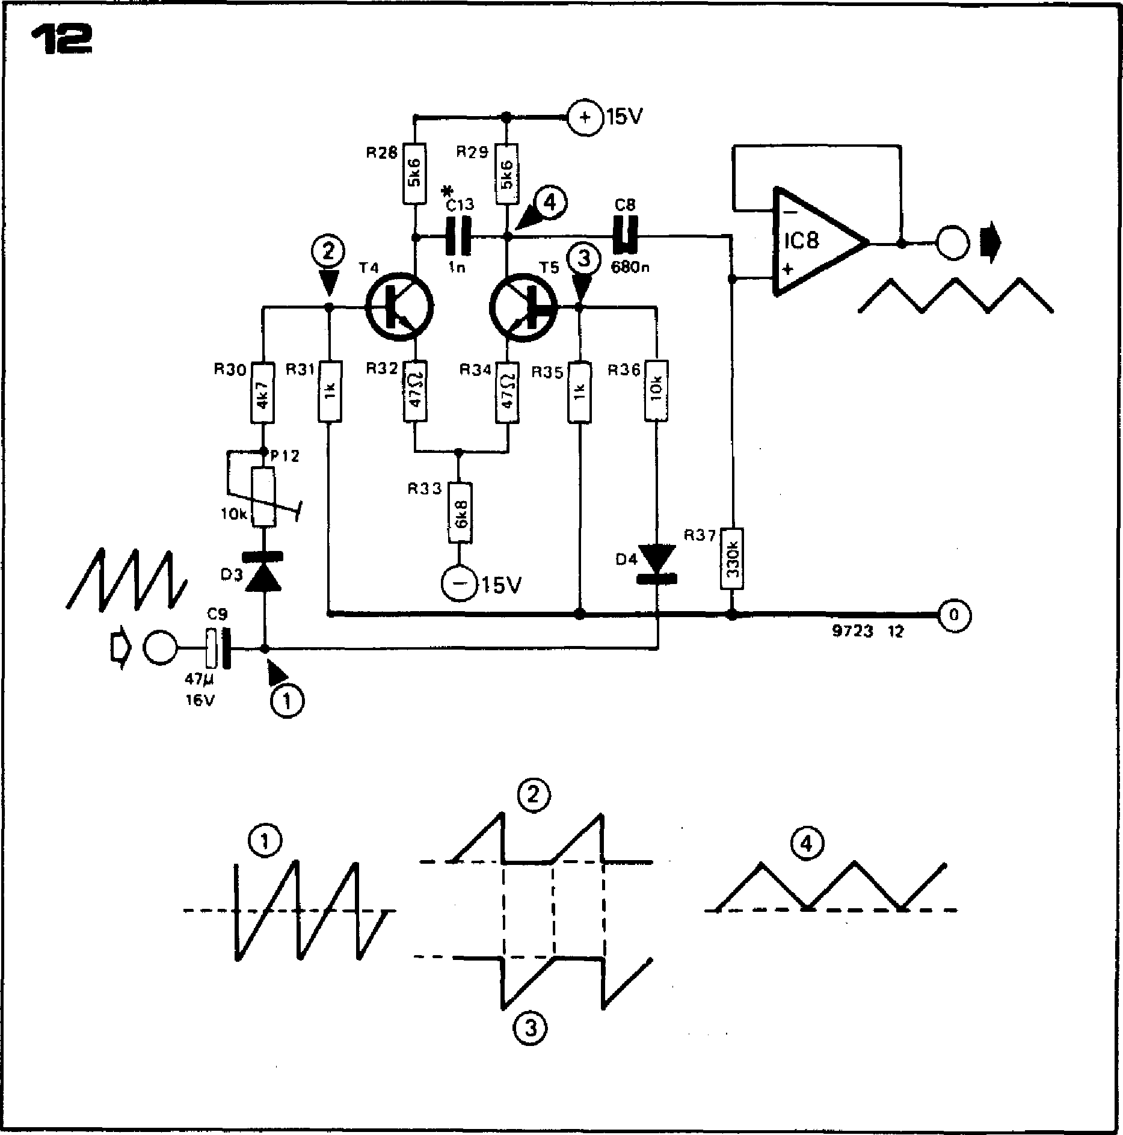

**Figure 12. The triangle converter operates by feeding the positive and negative half-wave rectified sawtooth to the inputs of a differen­tial amplifier. The resultant difference output is a triangle waveform.**

**Figure 13. The sine converter operates simply by 'rounding off' the peaks and troughs of the triangle to give an approximation to a sinewave.**

**Figure 14. The PWM squarewave generator is simply a voltage comparator whose output switches at a certain point on the sawtooth waveform. The trigger level can be varied, either by P5 or by an external input, thus pulse width modulating the squarewave as shown in figure 14b.**

**Figure 15. The output adder, which can be used to combine the variousoutput waveforms as desired.**

**is not particularly useful, since the odd harmonics cause the sound to be extremely harsh. However, filtered squarewaves are useful for the imitation of flute tones, and certain woodwinds such as clarinet.**

**The sawtooth waveform, which is rich in all harmonics is suitable for the imitation of brass, woodwind and many string instruments, and has an extremely bright and lively character.**

**The amplitudes of the sawtooth harmonics fall off at 6 dB per octave, i.e. the amplitude of the nth harmonic is 1/n times the amplitude of the**

**fundamental. Where this fall is too abrupt the spaced sawtooth waveform can be used. This has an even brighter character than the sawtooth and is extremely useful for imitating very brilliant instruments such as the violin family and some of the higher pitched brass instruments such as cornet and trumpet.**

**The triangle and sine waveforms are musically very similar. The triangle is completely lacking in even harmonics, and the odd harmonics are of low amplitude. The sound of the triangle is flutelike, very smooth and mellow.**

**A pure sine waveform is, of course, completely lacking in any harmonic content and sounds even smoother and more bland than the triangle — so far as to be completely without character.**

**A low harmonic distortion of the sine waveform is not particularly important for musical applications, provided the harmonic content is sufficiently low that the sinewave sound contrasts with that of the triangle. The sinewave is thus derived from the triangle by an extremely simple diode shaper circuit.**

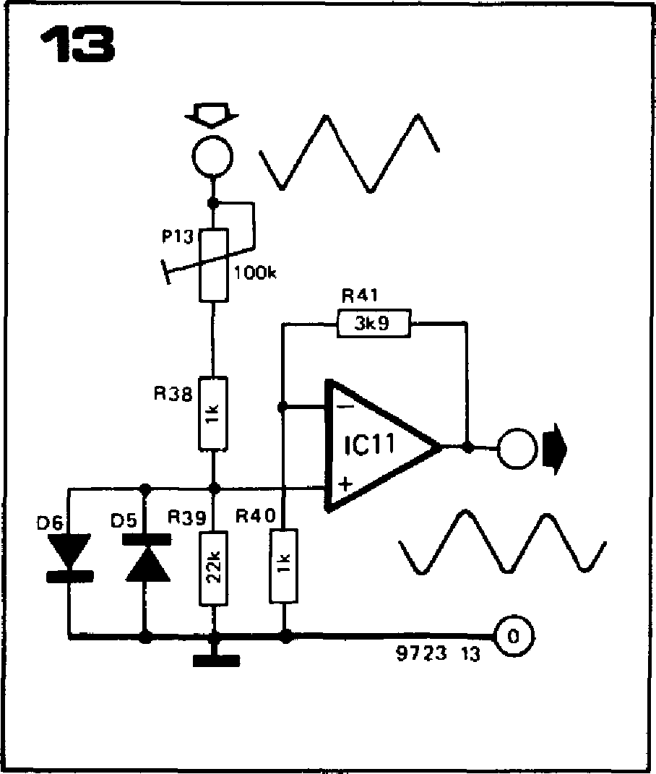

**FORMANT - 035**

**Spaced sawtooth converter**

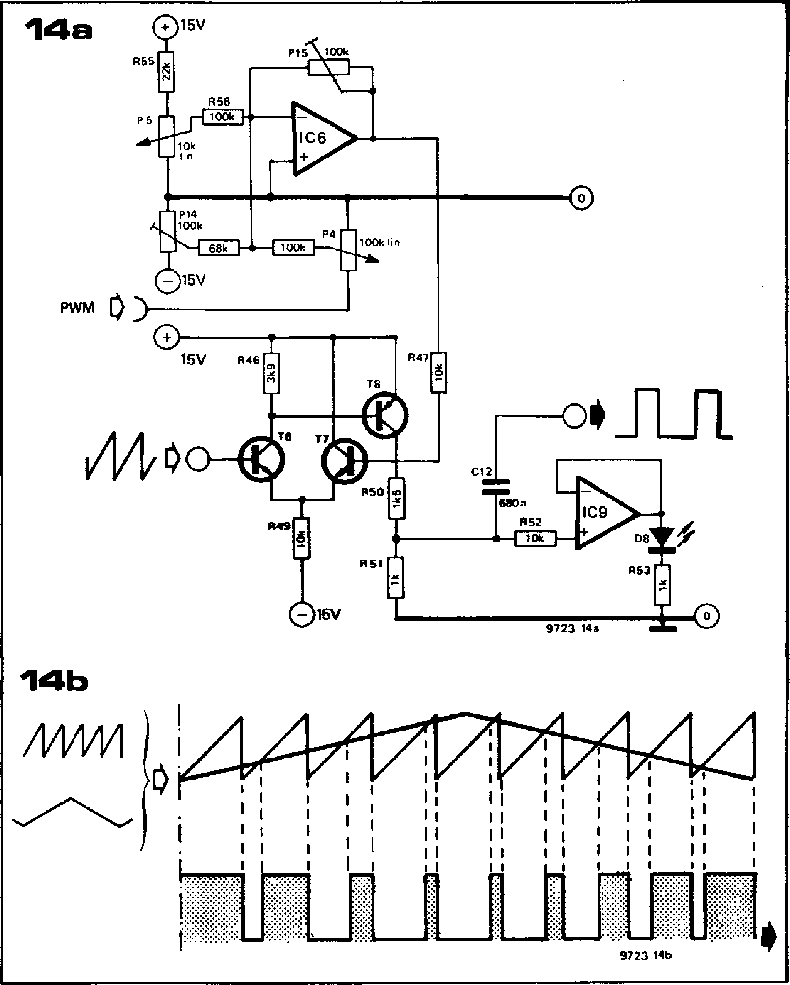

**R55**

**R56
  
100k**

**P5**

**pt5 100k**

**0**

15V

**14a**

**P4**

**100k** lin

15V **R46**

**18**

TO

**• (4**

**51**

**R53**

IC6

**P14**

**100k**

**100k**

15V

**um=**

**580n**

**R52**

**e--rWrk**

**9723 14a**

**PWM**

**R47**

**R50**

**54**

IC9

**08**

**A A.rr.1.4**

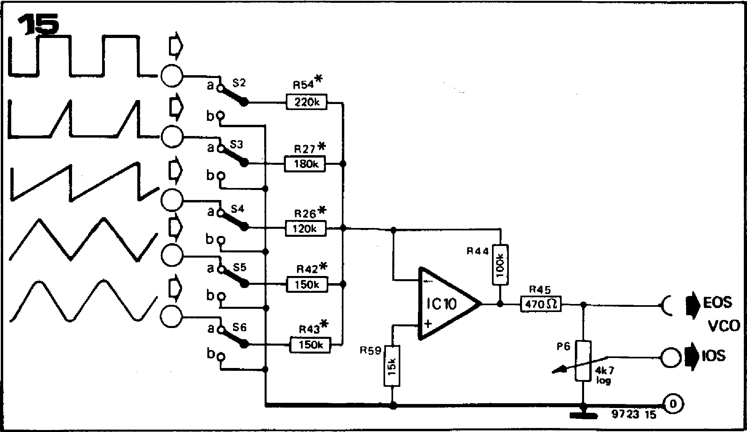

**elsewhere. The reason is that they have a limited slew rate, and this can result in a notch at the apex of the triangular waveform where the crossover from positive half-cycle to negative half-cycle occurs. This introduces harmonics that detract from the mellow sound of the triangular waveform. The discrete amplifier has a larger slew rate and is largely free from this defect. C13 also helps to filter out the spike, but it does cause a slight falloff of the triangle**

**Figure 11 a shows the circuit of the spaced sawtooth converter section. The sawtooth output of the VCO is fed into IC5 via R22. IC5 functions as an inverting half-wave rectifier, with a variable offset provided by P11. Depen­ding on the setting of P11, the negative voltage at its slider causes a positive offset at the output of IC5 of between zero and about +14 V.**

**While the output of IC5 is positive D7 is reverse biased and the op-amp amplifies and inverts the positive going input sawtooth with a gain of about 5.5. However, this applies only so long as the output of IC5 remains positive. As the sawtooth voltage increases, a point on the waveform will be reached where the output of IC5 falls below zero. D7 will become forward biased and will clamp the output of IC5 to about —0.6 V. The point on the sawtooth waveform at which clamping occurs depends on the setting of P11. With Pll adjusted to give an offset of zero the sawtooth will be clipped at a very low level. On the other hand, with Pll set to give a large offset voltage the sawtooth amplitude may never be high enough to cause the output of ICS to swing negative, and the sawtooth will appear at the output of IC5 unclipped.**

**IC7 amplifies and inverts the output from IC5 with a gain of about —4, and P1 1 is adjusted so that the amplitude is the same as that of the sawtooth waveform, nominally 1.5 V p-p.**

**Triangle converter**

**Half-wave rectification is again employed in the triangle converter, figure 12. The input sawtooth (1) is positive and negative half-wave rectified by D3 and D4, and the positive and negative half cycles are fed to the bases of T4 and T5 respectively (2) and (3). Since T4 and T5 form a differential amplifier the collector waveform of T5 is (2) - (3), which is a triangular waveform (4). IC8 is connected as a voltage follower to buffer the output.**

**It may seem a little strange to use a
  
discrete amplifier in this circuit when
  
extensive use is made of IC op-amps**

**amplitude at high frequencies. The value of 1 n for C13 is by no means manda­tory, and other values may be substituted to suit personal taste.**

**Sine converter**

**As mentioned previously, the sine converter does not produce an extremely pure sinewave, but the circuit (figure 13) is simple and the output waveform is musically adequate. The triangle output from IC8 is fed to the non-inverting input of IC11 via P13 and R38. The positive and negative excursions of the triangle at the op-amp input are limited logarithmically by a matched pair of diodes D5 and D6, and the resulting approximation to a sinewave is amplified by IC1 I.**

**P13, R38 and R39 form an attenuator. The setting of P13 determines the triangle amplitude that would appear across R39 were D5 and D6 omitted, and hence the point on the triangle waveform at which limiting occurs. For example, with P13 set to maximum the voltage appearing across R39 will be very small, and D5 and D6 may conduct only on the peaks and troughs of the triangle, so the output will be too `peaky'. On the other hand, with P13 set to minimum the signal will be**

**036 — FORMANT**

clipped very early in the waveform. Somewhere between these extremes is a setting of P13 that will give the best approximation to a sinewave. This setting can be found either by ear, or visually using an oscilloscope, or using a distortion meter to adjust for minimum distortion.

**Pulse width modulator**

This section of the curve shaper gener­ates a squarewave whose duty-cycle can be preset to any desired value from 0 to 100%, or which can be modulated by an external signal. T6, T7 and T8 (figure 14) form a high speed voltage comparator whose output will go high when the sawtooth input voltage exceeds the base voltage of T7, and which will go low on the trailing edge of the sawtooth.

The base voltage of T7 is set by the output voltage of summing amplifier 106, which can be fed both with a DC voltage via PS and with a signal from the PWM input. As the output voltage of IC6 becomes more positive the comparator will trigger later and later along the sawtooth ramp, so the output pulse will be narrower. This is illustrated in figure 14b, which shows the response to a low-frequency triangular PWM input signal.

P14 and P15 set the range of P5, so that this control can be used to preset the duty-cycle over the range 0 to 100%. The amplitude of the PWM input, and hence the modulation depth, is controlled by P4. 1C9, which is connec­ted as a voltage follower, lights LED D8 whenever the comparator output is high. This indicates that the VCO is func­tioning, and the LED brightness also gives an indication of the duty-cycle of the squarewave output.

**Output adder**

**The output adder circuit (figure 15) requires little explanation. When any switch is in the 'b' position then that input is open-circuit and the corre­sponding input resistor of** the op-amp, 1C10, is grounded. When a switch is **in the 'a' position then the corresponding waveform is fed to the summing amplifier. Two or more waveforms may be summed by closing several switches simultaneously, which greatly extends the range of output waveforms available. The adder stage has two** outputs: external output signal (EOS), which is routed to the socket on the VCO **front panel, and internal output signal (IOS), which is internally wired to the voltage-controlled filter (VCF).**

**As a suggestion for those experimenters who wish further to increase the flexi­bility of the VCO system, switches S2 to S6 may be replaced by potentiometers to form a mixer circuit in which the amplitude of each input waveform fed to the summing amplifier is infinitely variable.**

**Conclusion**

**The discussion of the VCO module has now reached the stage where the description of all the circuit sections is complete, and the musical value of the various output waveforms has** been given some consideration. The following chapter will deal with the constructional aspects of the VCO, including selection of components, assembly of the module p.c. board, testing and adjustment. When this stage is reached the synthesiser will at last start to become a playable instrument insofar as the VCO will produce an output signal of the correct pitch when a key is depressed, although the full musical potential cannot be realised until the rest of the synthesiser is complete.

***Literature:***

***Clayton, G.B.: "Experiments with operational amplifiers. 7. Using transistors for logarithmic conversion". Wireless World, Jan. 1973***

***"Nonlinear Circuits Handbook" Analog Devices, Norwood, Mass. (USA) 1974***

***Schaefer, R.A.: "New techniques for electronic organ tone generation". JARS (Journal of the Audio***

***Engineering Society), July/aug. 1971***

***Hamm, KO.: 'Tubes versus transistors — is there an audible difference? ". JARS May 1973***

**chapter 5**

**construction of the VCO**

**Having dealt with the theoretical circuits used in the VCO, this chapter goes on to discuss the selection of components and describes the practical construction, testing and adjustment of the VCO module.**

Care must be taken in the choice of components for, and in the construction of, the VCO, if reliable performance is to be obtained. The same general com­ments apply that were made earlier with regard to component quality. In addition, the following points should be noted:

1. Capacitor C2 should be a low leakage type — preferably MKM or equival­. ent.
2. Transistor Ti to T3 should be tested,

as will be **explained later.**

1. **Diodes D3** and **D4 should be a matched pair.**

**It is important that the reset transistor T1 in the CCO section should be selec­ted for low leakage current, as excessive leakage current means current lost from C2 and non-linearity of the CCO at low frequencies.**

**The test setup for Ti is shown in figure 1. The PNP transistor T8 can be used as the second transistor in the circuit, or any similar transistor can be used. The meter can be a multimeter set to the 1 mA range. The base of T8 is initially left open-circuit to check that it is not leaky. The meter should read zero. The base of T8 is then connected to the 0 V rail via a 100 k resistor to check that it has adequate current gain. The meter should read at least 1 mA (i.e. full-scale). The base of T8 is then connected to the collector of T 1. Any leakage current through Ti** will be amplified by the **current gain of T8 to give a deflection on the meter.** Only if the meter reads **zero is the leakage current** of T1 suf­ficiently **low.**

**Finally, the current gain of Ti can be checked by connecting its base** to +5 V **through a 2k2 resistor, when the meter should again show full-scale deflection.**

**FETs T2 and T3 can be tested using the circuit given in chapter 3 for testing the FETs in the keyboard interface. Unlike the keyboard interface circuit, FETs which show a Us in the test circuit of less than 0.5 V are not suitable for the VCO. However, FETs that have been rejected for the keyboard interface because their Us value was too high, can be used in the VCO if the value of Us lies between 1.6 V and 2 V. For FETs with Us values between 0.5 and 1.5 V the source resistors R 17 and R20 should be selected from table I in part 3. For FETs having a Us value between 1.6 V and 2 V, R17 and R20 should be 4k7. Diodes D3 and D4 should be purchased as a matched pair or, if several diodes of the correct type are to hand, a reason­ably matched pair may be selected by measuring the forward voltage drop versus forward current characteristics of the diodes and selecting the pair that are most similar.**

**Construction**

Once these critical components have been selected, construction of the VCO may commence. On the printed circuit board the VCO is split into two func­tional sections: the exponential converter and CCO, the complete circuit of which is given in figure 2a, and the curve shaper section, the complete circuit of which is given in **figure 2b. These two circuits are the combination** of all the partial circuits discussed in the previous chapter.

Printed circuit board and component layouts for the VCO are given in figure 4. The oscillator section occupies the top third of the board, whilst the remainder of the board contains the

**FORMANT — 037**

**Figure 1. Simple test circuit for selecting transistor T1 of the VCO.**

**15V**

|  |  |
| --- | --- |
| 0 |  |
| **C3** |

**Figures 2a and 2b. These two circuits consti­tute the complete VCO, and combine into two functional groups the partial circuits discussed the previous chapter.**

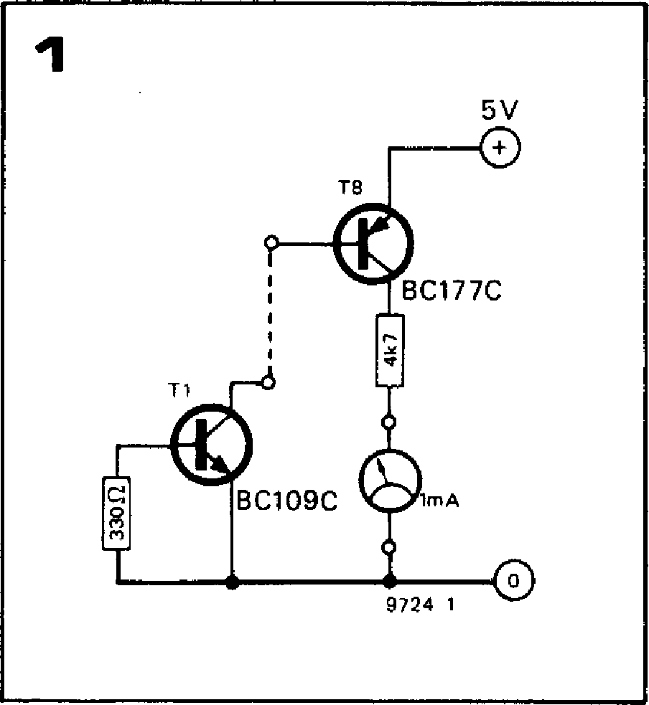

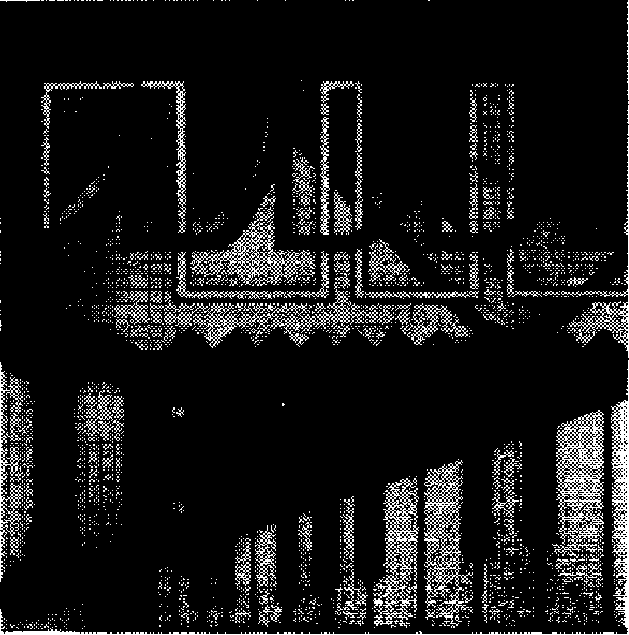

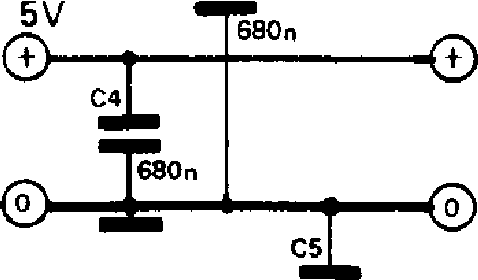

**15V**

0

**\*see text**

**15V**

**curve shaper circuits. To avoid interac­tion between the two sections of the circuit they each have separate supply and ground connections. The only link between them is at the source of T3, which is the CCO output (point A in figures 2a and 2b). Assembly of the board poses no particular problems, the only point to note being that at this stage C13, R26, R27, R42, R43, R54, and the link joining pin 4 of 1C3 to the gate of T2, are omitted for test purposes.**

**Test and adjustment**

0

**15V**

|  |  |  |
| --- | --- | --- |
|  | **R5  47k** | |
|  |
|  |
|  |
| **50k  log** |
|  |  |

**The first test is to check that the CCO is functioning, and for this purpose a 1 M resistor is connected between the gate of T2 and —15 V to act as a current**

**IC1 = 7413**

**IC2, IC4 =1/A741 C, MC1741 CPI (MINI DIP) IC3 = pA726 C (TO)**

**T1 = BC109 C**

**T2, T3 = BF245**

**D1, D2= I N4146,1N914**

**5V**

**R11**

**5 10**

**P10
  
4k7**

**R17**

**KOV**

**ECV
  
)**

**FM**

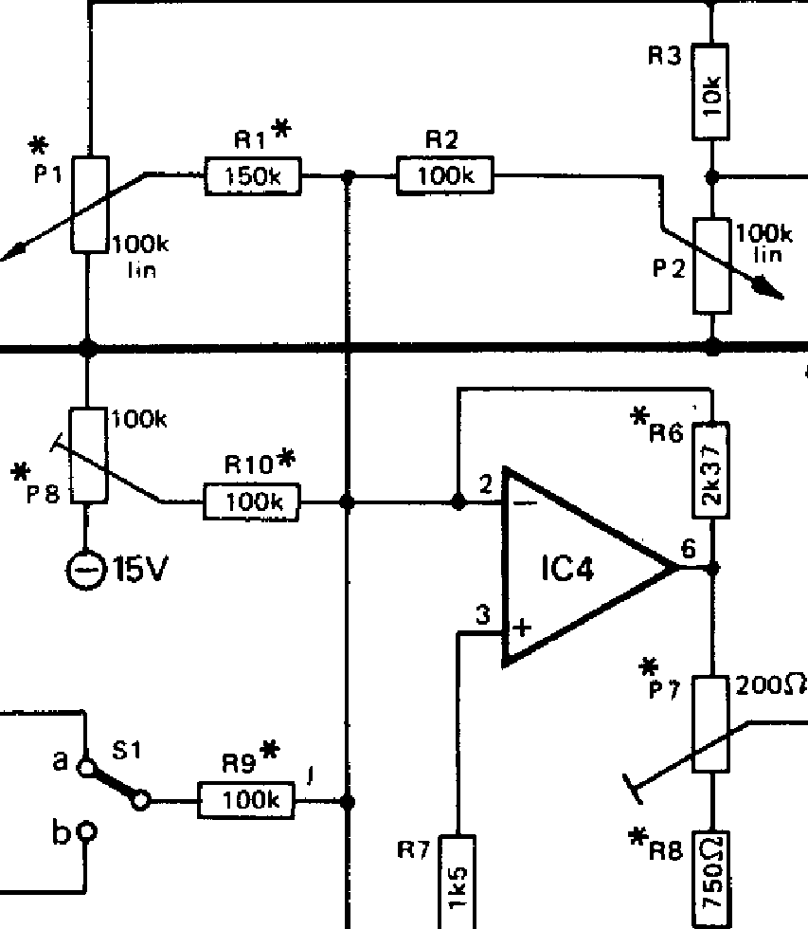

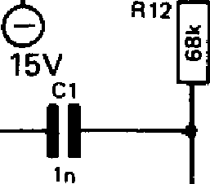

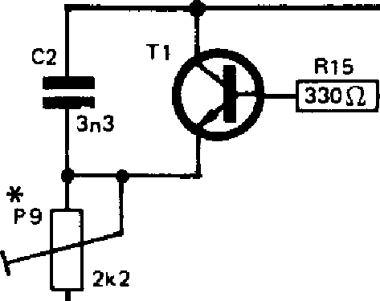

**R13**

1k78

**D1**

2

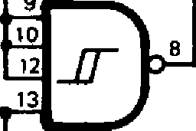

ICI

**IC3**

**T2**

9

**RI8**

**73**

9

R2

**R19**

**2**

**P3**

**9724 2a**

0

**IC2**

**3 +**

**R14**

**7**

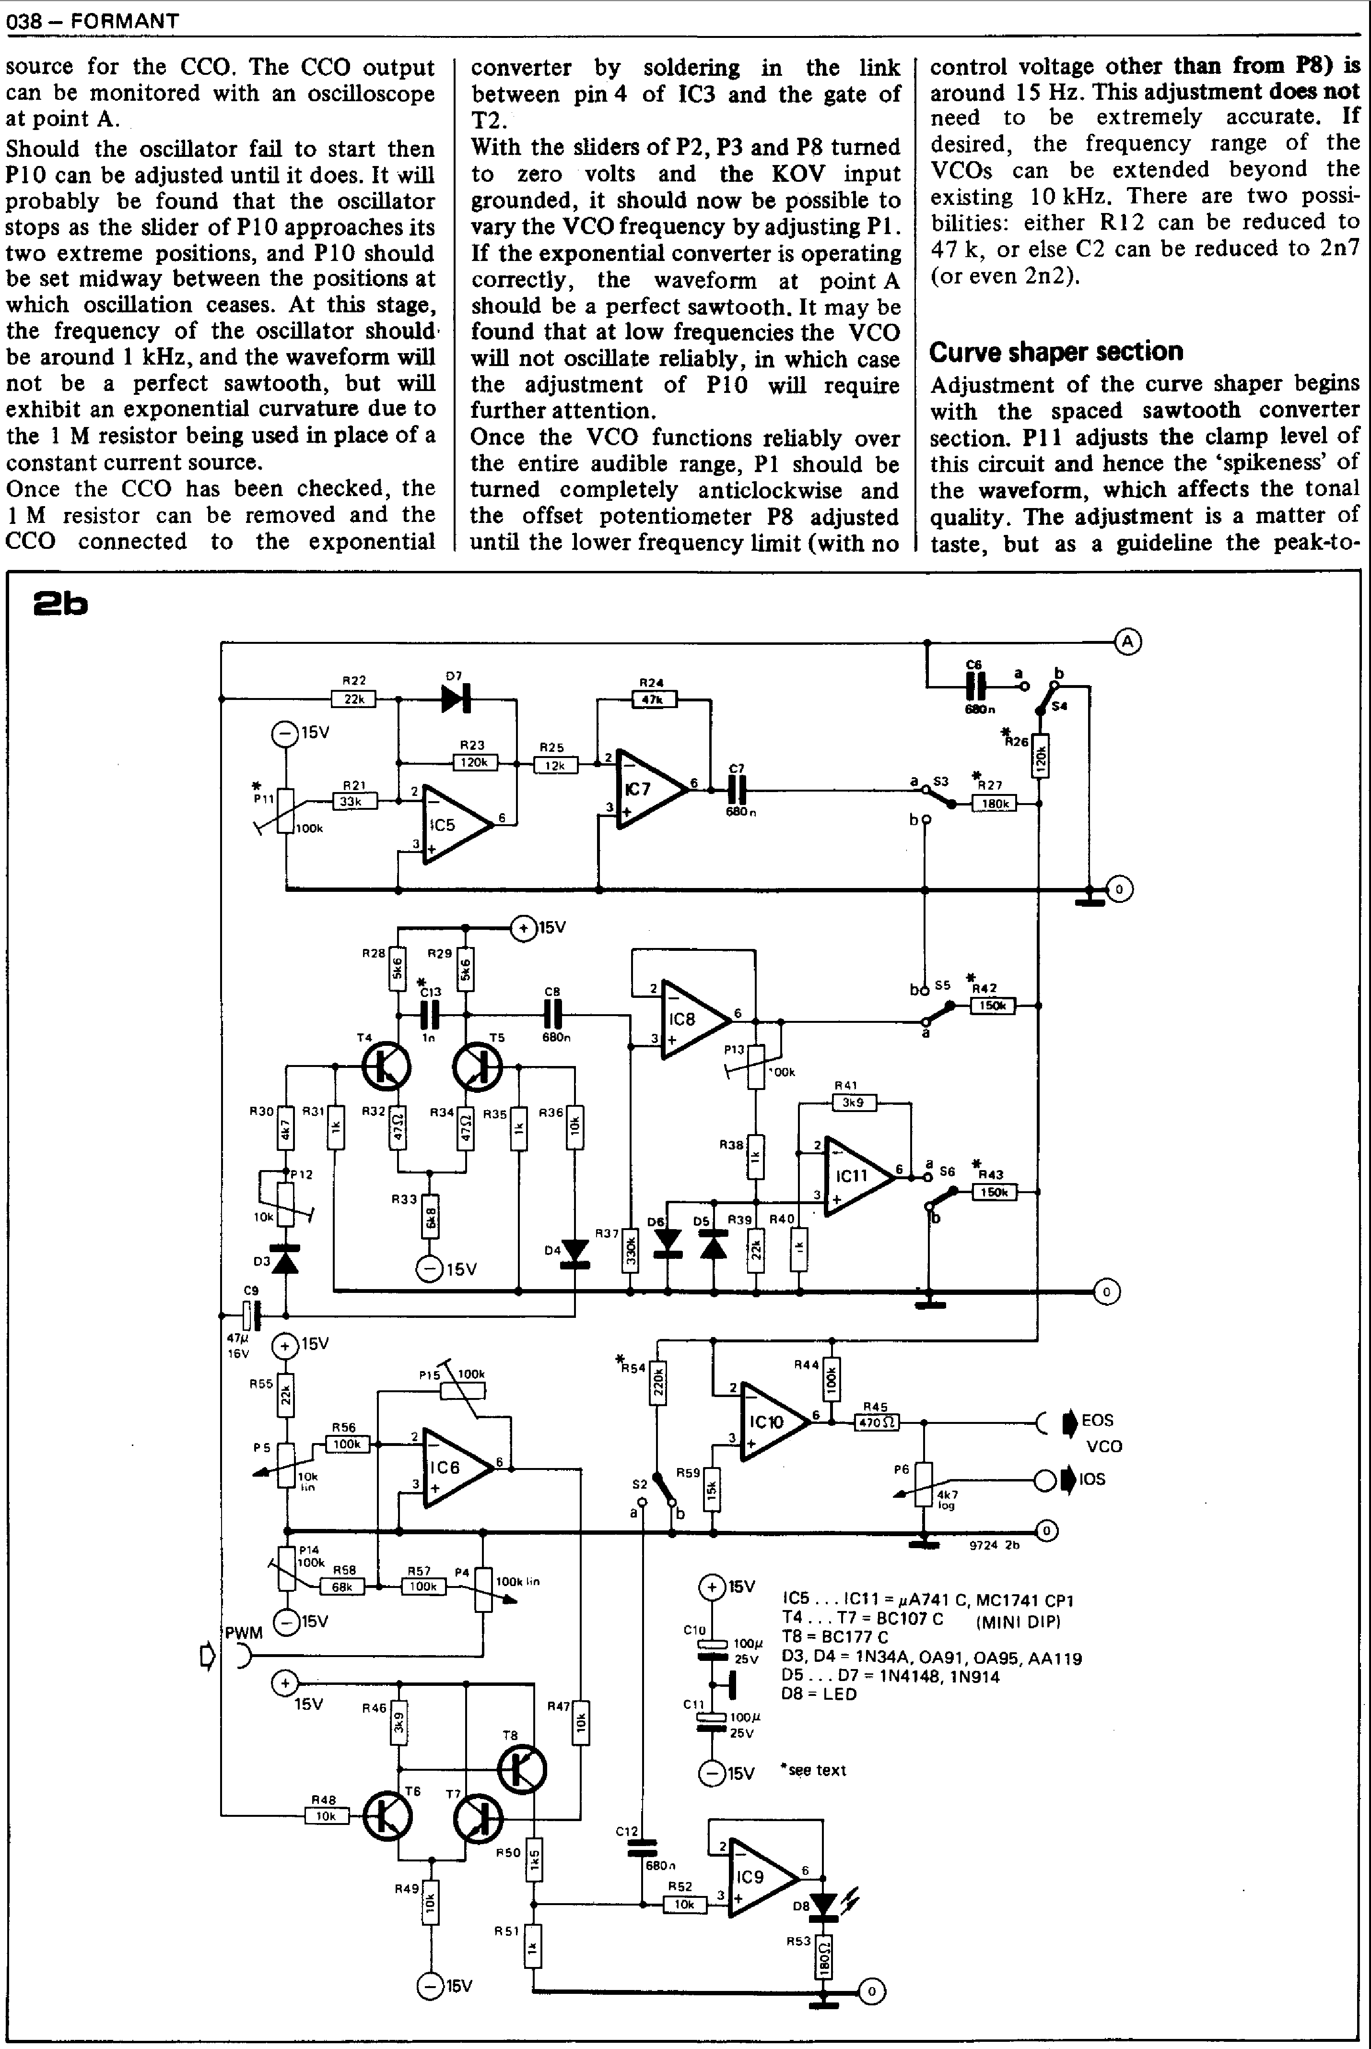

07

R22

**MEM**

L

**1C8**

R30

R31

•

813

'00k

R38

815 100k

R55

**P14**

**100k 858**

**68k**

e

**15V**

100P
  
25v

*-11

C11

C=1100),

725V

**15V**

**15V**

010

**105 .1C11 = pA741 C, MC1741 CP1 T4 . T7 = BC107 C (MINI DIP) 18 = BC177 C**

**03, D4 = 1N34A, 0A91, 0A95, AA 119 D5 ... D7 = 1N4148, 1N914**

**D8= LED**

*see text

**038— FORMANT**

**source for the CCO. The CCO output can be monitored with an oscilloscope at point A.**

**Should the oscillator fail to start then P10 can be adjusted until it does. It will probably be found that the oscillator stops as the slider of PI 0 approaches its two extreme positions, and P10 should be set midway between the positions at which oscillation ceases. At this stage, the frequency of the oscillator should, be around 1 kHz, and the waveform will not be a perfect sawtooth, but will exhibit an exponential curvature due to the 1 M resistor being used in place of a constant current source.**

**Once the CCO has been checked, the
  
1 M resistor can be removed and the
  
CCO connected to the exponential**

**converter by soldering in the link between pin 4 of 1C3 and the gate of T2.**

**With the sliders of P2, P3 and P8 turned to zero volts and the KOV input grounded, it should now be possible to vary the VCO frequency by adjusting P1. If the exponential converter is operating correctly, the waveform at point A should be a perfect sawtooth. It** may be **found that at low frequencies the VCO will not oscillate reliably, in which case the adjustment of P10 will require further attention.**

**Once the VCO functions reliably over the entire audible range, P1 should be turned completely anticlockwise and the offset potentiometer P8 adjusted until the lower frequency limit (with no**

**control voltage other than from P8) is around 15 Hz. This adjustment does not** need to be extremely accurate. **If** desired, the frequency range of the VCOs can be extended beyond the existing 10 kHz. There are two possi­bilities: either **R12** can be reduced to 47 k, or else C2 can be reduced to 2n7 (or even 2n2).

**Curve shaper section**

**Adjustment of the curve shaper begins with the spaced sawtooth converter section. Pll adjusts the clamp level of this circuit and hence the `spikeness' of the waveform, which affects the tonal quality. The adjustment is a matter of taste, but as a guideline the peak-to-**

**d**

100k

R24

C7

4c*

0

4CO10

T5

I

O **15V**

1**5V**

CB

680n 3

R36—

D8 D5 839

R37— **Irr**

**bo S, *R42**

**00011----s05**

**a**

a **56 *R43**

**150k**

R41 3k9

0

R28

R32

R35

R33

**04**

C9

47p

16V

**0**

**15V**

R59

**PWM**

P5

0

**15V** R46

10k

R56

It*

R47

a

S2

**9724 24**

C *EOS

VCO

Okos

0

R57 P4

100k

**1005 lin**

R48

R49

**®15V**

P50

**2b**

b

4

**015V**

P11

**R26**

**a** S3 *R27

-4:161.18--110k

**bo**

**$C5**

3

**ir** P12 10k

03

**R44**

it*6 ®'

P6

4k7

**1c9**

R45

R51

R25

**MEE**

R21

**ERE**

|  |  |
| --- | --- |
| **peak amplitude of the waveform, viewed at point S3a, should be about 3 V.**  **Next, the triangle converter (T4, T5) can be adjusted. The symmetry of the triangle waveform is determined by the matching of diodes D3 and D4. P12 can compensate for slight mismatches in these diodes, but if the degree of mismatch is large the only answer is a better matched pair of diodes. The output waveform should be monitored at point S5a with P12 in its mid-position, and P12 should then be turned one way or the other to obtain a sym­metrical triangular waveform. If notches are apparent at the peaks of the triangle waveform (especially noticeable at high frequencies) then capacitor C13 should be added. The value of 1 n is given as a guideline, but C13 should preferably be chosen experimentally to give the best compromise between elimination of the notches and attenuation of the signal at high frequencies.**  **Once the triangle waveform is satisfac­tory the sine converter may be adjusted. Ideally, diodes D5 and D6 should also be a matched pair in order to ensure symmetry of the sine waveform. However, a random pair of 1N4148s or 1N914s will usually prove to be a sufficiently close match in practice. The purity of the sinewave is adjusted visually by monitoring the waveform at point S6a and varying the resistance of P13 for best results. The sine converter output can be compared with the sine output of a signal generator, if available, or with a sine curve plotted on graph paper. The purists may like to adjust for minimum distortion using a distortion meter, though the simpler adjustment procedure is adequate from a musical point of view.**  **The final section of the circuit to be adjusted is the pulse-width modulated squarewave generator. The aim of this adjustment is to set trimmers P14 and P15 so that the adjustment range of P5 varies the duty-cycle from 1% to 99%. The setting-up procedure is as follows:**   1. **Adjust P14 until its wiper voltage is —5.5 V, and adjust P15 to maximum resistance.** 2. **Connect the voltmeter to the output of IC6 and monitor the PWM signal at point S2a with an oscilloscope.** 3. **Adjust P5 to give first maximum (approx. 99%) and then minimum pulse width (approx. 1%) of the PWM signal, and note the output voltage of IC6 for these two con­ditions thus: — Vmax = voltage for minimum pulse width, Vmin = voltage for maximum pulse width.**   **Figure 3. Suggested front panel layout for the VCO.** |  |
|  |

**040 — FORMANT**

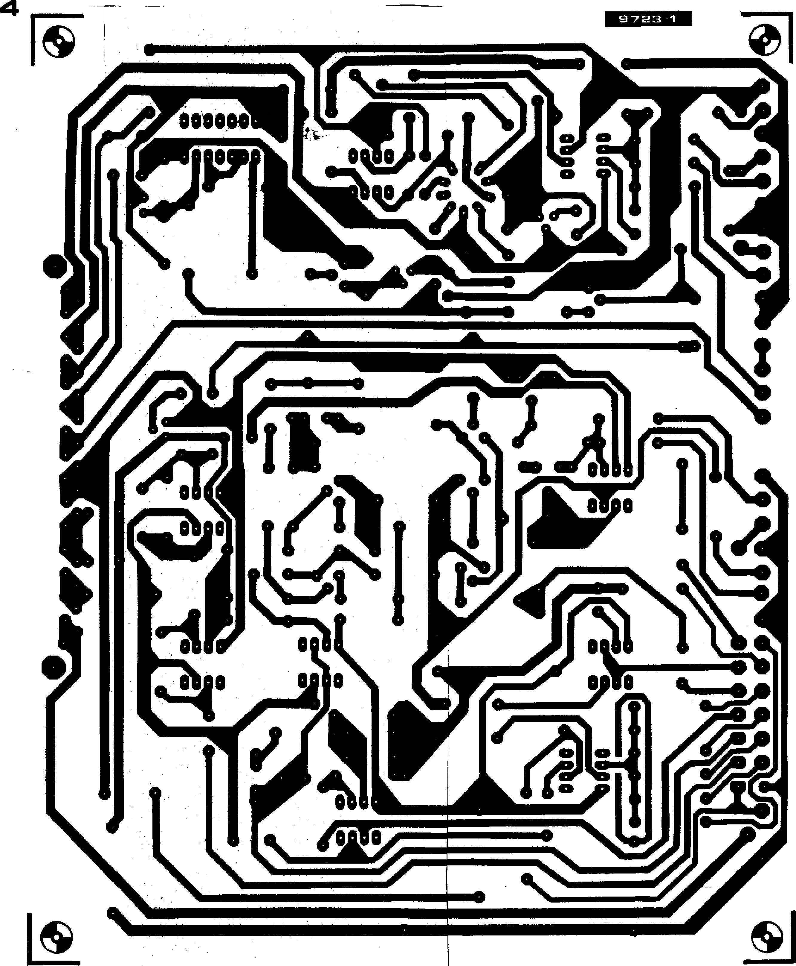

**Parts list for figures 2 and 4.**

**Resistors:**

**a. 1% metal oxide**

**R1 = 150 k R6 = 2k37' R8 = 750 St R9,R10 = 100 k**

**R11 = 1 M**

**R13 = 200 k R18 = 1 k78'**

**These are 'optimum'
  
values. However, 2k4 and**

**1 k8 resistors can be-tyset4-- -**

**for R6 and R18 respect­ively, provided they are 1% metal oxide types!!**

**b. 5% carbon film R2,R44,R56,R57 = 100 k R3,R36,R47,R48, R49,R52 = 10 k**

**R4 = 10011**

**R5,R24 = 47 k R7,R50 = 1k5 R12,R58 = 68 k R14 = 1 M**

**R15= 330 *n***

**GeR30•= 4k7**

**R19, R31,R35, R38,R40,R51 = 1 k**

**R21 = 33 k**

**R22 R39,R55 = 22 k**

**R23 = 120 k**

**R25 = 12 k**

**R26 = 120 k (nominal)**

**R27 = 180 k (nominal) R28, R29 = 5k6**

**R32, R34 = 47 11**

**R33 = 6k8**

**R37 330k**

**R41,R46 = 3k9**

**R42,R43 = 150 k (nominal) R45 = 470 t.**

**R53 = 180 n**

**R54 = 220 k (nominal) R59 = 15 k**

**Presets:**

**a. Cermet**

**P7= 200 St (or 220 n or**

**250 11) multiturn preset.**

**Note pinout, end pins spaced 5.1 mm and 7.6 mm from centre pin, which is offset by 2.5 mm.**

**P8,P11 = 100 k**

**P9 = 2k2**

**P10 = 4k7**

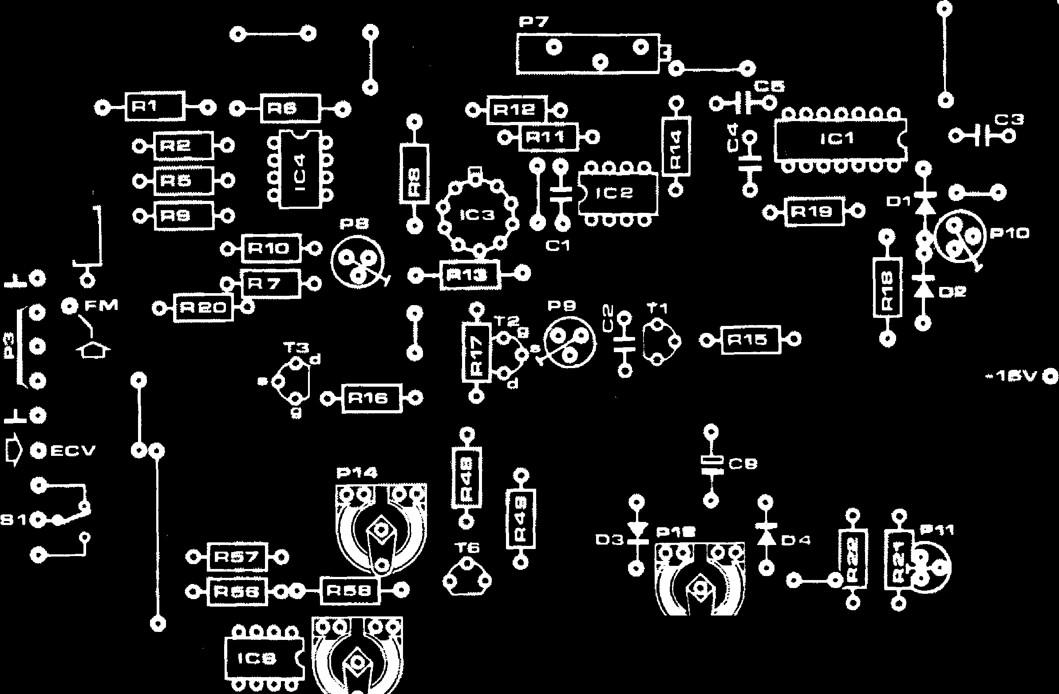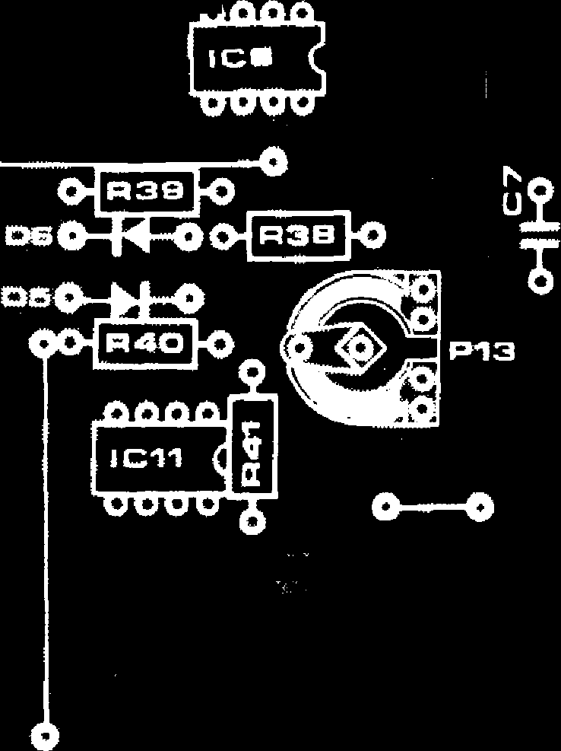

**FORMANT - 041**

a

a

It:

[0 a **(13**

**4.0 0 -r**

**PWM**

**ru**

**840 0 a U**

**Cie CHO**

**8120 0**

**0-In541-0**

**se() O a**

**630 0a**

**R**

**"" 0-1R271.0**

**o 0+061-0**

**El**

**°**

**0**

**‘itt**

**o**

**J-0o**

**oo**

**+e, 0**

0

**K ov000 o -isvoo 0_00**

**0_4100**

**+low**

I

**ei**





**0-1R5314) 01$451 EC)**

**0+44 FO**

**es0 "**

**0-F4-3-0**

[ .1 0

0

**T7**

**R tee foTat**

**04R4B10**

**Pie otPtast**

**OIR47** f **0 OA 13**

**H:4**

**T**

**0-1R281{) T15/.1c;**

**006014) O. R34**

**1:0454il** nn cio O **R33**

**0**

**Int el *fl* 105 a**



q

**a**

I

**01 R31 143 0-W1-Oca**

**04R315k)**

**041=137 /40**

**ru
  
a**

**b. Carbon**

**P12 = 10 k P13,P14,P15 = 100 k**

**Potentiometers:**

1. **Cermet**

**P1 = 100 k lin**

1. **Carbon**

**P2,P4 = 100 k lin P3 = 50 k log.**

**P5 = 10 k lin.**

**P6 = 4k7 (5 k) log.**

**Capacitors: Cl = 1 n**

**C2 = 3n3 (MKM) C3,C4,C5,C6,C7, C8,C12 = 680 n C9 = 47 p/16 V**

**Cl 0/C11 = 10014/25 V C13 = 1 n (see text)**

**Semiconductors: T1 = BC 109C**

**T2,T3 = BF 245A, B**

**T4 ... T7 = BC 107C**

**T8 = BC 177C**

**D3,D4 = 0A91, 0A95, AA118,AA119, or 1N34A**

**D1,D2,D5,**

**D6,D7 = 1 N4148, or**

**1 N914**

**D8 = LED, TIL209 or similar**

**IC1 = 7413 1C2,1C4,IC5,IC6,IC7,IC8, 1C9,1C10,IC11 = pA 741C or MC 1741 CP1**

**(MINI DIP)**

**IC3 = uA 726C (Fairchild, TO package)**

**Miscellaneous:**

**31 pin (DIN 41617) connector**

**S1 ... S6 = SPDT miniature toggle switch. 4 x 3.5 mm jack sockets**

**Figure 4. Printed circuit board and com­ponent layout for the Formant VCO (EPS 9723-1).**

**042 — FORMANT**

1. **Turn the wiper of P14 to zero volts and the wiper of P5 to maximum voltage. Now use P15 to adjust the output voltage of 106 so that it is equal to the difference between the two previously noted values Vmax and Vmin i.e.**

**Vo,IC6 = Vmin - Vmax.**

**The output voltage of 106 will be negative since it is connected as an inverting amplifier.**

1. **Adjust P14 to give maximum pulse-width** (99% **duty-cycle) of the output signal. When the wiper of P5 is now turned to zero volts the pulse width should be minimum (1% duty-cycle). This completes the adjustment of the PWM stage.**

**Oscillograms of all the waveforms are shown in photos 1 to 7.**

**Output adder**

**Once the various sections of the curve shaper have been adjusted the input resistors** of **the output adder may be selected (R26, R27, R42, R43 and R54). A 250 k potentiometer is connec­ted in place of each resistor in turn, and the peak-to-peak amplitude of the relevant waveform is adjusted to about 2.5 V at output EOS. The resistance of the pot is then measured and it is replaced by a fixed resistor of the nearest preferred value from the E24 range.**

**Front panel**

**A front panel layout for the VCO is given in figure 3. The three inputs, FM, ECV and PWM are at the top of the panel, with the switch (S 1) to select between ECV and KOV mounted below. Potentiometer P3, which controls the FM modulation depth, is mounted below the FM input socket, while P4 and P5, which control the pulse width modulation depth and duty-cycle re­spectively, are mounted below the PWM input socket. The coarse and fine tuning controls (P1 and P2) are also grouped together, on the left of the panel, while the output level control (P6) is grouped with the waveform selection switches (S2 to S6) and the output socket.**

**Module construction**

**It is essential that the VCO module should be screened to avoid any inter­ference pickup. To provide this screening, and to make the module mechanically rigid, the p.c. board is mounted on a carrier made from 16 or 18 SWG aluminium. The dimensions of the carrier are those of a large Eurocard (165 mm x 210 mm) so that the module will fit a Euro-standard card frame. A right-angle bend at the front edge of the carrier allows it to be secured to the front panel by means of the poten­tiometer mounting bushes. The p.c. board is mounted on the carrier using M3 screws and spacers. Photo 8 shows the completed module.**

|  |
| --- |
| **ECV = External Control Voltage,**  **i.e. front-panel input to VCO.**  **KOV = Keyboard Output Voltage,**  **i.e. permanently wired input to VCO from inter-**  **face receiver.**  **FM = Frequency Modulation**  **input**  **PWM = Pulse Width Modulation**  **input**  **EOS = External Output Signal**  **from VCO (front panel output)**  **VCO/10S = Internal Output Signal from VCO, will be perma­nently wired to one VCF input.** |

**Photos 1 to 7. These oscillograms give an indication of the waveforms that should be available at the curve shaper outputs:**

**1. Sawtooth 2. Spaced sawtooth 3. Triangle 4. Sinewave 5. Squarewave, minimum duty-cycle 6. Squarewave, 50% duty-cycle 7. Squarewave, maximum duty-cycle.**

**Photo 8. The completed VCO module.**

**FORMANT — 043**

**Octaves/Volt adjustment**

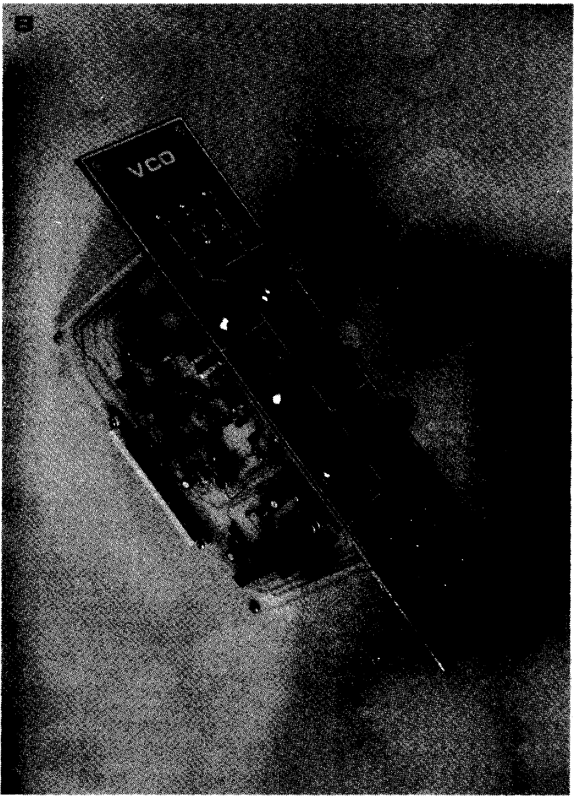

**The most critical adjustment made to the entire synthesiser is the setting up of the octaves/volt characteristic of the VCOs, as this adjustment determines the accuracy of the synthesiser tuning.**

**There are two methods of adjusting the VCO. The simpler method requires the use of a frequency counter and digital voltmeter, while the second method requires an audio signal generator with a calibrated frequency scale.**

**Before commencing the adjustment procedure power should be applied to the VCO for several minutes to allow the temperature (especially of 1C3) to stabilise.**

**To adjust the VCO using frequency counter and DVM, all inputs and controls of the VCO input adder are set to zero volts and P9 is set in its centre position. The connection between the wiper of P I and R1 must be unsoldered, and the free end of RI connected to ground, whilst the wiper of P1 is con­nected** to **the KOV input with S1 in position 'a'. The frequency counter is**

connected to the **VCO output and the DVM to** the wiper **of Pl. With P1 turned fully** anticlockwise **the frequency coun­ter** will read around 15 Hz, which was set **previously by means of P8. P1 is now turned slowly clockwise until the DVM reads I V, when the VCO frequency should be twice what it was with P1 set to zero, e.g. if the zero frequency was exactly 15 Hz the frequency should now be exactly 30 Hz. Of course, initially this will not be the case, and** some **adjustment of P7 will be required. P 1 is then turned until its wiper voltage is exactly 2 V, when the VCO frequency should be four times the zero voltage frequency, e.g. 60 Hz. This procedure is repeated at 1 V steps over the entire range of P1 ,checking that the correct frequency is obtained at each step. Thus if 0 V =** 15 **Hz, then 1 V = 30 Hz, 2 V = 60 Hz, 3 V = 120 Hz etc. P7 is adjusted to obtain the best accuracy possible over the widest frequency range. At high frequencies (greater than 3 kHz) P9 can be used to correct any deviations from the 1 octave/volt characteristic. To adjust the VCO using the beat note**

**method, the outputs of an audio oscillator and the VCO must be fed into the left- and right-channels of a stereo amplifier, or via an audio mixer into a mono amplifier, so that the beat notes can be heard via the loudspeakers. The VCO is connected to the KOV output of the previously calibrated keyboard. The audio oscillator is set to a frequency between 400 and 500 Hz, and the main tuning of the keyboard is switched off. The top note of the keyboard is then depressed, and the VCO tuning controls P1 and P2 are adjusted until the audio oscillator and VCO are in tune with zero beat.**

**Next, the key an octave lower is de­pressed, when a dissonance or very rapid beat note will be heard. P7 is then adjusted until** zero beat **is obtained between the audio oscillator and the VCO note one octave lower.**

**The top key is again depressed, when it will be found that, due to the adjust­ment of P7, a beat note is again heard. Using the VCO tuning controls, readjust for zero beat, then depress the key an octave lower, which will now be slightly out of tune due to adjusting the VCO tuning controls. P7 must therefore be readjusted to obtain a zero beat.**

**This procedure is repeated several times until the oscillator is perfectly in tune with both the top note and the note an octave lower. The tuning is then checked two octaves and three octaves below top C, and if necessary P7 is readjusted to obtain the best tuning over the entire keyboard range.**

**The higher ranges of the VCO must now be adjusted using P9. For this purpose the audio oscillator is tuned to around 2 kHz, the bottom note of the keyboard is depressed, and the coarse and fine tuning controls of the VCO are adjusted for zero beat. The key an octave higher is then depressed, and P9 is adjusted for zero beat using the same technique as for the previous adjustment procedure using P7. The tuning is then checked two octaves and three octaves above bottom C.**

**This completes the adjustment of the VCO.**