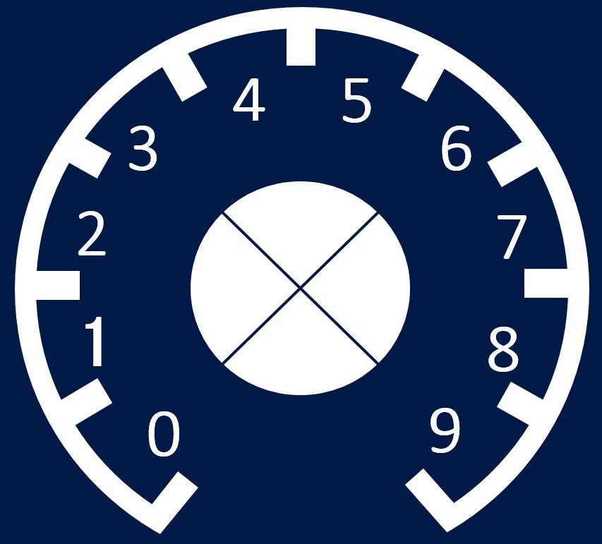
ELEKTOR
FORMANT V2
3,5mm Ø
X4
OUT
KOV
FM
ECV
PWM
10mm Ø
X6

VCO
OCTAVES
FINE
COARSE
PW
OUT
266 mm (6U)
Material: Aluminio Grosor: 1mm
71 mm
6,5mm Ø
X11

