**Chapter 1**

**Introduction to Online Crime File Management System**

* 1. **Introduction**

Online crime file management system provides facility for reporting online crimes, complaints, wanted persons list, various announcement for the particular locality with multimedia content (videos, pictures, verbal). This system will allow user to sign up and enter a complaint or register a grievance with enough evidence. Administrator from the National Authority will verify and take necessary steps. The users who complains will see the status or the actions taken from the authority on the complaints. To ensure security the complaints will only accessible by the authority and the complainer himself, no one outside this two can access complaints and crime report.

* 1. **Purpose of the project**

This system will help people to reduce sufferings to complaints and register grievance against crime. It will help to track the status about the complaints. The authority will also can provide various announcement for the particular locality if they want to. This is reduce the gap between the National Authority and Citizens of any country.

**Chapter 2**

**System Requirements Specifications**

* 1. **Requirements for the system**

**Chapter 3**

**Structured Analysis**

* 1. **DFD (Data flow Diagram)**

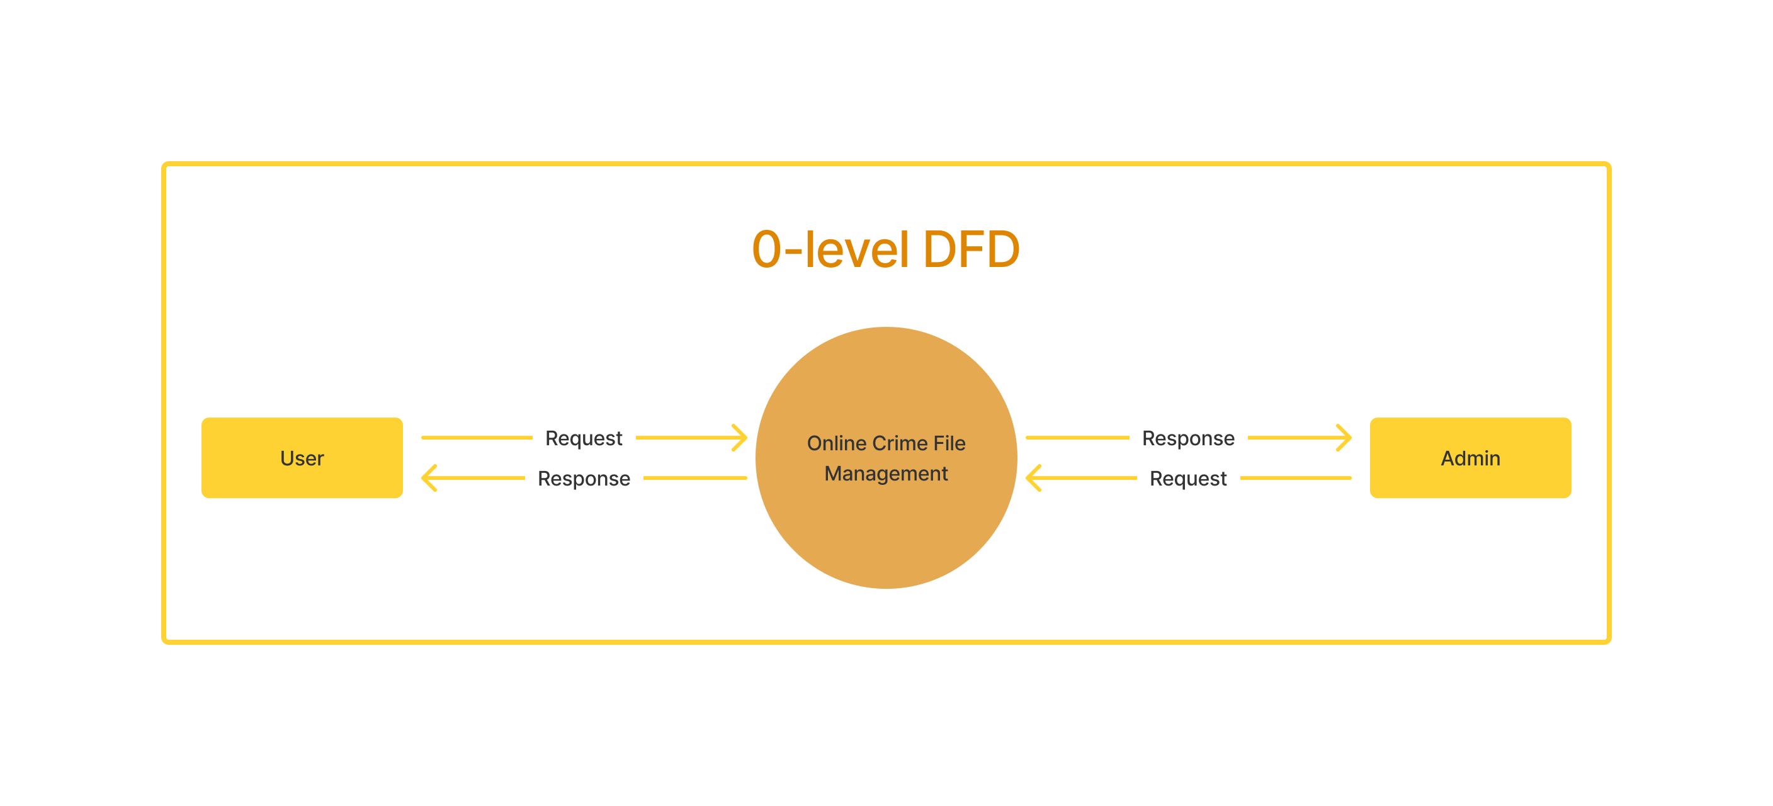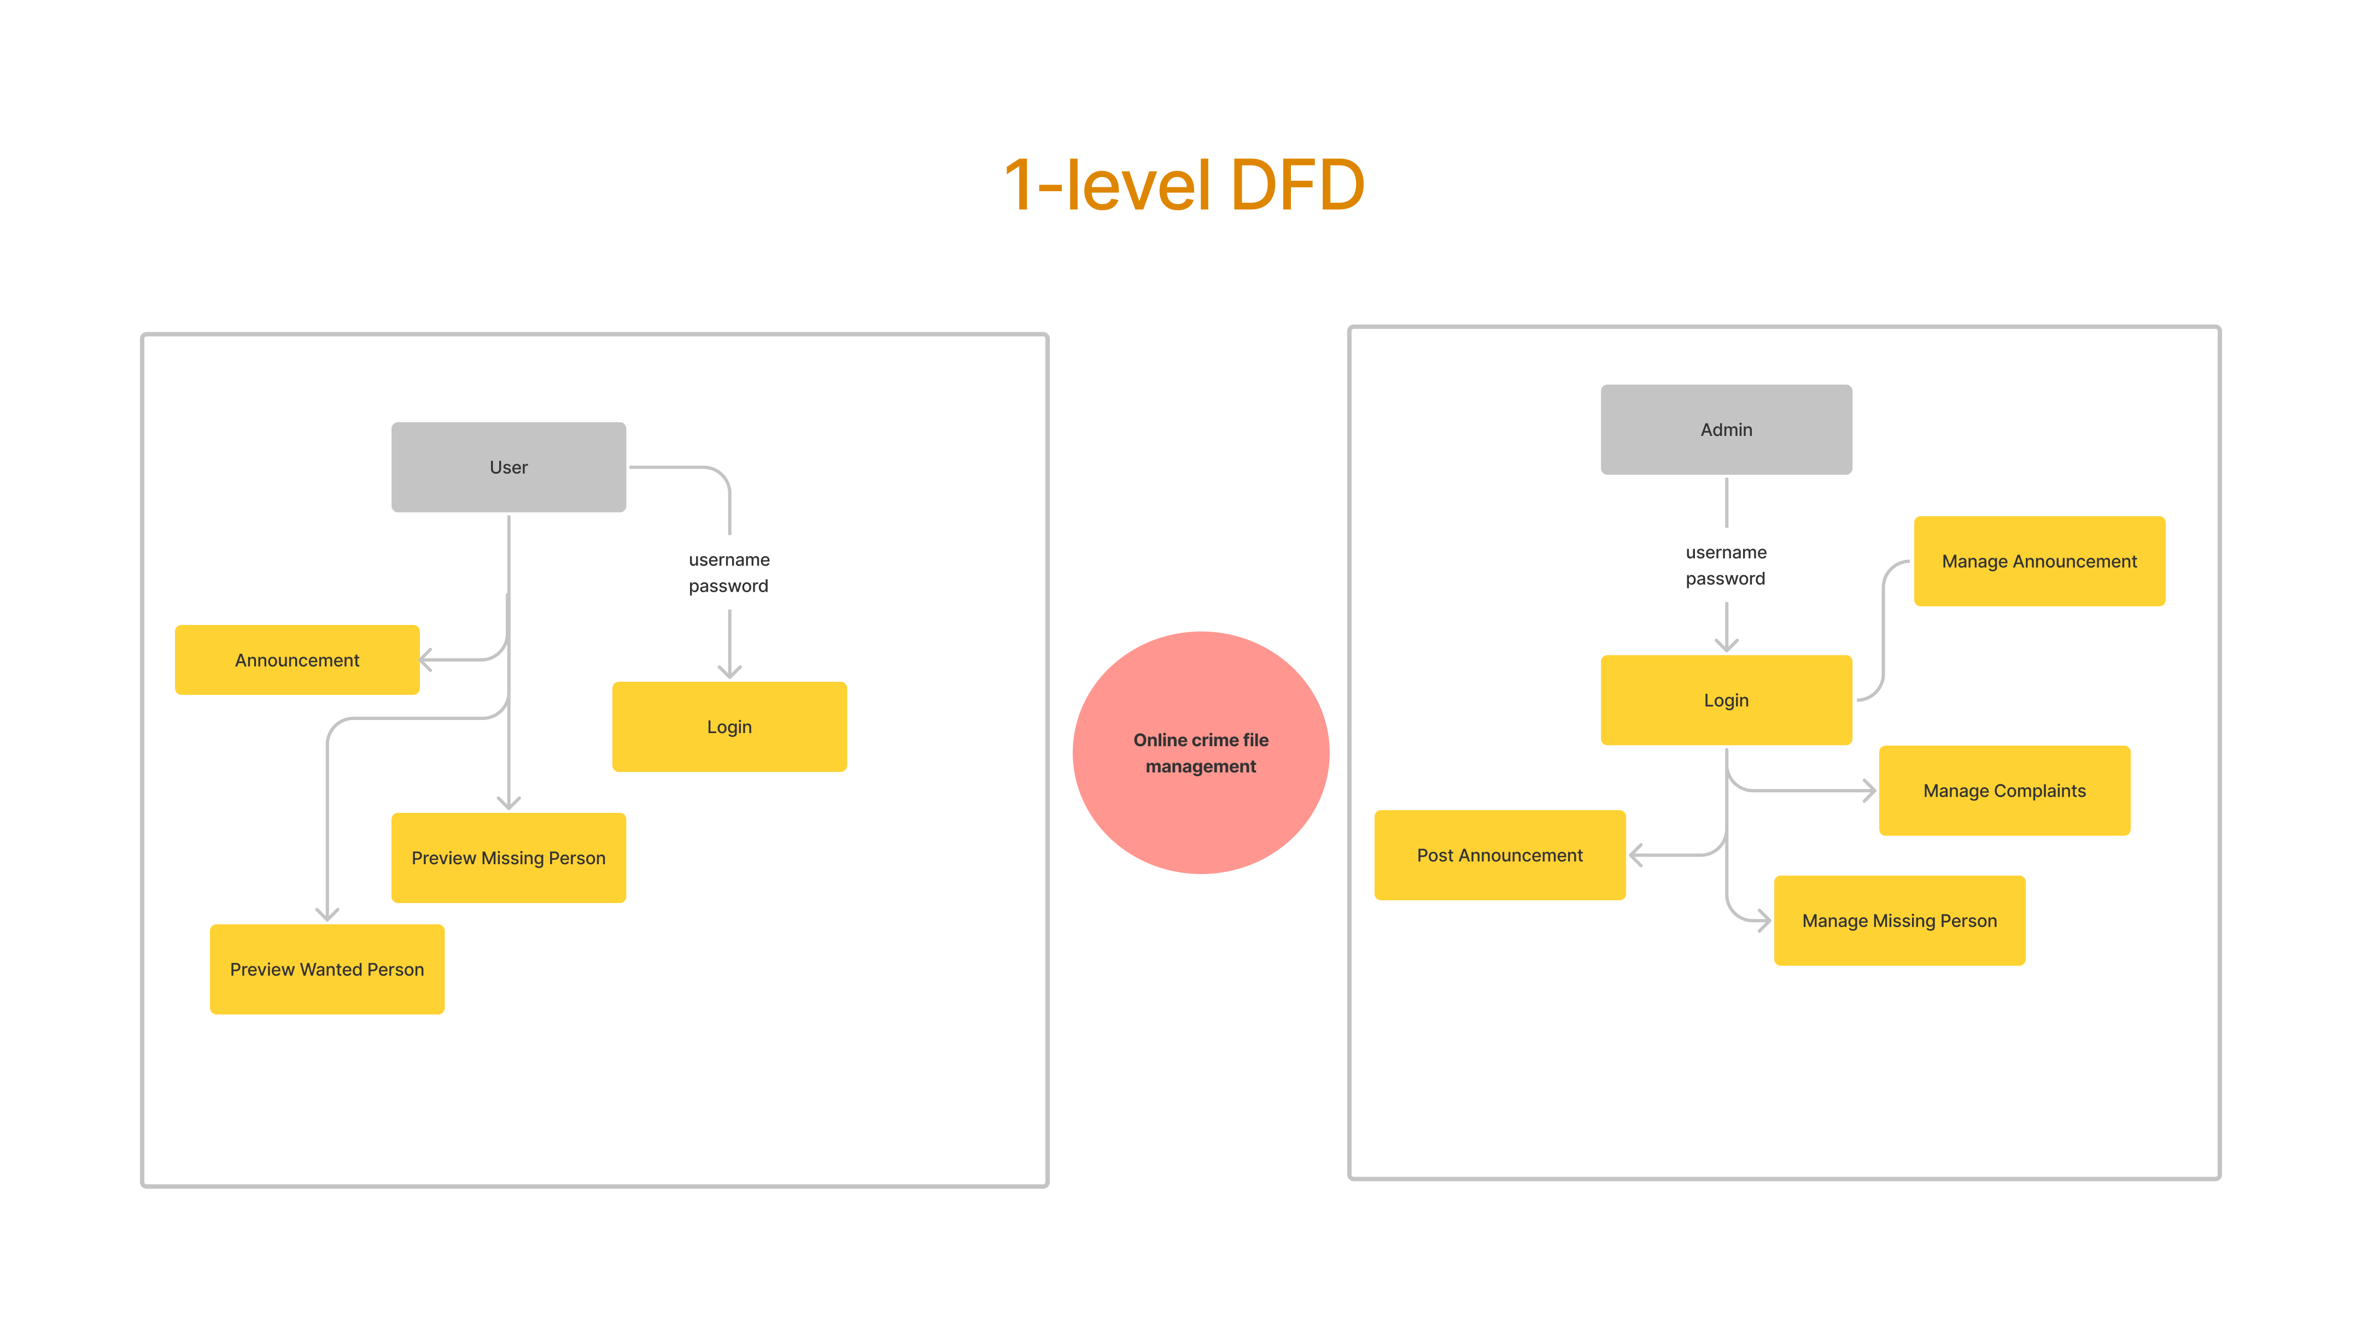

* 1. **Data Dictionary**

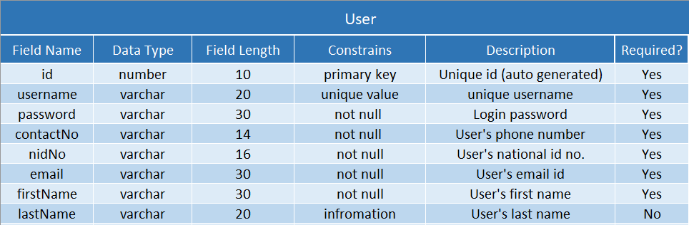

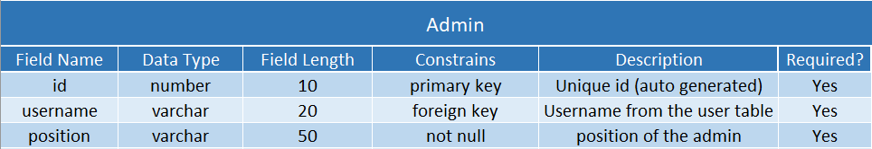

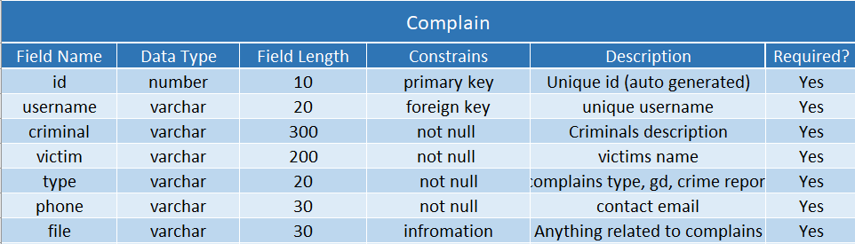

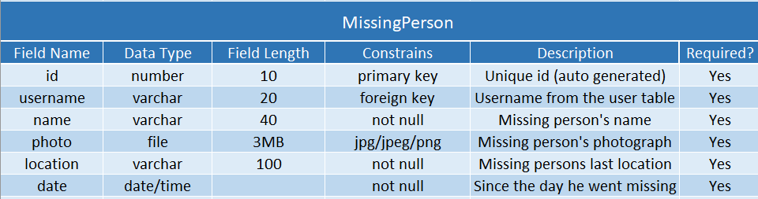

* 1. **Structured English**

A

* 1. **Pseudo Code**

A

* 1. **Decision Tree**

A

* 1. **Decision Table**

a