SwipeFish’s User Specification
- LOADING SCREEN
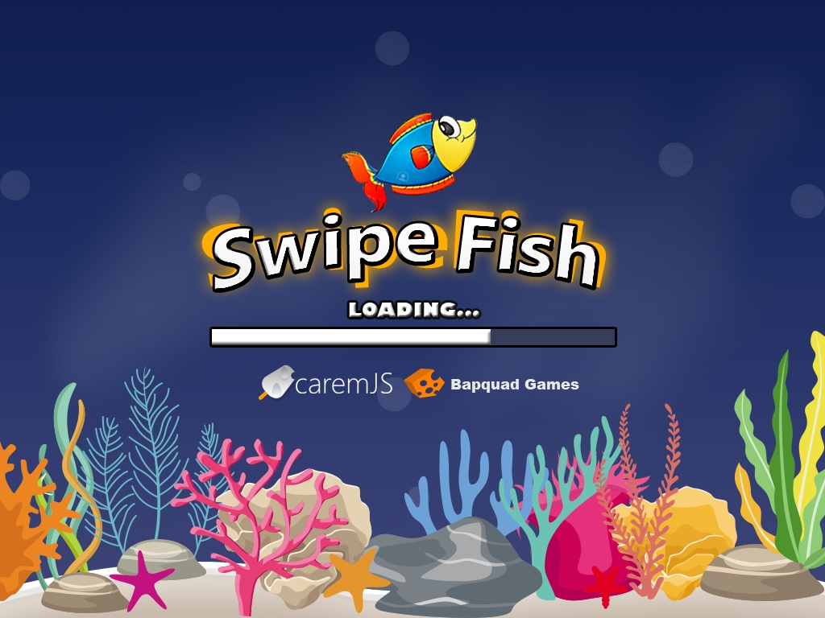
- First you go to loading screen
Case Finish: appears the start screen
- Background
- START SCREEN
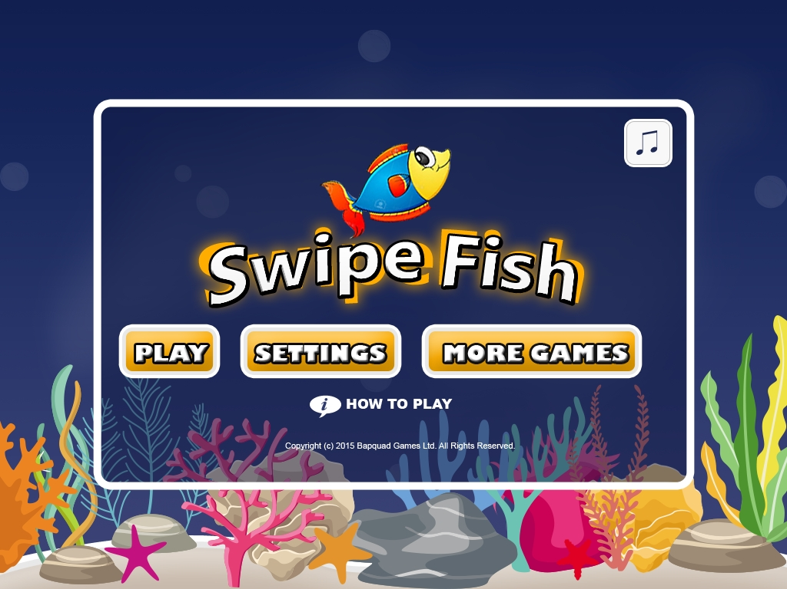
- Play Button – Go to Upgrade Screen.
- Settings Button – Go to Setting Screen.
- More Games – Go to Game Web Base.
- Sound Button – Turn on/off the sound of game.
- How To Play Button – Go to game tutorial.
- SETTINGS SCREEN
- Sound Enable – Turn on/off the sound of game.
- Sound Volume – Adjust game sound volume.
- FullScreen Enable – Fullscreen game.
- Back button – Go to the start screen.
- UPGRADE SCREEN
- Return Button – go to Level Game Screen.
- Back Button – Go to the referrent.
- Challenge Button – Go to the challenge Screen.
- Money stat – Show the current money.
- Item [Extra Live] self
- Item [Money x2] self
- Item [Shield x2] self
- Item [Magnet x2] drop
- Item [Money x2] drop
- Item [Speed & Shield x2] drop
- CHALLENGE SCREEN
- Back Button – Go to the referrent.
- Icon menu Quest – List of menu quest user completed.
- Description of Quest – Description of selected quest user want to know.
- LEVEL GAME SCREEN
- Gameover Event – go to Stat Screen.
- Game Pause Event – go to Game Pause Screen.
- STAT SCREEN
- Replay Button – Go to Start Screen.
- Challenge Button – Go to the Challenge Screen.
- Back Button – Go to the Start Screen.
- Your swipe – Count of click
- Your Far – Count of time
- Your Collection – Monney collected.
- Quest Complete – Bonus of quest completion.
- GAME PAUSE SCREEN
- Upgrade Button – Go to Upgrade Screen.
- Resume Button – Go to Level Game Screen.

