Programming Assignment: BreadCrumbFollower
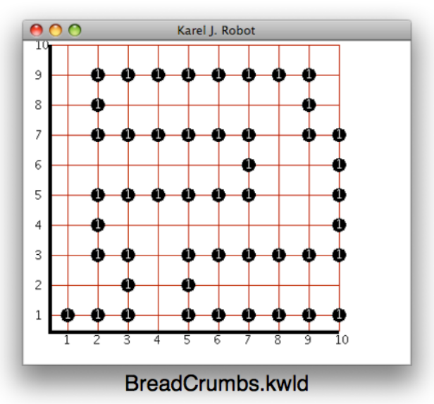
The initial project code has a robot starting on intersection (1,1) facing East. Complete the travel method in the BreadCrumbFollower class so that the robot recursively follows the trail of beeper "bread crumbs.” The robot should stop when there are no beepers to its left, right or in front of it. When the robot stops the world should be unaltered from its initial state. In doing this you are not to modify anything about the main method code. To do this, YOU SHOULD write some Boolean helper methods to tell you if there are beepers to your sides, or in front of you. Remember: boolean methods should not have side effects - if you have to move the robot to figure something out, you should move it back to the location and direction it was beforehand.

