TITLE PAGE

**Disentangling influence over group speed and direction reveals multiple patterns of influence in moving meerkat groups**

Baptiste Averly1,2,3,5, Vivek H. Sridhar2,3, Vlad Demartsev1,2,5, Gabriella Gall1,2,3,4,5,6, Marta Manser4,5,7*, Ariana Strandburg-Peshkin1,2,3,4,5*

1. Department of Biology, University of Konstanz, Konstanz, Germany
2. Department for the Ecology of Animal Societies, Max Planck Institute of Animal Behavior, Konstanz, Germany
3. Centre for the Advanced Study of Collective Behaviour, University of Konstanz, Konstanz, Germany
4. Department of Evolutionary Biology and Environmental Studies, University of Zurich, Zurich, Switzerland
5. Kalahari Meerkat Project, Kuruman River Reserve, Northern Cape, South Africa
6. Zukunftskolleg, University of Konstanz, Konstanz, Germany
7. Mammal Research Institute, University of Pretoria, South Africa

*joint senior author

**ABSTRACT**

Animal groups that travel together must constantly come to consensus about both the direction and speed of movement, often having to reach these two types of decisions simultaneously. Contributions to collective decisions may vary among group members, yet inferring who has influence over group decisions is challenging, largely due to the multifaceted nature of influence. Here we collected high-resolution GPS data from five habituated meerkat groups during foraging in their natural habitat and developed a method to quantify individual influence over both group direction and speed. We found that individual influence over direction and speed were correlated, but also exhibited substantial variation. Comparing patterns across social status of individuals revealed that dominant females have overall higher influence over group direction than other individuals, but have a weaker influence group speed. Individuals with high influence also tended to spend more time in the front of the group. We discuss our results in light of meerkat life-history and current literature on influence during movement. Our method provides a general approach which can be applied to disentangle individual influence over group direction and speed in other species, emphasizing the importance of integrating multiple lines of enquiry when inferring influence in moving animal groups.

Keywords: decision-making ; collective movement ; leadership ; dominance

**INTRODUCTION**

In social animals, different individuals often have heterogenous contributions to group decisions. Group members whose actions cause others to change their behavior can be said to exert influence, and the distribution and consistency of influence among group-mates can vary across decision types, contexts, and species (1). Group decision mechanisms can range from totally shared, when most individuals contribute to most decisions, to totally unshared, when one or a few individuals consistently impose their preference on other group members (2) . Studies of influence on collective movement have generally focused on single dimensions of influence, such as who leads in the front of the group (3–6), or who determines the group direction (7–11) and timing of travel (12,13). A positive link between influence and social rank has often been established (reviewed in Smith et al., 2015), though systems with influential subordinates are also found (14–16). Thus, there is a diversity of movement decisions-making mechanisms in nature depending on group characteristics such as size and composition, social structure, and type of movement (17–19).

Assessing patterns of influence and comparing them between social systems remains challenging because of this diversity. In order to correctly define and quantify influence in a social system, one has to first identify the decision-making mechanisms at play and the individual actions that impact behavioral decisions of others (1). In the context of movement, these actions can include an individual’s position in space, its movement in a given direction, or the production of signals such as vocalizations. How much influence an individual is able to exert may also vary depending on the type of decision being made. In particular, theoretical work has emphasized a fundamental distinction between decisions about movement *direction* and decisions about movement *timing*. These two types of decisions are expected to have different distributions of consensus costs, leading to contrasting predictions about whether they are likely to be shared or unshared (20,21). It can be particularly challenging to disentangle these two fields of influence, as both may occur at the same time when groups travel collectively, continuously needing to come to consensus on both the direction and speed of travel. Very few field studies have simultaneously looked at several measures of influence in the same system, to evaluate if influence in one domain necessarily translate to influence in other domains (but see (22–24) for lab experiments). The versatility of the notion of influence makes it crucial to define the context in which it is assessed, while also accounting for the biology and social structure of the study system.

We investigated patterns of influence in meerkats (*Suricata suricatta),* social mongooses living in highly cohesive groups of up to 50 individuals, in the arid parts of southern Africa (25,26). Meerkats are opportunistic generalists which forage on small invertebrate and some vertebrate prey distributed across their desert habitat by digging in the ground (27). The dispersed nature of prey is reflected in the groups’ movement dynamics: meerkat groups typically move in a relatively slow, continuous fashion while simultaneously foraging. Though individuals forage independently from one another, typically 1 to 10 meters from their nearest neighbors (28), groups remain highly cohesive throughout the day while navigating 2-5 km2 territories (29). Meerkats have a highly developed vocal repertoire (30) and calls have been shown to play an important role in maintaining cohesion (31,32) and in initiating rapid travel when relocating (15), returning to a sleeping burrow (33), or as a predator avoidance response (34). Yet, the extent to which different group members influence collective decisions about movement speed and direction remains unclear. Though meerkat groups are socially structured with a dominant pair monopolizing most of the breeding opportunities (35,36), and much less strong social hierarchy among subordinate group members (37), little evidence suggest that dominance translates into stronger influence over group movement decisions (33,38–40).

Here, we assess the distribution of influence over collective movement decisions in forging meerkats in their natural habitat using high-resolution GPS data from five social groups of varying sizes. We develop a general method for quantifying individual influence on the speed and direction of movement over continuous foraging periods, which could be applicable to other animal study systems. We use this method to assess if patterns of influence are associated with social status within groups, as well as whether the two different domains of influences correlate with one another. Since frontmost individuals are sometimes assumed to have more influence during collective movement (5,6,41), we also test whether individuals that spend more time in the front of the group have higher levels of influence.

**METHODS**

**Study site and data collection**

*Study system*

The study was conducted at the Kalahari Meerkat Project (KMP) within the Kuruman River Reserve in South Africa (26°58′S, 21°49′E) (42), where 7-15 habituated meerkat groups are continuously monitored for group composition, dominance status, life history etc... We collected simultaneous movement data on the majority of individuals within five distinct meerkat groups: HM17 (7 individuals) in August and September 2017, HM19 (18 individuals) in June and July 2019, L19 (19 individuals) in August 2019, ZU21 (13 individuals) in May 2021 and NQ21 (11 individuals) in August 2021. We chose the groups with the highest levels of habituation among the monitored population to enable collars to be deployed without the need for capture (see below and section 1 in the Supplements for tagging methodology). Individuals were attributed one of six different social statuses, based on established protocols at the KMP: dominant females (one per group), dominant males (one per group), other adults (2+ years), yearlings (<2 years), sub-adults (<1 year) and juveniles (<3 months). HM17 and HM19 were the same group two years apart, with similar home range, but only three individuals in common, two of which had different statuses in these two years (see Supplemental Table 2).

*Collar design, deployment and duty cycle*

To simultaneously record the trajectories of all individuals in meerkat groups, we designed collars consisting of a GPS unit (Gipsy 5 in 2017 and 2019, Axy-Trek Mini in 2021; Technosmart, Colleverde, Italy) and a ER14250M battery affixed to a 5 mm-wide leather strap. We protected these electronics from shocks and sand using parafilm and 2-part epoxy glue. Completed collars weighed 22-25g, never exceeding 5% of the animal’s body mass. Juvenile individuals were below the minimal size for fitting a GPS collar, therefore their movement could not be recorded. Once fitted on a meerkat, the GPS board rested on the back of the neck, with the whip antenna pointing down the back of the individual (Figure 1A).Owing to the high levels of habituation of meerkats at the KMP we could deploy the collars without anaesthetizing (see section 1 of the Supplements for detailed method). All GPS units in a given group were programmed to record simultaneously at 1 GPS fix/second for 3 hours every day during times when meerkats typically forage within their territory while moving as a group (either in the morning after the group had left the sleeping burrow, or in the afternoon before returning to it, depending on the deployment round). Total number of recording days for a single deployment round ranged from 6 to 10 depending on GPS-battery life. See Supplemental Table S1 and S2 for detailed information on deployment timing and group composition.During the recording session, an observer noted the times of any group-level disturbances (predator alarms, inter-group encounters, and resting periods) on an all-occurrence basis, and these events were not included in subsequent analyses (see below).

*GPS data pre-processing*

GPS coordinates were first converted from WGS84 to UTM S34 to allow for easier spatial analyses. To increase GPS reliability and reduce sampling biases, we performed minimal pre-processing of GPS data before subsequent analysis. Specifically, when GPS signals were not recorded continuously (for instance if signal was lost after a meerkat went below ground, e.g. entering a bolt-hole) we discarded all GPS fixes taken 30s before signal loss and 30s after signal return, as these positions tended to be unreliable. We also removed fixes with fewer than five satellites detected.  Finally, on six instances we removed data suggesting biologically unrealistic speeds (>10 m displacement between two fixes one second apart) as these likely represented GPS errors.

In some instances, single individuals were away from the rest of the group during recording times, either at the communal burrow babysitting pups, out travelling on their own (“roving” behavior exhibited by adult males before dispersing from their natal territory), and in one case a female being evicted from the group for a few days by the pregnant dominant female. In such instances the GPS trajectory of that given individual was discarded but the analyses were performed normally on the rest of the group.

Due to GPS tag battery failure and unsuccessful collaring attempts, we could not record every adult group member throughout the whole deployment (see Supplementary table S2 for details). We excluded time points when fewer than two-third of the non-juveniles present that day were recorded, to reduce the impacts of “invisible” (untracked) individuals. We also removed non-presentative group movement states such as predator alarms responses, rare instances of resting periods due to the heat, one instance of encounter with another meerkat group, and one day when three adult males (including the dominant) were not present with the group. After the removal of these data, we were left with a minimum of 9.5 hours (NQ21) and a maximum of 37.5 hours (HM17) of usable data per group (see table S1 in supplements).

**Analysis**

To quantify individual influence from movement data, we defined two complementary metrics, designed to capture influence over group direction (*turning influence*) and influence over group speed (*speeding influence*) separately. For each metric, we evaluated a given individual’s influence on the group by measuring the probability that the group’s movement temporally follows this individual’s past movement. Each metric also describes how these probabilities change as a function of how extreme an individual’s movement is relative to the group. We give a short general description of the approach here, with additional details described in the next section.

**Turn influence** is defined as the probability that the group turns in a given direction as a function of the focal individual’s velocity along the left-right axis of movement. Similarly, **speed influence** is defined as the probability that the group speeds up as a function of the difference between individual and group velocity along the front-back axis of movement. We also defined alternative versions of these influence metrics based on the spatial location of individuals within the group rather than their movement, and compared the outcome of the two versions (described in section 2 and 3 of the Supplements). For each individual, for each metric, we fit a curve to describe the relationship between its movement and the group’s subsequent movement, using a modified version of a logistic function. We then used these models to attribute a “turn influence score” and a “speed influence score” to each individual for both metrics. Finally, we fit Generalized Linear Mixed Models (GLMMs) for each influence score to compare their value between individual social statuses.

*Detailed explanation of the approach:*

To compute the influence metrics of a given individual, we first computed the track of the group centroid by averaging the position of all individuals recorded (other than the focal individual) at each time point (figure 1B). For every time point *t*, we then calculated the *future* and *past* velocity vectors of the group centroid (figure 1C). The *future velocity vector* was defined as the vector pointing from the position at time *t* (henceforth ‘current position’) to the next recorded position that was at least 10 meters away (henceforth ‘future position’). The *past velocity vector* was defined as the vector pointing to the current position from the most recent position that was at least 10 meters away (henceforth ‘past position’). We chose to use spatial rather than temporal thresholds to define these headings because of the stop-and-go nature of individual meerkat movement, which makes the temporal scale at which movements occur highly variable. Such a spatial approach also avoids introducing noise in the headings due to small fluctuations in the GPS data when groups are relatively stationary (43). Both of these features also make this spatial approach broadly applicable to tracking data from many systems, especially terrestrial species which do not move continuously. We chose 10 meters as the step length for spatial discretization as this reflects a biologically meaningful spatial scale for the system (see section 4 of the Supplements). To check for robustness, we repeated the analysis with thresholds of 5, 15 and 20 meters and obtained broadly similar results (see section 5 of the Supplement).

The group centroid’s current position and the group centroid’s past velocity vector were used to define the y-axis of an orthonormal basis relative to which the position and movement of the focal individual could be computed (henceforth group frame of reference, figure 1D). The group reference frame was thus defined such that the direction of motion pointed along the y axis in the positive direction, with the x axis representing the left-right axis of the group. We also calculated the past velocity vector of the focal individual at each time point, defined in the same way as for the group past velocity vector, and projected it into the group frame of reference to describe the individual’s movement relative to the group. From this, we computed two variables corresponding to the two metrics of influence: the y component of the individual’s past velocity vector (=left-right movement, corresponding to **turn influence**), and the difference between the x component of the centroid’s past velocity vector and the x component of the individual’s past velocity vector (=front-back movement, corresponding to **speed influence**)

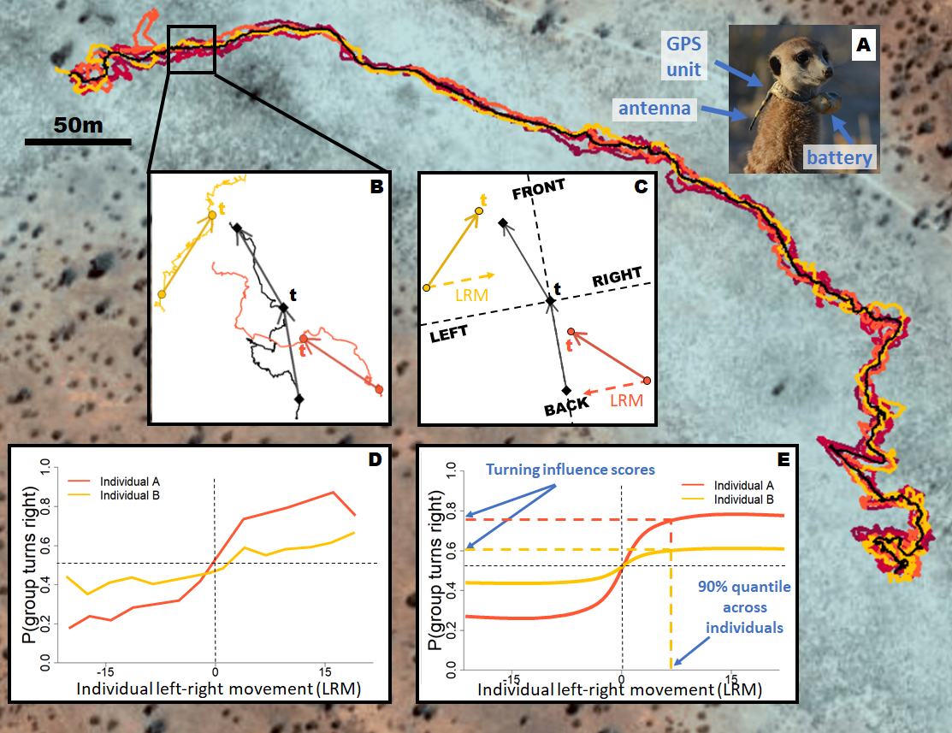Figure 1. Summary of the data processing pipeline to calculate the turn influence scores of each individual, from collection of individual meerkat trajectories to spatial discretization, modeling of the turn influence curve and computation of the influence score. Background shows the trajectories of six meerkats from group HM17 recorded over a three-hours time period at one fix / second from GPS collars. The black line represents the trajectory of the group centroid over the same time-interval, obtained by averaging the coordinates of every individual in the group at each time step. (A) Picture of a meerkat wearing a custom-made collar recording its movement at high resolution. (B) Close up on a portion of the trajectory, with only the group centroid and two individuals shown, in yellow and orange, for clarity. At a given time t, velocity vectors (solid arrows) are calculated from the points ten meters in the past (centroid and individual tracks) and ten meters in the future (centroid track only). (C) The velocity vector of the centroid from the past is used to define an orthonormal basis (group reference frame, dashed lines) relative to which the position and movement of individuals are calculated. Based on the centroid velocity vector from the future, the group is defined as either turning left or turning right at time t (turning left in the example). Individual left-right movement (LRM, dashed arrows) is calculated as the x-component of the individual velocity vectors from the past in the group reference frame. In this example, the orange individual has a positive turning influence at time t, despite being in the back of the group, because it was moving towards the left side of the group before the group turned left. On the other hand, the yellow individual has a negative turn influence at time t, despite being in the front of the group, because it was moving towards the right side of the group before the group turned left. (E) After doing the calculations for every available time step, the probability of the group to turn right is plotted as a function of an individual’s left-right speed. This shows that as individuals move faster towards the right (positive x-values), the probability of the group to turn right increases (and vice-versa), but the extent and rate of the increase varies for different individuals, reflecting differences in influence. Here the orange individual has a higher influence on the rest of the group than the yellow individual. (F) The influence curves are modelled using a modified logistic function, and the 90% quantile of the left-right movement across all individuals of a given group is used to compute a single turning influence score for each individual. The speed influence score is calculated analogously, using instead the probability of the group to speed up as the response variable and the difference between group and individual front-back speed as the predictor variable (not shown, see main text). Note that in the real analyses, the data for a given individual whose influence is being measured is excluded from the computation of the centroid location and movement, to avoid circularity.

Exploratory analyses showed that the probability of a group turning right increased sharply as a given individual’s movement towards the right increased before plateauing, and conversely for probability to turn left, resulting in a sigmoid-like curve (Figure 1E and section 7 of the Supplements). A similar shape was observed for speed influence (see section 7 of the Supplements). For each influence type, we therefore modelled the probability of a binary group response (turn left / right, speed up / slow down) as a function of a continuous individual predictor (movement relative to the group reference frame). Specifically, turn influence is the probability of the group to turn right as a function of an individual’s speed along the group’s left-right axis, and speed influence is the probability the group to speeds up as a function of the difference in speed between an individual and the group along the group’s front-back axis.

To model these probabilities, we fit a modified version of the logistic function to both types of influence, for each individual (equation 1):

(1)

Here, *x* represents the individual behavior (left-right or front-back movement) and *f(x)* represents the probability of the group turning right or speeding up. α and β are variable parameters which were fit for each individual separately, while γ is a fixed parameter which we set as described below. This modified sigmoidal shape was chosen due to its empirical correspondence with the data, as well as the interpretability of its parameters. In particular, α can be interpreted as the probability that the group is influenced by the focal individual at a given time point, and in practice controls the height of the curve. β can be interpreted as the logistic growth rate (steepness) of the curve and hence the strength of influence relative to how much an individual moves. γ is the baseline probability of the group either turning right or speeding up. For turning influence, γ was set to 0.5 (assuming an overall equal probability to turn left or right), whereas for speed influence, γ was fixed to the aggregate probability of a given group to speed up across all the data. Because groups tend to accelerate in rapid bursts but decelerate over longer time periods, the overall probability of a group speeding up is lower than the probability of the group slowing down, hence the value of γ ranged from 0.24 to 0.37.

We fit the values of α and β for each influence metric using maximum likelihood estimation, enabling us to define, for each individual, two curves representing its turn and speed influence (the model fits for each individual are shown in section 7 of the supplements). For ease of interpretation and subsequent modeling, we also defined an aggregate “influence score” as the value of the individual’s fitted curve at the 90% quantile of either continuous predictor variables across all individuals of a given group (figure 1F). This influence score therefore corresponds to the probability that the group is positively influenced by the focal individual for a fixed amount of movement (either left/right or front/back) relative to the group centroid. We used bootstrapping to calculate confidence intervals on these influence scores, first dividing the data for each individual into N chunks of four minutes (median duration for which the data autocorrelation had dropped close to zero). We then randomly sampled N chunks with replacement, and recomputed the influence score. We re-sampled the data 1000 times for each individuals and used the 0.05% and 0.95% quantiles of the influence score distributions as the lower and upper bound of the confidence intervals.

To test if there are consistent differences in influence based on individual social status, we fitted binomial GLMMs to predict influence score as a function of status (dominant female, dominant male, adult, sub-adult, juvenile), for both types of influence. Each individual was considered as one data point in the models, and we included group as a random effect to control for non-independence of data within each group. We also conducted post-hoc Tukey tests to compare the influence of each pair of social statuses (section 6 of the supplements). Finally, we tested whether speeding and turning influence were correlated with one another by computing the Spearman multilevel correlation with group as a random factor.

*Proportion of time in the front:*

To assess whether individuals differ in their propensity to be at the front of the group, we quantified for each individual the distribution of their front-back position relative to the direction of group travel. We also calculated the proportion of time each individual spent in the front half of the group, as a simple metric of ‘frontness’, to allow comparison with our influence scores. At time t, a given individual was considered in the front half of the group if its front-back position was positive. To quantify the variation in the propensity to be in the front between individuals and across groups, we computed the proportion of time points an individual was in the front half of the group in time segments of one hour.

To test whether individuals at the front of groups have greater influence, we computed Spearman multilevel correlations between the total proportion of time spent in the front for each individual and their turning and speeding influence scores, controlling for group as a random factor.

**RESULTS**

**Turn influence and speed influence vary as a function of social status**

We found that individuals varied substantially in their influence on group direction and speed (figure 2 and section 7 of the supplements), and that social status had a significant effect on both turn influence score (figure 2a, F = 7.217 ; DF = 40 ; p-value < 0.0001) and speed influence scores (figure 2b, F = 3.95 ; DF = 40 ; p-value < 0.0001) once group was taken into account as a random factor. In particular, the dominant females were outliers in terms of turn influence, having the strongest score in four out of five groups, and to a lesser extent in terms of speed influence. Post-hoc pair-wise Tukey tests (see section 6 of the Supplements) confirmed this, showing that the turn influence and speed influence scores of dominant females were overall significantly higher than the scores of all subordinate statuses (i.e. non-dominant adults, yearlings and sub-adults). Dominant males’ turn influence scores were not significantly different from scores of subordinates, but their speed influence scores were significantly different from yearlings and sub-adults.

Figure 2. Predicted influence scores for each recorded individual (colored dots) in the 5 study groups (vertical axis). Dot color indicates individual status as shown in the legend, dot size is proportional to the quantity of data available. Error bars show the 95% quantile of outputs from 1000 data resampling (see main text for details). Dotted vertical lines represent baseline probabilities for the outcome of group decision (50% percent chance of turning left or right for turn influence and overall probability to speed up for each group for speed influence). (A) Turn influence score represents the probability that the group turns toward the same direction (left or right) that individual was moving to. (B) Speed influence score represents the probability that the group speeds up after that individual had sped up towards the front of the group.

**A**

**B**

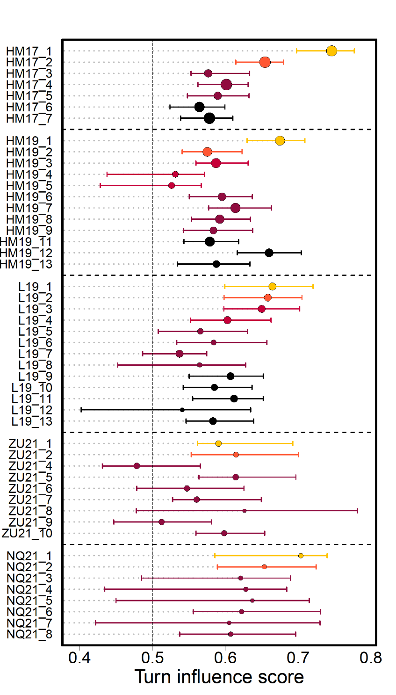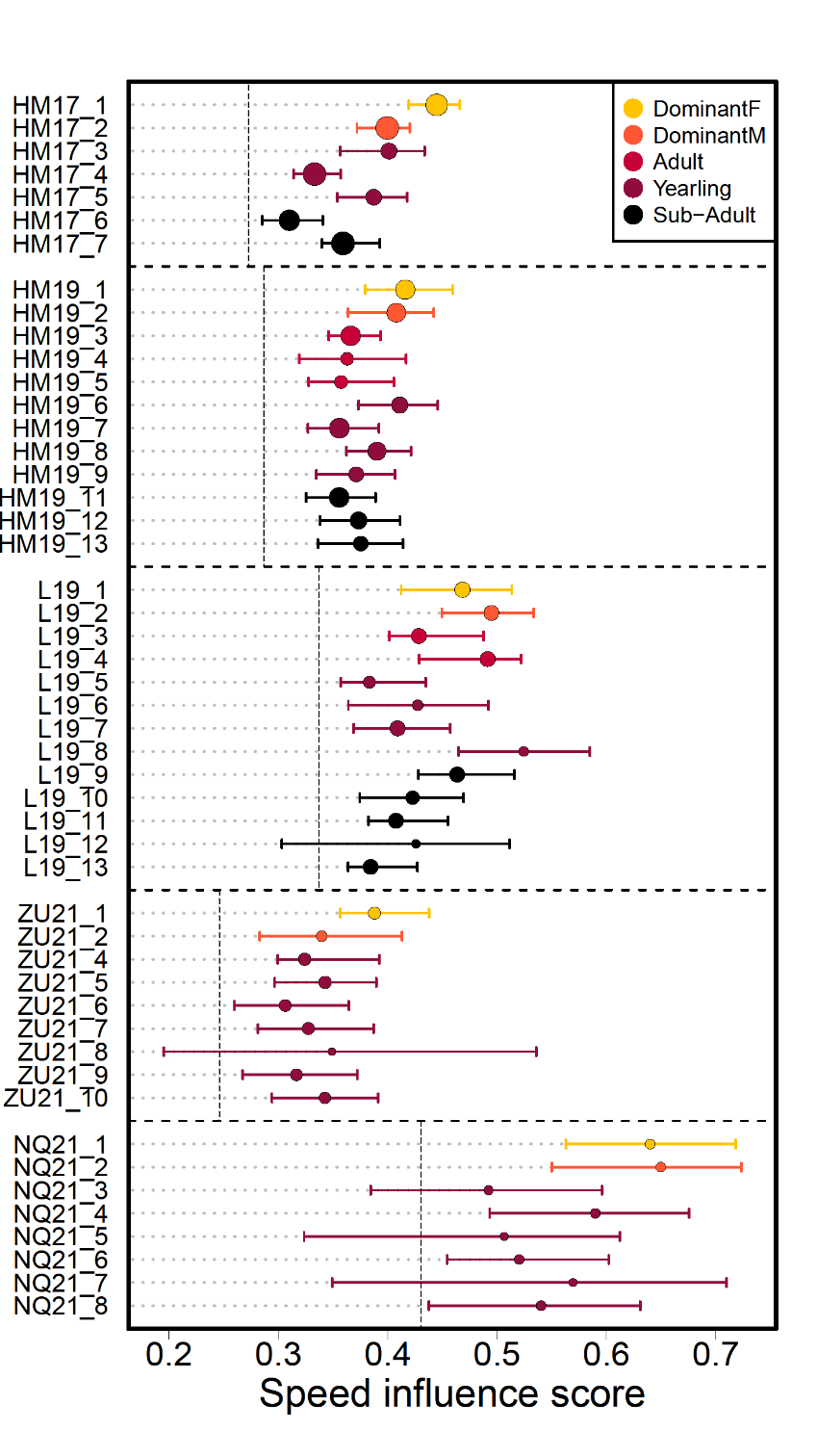

**Influence scores are associated with proportion of time spent in the front:**

We found that the association between the time spent in the front half of the group and the social status of individuals varied between groups (figure 3). The most consistent pattern was for the dominant female to be spending more time in the front of the group, with the notable exception of group ZU21, which is also the one group where the dominant female did not have the highest turn 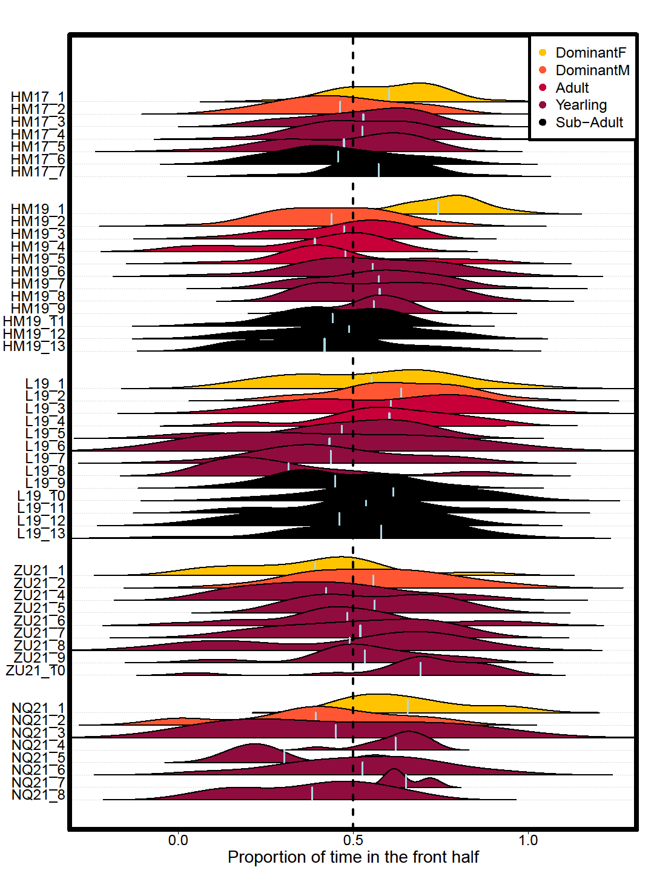influence. Other social statuses showed no consistent trends across groups.

Figure 3. Distribution of the proportion of time steps spent in the front half of the group over one-hour time periods, for each individual in the 5 study groups (vertical axis). Shape color indicates individual status as shown in the legend. Light vertical lines within each shape indicates the overall mean proportion of time spent in the front half of the group for that individual. Vertical dotted line indicates equal amount of time spent in the front and in the back half of the group.

The two influence metrics and the proportion of time spent in the front had some associations. With group controlled for as a random factor, we found weak positive correlations between turn influence scores and speed influence scores (r=0.48, p < 0.001, figure 4.a) and between turn influence scores and overall proportion of time spent in the front half (r=0.39, p=0.006, figure 4.b) but no correlation between speed influence scores and overall proportion of time spent in the front half (r=0.21, p=0.141, figure 4.c).

Figure 4. Pairwise associations between turn influence scores, speed influence scores, and proportion of time spent in the front. Each dot represents one individual, with color and shape indicating group membership, as shown in legend. Dominant females and dominant males are indicated by yellow and orange borders, respectively. (A) Turn influence as a function of speed influence. (B) Turn influence as a function of proportion of time spent in the front. (C) Speed influence as a function of proportion of time spent in the front.

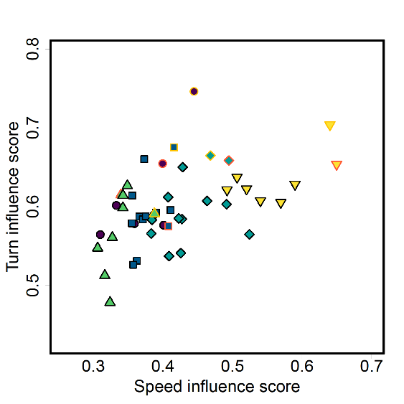

**A**

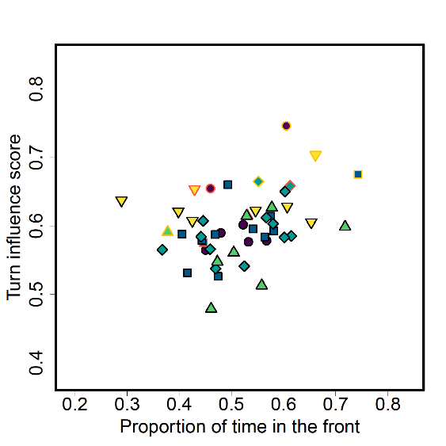

**B**

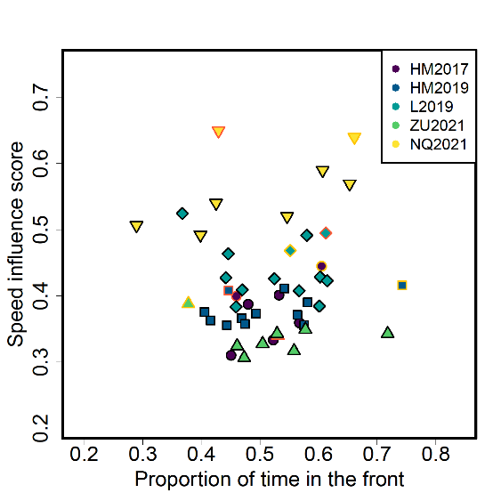

**C**

**DISCUSSION**

Influence can be a hard notion to define as it not absolute, with individuals exerting influence in one particular context not necessarily exerting it in others. The method we developed provides a simple way to separately quantify individual influence on group direction and speed, using high-resolution tracking data. It revealed that meerkats were more likely to positively influence the direction and speed of other individuals when their movement along the left-right, or front-back axis, respectively, was higher. Furthermore, individuals differed substantially in the amount of influence that their movement exerted on the group, and these differences were linked to social status. Individual influence over group movement has been assessed in multiple ways in social mammal species, with socially dominant individuals, and particularly dominant females, being frequently the most influential individuals (5,12,41,44), though exceptions are also found (11,14). Here, we found the dominant females to have significantly higher turn influence than other social statuses, meaning that the rest of the group was more likely to follow their movement directions than that of any of the other social statuses. In contrast, dominant males did not appear to have outsized influence relative to other adults in their social groups. In mammals, the finding that dominant females appear to wield more influence than dominant males is often interpreted in light of the higher energetic requirements of reproduction in females, with leadership potentially providing females with priority of access to higher-quality resources, therefore compensating the costs of pregnancy and/or lactation. In meerkats, dominant females have indeed been found more likely to initiate group movement via calling when they were breeding than when they were not (40). However, in the mentioned study as well as in ours, dominant females still had in general higher influence than other social statuses, regardless of their reproductive state (see table S2 in the Supplements), so this is unlikely the only explanation. Indeed, meerkats exhibit several cooperative breeding behaviors, including allolactation (45,46), so even though dominant females are usually the only ones in their group to bear pups, after birth the cost of reproduction is distributed among group members. It is noteworthy that in our data the one dominant female that had lower turning influence relative to other social statuses, and was also spending more time in the back (group ZU21) had by far the longest tenure at the time of data collection amongst dominant females of our study (104 weeks against 38 weeks maximum, see table S2 in Supplements). This suggests that females might be exerting more influence in the earliest part of their tenure in order to strongly assert their dominancy, but might not need to do so later on when their dominancy is better established. Similar data on more groups, with different life-histories, would be needed to explore these possibilities further.

Even though individuals with high influence on group turning also tended to have high influence on group speed, there were less striking intra-group differences between social statuses in terms of speed influence. The dominant female therefore seems to have less influence over the speed of travel of the group, than over its direction. When moving cohesively, social animal groups constantly have to make decisions regarding where to go and how fast to go there, and the method we used was designed specifically to assess individual contribution simultaneously on both types of decisions. Interestingly, the pattern we found reflect recent results on sleep site selection in meerkats. (39) looked at the selection of sleeping burrows (influence on direction) and found a stronger influence of the dominant female, whereas (33), which looked at the timing of return to the communal burrow (influence on speed) did not. This might be explained by the fact that in meerkats, contrary to timing decisions, sub-optimal decisions regarding the direction of movement could end up being very costly for all individuals in the groups, as they could end up in a location with little food, or no sleeping burrows, or in rival territories. Thus, it makes sense that experienced individuals, such as the dominant females of the group, are more likely to influence decisions involving directions than decisions involving speed. Given our results, influence over group speed could be either distributed, with all or most adults contributing to the decision to speed up or not at a given moment, or varying in time between group members, with individuals taking turns influencing others to speed up or slow down. Unfortunately, our methodology does not allow us to disentangle between these two options. The speed and direction of movement of meerkat groups are also probably differently affected by various factors that were not accounted for in the present work. For instance, group trajectories are very likely influenced by the distribution of preys across the territory, and by individual foraging success. In addition, quorum mechanisms, akin to a voting process by which a certain threshold of individuals giving a specific type of call is required for the group to start moving, have already been shown in meerkats (Bousquet et al. 2011). In future works it could therefore be very interesting to incorporate data about individual foraging success, as well as vocalizations, within our influence framework, to further our understanding of the interactions between these aspects.

Individuals influence on group direction was linked with their position along the front-back axis of movement. This is particularly striking for the dominant females, as the only one that did not have the highest turn influence of her group is also the only one that was spending more time in the back. The tendency to be in the front of the group is sometimes taken as a proxy for leadership in studies of group movement, but the validity of the assumption is debated. Our results suggest that in meerkats, there is indeed a link between being in the front and influencing the direction of movement the group. It is however hard to disentangle whether individuals need to be in the front in order to influence others, or whether they end up more in the front because they are influential. Being in the front should be most likely linked with influence in environments where visibility is high and in species where information is transferred primarily through vision (e.g. fish, Rosenthal et al., 2015; Strandburg-Peshkin et al., 2013). Because meerkats are very vocal and that several of their calls have been shown to be linked with group cohesion and coordination (15,30,31,49), individuals could have the potential to convey information, and therefore influence others, from anywhere in the group. One important factor coming into play here might be vegetation. Indeed, in the Kalahari, height and density of grass and bushes varies a lot from place to place or season to season, potentially impacting individuals’ perception of one another, and ability to lead from anywhere in the group. Understanding when and how individuals are able to exert influence from the back of groups, and how this is linked to the mechanisms of information transfer employed, are important questions for future work. Incorporating information about vegetation within our framework could provide interesting insight on how influence dynamics are impacted by environmental factors.

**CONCLUSION**

Overall our results show that dominant females tend to be the most influential individuals in meerkat groups, with outsized influence on group direction, and to a lesser extent on group speed, highlighting the importance of disentangling these two components of influence even in groups where both operate concurrently. The methodological approach developed here is species-general and could be applied more broadly across different species, or under different environmental conditions, to disentangle influence over timing and directional decisions. Because our approach by design captures influence aggregated over time, it could be interesting in future work to contrast it with complementary approaches, for instance identifying particular events in the trajectory such as sharp changes in direction or increases in speed during movement, in order to gain a more complete picture of the distribution and variability of influence in social groups. The method could also be used in combination with other features, such as vocalizations, to assess how such features impact influence dynamics. The results presented here highlight the complexity of the concept of influence, and demonstrate the need to study it from different perspectives across multiple groups to begin to reveal a more complete understanding of collective decision-making in animal societies.

**ACKNOWLEDGMENTS**

We thank the Kalahari Research Trust for permission to work at the Kuruman River Reserve, and the neighboring farmers to use their land. We also thank Tim Clutton-Brock for the organization of the field site, as well as managers, volunteers, students and staff at the Kalahari Meerkat Project for maintaining the habituation and collecting long-term data, as well as for assistance prior to and during data collection. Many thanks to Rebecca Shaefer, Pauline Toni and Camille Lysemna who worked as field assistant during some of the field seasons. Finally, we thank Andrew Gersick, Ben Hirsh, Kay Holekamp, Frants Jensen, Marie Roch from the Communication and Coordination Across Scales project, Alison Ashbury, Grace Davis and members of the Communication and Collective Movement group at the Max Planck Institute of Animal Behavior in Constance for helpful feedback during the elaboration of this paper.

**ADDITIONAL INFORMATION**

**Competing interests**

The authors declare no competing interests.

**Funding**

This work was supported by HFSP award RGP0051/2019 to ASP and MM and funded by the Deutsche Forschungsgemeinschaft (DFG, German Research Foundation) under Germany's Excellence Strategy – EXC 2117 – 422037984. ASP received additional support from the Gips-Schüle Stiftung and the Max Planck Institute of Animal Behavior. MM was funded by the University of Zurich. The long-term research on meerkats is currently supported by funding from the European Research Council (ERC) under the European Union's Horizon 2020 research and innovation program (no. 742808 and no. 294494) and a grant from the Natural Environment Research Council (grant NE/G006822/1) to T.C.-B as well as by grants from the University of Zurich to M.B.M. and the MAVA Foundation.

**Ethics**

All research was conducted under the permission of the ethical committee of Pretoria University, South Africa (permit number: EC031-17). We would like to thank the Northern Cape Department of Environment and Nature Conservation, South Africa for permission to conduct the research (FAUNA 1020/2016).

**Author contributions**

BA, VD, GG and ASP collected the data, with support from MM. MM organized the collection of the individualized long-term data (LH data) and the habituation of the study groups. BA, VHS and ASP analyzed and interpreted the data. BA wrote the manuscript, with inputs and revisions from all authors.

**BIBLIOGRAPHY**

1. Strandburg-Peshkin A, Papageorgiou D, Crofoot MC, Farine DR. Inferring influence and leadership in moving animal groups. Philosophical transactions of the Royal Society of London Series B, Biological sciences. 2018;373(1746):20170006–20170006.

2. Garland J, Berdahl AM, Sun J, Bollt EM. Anatomy of leadership in collective behaviour. Chaos. 2018 Jul 1;28(7):075308.

3. King AJ, Douglas CMS, Huchard E, Isaac NJB, Cowlishaw G. Dominance and Affiliation Mediate Despotism in a Social Primate. Current Biology. 2008 Dec 9;18(23):1833–8.

4. Lewis JS, Wartzok D, Heithaus MR. Highly dynamic fission–fusion species can exhibit leadership when traveling. Behav Ecol Sociobiol. 2011 May 1;65(5):1061–9.

5. Van Belle S, Estrada A, Garber PA. Collective group movement and leadership in wild black howler monkeys (Alouatta pigra). Behav Ecol Sociobiol. 2013 Jan 1;67(1):31–41.

6. Smith JE, Estrada JR, Richards HR, Dawes SE, Mitsos K, Holekamp KE. Collective movements, leadership and consensus costs at reunions in spotted hyaenas. Animal Behaviour. 2015 Jul 1;105:187–200.

7. Kerth G, Ebert C, Schmidtke C. Group decision making in fission–fusion societies: evidence from two-field experiments in Bechstein’s bats. Proceedings of the Royal Society B: Biological Sciences. 2006 Nov 7;273(1602):2785–90.

8. Nagy M, Ákos Z, Biro D, Vicsek T. Hierarchical group dynamics in pigeon flocks. Nature. 2010 Apr;464(7290):890–3.

9. Giuggioli L, McKetterick TJ, Holderied M. Delayed Response and Biosonar Perception Explain Movement Coordination in Trawling Bats. PLOS Computational Biology. 2015 Mar 26;11(3):e1004089.

10. Pettit B, Ákos Z, Vicsek T, Biro D. Speed Determines Leadership and Leadership Determines Learning during Pigeon Flocking. Current Biology. 2015 Dec 7;25(23):3132–7.

11. Strandburg-Peshkin A, Farine DR, Couzin ID, Crofoot MC. GROUP DECISIONS. Shared decision-making drives collective movement in wild baboons. Science. 2015;348(6241):1358–61.

12. Tokuyama N, Furuichi T. Leadership of old females in collective departures in wild bonobos (Pan paniscus) at Wamba. Behav Ecol Sociobiol. 2017 Feb 28;71(3):55.

13. Montanari D, O’Hearn WJ, Hambuckers J, Fischer J, Zinner D. Coordination during group departures and progressions in the tolerant multi-level society of wild Guinea baboons (Papio papio). Sci Rep. 2021 Nov 9;11(1):21938.

14. Papageorgiou D, Farine DR. Shared decision-making allows subordinates to lead when dominants monopolize resources. Science Advances. 2020;6(48):eaba5881.

15. Bousquet CAH, Sumpter DJT, Manser MB. Moving calls: a vocal mechanism underlying quorum decisions in cohesive groups. Proceedings of the Royal Society of London B: Biological Sciences. 2011 May 22;278(1711):1482–8.

16. Stahl J, Tolsma PH, Loonen MJJE, Drent RH. Subordinates explore but dominants profit: resource competition in high Arctic barnacle goose flocks. Animal Behaviour. 2001 Jan 1;61(1):257–64.

17. Boinski S. Social Manipulation Within and Between Troops Mediate Primate Group Movement. In: Boinski S, editor. On the Move: How and Why Animals Travel in Groups [Internet]. Chicago, IL: University of Chicago Press; 2000 [cited 2022 Jan 12]. Available from: https://press.uchicago.edu/ucp/books/book/chicago/O/bo3618301.html

18. Conradt L, Roper TJ. Consensus decision making in animals. Trends in Ecology & Evolution. 2005 août;20(8):449–56.

19. Conradt L, Roper TJ. Conflicts of interest and the evolution of decision sharing. Philos Trans R Soc Lond B Biol Sci. 2009;364(1518):807–19.

20. Byrne RW. How Monkeys Find Their Way: Leadership, Coordination, and Cognitive Maps of African Baboons. In: Boinski S, Garber PA, editors. On the Move: How and Why Animals Travel in Groups [Internet]. Chicago, IL: University of Chicago Press; 2000 [cited 2022 Jan 12]. Available from: https://press.uchicago.edu/ucp/books/book/chicago/O/bo3618301.html

21. Conradt L, Roper TJ. Deciding group movements: where and when to go. Behavioural processes. 2010 juillet;84:675–7.

22. Herbert-Read JE, Perna A, Mann RP, Schaerf TM, Sumpter DJT, Ward AJW. Inferring the rules of interaction of shoaling fish. PNAS. 2011 Nov 15;108(46):18726–31.

23. Katz Y, Tunstrøm K, Ioannou CC, Huepe C, Couzin ID. Inferring the structure and dynamics of interactions in schooling fish. PNAS. 2011 Nov 15;108(46):18720–5.

24. Jolles JW, Boogert NJ, Sridhar VH, Couzin ID, Manica A. Consistent Individual Differences Drive Collective Behavior and Group Functioning of Schooling Fish. Current Biology. 2017 Sep 25;27(18):2862-2868.e7.

25. Doolan SP, Macdonald DW. Breeding and juvenile survival among slender-tailed meerkats (Suricatu suricatta) in the south-western Kalahari: ecological and social influences. Journal of Zoology. 1997 Mar 24;242(2):309–27.

26. Clutton‐Brock TH, Manser MB. Meerkats: cooperative breeding in the Kalahari. In: Koenig WD, Dickinson JL, editors. Cooperative Breeding in Vertebrates. Cambridge University Press; 2016.

27. Doolan S, Macdonald D. Diet and foraging behaviour of group living meerkats, Suricata suricatta, in the southern Kalahari. Journal of Zoology. 1996;239:697–716.

28. Engesser S. Function of ‘close’ calls in a group foraging carnivore, Suricata suricatta. 2011.

29. Kranstauber B, Gall GEC, Vink T, Clutton‐Brock T, Manser MB. Long-term movements and home-range changes: Rapid territory shifts in meerkats. Journal of Animal Ecology [Internet]. 2019 [cited 2019 Dec 19];n/a(n/a). Available from: https://besjournals.onlinelibrary.wiley.com/doi/abs/10.1111/1365-2656.13129

30. Manser MB, Jansen DAWAM, Graw B, Hollén LI, Bousquet CAH, Furrer RD, et al. Vocal Complexity in Meerkats and Other Mongoose Species. Vol. 46. 2014. 281 p.

31. Gall GEC, Manser MB. Group cohesion in foraging meerkats : follow the moving ‘ vocal hot spot .’ Royal Society Open Science. 2017;

32. Engesser S, Manser MB. Collective close calling mediates group cohesion in foraging meerkats via spatially determined differences in call rates. Animal Behaviour. 2022 Mar 1;185:73–82.

33. Gall GEC, Strandburg-Peshkin A, Clutton-brock T, Manser MB. As dusk falls : collective decisions about the return to sleeping sites in meerkats. 2017;132:91–9.

34. Townsend SW, Rasmussen M, Clutton-Brock T, Manser MB. Flexible alarm calling in meerkats: the role of the social environment and predation urgency. Behavioral Ecology. 2012;23(6):1360–4.

35. Clutton-Brock TH, Brotherton PNM, O’Riain MJ, Griffin AS, Gaynor D, Kansky R, et al. Contributions to cooperative rearing in meerkats. Animal Behaviour. 2001 avril;61(4):705–10.

36. Griffin AS, Pemberton JM, Brotherton PNM, McIlrath G, Gaynor D, Kansky R, et al. A genetic analysis of breeding success in the cooperative meerkat (Suricata suricatta). Behavioral Ecology. 2003 Jul 1;14(4):472–80.

37. Thavarajah NK, Fenkes M, Clutton-Brock TH. The determinants of dominance relationships among subordinate females in the cooperatively breeding meerkat. Behaviour. 2014 Jan 1;151(1):89–102.

38. Bousquet CAH, Manser MB. Resolution of experimentally induced symmetrical conflicts of interest in meerkats. Animal Behaviour. 2011 Jun;81(6):1101–7.

39. Strandburg-Peshkin A, Clutton-Brock T, Manser MB. Burrow usage patterns and decision-making in meerkat groups. Behavioral Ecology. 2020 Mar 20;31(2):292–302.

40. Turbé A. Foraging decisions and space use in a social mammal, the meerkat - Chapter 6: Leadership pby lactating female in meerkats. University of Cambridge; 2006.

41. Barelli C, Reichard U, Boesch C, Heistermann M. Female white-handed gibbons (Hylobates lar) lead group movements and have priority of access to food resources. Behaviour. 2008 Jan 1;145(7):965–81.

42. Clutton-Brock TH, Maccoll A, Chadwick P, Gaynor D, Kansky R, Skinner JD. Reproduction and survival of suricates (Suricata suricatta) in the southern Kalahari. African Journal of Ecology. 1999 Mar;37(1):69–80.

43. Farine DR, Strandburg-Peshkin A, Couzin ID, Berger-Wolf TY, Crofoot MC. Individual variation in local interaction rules can explain emergent patterns of spatial organization in wild baboons. Proc R Soc B. 2017 Apr 26;284(1853):20162243.

44. Holekamp KE, Boydston EE, Smale L. Group Tarvel in Social Carnivores. In: Boinski S, Garber PA, editors. On the Move. University of Chicago Press; 2000.

45. Clutton-Brock TH, Gaynor D, Kansky R, MacColl ADC, McIlrath G, Chadwick P, et al. Costs of cooperative behaviour in suricates (Suricata suricatta). Proceedings of the Royal Society B: Biological Sciences. 1998 février;265(1392):185–90.

46. MacLeod KJ, Clutton-Brock TH. Low costs of allonursing in meerkats: mitigation by behavioral change? Behav Ecol. 2015 May 1;26(3):697–705.

47. Strandburg-Peshkin A, Twomey CR, Bode NWF, Kao AB, Katz Y, Ioannou CC, et al. Visual sensory networks and effective information transfer in animal groups. Current Biology. 2013 Sep;23(17):R709–11.

48. Rosenthal SB, Twomey CR, Hartnett AT, Wu HS, Couzin ID. Revealing the hidden networks of interaction in mobile animal groups allows prediction of complex behavioral contagion. PNAS. 2015 Apr 14;112(15):4690–5.

49. Reber SA, Townsend SW, Manser MB. Social monitoring via close calls in meerkats. Proceedings of the Royal Society B: Biological Sciences. 2013 juillet;280(1765):20131013–20131013.