FloodQAOA: Quantum Multi-Objective Dispatch of Flood-Relief Teams
Qiskit Fall Fest 2026 Hackathon — Domain 2: Disaster Response
Team: Baqir Raza, M. Ali Reza, Balaaj Raza
Code: https://github.com/Baqir376/Qiskit_Hackathon

1. Problem and who it serves
In the 2022 Pakistan floods, about one third of the country was under water and Sindh's Dadu district was among the worst hit. District and provincial disaster-management cells (PDMA / district control rooms) had to decide, under time pressure, which scarce specialised teams to send where. That decision has competing objectives: sending a team where it helps the most people is often far away, over washed-out roads, and several teams on one surviving highway congest it. There is also no single right answer: the right plan depends on how much the commander values speed against reach. FloodQAOA therefore gives the commander the whole trade-off curve (Pareto front) of dispatch plans, computed with QAOA, not one opaque optimum.
Data honesty: Place names and approximate coordinates are real locations in Sindh that were severely affected by the 2022 Pakistan floods. Team types, affected-population figures, need profiles, access factors and corridor labels are SYNTHETIC, chosen to create a realistic trade-off. They are not official NDMA/PDMA figures and must not be used for real operations.

2. Formulation
Instance: 3 teams (boat rescue — Sukkur, mobile medical camp — Hyderabad, relief convoy — Larkana) and 4 affected sites (Johi, Khairpur Nathan Shah, Dadu city, Jacobabad). Binary variable x[t,s] = 1 if team t goes to site s → 12 variables = 12 qubits.
- f1 (maximise) relief impact = Σ benefit[t,s]·x[t,s], with benefit = affected people × (team capability · site need profile) over the dimensions water-rescue, medical and supplies.
- f2 (minimise) response burden = Σ travel_h[t,s]·x[t,s] + congestion_h·Σ x[a]x[b] over pairs of teams that use the same road corridor (N-55 north/south, N-65). The quadratic congestion term makes this more than a linear assignment problem.
- Constraint 1: every team is dispatched to exactly one site (Σ_s x[t,s] = 1).
- Constraint 2: at most one team per site (staging capacity; Σ_t x[t,s] ≤ 1). With 3 teams and 4 sites one site is necessarily left for the second wave. That is the real dilemma.
Scalarisation: F_λ = −(1−λ)·f1/f1max + λ·f2/f2max, swept over λ ∈ {0, 0.1, …, 1}. Constraints become slack-free quadratic penalties with weight P = 2.0 (one-hot: P(Σx−1)²; capacity: P·Σ x x'). The model is built as a qiskit-optimization QuadraticProgram and mapped with to_ising() to a 12-qubit Z/ZZ Ising Hamiltonian. Feasible plans: 24 out of 4096 bit-strings.

3. Quantum algorithm and justification
QAOA is the natural fit: the problem is a QUBO, i.e. a diagonal Ising Hamiltonian whose ground state is the optimal plan, and QAOA prepares low-energy states with shallow, hardware-friendly circuits. We use four variants, an ablation that isolates two design decisions:
Variant | Mixer / initial state | Training objective | Constraint handling
A | X-mixer, |+>^12 | ⟨H⟩ expectation | one-hot + capacity penalties
B | X-mixer, |+>^12 | CVaR_0.1 (Barkoutsos et al. 2020) | one-hot + capacity penalties
C | XY ring mixer, W-state per team | ⟨H⟩ expectation | one-hot by construction; capacity penalty
D | XY ring mixer, W-state per team | CVaR_0.1 | one-hot by construction; capacity penalty

The XY mixer exp(−iβ(XX+YY)/2) on neighbouring qubits of a team register swaps an excitation and preserves Hamming weight (Hadfield et al., Quantum Alternating Operator Ansatz, 2019). Started from a W state, every team register stays in 'exactly one site', so the search space falls from 4096 to 4³ = 64 states and the one-hot penalty, which flattens the energy landscape, disappears. CVaR trains on the best α-tail of the distribution, which matches how a QAOA answer is actually read out (best sample). Parameters are transferred between neighbouring λ values (warm start), in the spirit of Kotil et al. (2025), with a linear-ramp and random restarts. The classical optimiser is COBYLA.
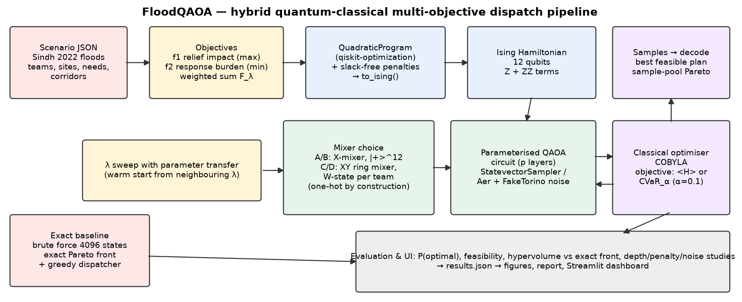
Figure 1 — System architecture (hybrid quantum-classical loop).

4. Implementation and validation
Qiskit 2.x circuits are built explicitly (RZ/RZZ cost layer, RX or RXX+RYY mixer), simulated exactly with Statevector for training and read out with StatevectorSampler (shots = 1024). The exact reference is brute-force enumeration of all 4096 bit-strings. Automated tests (pytest, 26 cases) verify that (i) the Ising energies equal the hand-computed objective for all 4096 states, (ii) the penalised ground state is the exact constrained optimum for every λ, (iii) qiskit-optimization's own QuadraticProgramToQubo gives the same qubit count and optimum, and (iv) the XY circuit keeps 100% of probability in the one-hot subspace.

5. Results
Exact Pareto front (brute force):
Plan | f1 impact | f2 burden (h) | reachable by weighted sum?
BOAT→JCD, MED→DADU, SUP→JOHI | 168.8 | 15.59 | NO
BOAT→JCD, MED→DADU, SUP→KNS | 154.9 | 12.61 | yes
BOAT→JOHI, MED→DADU, SUP→JCD | 204.3 | 18.95 | yes
BOAT→KNS, MED→DADU, SUP→JCD | 187.0 | 15.97 | yes

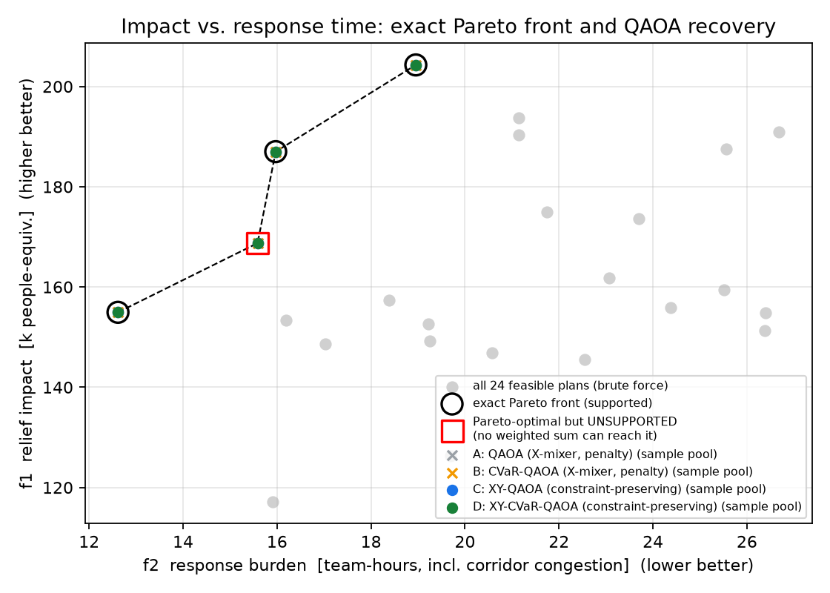
Figure 2 — All 24 feasible plans, the exact Pareto front, and the plans recovered by each QAOA variant.
Averages over the 11 λ values, p = 2:
Var. | Method | mean P(opt) | vs uniform 1/4096 | mean P(feasible) | optimum found (best sample) | mean feasible quality | Pareto pts (argmin) | Pareto pts (sample pool)
A | QAOA (X-mixer, penalty) | 0.007 | 30× | 0.116 | 10/11 | 0.494 | 3/4 | 4/4
B | CVaR-QAOA (X-mixer, penalty) | 0.020 | 81× | 0.258 | 11/11 | 0.541 | 3/4 | 4/4
C | XY-QAOA (constraint-preserving) | 0.047 | 192× | 0.982 | 11/11 | 0.470 | 3/4 | 4/4
D | XY-CVaR-QAOA (constraint-preserving) | 0.096 | 392× | 0.774 | 11/11 | 0.641 | 3/4 | 4/4

Classical greedy dispatcher (rule of thumb, best pair first): optimal at 5/11 λ values, mean normalised gap 0.160. Brute force is optimal by definition.
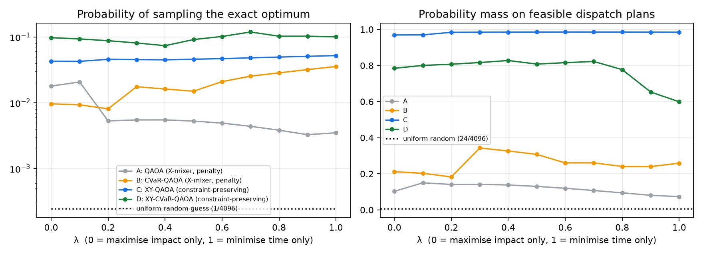
Figure 3 — Probability of the exact optimum (log scale) and of feasible plans, per λ.
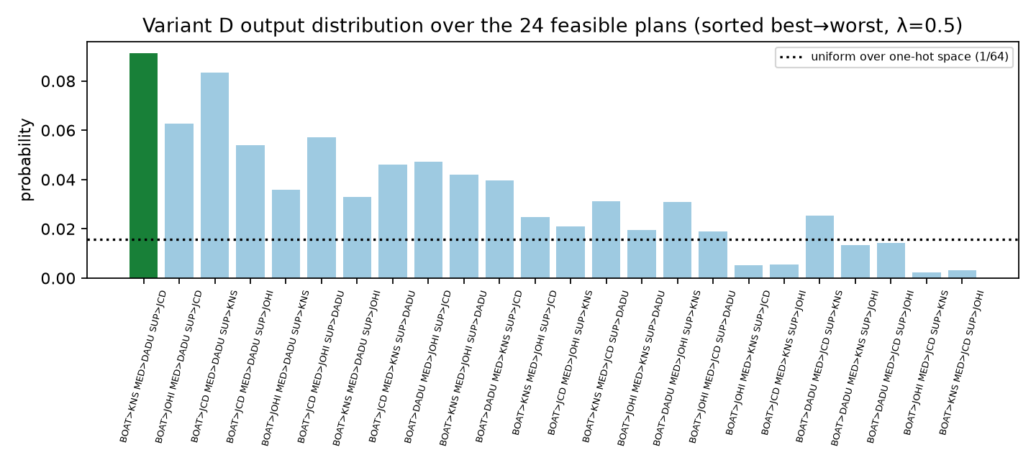
Figure 4 — Variant D output distribution over the 24 feasible plans at λ = 0.5.
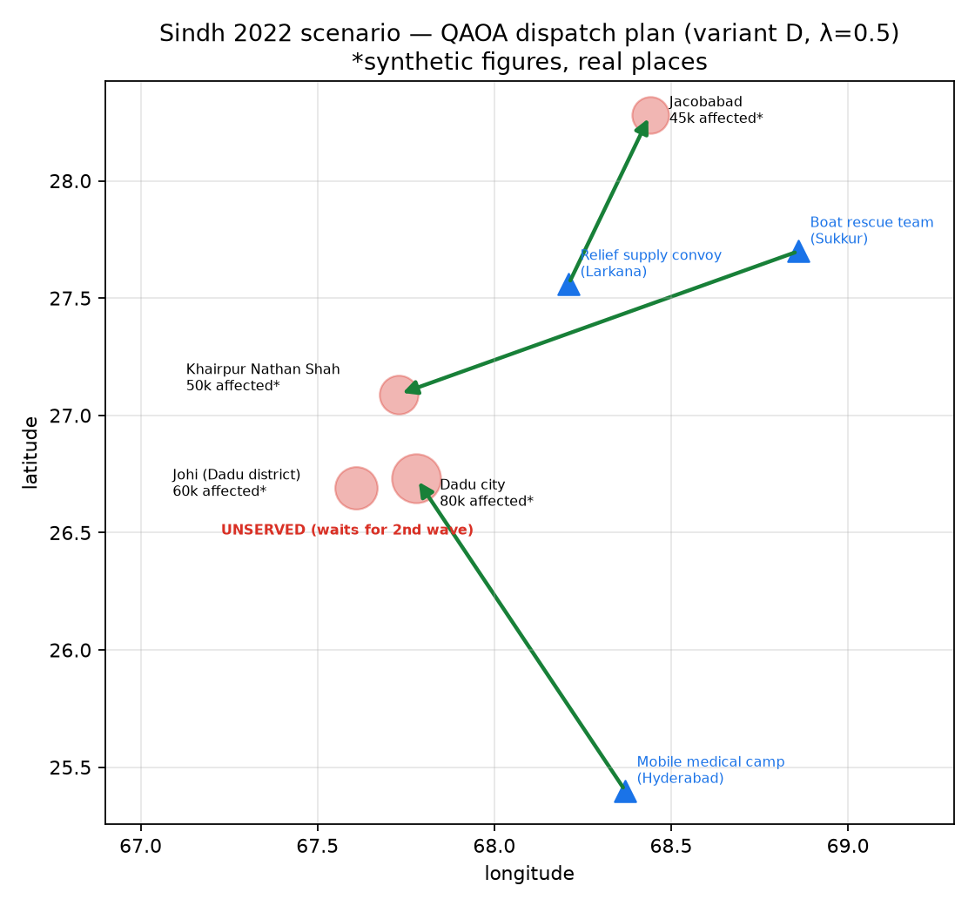
Figure 5 — The balanced (λ = 0.5) QAOA dispatch plan on the Sindh map.

5.1 Depth, penalty and noise studies
Var. | p | P(opt) mean ± sd (3 seeds) | P(feasible) | train time (s)
A | 1 | 0.003 ± 0.000 | 0.118 | 1.2
A | 2 | 0.006 ± 0.004 | 0.155 | 4.2
A | 3 | 0.009 ± 0.007 | 0.148 | 9.5
A | 4 | 0.010 ± 0.005 | 0.260 | 11.7
B | 1 | 0.006 ± 0.002 | 0.140 | 0.8
B | 2 | 0.010 ± 0.004 | 0.193 | 4.8
B | 3 | 0.013 ± 0.007 | 0.312 | 6.3
B | 4 | 0.008 ± 0.001 | 0.219 | 10.9
C | 1 | 0.034 ± 0.001 | 0.807 | 1.3
C | 2 | 0.042 ± 0.000 | 0.971 | 4.7
C | 3 | 0.039 ± 0.007 | 0.976 | 10.6
C | 4 | 0.031 ± 0.008 | 0.978 | 12.6
D | 1 | 0.035 ± 0.000 | 0.857 | 1.9
D | 2 | 0.060 ± 0.015 | 0.798 | 5.7
D | 3 | 0.065 ± 0.018 | 0.859 | 10.7
D | 4 | 0.078 ± 0.002 | 0.844 | 13.1

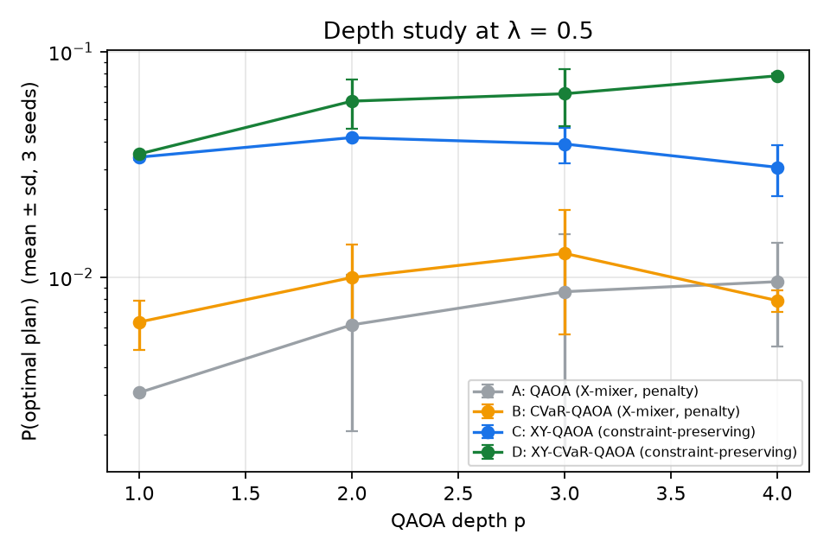
Figure 6 — QAOA depth study at λ = 0.5.
Penalty P | ground state = true optimum? | P(opt) after training (A) | P(feasible)
0.25 | yes | 0.011 | 0.246
0.5 | yes | 0.018 | 0.388
1.0 | yes | 0.002 | 0.035
2.0 | yes | 0.002 | 0.027
4.0 | yes | 0.000 | 0.000
8.0 | yes | 0.001 | 0.024

Var. | transpiled depth | CZ gates | P(opt) ideal | P(opt) noisy | P(feas) ideal | P(feas) noisy
A | 513 | 370 | 0.005 | 0.001 | 0.130 | 0.033
B | 509 | 370 | 0.015 | 0.002 | 0.308 | 0.071
C | 545 | 394 | 0.046 | 0.007 | 0.985 | 0.134
D | 541 | 394 | 0.091 | 0.012 | 0.808 | 0.126

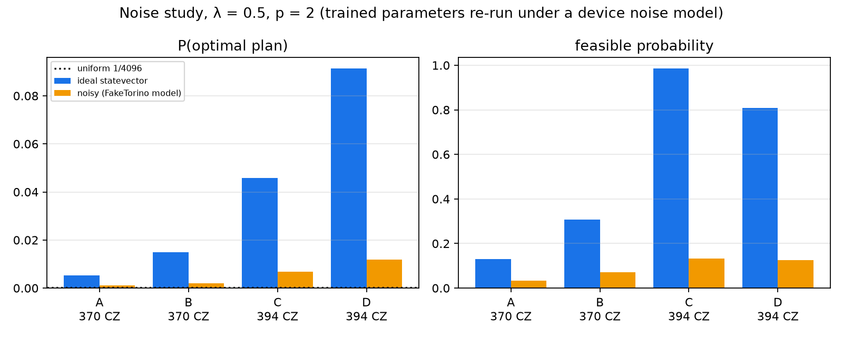
Figure 7 — Trained circuits re-run on an Aer noise model of IBM FakeTorino (simulated, not real hardware).
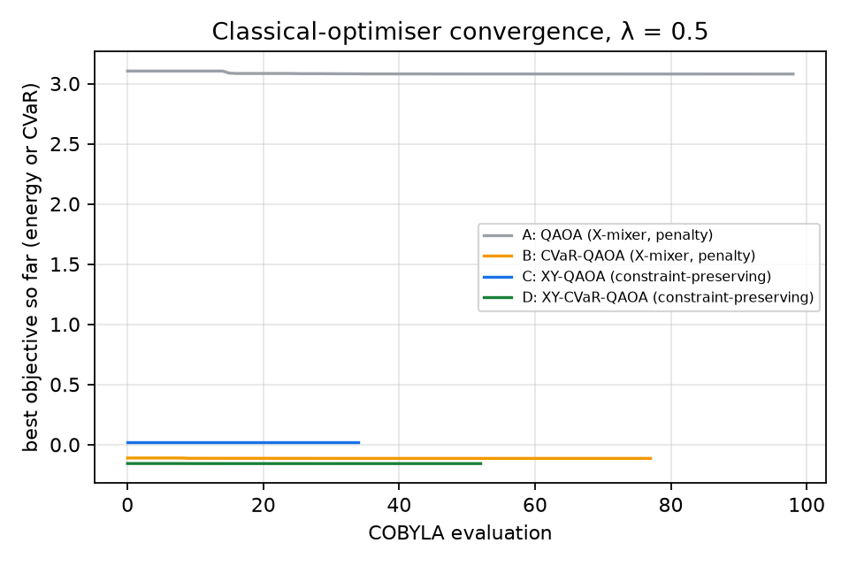
Figure 8 — COBYLA convergence at λ = 0.5.

6. Limitations and honest reflection
- No quantum advantage, and none is claimed. With 12 qubits, brute force over 4096 states takes milliseconds; simulating QAOA classically costs more than solving the problem. The value of this work is a correct, validated mapping and an ablation that shows which QAOA design choices matter for constrained dispatch.
- Fair comparison for the XY variants: C and D only ever sample the 64 one-hot states. Against uniform guessing inside that space (1/64), QAOA training amplifies the optimum about 3× (C) and 6× (D). Most of their gain over 1/4096 comes from the constraint-preserving encoding itself, which is a legitimate design win but not variational magic.
- Random sampling is a strong competitor at this size: 1024 uniform shots over 4096 states would hit a given optimum with probability ≈ 22%. That is why we report the probability amplification P(opt) rather than only 'found the optimum'.
- The weighted-sum sweep cannot reach unsupported Pareto points (the red square in Figure 2): taking only the best sample per λ recovers 3 of 4 Pareto plans for every variant. Because QAOA returns a distribution, pooling all feasible samples across the sweep recovered all 4, including the unsupported one. At this instance size, though, this is partly because the shots cover most of the 24 feasible plans. An ε-constraint or Chebyshev formulation would be the principled fix, at the cost of extra qubits.
- The penalty weight is a real trade-off (Section 5.1). An exhaustive check shows the penalised ground state stops being the true optimum below P ≈ 0.25 (at P = 0.1 it is wrong for 7 of 11 λ values). Yet trainability peaks just above that threshold (P = 0.5 trained best), and our default P = 2 was conservative, which hurt variants A/B. At P = 4 the training collapsed completely (P(feasible) = 0). The XY mixer removes the one-hot penalty entirely, but capacity is still enforced by a penalty.
- Under device noise (Aer model of IBM FakeTorino; ~370–394 CZ gates, depth ~510–545 after routing) every variant degrades sharply: feasibility falls from 0.81–0.99 to about 0.13 for the XY variants. The XY mixer costs only about 6% more CZ gates than the X-mixer after transpilation, and variant D still samples the optimum about 50× more often than uniform random under noise. Real hardware would need error mitigation and a hardware-aware (heavy-hex native) XY-ring layout.
- Increasing depth p does not help reliably: C peaks at p = 2, while D improves up to p = 4. COBYLA with a few restarts is the bottleneck, not circuit expressivity.
- Scaling: qubits = teams × sites (one-hot). A realistic district plan (20 teams × 30 sites) needs 600 qubits and deep circuits; parameter transfer and problem decomposition (per-corridor sub-problems) would be required.
- The data are synthetic. Need scores, access factors and corridor assignments are illustrative and have not been validated by NDMA/PDMA officials. Distances are great-circle × 1.3 road factor, not real road routing.
- Results are simulator results from a single instance; P(opt) varies with the random seed (see the depth table sd).

7. Reproducibility
- python -m venv .venv && .venv\Scripts\activate (or source .venv/bin/activate)
- pip install -r requirements.txt
- pytest # 26 correctness tests
- python -m floodqaoa.experiment # all QAOA runs → results/results.json
- python -m floodqaoa.noise_study # FakeTorino noise model
- python -m floodqaoa.plots # figures
- streamlit run app.py # interactive dashboard
- All seeds fixed (seed=7); full pipeline runtime ≈ 10 min on a laptop CPU.

References
- E. Farhi, J. Goldstone, S. Gutmann, A Quantum Approximate Optimization Algorithm, arXiv:1411.4028 (2014).
- S. Hadfield et al., From the QAOA to a Quantum Alternating Operator Ansatz, Algorithms 12, 34 (2019).
- Z. Wang, N. Rubin, J. Dominy, E. Rieffel, XY-mixers: analytical and numerical results for QAOA, PRA 101 (2020), arXiv:1904.09314.
- P. Barkoutsos et al., Improving Variational Quantum Optimization using CVaR, Quantum 4, 256 (2020).
- A. Kotil et al., Quantum Approximate Multi-Objective Optimization, Nature Computational Science (2025), arXiv:2503.22797.
- Qiskit and qiskit-optimization documentation, IBM Quantum (2026).

