
A System for diagnosing and providing solutions for growth deficiency in children
LittleSteps


Bar Bitton & Randa Assadi
Advisor: Dr. Natali Levi
Research Impact
• Early Detection –Supports early identification of pediatric growth disorders (including FTT).
• Accessible AI Support –Provides simple, AI-assisted diagnostic guidance for parents and non-specialist clinicians.
• Safety-First Approach –Prioritizes critical symptoms and encourages timely medical evaluation.
• Evidence-Based Reasoning –Uses CDC growth standards and explainable AI insights.
• Reduced Diagnostic Delays –Helps improve decision-making and early intervention.

Model
• Hybrid Decision Model –
Combines CDC-based growth percentile calculations with AI reasoning for explainable assessment.
• Symptom-Aware Safety Logic –
Integrates clinical red-flag detection to prioritize urgent medical cases.
• Continuous Model Improvement –
Designed for future refinement using additional validated pediatric cases and feedback.

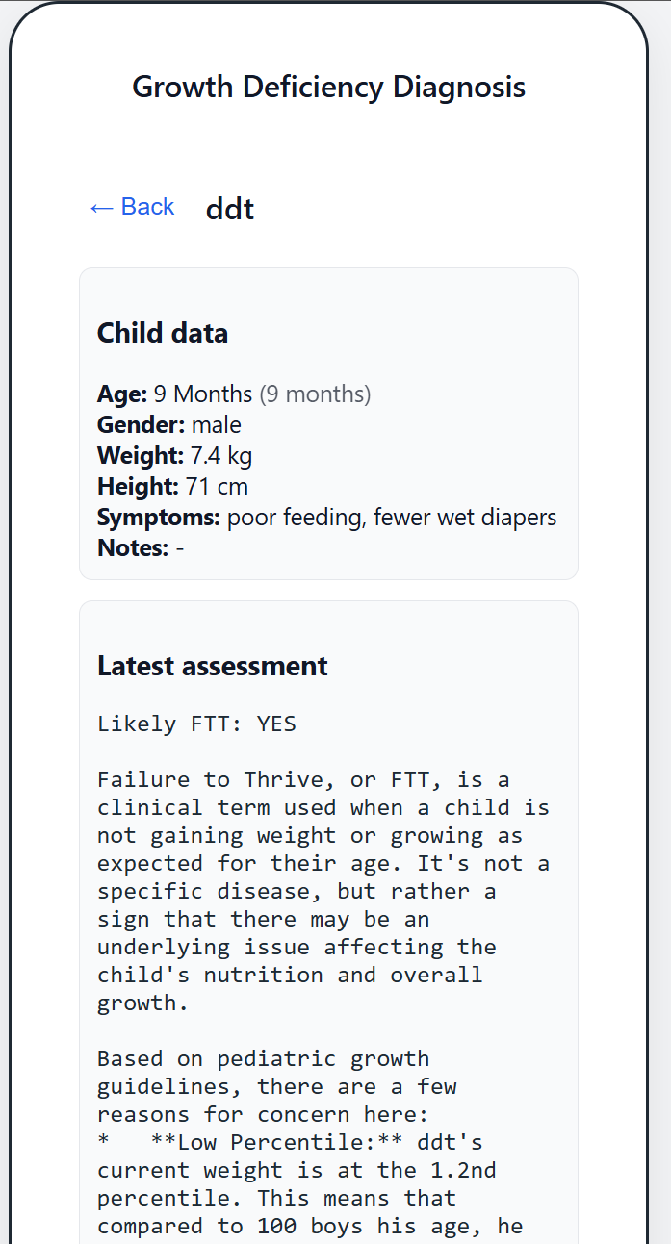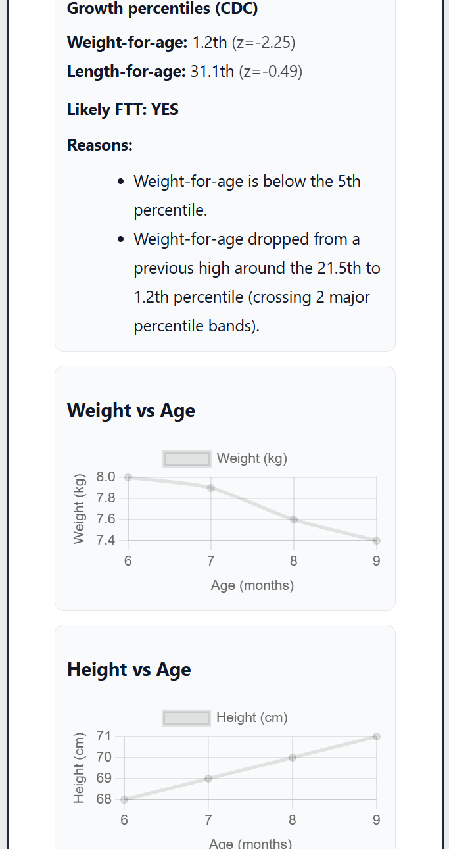

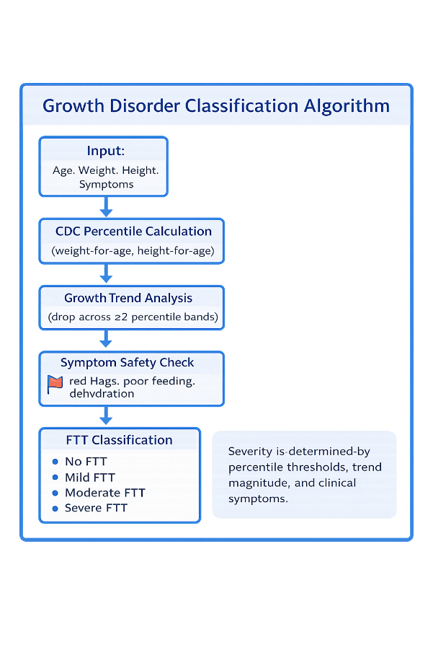
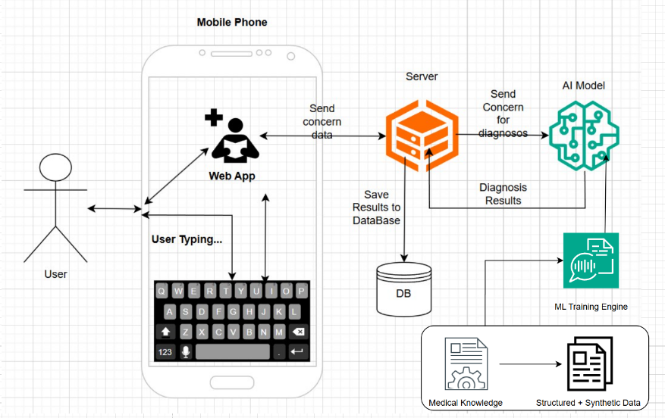
Retrieval-Augmented Generation
• In non-FTT cases, system decisions aligned primarily with physician evaluations.
• In severe FTT cases, system behavior showed stronger similarity to the OPM model.
• Moderate FTT cases demonstrated the highest disagreement, highlighting the value of AI-assisted decision support.
Future Improvements
• Expanded Pediatric Dataset –
Incorporate additional real-world pediatric cases to improve accuracy and robustness.
• Advanced Trend Analysis –
Enhance longitudinal growth modeling using longer historical records.
• Improved AI Reasoning –
Refine prompt design and reasoning logic for clearer and more precise medical explanations.
• Multilingual Support –
Extend support to additional languages for broader accessibility.

