# Protected Login Demonstration

## 1. Successful Login Attempt

The user provides a valid username and password.

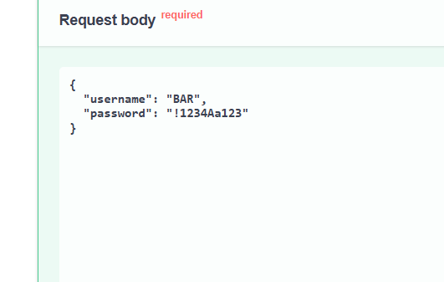

## 2. Successful Login Response

The server confirms the credentials and responds with a welcome message.

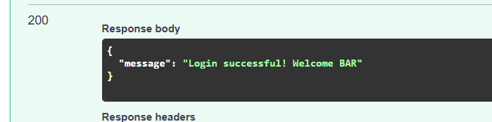

## 3. SQL Injection Attempt

An attacker tries to bypass authentication using a classic SQL injection technique.

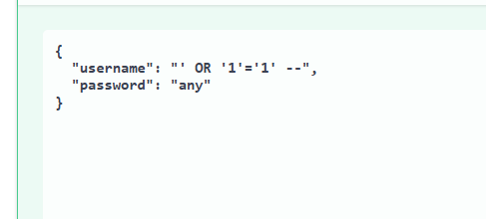

## 4. SQL Injection Blocked

Thanks to parameterized queries, the attempt is blocked and the server responds with an error.

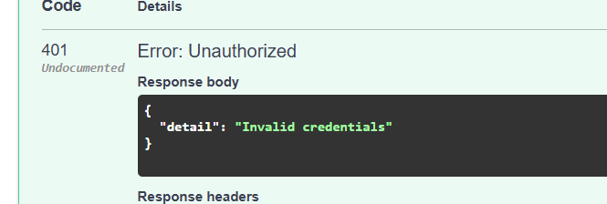

## 5. Secure Login Code

This code uses parameterized queries and securely validates passwords using hashed values with salts.

