ProyectoUnidad5

Bárbara Cruz Salazar

2/24/2020

## R Markdown

## Install Bioconductor

if (!requireNamespace("BiocManager", quietly = TRUE))  
 install.packages("BiocManager")  
BiocManager::install(version = "3.10")

## Bioconductor version 3.10 (BiocManager 1.30.10), R 3.6.2 (2019-12-12)

## Old packages: 'gsl'

BiocManager::install(c("gdsfmt","SNPRelate"))

## Bioconductor version 3.10 (BiocManager 1.30.10), R 3.6.2 (2019-12-12)

## Installing package(s) 'gdsfmt', 'SNPRelate'

##   
## The downloaded binary packages are in  
## /var/folders/_y/ccz7ddn963dg6ngl_dnz1pm40000gn/T//RtmpLGfdnE/downloaded_packages

## Old packages: 'gsl'

## Call libreries

library(SNPRelate)

## Loading required package: gdsfmt

## SNPRelate -- supported by Streaming SIMD Extensions 2 (SSE2)

library(ape)  
library(ggplot2)

## Change session

## Convert .bed, .fam, .bim

### It is converted with plink, from .ped file; to have the .ped file you must convert the .vcf file to .ped with vcftools

## Load dates in gds format from plink   
snpgdsBED2GDS("../data/maicesArtegaetal2015.bed",   
 "../data/maicesArtegaetal2015.fam",   
 "../data/maicesArtegaetal2015.bim",   
 out.gdsfn="../data/maices.gds", # here indicate name of gds file  
 option = snpgdsOption(Z=10)) # 10 cromosomas, this information is know

## Start file conversion from PLINK BED to SNP GDS ...  
## BED file: '../data/maicesArtegaetal2015.bed'  
## SNP-major mode (Sample X SNP), 1.5M  
## FAM file: '../data/maicesArtegaetal2015.fam'  
## BIM file: '../data/maicesArtegaetal2015.bim'  
## Mon Feb 24 17:07:55 2020 (store sample id, snp id, position, and chromosome)  
## start writing: 165 samples, 36931 SNPs ...  
## [..................................................] 0%, ETC: --- [==================================================] 100%, completed, 0s  
## Mon Feb 24 17:07:55 2020 Done.  
## Optimize the access efficiency ...  
## Clean up the fragments of GDS file:  
## open the file '../data/maices.gds' (1.6M)  
## # of fragments: 39  
## save to '../data/maices.gds.tmp'  
## rename '../data/maices.gds.tmp' (1.6M, reduced: 252B)  
## # of fragments: 18

# See summary   
snpgdsSummary("../data/maices.gds")

## Some values of 'snp.chromosome' are invalid (should be finite and >= 0)!

## Hint: specifying 'autosome.only=FALSE' in the analysis could avoid detecting chromosome coding.

## Some of 'snp.allele' are not standard (e.g., 0/G).

## The file name: /Users/barbaracruz-salazar/Desktop/BioinfinvRepro_viejo/Unidad5/Prac_Uni5/maices/data/maices.gds   
## The total number of samples: 165   
## The total number of SNPs: 36931   
## SNP genotypes are stored in SNP-major mode (Sample X SNP).  
## The number of valid samples: 165   
## The number of biallelic unique SNPs: 30804

# Load gds file created from .bed, .fam and .bim files  
gdsfile <- snpgdsOpen("../data/maices.gds")  
  
# Check snp.ids  
head(read.gdsn(index.gdsn(gdsfile, "snp.id")))

## [1] "abph1.15" "ae1.8" "an1.3" "ba1.5" "ba1.7" "csu1138.4"

# Check sample.ids  
head(read.gdsn(index.gdsn(gdsfile, "sample.id")))

## [1] "maiz_3" "maiz_68" "maiz_91" "maiz_39" "maiz_12" "maiz_41"

# Create an object to names the samples of gdsn  
sample.id <- read.gdsn(index.gdsn(gdsfile, "sample.id"))  
sample.id

## [1] "maiz_3" "maiz_68" "maiz_91" "maiz_39" "maiz_12" "maiz_41"   
## [7] "maiz_35" "maiz_58" "maiz_51" "maiz_82" "maiz_67" "maiz_93"   
## [13] "maiz_21" "maiz_6" "maiz_101" "maiz_27" "maiz_43" "maiz_1"   
## [19] "maiz_33" "maiz_100" "maiz_24" "maiz_103" "maiz_72" "maiz_10"   
## [25] "maiz_28" "maiz_49" "maiz_56" "maiz_66" "maiz_52" "maiz_47"   
## [31] "maiz_80" "maiz_65" "maiz_94" "maiz_36" "maiz_26" "maiz_105"   
## [37] "maiz_30" "maiz_16" "maiz_42" "maiz_4" "maiz_31" "maiz_17"   
## [43] "maiz_46" "maiz_5" "maiz_32" "maiz_19" "maiz_50" "maiz_8"   
## [49] "maiz_34" "maiz_23" "maiz_54" "maiz_14" "maiz_37" "maiz_25"   
## [55] "maiz_55" "maiz_40" "maiz_29" "maiz_60" "maiz_44" "maiz_74"   
## [61] "maiz_89" "maiz_64" "maiz_83" "maiz_75" "maiz_92" "maiz_69"   
## [67] "maiz_84" "maiz_76" "maiz_97" "maiz_70" "maiz_85" "maiz_77"   
## [73] "maiz_71" "maiz_86" "maiz_78" "maiz_102" "maiz_73" "maiz_88"   
## [79] "maiz_79" "maiz_106" "maiz_119" "maiz_148" "maiz_108" "maiz_120"   
## [85] "maiz_151" "maiz_134" "maiz_123" "maiz_153" "maiz_135" "maiz_124"   
## [91] "maiz_184" "maiz_140" "maiz_125" "maiz_141" "maiz_131" "maiz_189"   
## [97] "maiz_57" "maiz_126" "maiz_113" "maiz_138" "maiz_63" "maiz_127"   
## [103] "maiz_114" "maiz_139" "maiz_99" "maiz_129" "maiz_116" "maiz_142"   
## [109] "maiz_110" "maiz_132" "maiz_118" "maiz_144" "maiz_133" "maiz_121"   
## [115] "maiz_111" "maiz_137" "maiz_109" "maiz_146" "maiz_164" "maiz_157"   
## [121] "maiz_171" "maiz_149" "maiz_165" "maiz_159" "maiz_172" "maiz_150"   
## [127] "maiz_166" "maiz_160" "maiz_173" "maiz_152" "maiz_167" "maiz_161"   
## [133] "maiz_174" "maiz_154" "maiz_169" "maiz_162" "maiz_176" "maiz_156"   
## [139] "maiz_170" "maiz_163" "maiz_177" "maiz_178" "maiz_192" "maiz_185"   
## [145] "maiz_201" "maiz_179" "maiz_193" "maiz_186" "maiz_202" "maiz_180"   
## [151] "maiz_195" "maiz_187" "maiz_181" "maiz_197" "maiz_188" "maiz_182"   
## [157] "maiz_198" "maiz_190" "maiz_200" "maiz_183" "maiz_191" "teos_96"   
## [163] "teos_203" "teos_911" "teos_9107"

# Metadates  
# load  
metadata<- read.delim(file= "../meta/maizteocintle_SNP50k_meta_extended.txt")  
  
# check  
head(metadata)

## OrderColecta NSiembra Origen Raza Estado  
## 1 2 3 INIFAP-2009-16 Apachito Chihuahua  
## 2 1 68 2009-72 Chalque̱o Tlaxcala  
## 3 1 91 2007-33 Dulcillo del Noroeste Sonora  
## 4 2 39 Chis-2009-18 Dzit-Bacal Chiapas  
## 5 2 12 Celaya-2009-114 Celaya Guanajuato  
## 6 2 41 Celaya-2009-2 Elotes Occidentales Guanajuato  
## Num_Colecta Nombre_comun Raza_Primaria Raza_Secundaria  
## 1 16 Ocho carreras Apachito NA  
## 2 22 Chalque̱o Criollo Chalque̱o NA  
## 3 SON2007-033 Ma\xcc_z Dulce Dulcillo del Noroeste NA  
## 4 Repetida 18 Olotillo crema Dzit-Bacal NA  
## 5 2009-REPO-114 Ma\xcc_z Criollo Celaya NA  
## 6 2009-REPO-002 Ma\xcc_z Criollo Elotes Occidentales NA  
## A.o._de_colecta Localidad Municipio Estado.1 Longitud  
## 1 2009 Santo Tom\xcc\xc1s Guerrero Chihuahua -107.58300  
## 2 2008 Ignacio Zaragoza Cuapiaxtla Tlaxcala -97.92944  
## 3 2007 Agua Blanca Y̩cora Sonora -108.92467  
## 4 2009 Nuevo Vicente Guerrero Villacorzo Chiapas -92.97972  
## 5 2009 El Ahuacate Uriangato Guanajuato -101.11889  
## 6 2009 Comonfort Comonfort Guanajuato -100.76583  
## Latitud Altitud Ruizetal2008_grupo  
## 1 28.68578 1975 1A_templado540-640mm  
## 2 19.29083 2497   
## 3 28.53703 1435 2A_semicalido500-870mm  
## 4 16.03225 618 3A_muycalido990-1360mm  
## 5 20.09111 1877 2A_semicalido500-870mm y 1B_templado>650mm  
## 6 20.74417 1800 2C_semicalido740-855mm y 1B_templado>650mm  
## Sanchezetal_grupo Categ.Altitud Rbiogeo  
## 1 Sierra de Chihuahua mid Sierra Madre Occidental  
## 2 C\xcc_nico high Eje Volcanico  
## 3 Chapalote mid Sierra Madre Occidental  
## 4 Maduraci\xcc_n tard\xcc_a low Costa del Pacifico  
## 5 Dentados tropicales mid Eje Volcanico  
## 6 Ocho Hileras mid Eje Volcanico  
## DivFloristic PeralesBiog  
## 1 Sierra Madre Occidental Ca\xe5_ones Chi  
## 2 Serranias Meridionales Mesa Centra  
## 3 Sierra Madre Occidental Sierras del  
## 4 Serranias Transismicas Chiapas  
## 5 Altiplanicie Baj\xe5\xc1o  
## 6 Altiplanicie Baj\xe5\xc1o

nrow(metadata)

## [1] 165

head(metadata$NSiembra) # ID number of the samples

## [1] 3 68 91 39 12 41

head(sample.id)

## [1] "maiz_3" "maiz_68" "maiz_91" "maiz_39" "maiz_12" "maiz_41"

# Do PCA

pca <- snpgdsPCA(gdsfile, num.thread=2)

## Principal Component Analysis (PCA) on genotypes:  
## Excluding 5,290 SNPs on non-autosomes  
## Excluding 837 SNPs (monomorphic: TRUE, MAF: NaN, missing rate: NaN)  
## Working space: 165 samples, 30,804 SNPs  
## using 2 (CPU) cores  
## PCA: the sum of all selected genotypes (0,1,2) = 2543593  
## CPU capabilities: Double-Precision SSE2  
## Mon Feb 24 17:07:56 2020 (internal increment: 2156)  
## [..................................................] 0%, ETC: --- [==================================================] 100%, completed, 0s  
## Mon Feb 24 17:07:56 2020 Begin (eigenvalues and eigenvectors)  
## Mon Feb 24 17:07:56 2020 Done.

# Calculate the variation percentaje for first components   
pc.percent <- pca$varprop*100 # multiply by 100 to see the value in percentage  
head(round(pc.percent, 2)) # see the values with two digits

## [1] 6.44 2.13 1.42 1.19 1.10 1.08

# To round the values, use round function  
x<-round(pc.percent, 2) # 2 digits  
  
# See sum of comonents  
sum(x[1:4])

## [1] 11.18

sum(x[1:10])

## [1] 17.08

sum(x[1:30])

## [1] 31.92

# For do a plot I have to do a data frame  
table_pca <- data.frame(sample.id = pca$sample.id, # sample.id of PCA in a column  
 EV1 = pca$eigenvect[,1], # the first eigenvector  
 EV2 = pca$eigenvect[,2], # the second eigenvector  
 stringsAsFactors = FALSE)  
head(table_pca)

## sample.id EV1 EV2  
## 1 maiz_3 -0.05654163 0.11522741  
## 2 maiz_68 -0.09909519 -0.05460776  
## 3 maiz_91 -0.01718140 0.24928583  
## 4 maiz_39 0.10705139 -0.05925765  
## 5 maiz_12 -0.01515252 0.01879029  
## 6 maiz_41 -0.02124046 0.03231120

## Do a plot

ggplot(data = table_pca, aes(x=EV2, y=EV1)) + geom_point() + # plot will be of points  
 ylab(paste0("Eigenvector 1 explain ", round(pc.percent, 1)[1], "%")) + # round will put the rounding you did up  
 xlab(paste0("Eigenvector 2 explain ", round(pc.percent, 1)[2], "%")) # 1 indicate one digit; the number in brackets is the component

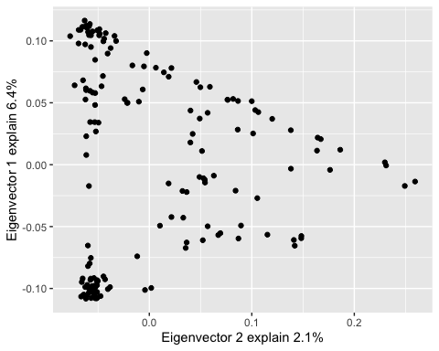

### paste0 paste  
  
# Load metadates for PCA  
group <- as.vector(metadata$DivFloristic) # Do a vector with the information of geographic zone to group the genetic data with that factor  
  
# Do the data frame again including the factor (DivFloristic)  
table_pca_group <- data.frame(sample.id = pca$sample.id,  
 pop = factor(group)[match(pca$sample.id, sample.id)], # pop will be the factor (group),   
 # match function makes it fit the data frame considering the new column included,   
 # and that the data is not messy.   
 EV1 = pca$eigenvect[,1], # the first eigenvector  
 EV2 = pca$eigenvect[,2], # the second eigenvector  
 stringsAsFactors = FALSE)  
  
# Do plot of PCA  
  
ggplot(data = table_pca_group, aes(x=EV2, y=EV1, colour = pop)) + geom_point() + #Indicate that color according to the group that was created (group=DivFloristic)  
 ylab(paste0("Eigenvector 1 explain ", round(pc.percent, 1)[1], "%")) +  
 xlab(paste0("Eigenvector 2 explain ", round(pc.percent, 1)[2], "%"))

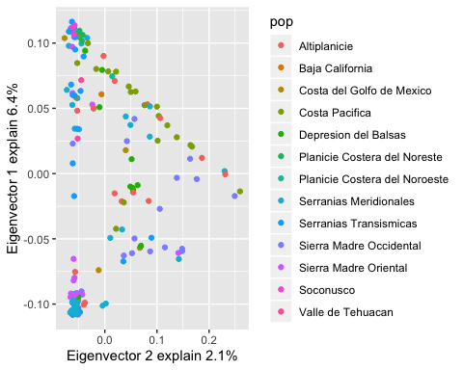

# Do an others plots

# Do an other object  
race_by_state <- as.vector(metadata$Raza)  
  
# Do an other data frame that include the race  
table_two <- data.frame(sample.id=pca$sample.id, pop = factor(group)[match(pca$sample.id, sample.id)], group=factor(race_by_state)[match(pca$sample.id, sample.id)],  
 EV1 = pca$eigenvect[,1])  
  
  
ggplot (data =table_two, aes(x=EV1, y=group,colour=pop)) + geom_line() +  
 labs (x= "Eigenvector 1", y = "Race")

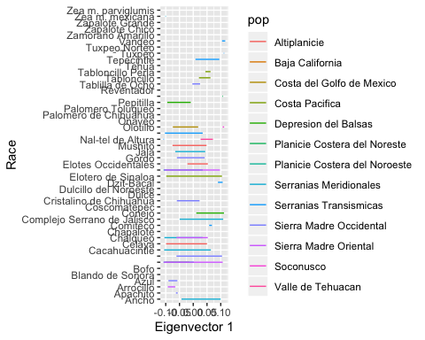

ggplot (data = metadata, aes(x=Raza, y=Altitud, col=DivFloristic)) + geom_line() +  
 labs (x="Raza", y="Estado")

