**Bar Down Boys Hockey Team**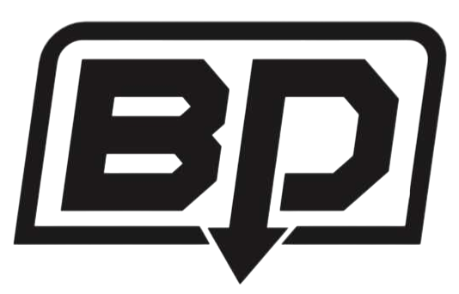

***AGENDA***

**September, 2025  
7:30pm**

**16 Clover Lane, CBS**

*Mission: Our mission is to foster a love for hockey by developing the skills, teamwork, and sportsmanship of every player. Through dedication, encouragement, and friendship, we strive to create a positive and supportive environment where youth can grow both on and off the ice.*

1. **Attendance**
2. **Call to Order**
3. **Follow Up Business**
   1. **9U Jamboree Canteen**
   2. **BDB Squares (Daniel/Dave)**
   3. **Strikers Canteen**
   4. **9U Selects Canteen**
   5. **Volleyball Skills**
   6. **Bardown Showdown Tournament**
   7. **Bardown Showdown Canteen**
4. **New Business:**
   1. **Tournament Registration**
   2. **Men’s Year-End Softball Canteen**
   3. **Piatto Pizza Fundraiser**
   4. **Indoor Soccer Tournament**
   5. **Yetman’s Remembrance Day Canteen**
   6. **Cut-a-Thon**
   7. **Bottle Drive - square account for donations - BDB account at bottle depot (5899841)**
   8. **Insurance coverage**
5. **Other 2025 Fundraisers?**
6. **2026 Fundraisers?**
7. **Treasurer’s Report**
8. **Adjournment**