6-12v RS385 Water Pump  https://www.banggood.com/12V-DC-Diaphragm-Pump-Water-Device-Mini-Self-priming-Pump-Fish-Tank-Motor-p-1078807.html?rmmds=search | 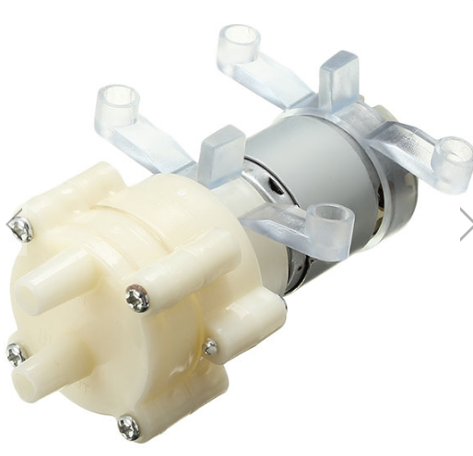 | QTY: 10 pc
Switch: 16mm body, 19x24mm rectangle, MOMENTARY, 12V  (Similar to https://www.banggood.com/16mm-DC-12V-Push-Button-Self-Lock-Switch-Square-LED-Light-Momentary-Button-p-1002462.html?rmmds=search but MOMENTARY NB) | 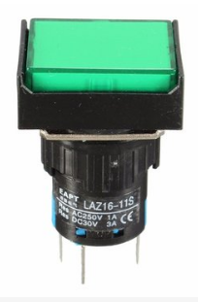 | QTY: 20 pc GREEN MOMENTARY  QTY: 20 pc RED MOMENTARY  QTY: 20 pc AMBER MOMENTARY
12V 2A power Supply EU Plug  2.1mm x 5.5mm Plug  https://www.banggood.com/AC-110-240V-To-DC-12V-2A-Power-Supply-Transformer-EUUK-LED-Strip-Light-Belt-Adapter-p-1166863.html?rmmds=search&cur_warehouse=CN | 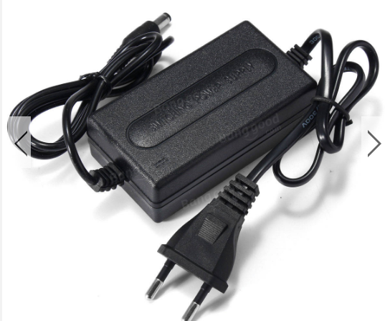 | QTY: 10 pc  220/240v->12v 2A
2.1mm x 5.5mm Socket – Panel Mount  (Matching socket for PSU above)  https://www.banggood.com/10Pcs-5_5mm-x-2_1mm-DC-Power-Supply-Metal-Jack-Socket-With-Nut-And-Washer-p-1063885.html?rmmds=search | 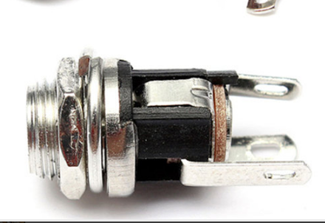 | QTY: 10pc
8MM ID Silicon tubing (for use with the pump above) | 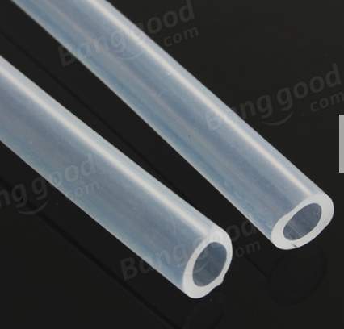 | QTY: 15 meter
3 position selector switch  https://www.banggood.com/Rotary-Three-Position-Selector-Switch-Push-Button-Switch-p-1126181.html?cur_warehouse=CN | 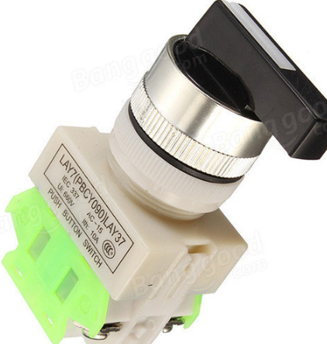 | QTY: 10 pc

