

**Computer Science Department**

**COMP133 ( Spring 2017 )**

**Project Phase One *Due Date: Wed (12/4/2017) by 10:00 pm ( on Ritaj )***

**Notes:**

1. This project phase should be submitted by the due date and time ***( Late project phases will not be accepted for any reason ) on Ritaj.***
2. ***ONLY one selected member*** of each group should turn in ***ONLY ONE COPY*** on behalf of all group members.

Each group (two students) will have to build a ***bookstore management system*** for adding, deleting, or searching for books in the store. Each book will have a title (*string*), bin number (*four digit integer*), and a price (*double*). When the program starts, it will load existing book information from a text file and when the program exits, it will save all changes made while running the program to that same file.

After the book information is loaded from the file ***( In this phase all you need to do is just print a message that the book information is loaded, but you don’t really open any files or load anything)*** , the program will display the following main menu to the user:

***Please Select an Operation (1-4):***

***1- Add a Book***

***2- Remove a Book***

***3- Search for a Book***

***4- Exit System***

This menu will keep showing after each time a user selects an operation and that operation is performed. When the user selects operation 4 (exit system), the program will load all changes (updates) to the file ***( In this phase all you need to do is just print a message that the book information is updated, but you don’t really open any files or update anything)*** and will then exit.

Your program should at least contain the following functions:

void displayMainMenu(); // displays the main menu shown above

void addBook(); // adds information for a new book

void removeBook(); // removes information of old book

void searchForBook(); // searches for a book in the store

void uploadDataFile(); // uploads book data from file

void updateDataFile(); // saves book data updates to file

**For this phase those functions are just void functions that will mostly contain *printf* statements just to print what they are supposed to do. In later phases, the function prototypes will change and the functions will do more.**

**VERY IMPORTANT:**

1. Turn in your project phase by ***replying to the course coordinator’s message*** on Ritaj and attaching your code file (***main.c***). Only one selected member of each group should turn in this phase.
2. You must include the full names, student id numbers of all group members in a comment at the beginning of your group code file.

Make sure your program works **very similar** to the following sample run:

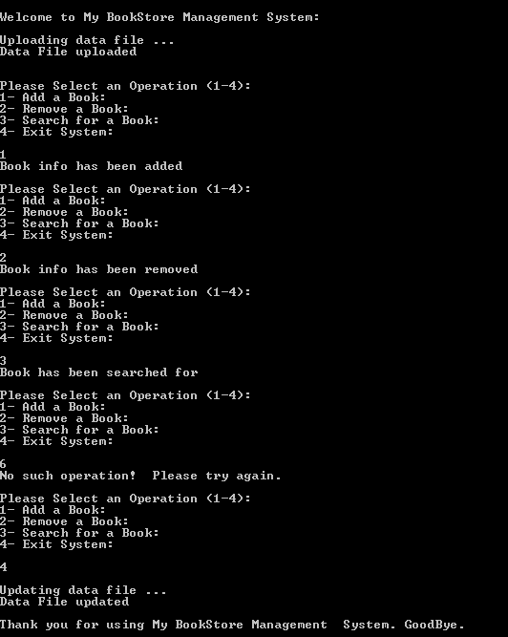

***Late project phases will not be accepted for any reason***.