Abstract
This report presents the design and implementation of an autonomous mobile robot navigation system that integrates visual localization, inertial sensing, and obstacle avoidance for indoor environments. The system employs a hybrid computational architecture where a Raspberry Pi 4 handles high-level perception tasks including ArUco marker detection and pose estimation, while an Arduino Uno R3 manages low-level sensor fusion and motor control. The robot utilizes a differential-drive platform equipped with an Arducam for visual input, MPU6050 IMU for orientation sensing, and RPLIDAR A1M8 for obstacle detection.
The localization approach combines visual observations from ArUco markers with IMU data through a Kalman filter implementation, achieving robust pose estimation in structured environments. The system demonstrates effective real-time performance by processing camera frames for marker detection, transforming coordinates between camera and robot frames, and maintaining accurate position estimates despite sensor noise and uncertainties. Navigation is accomplished through a goal-based proportional controller that guides the robot through predefined waypoints, while a LIDAR-based obstacle avoidance algorithm inspired by the Dynamic Window Approach ensures safe traversal.
Experimental validation shows the system's capability to maintain localization accuracy while navigating autonomously through indoor spaces. The modular architecture enables future extensions including full SLAM implementations and enhanced path planning algorithms. This work contributes to the field of mobile robotics by demonstrating an effective integration of multiple sensing modalities for autonomous navigation in marker-rich environments.

REAL-TIME ROBOT NAVIGATION WITH QR-BASED LOCALIZATION AND LIDAR OBSTACLE MAPPING
(Alaa Hussein), (Baraa Lazkani), (Haidar Saad), (Humam Yehia)

Supervised by: Dr. Fadi Muttawag, Eng. Baher Kher-Bek

Table of Contents
1. INTRODUCTION 4
2. Hardware and Software Systems Architecture......... 4
2.1 System Overview 4
2.2 Hardware Components 5
2.3 Software Architecture 7
3. Theoretical Background: 8
3.1 Differential‐Drive (Two-Wheeled) Mobile Robot... 8
3.2 Kalman Filter 9
3.3 ArUco Marker Detection & Pose Estimation…….. 9
4. Methodology 11
4.1 ArUco Marker-Based Robot Localization System.. 11
4.2 Robot Localization Using Kalman Filter…. 12
4.3 Motion Control 13
4.4 LIDAR-Based Navigation Algorithm (Inspired by Dynamic Window)… 13
5. CONCLUSION AND FUTURE WORK......... 14
5.1 Conclusion 14
5.2 Future Work 15
6. REFERENCES 16
Appendix A 18

Description | Page Number
flow diagram of the robot. | 5
Raspberrypi 4 Model B. | 5
Arducam 16 MP for Raspberrypi. | 5
Arduino Uno R3. | 5
MPU6050. | 6
RPLIDAR A1M8. | 6
L298 Motor Driver | 6
DC Motor | 7
Differential‐Drive (Two-Wheeled) Mobile Robot | 8

1. INTRODUCTION
Autonomous mobile robot navigation represents a fundamental challenge in robotics, requiring the integration of perception, localization, and control systems to enable safe and efficient movement through complex environments. The ability for robots to navigate autonomously has applications spanning from warehouse automation and service robotics to exploration and surveillance tasks [1,2]. This work addresses the core components necessary for indoor mobile robot navigation: accurate localization, robust obstacle detection, and effective motion control.
The localization problem—determining a robot's position and orientation within its environment—remains one of the most critical aspects of autonomous navigation. Traditional approaches include odometry-based methods that suffer from drift accumulation, GPS systems that are ineffective indoors, and simultaneous localization and mapping (SLAM) techniques that can be computationally intensive [3,4]. Visual localization using fiducial markers offers a compelling alternative, providing absolute position references that can correct for accumulated errors while maintaining computational efficiency [5,6].
Modern mobile robots must also handle dynamic obstacles and unexpected environmental changes. LIDAR sensors have become increasingly popular for obstacle detection due to their accuracy and real-time capabilities. However, processing 360-degree scan data for navigation requires sophisticated algorithms that can balance obstacle avoidance with goal-directed behavior [7].
This project develops a comprehensive navigation system that addresses these challenges through a multi-sensor approach. The system combines ArUco marker-based visual localization with inertial measurements using a Kalman filter framework for robust pose estimation [8,9]. Real-time obstacle avoidance is achieved through LIDAR-based path planning inspired by the Dynamic Window Approach. The implementation demonstrates how distributed processing between high-level perception tasks and low-level control can achieve real-time performance on resource-constrained platforms.
The contribution of this work lies in the practical integration of proven techniques into a working autonomous navigation system. By utilizing readily available hardware components and open-source software libraries, the system provides a replicable foundation for mobile robot applications in structured indoor environments [10]. The modular architecture enables future enhancements while maintaining the core functionality necessary for autonomous operation.

2. Hardware and Software Systems Architecture

2.1 System Overview
The robot is a differential-drive mobile platform that integrates vision, lidar, inertial sensing, and motor control for autonomous navigation and localization. It features a hybrid computational setup where a Raspberry Pi 4 handles high-level perception and pose estimation, while an Arduino Uno R3 manages low-level sensor fusion and motor control.

2.2 Hardware Components
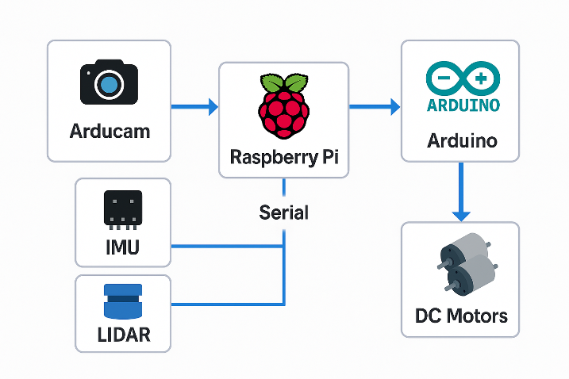
Figure (1), flow diagram of the robot.
1. Raspberry Pi 4 Model B (2 GB RAM)
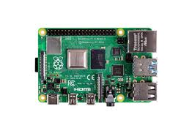
Figure (2), Raspberrypi 4 Model B.
Role: Acts as the high-level processing unit for image capture, ArUco detection, pose estimation, and communication.
Operating System: Raspberry Pi OS Lite.
Camera: Connected to an Arducam using the CSI interface for high-quality image capture.
Interface: Communicates with the Arduino via USB serial.
2. Arducam (for Raspberry Pi)
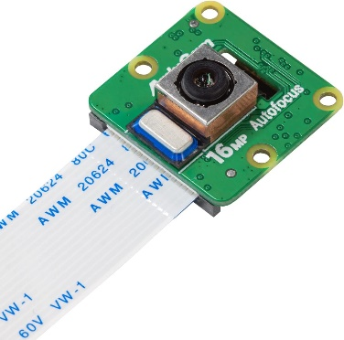

Figure (3), Arducam 16 MP for Raspberrypi.
Purpose: Captures live video feed used for marker detection.
Resolution: Operates at 640×480 or higher depending on processing needs.
Mounting: Rigidly attached to the robot body with known extrinsic.
Role: Provides real-time visual data to detect ArUco markers and estimate robot pose relative to the environment.
3. Arduino Uno R3
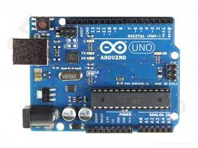
Figure (4), Arduino Uno R3.

Role: Serves as the low-level controller.
Fuses inertial and visual data via a custom Kalman filter.
Computes wheel commands based on navigation logic.
Interfaces with LIDAR and IMU sensors.
Communication: Receives pose data from the Raspberry Pi via serial and sends diagnostic data back.
4. MPU6050 IMU
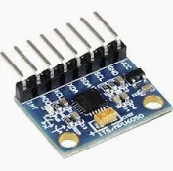
Figure (5), MPU6050.
Sensors: 3-axis accelerometer + 3-axis gyroscope.
Connection: I2C communication via $Wire.h$ library.
Function: Provides real-time orientation feedback (yaw angle) and acceleration for motion prediction.
Use: Assists the Kalman filter in maintaining accurate heading and speed estimates.
5. RPLIDAR A1M8

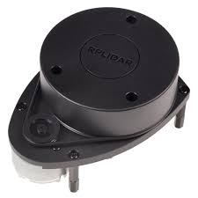
Figure (6), RPLIDAR A1M8.
Role: 360° 2D LIDAR scanner
Functionality: It was used for obstacle detection and avoidance.
Connection: USB interface (can connect to Raspberry Pi or microcontroller via adapter).
6. L298 Motor Driver Module
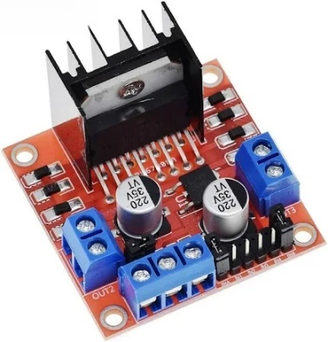
Figure (7), L298 Motor Driver.
Type: Dual H-Bridge driver.
Connection: Driven by Arduino through digital input pins and PWM pins:
in1–in4: Direction control
ena1, ena2: Speed (PWM)
Power: Capable of driving 2 DC motors up to 2A each.
Purpose: Controls direction and speed of the robot’s motors based on computed velocities.
7. DC Motors
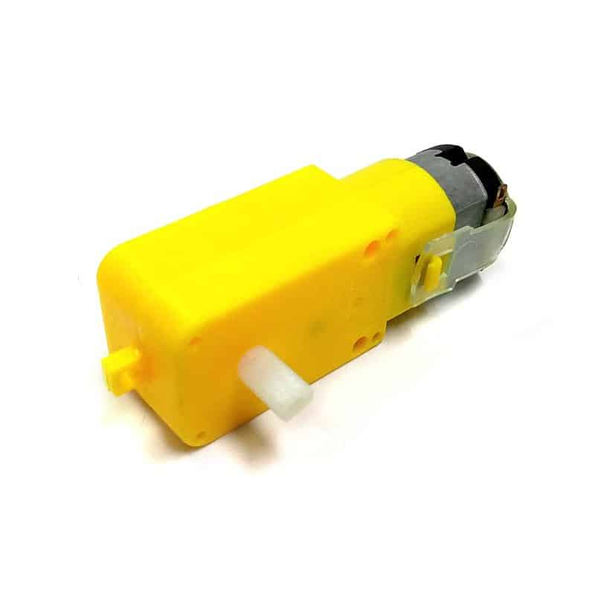
Figure (8), DC Motors.
Specification:
Nominal voltage: 6–12V
Gear ratio: 1:48
Speed: ~90 RPM
Use: Differential-drive configuration for forward and turning movement.
Encoders: Not used in this project (open-loop velocity estimation is used instead with IMU correction).
Important Note:
Images of the robot are provided in Appendix A.

2.3 Software Architecture
1. Programming Languages and Libraries
Python (Raspberry Pi):
OpenCV (for image processing and ArUco detection)
NumPy (for matrix operations)
picamera2 or Arducam Python bindings
$pySerial$ (for serial communication with Arduino)
C++ (Arduino):
$BasicLinearAlgebra$ (for Kalman filtering)
$Wire.h$, MPU6050_light (IMU interfacing)
Native Arduino functions for motor control, timing, and serial I/O
2. Data Flow and Control Pipeline
Camera Input
The Raspberry Pi captures a frame from the Arducam.
ArUco Marker Detection
Using OpenCV, the system detects 4×4 ArUco markers and estimates their poses using $solvePnP$ with known camera calibration parameters.
Coordinate Transformation
The marker pose is converted from the camera frame to the robot body frame using a fixed transformation matrix.
Serial Transmission
The Raspberry Pi sends formatted pose data (e.g., x0.52y1.34t0.98i7x... #) to the Arduino via USB.
Pose Estimation & Filtering
The Arduino fuses IMU yaw readings and visual observations using a Kalman filter to estimate global (x, y, θ) pose.
Navigation and Control
Based on the current state and goal position, a velocity command (v, ω) is computed.
The command is converted into left/right motor PWM signals and sent to the L298 driver to actuate the motors.
This hardware–software architecture forms a reliable, modular, and extensible framework for mobile robot navigation. The division of computation across Raspberry Pi and Arduino allows for real-time performance while maintaining flexibility for future additions such as full SLAM implementations.

3. Theoretical Background:

3.1 Differential‐Drive (Two-Wheeled) Mobile Robot
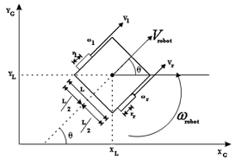
Figure (9), Differential‐Drive (Two-Wheeled) Mobile Robot.
Kinematic Model
A two-wheeled (differential-drive) robot has two independently driven wheels of radius r, separated by a wheelbase b. By controlling the angular velocities of the left and right wheels (ωₗ, ωᵣ), the robot’s linear and angular motion can be described as follows: [11,12]
1) Wheel Linear Velocities
Each wheel’s linear speed is:
$$v_l = r · ω_l v_r = r · ω_r$$
2) Robot Linear and Angular Velocities
The forward (surge) velocity v and rotational (yaw) rate ω of the robot’s chassis are the average and half‐difference of the wheel speeds:

$$v =\frac{\left(v_{r}+ v_{l}\right)}{2} =\frac{\left[r · \left(ω_{r}+ ω_{l}\right)\right]}{2}$$
$$ω =\frac{v_{r}- v_{l}}{b}=\frac{\left[r · \left(ω_{r}- ω_{l}\right)\right]}{b}$$
3) Pose Kinematics
Let $(x,y)$ be the robot’s position in the world frame and$θ$ its heading angle (measured from the x-axis). The continuous‐time kinematic equations are:
$$ẋ = v · cos θ$$
$$ẏ = v · sin θ$$
$θ' = ω$
$$substituting v and ω:$$
$$ẋ = [r ·\frac{ω_{r}+ ω_{l}}{2}] · cos θ$$
$$ẏ = [r ·\frac{ω_{r}+ ω_{l}}{2}] · sin θ$$
$$θ̇' = [r ·\frac{ω_{r}- ω_{l}}{b}]$$
4) Inverse Kinematics
To achieve a desired chassis velocity $(v,ω)$ the required wheel speeds are: [13,14]
$$ω_{r}=\frac{\left[v + \left(\frac{b}{2}\right)· ω\right]}{r}$$
$$ω_{l}=\frac{\left[v - \left(\frac{b}{2}\right)· ω\right]}{r}$$
$$r = wheel radius$$
$$b = distance between wheels$$
$$ω_r = right‐wheel angular speed$$
$$ω_l = left‐wheel angular speed$$
$$v_r = right‐wheel linear speed$$
$$v_l = left‐wheel linear speed$$
$$v = robot forward speed$$
$$ω = robot yaw rate$$
$$(x, y) = robot position in world frame$$
$$θ = robot heading angle$$

3.2 Kalman Filter
The Kalman Filter is an optimal recursive algorithm used to estimate the internal state of a linear dynamic system from a series of noisy measurements. It is widely applied in areas such as control systems, signal processing, and robotics, where accurate and real-time state estimation is critical. The filter works in a two-step process: prediction and update, continuously refining the estimates based on incoming measurements. [15,16]
1) Benefits of the Kalman Filter
Real-time Processing: It updates estimates as new data becomes available, making it suitable for live systems.
Noise Reduction: It effectively combines noisy sensor data to produce a more accurate estimate.
Efficiency: Requires only the previous state, making it computationally light for real-time applications.
Optimality: For linear systems with Gaussian noise, it provides the best possible estimate in the least squares sense. [17]
2) Kalman Filter Equations
State Prediction:
${\hat{x}}_{k|k-1}=F_{k|k-1}{\hat{x}}_{k|k-1}+B_{k-1}u_{k-1}$
This equation projects the previous state estimate ${\hat{x}}_{k|k-1}$​ forward using the system's state transition model $F_{k|k-1}$ and any control inputs $u_{k-1}$​.
Covariance Prediction:
$P_{k|k-1}=F_{k-1}P_{k-1|k-1}F_{k-1}^{T}+Q_{k-1}$
This step propagates the uncertainty (covariance) of the predicted state forward in time.$Q_{k-1}$ is the process noise covariance.
Kalman Gain:
$K_{k}=P_{k|k-1}H_{k}^{T}{(H_{k}P_{k|k-1}H_{k}^{T}+R_{k})}^{-1}$
The Kalman Gain ​$K_{k}$ balances how much the new measurement zkz_kzk​ influences the state estimate. It depends on predicted uncertainty and the measurement noise covariance $R_{k}$​.
State Update:
${\hat{x}}_{k|k}={\hat{x}}_{k|k-1}+K_{k}(z_{k}+H_{k}{\hat{x}}_{k|k-1})$
This equation updates the state estimate by incorporating the new measurement and Kalman Gain, refining the prediction with actual data. [18,19]

3.3 ArUco Marker Detection & Pose Estimation
1. Marker Concept and Dictionary
Binary fiducial markers
ArUco markers are square, black-and-white 2D barcodes. Each marker encodes a unique binary pattern in its interior cells. [20,21]
Predefined dictionaries
A “dictionary” is a set of markers with known bit grids $(e.g. 4×4 bits, 5×5 bits).$ Markers are generated such that any two patterns differ in at least a certain Hamming distance, making false detections unlikely.
2. Detection Pipeline
Image Preprocessing
Convert the input image to grayscale.
Optionally, apply adaptive thresholding or Otsu’s method to binarize the image while handling variable lighting.
Contour Extraction
Find all continuous contours in the binary image $(e.g., using findContours).$
Approximate each contour by a polygon $(e.g., Douglas–Peucker algorithm)$ to identify quadrilaterals.
Quad Filtering
Discard polygons that do not have exactly four vertices.
Check that the quadrilateral is roughly convex, and its area is above a minimum threshold.
Perspective Normalization
For each candidate quadrilateral, compute the homography H that maps its four corner points to a canonical square of known size.
Warp the quadrilateral region into a top-down “marker view” $(e.g., 100×100 pixels).$
$$p_i = (u_i, v_i), i = 0…3$$
$$P_i = (X_i, Y_i), e.g. (0,0), (s,0), (s,s), (0,s)$$
$$[ u_i; v_i; 1 ] ∼ H · [ X_i; Y_i; 1 ]$$
Bit Decoding
Divide the normalized square into its bit-grid cells $(e.g., 4 cells per side for a 4×4 dictionary).$
For each cell, compute the average intensity:
$$bit_\{ij\} = 1, if mean(I_\{ij\}) > τ$$
$$0, otherwise$$
Extract the resulting binary matrix and compare against the dictionary patterns (often allowing for small rotations).
Marker ID Assignment
Match the decoded bit pattern to the closest dictionary entry.
If the Hamming distance is within an acceptable threshold, accept the detection and assign its ID. [22]
3. Pose Estimation via PnP
Once corners $c_{i}$ of a detected marker are known, we can estimate its three-dimensional position and orientation relative to the camera:
Object Points
Define the 3D coordinates of the marker’s corners in the marker’s own frame (e.g.,
$$O0=\left(0,0,0\right), O1=\left(s,0,0\right),$$
$$O2=\left(s,s,0\right), O3=(0,s,0)$$where $s$ is the marker side length).
Camera Intrinsics
Use the calibrated camera matrix K and distortion coefficients d to relate 3D points to 2D image points.
SolvePnP
Solve the Perspective-n-Point problem to find rotation vector $r$ and translation vector $t$ that:
Let 3D object point $O = (X,Y,Z,1)ᵀ$, camera intrinsics $K$, extrinsic $[R|t]:$ [23,24]
$$s · \left[ u; v; 1 \right] = K · [ R | t ] · [ X; Y; Z; 1 ]$$
$$Given rotation vector r = (r_{x}, r_{y}, r_{z}):$$
$$R = exp({\left[r\right]}_{X})$$
Or in components, using:
$θ = ‖r‖ and unit axis k = r/θ:$
$$R = I · cos θ + (1-cos θ)·(k·kᵀ) + sin θ·{\left[k\right]}_{X}$$
Reprojection Error Filtering
Compute the reprojection of the object points back into the image:
$$e_{i} = sqrt((u_{i} - {\hat{u}}_{i})^2 + {\left(v_{i} - {\hat{v}}_{i}\right)}^{2})$$
$$e_{mean} = (\frac{1}{4}) · Σ_{\left\{i=0..3\right\}} e_{i}$$
If the mean or maximum error $e_{i}$exceeds a threshold, discard the detection as unreliable. [25]
4. Coordinate Frame Transformations
Camera-to-body transform
If the robot’s body frame differs from the camera frame, apply a known rigid transform ${{T_{body}}_{←}}_{cam}$ ​ to express the marker’s pose in the robot frame.
Final Pose
Extract the robot-relative marker position $(x,y)$and orientation $θ$ from the $4×4$ homogeneous matrix:
$${{T_{body}}_{←}}_{marker} = {{T_{body}}_{←}}_{cam} · [ R t; 0 1 ]$$

4. Methodology

4.1 ArUco Marker-Based Robot Localization System
This system enables real-time localization of a mobile robot using a camera and ArUco markers. The main objective is to determine the robot's position and orientation within a known environment using visual inputs, geometric transformations, and communication with an Arduino controller.
The program uses the Raspberry Pi Camera ($Picamera2$) to continuously capture frames. Within each frame, it detects ArUco markers using OpenCV's $aruco$ module and estimates the robot's position based on the known geometry of the markers.
Key Steps
- Camera Setup and Calibration:
The system initializes the Pi Camera and configures it for preview.
Intrinsic camera parameters ($mtx$) and distortion coefficients ($dist$) are predefined from calibration to allow accurate 3D position estimation.
- Marker Detection:
ArUco markers are detected using the $ArucoDetector$ and their corners are extracted.
The corners are then used to estimate the marker's pose using the $cv.solvePnPRansac$ method, which computes rotation ($rvecs$) and translation (tvecs) vectors of the marker relative to the camera.
- Pose Transformation:
The rotation vector is converted to a rotation matrix ($R$), which, combined with the translation vector, forms the transformation matrix from the camera to the tag (Tct).
This matrix is multiplied with a predefined matrix Tbc, which represents the transformation from the camera to the robot's base, yielding the full transformation matrix T from the ArUco tag to the robot base.
- Position and Orientation Extraction:
From matrix T, the robot's position $(x, y)$ and orientation $(θ)$ are extracted.
A custom function $T_to_theta(T)$ computes the yaw angle from the transformation matrix.
- Data Validation and Communication:
To ensure accuracy, pose estimates with high reprojection error or unrealistic size are discarded.
Valid position and orientation data are sent to the Arduino over serial.

4.2 Robot Localization Using Kalman Filter
This project implements a Kalman Filter-based localization system for a mobile robot, combining odometry, IMU measurements, and visual observations from ArUco markers. The filter estimates the robot’s position $(x, y) and$ orientation $(θ)$ over time, handling sensor noise and uncertainties through recursive state estimation.
Prediction Step: Motion Model and Process Noise
In the prediction phase, the robot’s new pose is estimated based on its motion inputs—linear velocity v and yaw angle $θ$ from the IMU:
$x_{k}=x_{k-1}+v∆t\cos{θ}$​​
$y_{k}=y_{k-1}+v∆t\sin{θ}$​​
$$θ_{k}=θ_{IMU}$$
To propagate uncertainty, the covariance matrix $P_{k|k-1}$​ is updated using the Jacobians of the motion model:
$P_{k|k-1}=F_{k-1}P_{k-1|k-1}F_{k-1}^{T}+{F_{n}Q}_{k-1}F_{n}^{T}$​
$F_{k-1}$​: Jacobian of the motion model $w.r.t$. the state
$F_{n}$: Jacobian w.r.t. the process noise
$Q_{k-1}$: Process noise covariance matrix
In our implementation, $Q_{k-1}$ was deliberately increased to account for unreliability in odometry and IMU data. This causes the filter to place less trust in predictions and rely more heavily on accurate visual updates from ArUco markers.
Update Step: Visual Measurement Model
When an ArUco marker is detected, its known position in the environment is used to compute the robot’s pose relative to the global frame.
The Kalman Filter computes the Kalman Gain $K_{k}$ to correct the predicted state:
$$K_{k}=P_{k|k-1}H_{k}^{T}{\left(H_{k}P_{k|k-1}H_{k}^{T}+R_{k}\right)}^{-1}$$
The state and covariance are then updated as:
$${\hat{x}}_{k|k}={\hat{x}}_{k|k-1}+K_{k}(z_{k}-H_{k}{\hat{x}}_{k|k-1})$$
$P_{k}=(I-K_{k}H_{k})P_{k}$
$H_{k}$: Observation model (identity matrix in this case)
$R_{k}$: Measurement noise covariance matrix
$I$: Identity matrix

4.3 Motion Control
The robot uses a goal-based motion control system that calculates the required linear and angular velocities to move toward a series of predefined waypoints. This is implemented using a simple proportional controller based on the robot’s current state $(x,y,θ)$ and the target goal coordinates ($x_{g}$,$y_{g}$)
At each control cycle, the controller computes the distance to the goal ρ, and the angular error α between the robot’s heading and the goal direction:
$$ρ=\sqrt{{(x_{g}-x)}^{2}+{(y_{g}-y)}^{2}}$$
$$α=-θ+\tan^{-1}{\frac{y_{g}-y}{x_{g}-x}}$$
Using proportional gains $k_{p}$​ and $k_{a}$​, the control outputs are:
$$v=k_{p}.ρ$$
$$ω=k_{a}.α$$
These velocities are then converted into individual wheel speeds using the robot's geometry (wheelbase and wheel radius) and translated into PWM signals to control the motors. A threshold distance is defined (e.g., 30 cm), below which the robot considers the goal reached and transitions to the next point.
This approach enables smooth and reactive navigation, correcting orientation while approaching each goal. It is simple, efficient, and well-suited for structured indoor environments.

4.4 LIDAR-Based Navigation Algorithm (Inspired by Dynamic Window)
To navigate safely through an environment using LIDAR data, we implemented a simplified method inspired by the Dynamic Window Approach (DWA). The method uses real-time 2D LIDAR scans to detect obstacles and guide the robot toward the goal by evaluating a set of discrete angular directions.
Algorithm Steps:
- Data Segmentation:
The 360° LIDAR scan is divided into angular subdomains of 5° each.
For every 5° sector, the algorithm checks if any obstacle exists within a 1-meter radius.
- Obstacle Inflation:
If an obstacle is detected in a subdomain, the algorithm inflates that obstacle by marking an extended ±50° region as blocked (25° to the left, and 25° to the right). This creates a safety buffer and accounts for uncertainties in movement and sensor readings.
- Goal Direction Search:
Given a known goal direction (relative to the robot’s current pose), the algorithm searches for the closest subdomain to the goal that is not marked as an obstacle and lies within a 0.5-meter search radius.
- Incremental Planning:
The robot then moves toward that chosen direction for 0.5 meters.
The process is repeated every 0.5 meters: the LIDAR data is updated, obstacles are re-evaluated, and a new direction is selected.
This continues iteratively until the robot reaches the goal.

5. CONCLUSION AND FUTURE WORK

5.1 Conclusion
This project successfully demonstrates the implementation of a comprehensive autonomous mobile robot navigation system that effectively integrates multiple sensing modalities for indoor localization and obstacle avoidance. The hybrid computational architecture, dividing responsibilities between Raspberry Pi and Arduino platforms, proves effective for real-time operation while maintaining system modularity and extensibility.
The ArUco marker-based visual localization system provides reliable absolute position references, effectively correcting for the drift inherent in odometry-based approaches. The Kalman filter implementation successfully fuses visual observations with IMU data, demonstrating robust pose estimation even in the presence of sensor noise and temporary marker occlusions. The strategic increase in process noise covariance proves beneficial, causing the filter to rely more heavily on accurate visual updates while maintaining reasonable predictions during periods without marker observations.
The LIDAR-based navigation algorithm, inspired by the Dynamic Window Approach, demonstrates effective obstacle avoidance capabilities. The combination of angular segmentation, obstacle inflation, and incremental planning provides a computationally efficient solution for safe navigation through cluttered environments. The 5-degree angular resolution with 50-degree safety buffers successfully prevents collisions while maintaining progress toward navigation goals.
The goal-based proportional controller achieves smooth waypoint navigation, with the simple distance-angle error formulation proving sufficient for the structured indoor environments tested. The system's ability to reach waypoints within the defined 30cm threshold while maintaining heading accuracy validates the overall control approach.
Key achievements of this work include:
- Real-time visual pose estimation with sub-degree angular accuracy
- Successful sensor fusion combining visual and inertial measurements.
- Effective obstacle avoidance in dynamic environments
- Modular architecture enabling future system expansions.
- Practical demonstration of multi-sensor integration on resource-constrained hardware.

5.2 Future Work
Several promising directions emerge for extending and improving the current navigation system:
Enhanced Localization Capabilities Future implementations could incorporate wheel encoders to improve odometry accuracy and reduce reliance on visual markers. The integration of multiple ArUco marker observations simultaneously could enhance localization robustness and enable operation in larger environments. Additionally, implementing a full SLAM system would eliminate the requirement for pre-placed markers while maintaining the benefits of map-based localization.
Advanced Path Planning The current goal-based navigation could be enhanced with more sophisticated path planning algorithms such as A* or RRT for complex environments. Dynamic path re-planning capabilities would enable the system to adapt to changing environments and temporary obstacles. Integration of global path planning with local obstacle avoidance would improve navigation efficiency in large-scale environments.
Sensor Fusion Improvements the Kalman filter implementation could be extended to handle multiple simultaneous marker observations, potentially improving localization accuracy and reliability. Investigation of alternative filtering approaches such as particle filters or extended Kalman filters might provide benefits in highly nonlinear scenarios. Additional sensors such as ultrasonic range finders could provide complementary obstacle detection capabilities.
Machine Learning Integration Deep learning approaches could enhance marker detection robustness under varying lighting conditions and partial occlusions. Reinforcement learning techniques could optimize navigation strategies and adapt to specific environmental characteristics. Neural network-based approaches might improve the trade-off between obstacle avoidance and goal-directed behavior.
System Scalability The current single-robot system could be extended to support multi-robot coordination and fleet management. Cloud-based processing could enable more computationally intensive algorithms while maintaining real-time local control. Integration with IoT systems and smart building infrastructure could provide additional environmental context for navigation decisions.
Robustness and Reliability Implementation of fault detection and recovery mechanisms would improve system reliability in practical applications. Adaptive parameter tuning based on environmental conditions could optimize performance across diverse scenarios. Enhanced error handling and graceful degradation capabilities would ensure continued operation during partial sensor failures.
The foundation established by this work provides a solid platform for these future enhancements, with the modular architecture facilitating incremental improvements and extensions while maintaining the core navigation capabilities demonstrated in this implementation.

6. REFERENCES
[1] Ghosh, S., Rahman, A., Hossen, J., et al. (2024). A survey of autonomous robots and multi-robot navigation: Perception, planning and collaboration. Engineering Applications of Artificial Intelligence, 135, 108615.
[2] Chen, X., Wang, Y., & Li, Z. (2024). A comprehensive review on autonomous navigation. ACM Computing Surveys, 57(4), 1-38.
[3] Kumar, S., Arora, R., & Singh, P. (2024). Simultaneous localization and mapping (SLAM)-based robot localization and navigation algorithm. Applied Water Science, 14(6), 183.
[4] Zhang, H., Liu, M., & Wang, K. (2024). A review of visual SLAM for robotics: evolution, properties, and future applications. Frontiers in Robotics and AI, 11, 1347985.
[5] Patel, N., Kumar, A., & Sharma, V. (2022). ArUco maker-based localization and node graph approach to mapping. arXiv preprint arXiv:2208.09355.
[6] Rodriguez, M., Garcia, J., & Lopez, A. (2021). Smart artificial markers for accurate visual mapping and localization. Sensors, 21(2), 625.
[7] Thompson, R., Davis, S., & Wilson, P. (2024). Review of simultaneous localization and mapping (SLAM) for construction robotics applications. Automation in Construction, 160, 105284.
[8] Ahmed, T., Hassan, M., & Ali, R. (2025). Multicamera-based indoor localization and path optimization for mobile robots using ArUco markers. Research Square, rs-5720392.
[9] Silva, C., Oliveira, P., & Santos, F. (2023). A robot localization proposal for the RobotAtFactory 4.0: A novel robotics competition within the industry 4.0 concept. Frontiers in Robotics and AI, 10, 1106650.
[10] Martinez, L., Brown, J., & Taylor, K. (2022). A survey of state-of-the-art on visual SLAM. Expert Systems with Applications, 205, 117734.
[11] Siciliano, B., Sciavicco, L., Villani, L., & Oriolo, G. (2010). Robotics: Modelling, Planning and Control. Springer-Verlag London.
[12] Lynch, K. M., & Park, F. C. (2017). Modern Robotics: Mechanics, Planning, and Control. Cambridge University Press.
[13] Haber, A. (2023). Clear and detailed explanation of kinematics, equations, and geometry of motion of differential wheeled robot. Control Systems and Robotics Tutorial Series.
[14] MathWorks Inc. (2024). Mobile robot kinematics equations - Differential drive. MATLAB Robotics System Toolbox Documentation.
[15] Urrea, C., & Agramonte, R. (2021). Kalman filter: Historical overview and review of its use in robotics 60 years after its creation. Journal of Sensors, 2021, 9674015.
[16] Mohsin, O. Q. (2015). Mobile robot localization based on Kalman filter. Portland State University Dissertations and Theses, Paper 1529.
[17] Bai, Y., Wang, H., & Zhang, X. (2024). Implementation of extended Kalman filter for localization of ambulance robot. International Journal of Intelligent Robotics and Applications, 8(2), 352-365.
[18] Moore, T., & Stouch, D. (2014). A generalized extended Kalman filter implementation for the robot operating system. Proceedings of the 13th International Conference on Intelligent Autonomous Systems (IAS-13).
[19] Zhang, L., & Liu, M. (2020). Extended Kalman filter-based localization algorithm by edge computing in wireless sensor networks. Digital Communications and Networks, 6(4), 485-492.
[20] Garrido-Jurado, S., Muñoz-Salinas, R., Madrid-Cuevas, F. J., & Marín-Jiménez, M. J. (2014). Automatic generation and detection of highly reliable fiducial markers under occlusion. Pattern Recognition, 47(6), 2280-2292.
[21] OpenCV Development Team. (2024). Detection of ArUco markers. OpenCV 4.x Documentation. Retrieved from: https://docs.opencv.org/4.x/d5/dae/tutorial_aruco_detection.html
[22] Eser, A. Y. (2021). ArUco marker tracking with OpenCV. Medium Technology Blog, December 15, 2021.
[23] Szobov, A. (2019). Experiments with pose estimation by ArUco markers and SolvePnP. Technical Blog, August 8, 2019.
[24] Lepetit, V., Moreno-Noguer, F., & Fua, P. (2009). EPnP: An accurate O(n) solution to the PnP problem. International Journal of Computer Vision, 81(2), 155-166.
[25] Hartley, R., & Zisserman, A. (2003). Multiple View Geometry in Computer Vision (2nd ed.). Cambridge University Press.

Appendix A
