**Department of Computer Science and Information Technology**

|  |  |  |  |  |  |
| --- | --- | --- | --- | --- | --- |
| **Course** | CSCI475 Artificial Intelligence | | | | |
| **Date** | 08 July 2022 | **Time** | 09:30 - 11:00 PM | **Duration** | 90 minutes |
| **Pages** | 7 | **Calculators** | Not Allowed | **Documents** | Not Allowed |

**Part I: Search [65 points]**

**Question 1** (20 pts)

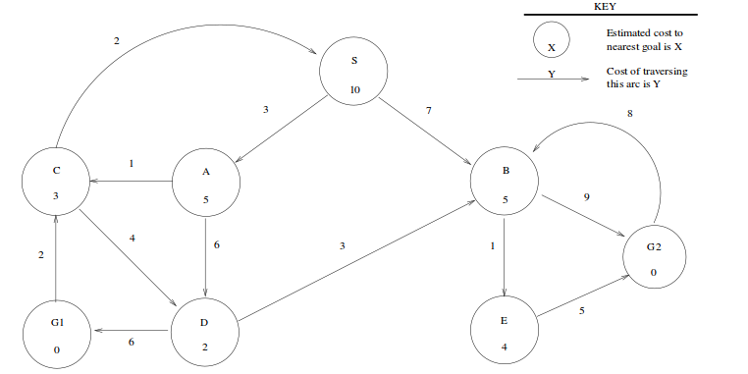Assume you have the below search graph, where S is the start node and G1 and G2 are goal nodes. Arcs are labeled with the cost of traversing them and the estimated cost to a goal is reported inside nodes.

For each of the search strategies listed below, indicate which goal state is reached (if any) and list, in order, the states expanded:

**Depth-First**

Goal state reached: ______ **G2**__________ States expanded **S, A, C, D, B, E, G2**_______ *(10 pts)*

**Breadth First**

Goal state reached: _____ **G2**________ States expanded **S, S, A, B, S, A, C, D, B, E, G2** *(10 pts)*

**Question 2** (25 pts)

Use the following tree to indicate the order that nodes are expanded, for different types of search. Assume that A is the start node and G (double box) is the only goal node. Here, path costs are shown to the right of each path, g = cost of path so far, h = estimate of remaining cost to goal, f = estimate of total path cost.

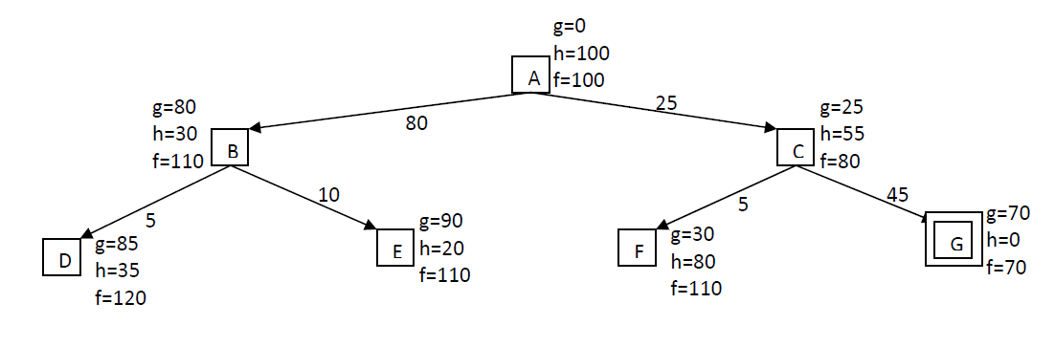

1. *Uniform-cost search. (5 pts)*

A, C, F, G

1. *Best-first search. (5 pts)*

A, B, E, D, C, G.

1. *A* search. (5 pts)*

A, C, G.

1. *Is the heuristic h admissible? (5 pts)*

NO. For example, h(A)=100, but the optimal cost to the goal node G is only 70. Thus, h(A) sometimes OVER-ESTIMATES the remaining optimal distance to G, and so is not admissible.

1. *Relabel the heuristic values h so that h is admissible but not consistent. (5 pts)*

There are many possibilities. One minimal change is to set h(A)=60 and h(C)=20. This is admissible because h(A) = 60 ≤ h*(A) = 70 and h(C) = 20 ≤ h*(C) = 45 (recall that h* is the true optimal remaining distance to the goal). It is not consistent because f(n) decreases along the path

A-C-G, i.e., f(A) = g(A)+h(A) = 0+60 = 60 > 45 = 25+20 = cost(A,C)+h(C) = g(C)+h(C) = f(C).

Any solution satisfying the following criteria should receive full credit:

Admissible:

70 ≥ h(A)

45 ≥ h(C)

Not consistent:

h(A) > cost(A,C)+h(C) = 25+h(C)

Admissible and not consistent:

70 ≥ h(A) > cost(A,C)+h(C) = 25+h(C)

**Question 3** (20 pts)

Consider the following map and table:

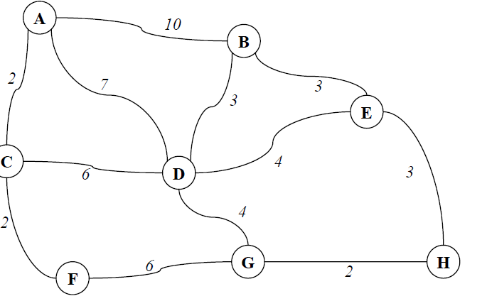

Heuristic values of states:

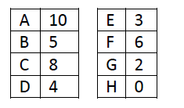

1. With the initial state being A and the goal state being H, what are the first four nodes, in order, that will be expanded using Greedy Search? (do **NOT** show anything else)

List of the first four expanded nodes: ADGH *(10 pts)*

1. With the initial state being A and the goal state being H, what are the first four nodes, in order, that will be expanded using BFS? (Assume that nodes are inserted into the fringe in ascending alphabetic order: A to Z) (do **NOT** show anything else)

List of the first four expanded nodes: ABCD *(10 pts)*

**Part II: Adversarial Search [35 points]**

**Question 1: Minimax Algorithm (15 points)**

Perform Minimax on this tree. Write the Minimax value associated with each node in the box below, next to its corresponding node letter.

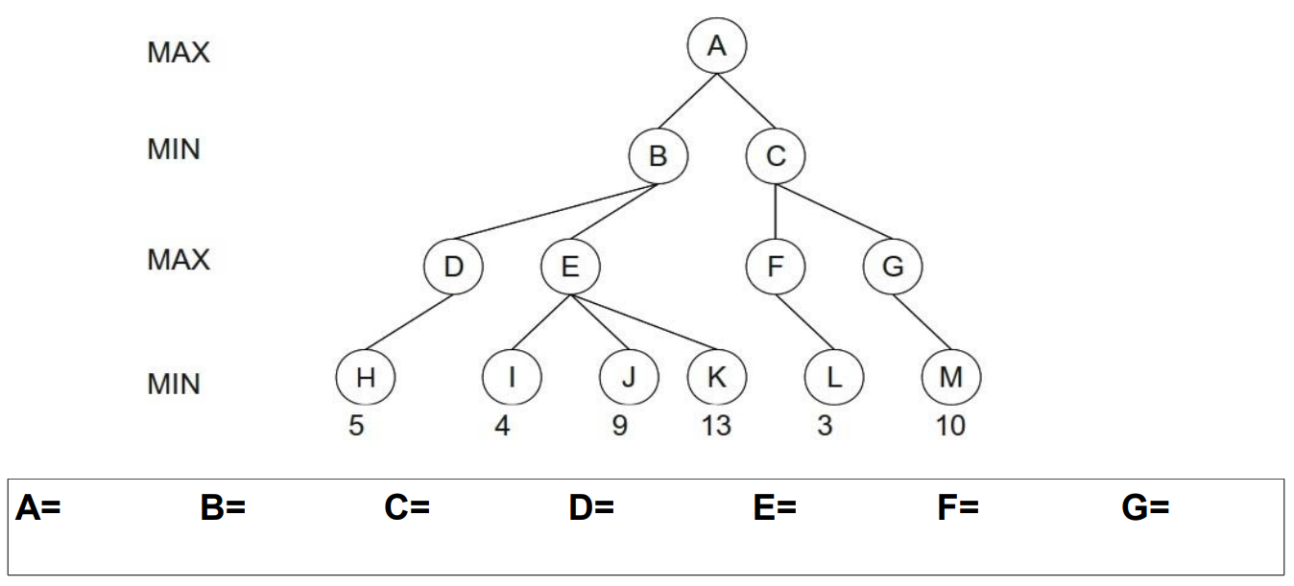

10

3

13

5

3

5

5

What path will be selected by MAX? Assume that MIN and MAX are both rational agents.

A – B – D – H

**Question 2: alpha-beta pruning (20 points)**

Indicate which branches of the below tree will be pruned by alpha-beta pruning

