YallaMarket
Final Report — Comprehensive System Documentation
Software Engineering Course Project
University | An-Najah National University
Course | Software Engineering
Instructor | Dr. Firas Shakaa
Program / Major | Computer Science Apprenticeship
Semester | Second Semester
Methodology | Agile / Scrum
Technology Stack | React + Vite + Tailwind CSS, Express.js, SQLite, JWT
GitHub Repository | https://github.com/BaraaMasri99/yallaMarket
Team Members
Baraa Masri | Scrum Master / Development / Documentation
Hamed Bizreh | Development / Design / QA Evidence
Yahya Ziyoud | Development / Design / QA Evidence
Final Submission Version | May 2026

Contents
Table of Contents 2
1. Executive Summary 3
2. Project Overview and Problem Definition 3
2.1 Problem Definition 3
2.2 Product Scope 3
3. Stakeholder Analysis 3
4. Requirements Summary 4
4.1 Functional Requirements Summary 4
4.2 Non-Functional Requirements Summary 4
5. System Architecture and Technology Stack 4
6. System Design Document (SDD) 5
6.1 Use Case Diagram 6
6.2 Class Diagram 7
6.3 Sequence Diagrams 7
6.3.1 Login / Logout Flow 9
6.3.2 Language Switch Flow 10
7. Database Design 11
7.1 Entity Relationship Diagram 12
7.2 Data Model Summary 13
8. Implementation Overview 13
8.1 Frontend Implementation 13
8.2 Backend Implementation 13
8.3 API Summary 13
9. Quality Assurance 14
9.1 Test Plan Summary 14
9.2 Test Execution Summary 14
9.3 Bug Summary 14
9.4 Requirements Traceability Matrix 14
10. Agile Project Management Evidence 14
11. Version Control and Collaboration Evidence 15
12. Final Demo and Presentation Plan 15
13. Known Limitations and Future Enhancements 15
14. Final Submission Checklist 16
15. Conclusion 16
Appendix A. Detailed QA Test Cases 17
Appendix B. Jira and GitHub Evidence Screenshots 18
B.1 Sprint 1 Evidence 18
B.2 Sprint 2 Evidence 19
B.3 Sprint 3 Evidence 20
B.4 Sprint 4 Evidence 21
B.5 Sprint 5 Final QA Evidence 22
B.6 Jira-GitHub Integration Evidence 23
B.7 Velocity Report 24
B.8 GitHub Repository Evidence 25

1. Executive Summary
YallaMarket is a full-stack bilingual digital marketplace developed as a Software Engineering course project. The system provides a storefront for digital products such as game cards, subscriptions, balances, and related digital services. It supports Arabic and English interfaces, RTL/LTR layout switching, product browsing, cart management, checkout/order submission, authentication, and admin management features.
The final implementation follows a layered architecture using React, Vite, Tailwind CSS, React Router, and Context API on the frontend; Express.js REST APIs and JWT authentication on the backend; and SQLite for server-side persistence. The development lifecycle was managed through Jira using Agile/Scrum practices, while GitHub was used for collaboration, branching, commits, and pull request evidence.
This report consolidates the engineering process: requirements, system design, implementation, QA testing, bug tracking, Agile evidence, version control evidence, and final submission readiness.

2. Project Overview and Problem Definition

2.1 Problem Definition
Digital marketplace users need a clear, responsive, and localized shopping experience that allows them to browse digital products, manage a cart, submit orders, and interact with a bilingual interface. YallaMarket addresses this need by providing a structured web-based marketplace with customer-facing features and administrative management support.

2.2 Product Scope
- Bilingual storefront interface with Arabic RTL and English LTR support.
- Homepage with category entry points and product navigation.
- Category pages with product listing and search/filter behavior.
- Product details pages showing product information, price, stock status, and related products.
- Shopping cart operations: add, update quantity, remove items, subtotal, delivery fee, total.
- Cart persistence using browser localStorage.
- Checkout flow with customer information, delivery details, payment method selection, and order summary.
- Backend API support for authentication, catalog data, order submission, and admin workflows.
- SQLite database persistence for users, categories, products, orders, and order items.
- Agile project tracking through Jira and collaborative source control through GitHub.

3. Stakeholder Analysis
Stakeholder | Description | Main Interest / Access
Guest | Unauthenticated visitor browsing the storefront. | Browse categories, products, cart, and checkout UI.
Registered User | Customer with an account. | Login, use cart, submit orders, and track personal actions.
Admin | Store manager/operator. | Manage products, categories, orders, and dashboard information.
Development Team | Students building and documenting the system. | Implementation, testing, Jira tracking, GitHub collaboration, and final delivery.
Instructor / Evaluator | Software Engineering course reviewer. | Assess requirements, design, implementation, QA, Agile process, and proof of work.

4. Requirements Summary

4.1 Functional Requirements Summary
ID | Requirement | Implementation Area | Final Status
FR-01 | Browse categories | Homepage, category API/service | Implemented
FR-02 | View category products | CategoryPage, product API/service | Implemented
FR-03 | Search/filter products | Category search and API filtering | Implemented
FR-04 | View product details | ProductPage and related products | Implemented
FR-05 | Add to cart | ProductCard/ProductPage + CartContext | Implemented
FR-06 | Update quantity | CartPage + CartContext | Implemented
FR-07 | Remove cart item | CartPage + CartContext | Implemented
FR-08 | Persist cart | localStorage under cart state | Implemented
FR-09 | View cart summary | OrderSummary/cart totals | Implemented
FR-10 | Checkout form | CheckoutPage + order service | Implemented
FR-11 | Language switch | LanguageContext + document dir/lang | Implemented
FR-12 | Display feedback | Toast/errors/fallback UI | Implemented
FR-13 | Register account | Auth API + Register UI | Implemented
FR-14 | Login | Auth API + Login UI + JWT | Implemented
FR-15 | Logout | Client-side session clearing | Implemented / limited
FR-16 | Protected routes | Frontend route guard + backend middleware | Implemented
FR-17 | Submit order | POST /api/orders + SQLite persistence | Implemented
FR-18 | Admin management | Admin dashboard, products, categories, orders | Implemented

4.2 Non-Functional Requirements Summary
Category | Requirement | Verification Approach
Performance | Primary pages should load within an acceptable time for local/demo use. | Build verification and manual browser testing.
Responsiveness | Support mobile, tablet, and desktop layouts. | Manual UI review using responsive layouts.
Usability | User can move from browsing to checkout through a clear flow. | Manual end-to-end checkout test.
Localization | Arabic RTL and English LTR should be supported. | Language switch and direction test cases.
Reliability | Handle empty states, invalid routes, and API errors gracefully. | Error handling and route fallback tests.
Maintainability | Organized frontend/backend structure with reusable services/components. | Repository structure review.
Security | Use password hashing and JWT authentication. | Auth API and middleware review.
Quality Assurance | Manual test cases, results, and Jira bug tracking evidence. | QA report and Sprint 5 evidence.

5. System Architecture and Technology Stack
YallaMarket follows a three-layer architecture. The presentation layer renders the user interface and manages client-side state. The application/API layer exposes REST endpoints and applies business logic, authentication, validation, and protected route handling. The data layer persists users, categories, products, orders, and order items using SQLite.
Layer | Technology | Responsibility
Presentation Layer | React + Vite + Tailwind CSS + React Router | UI, routing, RTL/LTR, product browsing, cart, checkout, admin screens.
Application/API Layer | Express.js + controllers + middleware | Business logic, REST endpoints, JWT authentication, validation, admin protection.
Data Layer | SQLite | Persistent storage for users, categories, products, orders, and order items.
Client Storage | localStorage | Cart persistence and selected session/auth data where appropriate.
Collaboration & Process | Jira + GitHub | Sprint planning, bug tracking, commits, branching, pull requests, and evidence.
W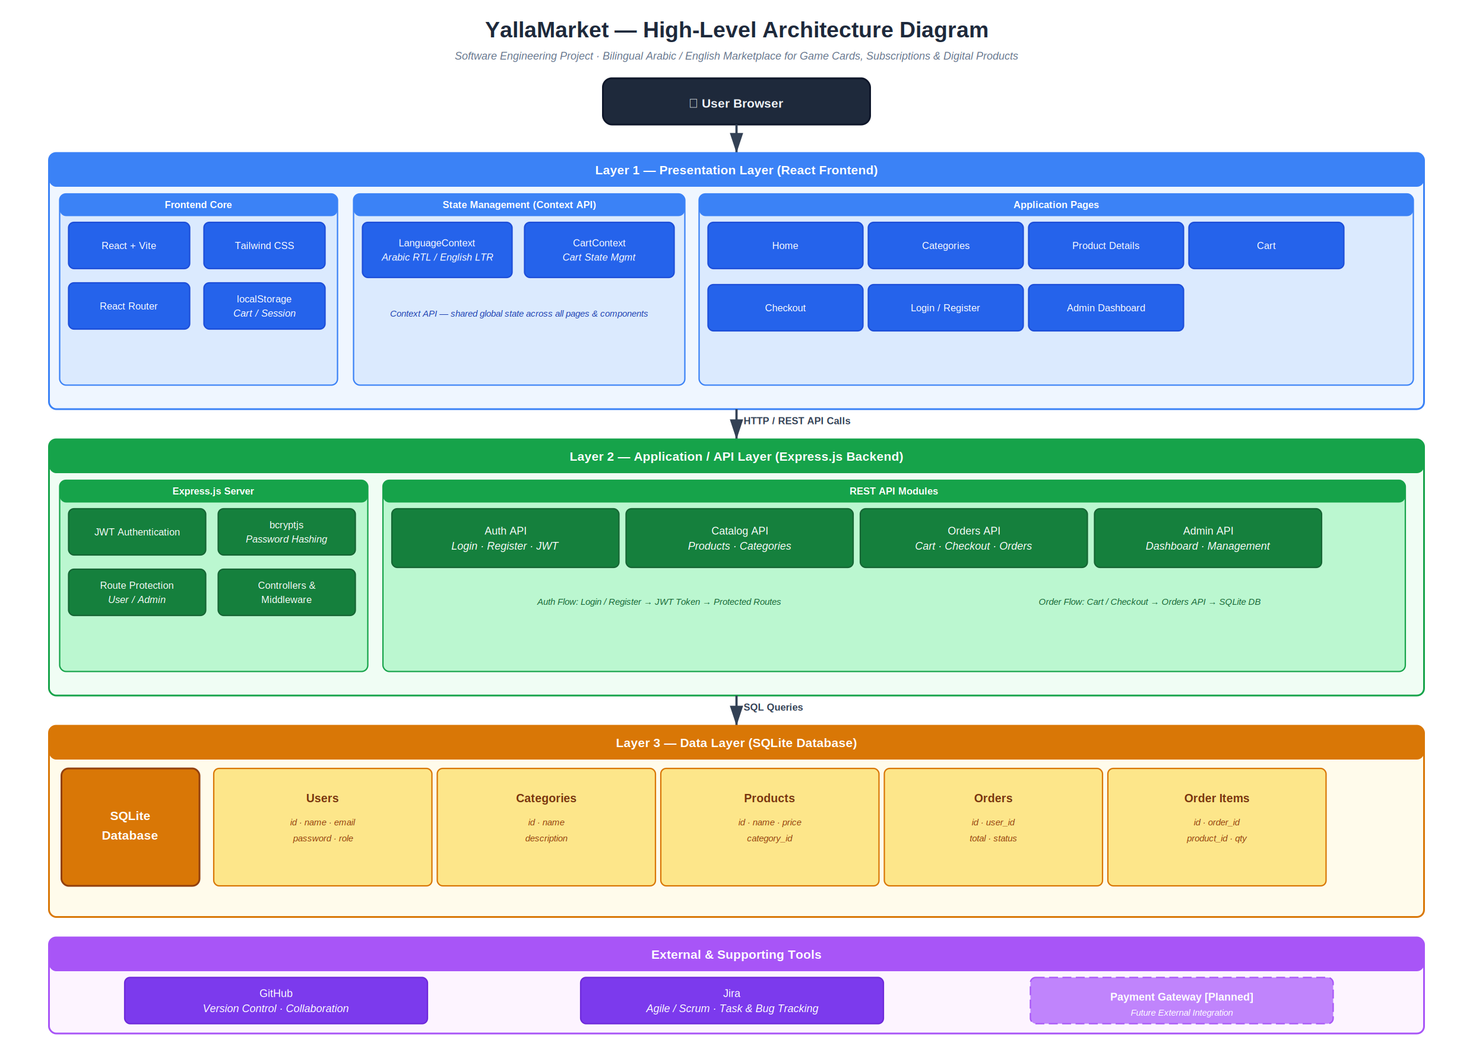
Figure 1. YallaMarket high-level three-layer architecture.

6. System Design Document (SDD)
This section presents the main UML and architecture artifacts used to model YallaMarket. The design diagrams describe users, system behavior, class-level structure, database relationships, and important sequence flows.

6.1 Use Case Diagram
The use case diagram models the interaction between customers, admins, and external systems. It covers browsing, authentication, cart operations, order placement, payment method selection, and administrative management.
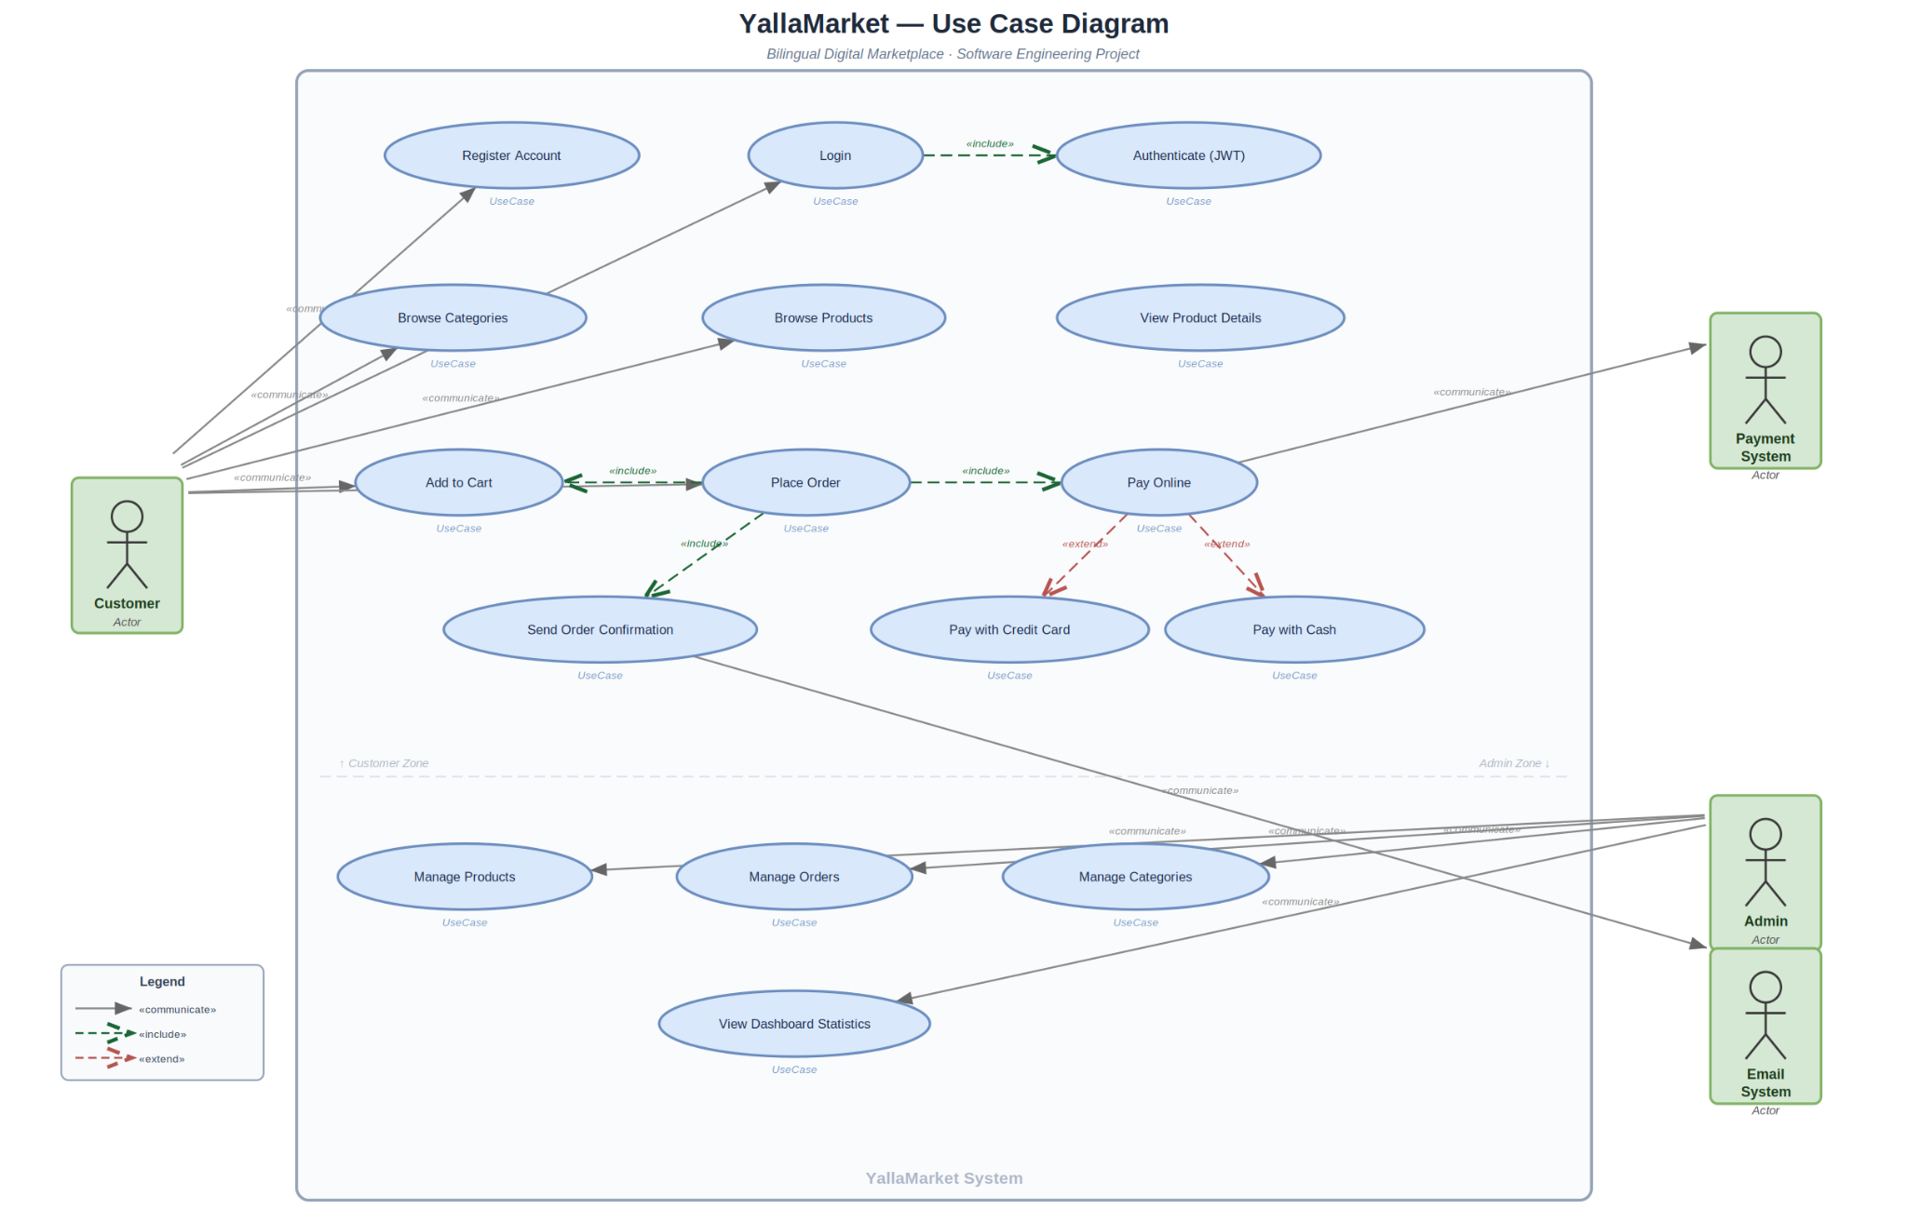

6.2 Class Diagram
The class diagram represents the main domain concepts and supporting client services/contexts, including User, Category, Product, Cart, CartItem, Order, OrderItem, LanguageContext, CartContext, and service modules.
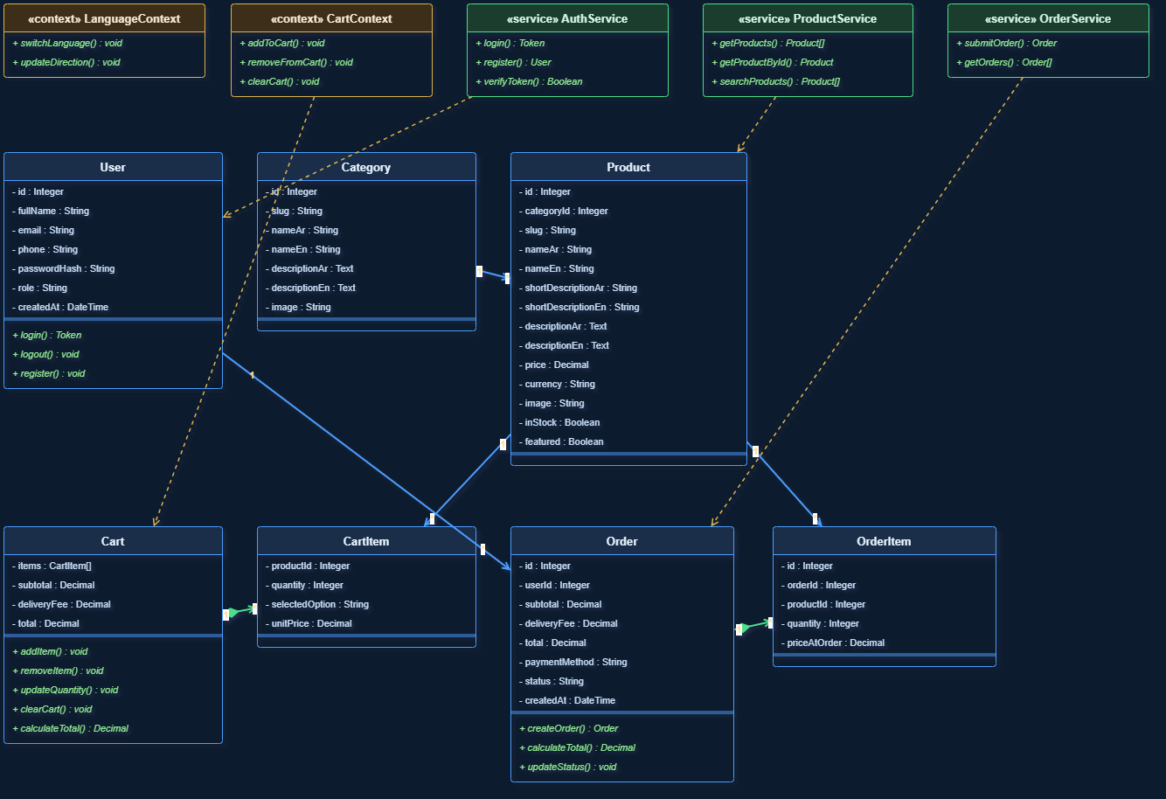

6.3 Sequence Diagrams
Three sequence diagrams document important runtime flows: checkout order submission, login/logout, and language switching. These diagrams demonstrate how frontend state, backend APIs, localStorage, JWT, and SQLite interact during key system operations.
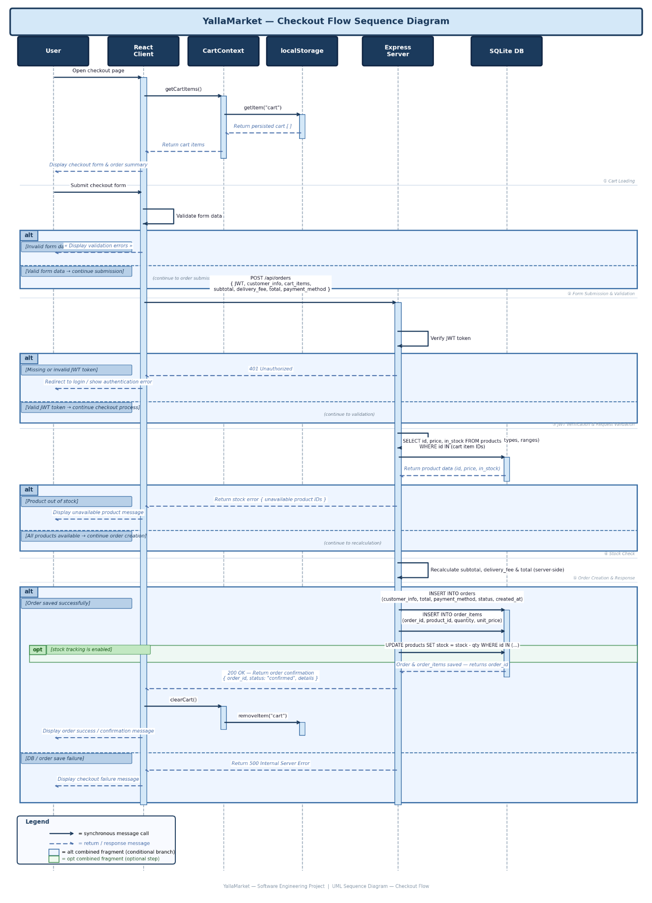

6.3.1 Login / Logout Flow
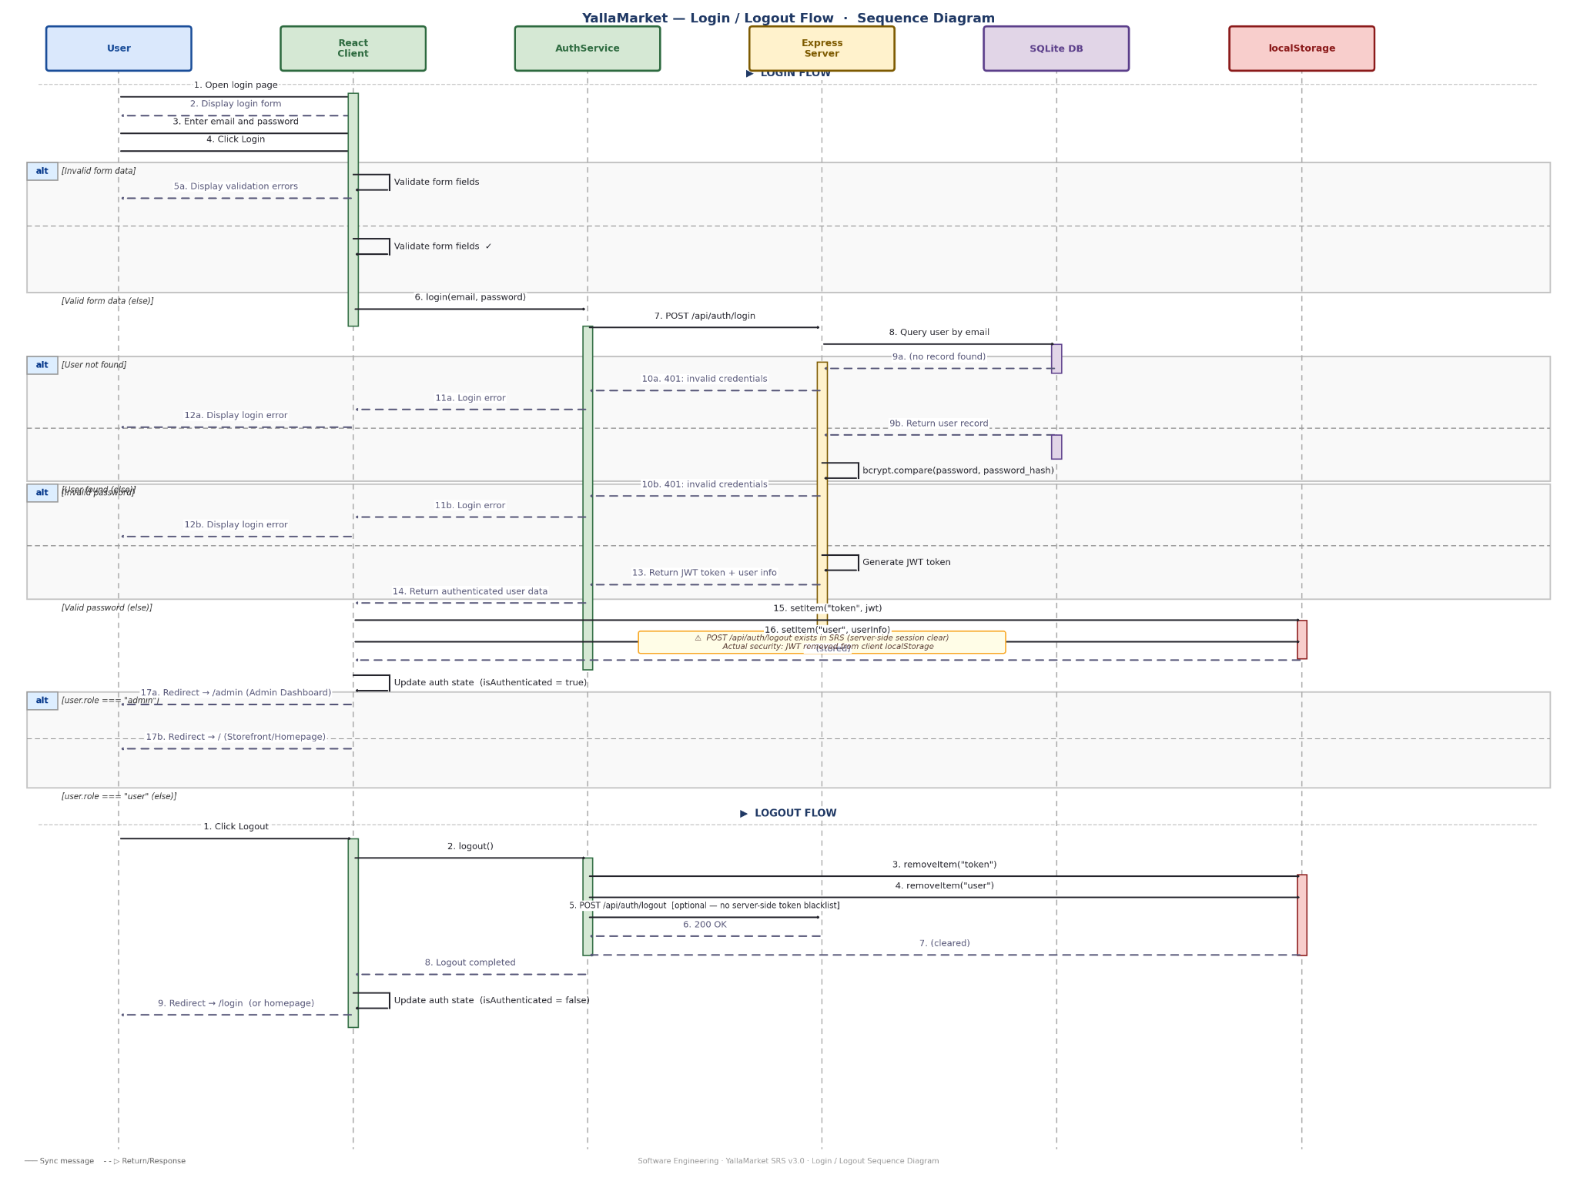

6.3.2 Language Switch Flow
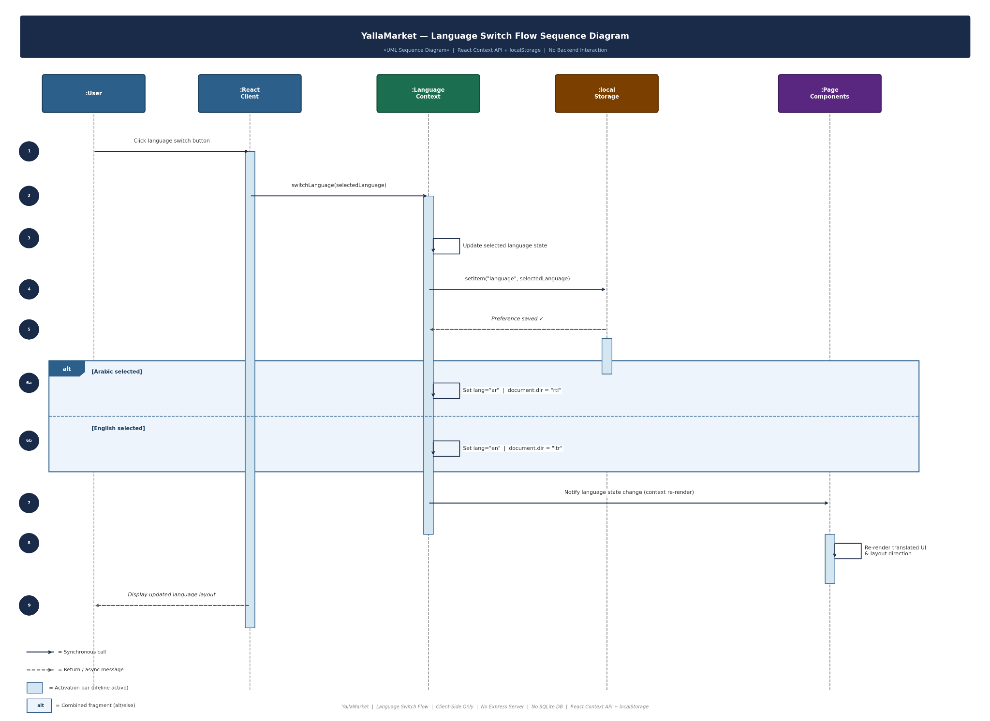

7. Database Design
YallaMarket uses SQLite as a lightweight relational database. The main persistent entities are categories, products, users, orders, and order_items. The cart is intentionally client-side only and is persisted in localStorage until the checkout flow converts cart items into order_items.

7.1 Entity Relationship Diagram
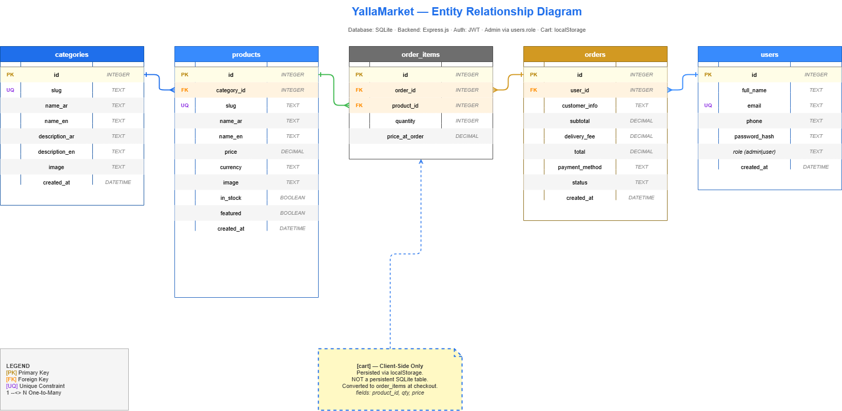

7.2 Data Model Summary
Entity | Purpose | Key Fields / Relationships
categories | Stores product categories. | id, slug, name_ar/name_en, descriptions, image. One category has many products.
products | Stores purchasable digital products. | id, category_id, names, descriptions, price, image, stock/availability fields.
users | Stores customer/admin accounts. | id, full_name, email, phone, password_hash, role, created_at.
orders | Stores checkout orders. | id, user_id, customer_info, totals, payment_method, status, created_at.
order_items | Stores items belonging to an order. | id, order_id, product_id, quantity, price_at_order.
client cart | Temporary client-side cart before checkout. | Stored in localStorage; converted to order_items during order submission.

8. Implementation Overview

8.1 Frontend Implementation
- React + Vite project structure under client/src.
- Customer pages: Home, CategoryPage, ProductPage, CartPage, CheckoutPage, LoginPage, RegisterPage, NotFoundPage.
- Admin pages: AdminDashboard, AdminProducts, AdminCategories, AdminOrders.
- Reusable components include Layout, Navbar, Footer, ProductCard, CategoryCard, CartItem, QuantitySelector, OrderSummary, Toast, AuthForm, AdminRoute, and Spinner.
- Context providers handle language, cart, and authentication state.
- LanguageContext updates document language and direction and persists user language preference.
- CartContext manages add/update/remove/clear behavior and persists the cart in localStorage.
- AuthContext stores the JWT and authenticated user data.

8.2 Backend Implementation
- Express.js backend under server/src.
- Main app/server files handle middleware, routing, and application startup.
- Auth routes support register, login, and logout behavior.
- Product and category routes support public catalog access and admin CRUD operations.
- Order routes support authenticated order creation, user order retrieval, and admin order management.
- JWT middleware protects authenticated routes; admin middleware protects role-based actions.
- Passwords are hashed using bcrypt/bcryptjs and tokens are signed/verified using jsonwebtoken.
- SQLite schema and data are initialized through backend database configuration.

8.3 API Summary
Method | Endpoint | Purpose | Auth | Status
GET | /api/health | API health check | No | Implemented
POST | /api/auth/register | Create user account | No | Implemented
POST | /api/auth/login | Authenticate user and return JWT | No | Implemented
POST | /api/auth/logout | Logout / clear client session | Token optional | Implemented / limited
GET | /api/categories | List categories | No | Implemented
GET | /api/categories/slug/:slug | Get category by slug | No | Implemented
POST | /api/categories | Create category | Admin | Implemented
PUT | /api/categories/:id | Update category | Admin | Implemented
DELETE | /api/categories/:id | Delete category | Admin | Implemented
GET | /api/products | List/search/filter products | No | Implemented
GET | /api/products/:id | Product details | No | Implemented
GET | /api/products/related/:id | Related products | No | Implemented
POST | /api/products | Create product | Admin | Implemented
PUT | /api/products/:id | Update product | Admin | Implemented
DELETE | /api/products/:id | Delete product | Admin | Implemented
POST | /api/orders | Submit order | User | Implemented
GET | /api/orders/my | Current user orders | User | Implemented
GET | /api/orders | Admin order list | Admin | Implemented
GET | /api/orders/:id | Order details | Owner/Admin | Implemented
PUT | /api/orders/:id/status | Update order status | Admin | Implemented
GET | /api/admin/dashboard/stats | Dashboard statistics | Admin | Implemented

9. Quality Assurance
Quality assurance focused on manual functional testing, integration testing, UI validation, authentication validation, cart persistence, checkout/order flow, admin functionality, localization, and route/error handling. Testing was documented as part of the final QA sprint and connected with Jira bug tracking evidence.

9.1 Test Plan Summary
Area | QA Approach
Scope | Storefront, categories, products, cart, checkout, auth, admin, localization, routing, and error handling.
Environment | Local frontend/backend environment, modern browser, SQLite database with seeded/demo data.
Testing Type | Manual functional testing, integration testing, UI/UX verification, regression checks.
Entry Criteria | Frontend and backend run successfully; database available; main pages accessible.
Exit Criteria | Core test cases pass; discovered bugs are resolved/verified; Jira evidence captured.

9.2 Test Execution Summary
Metric | Value | Notes | Result
Manual Test Cases | 20 | Covers storefront, cart, auth, checkout, admin, localization, and error handling. | Completed
Passed | 20 | All final manual test cases passed after final QA fixes. | Pass
Failed | 0 | No open blocking failures at final QA sign-off. | Pass
Jira Bugs Tracked | 4 | SCRUM-127 to SCRUM-130. | Resolved
Final QA Tasks | 3 | SCRUM-131 to SCRUM-133. | Done

9.3 Bug Summary
Jira Key | Bug Summary | Severity | Resolution | Status
SCRUM-127 | Cart total did not update immediately after quantity changes. | Medium | Cart recalculation behavior verified and corrected. | Done
SCRUM-128 | Checkout validation messages were unclear for incomplete forms. | Medium | Validation feedback improved and verified. | Done
SCRUM-129 | Language direction was inconsistent after switching languages. | Medium | RTL/LTR behavior verified and synchronized. | Done
SCRUM-130 | Invalid product routes needed improved fallback handling. | Medium | NotFound/fallback behavior improved and verified. | Done

9.4 Requirements Traceability Matrix
Requirement Area | Implementation Area | Related Test Cases | Result
Browse categories | HomePage + category API | TC-01, TC-02 | Pass
Search/filter products | CategoryPage + product service | TC-03, TC-04 | Pass
Product details | ProductPage + related products | TC-05, TC-06 | Pass
Cart operations | CartContext + CartPage | TC-07 to TC-10 | Pass
Authentication | Auth API + AuthContext | TC-11 to TC-13 | Pass
Checkout/orders | CheckoutPage + Order API | TC-14 to TC-16 | Pass
Admin features | Admin dashboard/products/orders | TC-17, TC-18 | Pass
Localization | LanguageContext + RTL/LTR | TC-19 | Pass
Error handling | NotFound/fallback UI | TC-20 | Pass

10. Agile Project Management Evidence
The project was managed using Agile/Scrum in Jira. The backlog included requirements, design activities, frontend tasks, backend tasks, integration tasks, deployment/testing tasks, and a final QA sprint. Sprint 5 was used for final quality assurance, bug tracking, documentation, presentation preparation, and delivery evidence.

Sprint | Focus | Representative Work | Status
Sprint 1 | Project setup and early frontend foundation | React + Vite setup, homepage, navbar, repository setup, SRS and initial diagrams. | Completed
Sprint 2 | Frontend stabilization and core storefront | CartContext, cart page, CategoryPage, ProductCard, language support, UX refinements. | Completed
Sprint 3 | Backend and database integration | Node/Express setup, SQLite models, Auth API, products/categories/orders REST APIs, sample data. | Completed
Sprint 4 | Full-stack integration and admin functionality | API connection, admin dashboard/products/orders, deployment/testing, Postman API validation. | Completed
Sprint 5 | Final QA and delivery preparation | Bugs SCRUM-127..130, QA documentation, final presentation/demo flow, Jira/GitHub evidence. | Completed

11. Version Control and Collaboration Evidence
GitHub was used as the team repository for collaborative implementation. Evidence includes commit history, branches, pull requests, merge activity, and Jira integration through issue keys. The repository URL is: https://github.com/BaraaMasri99/yallaMarket
Evidence Type | What It Demonstrates | Included Evidence
Repository overview | Project structure and final working codebase. | GitHub repository screenshot.
Commit history | Incremental implementation and maintenance. | Commit count and recent commit activity.
Branches | Team collaboration and task separation. | Branch count evidence.
Pull requests | Integration workflow and Jira issue linking. | Merged PR screenshot with Jira issue references.
Jira integration | Traceability between project management and code changes. | GitHub/Jira link screenshot.

12. Final Demo and Presentation Plan
The recorded presentation should demonstrate the full engineering process and the working system. All team members should participate. The recommended demo flow is structured to reduce risk and present the strongest features first.
Step | Presenter / Focus | Content
1 | Project introduction | Problem, solution idea, scope, and target users.
2 | Requirements and design | SRS summary, stakeholders, use case diagram, architecture, ERD.
3 | Storefront demo | Home, language switch, categories, product browsing, search.
4 | Cart and checkout demo | Add to cart, update quantity, refresh persistence, checkout submission.
5 | Authentication demo | Register/login and protected behavior.
6 | Admin demo | Dashboard, products/categories/orders, update order status.
7 | QA and Agile evidence | Test cases, bugs, Jira sprints, GitHub commits/PRs, velocity report.
8 | Conclusion | Known limitations, future enhancements, and final readiness.

13. Known Limitations and Future Enhancements
- Real external payment gateway integration is not included; the current system supports payment method selection and order recording.
- Logout mainly clears the client-side token/session; server-side token invalidation can be improved in future versions.
- The system uses SQLite for lightweight academic/demo persistence; a production deployment could migrate to a managed relational database.
- Automated test coverage can be added in future work; the current submission provides structured manual QA testing and Jira bug tracking evidence.
- Additional deployment hardening, monitoring, and production secrets management can be added beyond the course scope.

14. Final Submission Checklist
Submission Item | Evidence / File | Status
Final Report PDF | This comprehensive report exported to PDF. | Ready for export
SRS | SRS v3.0 included/summarized in the report. | Ready
System Design Document | Use Case, Class, Sequence diagrams, Architecture, ERD. | Ready
QA Documentation | QA report, test cases, test results, bug summary. | Ready
Agile Evidence | Jira backlog, sprints, Sprint 5 bugs/tasks, velocity report. | Ready
GitHub Evidence | Repository URL, commits, branches, pull requests, Jira links. | Ready
Source Code ZIP | Final working project archive. | Prepare before upload
Presentation PPTX | Final presentation slides. | Prepare/polish
Video Recording | All members participate in presentation and proof-of-work demo. | Record after rehearsal

15. Conclusion
YallaMarket demonstrates a complete Software Engineering lifecycle for a full-stack digital marketplace: requirements definition, stakeholder analysis, system design, implementation, testing, Agile tracking, and final delivery preparation. The project includes a working bilingual storefront, authentication, cart persistence, checkout/order flow, admin management, SQLite persistence, Jira evidence, GitHub collaboration evidence, and QA documentation.
The final focus was not to redesign the product, but to stabilize the existing implementation, document quality assurance, resolve final QA issues, and prepare a professional submission package. Based on the completed implementation and documentation artifacts, the project is ready for final presentation and course submission after final packaging and video recording.

Appendix A. Detailed QA Test Cases
TC ID | Feature | Scenario | Expected Result | Actual Result | Status
TC-01 | Home / Categories | Open homepage | Categories are displayed correctly. | Categories loaded successfully from API. | Pass
TC-02 | Categories | Open a category page | Related products are displayed. | Products displayed successfully. | Pass
TC-03 | Search | Search using an Arabic keyword | Matching Arabic products appear. | Arabic filtering works correctly. | Pass
TC-04 | Search | Search using an English keyword | Matching English products appear. | English filtering works correctly. | Pass
TC-05 | Product Details | Open product details page | Product name, price, description, and stock are visible. | Product details loaded successfully. | Pass
TC-06 | Related Products | View related products section | Related products are displayed. | Related products displayed successfully. | Pass
TC-07 | Cart | Add available product to cart | Cart count and item list update. | Product added successfully. | Pass
TC-08 | Cart | Update item quantity | Quantity and totals update correctly. | Totals update after quantity changes. | Pass
TC-09 | Cart | Remove item from cart | Item is removed and totals recalculate. | Item removed successfully. | Pass
TC-10 | Cart Persistence | Refresh browser after adding cart items | Cart remains saved. | Cart persisted using localStorage. | Pass
TC-11 | Authentication | Register new user | Account is created successfully. | Registration completed successfully. | Pass
TC-12 | Authentication | Login with valid credentials | User is authenticated and token stored. | JWT authentication works correctly. | Pass
TC-13 | Authentication | Login with invalid credentials | Clear error message is displayed. | Invalid login feedback displayed. | Pass
TC-14 | Checkout | Open checkout with empty cart | User sees empty cart/checkout restriction. | Empty cart behavior handled. | Pass
TC-15 | Checkout | Submit checkout while logged out | System requires authentication. | Login/authentication requirement displayed. | Pass
TC-16 | Checkout | Submit valid order while logged in | Order is created and saved. | Order submitted successfully. | Pass
TC-17 | Admin | Admin dashboard access | Dashboard statistics are visible to admin. | Admin dashboard loaded correctly. | Pass
TC-18 | Admin Orders | Update order status | Order status updates and persists. | Order status updated successfully. | Pass
TC-19 | Localization | Switch Arabic/English | Language and direction update correctly. | RTL/LTR switch verified. | Pass
TC-20 | Routing/Error Handling | Open invalid product/category URL | Fallback or NotFound message appears. | Fallback handling verified. | Pass

Appendix B. Jira and GitHub Evidence Screenshots

B.1 Sprint 1 Evidence
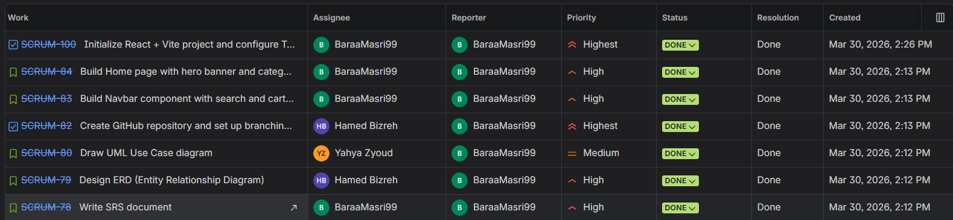
Figure 8. Sprint 1 completed work items.

B.2 Sprint 2 Evidence
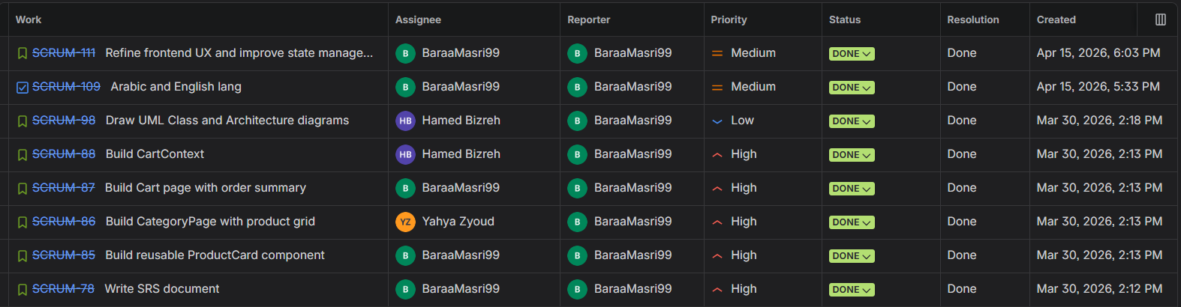
Figure 9. Sprint 2 completed work items.

B.3 Sprint 3 Evidence
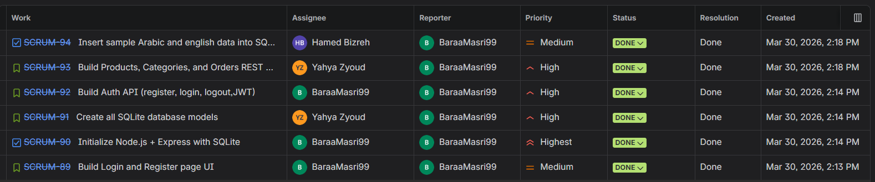
Figure 10. Sprint 3 backend and integration items.

B.4 Sprint 4 Evidence
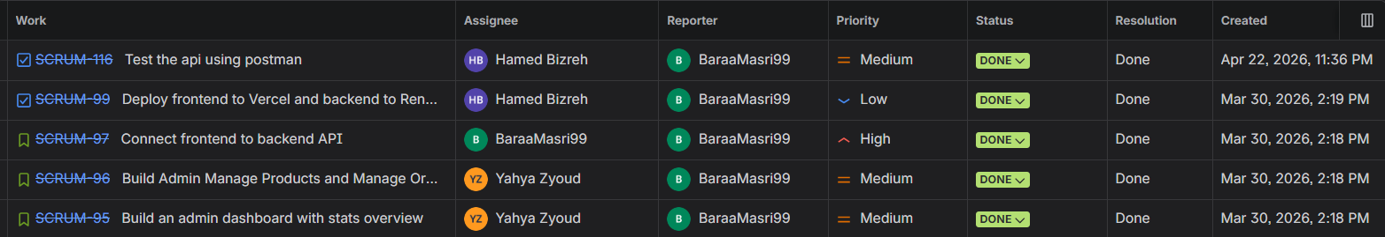
Figure 11. Sprint 4 integration, admin, deployment/testing items.

B.5 Sprint 5 Final QA Evidence
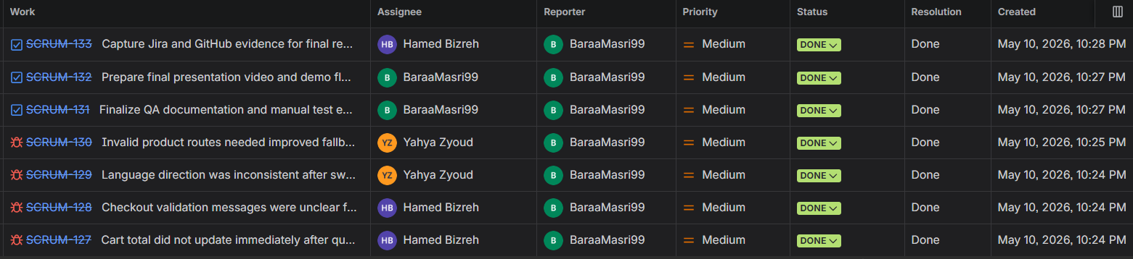
Figure 12. Sprint 5 final QA bugs and tasks marked Done.

B.6 Jira-GitHub Integration Evidence
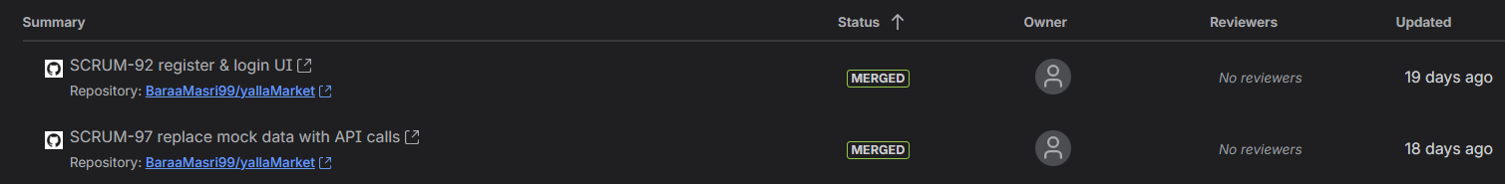
Figure 13. Merged pull requests linked to Jira issue keys.

B.7 Velocity Report
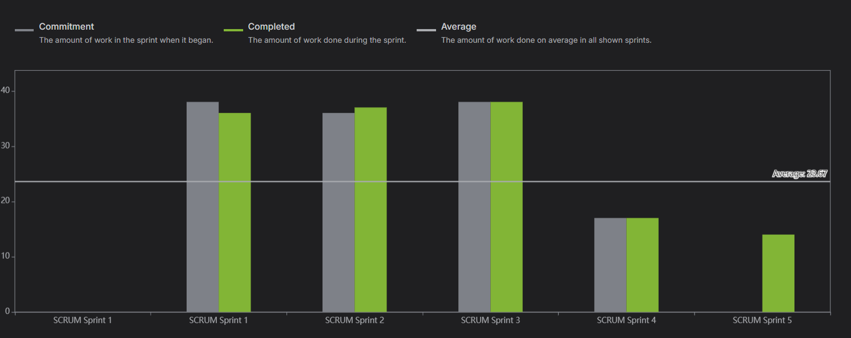
Figure 14. Jira velocity report showing sprint progress.

B.8 GitHub Repository Evidence
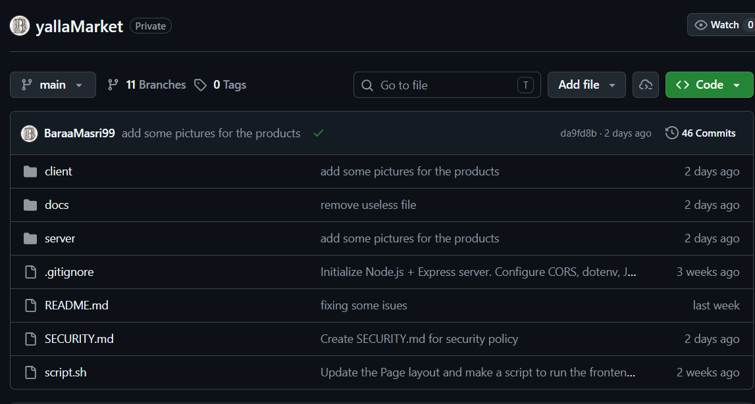
Figure 15. GitHub repository overview showing project structure and commit history.

