**Translify**

‘WEB APPLICATION FOR A FREIGHT FORWARDING AGENCY’

A Project Submitted for partial fulfillment of the requirements for the award of Diploma in Full Stack Software development to the department of web development at the Institute of Software Technologies.

Baraka Mulumia Mshindi



2021

# DECLARATION

I, Baraka Mulumia Mshindi do hereby declare that the work presented herein is my original work done by me. No substantial part of this work has already been submitted or is being submitted for any other qualification in the institution. I further state that any word done by someone else and is cited in this document has the been properly acknowledged and referenced.

Baraka Mulumia Mshindi

Signature: ____________ Date: ____________

This proposal has been submitted for examination with my approval as a supervisor

Mr. Boniface Tum

**(Supervisor)**

Signature: ____________ Date: ____________

# ACKNOWLEDGEMENT

I would like to express my deep sense of gratitude to my supervisor Mr. Boniface Tum, for the encouragement, continuous guidance, advice and extraordinary significant effort throughout the project and in the various stages of my training period.

My utmost gratitude to my fellow students Festus Ribiro, Nasra Mohamed and William Muthama for their loving, inspirational and timely academic support in carrying out this project.

Lastly, I would like to express my sincere appreciation to my parents especially my Mom for encouraging and supporting me throughout the project.

# ABSTRACT

Good things happen when people can move, whether across town or toward their dreams. Opportunities appear, open up and become a reality, **Translify** project is an online freight management web application with the aim of connecting freight clients with truck drivers and other freight transport providers to be able to improve the circulation of goods and residence relocation to different geographical locations.

**Translify**, completely replaces phone calls, emails, and haggling using transparent pricing and instant booking. Get your products in the move in less than five minutes. Drivers can use the app for commercial navigation, check-in and check-out, and get detailed load information.

The application is far way better than the current freight management systems as it provides an honest and flexible environment for both drivers and freight clients, the application is designed to work like taxi ordering applications, think of it as uber, except it’s tailored to the specifics and needs of the freight forwarding market. It also implements ratings for both drivers and shippers as a way to uphold integrity and transparency within the society as those who will have consistent low ratings will be weeded out of the system.

# List of Abbreviations

GDP - Gross Domestic Product

SDLC – Software Development Life Cycle

SSL - Secure Sockets Layer

UI – User Interface

IT – Information Technology

# List of Tables

1. Table 1.1 – Project Budget and resources ……………………….3
2. Table 5.1 – Clients Model ……………………………………......23
3. Table 5.2 – Drivers Model………………………………………...23
4. Table 5.3 – **Translify** certified Driver’s Model……………….24
5. Table 5.4 – Orders Model………………………………………….24
6. Table 5.5 – Drivers Transactions Model………………………….25
7. Table 5.6 – Client Transactions Model……………………….…...25

# List of Figures

1. Figure 1.1 - Project schedule grant chat…...…………………………….3
2. Figure 2.1 – Use case diagram …………………………………………5
3. Figure 3.1 - Agile software development life cycle …………………….8
4. Figure 4.1 - System data flow diagram …………………………………18
5. Figure 4.2 - System Admin’s flow chart ……….………………………19
6. Figure 4.3 - clients program data flow chart ………….………..............20
7. Figure 4.4 - drivers program data flow chart ……………………...........21
8. Figure 5.1 - Entity relationship diagram ……………………………….22

Table of Contents

Contents

DECLARATION i

ACKNOWLEDGEMENT ii

ABSTRACT iii

List of Abbreviations iv

List of Tables v

List of Figures vi

CHAPTER ONE: INTRODUCTION 1

1.1 Background of the study 1

1.2 Problem statement 1

1.3 Purpose of the study 2

1.4 Objectives of the study 2

1.5 Scope and Limitation of the study 2

1.6 Justification of the study 2

1.7 Budget and Resources 3

1.8 Project schedule 3

CHAPTER TWO: EVALUATIVE REPORT 4

2.1 Introduction 4

2.2 Elementary statement 4

2.3 Global Freight forwarding 5

2.3.1 Amazon Relay 5

2.4 Freight forwarding in Kenya 5

2.4.1 G4s 5

2.4.2 Ahadi, Tylor movers and the many moving companies in Kenya. 6

2.5 Gaps in the current systems 6

2. 6 Merits of The Proposed System 7

2.6.1 Availability 7

2.6.2 Cashless 7

2.6.3 Professional Service 7

2.6.4 Safe and Flexible for Drivers 7

2.6.5 Timely delivery of goods 8

2.6.6 Competitive Pricing 8

2.6.7 Reduced Working Costs for Drivers 8

2.7 Demerits of The Proposed System 8

2.7.1 Surge Pricing 8

2.7.2 Adverse Impact on Traditional Truck drivers 8

2.7.3 Car wear and tear 8

2.7.4 Work rate can be slow when a driver wants it to be busy 8

2.8 Conclusion 9

CHAPTER THREE: PROJECT METHODOLOGY 10

3.1 Introduction 10

3.2 Reasons for agile software development methodology 11

3.3 Phases initiated in the Development Cycle 11

3.3.1 Over view 11

3.3.2 Planning phase 11

3.3.3 Definition of requirements 12

3.3.4 Designing and Prototyping 13

3.3.5 Software Development 14

3.3.6 Integration and Testing 14

3.2.7 Deployment 15

3.2.8 Operations and Maintenance 15

CHAPTER FOUR: SYSTEM ANALYSIS AND REQUIREMENTS MODELING 16

4.1 Analysis Method 16

4.2 Understanding Problems Posed by the Current system 16

4.3 The Proposed System 17

4.5 Requirements Modeling - Data Flow 18

4.6 Specification of App users 18

4.6.1 Admin 18

4.6.2 Clients 19

4.6.3 Drivers 21

CHAPTER FIVE: SYSTEM DESIGN 22

5.1 Entity Relationship Diagram 22

5.2 Designing of Database Models 23

5.3 Database Connection 26

5.3 System screen shots 26

5.3.1 Main Activity page 26

5.3.2 Sign In 27

5.3.3 Sign Up 27

5.3.4 Client Order Truck page 28

5.3.5 Driver dashboard 28

5.3.6 Admin dashboard 29

CHAPTER SIX: SYSTEM IMPLEMENTATION 30

6.1 INTRODUCTION 30

6.2 Main Activity Page 30

6.3 User Decision Page 30

6.4 Sign-in and Sign-up page 31

6.7 Client Module 31

6.7.1 Client Dashboard 31

6.7.2 Profile Page 31

6.8 Driver Module 31

6.7.1 Driver Dashboard 31

6.7.3 Profile Page 31

6.9 Discover Page 31

6.9.1 About us page 31

6.9.2 How it works page 31

6.10 Services Page 31

6.11 Admin Module 31

CHAPTER SEVEN: CONCLUSION AND RECOMMENDATIONS. 32

REFERENCES 33

APPENDIX 34

# CHAPTER ONE: INTRODUCTION

## 1.1 Background of the study

Blake (2000) noted that the impact of e-business on strategic freight forwarding will be felt on both the demand and supply edges. The technological advancements that have led to an increase in the number of businesses competing for the electronic market has also spited the relocation of businesses and shipping of industrial products within the societies economic cycle. This has changed the patterns of freight flow in major cities.

Business owners, product manufacturers, industries, entrepreneurs and other various capital investors regularly need to move goods whether to distribution centers or to the market for consumption, this is referred to as freight forwarding and just but to rephrase it is the process of shipping goods from one point to another.

Global trade is the vigorous willpower triggering the growth of both regional and international economy. Trade brings a lot of advantages to nations and enterprises, as they get to bestow the fruit of delivery and distribution services. Trade also provides people with various options to buy their daily necessities. To facilitate business growth and regional prosperity, these activities rely on the available transport system to connect the industrial products and people.

Often, in the supply chain management the transport system is spoken of as the moving force for a modern society. Freight transit being a major constituent of this system, its benefits to the economy are enormous as freight transportation increases the value of goods by moving them to locations in which the goods are of more worth, this widens the labor market by encouraging competition and production of goods. Furthermore, freight transportation has provided jobs for millions of truck drivers and other relevant employees which makes a productive society, an important indicator of global economic growth.

## 1.2 Problem statement

Due to megatrends such as digitalization, demographic change, urbanization, globalization and population growth, freight transports are anticipated to keep on increasing in the future. From a freight transport frame of reference, the number of people joining the middle social class in the society is increasing at an alarming rate. As a repercussion the demand for products and relocation will increase panoramically. In the current times, to be able to get freight transport services you would have to make a lot of calls, write some emails and even physically contact a product moving company.

As society continues to grow in all aspects, moving of products from one point to another will be on high demand for both business and personal needs. In order to meet the subsequent arduous necessity of road freight it is essential to have an integrated freight transport management system that can make freight transport services convenient and available always.

## 1.3 Purpose of the study

The purpose of this project is to examine and improve the effectiveness, efficiency and availability of the freight transport system, then design a modern and ameliorated system that aims to provide better service delivery to freight transport users, reduce road congestion and create job opportunities.

## 1.4 Objectives of the study

The major objective of this project to create a blended web application that will provide a platform for both freight clients and freight shippers alongside product distributors by making technological advancements to the logistic utility of the freight forwarding industry to make:

* Freight services accessible via smartphones.
* Freight clients able to move products and have real time updates on the whereabouts of their products.
* Have commodities be where and when they are demanded by the clients.
* Provide time utility and place utility from the point of product production to the point of consumption.

## 1.5 Scope and Limitation of the study

The expanse of this project is limited to a number of areas:

* The application is used only by shippers (freight clients) and truck drivers via their mobile phones and personal computers with an internet connectivity.
* During the initial project deployment, the intended audience of the app are strictly residents of Kenya.
* The app is restricted to one (Credit card) payment systems only.

## 1.6 Justification of the study

Both small- and large-scale enterprises are looking for ways to expand their business in a competitive industry. Finding the easiest way to help these enterprises grow is by managing their transport network.

Having a system that connects shippers to truck drivers easily without many complications guarantees a boost in the escalation of growth for any organization.

## 1.7 Budget and Resources

|  |  |  |
| --- | --- | --- |
|  | Resource | Amount in dollars ($) |
| 1 | Computer | 1000 |
| 2 | Cloud Database Charges | 100 |
| 3 | Personnel | 1000 |

***Table 1.1 Project budget and resources***

## 1.8 Project schedule

The project is scheduled to be developed between 1st December 2020 and 30th April 2021, after deployment of the app, operations, maintenance and feature updating will be done often.

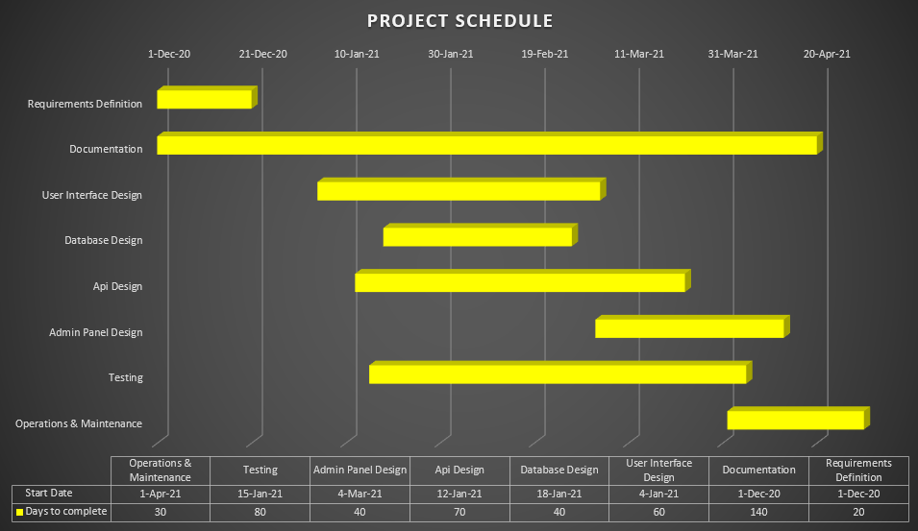

***Figure 1.1 project schedule grant chat***

# CHAPTER TWO: EVALUATIVE REPORT

## 2.1 Introduction

This section provides an evaluative report done after extensive research as a driving force towards getting to comprehend the nature of online freight forwarding systems, evaluate service quality of the existing systems, present a clear case and provide the project’s context

## 2.2 Elementary statement

Advanced technology has made it possible to do a lot of things online at the comfort of your home by the click of a button, technologies like uber enable you to get a ride within minutes and there is where the idea of an online freight management system did arise, to make it possible that the same way we can order for a ride, we can also book a truck and get to move our products or relocate to new regions at ease by the use of a smartphone. Think of it as Uber, not for people but for industrial goods.

Freight forwarding is fundamentally the act of shipping products mainly from the production area to the consumption area, while it also can be geographical relocation, it works by one hiring a truck driver to deliver their product to the intended destination. Currently that happens by explicitly contacting a freight forwarding agency and having to arrange for the transit.

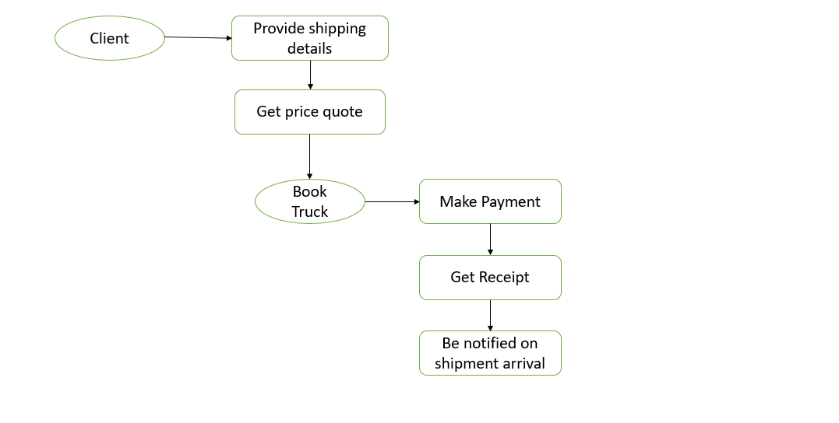

***Figure 2.1 use case diagram***

## 2.3 Global Freight forwarding

International tech giants like Amazon have tried to implement an online application for managing transport of industrial goods, and shipping of products.

### 2.3.1 Amazon Relay

Amazon relay was launched back in October 2019 in an effort to automate the entire application and booking process involved in the transport industry, it works by connecting small freight carriers straight up to available loads to help them quicky grow their businesses, it equips trucking companies, fleet owners, and their drivers everything needed to book and haul loads.

Even though it started out as a successful venture, amazon has the need to revisit its business model as recent events threaten to upset its strategy of winning client loyalty, this has come by because of the expensive cost of shipping with amazon. With client satisfaction and low prices being the chief tools for growth, amazon hasn’t been able to reduce their costs. According to *Tarek Abdallah*, assistant professor of operations at Northwestern University’s Kellogg School of Management, He says *“Amazon’s shipping costs at current levels are not sustainable in the long term.*” If this system were to be implemented in a third world country like Kenya, embracing it would be unrelenting.

A major limitation however is that amazon has had to build two different applications one for the freight clients and another for drivers, this increases the maintenance cost for both applications and also it is not available to countries within east Africa.

## 2.4 Freight forwarding in Kenya

Locally Kenya as country does not have a centralized freight management system, its implementation is scattered in between companies that offer house moving services and cargo currying companies like G4S, Furgo currier and Ahadi Movers, just to name but a few.

### 2.4.1 G4s

G4S is the world's leading global integrated security company specializing in the delivery of security and logistical solutions to clients.

They have been in the logistics industry for a while but their major limitation is service availability as to be able to access logistical services you have to contact the company via email or call them to arrange for transit. This can be frustrating

### 2.4.2 Ahadi, Tylor movers and the many moving companies in Kenya.

These are full service moving and storage companies that pride themselves on servicing clients with local and long distant moves.

A bigger limitation is also availability of their services as you have to email them, Residential moves by these companies start with a price estimate by a professional consultant. Getting an estimate for the amount you will pay for the service is something that should be done online by a client with less work and no boring long calls

## 2.5 Gaps in the current systems

There **Translify** app aims to solve a number of problems faced by the current systems.

The availability of affordable freight forwarding services on a 24/7 basis, is not yet well established as clients cannot get to move goods conveniently.

Freight clients tend to want full transparency on the whereabouts of their delivery at all times, this cannot be evinced in the current times and discourages clients as just about 64 percent of consumers are unwilling to pay before shipping as they have no way of tracking their shipment.

Truck drivers do not have a platform that offers them the opportunity to get more jobs, they rely on middle-men and the moving companies to allocate them jobs.

## 2. 6 Merits of The Proposed System

### 2.6.1 Availability

With an online system getting freight transport services will be available to anyone and at any time. You will not have to call a truck company and reserve a truck in advance for it to be available. Just by a simple tap on a smart phone one can book a truck from any location within minutes.

### 2.6.2 Cashless

The web application comes with a feature that links an individual’s account to their credit card and other supported electronic payment plans. Upon a satisfactory delivery of goods, no cash needs to change hands as the client can make a payment online and receive a receipt of their transaction via email.

### 2.6.3 Professional Service

The truck industry will be well regulated and maintained by the application engineers who will make sure that clients are able to track a driver’s route to ensure the safety of their goods, furthermore the app will only authenticate professional drivers who have proper commercial insurance coverage and meet minimum requirements stipulated for truck driving by the National Transport and Safety Authority.

After every service of goods transportation from one point to another, the clients are able to rate the driver’s performance. A consistently low rating performance will force a driver out of the truck business and hence paving way for an authentic platform where the drivers do their best to give their clients a taste of an ultimate freight transport experience.

### 2.6.4 Safe and Flexible for Drivers

Safety being the most important aspect of a journey, its will be an added advantage for drivers using the application

Firstly, Transactions are cashless which eliminates a driver from facing unpaid fares.

Also, the app provides feature where drivers are able to rate their clients. Rude, aggressive, and disruptive clients are exterminated and their accounts deactivated.

The application offers freedom and flexibility for drivers as instead of the traditional way where they had to work for 12-hour long shifts, they can check in and out of the app anytime and choose their own working hours.

### 2.6.5 Timely delivery of goods

The application is able to filter through the road network and using the global positioning system it is able to recommend the fastest and safest root to drivers, this helps drivers avoid roads with traffic congestion and deliver goods in time.

### 2.6.6 Competitive Pricing

The transport charges are comparatively less expensive and more affordable as compared to the traditional transit goods trucks.

### 2.6.7 Reduced Working Costs for Drivers

In many large cities truck drivers pay up to almost a thousand dollars a month to their company and the city for various administrative services. A web app will not charge any monthly fee for drivers, this makes it possible for beginners and amateur drivers to earn some cash with the app as a side hustle as long as they pass the minimum requirements for being a truck driver.

## 2.7 Demerits of The Proposed System

### 2.7.1 Surge Pricing

Surge pricing is a pricing method that involves increasing or decreasing prices as per the demand and supply of clients. This causes most annoyance to clients as sudden price fluctuation might make the transportation of goods expensive and un affordable

### 2.7.2 Adverse Impact on Traditional Truck drivers

The app will offer cheap prices and frequent discounts on transportation of goods, this pulls clients away from the normal traditional system of goods transit, making it harder for truck drivers who still use conventional means to earn a living. With the web app in place, at one point in the future the traditional transit methods will have zero market share in the economy.

### 2.7.3 Car wear and tear

Drivers are responsible for all truck expenses which can add up to significant added car depreciation, maintenance and repairs on truck.

### 2.7.4 Work rate can be slow when a driver wants it to be busy

There are times when there are too many drivers available compared to clients who need them and as such job requests are low for drivers. It can be frustration to want to work and be on call but not be getting any work.

## 2.8 Conclusion

It is indisputable that the current systems offering freight forwarding services have a number of drawbacks, this project aims to develop a web-based application. With this app, businesses of all sizes can manage their shipments fast and efficiently, receive transportation services at a fair price, and have constant access to a vast network of reliable carriers.

**Translify** also aims to become a driving force for traditional freight forwarders as it will encourage them to embrace innovations and deliver better logistic services by having a custom software solution for their business integrated into the existing IT systems.

**Translify** gives users an opportunity to track their goods using the web application’s global positioning system in real time, which means one can monitor the status of their shipment from departure to arrival and be constantly updated.

Freight forwarding companies are playing a major role in global trade today. They provide individuals and business’ the assurance that their goods will travel and reach their destination in a proficient and timely manner. However, these benefits are only present if you choose the [right company](https://www.sdcexec.com/risk-compliance/article/12298336/seven-tips-for-selecting-the-right-freight-forwarder) to work with. **Translify** will be committed to creating a safe environment for both clients and drivers.

# CHAPTER THREE: PROJECT METHODOLOGY

## 3.1 Introduction

To be able to manage and achieve the goals of this project agile software development methodology is used, this is a methodology based on iterative development where requirements and solutions evolve throughout the software development life cycle of the project with development and testing activities being carried out concurrently.

It employs continual planning, learning, remodeling, adaptive prototyping and early delivery which encourages flexible responses to change.

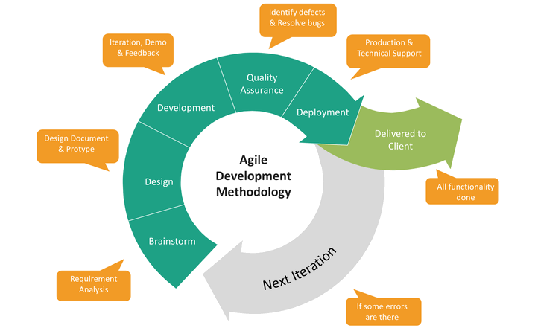

***Figure 3.1 diagrammatic representation of agile Software development methodology***

## 3.2 Reasons for agile software development methodology

* Increases the quality of deliverables.
* Expects and copes better with changes in technology trends.
* Efficient - Agile provides better estimates while spending less time creating them.
* Offers more control on the project schedule and state.
* Software development process is broken down to individual modules that are easy to work on
* Every iteration has its own testing phase hence allowing regression testing every time new functions or logics are released.

## 3.3 Phases initiated in the Development Cycle

### 3.3.1 Over view

1. Planning
2. Definition of requirements
3. Designing and prototyping
4. Software development
5. Integration and Testing
6. Deployment
7. Operations and maintenance

### 3.3.2 Planning phase

During the idealization and problem identification, the development team evaluated the terms of the project by calculating labor and material costs, creating a timetable with target goals and defining the projects architectural structure.

A feasibility study was conducted to ensure that the project is legally and technically viable, this was done in stages.

#### Technical feasibility

An analysis of the technical requirements needed for the development, testing and implementation of the project was done and the results were compared to the available resources to be able to determine whether the resources meet the technical capacity required for the project.

Evaluation of software, hardware and other technical requirements of the proposed web application was done and as a result the reports derived from the study indicated that the idea is technically feasible as most of the resources needed are readily available.

#### Economic feasibility

Questionnaires and face to face interviews with economist within Nairobi county were conducted to determine the viability, cost and benefits associated with the project before financial resources are allocated. An analysis of the findings stipulated that the financial benefits the project brings to the table outrank the cost of development. From an economist’s point of view*, Bethwel Wafula – (Financial Chief Officer, Nairobi)* the project would be a rising star in a technologically evolving nation.

#### Scheduling feasibility

Data science prediction algorithms were used to analyze the stages involved from the start of the project to its implementation in relation to the given timeframe to determine whether the project will be completed in time and also estimate how much time each project stage will take to complete.

The project management team was given all the feasibility reports to aid in the decision making to accept or decline the project proposal.

### 3.3.3 Definition of requirements

After a go-ahead approval of the project, the requirements for the development process were defined and acquired.

#### Hardware requirements

Computer:

* 8gb Random Access Memory (RAM)
* 512gb Solid State Drive (SSD)
* Intel Core I3 Processor

#### Software Requirements

* Visual Studio Code Editor
* Web browser (Google Chrome)
* Graphics Editor (Adobe Photoshop)
* Stable internet connectivity.

### 3.3.4 Designing and Prototyping

#### Architecture

At a higher level the application architecture will involve three main core components, system administrator, drivers and clients. From the three components respective subcomponents will be modeled to fulfill all functionality requirements of the app.

#### Programming

Languages, Libraries and frameworks to be used in the development process:

* **JavaScript**

The core programming language of the application is JavaScript.

JavaScript is a programming language that allows you to create highly responsive interfaces to improve the user experience and provide dynamic functionality, more so JavaScript can be used both for the server-side and client-side development which makes it a powerful language.

* **React and material-ui for user interface design**

Originally developed by Facebook, react is a simple and lightweight JavaScript library that builds user interfaces for single page applications by dividing the UI into composable components, while material-ui which is a UI library developed based on the principles of Google’s material design, offers Reusable React components for faster and easier web development. This component-based structure is a great development model that increases the speed of app development and also improves the scalability of the application.

* **Google maps API for geo location positioning**

Google Maps is a web mapping service developed by Google. It offers satellite imagery, aerial photography, street maps, 360° interactive panoramic views of streets (Street View), real-time traffic conditions, and route planning for traveling. In this application google maps will make it possible for clients to track their goods during the transit time.

* **Mongoose for interaction with the MongoDB Database**

MongoDb is a document database built on a scale-out architecture for use with developers of all kinds who are building scalable applications using agile methodologies. An online freight management app is an application that will regularly evolve and scale elegantly and therefore to handle huge volumes of data and traffic, MongoDb is a good choice.

Mongoose is an object modeling tool designed to work in an asynchronous environment by use of JavaScript to communicate to the MongoDb database, it provides a straight-forward, schema-based solution to model application data. It includes built-in type casting, validation, query building, business logic hooks and more, out of the box.

#### Communications

The application will use emails and messaging services to communicate with its users.

#### Security

Google authentication as well is built in security protocols including SSL traffic encryption, password protection, and secure storage of user credentials will be just but a few of the many security measures to be implemented in the application.

### 3.3.5 Software Development

This is the actual writing of the program, the development of the application will be subdivided into small independent modules, each module will be developed independently and later integrated into the master application, Git version control tool will be used to track code changes and merge modules.

A video showcasing a quick guided tour of the applications basic features that display on the first launch will also be developed at this stage.

### 3.3.6 Integration and Testing

#### UI testing

The application will run locally on google chrome web browser, where manual testing of the user interface by checking on various display pages will be done. React Dom testing libraries shall be used to critique the user interface.

#### Automated Testing

Jest a JavaScript test runner aided in the writing of test suites for the application and proved to be good enough for testing the web application as it was built on React.js, more so it’s integration with react testing library offered a set of helpers to test React components without relying on their implementation details. Additionally, test suites were run as a part of continuous integration.

#### Security Testing

A simulation of the production environment will be created in order to carry out security tests and build counter measures as response to any security threat that might arise in the real production environment.

### 3.2.7 Deployment

Yarn a node.js package manager will be used to build and optimize the application for production before it is deployed and hosted on Vercel.

### 3.2.8 Operations and Maintenance

Once the development process is complete, Throughout the use of the web application by consumers in the production environment, the development team will continually receive both positive and negative feedback via the applications contact page and various social media sites, in case of an arising bug that was not captured during the testing phase the development team is tasked with fixing the bug by going through all the underlined development stages.

In a period of a month after the application is launched for use, the project development team will still be tasked with research and improvement of the applications features for a continuous integration to meet up-to date and new emerging user-needs

# CHAPTER FOUR: SYSTEM ANALYSIS AND REQUIREMENTS MODELING

## 4.1 Analysis Method

For the analysis of the current system, a systematic structured analysis was employed in order to understand, analyze and refine the objectives of the existing system and develop a new system specification that solves the problems faced by the current system.

## 4.2 Understanding Problems Posed by the Current system

Freight forwarding in this current time is somewhat a cumbersome process, in the old system there isn’t a platform that connects product owners/consumers with product movers, the timeliness of product delivery when its needed is also a big challenge in the current freight transport system.

As the society moves towards embracing a cashless transactional regime, the current system will not be able to promote that furthermore, because of uncertainty surrounding the freight transport industry, there is a serious issue of hiring and retention. Due to seasonal changes a lot of trucks remain unused and driver’s losing their jobs.

A lot of truck drivers view transportation just as a commodity to earn them income. They do not give importance to the service but are just concerned about prices. This makes it hard for clients to find trustworthy personnel to handle their shipments.

In Kenya as a country having an economical and reliable transport system for industrial goods in and around major cities in the country has proven to be a challenge, the current methods Do not offer:

* Real time updates on the whereabouts of your goods
* Security guarantee and insurance of goods
* Technical Support
* Availability to the transport

Also, house and office moving for those wishing to re-locate to another part of the county as of now requires you to explicitly have the contacts of a house moving company or a truck driver which makes the availability of safe transport services on a timely regular basis a hard thing to come by.

## 4.3 The Proposed System

The idea of an online freight transport web application is to aid individuals in need of truck transport to secure one via a smart phone from any location. In the old industry clients needed to exclusively contact truck owners to be able to get their services

The **Translify** project aims to bridge the gap between clients and cargo currier companies/moving companies/individual truck drivers by:

Clients in need of relocation or product transport will:

* Create an account.
* Provide information about the size of their goods, pick up point and delivery point.
* Choose a favorable transit package.
* Pay for the services online.
* Track their goods in real time.
* Be notified on goods arrival.
* Have 24hour technical support.

Truck Drivers/Moving companies/ cargo curriers:

* Have an account.
* Market their services which will be scrutinized by clients.
* Receive notifications when clients choose them as designated drivers for their product.
* Receive online payments from the clients.
* Earn rating points from clients on every job to boost their service quality percentage.

The web app also aims to solve the congestion problem by providing drivers with the best and safest route to use and provide real time geolocation feedback to improve data analytics

Online payments will be implemented by the new system as a way to keep in check the technological advancements in the society, the new system also aims at taking care of taxes, exercise duty fees and upholding all the regulations imposed by the government thereby unburdening the driver the need to have to deal with all the legal logistics.

With every safety feature the web application provides it is an additive to meet and uphold the standards in the Community Guidelines, by being committed to working towards creating a safe environment for all users.

The new developed system functioning through a web application will be run con-currently with the old system to ensure smooth transition.

## 4.5 Requirements Modeling - Data Flow

Figure 4.1 below is a top-down visual representation of the information flow within the Application, it depicts logic models, functional decomposition and expresses data transformation in the application.

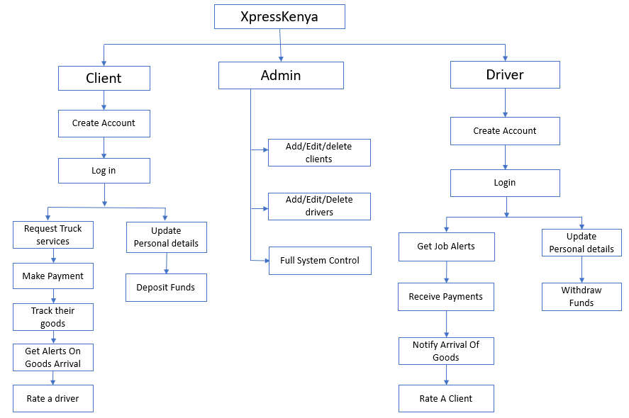

***Figure 4.1 system data flow diagram***

## 4.6 Specification of App users

### 4.6.1 Admin

An administrator is a critical component of the web application. For a reliable and successful operation of the app, the admin has full control over the application’s functionality and full access to all its information.

In modeling the requirements for a system administrator, the following duties and responsibilities will be designed and tasked to the application’s system admin.

* Setting up new users and giving them restricted access to the information
* Managing and maintaining file servers
* Employing latest security protocols
* Updating the application with fresh content about offers and new products available
* Edit user’s details
* Delete/Deactivate user accounts for both drivers and clients.

The flowchart below represents the flow of information in relation to its sequence of functions for the system administrator.

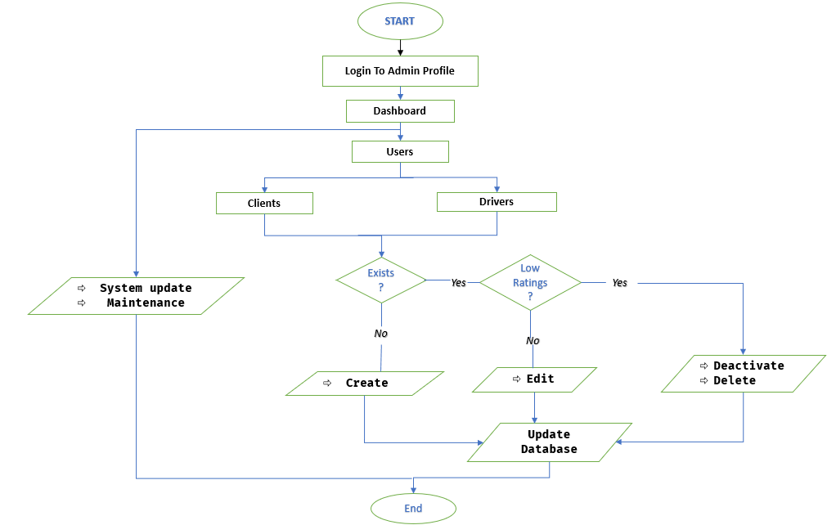

***Figure 4.2 System Admin’s flow chart.***

### 4.6.2 Clients

Clients who are goods producers, goods buyers and essentially everyone that will have the need to transport goods from one place or another or relocate will be given a high priority when it comes to delivery of services by the application. To ensure a good end user experience, the application was designed to allow clients (clients) to create an account, login to the app, request for a truck, make payment, track their goods and also rate the individual driver who delivered the goods. Clients will also be able to deposit money into a virtual account as well updating their personal details s whenever they please.

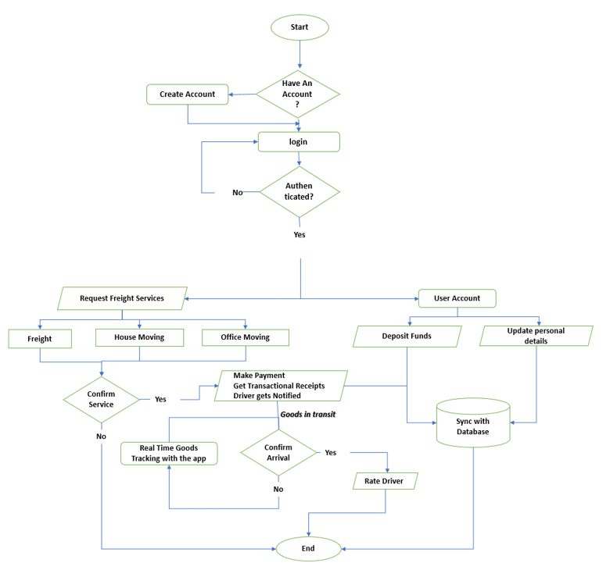

***Figure 4.3 clients program data flow chart***

### 4.6.3 Drivers

Truck drivers will be able to use the app by creating an account and registering for a driving permit with the app, upon approval they can get job alerts and payments from clients when the goods are delivered. Drivers can also cash out their payments.

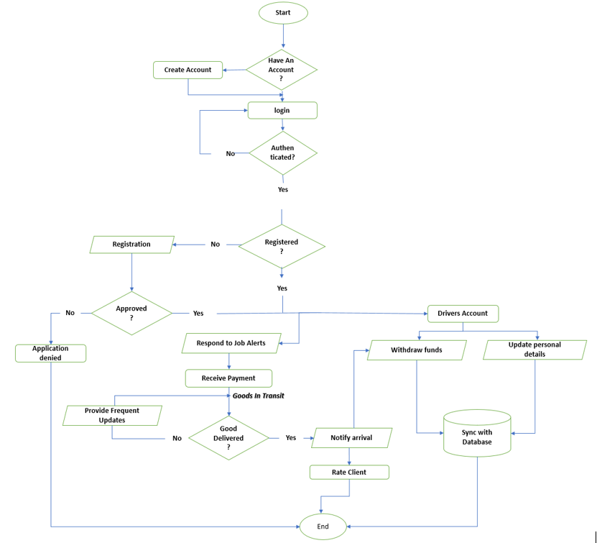

***Figure 4.4 drivers program data flow chart***

# CHAPTER FIVE: SYSTEM DESIGN

## 5.1 Entity Relationship Diagram

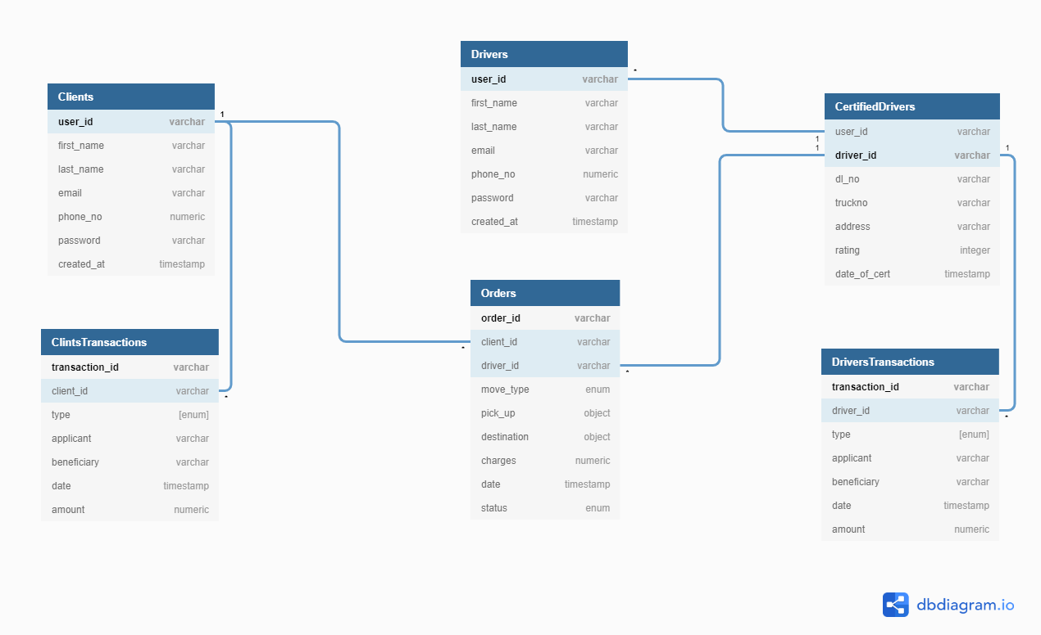

***Figure 5.1 Entity relationship diagram***

## 5.2 Designing of Database Models

#### 5.2.1 Clients Model

|  |  |  |  |  |  |
| --- | --- | --- | --- | --- | --- |
| S/NO | ENTITY | DATA TYPE | SIZE | CONSTRAINT | DESCRIPTION |
| 1 | UserID | varchar | 15 | Identification Key | Unique client’s identification key |
| 2 | First Name | varchar | 255 | Not Null | First Name of Client |
| 3 | Last Name | varchar | 255 | Not Null | Last Name of Client |
| 4 | Email | varchar | 255 | Not Null | Client’s Email Address |
| 5 | Phone No | integer | 12 | Not Null | Client’s Phone No. |
| 6 | Password | varchar | 16 | Not Null | Client’s Password |
| 7 | Rating | integer | 2 | Null | Average rating from drivers |

***Table 5.1 Table representation of the client model***

#### 5.2.2 Drivers’ Model

|  |  |  |  |  |  |
| --- | --- | --- | --- | --- | --- |
| S/NO | ENTITY | DATA TYPE | SIZE | CONSTRAINT | DESCRIPTION |
| 1 | UserID | varchar | 15 | Identification  Key | Unique driver’s identification key |
| 2 | First Name | varchar | 255 | Not Null | First Name of Driver |
| 3 | Last Name | varchar | 255 | Not Null | Last Name of Driver |
| 4 | Email | varchar | 255 | Not Null | Driver’s Email Address |
| 5 | Phone No | integer | 12 | Not Null | Driver’s Phone No. |
| 6 | Password | varchar | 16 | Not Null | Driver’s Password |

***Table 5.2 Table*** ***representation of the driver’s model***

#### 5.2.3 Certified Drivers Model

|  |  |  |  |  |  |
| --- | --- | --- | --- | --- | --- |
| S/NO | ENTITY | DATA TYPE | SIZE | CONSTRAINT | DESCRIPTION |
| 1 | DriverID | varchar | 15 | Identification Key | Unique certified driver’s identification key |
| 2 | UserID | varchar | 15 | Reference Key | Drivers id key referenced to the driver’s model |
| 3 | Driving License, no | varchar | 15 | Not Null | Driving license number for a driver |
| 4 | Truck No. | varchar | 8 | Not Null | The driver’s truck No |
| 5 | Address | varchar | 255 | Not Null | Physical address of the driver |
| 6 | Date of Certification | timestamp |  | Null | Date of approval as a driver with the app |
| 7 | Rating | integer | 2 | Null | Average rating from clients |

***Table 5.3 Table*** ***representation of the certified driver’s model***

#### 5.2.4 Orders Model

|  |  |  |  |  |  |
| --- | --- | --- | --- | --- | --- |
| S/NO | ENTITY | DATA TYPE | SIZE | CONSTRAINT | DESCRIPTION |
| 1 | OrderID | uniqueidentifier | 15 | Identification Key | Unique order identification key |
| 2 | DriverID | uniqueidentifier | 15 | Reference Key | Driver id key referenced to the driver’s model |
| 3 | ClientID | uniqueidentifier | 15 | Reference Key | Client id key referenced to the client’s model |
|  | MoveType | varchar | 2 | Not Null | The type of move e.g., “fr” for freight |
|  | Pickup | object |  | Not Null | The pickup details of the load |
|  | Destination | object |  | Not Null | The destination details of the load |
|  | Charges | number | 9 | Not Null | The amount paid for the order |
| 4 | Date | timestamp |  | Not Null | Date and time of the order. |
| 5 | Status | varchar | 10 | Null | The status of the order. e.g., Pending, completed |

***Table 5.4 Table representation of the Orders Model***

#### 5.2.5 Driver’s Transactions model

|  |  |  |  |  |  |
| --- | --- | --- | --- | --- | --- |
| S/NO | ENTITY | DATA TYPE | SIZE | CONSTRAINT | DESCRIPTION |
| 1 | TransactionID | uniqueidentifier | 15 | Reference Key | Unique payment identification key |
| 2 | DriverXpressID | uniqueidentifier | 15 | Reference Key | Driver id key referenced to the certified driver’s model |
| 3 | Applicant | uniqueidentifier | 15 | Not Null | Applicant of the particular transaction |
| 4 | Beneficiary | uniqueidentifier | 15 | Not Null | The benefiting party from the transaction |
| 5 | Type | varchar | 10 | Not Null | The type of transaction e.g., withdrawal |
| 6 | Date | timestamp | 15 | Reference Key | Date and time of the transaction |
| 7 | Amount | integer | 9 | Not Null | Amount Transacted |

***Table 5.5 Table representation of the Drivers Personal Transactions Model***

#### 5.2.6 Client’s Personal Transactions Model

|  |  |  |  |  |  |
| --- | --- | --- | --- | --- | --- |
| S/NO | ENTITY | DATA TYPE | SIZE | CONSTRAINT | DESCRIPTION |
| 1 | TransactionID | uniqueidentifier | 15 | Reference Key | Unique transaction identification key |
| 2 | ClientID | uniqueidentifier | 15 | Reference Key | Client id key referenced to the client’s model |
| 3 | Applicant | uniqueidentifier | 15 | Not Null | Applicant of the particular transaction |
| 4 | Beneficiary | uniqueidentifier | 15 | Not Null | The benefiting party from the transaction |
| 5 | Type | varchar | 10 | Not Null | The type of transaction e.g., withdrawal |
| 6 | Date | timestamp | 15 | Not Null | Date and time of the transaction |
| 7 | Amount | integer | 9 | Not Null | Amount Transacted |

***Table 5.6 Table representation of the Client Personal Transactions model.***

## 5.3 Database Connection

Mongoose a schema-based node module package was use as a bridge to enable communication between the front-end part of the application and the server. When a HTTP request is made by a user from the front-end an API was built to interact with the server to handle and process requests henceforth when the request is processed responses are disseminated accordingly.

***Figure 5.2 Database connection diagram.***

# CHAPTER SIX: SYSTEM IMPLEMENTATION

## 6.1 INTRODUCTION

**Translify** is a web application designed to help improve circulation of industrial goods in the business platform as well as aid in the geographical relocation of businesses and homes. A driver signs up and applies for registration by providing their details like a driving license number and truck no for their respective trucks. Shippers or what I would call clients on the other hand are able to sign up and order for a truck to transport their industrial goods or relocate them to wherever they want whenever they want.

This chapter illustrates the project implementation for developing the **Translify** Application. The web application is built mostly using an MERN stack (MongoDB, Express, React and NodeJS) architecture. Even though during the designing phase the project was tested a lot on the google chrome browser it has been optimized to run all modern standard web browsers.

## 6.1 User Interface

The user interface design is developed by integrating the use of Google’s material design patterns implemented by the UI library material-ui and React.js a popular UI design framework. The application is made up of folders and files encapsulating the many components that together make up the different pages of the application. All components are built using the function component syntax, with a little bit of a super touch from material-ui library and most of the styling done with react styled components to abstract styling from functional implementation of individual components.

To be able to manage rendering different components and the application being a multi user system, redux is used to provide, manage and update the applications state in a predictable manner.

## 6.1.1 Main activity page

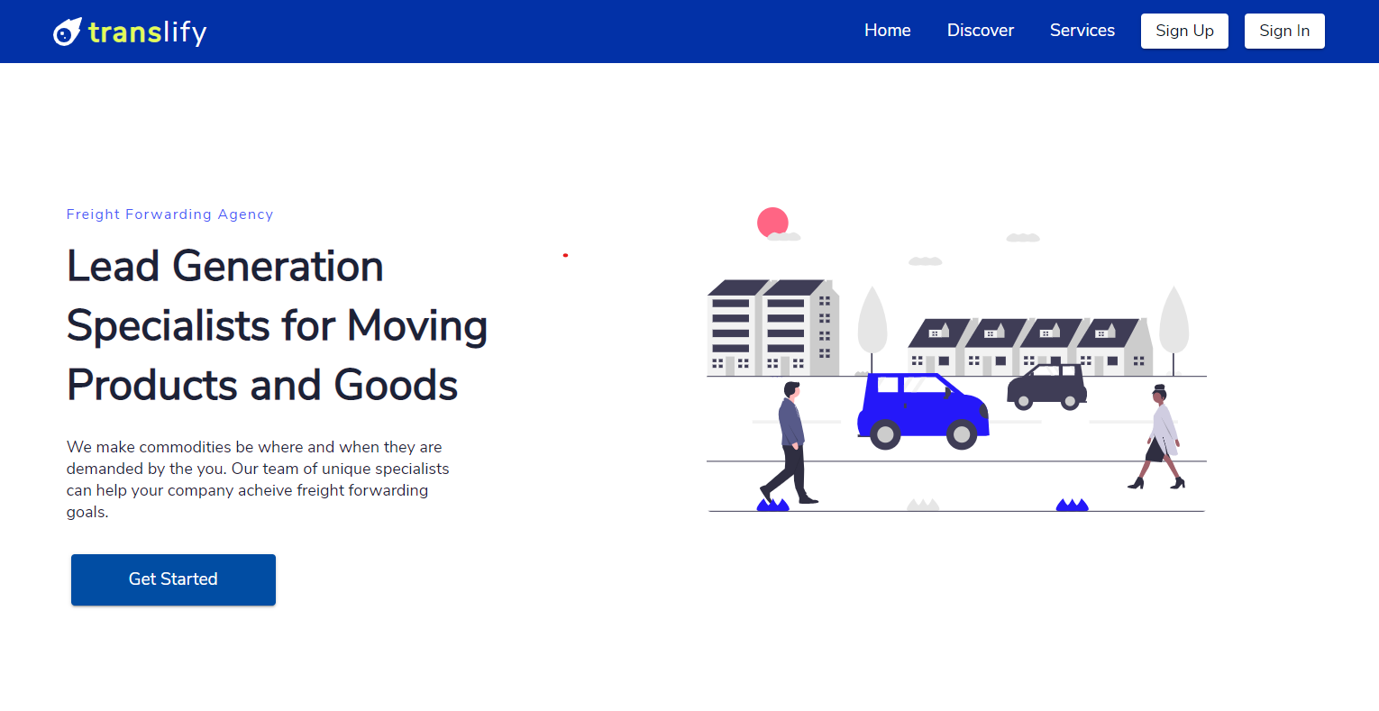

6.1.2 User decision page

When a user clicks on either button of sign-in or sign-up, they are given an option as to whether they want to join the driving community or ship their goods with **Translify**.

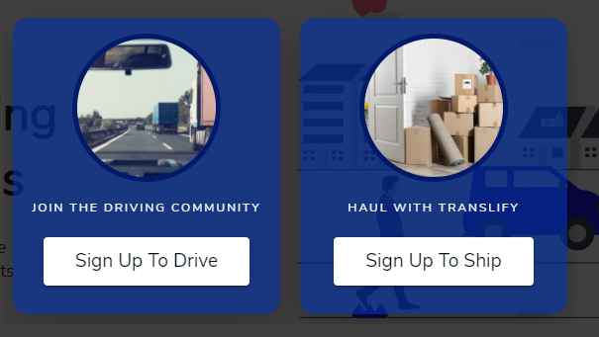

6.1.3 Sign Up page

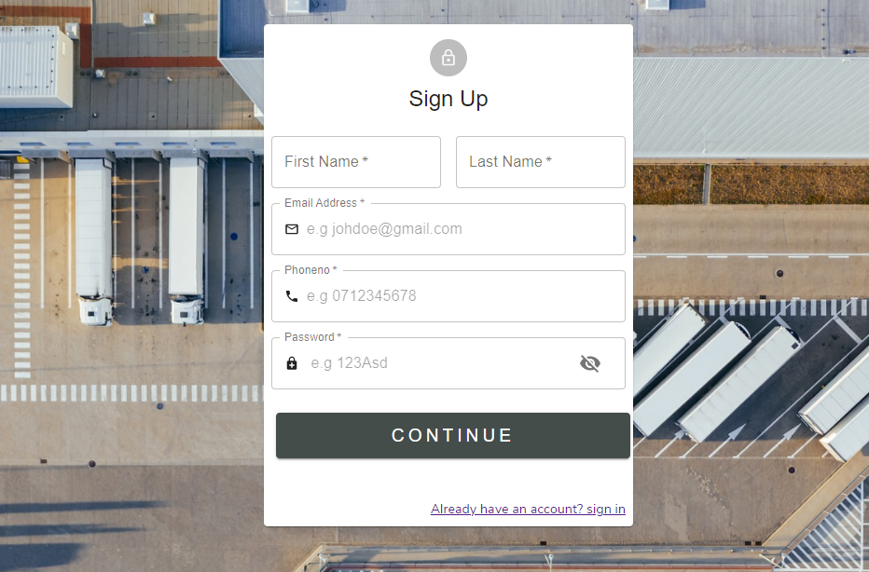

6.1.4 Login Page

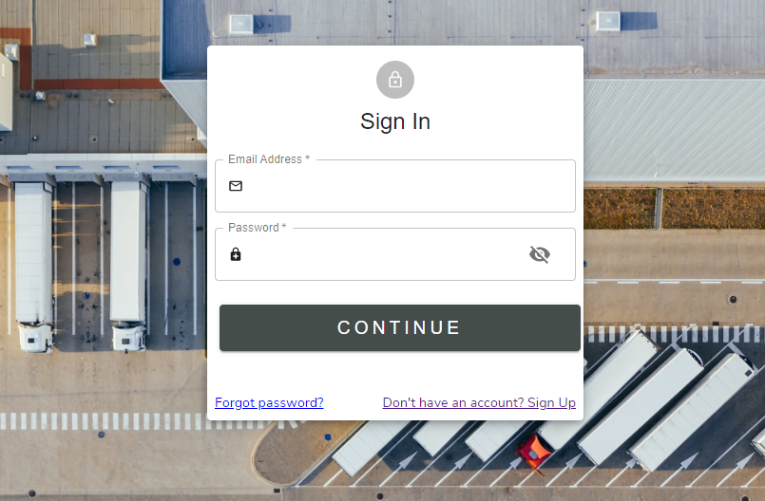

6.1.5 Client Order page

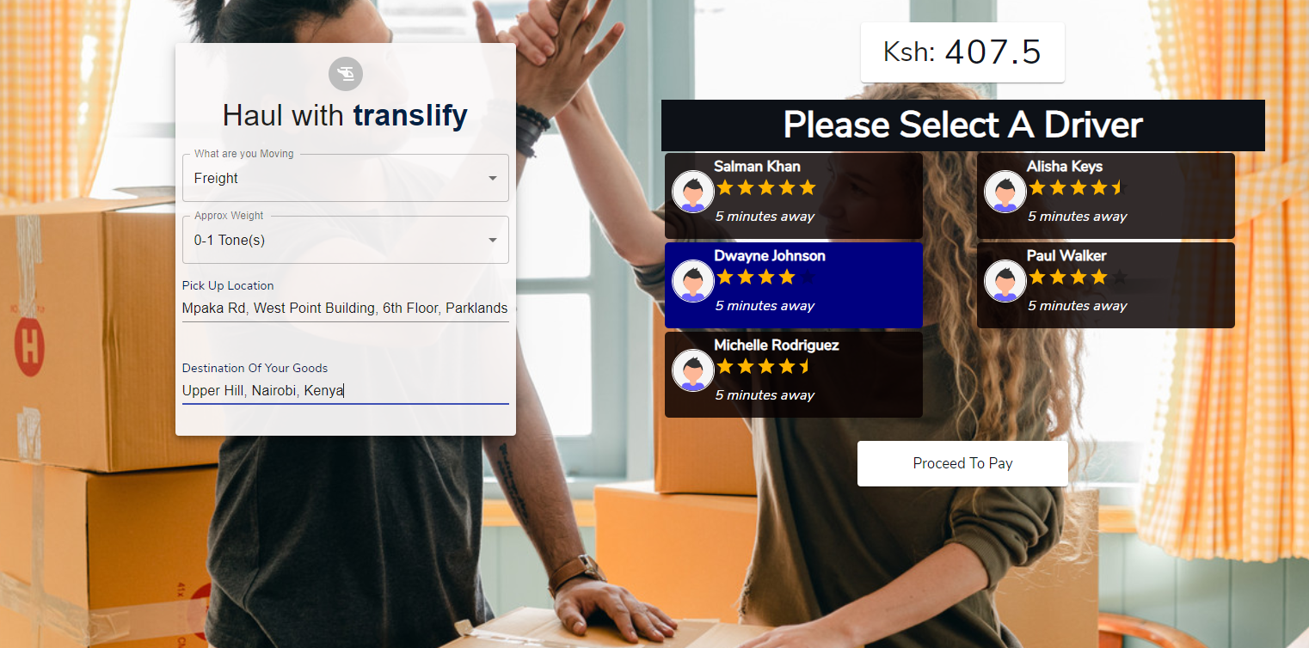

6.1.6 Client Dashboard

6.1.7 Driver Dashboard page

6.1.8 Admin Dashboard page

## 6.2 API design

## 6.3 Backend Design

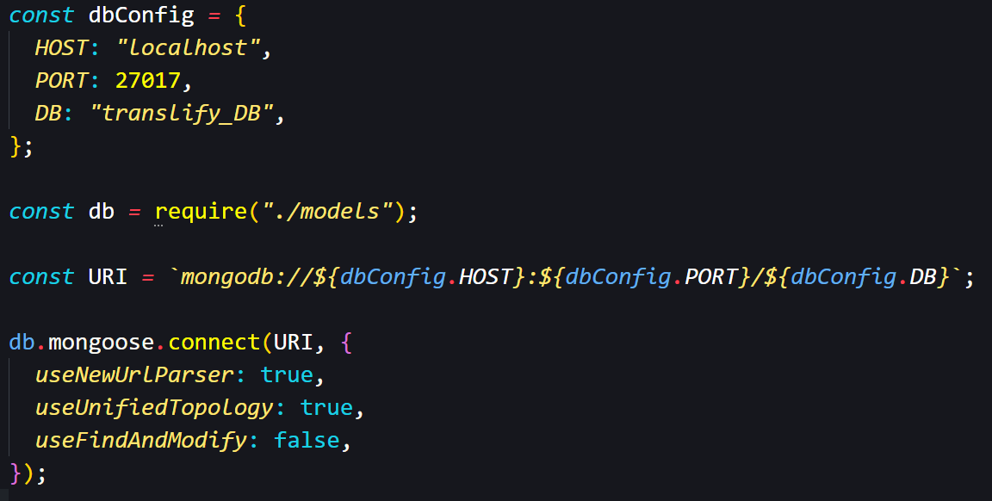

# CHAPTER SEVEN: CONCLUSION AND RECOMMENDATIONS.

User Manual – how the system works.

Recommendations – Highlighted suggestions for further improvement of the system

# REFERENCES

The future of freight transport (Cathy Macharis & Silvio Nocera, 2019)-<https://link.springer.com/article/10.1186/s12544-019-0359-3>

The Academic Literature on Intermodal Freight Transport (Terje Andreas Mathisen, 2014) - <https://www.sciencedirect.com/science/article/pii/S2352146514002038>

**Modelling a rail/road intermodal transportation system (Arnold et al, 2004)-** [https://www.researchgate.net/publication/251780417_modeling_intermodal_transportation_systems_establishing_a_common_language](https://www.researchgate.net/publication/251780417_MODELING_INTERMODAL_TRANSPORTATION_SYSTEMS_ESTABLISHING_A_COMMON_LANGUAGE)

Analyzing Freight Transport in Social Media, Disruptive Technology or Institutional Disruption? https://www.worldscientific.com/doi/abs/10.1142/9781786347602_0017

Global sky International Freight Forwarding Logistics - <https://globalskylogistics.com/logistics-and-freight-forwarding-articles/globalsky-international-freight-forwarding-logistics/>

Forwarder Magazine - https://forwardermagazine.com

# APPENDIX

Sample code