3. Materials and Methodologies

The study was executed as shown in Fig. 1, including

image acquisition, data preparation, model training and

model validation.

3.1. Datasets

**Study participants.** We used two datasets in this study. Data in the first dataset—

the UK Biobank—were generated in an observational study that recruited

500,000 participants, aged 40–69 years, across the UK between 2006 and 2010.

Each participant gave consent and went through a series of health measurements

and questionnaires. Participants were then followed for health outcomes, such

3.2. Model Architecture (DenseNet)

3.3 Experimental Setups

Gpu, tensorflow ….

3.4 Model Training

3.5 Model Evaluation

4. Results

5. Discussion

6. Conclusion and Future Work

Summary of the findings

* Implications of the findings for the research question or hypothesis
* Limitations of the study
* Future research directions
* Conclusion

In the thesis, merge a results and discussion part

The above Figure 1 demonstrates that the lth layer of the network takes in the feature-maps of all preceding layers as input, denoted as xl, and concatenates them together as a tensor [x0, x1,...,xl-1]-mathematically expressed as xl = Hl([x0, x1, . . . , xl−1]), where H represents the composite function for concatenation.

Figure 1 above illustrates that the lth layer of the network concatenates the feature-maps of preceding layers as a tensor [x0, x1, ..., xl-1], using the composite function H, mathematically represented as xl = Hl([x0, x1, ..., xl-1]).

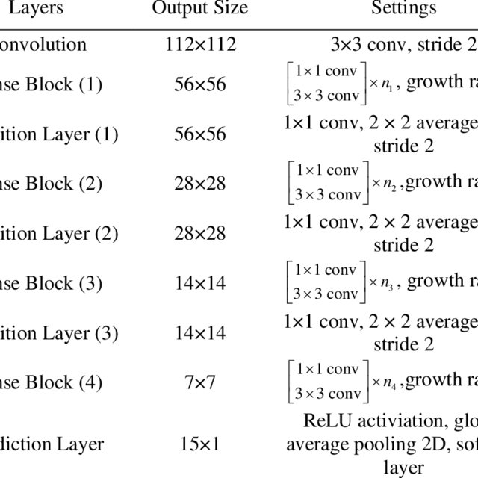

We use the ChestX-ray14 dataset released by Wang

et al. (2017) which contains 112,120 frontal-view X-ray

images of 30,805 unique patients. Wang et al. (2017)

annotate each image with up to 14 di_erent thoracic

pathology labels using automatic extraction methods

on radiology reports. We label images that have pneumonia

as one of the annotated pathologies as positive

examples and label all other images as negative examples.

For the pneumonia detection task, we randomly

split the dataset into training (28744 patients, 98637

images), validation (1672 patients, 6351 images), and

test (389 patients, 420 images). There is no patient

overlap between the sets.

Before inputting the images into the network, we

downscale the images to 224_224 and normalize based

on the mean and standard deviation of images in the

ImageNet training set.