**DEEP-LEARNING-BASED-CNN ALGORITHMIC TOOL DIAGNOSING 14 DIVERSE LUNG DISEASES AND ARBORNAMILITIES ON A CHEST X-RAY IMAGE**

First author [Baraka H.Kimwanga], Second author [Li Li]

School of Electronic Engineering, Tianjin University of Technology and Education, Tianjin, China

[Barrykim9891@gmail.com](mailto:Barrykim9891@gmail.com)

**ABSTRACT**

The global public health concern of lung diseases is substantial due to the rise in morbidity and mortality rates. The emergence of the COVID-19 pandemic in late 2019 has brought even greater urgency for early and accurate diagnosis and management of these diseases. Although chest X-rays play a crucial role in identifying and monitoring these conditions, accurately interpreting the images remains challenging—as the task relies on the expertise and experience of radiologists—making the process time-consuming for large datasets and susceptible to human error when detecting subtle signs or early stages of the diseases. Considering the issue, this paper presents a state-of-the-art deep-learning-based CNN algorithm that enables the development of an automated AI tool capable of accurately and independently identifying various abnormalities and detecting diverse lung diseases in a Chest X-ray Image. The Chest X-ray 14 dataset, containing 14 categories of lung diseases—with the available 112,120 images from 30,805 patients—was proposed and split the data into training, validation, and test sets. The model designing process involved the fine-tuned DenseNet architecture via a transfer learning approach, which achieved an average AUC-ROC score of 0.83 on the test set—surpassing previous studies. Furthermore, researchers evaluated the model's performance on an independent dataset from multiple sources, and the results demonstrated comparable performance, highlighting the generalizability in new datasets. In conclusion, this study indicates that the developed automated AI tool offers a promising solution to the challenges of interpreting chest X-ray images, potentially improving patient outcomes, reducing healthcare costs, and saving lives.

**Keywords:** Convolution Neural Network (CNN), Chest X-Ray (CXR), Deep-learning (DL), Densely Connected Convolutional Network (DenseNet), Lung Diseases

1. **INTRODUCTION**

Lung diseases are medical conditions that affect the lungs and respiratory system. These conditions develop from various causes such as infections, genetic factors, or environmental factors like smoking, pollution, or chemical exposure. Lung diseases manifest in several types, from acute conditions like pneumonia and bronchitis to chronic conditions such as asthma, lung cancer, and COPD. These diseases often exhibit diverse symptoms, including coughing, shortness of breath, wheezing, chest pain, and fatigue [1], [2]. Consequently, lung diseases have become a substantial cause of morbidity and mortality globally, leading to millions of deaths annually—particularly in low and middle-income countries [3], [4].

The outbreak of the COVID-19 pandemic in late 2019 has emphasized the critical importance of diagnosing and managing lung conditions: not only to prevent infection in individuals with pre-existing lung diseases but also to reduce the risk of severe illness to those already infected [5], [6]. While chest X-rays are a fast, cost-effective, and non-invasive imaging tool that provides valuable and relevant information for diagnosing lung diseases, accurately interpreting the images remains challenging for subtle abnormalities or early-stage diseases. The process relies on the expertise and experience of radiologists, making it expensive, time-consuming, and prone to human errors —resulting in missed or incorrect diagnoses [7]–[10].

In recent years, Artificial Intelligence (AI) has established itself as a dominant and potent technology in medical imaging [11], [12]. By automatically and objectively analyzing images, AI can achieve improved levels of accuracy. Hence, incorporating AI into the analysis of Chest X-ray images can aid in reducing subjectivity interpretation by radiologists [13]. However, earlier studies have suggested that the top traditional machine learning AI algorithms, including support vector machines (SVMs) and decision trees, have certain drawbacks. Specifically, they are subjective due to their dependence on expert domain knowledge and manual feature engineering. Additionally, these techniques are not well-suited for handling large unstructured datasets and can be time-consuming [14], [15].

The capability of Deep learning (DL) to mimic human brain behavior in solving intricate problems—by training artificial neural networks in multiple computational layers: has exhibited immense potential in medical imaging analysis [16]–[18]. As a result, DL has emerged as breathtaking AI innovation in Chest X-ray imaging [19]. With the help of the CNN algorithm, it is now viable to effectively analyze and categorize high-dimensional Chest X-ray images [20] —as the algorithm extracts relevant patterns and structures from numerous data, regardless of their variation in qualities—without explicitly feature engineering. Hence, it computes faster and achieves accurate results at a low cost [21]–[23].

This research study showcases an AI algorithmic tool that diagnoses lung diseases and detects several lung abnormalities from a chest X-ray image—by employing deep learning Convolutional Neural Networks (CNNs) algorithm. The paper is structured as follows: Section I provides background information; Section II outlines the materials used and justifies the proposed methods; Section III presents the results obtained; Section IV interprets and analyses the study findings; and Section V concludes the paper.

1. **MATERIALS AND METHODS**

This section provides a comprehensive description of the materials and methods used. It includes the datasets (ChestX-ray14), proposed methodology (DenseNet-121), and model design: to ensure the reproducibility and validity of our findings.

* 1. **Datasets**

The ChestX-ray14 database from the National Institutes of Health Clinical Center ([NIH](https://nihcc.app.box.com/v/ChestXray-NIHCC)), which is publicly available and has privacy and security measures in place, was used. The dataset contains 112,120 front-view chest X-ray images with 14 different thoracic pathologies labeled by a panel of four expert radiologists. These images come from 30,805 unique patients [24].

**Data Preprocessing:** The datasets are labeled with 0 for absence and 1 for the presence of 14 different thoracic pathologies, including Atelectasis, Cardiomegaly, Effusion, Infiltration, Mass, Nodule, Pneumonia, Pneumothorax, Consolidation, Edema, Emphysema, Fibrosis, Pleural Thickening, and Hernia. To ensure compatibility and computational efficiency with the DenseNet architecture—trained on pre-trained ImageNet [25], [26], the images are resized into 224 x 224 pixels and normalized the values to a mean of 0 and a standard deviation of 1. The dataset is respectively split in a ratio of 80:10:10 for training, validation, and testing—while employing data augmentation techniques such as rotations, flips, and shifting: to increase data diversity [27].

**Addressing Class imbalance:** The imbalanced class distribution is a significant challenge in the ChestX-ray14 dataset—where some pathologies are much rarer than others—leading to a better performance (model bias) towards the more prevalent classes like Infiltration (25%), Effusion (15%), and Atelectasis (10%) than on hernia (0.1%) and pneumonia (2%) classes. Hence, This study addresses the issue using a Transfer Learning approach via DenseNet architecture.

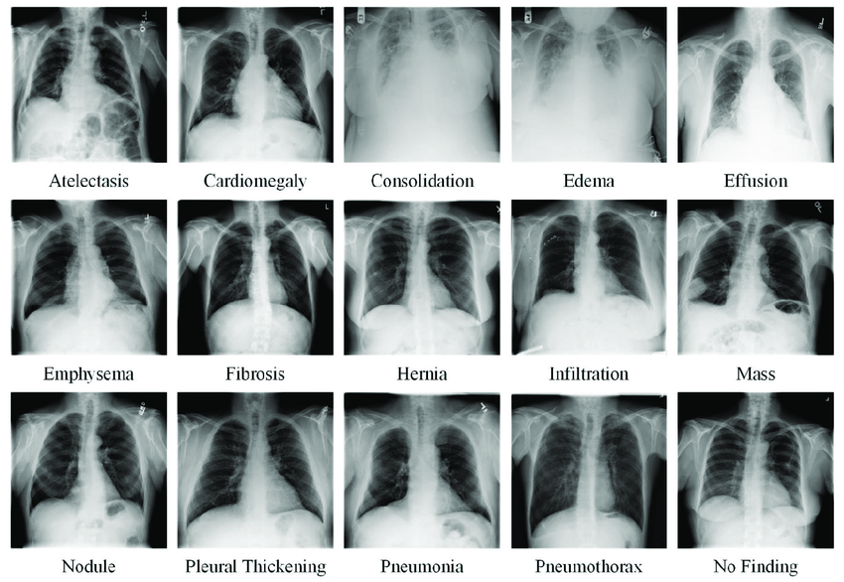

Figure 1: Chest X-ray Images Representing 14 Thoracic Pathologies

* 1. **DenseNet 121 Architecture**

The DenseNet, or Densely Connected Convolutional Network, is a robust CNN architecture that has transformed the field of medical imaging. Being trained on the ImageNet dataset, the architecture achieves a state-of-the-art performance by connecting each layer to all subsequent layers in a feed-forward manner to maintain feature maps while using fewer parameters [28].

With this attribute, DenseNet has outperformed traditional CNNs: in addressing issues such as information loss, vanishing gradients, and overfitting—whenever training large datasets.

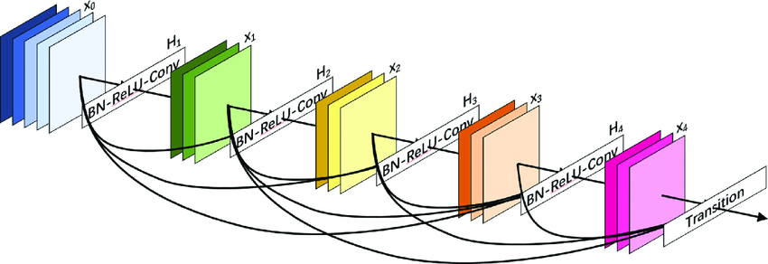

Figure 2: A Visual DenseNet Architecture Representation: A Simplified Overview

The DenseNet architecture consists of initial convolutional layers, followed by a sequence of densely connected convolutional layers (Dense blocks)interposed with several transition layers. It concludes with a Global Average Pooling (GAP) layer and a fully-connected layer (FC). In this design, the input RGB image with a height (H) and width (W) undergoes initial feature extraction via a Convolutional layer with 'k' filters. Each dense block concatenates feature maps—instead of summing them—to maintain constant dimensions for feature reuse and information flow.

This operation is viable through Batch normalization (BN) [29], Rectified Linear Unit (ReLU) activation [30], and a 3x3 Convolutional layer (Conv)—however, this concatenation increases the number of parameters in the network. To reduce dimensionality and control network growth, transition layers between the blocks use Batch Normalization, a 1x1 Conv layer, and a 2x2 average pooling layer. Finally, the GAP layer generates a single feature vector from the feature maps. This vector is fed into an FC layer with Softmax activation to produce the final output [31], [32]. Figure 2 above illustrates that the $l^{th}$ layer of the network concatenates the feature maps of preceding layers as a tensor [$x_{0}$, $x_{1}$, ..., $x_{l-1}$], using the composite function H, mathematically represented as = ([, , ..., ]).

This paper proposes the DenseNet-121 architecture. Compared to other DenseNet architectures, the design is preferred for medical image analysis due to its well-balanced, versatile, and lightweight architecture—making it easy to train, achieving high accuracy at high speed, and deploying on devices with limited resources. DenseNet-121 architecture comprises 121 layers: 117 Convolutional, 3 pooling, and 1 Fully-connected layer.

It includes (4) dense blocks with a growth rate of 32, (3) transition layers, (1) global average pooling (GAP) layer, and (1) a fully connected layer. Since there are L (L+1)/2 direct connections for 'L' layers, DenseNet-121 has 159 connections—with more than 7 million learnable parameters.

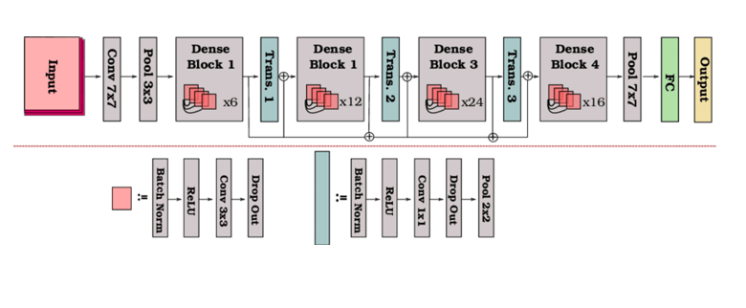

Figure 3: An In-Depth Analysis of Blocks and Layers of DenseNet-121

Table 1: A Summarized table comparing DenseNet-121 with other architecture from ImageNet

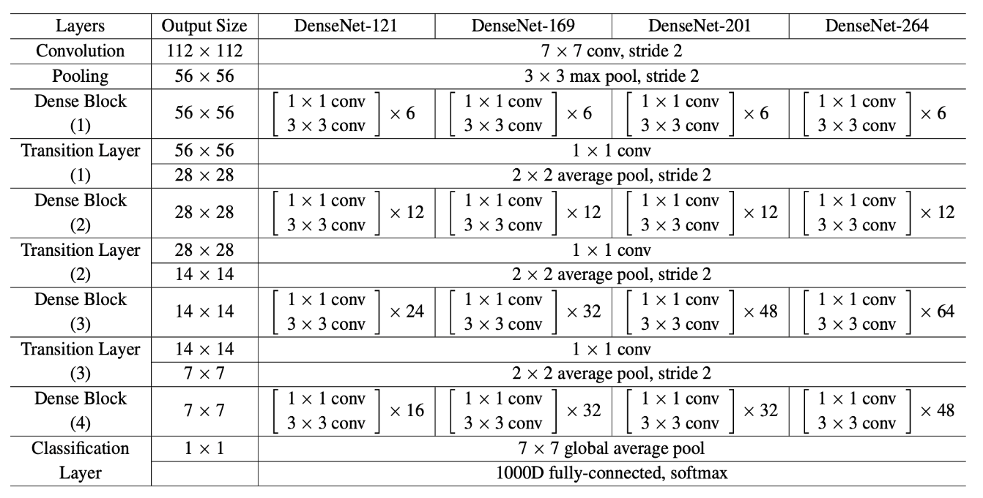

* 1. **Model Design**

**Environmental Setup:** The hardware utilized in this study includes an NVIDIA RTX 3070 GPU with CUDA support and 16 GB of RAM. The TensorFlow 2.11 framework is used with Python 3.9 in a Jupyter Notebook IDE, along with software libraries like NumPy, Pandas, Matplotlib, and ImageDataGenerator.

**Training:** After completing the setup, the transfer learning approach trained the preprocessed images using the DenseNet-121 architecture. The first step was to pre-train the DenseNet model as a feature extractor and replace its fully connected layers with new classification layers—while freezing some initial layers. This idea enabled the model to leverage the knowledge gained by DenseNet for classification while achieving higher accuracy in less time. The training process employed a batch size of 64 and utilized the ReLU activation function for all layers [33].

For the model’s performance optimization, the training process minimized the binary cross-entropy loss using the Adam optimizer with a learning rate of 0.001 while avoiding overfitting on the validation set by employing early stopping with the patience of 5 epochs while training the model for 50 epochs [34].

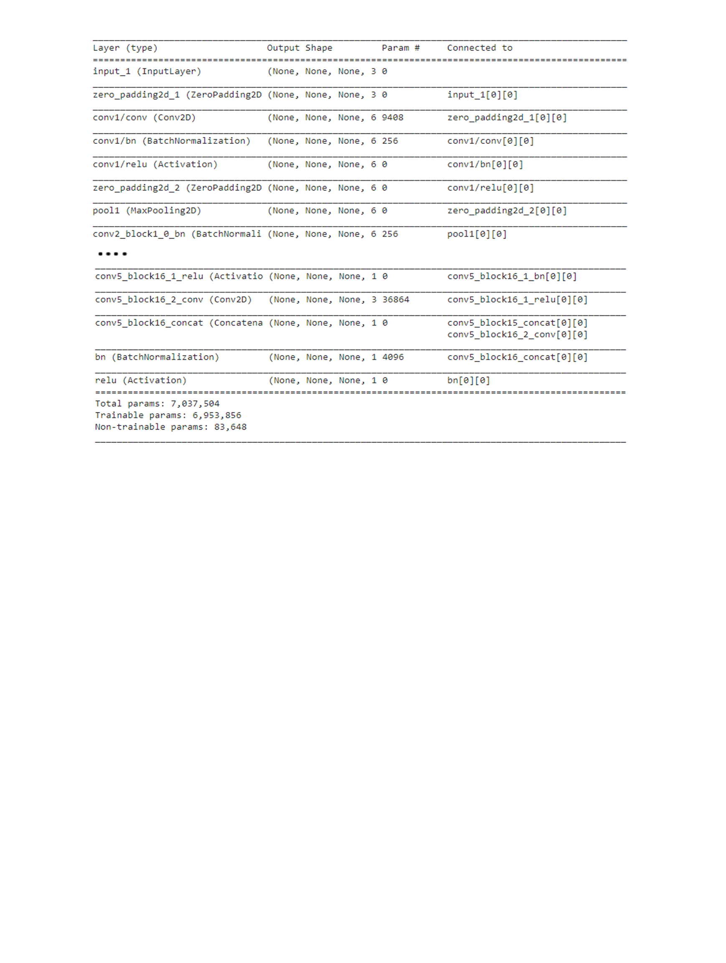

Table 2: A Model summary for pre-trained DenseNet-121 on a TensorFlow framework

* 1. **Model Evaluation:**

The evaluation process utilized various metrics to assess the effectiveness of the designed model in analyzing test datasets. These metrics include Accuracy, Precision (PPV), Recall (Sensitivity), Specificity, Negative Predictive Value (NPV), and F1 score. However, due to the imbalanced dataset for classification tasks in the designed model, the AUC (Area Under the Curve)-ROC (Receiver Operating Characteristic) was prioritized as the overall performance metric. [35].

**AUC-ROC/ AUROC**: The Area under the Receiver Operating Characteristics curve is a comprehensive and independent visualization metric that evaluates the performance of a model in classification problems. This metric considers both the True Positive Rate (Sensitivity/Recall) and False Positive Rate (specificity), then provides a trade-off across a range of decision thresholds, thereby providing a single value that summarizes the model's performance and compares with the others. AUROC of 1 indicates that the model is excellent, while a value of 0 reflects a poor model, and 0.5 implies the model cannot distinguish between the classes.

AUROC is a crucial metric in Chest X-ray imaging, as it helps to evaluate the model's ability to distinguish between different chest conditions and determine the optimal decision threshold for classification. This metric provides the probability that a randomly selected patient who has a particular condition has a higher risk score than a patient who does not have the condition [36].

**3. RESULTS**

This section presents the findings of our study and addresses the research questions posed earlier. It discusses the evaluation metrics employed to assess the performance of a designed model and compares it with other state-of-the-art approaches reported in the literature.

Table 3: This table indicate the model has achieved the better average results with the NPV (97.9%), AUC-ROC (0.8304), Accuracy (77.8%), Specificity (0.765), and Sensitivity (0.73).

|  |  |  |  |  |  |  |  |  |  |  |  |  |
| --- | --- | --- | --- | --- | --- | --- | --- | --- | --- | --- | --- | --- |
|  | TP | TN | FP | FN | Accuracy | Sensitivity | Specificity | PPV | NPV | AUC | F1 | TH |
| Cardiomegaly | 16 | 814 | 169 | 1 | 0.83 | 0.941 | 0.828 | 0.086 | 0.999 | 0.963 | 0.158 | 0.5 |
| Emphysema | 20 | 869 | 103 | 8 | 0.899 | 0.714 | 0.894 | 0.163 | 0.991 | 0.965 | 0.256 | 0.5 |
| Effusion | 99 | 690 | 196 | 15 | 0.789 | 0.868 | 0.779 | 0.336 | 0.979 | 0.901 | 0.484 | 0.5 |
| Hernia | 1 | 743 | 255 | 1 | 0.754 | 0.5 | 0.774 | 0.004 | 0.999 | 0.712 | 0.008 | 0.5 |
| Infiltration | 114 | 543 | 256 | 78 | 0.697 | 0.594 | 0.672 | 0.302 | 0.874 | 0.726 | 0.399 | 0.5 |
| Mass | 40 | 789 | 158 | 13 | 0.829 | 0.755 | 0.833 | 0.202 | 0.984 | 0.888 | 0.319 | 0.5 |
| Nodule | 28 | 731 | 220 | 21 | 0.769 | 0.571 | 0.769 | 0.113 | 0.972 | 0.765 | 0.189 | 0.5 |
| Atelectasis | 64 | 657 | 249 | 30 | 0.791 | 0.681 | 0.725 | 0.204 | 0.956 | 0.781 | 0.314 | 0.5 |
| Pneumothorax | 24 | 785 | 183 | 8 | 0.809 | 0.75 | 0.811 | 0.116 | 0.99 | 0.826 | 0.201 | 0.5 |
| Pleural_Thickening | 24 | 713 | 259 | 4 | 0.757 | 0.857 | 0.734 | 0.085 | 0.994 | 0.868 | 0.154 | 0.5 |
| Pneumonia | 14 | 661 | 320 | 5 | 0.735 | 0.737 | 0.674 | 0.042 | 0.994 | 0.762 | 0.154 | 0.5 |
| Fibrosis | 10 | 725 | 261 | 4 | 0.755 | 0.714 | 0.735 | 0.037 | 0.995 | 0.801 | 0.07 | 0.5 |
| Edema | 15 | 767 | 213 | 5 | 0.782 | 0.75 | 0.789 | 0.066 | 0.994 | 0.856 | 0.121 | 0.5 |
| Consolidation | 36 | 658 | 297 | 9 | 0.698 | 0.8 | 0.689 | 0.108 | 0.987 | 0.812 | 0.19 | 0.5 |

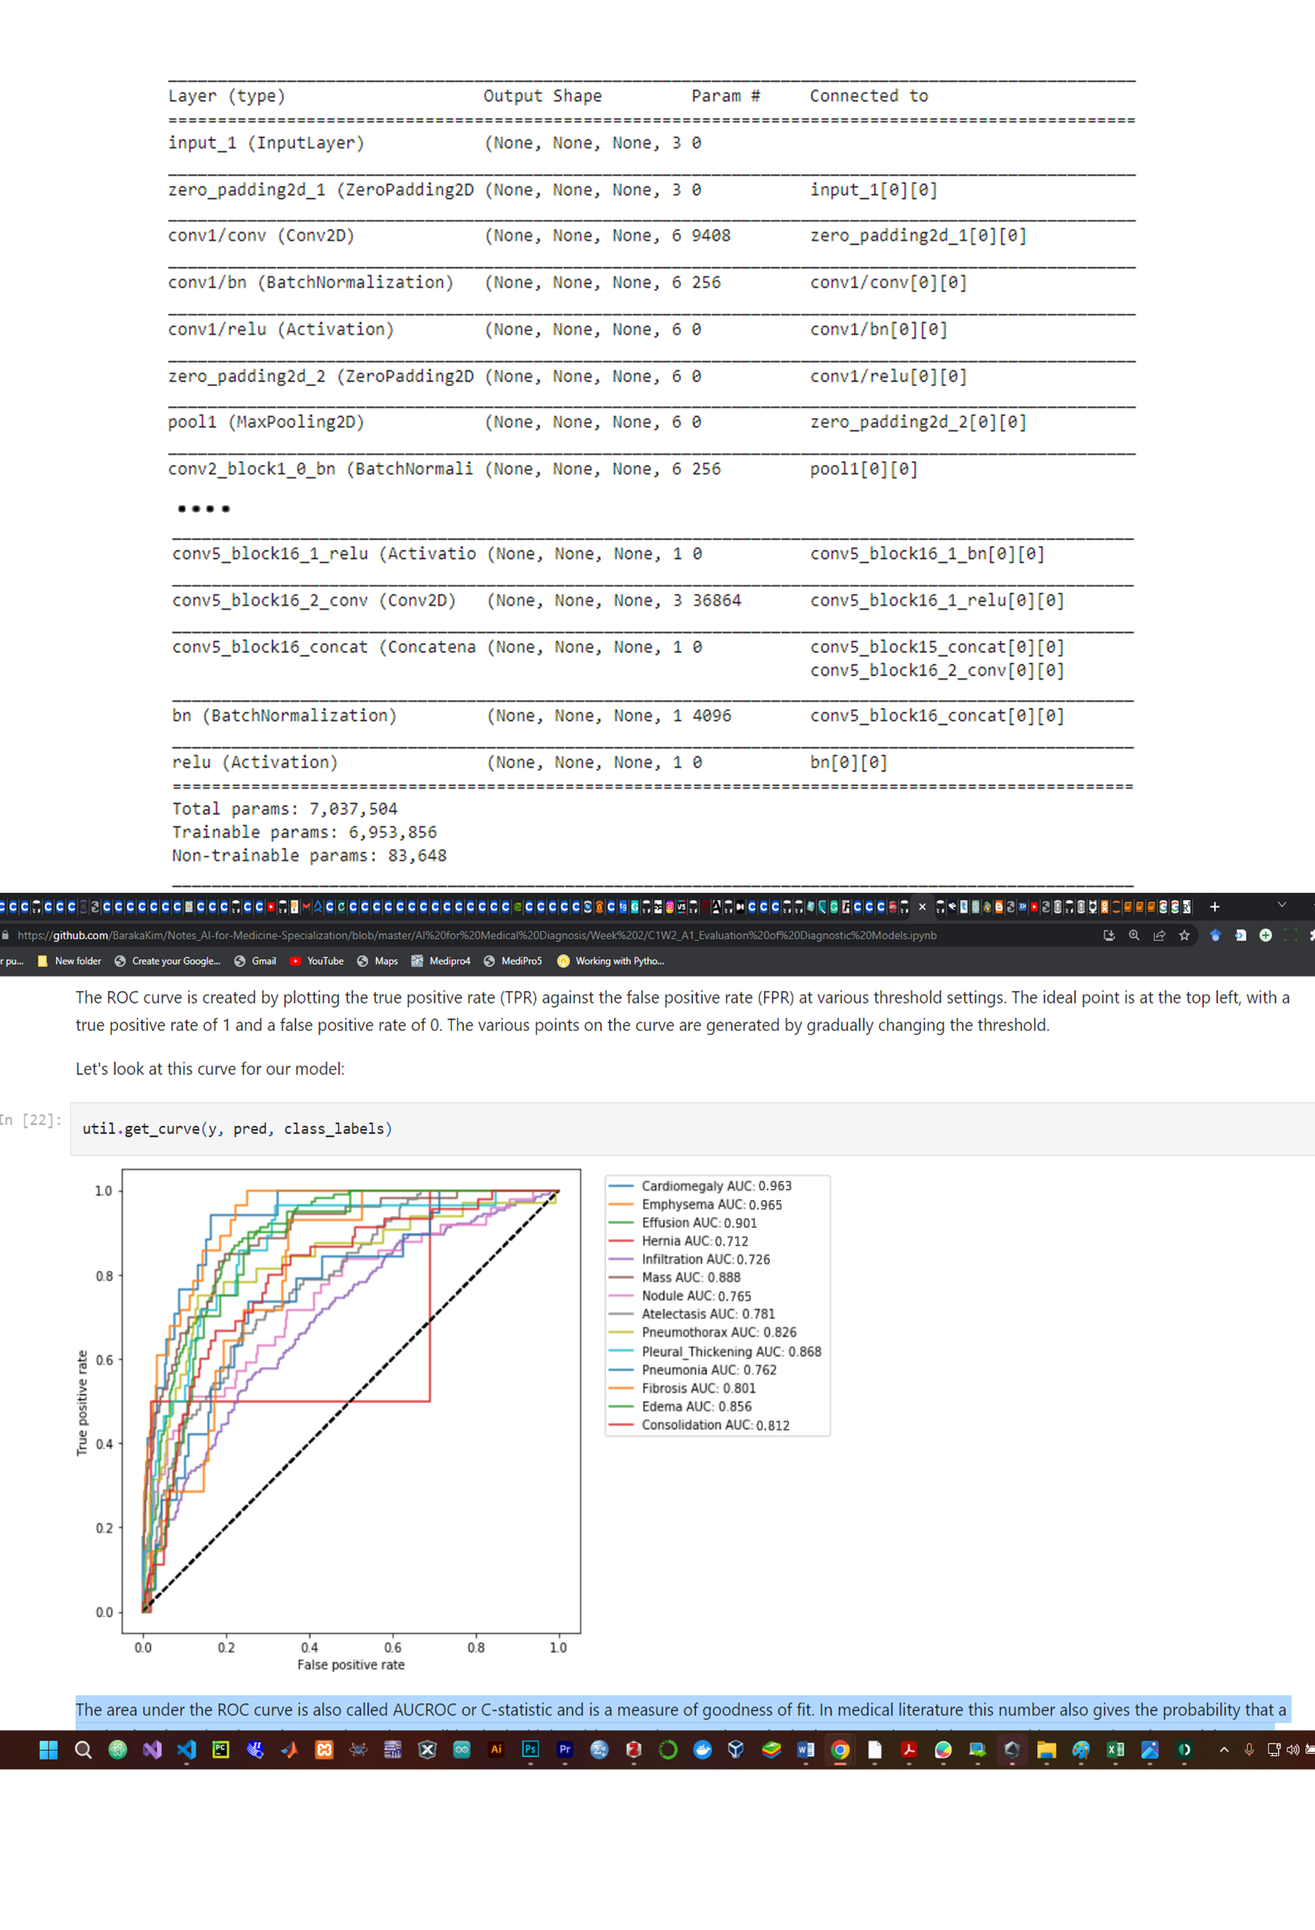

Figure 4: The Area under the ROC curve (AUROC) plotted with the Sensitivity (TPR of 1) against the Specificity (FPR of 0) at various Threshold settings (TH)—as presented in table 3.

Table 4: Comparison study between our designed model and among the best model in classifying Chest X-ray 14 Dataset using DenseNet-121 Architecture.

|  |  |  |  |  |
| --- | --- | --- | --- | --- |
|  | Wang et al. (2017) | Yao et al. (2017) | CheXNet | Our Model |
| Emphysema | 0.815 | 0.829 | 0.9371 | 0.965 |
| Cardiomegaly | 0.807 | 0.904 | 0.9248 | 0.963 |
| Effusion | 0.784 | 0.859 | 0.8638 | 0.901 |
| Mass | 0.706 | 0.792 | 0.8676 | 0.888 |
| Pleural_Thickening | 0.708 | 0.765 | 0.8062 | 0.868 |
| Edema | 0.835 | 0.882 | 0.8878 | 0.856 |
| Pneumothorax | 0.806 | 0.841 | 0.8887 | 0.826 |
| Consolidation | 0.708 | 0.788 | 0.7901 | 0.812 |
| Fibrosis | 0.769 | 0.767 | 0.8047 | 0.801 |
| Atelectasis | 0.716 | 0.772 | 0.8094 | 0.781 |
| Nodule | 0.671 | 0.717 | 0.7802 | 0.765 |
| Pneumonia | 0.633 | 0.713 | 0.7680 | 0.762 |
| Infiltration | 0.609 | 0.695 | 0.7345 | 0.726 |
| Hernia | 0.767 | 0.914 | 0.9164 | 0.712 |

**4. DISCUSSION**

The study evaluated the performance of the DenseNet-121 architecture in classifying lung diseases and abnormalities in chest X-ray images using the Chest X-ray 14 dataset. Through several evaluation metrics, the results show that the model achieved an overall NPV (97.9%), Specificity (0.765), Sensitivity (0.73), and Accuracy (77.8%)—a significant improvement over traditional machine learning with accuracy around 60-70%. The use of data augmentation, Adam optimization, and early stopping further enhanced the model's performance, making it superior to several other top-performing deep learning models—as indicated in Table 4 [24], [37], [38]. The model demonstrated superior classification accuracy for several diseases, including Emphysema, Cardiomegaly, Effusion, Mass, and Pleural_Thickening. It has also achieved an overall AUROC of 0.83, with a strong performance for Emphysema (0.965) and Cardiomegaly (0.963) and a relatively weaker performance for Infiltration (0.726) and hernia (0.712).

**Limitation:** Future research needs to address several limitations of this study, including the relatively small dataset and classes compared to other medical image datasets and poor image quality in some cases, such as blurry images, images with artifacts, or low contrast. The annotation of a dataset using natural language processing and expert radiologists may result in inconsistencies in image labeling. Furthermore, the variability of chest radiographs, such as patient demographics, imaging equipment, and technical factors like exposure settings and image resolution, can also impact the model's performance. Additionally, the Chest X-ray 14 dataset only contains images captured from a front-view perspective, which may limit the model's generalizability to other views.

**Future work:** The future research will focus on integrating the designed model into clinical practice and assess its performance in real-world settings—especially on mobile devices. However, several areas of improvement need to be addressed to enhance the model's performance based on the results and limitations of this study. These areas include increasing the dataset size, improving image quality, annotating datasets with more consistent labeling, expanding radiographs with different views, or developing more advanced deep-learning models. In addition, there is an opportunity to explore a multi-task learning approach to identify multiple abnormalities or diseases simultaneously and incorporate different model modalities, such as CT scans, to improve the accuracy and robustness of the chest X-ray analysis model.

**5. CONCLUSION**

In Summary, this study highlights that the developed deep learning-based CNN algorithm offers a promising solution to the challenges associated with the time-consuming and accurate interpretation of chest X-ray images. Such automated tools potentially improve patient outcomes, reduce healthcare costs, and ultimately save lives. Further research and development in this area will undoubtedly lead to even more sophisticated tools for medical image analysis, revolutionizing the field of radiology and enhancing the quality of healthcare globally. However, this model should not replace radiologists but rather than used as diagnostic support. Moreover, addressing privacy, security, and bias concerns is significant before extensively (large scale) deploying the model.

Top of Form

**BIBLIOGRAPHY**

[1] A. Lorensia, R. V. Suryadinata, and I. N. Y. Diputra, “Risk Factors and Early Symptoms Related to Respiratory Disease in Pedicab Drivers in Surabaya,” *KEMAS J. Kesehat. Masy.*, vol. 15, no. 2, Art. no. 2, 2019, Accessed: Apr. 03, 2023. [Online]. Available: http://repository.ubaya.ac.id/37026/

[2] P. Montnémery, P. Bengtsson, A. Elliot, L.-H. Lindholm, P. Nyberg, and C.-G. Löfdahl, “Prevalence of obstructive lung diseases and respiratory symptoms in relation to living environment and socio-economic group,” *Respir. Med.*, vol. 95, no. 9, pp. 744–752, Sep. 2001, doi: 10.1053/rmed.2001.1129.

[3] GBD 2015 LRI Collaborators, “Estimates of the global, regional, and national morbidity, mortality, and aetiologies of lower respiratory tract infections in 195 countries: a systematic analysis for the Global Burden of Disease Study 2015,” *Lancet Infect. Dis.*, vol. 17, no. 11, pp. 1133–1161, Nov. 2017, doi: 10.1016/S1473-3099(17)30396-1.

[4] “Prevalence and attributable health burden of chronic respiratory diseases, 1990–2017: a systematic analysis for the Global Burden of Disease Study 2017,” *Lancet Respir. Med.*, vol. 8, no. 6, pp. 585–596, Jun. 2020, doi: 10.1016/S2213-2600(20)30105-3.

[5] H. Kilic *et al.*, “Effect of chronic lung diseases on mortality of prevariant COVID-19 pneumonia patients,” *Front. Med.*, vol. 9, p. 957598, Oct. 2022, doi: 10.3389/fmed.2022.957598.

[6] S. J. Tzotzos, B. Fischer, H. Fischer, and M. Zeitlinger, “Incidence of ARDS and outcomes in hospitalized patients with COVID-19: a global literature survey,” *Crit. Care Lond. Engl.*, vol. 24, no. 1, p. 516, Aug. 2020, doi: 10.1186/s13054-020-03240-7.

[7] D. C. Moncada, Z. V. Rueda, A. Macías, T. Suárez, H. Ortega, and L. A. Vélez, “Reading and interpretation of chest X-ray in adults with community-acquired pneumonia,” *Braz. J. Infect. Dis. Off. Publ. Braz. Soc. Infect. Dis.*, vol. 15, no. 6, pp. 540–546, 2011.

[8] B. Moifo *et al.*, “Inter-Observer Variability in the Detection and Interpretation of Chest X-Ray Anomalies in Adults in an Endemic Tuberculosis Area,” *Open J. Med. Imaging*, vol. 5, no. 3, Art. no. 3, Aug. 2015, doi: 10.4236/ojmi.2015.53018.

[9] R. M. Hopstaken, T. Witbraad, J. M. A. van Engelshoven, and G. J. Dinant, “Inter-observer variation in the interpretation of chest radiographs for pneumonia in community-acquired lower respiratory tract infections,” *Clin. Radiol.*, vol. 59, no. 8, pp. 743–752, Aug. 2004, doi: 10.1016/j.crad.2004.01.011.

[10] S. Sakurada *et al.*, “Inter-rater agreement in the assessment of abnormal chest X-ray findings for tuberculosis between two Asian countries,” *BMC Infect. Dis.*, vol. 12, p. 31, Feb. 2012, doi: 10.1186/1471-2334-12-31.

[11] “Artificial intelligence in healthcare: past, present and future - PubMed.” https://pubmed.ncbi.nlm.nih.gov/29507784/ (accessed Apr. 02, 2023).

[12] K. G. van Leeuwen, M. de Rooij, S. Schalekamp, B. van Ginneken, and M. J. C. M. Rutten, “How does artificial intelligence in radiology improve efficiency and health outcomes?,” *Pediatr. Radiol.*, vol. 52, no. 11, pp. 2087–2093, Oct. 2022, doi: 10.1007/s00247-021-05114-8.

[13] J. T. Wu *et al.*, “Comparison of Chest Radiograph Interpretations by Artificial Intelligence Algorithm vs Radiology Residents,” *JAMA Netw. Open*, vol. 3, no. 10, p. e2022779, Oct. 2020, doi: 10.1001/jamanetworkopen.2020.22779.

[14] A. Yilmaz, A. A. Demircali, S. Kocaman, and H. Uvet, “Comparison of Deep Learning and Traditional Machine Learning Techniques for Classification of Pap Smear Images.” arXiv, Sep. 11, 2020. Accessed: Apr. 03, 2023. [Online]. Available: http://arxiv.org/abs/2009.06366

[15] Y. Lai, “A Comparison of Traditional Machine Learning and Deep Learning in Image Recognition,” *J. Phys. Conf. Ser.*, vol. 1314, no. 1, p. 012148, Oct. 2019, doi: 10.1088/1742-6596/1314/1/012148.

[16] Y. LeCun, Y. Bengio, and G. Hinton, “Deep learning,” *Nature*, vol. 521, no. 7553, Art. no. 7553, May 2015, doi: 10.1038/nature14539.

[17] “Deep Learning Techniques for Biomedical and Health Informatics | SpringerLink.” https://link.springer.com/book/10.1007/978-3-030-33966-1 (accessed Apr. 03, 2023).

[18] A. Anaya-Isaza, L. Mera-Jiménez, and M. Zequera-Diaz, “An overview of deep learning in medical imaging,” *Inform. Med. Unlocked*, vol. 26, p. 100723, Jan. 2021, doi: 10.1016/j.imu.2021.100723.

[19] E. Çallı, E. Sogancioglu, B. van Ginneken, K. G. van Leeuwen, and K. Murphy, “Deep learning for chest X-ray analysis: A survey,” *Med. Image Anal.*, vol. 72, p. 102125, Aug. 2021, doi: 10.1016/j.media.2021.102125.

[20] X. Lessage, S. Mahmoudi, S. A. Mahmoudi, S. Laraba, O. Debauche, and M. A. Belarbi, “Chest X-ray Images Analysis with Deep Convolutional Neural Networks (CNN) for COVID-19 Detection,” in *Healthcare Informatics for Fighting COVID-19 and Future Epidemics*, L. Garg, C. Chakraborty, S. Mahmoudi, and V. S. Sohmen, Eds., in EAI/Springer Innovations in Communication and Computing. Cham: Springer International Publishing, 2022, pp. 403–423. doi: 10.1007/978-3-030-72752-9_21.

[21] D. R. Sarvamangala and R. V. Kulkarni, “Convolutional neural networks in medical image understanding: a survey,” *Evol. Intell.*, vol. 15, no. 1, pp. 1–22, 2022, doi: 10.1007/s12065-020-00540-3.

[22] R. Yamashita, M. Nishio, R. K. G. Do, and K. Togashi, “Convolutional neural networks: an overview and application in radiology,” *Insights Imaging*, vol. 9, no. 4, pp. 611–629, Aug. 2018, doi: 10.1007/s13244-018-0639-9.

[23] K. Simonyan and A. Zisserman, “Very Deep Convolutional Networks for Large-Scale Image Recognition.” arXiv, Apr. 10, 2015. doi: 10.48550/arXiv.1409.1556.

[24] X. Wang, Y. Peng, L. Lu, Z. Lu, M. Bagheri, and R. M. Summers, “ChestX-ray8: Hospital-scale Chest X-ray Database and Benchmarks on Weakly-Supervised Classification and Localization of Common Thorax Diseases,” in *2017 IEEE Conference on Computer Vision and Pattern Recognition (CVPR)*, Jul. 2017, pp. 3462–3471. doi: 10.1109/CVPR.2017.369.

[25] A. Krizhevsky, I. Sutskever, and G. Hinton, “ImageNet Classification with Deep Convolutional Neural Networks,” *Neural Inf. Process. Syst.*, vol. 25, Jan. 2012, doi: 10.1145/3065386.

[26] O. Russakovsky *et al.*, “ImageNet Large Scale Visual Recognition Challenge.” arXiv, Jan. 29, 2015. doi: 10.48550/arXiv.1409.0575.

[27] Y. Xu and R. Goodacre, “On Splitting Training and Validation Set: A Comparative Study of Cross-Validation, Bootstrap and Systematic Sampling for Estimating the Generalization Performance of Supervised Learning,” *J. Anal. Test.*, vol. 2, no. 3, pp. 249–262, Jul. 2018, doi: 10.1007/s41664-018-0068-2.

[28] G. Huang, Z. Liu, L. van der Maaten, and K. Q. Weinberger, “Densely Connected Convolutional Networks.” arXiv, Jan. 28, 2018. doi: 10.48550/arXiv.1608.06993.

[29] S. Ioffe and C. Szegedy, “Batch Normalization: Accelerating Deep Network Training by Reducing Internal Covariate Shift.” arXiv, Mar. 02, 2015. doi: 10.48550/arXiv.1502.03167.

[30] A. F. Agarap, “Deep Learning using Rectified Linear Units (ReLU).” arXiv, Feb. 07, 2019. doi: 10.48550/arXiv.1803.08375.

[31] X. Glorot, A. Bordes, and Y. Bengio, “Deep Sparse Rectifier Neural Networks,” in *Proceedings of the Fourteenth International Conference on Artificial Intelligence and Statistics*, JMLR Workshop and Conference Proceedings, Jun. 2011, pp. 315–323. Accessed: Apr. 16, 2023. [Online]. Available: https://proceedings.mlr.press/v15/glorot11a.html

[32] R. Hu, B. Tian, S. Yin, and S. Wei, “Efficient Hardware Architecture of Softmax Layer in Deep Neural Network,” in *2018 IEEE 23rd International Conference on Digital Signal Processing (DSP)*, Nov. 2018, pp. 1–5. doi: 10.1109/ICDSP.2018.8631588.

[33] S. J. Pan and Q. Yang, “A Survey on Transfer Learning,” *IEEE Trans. Knowl. Data Eng.*, vol. 22, no. 10, pp. 1345–1359, Oct. 2010, doi: 10.1109/TKDE.2009.191.

[34] D. Shulman, “Optimization Methods in Deep Learning: A Comprehensive Overview.” arXiv, Feb. 19, 2023. doi: 10.48550/arXiv.2302.09566.

[35] D. Powers, “Evaluation: From Precision, Recall and F-Factor to ROC, Informedness, Markedness & Correlation,” *Mach Learn Technol*, vol. 2, Jan. 2008.

[36] A. C. J. W. Janssens and F. K. Martens, “Reflection on modern methods: Revisiting the area under the ROC Curve,” *Int. J. Epidemiol.*, vol. 49, no. 4, pp. 1397–1403, Aug. 2020, doi: 10.1093/ije/dyz274.

[37] L. Yao, E. Poblenz, D. Dagunts, B. Covington, D. Bernard, and K. Lyman, “Learning to diagnose from scratch by exploiting dependencies among labels.” arXiv, Feb. 01, 2018. doi: 10.48550/arXiv.1710.10501.

[38] P. Rajpurkar *et al.*, “CheXNet: Radiologist-Level Pneumonia Detection on Chest X-Rays with Deep Learning.” arXiv, Dec. 25, 2017. Accessed: Apr. 08, 2023. [Online]. Available: http://arxiv.org/abs/1711.05225