

**At least 90 dead as violence grips the country**

REGD No. DA 789 VOL. XXXIV No. 193 SRABAN 21, 1431 BS [www.thedailystar.net](http://www.thedailystar.net) MUHARRAM 29, 1446 HIJRI 16 PAGES TK 15.00

DHAKA MONDAY AUGUST 5, 2024



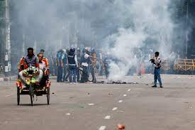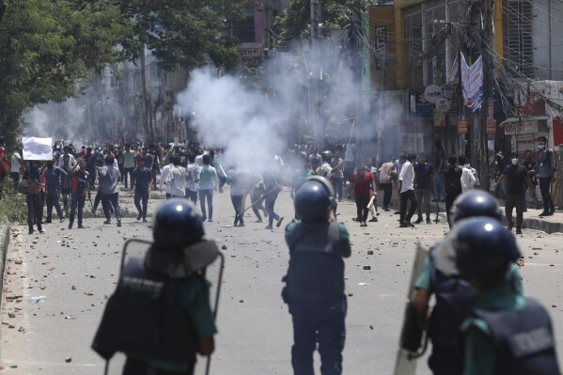

**STAR REPORT**

At least 90 people, including 14 police personnel, were killed and over a thousand others injured, many with bullets, as a new wave of violence convulsed in Bangladesh.

Ruling party activists and police clashed with protesters in Dhaka and other parts of Bangladesh yesterday in three-way attacks on the first day of the student led non-cooperation movement.

The day began peacefully, but it turned violent after supports of the ruling Awami League descended on streets and neighborhoods to put up resistance against anti-government protests.

Details of violence emerged from across the country

a

y

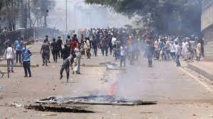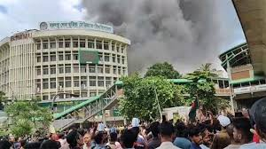

Prime Minister Sheikh Hasina yesterday asked people to deal with saboteurs with an iron hand.

“Those who are now causing the violence are students. They are criminals,” Hasina was quoted as saying by Assistant Press Secretary ABM Sarwer-E-Alam Sarker.

The government in a press release urged students and parents to return home and

**SEE PAGE 2 COL 5**

STAFF CORRESPONDENT

Resist the saboteurs with an iron hand

**PM urges people**

At least 24 vehicles parked inside BSMMU in the capital’s Shahbagh were set on fire and several others vandalized, during chase and counter chase between ruling party activists and protesters yesterday.

According to witnesses, the protesters gather at Shahbagh

**SEE PAGE 2 COL 5**

STAFF CORRESPONDENT

Patients panic as clash spills over into BSMMU

**24 vehicles torched**

**Plums of smoke bellowing from the BSMMU as protesters set fire to several vehicles, inset, parked inside the compound yesterday.**

The anti-discrimination student movement has moved up the “March to Dhaka” program from Tuesday to today to press for their one-point demand – the resignation of Sheikh Hasina-led government.

They called upon the students and people from all across the country to join the march towards the capital.

**SEE PAGE 2 COL 5**

STAFF CORRESPONDENT

‘1-POINT DEMAND’

Protesters call for ‘March to Dhaka’ today

police said, a mob tried to attack the police station and police opened fire and lobbed teargas to disperse them.

At one stage, the police officers there believed they were safe. But hundreds of people made a sudden attack on the station.

**SEE PAGE 2 COL 2**

At least 13 policemen, including an officer-in-charge, were beaten to death at Enayetpur police station in Sirajganj yesterday.

Police headquarters in a release said goons carried out the brutal attack.

Mohammad Hannan Miah, additional superintendent (crime) of Sirajganj

-in-ch

**STAFF CORRESPONDENT**

**t**

**13 cops killed in attack on police station**

Until late last night: 18 died in Sirajganj, eight each in Laxmipur, and Feni; six in Narsingdi; five in Bogura; four each in Rangpur, Magura, and Sylhet; three each in Pabna, Munshiganj, cumilla, Kishoreganj, and Sherpur; one each in Habiganj, Barishal, Savar, Joypurhat, Bhola, and Cox’s Bazar.

The job quota reform protests by students pulled in people from all walks of life. The protests entered a dangerous phase after at least 204 people were killed in indiscriminate firing by law enforcers, members of BGB and ruling party activists, in a spasm of violence from July 16 to July 21.

**SEE PAGE 2 COL 2**

**The death toll may rise as reports of many bullets injuries got admitted to hospitals and health complexes, according to reports filed by The Daily Star correspondents from many districts.**

**Police fires at the protesters during clash between police and protesters**