This document is going to explain about the 1. Confluent Kakfa -> 2. Azure Blob (iceberg table format) -> 3. Snowflake setup is explained in the this URL.
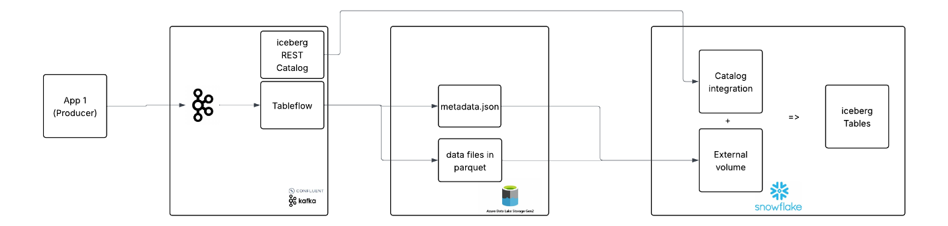
Below steps are involved settings up iceberg rest catalog in snowflake.
- Confluent Setup:
  - Setup Tableflow in Confluent Cluster
    - Create Storage Connection that connects to Blob
      - az ad sp create --id 8b40b63c-22fe-4860-97e8-d3fda65e25f7
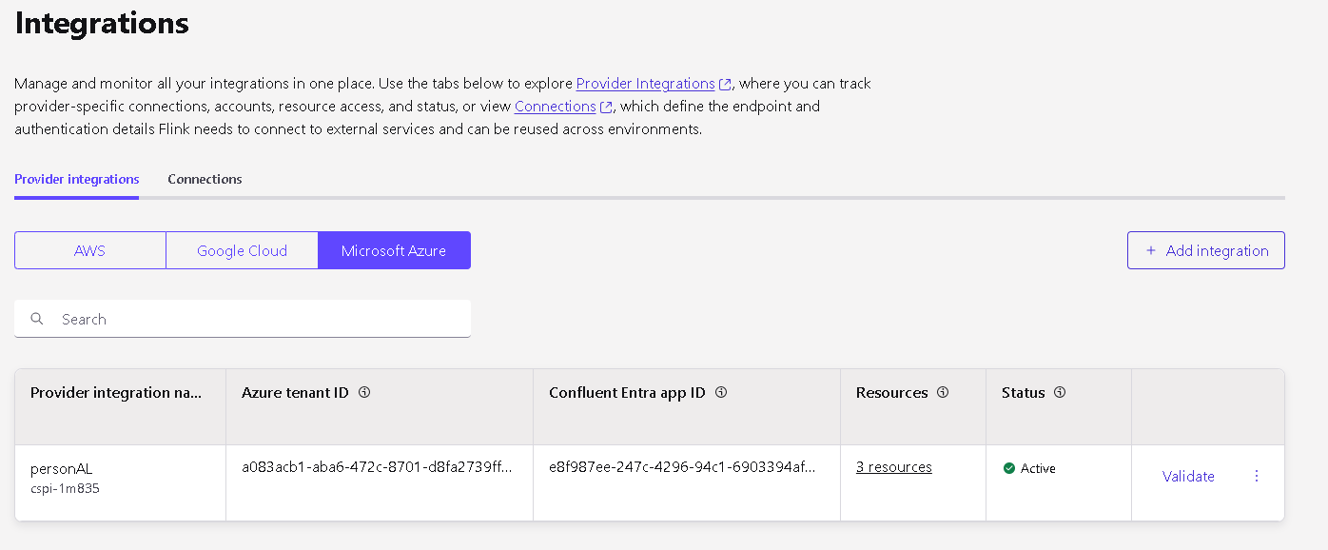
List of permissions needed
- Storage Blob Data Contributor
- Reader

    - Now enable tableflow
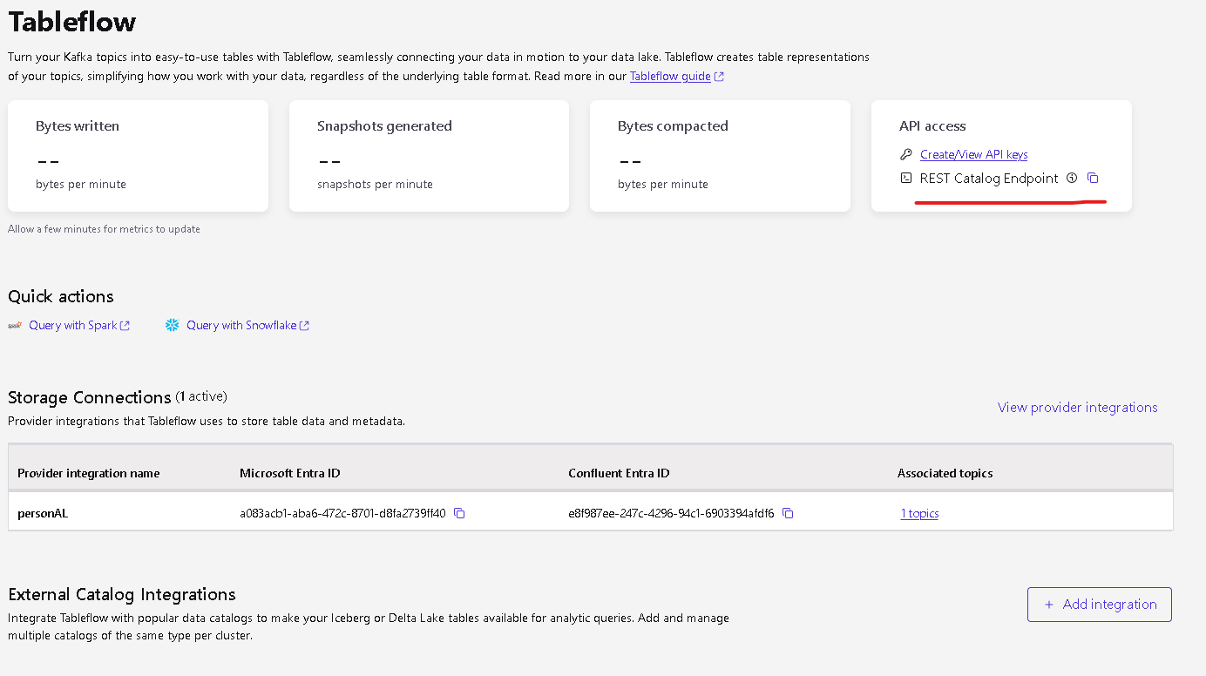

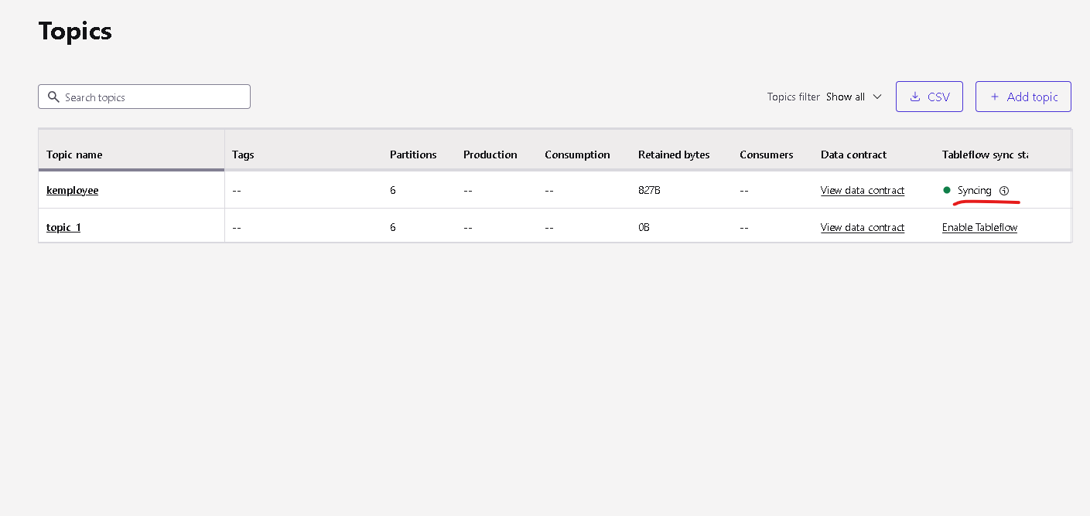

- Azure iceberg folder walk-through
- Snowflake
  - REST catalog integration
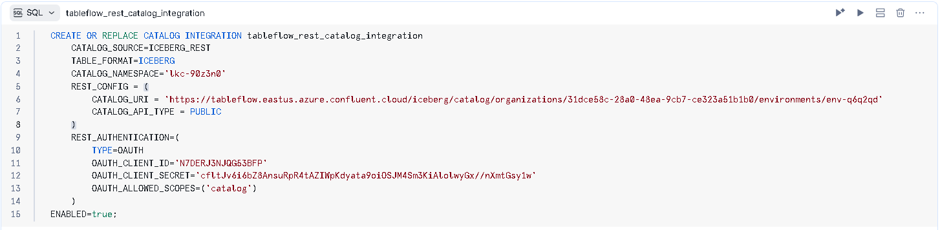
  - Create an external volume of Azure Storage account
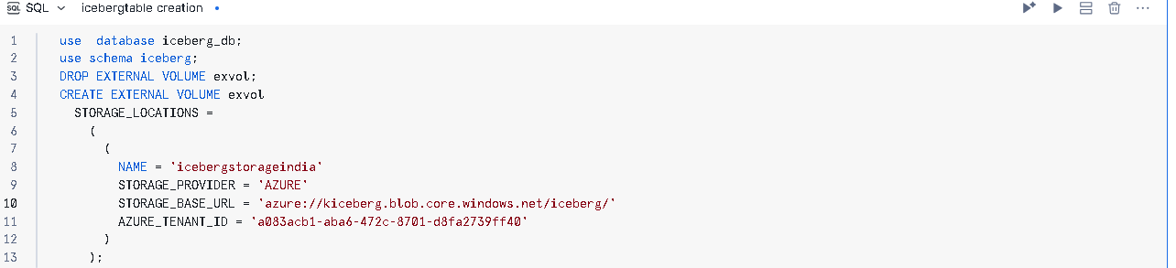
For the app, we need
      - Storage Blob Data Contributor
      - Storage Blob Data Reader
  - Finally, create iceberg table

