Sports Center Management Software

# Introduction

This artifact defines the view of the stakeholders of the technical solution to be developed. This definition is specified in terms of the key needs and features of the stakeholders. The vision contains an outline of the envisioned core requirements for the system.

# Positioning

## Problem Statement

|  |  |
| --- | --- |
| The problem of | lack of communication between company and its departments,  tracking of member’s sport activities and enroll,  people not getting enough information, |
| affects | stuff and managers of the company,  Anyone who wants to register, |
| the impact of which is | latency of work to do, potential customers, loss of information, |
| a successful solution would be | efficient use of time, increases company’s prestige and accessibility, wide spreading. |

## 

## Product Position Statement

|  |  |
| --- | --- |
| For | sport center companies, |
| Who | needs more efficient internal and external communication, |
| The SportSupport | is a tracking and management software, |
| That | systematize the communication, |
| Unlike | manual records, |
| Our product | efficient usage of the resources and time. |

# 

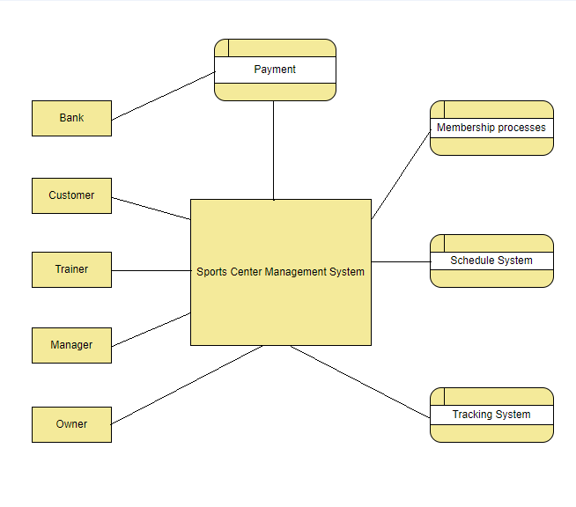

Context (Data Flow) Diagram of the Project

# Stakeholder Descriptions

## Stakeholder Summary

| **Name** | **Description** | **Responsibilities** |
| --- | --- | --- |
| Owners | Investors of the company. | Invest in projects that increase profits. |
| Managers | Anyone who manages the staff of company. | Increase the profit of the company by using the necessary projects and using the employees more efficiently. |
| Employees | Anyone who works for company. | Efficient usage of the company’s resources and provide customer happiness. |
| Customers | Anyone who benefit from company’s services. | Obey the rules. Do not disturb other customers. |
| Software project manager | The person who allocates resources, shapes priorities, coordinates interactions with customers and users, and generally keeps the project team focused on the right goal. | Planning, setting goals, time management, budget allocation and cost estimates, implementation and monitoring. |
| Software analyst | The person who studies of the software application domain, prepares software requirements, and specification documents. | Performing complex analysis, designing and programming to meet business requirements. Maintaining, managing and modifying all software systems and applications. Defining specifications, Interfacing with end-users and consultants. |
| Software architect | The person who is a software expert who makes high-level design choices and dictates technical standards, tools and platforms. | Design, develop and execute software solutions to address issues. Provide architectural blueprints and technical leadership to our IT team. Evaluate and recommend tools. |
| Software configuration manager | The person who provides the overall configuration management infrastructure and environment to the product development team. | Supports the product development activity so that developers and integrators have appropriate workspaces to build and test their work, and so that all artifacts are available for inclusion in the deployment unit as required. |
| Software tester | The person who is an individual that tests software for bugs, errors, defects or any problem that can affect the performance of computer software or an application. | Identifying the most appropriate implementation approach for a given test. Implementing individual tests. Setting up and executing the tests. Analyzing and recovering from execution errors. |

## User Environment

* First task is the online registration system which takes about five minutes to complete registration. Difference between old system that been used are the now registration takes less time, remove the paperwork of registration process and it removes constraints about location while registering.
* Second task is the tracking system which allows customers track their task and features online.
* Third task is the notification system that notifies to customers about their schedule.
* Fourth task is the system that makes easier and quicker information sharing between centers.

# Product Overview

## Needs and Features

|  |  |  |  |
| --- | --- | --- | --- |
| **Need** | **Priority** | **Features** | **Planned Release** |
| Sign in | High | Member / Non-member can register to sports center’s database. | Release 1 |
| Login / Logout | High | A member can reach his/her profile. | Release 1 |
| View / Attend available classes | Medium | A member can view / attend special activity classes. | Release 2 |
| Tracking activity and nutrition schedule | Medium | A member can reach his/her plans and track his/her progress. | Release 2 |
| Open / Close classes | High | Manager can open/close special activity classes. | Release 2 |
| Payment system | High | Members can pay their fees online. | Release 1 |
| Membership management | High | Members can buy / extend / cancel their memberships. | Release 1 |
| Achievement system | Medium | Evaluating members' attendance / interests and offering related campaigns. | Release 3 |
| Online Consultancy | Low | Premium users can access online consultancy chat system with their trainers. | Release 3 |
| Open / Close branches | High | Owner can open/close branches with management panel. | Release 3 |
| Create campaigns | Low | Manager can create campaigns for who has a right. | Release 2 |
| View branch’s status | High | Manager and owner can view stats of branches. | Release 3 |

# Other Product Requirements

|  |  |  |
| --- | --- | --- |
| **Requirement** | **Priority** | **Planned Release** |
| Android version 4.2 application. | High | It is concurrent with release dates. |
| Web interface (Angular). | High | It is concurrent with release dates. |
| User manual for starters. | Low | Release 3 |
| Server for database processes | High | Release 1 |
| Robustness | Medium | Release 3 |
| Very low fault tolerance. It is very important for this project especially on topics of payment, class enrollment and register processes. | High | It is concurrent with release dates. |
| Usability. The application will be served very wide group of people from different ages. | High | It is concurrent with release dates. |
| Object oriented design | High | It is concurrent with release dates. |
| Member cards assumed to be read and recorded to our server by a system in the center like turnstiles. | High | - |
| It is assumed that payment is verify by the negotiated bank online. | High | - |