MODULE 4 CHALLENGE ANALYSIS

Local School Performance Report

|  |  |
| --- | --- |
| **Module number** | #4 |
| **Week** | #4 |
| **Module Challenge** | #4 |
| **Reported On** | Mar 26th 2023 |

# Local Government Area Summary

Question-

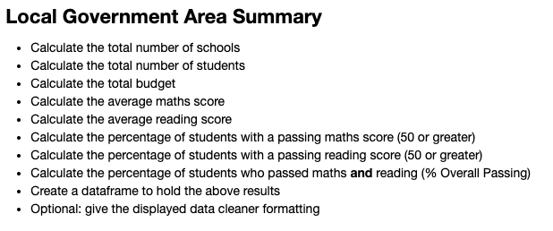

Answer-



## Summary:

* The given dataset has a total of 15 schools and 39,170 students across the schools.
* The total budget allocated to the 15 schools is $24,649,428.00.
* The students scored an average math score of 70.33 and an average reading score of 69.98 across the 15 schools.
* A total of 86.07% students passed maths and 84.42% passed reading.
* The overall passing is at 72.80% indicative of the percentage of students that passed both maths and reading.

# School Summary

Question-

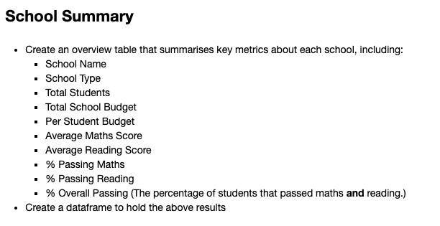

Answer-

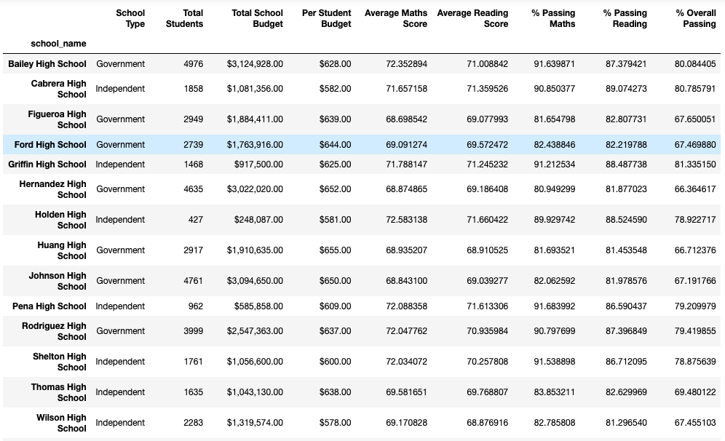

## Summary:

The original dataset is grouped by school and the same statistics split by school.

* Bailey High School (a government school) has the highest number of students at 4,976 followed by Johnson High School (Government) with 4,761 students. Holden High School (Independent) has the lowest number of students (427).
* Bailey High School has the highest budget amounting to $3,124,928.00 compared to Holden High School (Independent) which has the lowest budget amount, amounting to $248,087.00. This implies that, Holden High School has a higher budget per student in terms of percentage (0.234%) in comparison to Bailey High School (0.02%)
* Holden High School (Independent) however is leading in terms of average maths score with 72.58 compared to Figueroa High School (Government) with an average maths score of 68.69.
* Holden High School is also leading in terms of average reading score with 71.66 compared to the lowest (Wilson High School) with an average reading score of 68.87.
* Pena High School (Independent) has the highest % of students passing maths- 91.68%, while Hernandez High School (Government) has the lowest % of students passing maths- 80.95%
* Cabrera High School (Independent) has the highest % of students passing reading – 89.07%, while Wilson High School (Independent) has the lowest % of students passing reading- 81.29%
* Based on this dataset and set of analyses, it can be summarised that independent schools in general have a better performance in terms of % students passing reading and maths respectively.

# Top Performing Schools

Question-

Answer-

## Summary:

* Griffin High School (Independent) has the highest overall passing % (81.33%)
* This is followed by Cabrera High School at 80.78% and Bailey High School at 80.08%
* From the analysis, it can be summarised that 3 of top 5 schools are independent.

# Bottom Performing Schools

Question-

Answer-

## Summary:

* Worst performing school from the dataset based on overall passing % is 66.34%
* This is followed by Huang High School with 66.71% and Johnson High School at 67.19%
* From the analysis, it can be summarised that 4 of worst 5 schools are government.

# Maths Scores By Years

Question-

Answer-

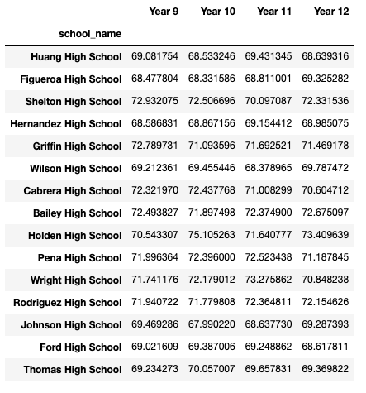

## Summary:

* Majority of the schools have performed consistently from Year 9 to Year 12 with a variance of +/- 1. E.g.: Huang High School and Thomas High School
* Some schools have performed consistently from year 9 to Year 12 with a variance of +/- 2. E.g.: Shelton High School and Johnson High School
* Holden High School has a significant variance (5) from Year 9 to 12.
  + Year 10 has the highest average maths score at 75.10% while Year 9 scored 70.54%

# Reading Sore By Year

Question-

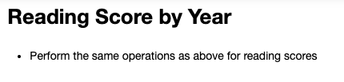

Answer-

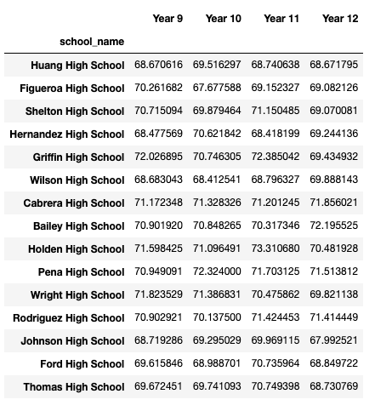

## Summary:

* Majority of the schools have performed consistently from Year 9 to Year 12 with a variance of +/- 1. E.g.: Huang High School
* Majority of the schools have performed consistently from Year 9 to Year 12 with a variance of +/- 2. E.g.: Pena High School
* Holden High School has a significant variance (3) from Year 9 to 12.
  + Year 11 has the highest average maths score at 73.31% while Year 12 scored 70.48%

# Scores By School Spending

Question-

Answer-

## Summary:

* For a spending range of $585-630 per student, the overall % of passing was highest at 79.87%
* Surprisingly, a higher spending per student showcases lower overall passing percentage.
  + $645-680 -> 66.75% passing
* Also, lowest spending per student did significantly better (with respct to overall passing) than the highest spending per student
  + <$584 -> 76.72%

# Scores By School Size

Question-

Answer-

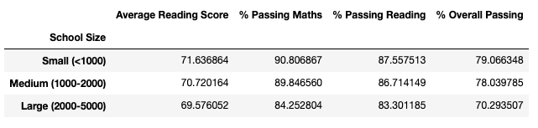

## Summary:

* Schools with less than 1000 students had an overall passing % of 79.
* Medium sized schools with 1000-2000 students had an overall passing % of 78.03.
* Large sized schools with >2000 students had an overall passing % of 70.29.
* It can be summarised that % overall passing is inversely proportional to the size of the school.

# Scores By School Type

Question-

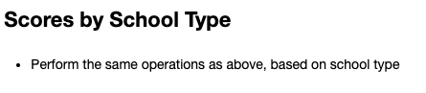

Answer-

## Summary:

* It can be summarised that independent schools are performing better than Government schools by roughly 7%
* As an add on summary, it can also be stated that the independent schools were consistently better in all areas (average maths score, average reading score, % passing maths, % passing reading & overall passing %)