WHATSNEXT VISION MOTORS
VEHICLE ORDER MANAGEMENT SYSTEM USING SALESFORCE
PROJECT DOCUMENTATION

Prepared By: BARANI SREE A M 24CSR035
Department: Computer Science and Engineering

USER STORY

The Vehicle Order Management System at WhatsNext Vision Motors is designed to simplify vehicle and dealer management using Salesforce CRM. As an administrator, the user should be able to maintain vehicle details, stock availability, dealer information, and customer orders in a centralized system. This helps ensure that vehicle and order records are organized and easily accessible.
As a customer or order-processing user, the user should be able to place vehicle orders only when sufficient stock is available. The system validates stock availability before accepting an order and updates the vehicle's stock after a valid order is placed. This helps prevent out-of-stock orders and maintain accurate inventory records.
As an order administrator, the user should be able to process multiple vehicle orders automatically using Batch Apex and Scheduled Apex. The system is intended to update order statuses based on stock availability, assigning Confirmed status when stock is available and Pending status when stock is unavailable. Additional requirements include assigning the nearest dealer based on customer location and sending test-drive reminders to improve customer convenience.

1. INTRODUCTION

1.1 Project Overview
WhatsNext Vision Motors is an automotive company focused on improving customer experience and streamlining vehicle-related business operations through Salesforce CRM. The project aims to develop a centralized Vehicle Order Management System to manage vehicle details, stock availability, dealer information, and customer orders.
The system uses Salesforce custom objects, fields, relationships, Apex triggers, trigger handler classes, and Batch Apex to support vehicle order processing and inventory management. The stock validation functionality is intended to prevent orders when sufficient vehicle stock is unavailable.
The project requirements also describe automatic assignment of orders to the nearest dealer based on the customer's location and scheduled processing of bulk orders. These features should be documented as implemented only if they have been configured and tested in the Salesforce organization.

1.2 Purpose
The purpose of this project is to reduce manual work in vehicle order processing, maintain accurate stock information, and provide a structured way to manage vehicle and order records within Salesforce.

1.3 Objectives
- Create and manage vehicle, dealer, and vehicle order records in Salesforce.
- Maintain vehicle stock information and related order details.
- Validate stock availability before accepting a vehicle order.
- Update vehicle stock after a valid order according to the implemented logic.
- Use Apex triggers and handler classes to separate trigger execution from business logic.
- Process eligible vehicle orders in bulk through Batch Apex, if implemented.
- Update order statuses according to stock availability through the configured process.
- Improve data accuracy and operational efficiency.

2. PROJECT OVERVIEW AND SCOPE

2.1 Business Background
Vehicle order processing depends on reliable vehicle inventory data and clear order status information. If orders are accepted when stock is unavailable, it can cause delays, incorrect expectations, and additional manual work. The proposed Salesforce solution centralizes vehicle and order information and applies business rules during order processing.

2.2 Project Scope
The project scope includes Salesforce environment setup, custom object creation, field configuration, relationship configuration, tabs and application setup, Apex trigger development, trigger handler logic, stock validation, stock updates, and testing. Batch and scheduled processing are included where the corresponding classes and jobs have been implemented.

2.3 Functional Requirements
- Maintain vehicle details and available stock.
- Maintain dealer information.
- Create and manage vehicle order records.
- Prevent orders when the requested stock exceeds available stock.
- Update vehicle stock after a valid order, according to the implemented logic.
- Identify eligible pending orders for bulk processing, if configured.
- Support nearest-dealer assignment and test-drive reminders if those features are implemented.

2.4 Non-Functional Requirements
- Data consistency: stock and order records should remain consistent.
- Maintainability: business logic should be organized into handler classes where appropriate.
- Usability: records should be accessible through the Salesforce Lightning interface.
- Reliability: automation should be tested for valid and invalid scenarios.

3. PHASE 1: REQUIREMENT ANALYSIS AND PLANNING

3.1 Understanding Business Requirements
The requirements focus on maintaining vehicle inventory, dealer details, and vehicle orders. A key business rule is to prevent an order from being accepted when the associated vehicle does not have sufficient available stock. The project also specifies batch processing to update order statuses according to stock availability.

3.2 Data Model
The known core objects include Vehicle (Vehicle__c) and Vehicle Order (Vehicle_Order__c). The Vehicle Order object contains a relationship field to identify the related vehicle. A Dealer object is also mentioned in the project requirements; its exact API name and relationship fields should be recorded from the Salesforce setup.

4. PHASE 2: SALESFORCE SETUP AND DATA MANAGEMENT

4.1 Salesforce Environment Setup
The project is configured in Salesforce Lightning Experience. Salesforce Setup and Object Manager are used to create custom objects, define fields, configure relationships, and organize the application.

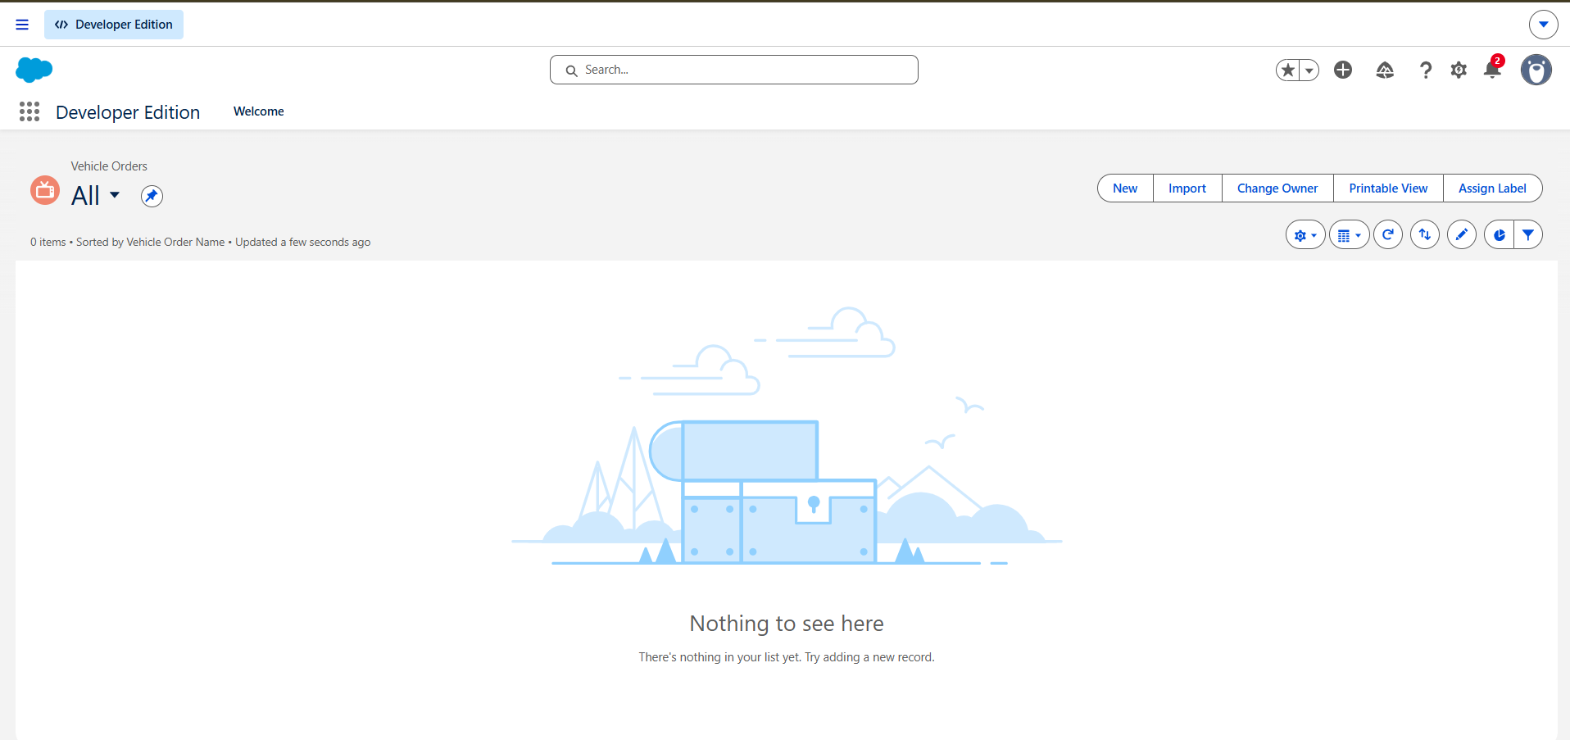

4.2 Custom Objects

Vehicle Object (Vehicle__c)
The Vehicle object stores vehicle-related information, including the stock quantity used by the order validation logic. The exact field labels and API names should be documented as they appear in Object Manager.

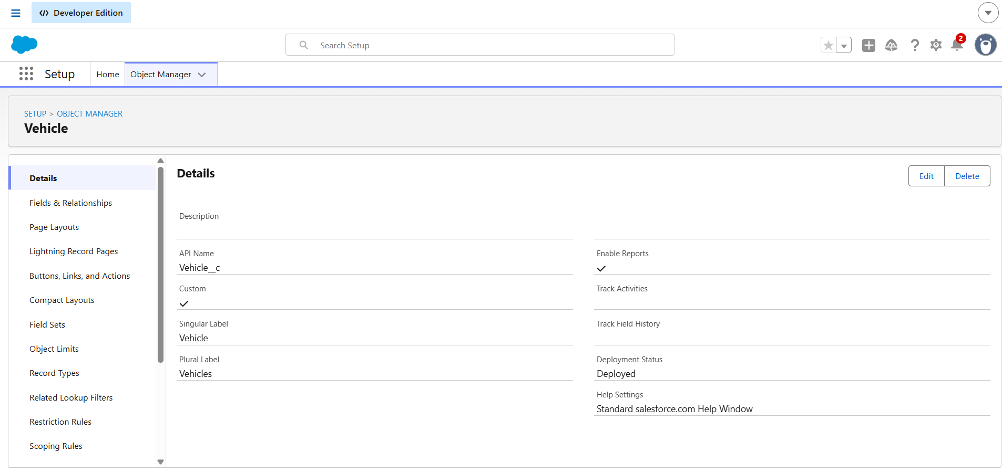

Vehicle Order Object (Vehicle_Order__c)
The Vehicle Order object stores vehicle order information and references the associated vehicle through the configured Vehicle__c relationship field.

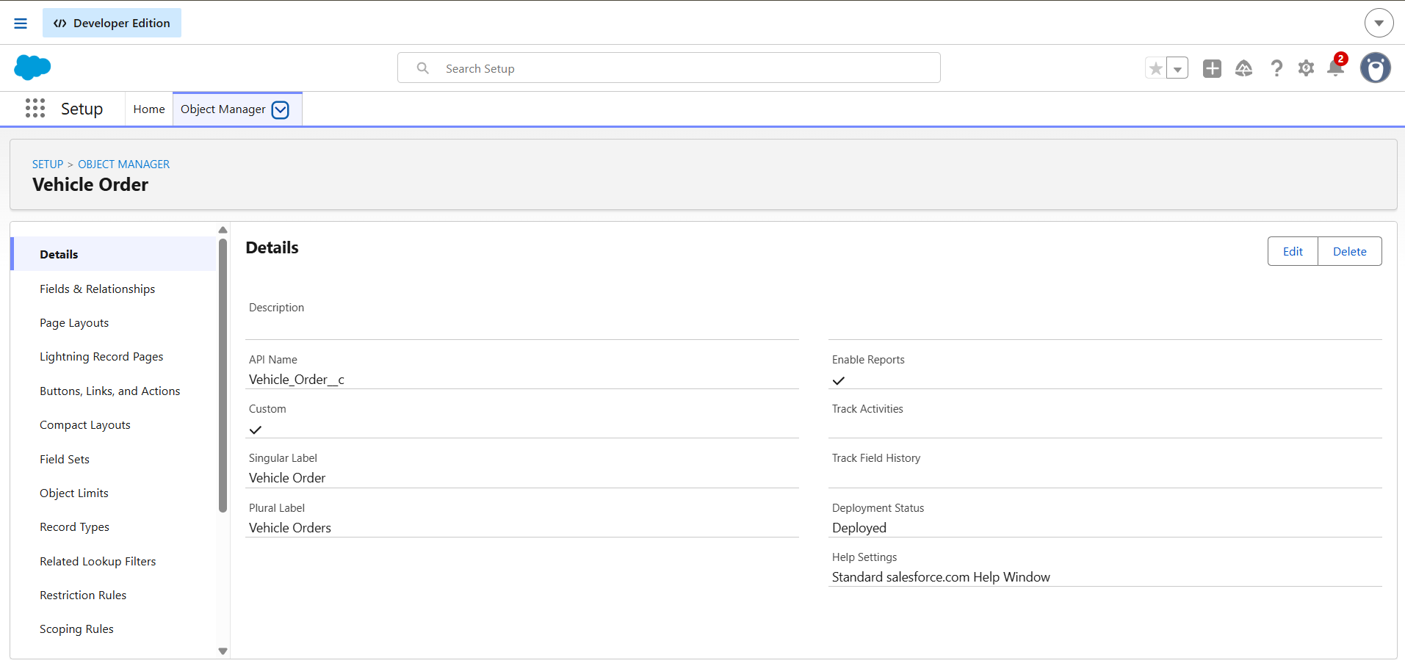

Dealer Object
The project requirements include dealer information for dealer selection and order assignment. Add the actual Dealer object API name and its fields here if the object has been created.

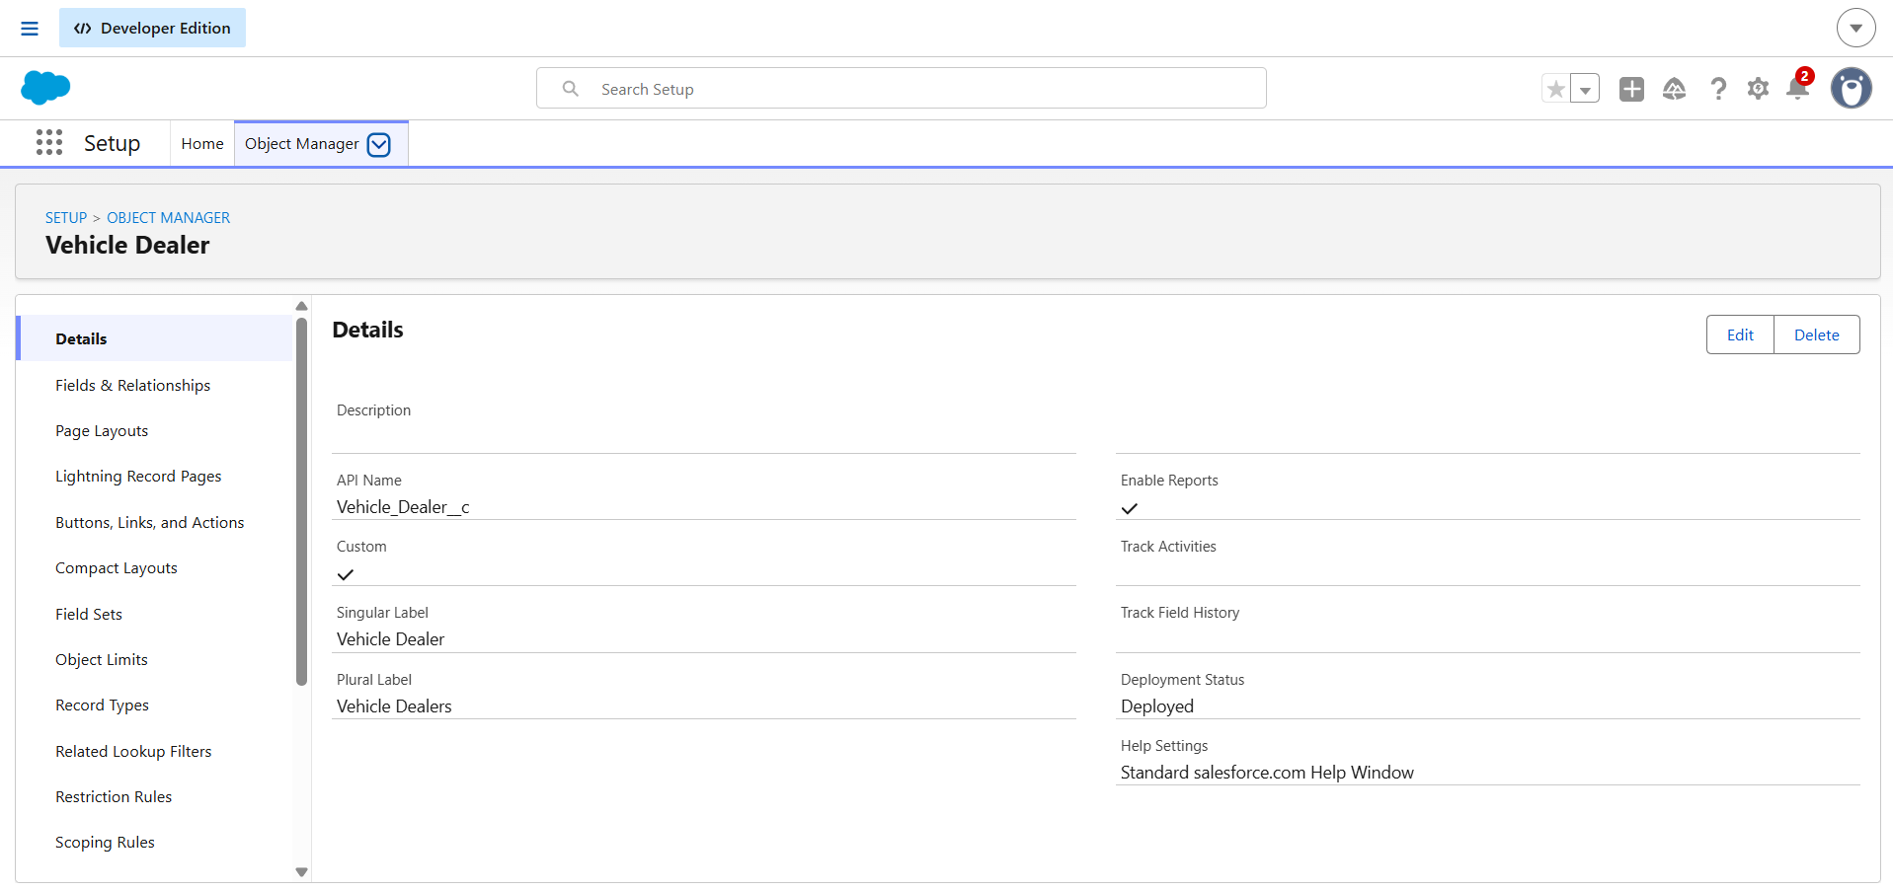

4.3 Custom Fields
Fields are configured to capture the information needed for vehicle management and order processing. Important fields include the Vehicle relationship field on Vehicle_Order__c, the stock quantity field on Vehicle__c, and the order status field if configured. Use the actual field labels and API names from the Salesforce organization.
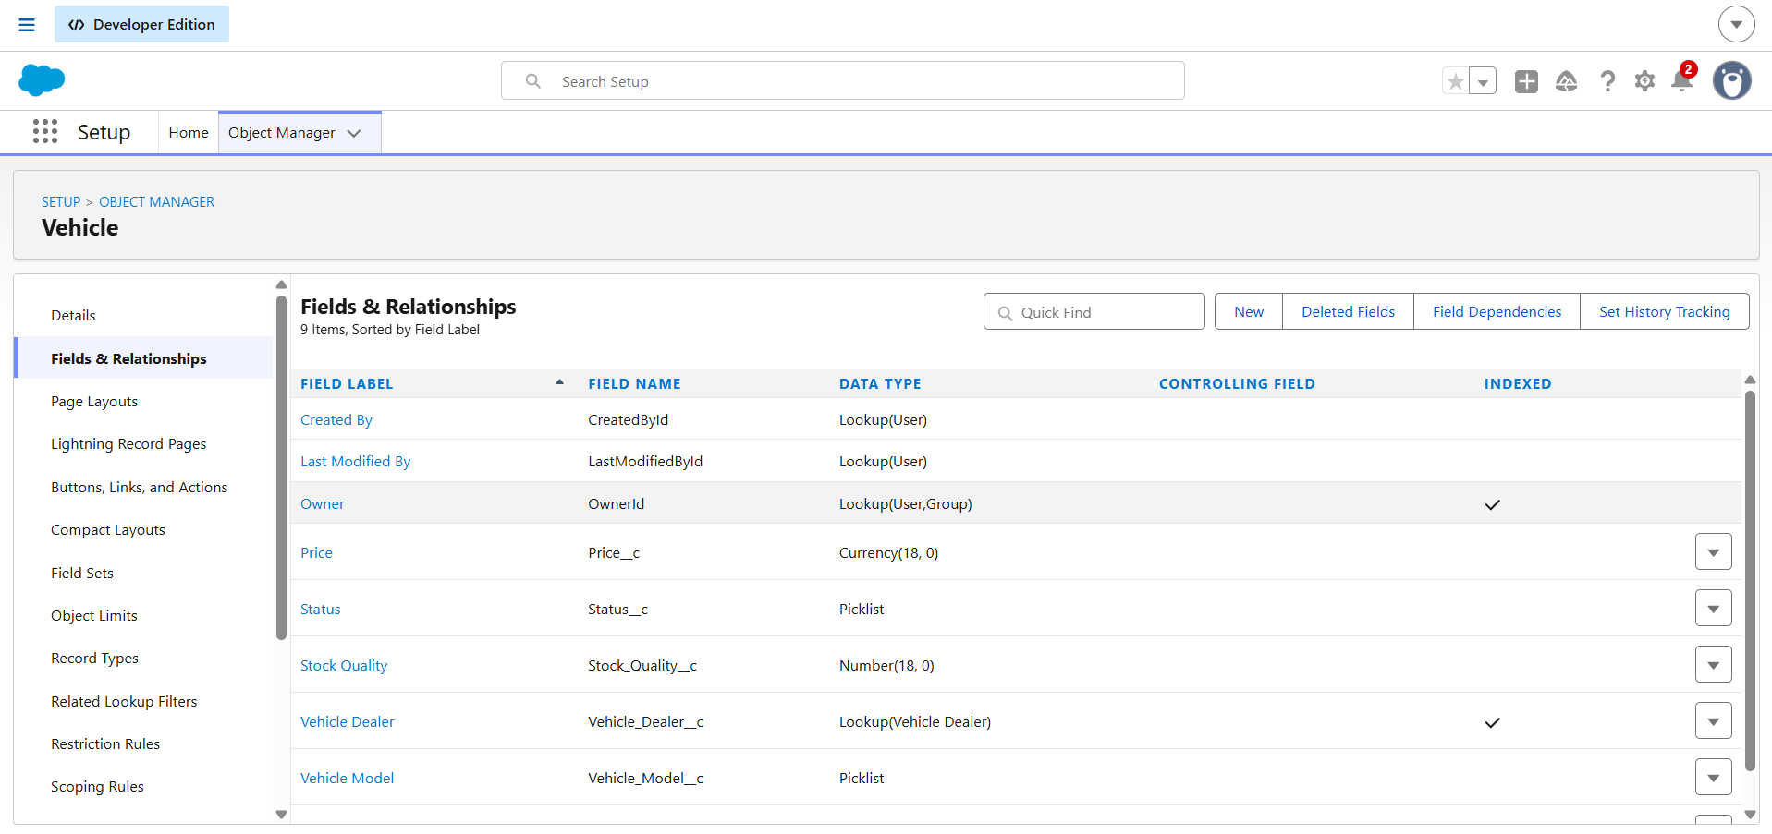

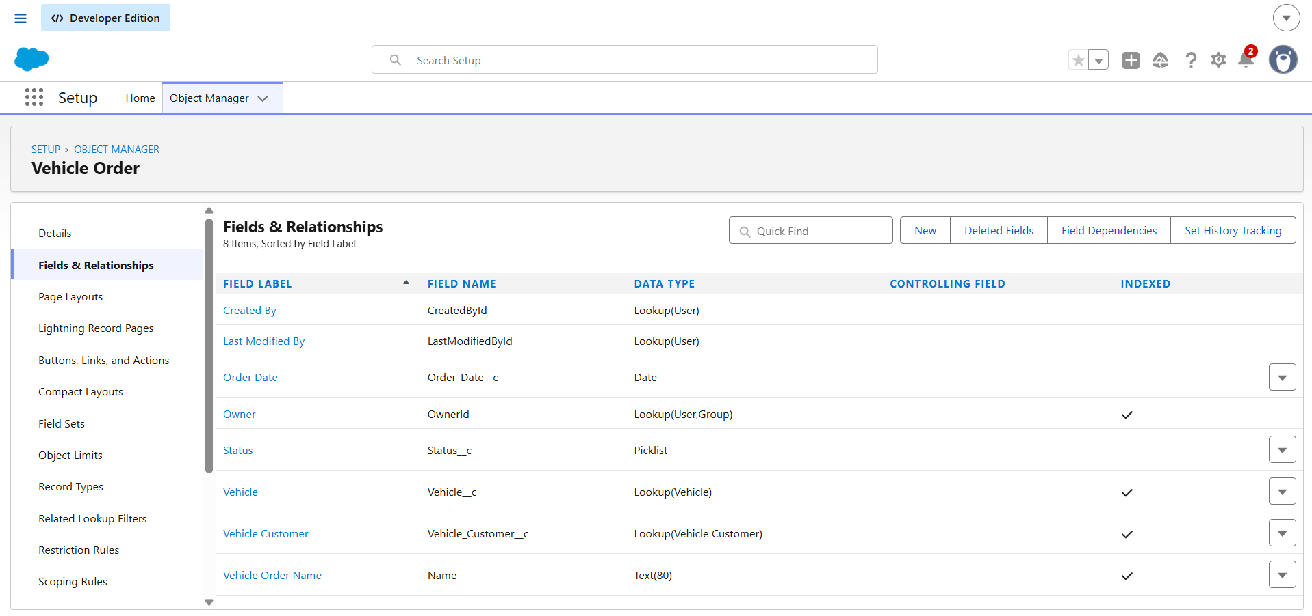

4.4 Relationships
The Vehicle Order record is associated with a vehicle through the configured Vehicle__c relationship field. This relationship enables order processing logic to identify the vehicle whose stock must be checked or updated.

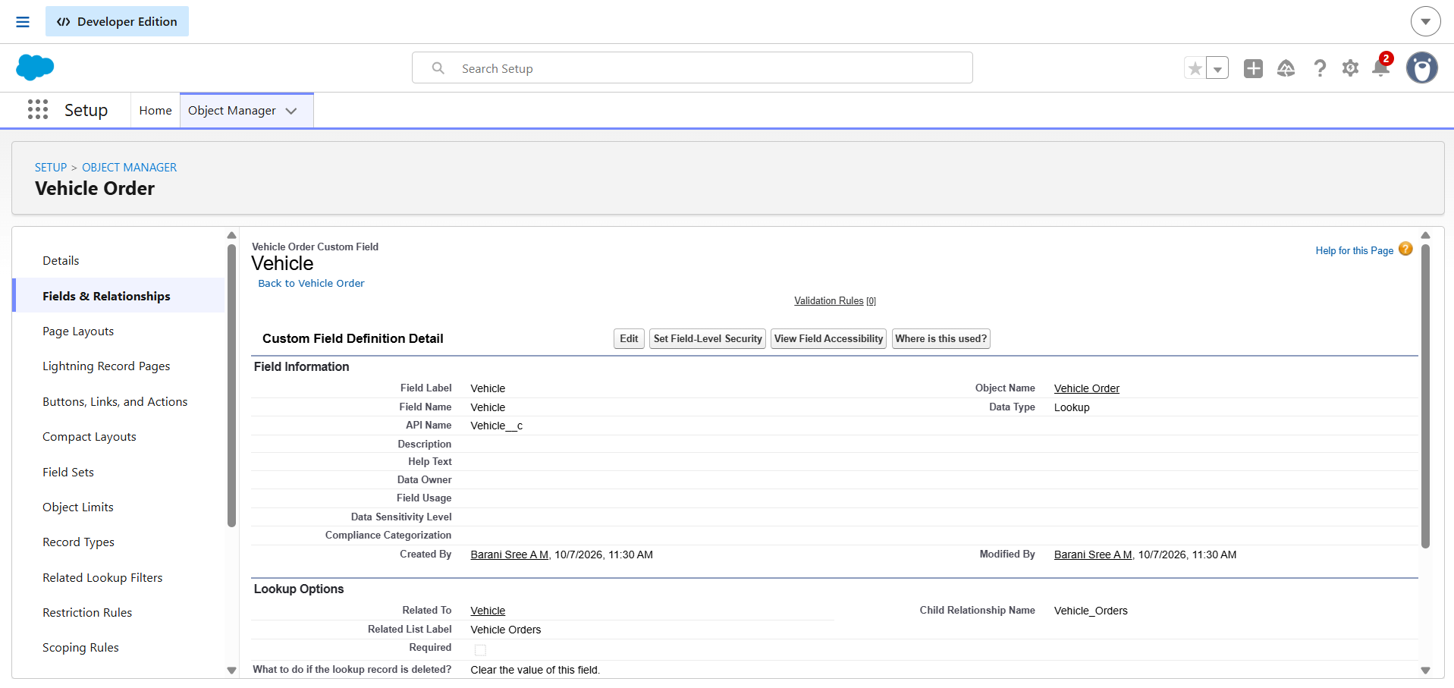

4.5 Tabs and App Manager
Custom tabs and the Salesforce application configuration provide navigation to the records used by the project. Include only the tabs and application components that have actually been configured.
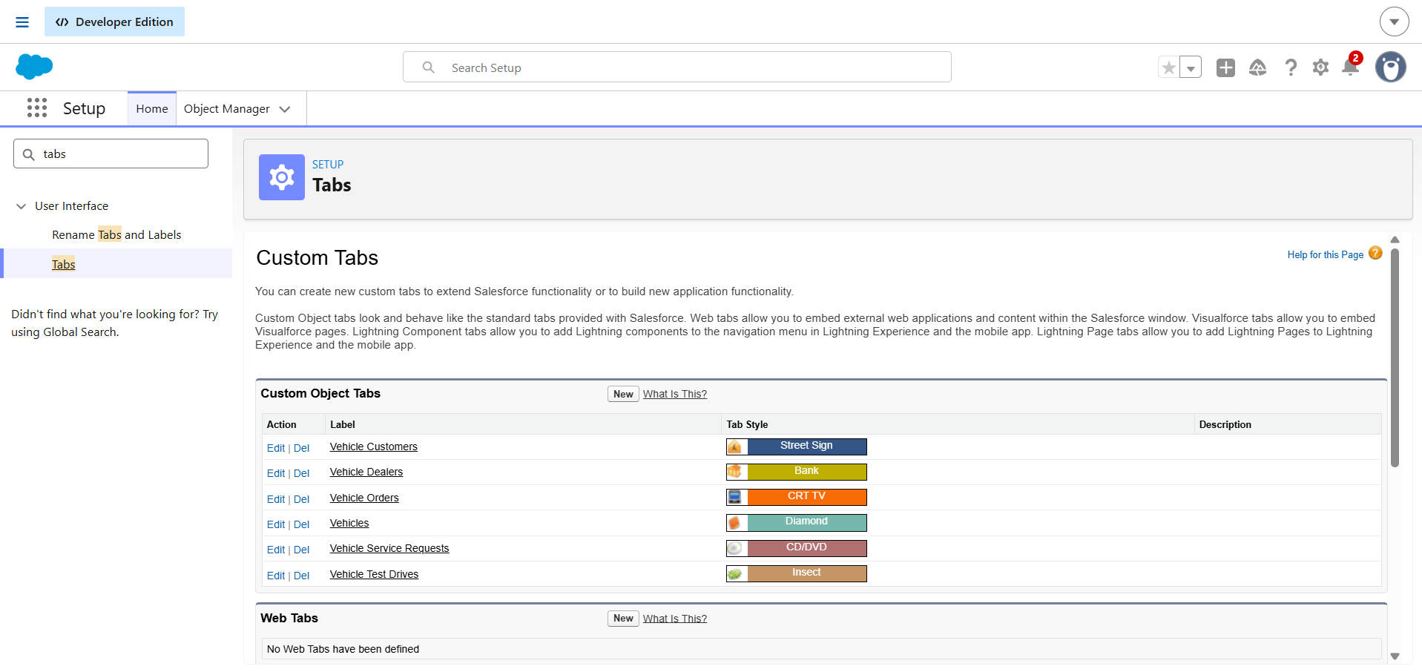
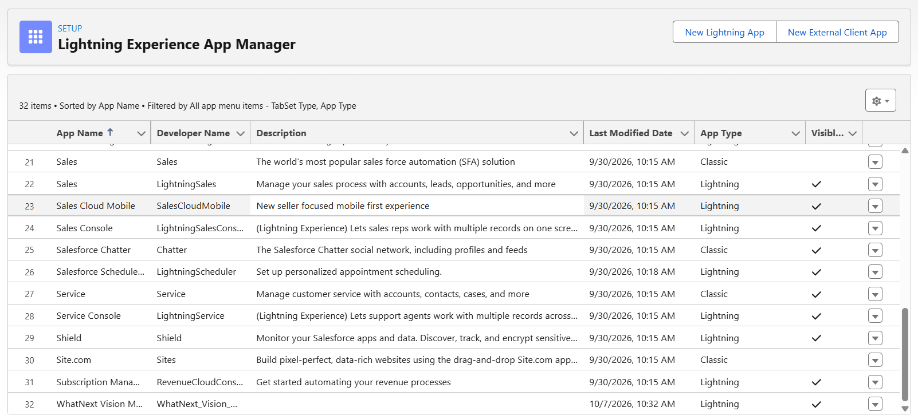

5. PHASE 3: AUTOMATION AND APEX DEVELOPMENT

5.1 Automation Overview
Apex triggers execute business logic when relevant vehicle order records are inserted or updated. The trigger handler class separates the trigger entry point from the business logic and supports a more organized implementation.

5.2 Vehicle Order Trigger
The Vehicle Order trigger calls the handler during the configured trigger events. The handler is responsible for stock validation before the relevant record operation and stock updates after the relevant operation, according to the code.

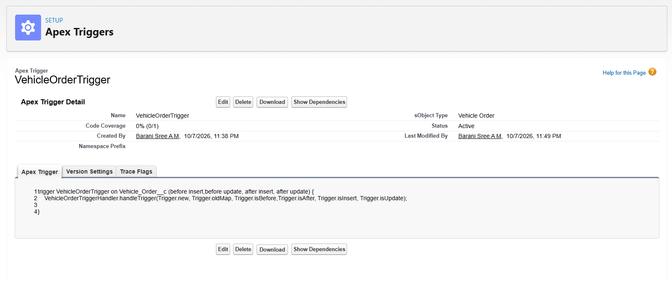

5.3 VehicleOrderTriggerHandler
The VehicleOrderTriggerHandler class contains the core logic for checking vehicle stock availability and updating stock after a valid order. The documented methods should match the actual class implementation, including the relevant before-insert, before-update, after-insert, and after-update contexts.

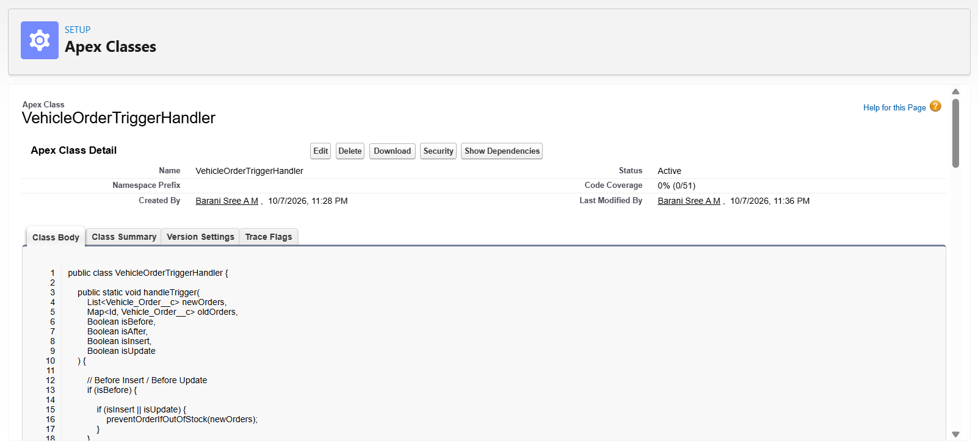

5.4 Stock Validation
The stock validation logic checks the available quantity for the vehicle associated with an order. If the requested quantity cannot be fulfilled from the available stock, the operation should be prevented by the implemented validation logic.

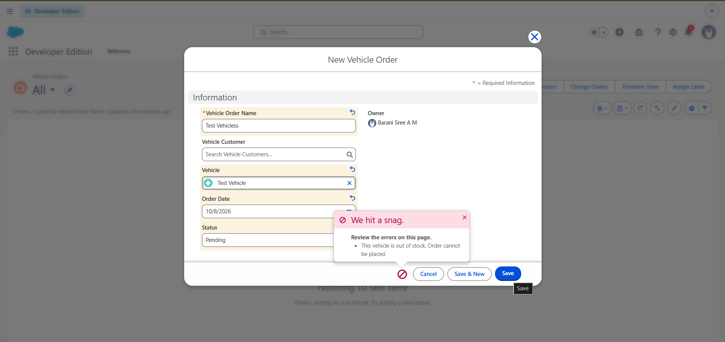

5.5 Vehicle Stock Update
After a valid order is placed, the handler updates the associated vehicle's stock quantity according to the project's business logic. A before-and-after comparison is useful evidence that the automation is working.

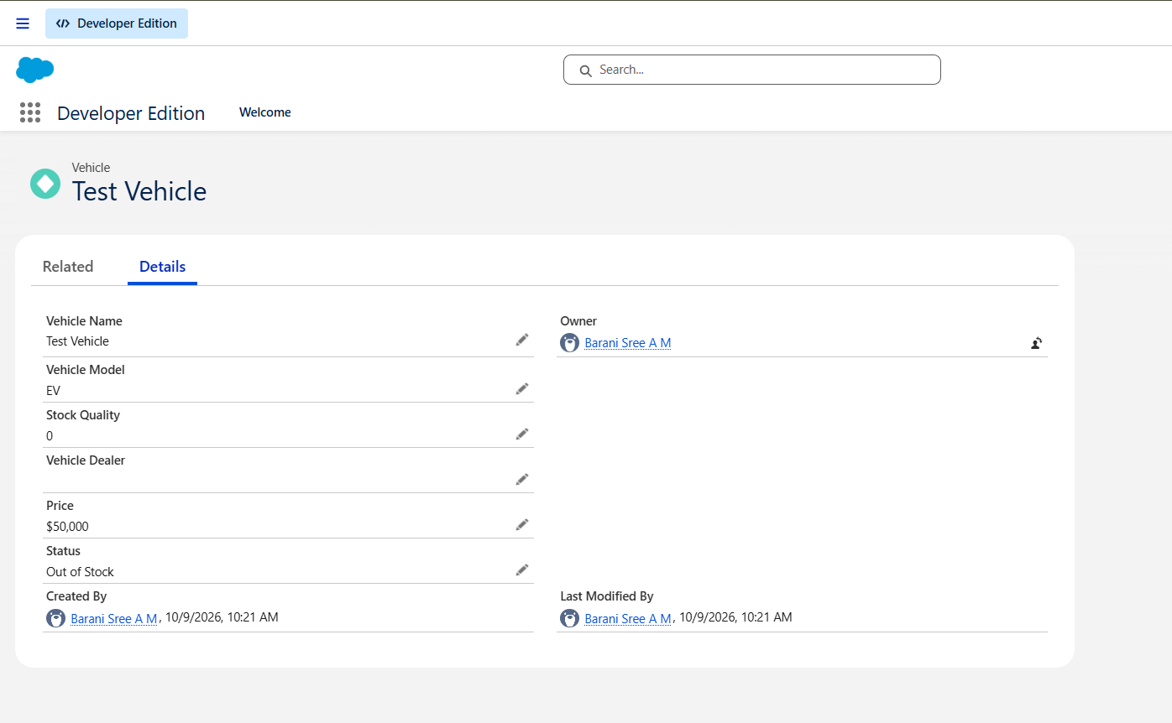

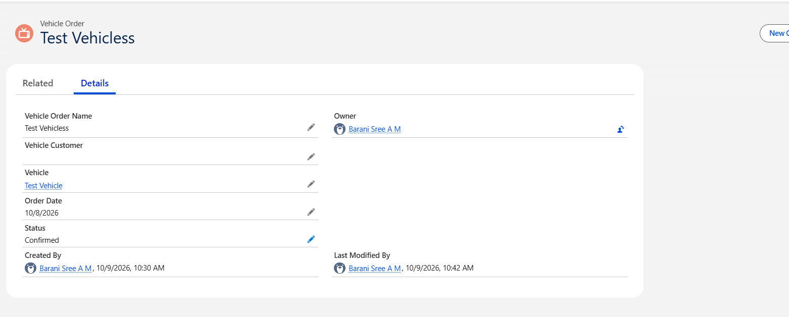

5.5 Test Drive Remainder Flow Configuration
A record-triggered Flow is configured for the Vehicle Test Drive object. The Flow includes scheduled paths and a customer information retrieval step, followed by the Send Test Drive Reminder action.

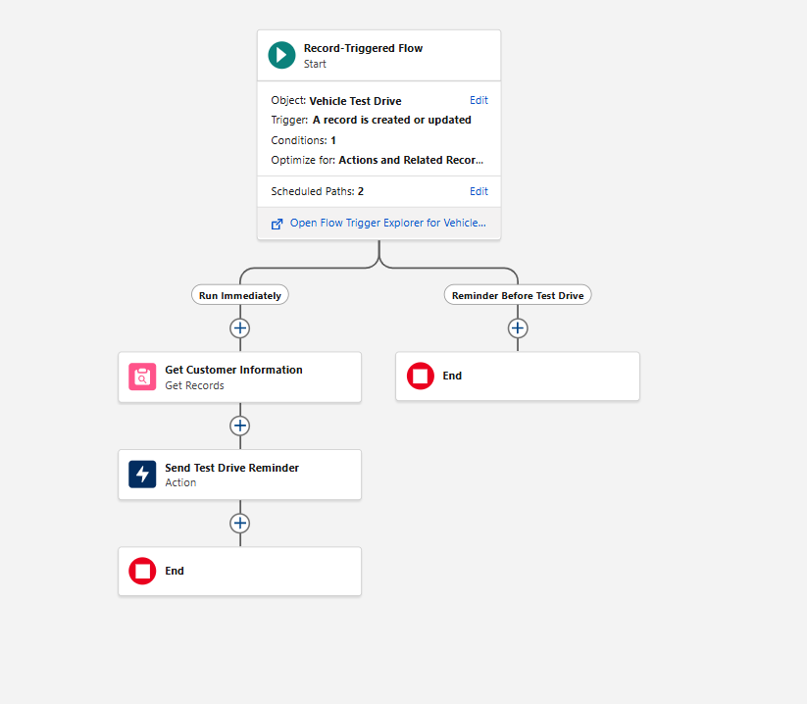

6. PHASE 4: BATCH APEX AND SCHEDULED PROCESSING

6.1 Batch Apex
Batch Apex can process a large number of vehicle order records in manageable groups. The project requirement describes checking vehicle stock and updating order status: orders with available stock are intended to be marked Confirmed, while orders without available stock are intended to be marked Pending. The final documentation must match the actual query, processing logic, and status values used in the batch class.

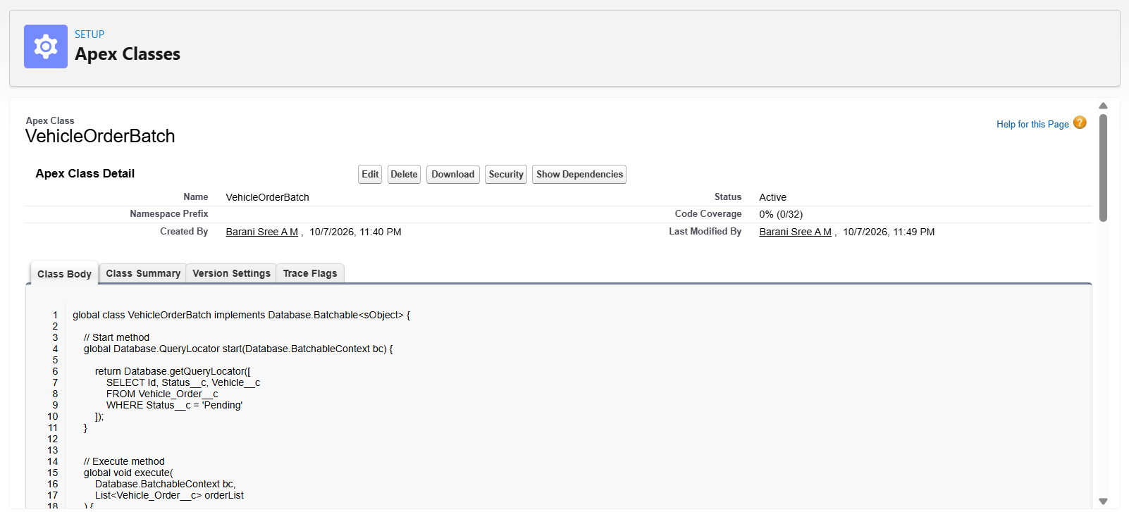

6.2 Scheduled Apex
Scheduled Apex can run the batch process automatically at a configured time. The scheduler must implement Salesforce's scheduling interface and invoke the batch class. Record the schedule and execution result only after confirming that the job is configured and runs successfully.
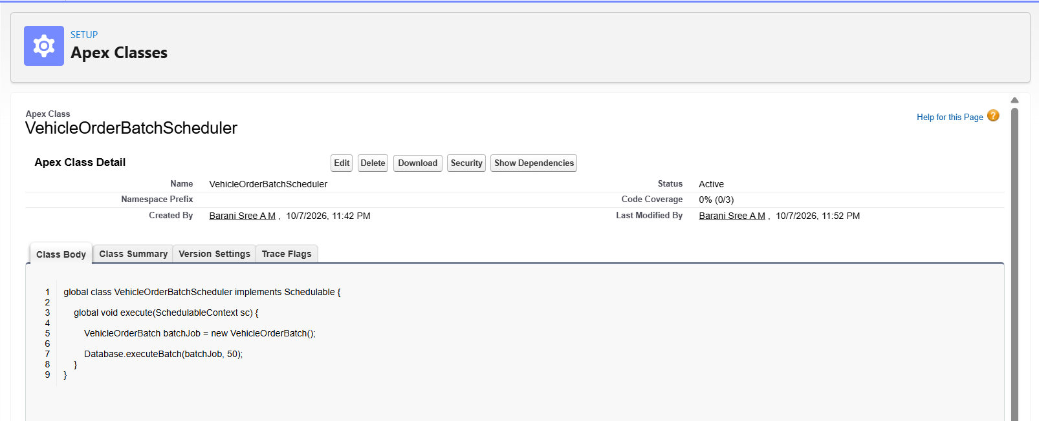
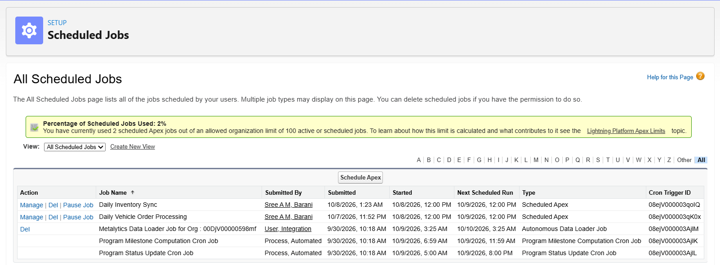

7. PHASE 5: TESTING AND VALIDATION

7.1 Testing Overview
Testing verifies that the trigger, handler, and batch logic behave as expected for valid and invalid order scenarios. Actual outcomes should be recorded after running the tests in Salesforce.

7.2 Test Cases

Test Case | Input / Action | Expected Result
TC-01: Valid vehicle order | Create an order with a requested quantity within available stock. | Order is accepted and stock is updated according to the implemented logic.
TC-02: Insufficient stock | Attempt an order with a quantity greater than available stock. | Order is prevented and an appropriate error is shown.
TC-03: Order update | Update an existing order record. | The applicable trigger logic runs without unintended stock changes.
TC-04: Batch processing | Run the batch against records matching its query conditions. | Eligible records are processed according to the implemented logic.
TC-05: Scheduled execution | Run or wait for the configured scheduled job. | The scheduler invokes the batch process successfully.
TC-06: Dealer assignment | Create an order with customer location information. | The nearest dealer is assigned, if this feature is implemented.
Replace expected results with actual results after executing each test. Do not claim a test passed unless you have verified it.

8. RESULTS AND CONCLUSION
The Vehicle Order Management System demonstrates how Salesforce can be configured to manage vehicle inventory and vehicle orders through a centralized platform. The custom objects and fields organize business information, while the Apex trigger and VehicleOrderTriggerHandler support stock validation and stock updates.
The stock validation mechanism is intended to prevent orders that exceed available inventory. Batch Apex and Scheduled Apex can provide bulk order processing when correctly implemented and tested. The final project outcome should be described using the actual Salesforce behavior and test evidence collected during implementation.

9. FUTURE ENHANCEMENTS
- Implement nearest-dealer assignment using customer location and dealer location data.
- Add test-drive scheduling and automated email reminders.
- Add service request management.
- Configure low-stock alerts and replenishment notifications.
- Create reports and dashboards for vehicle stock and order status.
- Improve Apex test coverage for bulk records, edge cases, and error handling.
- Validate scheduled batch execution and monitor failed jobs.
- Review object permissions and access controls for different user roles.

