1. i)

ii)

1. i)

ii)

SCREENSHOTS:

1. N=2 s=64

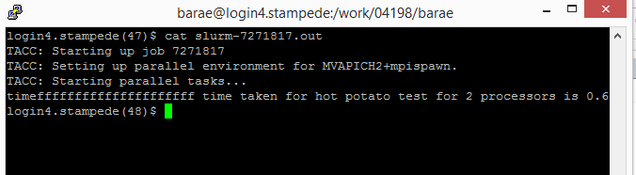

N=4 s=64

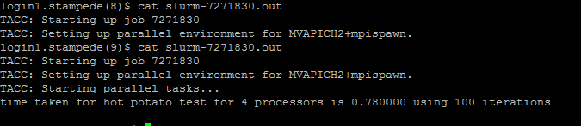

N=8 s=64

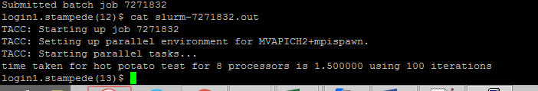

N=16 s=64

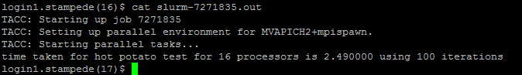

N=2 s=512

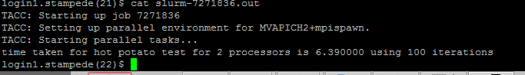

N=4 s=512

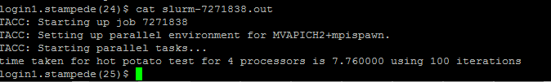

N=8 S=512

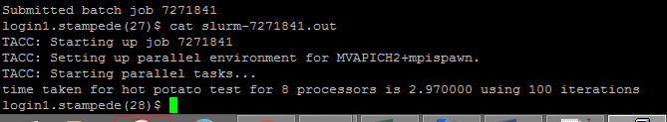

N=16 S=512

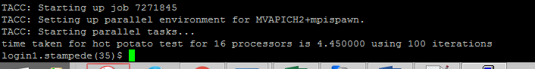

2)

N=2, S=64

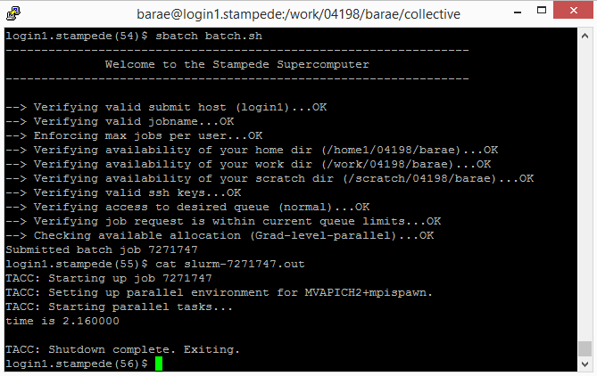

N=4, 64

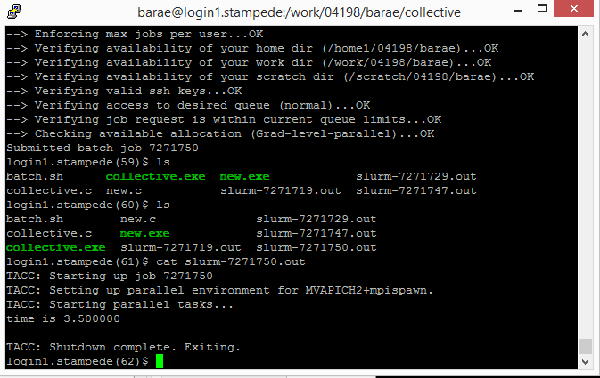

N=8, 64

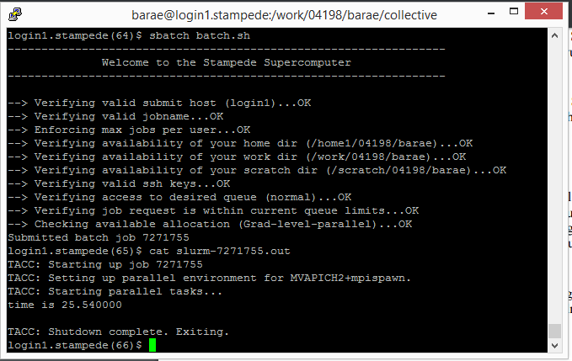

N=16 S= 64

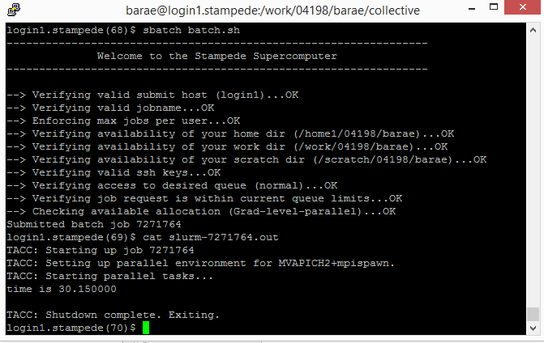

N=2 s=128

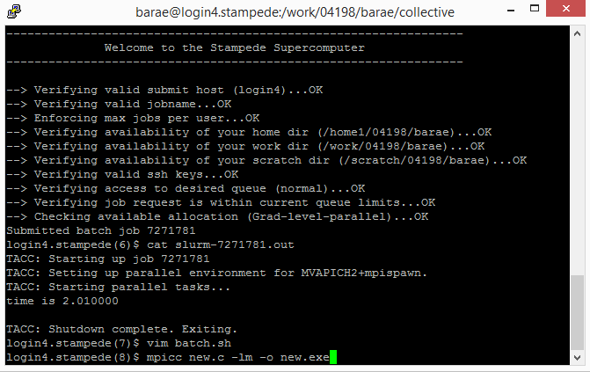

N=4 s= 128

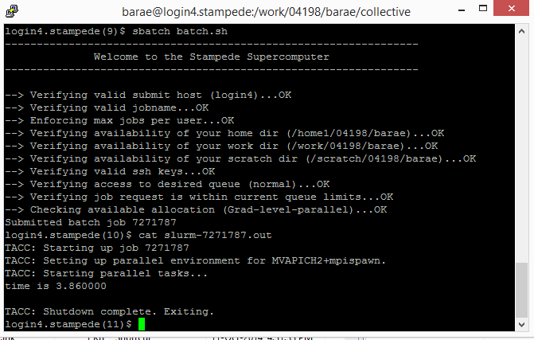

N=8 s=128

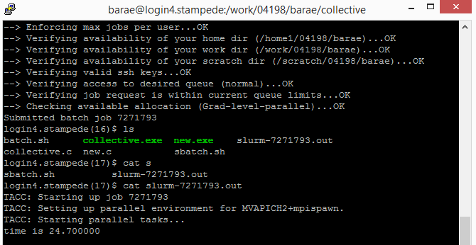

N=16 s=128

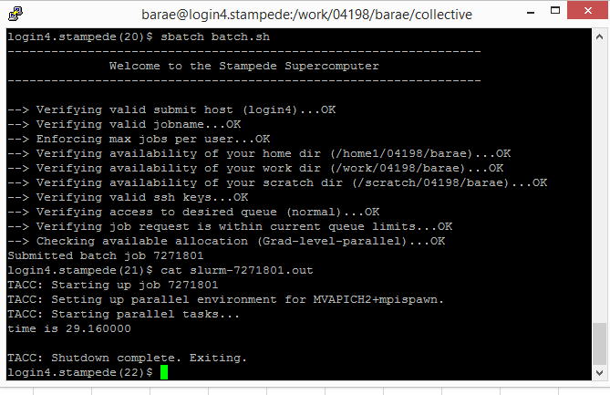

Instructions:

For question 1,

🡪 For different S values, please modify the size variable (int size) inside the code (ring.c, line no 19) .

* For different N values, please modify the batch file (batch.sh) with N.

For question 2,

* For different N values, please modify the batch file (batch.sh) with N.
* For different S values, please modify the batch file (batch.sh) and pass the S value as a command line argument!

Commands:

For question 1 inside the folder (hot potato)

mpicc ring.c –lm –o ring.exe

Sbatch batch.sh

And cat the output file to view the output.

For question 2 inside the folder (collective)

mpicc new.c –lm –o new.exe

Sbatch batch.sh

And cat the output file to view the output.