Baseline metabolomic profile as potential biomarker for weight change after Roux-en-Y gastric bypass (RYGB) surgery
Wanjun Gu¹, Shuliang Deng², Nicholas Stylopoulos³, Clary Clish⁴, Joel N Hirschhorn³, Rany M Salem¹, Vidhu V Thaker⁵
¹ Herbert Wertheim School of Public Health and Longevity Science, University of California, San Diego, La Jolla, California, United States of America
² Department of Biostatistics, Mailman School of Public Health, Columbia University, New York, New York, United States of America
³ Division of Pediatric Endocrinology, Boston Children’s Hospital, Boston, Massachusetts, United States of America
⁴ The Metabolomics Platform, Broad Institute, Cambridge, Massachusetts, United States of America
⁵ Department of Pediatrics, Columbia University Irving Medical Center, New York, New York, United States of America
Corresponding author
E-mail: vvt2114@cumc.columbia.edu (VVT)
Short title: Baseline metabolomic profile in RYGB surgery
Funding: This publication was supported in part by the National Institute for Diabetes and Digestive and Kidney Diseases, NIH, through Grant Number R01 DK136134 (VVT) and the Boston Children’s Hospital–Broad Institute Collaborative Grant (VVT). National Heart, Lung, and Blood Institute grant R00HL122515 (RMS).
Competing interests: The authors have declared that no competing interests exist.

Extended data Table 1. Baseline characteristics of the study cohort.

This table summarizes demographic, anthropometric, and metabolic parameters of the 80 individuals with sustained weight loss (SWL) and the 80 individuals with significant weight regain (RGN) selected from the LABS-2 cohort for untargeted metabolomic profiling. Groups were matched using propensity scores for age, sex, baseline BMI, and renal function. Data are reported as mean ± standard deviation or percentage, and p-values indicate between-group comparisons using t-tests or chi-square tests where appropriate. Abbreviations: BMI, body mass index; HDL, high-density lipoprotein; LDL, low-density lipoprotein; HbA1c, Hemoglobin A1C; hsCRP, high sensitivity C-reactive protein.

Extended data Figure 1. Excess Body Weight (EBW) and Weight Regain Across Longitudinal Trajectory Classes Following RYGB.
Boxplots display EBW (in kg) at key timepoints and weight regain at 5 years across the three latent trajectory classes identified by growth mixture modeling in the LABS-2 cohort. Class 1 (blue) represents individuals with initial weight loss followed by substantial long-term regain. Class 2 (green) includes individuals with sustained long-term weight loss. Class 3 (red) reflects individuals with limited weight loss and early plateau. a) EBW at baseline was similar between Classes 1 and 2 but significantly lower in Class 3. b) At 1 year, all classes showed weight loss, with Class 2 maintaining the highest EBW. c) By year 5, Class 2 sustained lower EBW, while Class 1 demonstrated partial regain and Class 3 showed minimal additional loss. d) Net weight regain at 5 years was lowest in Class 2, moderate in Class 1, and highest in Class 3.
Asterisks denote statistically significant differences between classes (***p < 0.001). Outliers are shown as individual points beyond whiskers.

Extended data Figure 2. Longitudinal excess body weight (EBW) trajectories among matched RYGB subgroups.
Left panel: Boxplots of EBW (in kg) from years 3 to 5 post-RYGB comparing Class 1 (blue; weight regain group) and Class 2 (green; sustained weight loss group). Class 1 exhibited progressive EBW increase over time, whereas Class 2 maintained substantially lower EBW across all time points.
Right panel: Summary statistics for EBW and percent EBW reduction from baseline in both groups (n = 80 per class). By year 5, Class 1 retained 72.4 ± 15.2 kg EBW (30.2 ± 14.2% reduction from baseline), while Class 2 maintained 28.7 ± 21.1 kg EBW (73.1 ± 18.3% reduction). Differences between classes at each time point approached statistical significance (p ≈ 0.08–0.09), highlighting distinct long-term weight trajectories despite similar baseline characteristics.

Extended data Figure 3. Longitudinal weight trajectories and cohort characteristics in the LABS-2 metabolomics sub-study.
a. Excess body weight (EBW, in kg) trajectories over 7 years post–RYGB are shown for participants in the nested metabolomics cohort (n = 160). Blue lines represent those in Class 1 (weight regain) and red lines represent individuals in Class 2 (sustained weight loss), as identified through latent class growth mixture modeling.
b. Percent excess body weight (%EBW), defined as the proportion of baseline EBW remaining at each time point, shows similarly divergent long-term patterns by trajectory class.
c. EBW trajectories stratified by sex show comparable patterns in both male and female participants, with no major sex-specific differences in long-term weight loss dynamics.
d. EBW trajectories stratified by surgical site ID indicate consistent weight loss trends across clinical centers, supporting generalizability of observed trajectories.
These plots demonstrate the clear separation between weight regain and sustained weight loss groups and confirm that weight trajectory patterns were not confounded by sex or surgical site.

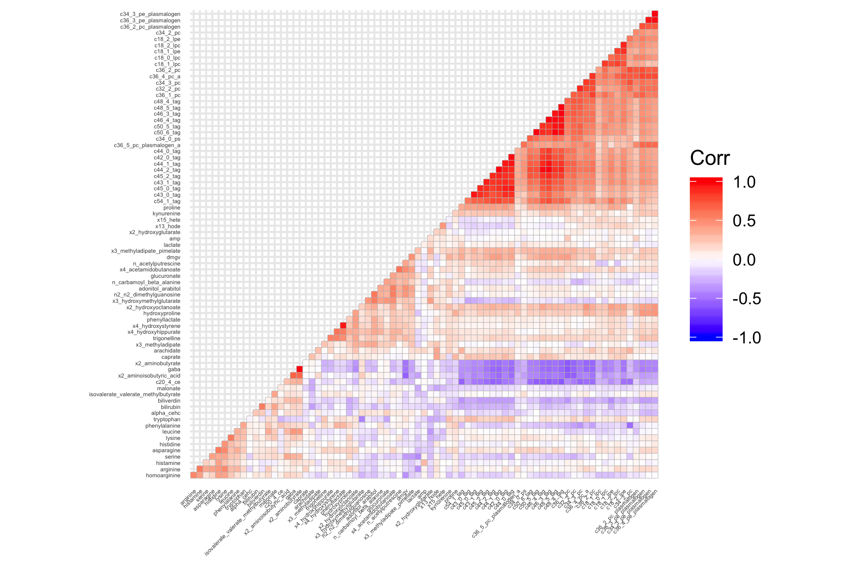
Extended data Figure 4. Pairwise correlation matrix of metabolite levels in the LABS-2 cohort.
This heatmap shows Spearman correlation coefficients among 62 high-confidence plasma metabolites quantified in preoperative fasting samples. Only the lower triangle of the matrix is displayed to reduce redundancy. Each square represents the correlation between a pair of metabolites, with values ranging from –1 (blue, strong negative correlation) to +1 (red, strong positive correlation), as indicated by the color scale on the right.
Metabolites are clustered by biochemical similarity and correlation strength, revealing distinct co-regulated modules. Strong positive correlations (dark red blocks) are observed among lipid species, including phosphatidylcholines (PCs), triacylglycerols (TAGs), and plasmalogens. In contrast, amino acid derivatives and nucleotide metabolites (e.g., kynurenine, BAIBA, N-acetylserine) exhibit weaker or inverse correlations with lipid clusters, suggesting divergent regulatory pathways.
This correlation structure informed metabolite selection and redundancy assessment for the Metabolite Risk Score (MetRS) and supports the presence of metabolically coherent pathways underlying post-surgical weight trajectories.

Extended Data Figure 6. Characteristics and metabolomic separation of participants in the Estonian Biobank obesity extremes cohort.
Left panel: Demographic and clinical characteristics of participants classified as lean (n = 98) or obese (n = 100) based on BMI. Groups were matched by age and fasting duration at blood draw. Lean individuals had a mean BMI of 18.0 ± 1.1 kg/m², while the obese group had a mean BMI of 40.5 ± 4.8 kg/m². Metabolomic profiling identified 18,667 unknown and 333 known metabolite features from fasting plasma using untargeted LC-MS.
Right panel: Principal component analysis (PCA) of metabolomic profiles shows clear separation between lean (blue circles) and obese (orange triangles) individuals based on the first two principal components. Ellipses represent 95% confidence intervals for each group. The observed clustering supports distinct global metabolic signatures associated with extremes of adiposity and validates this cohort as an appropriate external population for testing metabolite-based predictors of obesity-related traits.

Extended Data Figure 5. Sparse partial least squares discriminant analysis (sPLS-DA) of serum metabolomic profiles in the post-RYGB validation cohort.
Left panel: Demographic and clinical characteristics of RYGB participants with sustained weight loss (SWL) or weight regain (WRG). Values represent mean ± standard error. Weight regain was defined as ≥20% of maximum weight lost. WRG participants (n=21) were matched to SWL controls (n=14) by age, sex, preoperative BMI, and comorbidity burden.
Right panel: This supervised multivariate analysis illustrates separation among three groups: CTRL (red circles): Non-surgical controls. WL (blue crosses): Individuals with sustained weight loss following Roux-en-Y gastric bypass (RYGB). WR (gray triangles): Individuals with significant weight regain after RYGB. sPLS-DA was performed on fasting serum metabolomic data collected a median of 7.2 years post-surgery. Ellipses represent 95% confidence intervals for each group. The first two latent variables (X-variate 1 and 2) together explain 34% of the total variance in the dataset. The WL and WR groups show partial metabolic divergence, while the control group is distinctly separated from surgical participants. These findings support durable metabolic remodeling after RYGB and highlight metabolite signatures associated with weight maintenance versus recidivism.

b.

c.

Extended data Figure 8. Genetic architecture of metabolite predictors in the Framingham Heart Study (FHS) Offspring cohort.
a) Phenotype summary for the cohort; b) Summary tables of genome-wide association study (GWAS) results for the Metabolite Risk Score (MetRS) and three individual metabolites: BAIBA, kynurenine, and glucuronate. SNP identifiers, genomic coordinates, nearest genes, effect alleles, allele frequencies, and statistical significance are reported. Significant associations (p < 5 × 10⁻⁸) were identified for variants in or near the genes AGXT2, SLC7A5, and LINC00351, implicating loci involved in amino acid metabolism and transport. c) LocusZoom plots depicting three independent genome-wide significant variants within the AGXT2 locus associated with β-aminoisobutyric acid (BAIBA) levels. Each plot displays the –log₁₀(p-value) of association for SNPs in the AGXT2 region, with chromosomal position on the x-axis. The lead SNPs (rs37376, rs163910, and rs11749934) are highlighted in red, and surrounding variants are color-coded by degree of linkage disequilibrium (LD).
These data illustrate the polygenic architecture of the AGXT2 locus, with multiple independent signals influencing BAIBA concentrations—a key metabolite within the Metabolite Risk Score (MetRS). The findings underscore the heritable component of amino acid metabolism relevant to long-term bariatric surgery outcomes. These results demonstrate that several key metabolite components of the MetRS are under partial genetic control, suggesting a heritable component to the observed metabolic variation predictive of long-term bariatric surgery outcomes.

