727721euit042-GOWTHAM K CIA-1 SOFTWARE TESTING USING SELENIUM

Q.NO:1

1.

**package** com.Selenium.Test.selenium1;

**import** java.util.List;

**import** org.openqa.selenium.By;

**import** org.openqa.selenium.JavascriptExecutor;

**import** org.openqa.selenium.WebDriver;

**import** org.openqa.selenium.WebElement;

**import** org.openqa.selenium.chrome.ChromeDriver;

**import** org.openqa.selenium.chrome.ChromeOptions;

**import** org.openqa.selenium.edge.EdgeDriver;

**import** org.openqa.selenium.interactions.Actions;

**import** org.openqa.selenium.support.ui.Select;

**import** dev.failsafe.internal.util.Assert;

**import** io.github.bonigarcia.wdm.WebDriverManager;

**public** **class** Q1 {

**public** **static** **void** main( String[] args ) **throws** InterruptedException

{

WebDriverManager.*chromedriver*().setup();

ChromeOptions co=**new** ChromeOptions();

co.addArguments("--remote-allow-origins=*");

WebDriver driver=**new** ChromeDriver(co);

driver.manage().window().maximize();

driver.get("https://www.amazon.in/Anne-Diamond-Analog-Womens-Watch-AK3686BKGB/dp/B0968Q7L3M/ref=sr_1_1_sspa?crid=293FS4VHUVN6K&keywords=watches&qid=1681287782&sprefix=watches%2Caps%2C323&sr=8-1-spons&sp_csd=d2lkZ2V0TmFtZT1zcF9hdGY&psc=1");

driver.findElement(By.*id*("add-to-cart-button")).submit();

String t=driver.getTitle();

System.***out***.println(t);

String cart=driver.findElement(By.*xpath*("//*[@id=\"NATC_SMART_WAGON_CONF_MSG_SUCCESS\"]/span")).getText();

**if**(cart.equals("Added to cart"));

System.***out***.println("1. Verified that Product added to cart ");

driver.navigate().back();

WebElement sort1=driver.findElement(By.*xpath*("//*[@id=\"quantity\"]"));

sort1.click();

Select select=**new** Select(sort1);

select.selectByIndex(1);

String drop=driver.findElement(By.*xpath*("//*[@id=\"quantity\"]")).getText();

**if**(drop.equals("2"));

System.***out***.println("3. Verified that Product is updated to cart ");

}

}

OUTPUT:

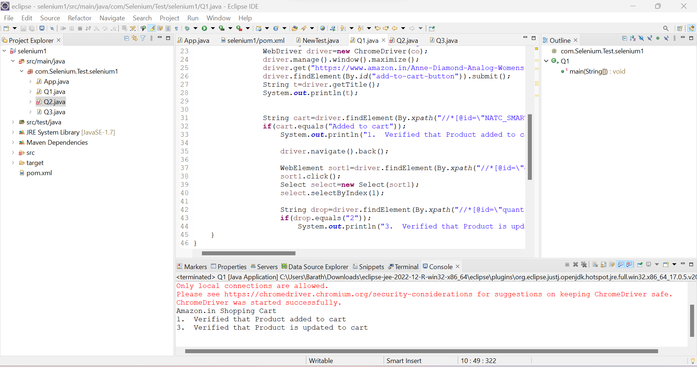

Q.NO:2.

1.

package com.selenium.test1.Selenium;

import org.openqa.selenium.By;

import org.openqa.selenium.WebDriver;

import org.openqa.selenium.chrome.ChromeDriver;

import org.openqa.selenium.chrome.ChromeOptions;

import io.github.bonigarcia.wdm.WebDriverManager;

public class search2 {

public static void main(String[] args) {

// Set the path to the chromedriver executable

System.setProperty("webdriver.chrome.driver", "/path/to/chromedriver");

WebDriverManager.chromedriver().setup();

ChromeOptions co=new ChromeOptions();

co.addArguments("--remote-allow-origins=*");

WebDriver driver=new ChromeDriver(co);

driver.get("https://www.amazon.com/");

driver.manage().window().maximize();

System.out.println("Page Title: " + driver.getTitle());

String name = driver.getTitle();

System.out.println(name);

String title = "Online Shopping site in India: Shop Online for Mobiles, Books, Watches, Shoes and More - Amazon.in";

if(name.equals(title)) {

System.out.println("Validated Page Title");

}

driver.findElement(By.id("twotabsearchtextbox")).sendKeys("bag");

driver.findElement(By.id("nav-search-submit-button")).click();

String expectedSearchTitle = "Amazon.com : bag";

String actualSearchTitle = driver.getTitle();

if (actualSearchTitle.contains(expectedSearchTitle)) {

System.out.println("Search is successfull");

} else {

System.out.println("Search is failed!");

}

driver.quit();

}

}

OUTPUT:

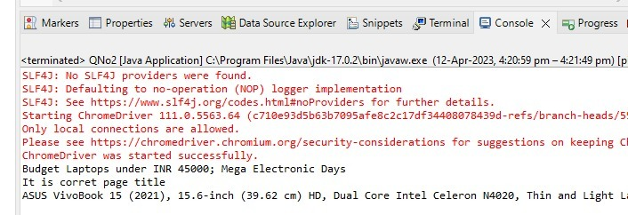

2.

package com.Selenium.test1;

import java.util.List;

import org.openqa.selenium.By;

import org.openqa.selenium.JavascriptExecutor;

import org.openqa.selenium.WebDriver;

import org.openqa.selenium.WebElement;

import org.openqa.selenium.chrome.ChromeDriver;

import org.openqa.selenium.chrome.ChromeOptions;

import io.github.bonigarcia.wdm.WebDriverManager;

public class QNo2 {

public static void main(String args[]) {

WebDriverManager.chromedriver().setup();

ChromeOptions co=new ChromeOptions();

co.addArguments("--remote-allow-origins=*");

WebDriver driver=new ChromeDriver(co);

driver.get("https://www.amazon.in/deal/2c2d3a50/?_encoding=UTF8&showVariations=true&_ref=dlx_gate_sd_dcl_tlt_2c2d3a50_dt&pd_rd_w=YgMyt&content-id=amzn1.sym.a532052b-26f3-4811-a261-3b35ffa57237&pf_rd_p=a532052b-26f3-4811-a261-3b35ffa57237&pf_rd_r=SWJFXC5PAM03PF4G0AWT&pd_rd_wg=6zviy&pd_rd_r=1f436e7b-ab36-4c27-9e50-8f8c69db422a&ref_=pd_gw_unk");

driver.manage().window().maximize();

JavascriptExecutor js=(JavascriptExecutor) driver;

js.executeScript("window.scrollBy(0,1000)","");

String title = driver.getTitle();

System.out.println(title);

String title2="Budget Laptops under INR 45000; Mega Electronic Days";

//title2=driver.getTitle();

if(title2.equals(title)) {

System.out.println("It is corret page title");

}

List<WebElement>li=driver.findElements(By.xpath("//*[@id=\"octopus-dlp-asin-stream\"]/ul/li[2]/span/div/div[2]/div[1]/a"));

for(WebElement link:li) {

System.out.println(link.getText());

}

driver.navigate().back();

driver.navigate().forward();

driver.navigate().refresh();

driver.quit();

}

}

OUTPUT:

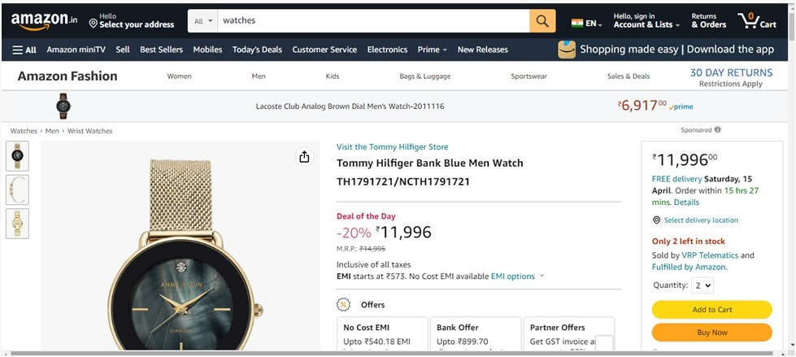

Q.NO:3.

**package** com.Selenium.Test.selenium1;

**import** java.util.List;

**import** org.openqa.selenium.By;

**import** org.openqa.selenium.JavascriptExecutor;

**import** org.openqa.selenium.Keys;

**import** org.openqa.selenium.WebDriver;

**import** org.openqa.selenium.WebElement;

**import** org.openqa.selenium.chrome.ChromeDriver;

**import** org.openqa.selenium.chrome.ChromeOptions;

**import** org.openqa.selenium.support.ui.Select;

**import** io.github.bonigarcia.wdm.WebDriverManager;

**public** **class** Q3 {

**public** **static** **void** main( String[] args ) **throws** InterruptedException

{

WebDriverManager.*chromedriver*().setup();

ChromeOptions co = **new** ChromeOptions();

co.addArguments("--remote-allow-origins=*");

WebDriver driver=**new** ChromeDriver(co);

driver.get("https://www.amazon.in/ref=nav_logo");

driver.manage().window().maximize();

String title=driver.getTitle();

System.***out***.println(title);

**if**(title.equals("Online Shopping site in India: Shop Online for Mobiles, Books, Watches, Shoes and More - Amazon.in")) {

System.***out***.println("Verified title of the page");

}**else** {

System.***out***.println("Title not matched");

}

driver.findElement(By.*id*("nav-link-accountList")).click();

driver.findElement(By.*id*("ap_email")).sendKeys("727721euit042@gmail.com");

driver.findElement(By.*id*("ap_email")).sendKeys(Keys.***ENTER***);

driver.findElement(By.*id*("ap_password")).sendKeys("gow2003*");

driver.findElement(By.*id*("ap_password")).sendKeys(Keys.***ENTER***);

Thread.*sleep*(2000);

String name=driver.findElement(By.*id*("nav-link-accountList-nav-line-1")).getText();

**if**(name.equals("Hello, Feviliya")) {

System.***out***.println("Successfully, signed in");

}**else** {

System.***out***.println("Sign in failed");

}

System.***out***.println("Testing Ended");

driver.quit();

}

}

OUTPUT:

