**Assignment - 1**

1. Start Hadoop single node on AcadGild VM. The command is start-all.sh.

Command start-all.sh will start the below mentioned daemons.

1. Secondary Namenode
2. Namenode
3. Resource Manager
4. JPS
5. Datanode
6. Node Manager

Screenshot is provided below:

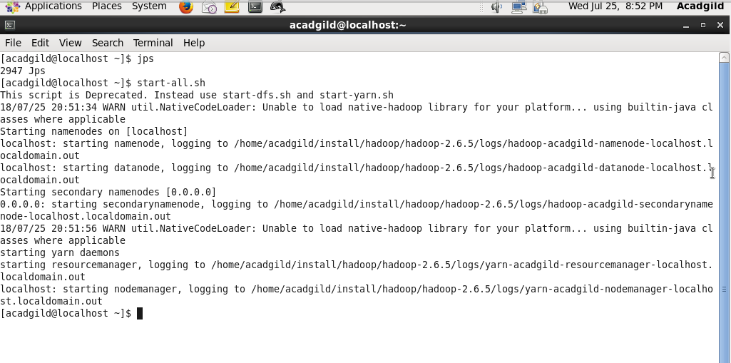

1. Run a JPS command to see if all Hadoop daemons are running.

Running JPS command will be display all the running Hadoop daemons.

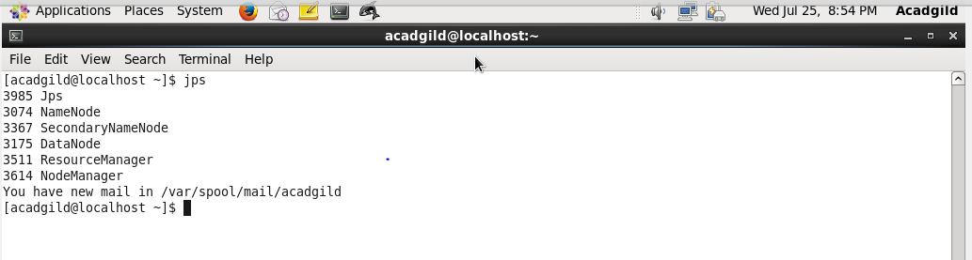

1. Run few Unix commands like pwd, ls -ls, etc.
2. Pwd: This command is useful for printing current working directory.

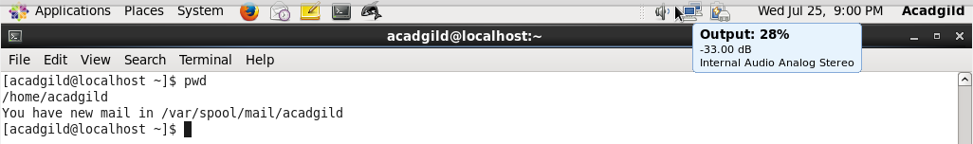

1. ls –ls : This command will print the files present in the working directory in alphabetical order.

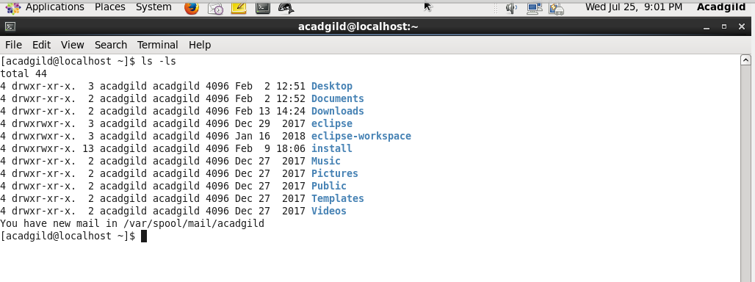

1. ls –lrt: This command will print the files present in the working directory in time sorted order.

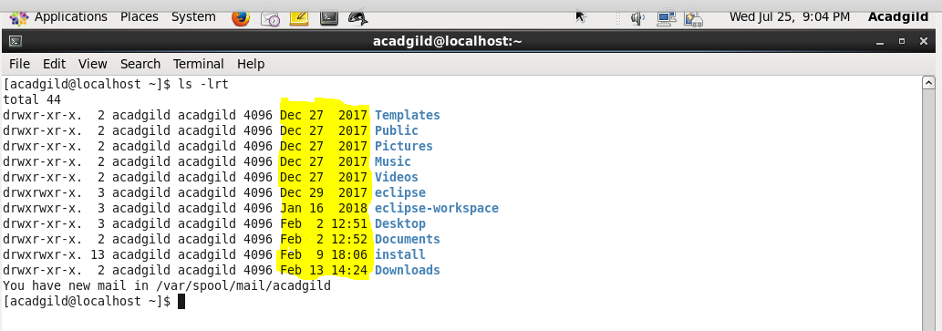

1. cd: This command is used for shifting from current directory to another directory.

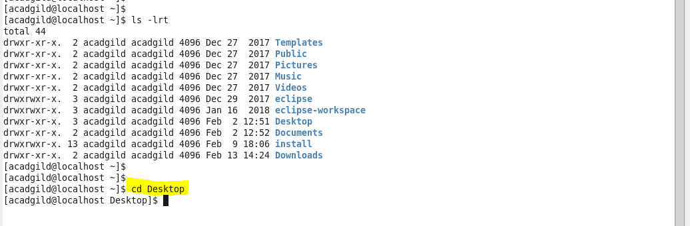

1. Cat: This command is used to see content present in a file.

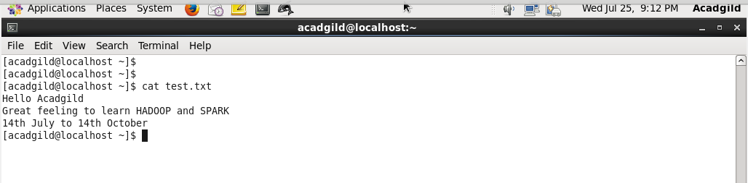

1. Create a file from the terminal using nano editor (example: nano test.txt), and add

some content to it. Cat it to see if the content is saved.

Ans:- File has been created using nano editor.

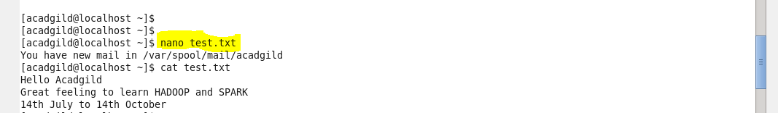

Cat command is used to view the content saved in it.

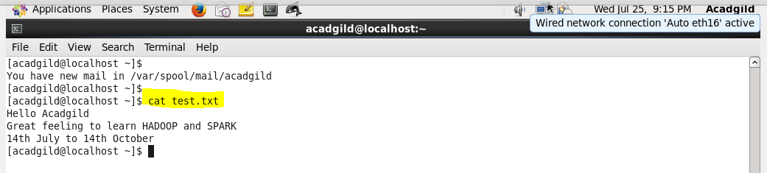

1. Open the hdfs web page by typing localhost:50070 in the browser. Check all the

details of the HDFS.

