**Description**

This sign-up form uses HTML, CSS, JavaScript, and Formik in React and is fully functional. I used JavaScript to validate the entire form before it was submitted, formik and JavaScript to modify error messages, and attributes on the input fields to validate the form's inputs. Devices such as desktop, mobile, and tablet computers can all use the form.

**Formik:**

Formik takes care of the repetitive and annoying stuff—keeping track of values/errors/visited fields, orchestrating validation, and handling submission—so you don't have to. This means you spend less time wiring up state and change handlers

### Built With

HTML

CSS

Java Script

Formkik

Sweetalert

React

**Desktop Device**

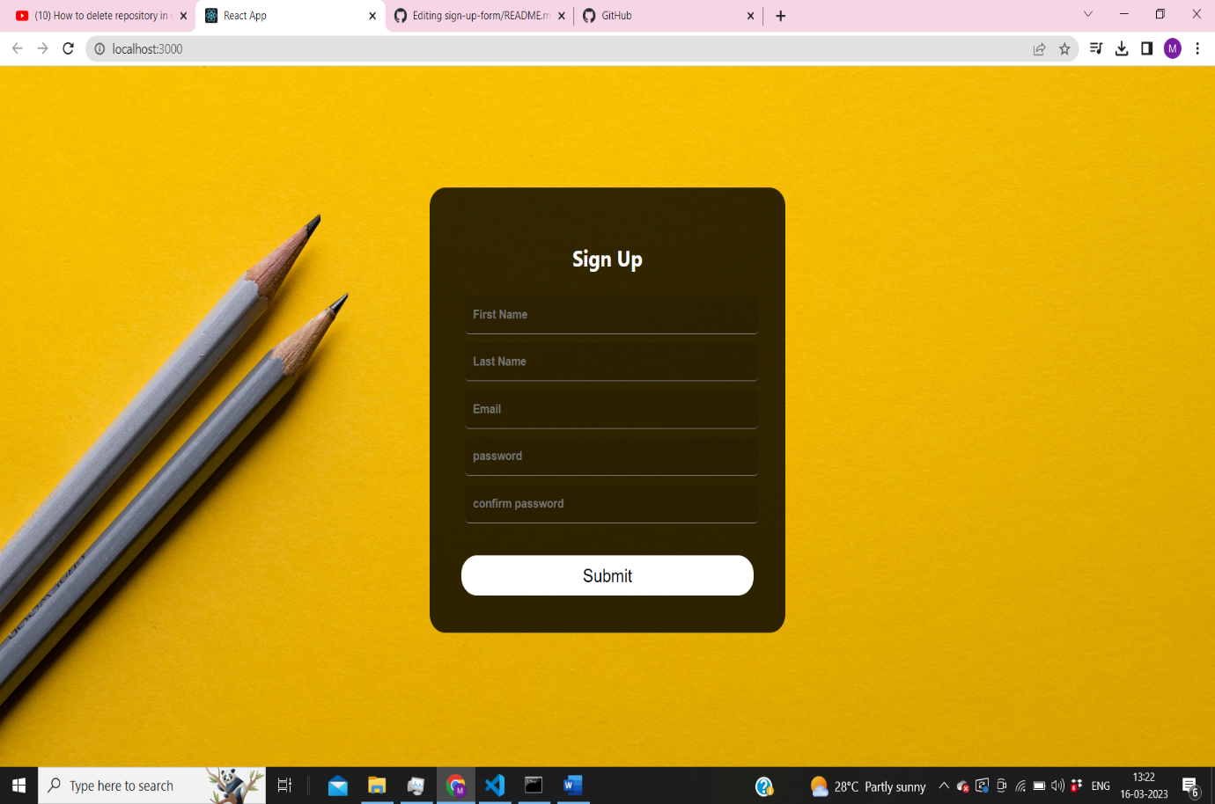

**Features**

Accepts letters and numbers for first and last name.

Accepts a valid email address format

Checks that email match regex pattern using JavaScript.

Accepts password with at least 4 characters and maximum 12 characters.

Checks that password and confirmation passwords match on input and before form is submitted.

Shows error messages and prevents form submission if any fields are invalid.