**HOW TO BUILD AND DEPLOY DOCKER IMAGE USING ECLIPSE**

**STEP 1:**  Install Eclipse Docker Tooling from Eclipse Marketplace

**STEP 2** : Create a simple spring boot application using below link

**https://spring.io/guides/gs/spring-boot/**

**STEP 3: Create a DockerFile**

**Add the instructions to build a docker image using DockerFile :**

**Example :**

FROM java:8

MAINTAINER BARATH

EXPOSE 8082

ADD target/Spring-Docker-Sample-WAR-1.0.0.RELEASE.war spring-docker-sample-war.war

ENTRYPOINT [“java","-jar","spring-docker-sample-war.war"]

**STEP 4:**

**Right click on DockerFile —> Run as —> Docker image build**

Eclipse IDE uses Eclipse Docker tooling plugin to build docker image using the instructions provided using DockerFile.

Another way to build a docker image is using Docker command:

**Docker CLI:**

**docker build <<path to DockerFile>>**

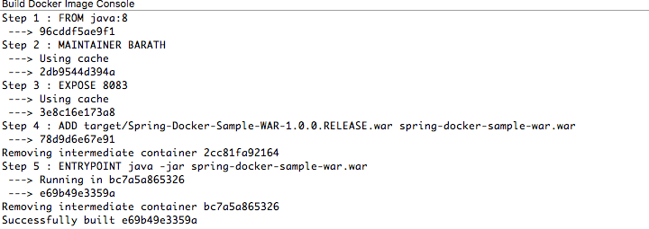

**STEP 5**: Once docker image is successfully built.

**Click on Window—> Perspective —> Open Perspective —> Docker Tooling**





**Another way :**

Go to CLI : docker images — to show list of docker images

**STEP 6:**

**Right click on the image —> click on Run.**

**Following popup opens.**

**Click on Next and then finish .**



**STEP 7: Application will get started and logs rolls out in Eclipse IDE console**

**STEP8: Final output Go to http://127.0.0.1:8082/**

**hit the url to test : http://<<IP-ADDRESS>>:<<PORT>>**

