**ATTRIBUTE**

**What is the html attribute?**

Attributes provide extra information about the tags. It always comes in pair i.e. (atribute_name=”value”). We always separate the attribute name and value by “=”.

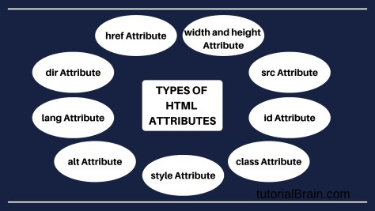

**1. href Attribute**

We use <a> tag to define hyperlink, between pages images and more. It is a most used element in the href attribute which specifies the direction of the links.

## 2. src Attribute

We define a source in the form of src attribute. We use src attribute along with a <img> tag to show the images on a website.  
The tag used to define[images in HTML.](https://www.tutorialbrain.com/html_tutorial/html_images/)

## 3. alt Attribute

The **alt** attribute provides the alternative text in case, the user is not able to view an image in the website.

If the website has an image, then the 2 most important reasons for images not been shown are –

* The name of the image or the format of the image mentioned in the website is wrong.
* The path of the image is wrong.

## 4. id Attribute

**Id** attribute is a way to group some elements and apply a particular style to it. id Name must be unique within the HTML document.

## 5. class Attribute

The**class**attribute is a way to group some elements and apply a particular style to it. It is similar to id but the main difference is that **id** must be unique in an HTML document while classes can have duplicate names.

## 6. style Attribute

The**style**attribute sets the style of the HTML document.

## 7. lang Attribute

The lang Attributes specifies the language used in a particular document.

Example –  
**lang=en** – It sets the **language**as **English**.

## 8. dir Attribute

The dir attributes help the browser to flow text in a particular direction like left and right direction.

## 9. width and height Attribute

## Using width and height attribute you can set a size.

## 10. title Attribute

## Title attribute displays the title of the content when you mouse over the content.