TAGS

1. Definition of Tag

* HTML Tag Are special words wrapped in angle brackets (< >) which used to define different types of content in a webpage.
* The browsers use these to decide how to render or display the following content on the screen. Example <p>, <h1>, <img>, etc.
* Suppose browsers come up with <p> tag (paragraph tag) then it understands that content coming next after it before closing the tag is a paragraph, so browser attaches all the default style with it and display it on screen.
* So if you want to create a paragraph then use <p> tag and wrap paragraph content around it as shown in the image below.

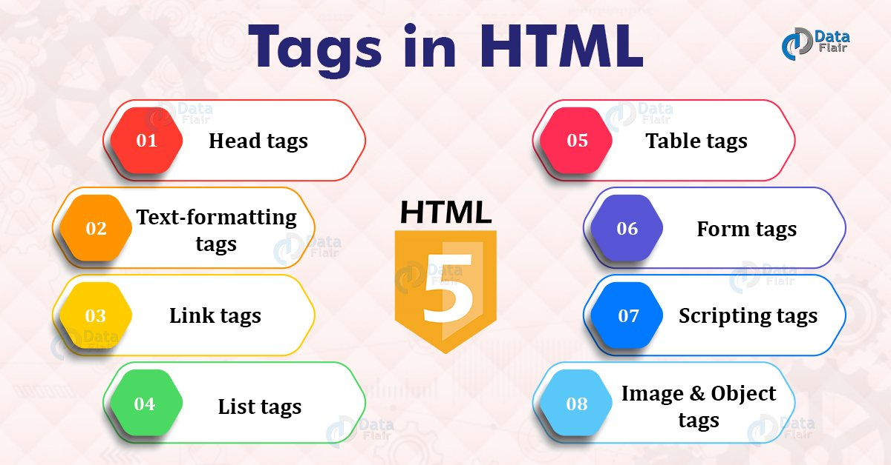

1. **Head tags:**

* <title>, <style>,<script>,<link>,<meta> and <base>.

1. **Text-formatting tags:**

* <h>,<b>,<strong>,<small>,<pre>,<i>,<em>,<sub>,<sup>,<ins>,<dfn>,<del>,<div> and <span>.

**Link tags:**

<a>, <base>.

**List tags:**

<ul>, <ol>, <li>, <dl>, <dd>

**Table tags:**

<table> ,<tr> , <td>, <th>, <thead>, <tbody>, <tfoot>.

**Form tags:**

<form>, <input>, <select>, <option>, <button>, <label>, <fieldset>, <textarea>.

**Scripting tags:**

<script>, <noscript>

**Image and Object tags:**

<img>, <figure>, <figcaption>, <area>, <map>, <object>.

**Examble of syntax tags:**

Head tags:

Syntax:

<!DOCTYPE html>  
<html>  
<head>  
  <title>A Meaningful Page Title</title>  
</head>  
<body>  
  
The content of the document......  
  
</body>  
</html>.

Text formitting tag:

1. <b> - Bold text
2. <strong> - Important text
3. <i> - Italic text
4. <em> - Emphasized text
5. <mark> - Marked text
6. <small> - Smaller text
7. <del> - Deleted text
8. <ins> - Inserted text
9. <sub> - Subscript text
10. <sup> - Superscript text

**Link tag:**

**Syntax:**

<head>  
  <link rel="stylesheet" href="styles.css">  
</head>

**List tag:**

**Syntax:**

## Unordered HTML List

## <ul>   <li>Coffee</li>   <li>Tea</li>   <li>Milk</li> </ul>

## Table tags:

## Syntax:

## <table>   <tr>     <th>Month</th>     <th>Savings</th>   </tr>   <tr>     <td>January</td>     <td>$100</td>   </tr> </table>

## Form tag:

## Syntax:

## <form action="/action_page.php" method="get">   <label for="fname">First name:</label>   <input type="text" id="fname" name="fname"><br><br>   <label for="lname">Last name:</label>   <input type="text" id="lname" name="lname"><br><br>   <input type="submit" value="Submit"> </form>

## Scripting tag:

## Syntax:

## <script> document.getElementById("demo").innerHTML = "Hello JavaScript!"; </script>

## Image&objects tag:

## Syntax:

## <object data="pic_trulli.jpg" width="300" height="200"></object>

<img src="img_girl.jpg" alt="Girl in a jacket" width="500" height="600">

Usage and definition

## Head tag:

The <head> element is a container for metadata (data about data) and is placed between the <html> tag and the <body> tag.

Metadata is data about the HTML document. Metadata is not displayed.

Metadata typically define the document title, character set, styles, scripts, and other meta information.

The following elements can go inside the <head> element:

* [<title>](https://www.w3schools.com/tags/tag_title.asp) (required in every HTML document)
* [<style>](https://www.w3schools.com/tags/tag_style.asp)
* [<base>](https://www.w3schools.com/tags/tag_base.asp)
* [<link>](https://www.w3schools.com/tags/tag_link.asp)
* [<meta>](https://www.w3schools.com/tags/tag_meta.asp)
* [<script>](https://www.w3schools.com/tags/tag_script.asp)
* [<noscript>](https://www.w3schools.com/tags/tag_noscript.asp)

Text formitting tag:

|  |  |
| --- | --- |
| **Tag** | **Description** |
| [<b>](https://www.w3schools.com/tags/tag_b.asp) | Defines bold text |
| [<em>](https://www.w3schools.com/tags/tag_em.asp) | Defines emphasized text |
| [<i>](https://www.w3schools.com/tags/tag_i.asp) | Defines a part of text in an alternate voice or mood |
| [<small>](https://www.w3schools.com/tags/tag_small.asp) | Defines smaller text |
| [<strong>](https://www.w3schools.com/tags/tag_strong.asp) | Defines important text |
| [<sub>](https://www.w3schools.com/tags/tag_sub.asp) | Defines subscripted text |
| [<sup>](https://www.w3schools.com/tags/tag_sup.asp) | Defines superscripted text |
| [<ins>](https://www.w3schools.com/tags/tag_ins.asp) | Defines inserted text |
| [<del>](https://www.w3schools.com/tags/tag_del.asp) | Defines deleted text |
| [<mark>](https://www.w3schools.com/tags/tag_mark.asp) | Defines marked/highlighted text |

Link tag:

The <link> tag defines the relationship between the current document and an external resource.

The <link> tag is most often used to link to external style sheets or to add a [favicon](https://www.w3schools.com/html/html_favicon.asp) to your website.

The <link> element is an empty element, it contains attributes only.

List tag:

|  |  |
| --- | --- |
| **Tag** | **Description** |
| [<ul>](https://www.w3schools.com/tags/tag_ul.asp) | Defines an unordered list |
| [<ol>](https://www.w3schools.com/tags/tag_ol.asp) | Defines an ordered list |
| [<li>](https://www.w3schools.com/tags/tag_li.asp) | Defines a list item |
| [<dl>](https://www.w3schools.com/tags/tag_dl.asp) | Defines a description list |
| [<dt>](https://www.w3schools.com/tags/tag_dt.asp) | Defines a term in a description list |
| [<dd>](https://www.w3schools.com/tags/tag_dd.asp) | Describes the term in a description list |

Table tag:

The <table> tag defines an HTML table.

An HTML table consists of one <table> element and one or more [<tr>](https://www.w3schools.com/tags/tag_tr.asp), [<th>](https://www.w3schools.com/tags/tag_th.asp), and [<td>](https://www.w3schools.com/tags/tag_td.asp) elements.

The <tr> element defines a table row, the <th> element defines a table header, and the <td> element defines a table cell.

An HTML table may also include [<caption>](https://www.w3schools.com/tags/tag_caption.asp), [<colgroup>](https://www.w3schools.com/tags/tag_colgroup.asp), [<thead>](https://www.w3schools.com/tags/tag_thead.asp), [<tfoot>](https://www.w3schools.com/tags/tag_tfoot.asp), and [<tbody>](https://www.w3schools.com/tags/tag_tbody.asp) elements.

Form tag:

The <form> tag is used to create an HTML form for user input.

The <form> element can contain one or more of the following form elements:

* [<input>](https://www.w3schools.com/tags/tag_input.asp)
* [<textarea>](https://www.w3schools.com/tags/tag_textarea.asp)
* [<button>](https://www.w3schools.com/tags/tag_button.asp)
* [<select>](https://www.w3schools.com/tags/tag_select.asp)
* [<option>](https://www.w3schools.com/tags/tag_option.asp)
* [<optgroup>](https://www.w3schools.com/tags/tag_optgroup.asp)
* [<fieldset>](https://www.w3schools.com/tags/tag_fieldset.asp)
* [<label>](https://www.w3schools.com/tags/tag_label.asp)
* [<output>](https://www.w3schools.com/tags/tag_output.asp)

Scripting tag:

The <script> tag is used to embed a client-side script (JavaScript).

The <script> element either contains scripting statements, or it points to an external script file through the src attribute.

Common uses for JavaScript are image manipulation, form validation, and dynamic changes of content.

Image tag:

The HTML <img> tag is used to embed an image in a web page.

Images are not technically inserted into a web page; images are linked to web pages. The <img> tag creates a holding space for the referenced image.

The <img> tag is empty, it contains attributes only, and does not have a closing tag.

The <img> tag has two required attributes:

* src - Specifies the path to the image
* alt - Specifies an alternate text for the image

object tag:

The <object> tag defines a container for an external resource.

The external resource can be a web page, a picture, a media player, or a plug-in application.

To embed a picture, it is better to use the <img> tag.

To embed HTML, it is better to use the <iframe> tag.

To embed video or audio, it is better to use the <video> and <audio> tags.