Project Title: Analyzing the Growth of Hybrid and Electric Vehicles in the U.S.

Question:

What do the sales of Hybrid and Electric Vehicles look like over the past few years?

Findings:

We decided to perform our analysis on data from 2010 to 2017, as this was the broadest time range possible to obtain data for sales of mass-produced vehicles of both types in the U.S. Hybrid Vehicles having representation as early as 2000 with the Toyota Prius and Plug-in Electric Vehicles with cars such as the Nissan Leaf and Chevrolet Volt arriving in 2010.

From data obtained through the Department of Energy’s Transportation Energy Data Book, from 2010 to 2017, sales of Electric Vehicles increased from 300 to 195,600 vehicles per year, while sales of Hybrid Vehicles increased from 274,600 to 362,900 vehicles per year. These changes are illustrated below.

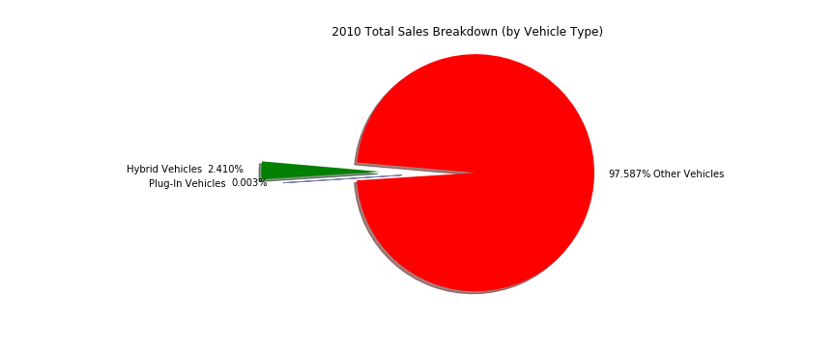

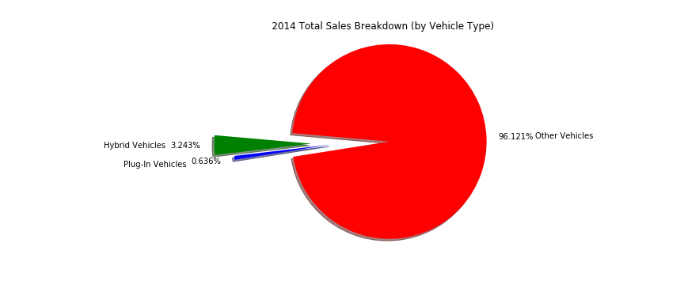

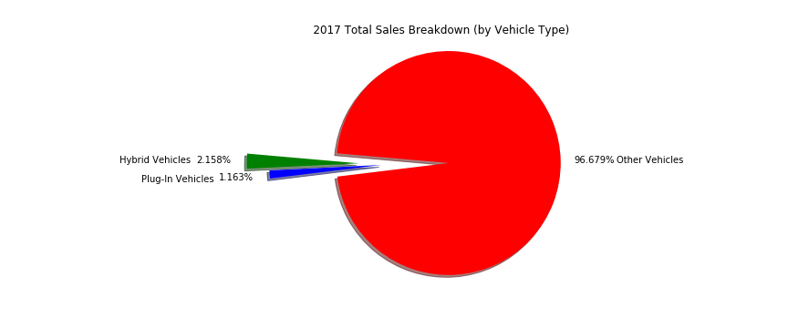

Additional Questions:

Review of the charts listed above led us to question why Hybrid sales appear to fluctuate while Electric sales increase in each year given. The plot below gives a smoother depiction of this phenomenon.

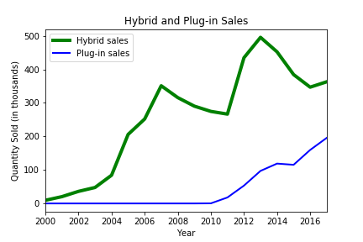

What could be causing this disparity? After investigating U.S. gasoline prices, we obtained the following apparent relationship:

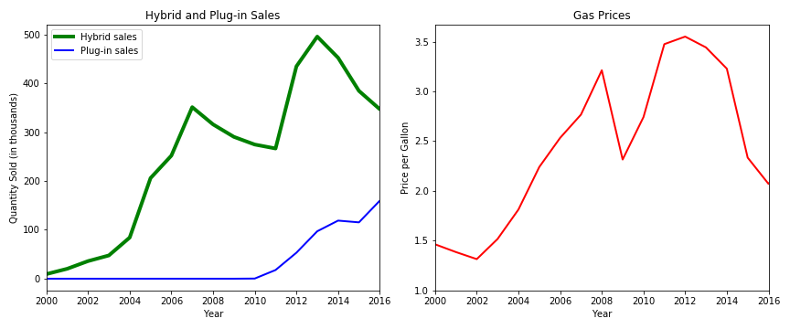

Conclusions:

While sales of Hybrid and Electric Vehicles constitute a much greater percentage of the light automobile market share, sales of Electric vehicles appear to be more consistently trending positively and appear to be impacted far less by major changes in U.S. gasoline prices.

Sources:

Toyota Prius – Wikipedia - <https://en.wikipedia.org/wiki/Toyota_Prius>

Plug-in electric vehicle – Wikipedia - <https://en.wikipedia.org/wiki/Plug-in_electric_vehicle>

Hybrid and Plug-in Vehicle Sales, 1999-2017 – Oak Ridge National Laboratory - <https://cta.ornl.gov/data/chapter6.shtml>

U.S. Regular Conventional Retail Gasoline Prices – U.S. Energy Information Administration - <https://www.eia.gov/dnav/pet/hist/LeafHandler.ashx?n=PET&s=EMM_EPMRU_PTE_NUS_DPG&f=A>