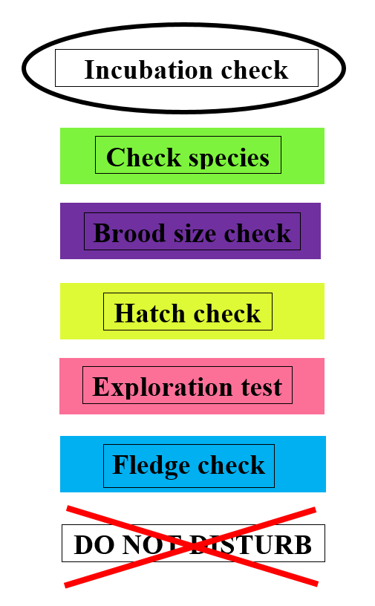**Cheat sheet**

**1. Brood overview**

**Species:** (female incubating) **BT** (blue tit) **CT** (coal tit)

**GT** (great tit) **NH** (nuthatch)

**Density:** **1**= GL/BL **3**= GH/BH

**2**=GH/BL  **4**=GL/BH

**Nest box type: BT** (blue tit box)

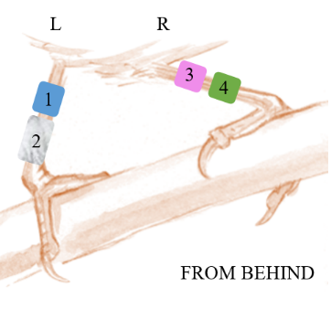**GT** (great tit box)

**Color code:** **B** = Blue **C** = Hot pink

**G** = Green **M** = Metal

**N** = Black **O** = Orange

**R** = Red **V** = Violet

**W** = White **Y** = Yellow

**2. Nest visits**

**Nest stage: LM =** Little moss

**HN =** Half a nest, evidence of nesting material; nest building appears to be in process. No cup shape yet.

**IN =** Incomplete nest with cup shape, but without final lining.

**CN =** Complete nest, nest appears structurally complete with cup and final lining with hair/soft materials.

**DN =** Nest appears to be damaged and/or torn apart.

**Egg cond: no =** indicates that no eggs are in the nest

**cc =** eggs are cold and covered with nest material

**co =** eggs are cold and not covered

**wc =** eggs are warm and covered with nest material

**wo =** eggs are warm not covered

**Adult activ: NO =** No adults seen

**BA =** Female seen building the nest or carrying nest material

**AA =** Adult hissing or giving alarm calls when you approach the nest

**FA =** Adults seen carrying food to the nest

**VA =** Adult(s) seen in vicinity of the nest

**OA =** When opening the lid, adult is in or flushes out of the nest-box

**Adults ageing**

**4**: at least last year born, if unsure

**5**: moulting border

**6**: no moulting border

* Moult after breeding

**Chick stage: HY =** Hatching young, a chick is emerging or has just hatched from an egg

**NY =** Naked young, nestlings with no or little down feathers (usually day 1- 4, see Figure 2)

**PY =** Partially feathered, outermost flight feathers on the wing are emerging, encased within a pointed sheath, OR feathers have broken through the sheath and have a stubby brush-like appearance, OR the flight feathers appear fully grown but tail feathers and body feathers are not yet complete. Some skin visible

**FY =** The tail feathers are short and most body feathers are visible, little or no skin visible. Nestlings are well feathered and look ready to leave the nest

**YY =** Young presumed or known to have fledged

**NY =** No young, use only when presumed to be dead or predated

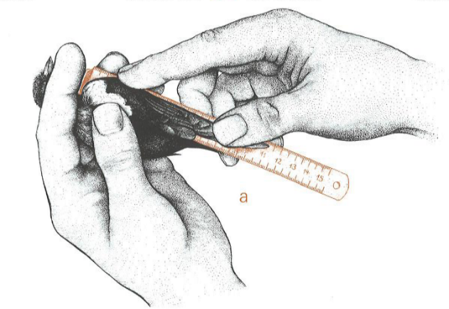

**Mgmt Activ: NB =** Regular nest box check

**HC =** Hatch check

**BSC =** Brood size check on day 3 or 4

**ET =** Exploration test is performed

**CM =** Chick measurements on day 14 or 15

**FC =** Fledge check on day 19 or after

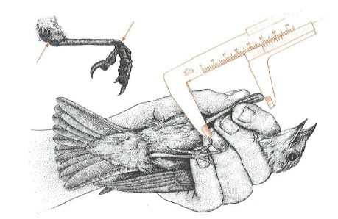

**Wing length**

**Obs: Do not forget your number!**

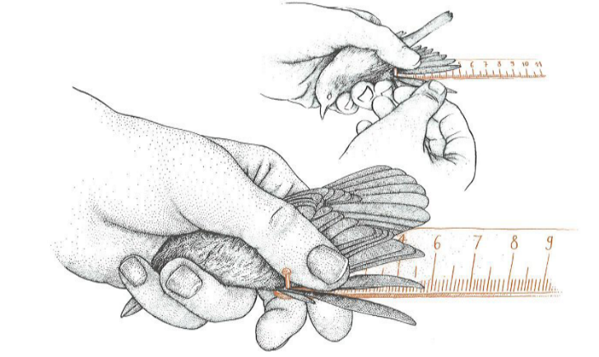**3. Chick measurements**

**Fat: see fat score pictures**

**Tarsus**

**4. Exploration test**

**P3**

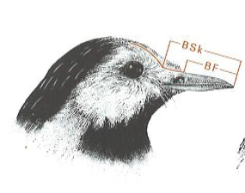**Metal ring: Blue tit: blue band**, starting letter **B, seven positions in total!**

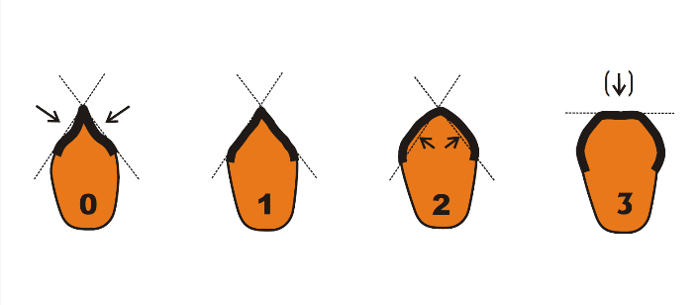**Handling aggression:**

**Bill length**

|  |  |  |  |
| --- | --- | --- | --- |
| Score | Wings spread | Tail feathers spread | Bird strikes fingers |
| **0** | No | No | No |
| **1** | No | No | Yes, but only if provoked |
| **2** | No | Yes | Yes, spontaneously |
| **3** | Yes | Yes | Yes, spontaneously |

When the bird displayed one reaction specific to one score and another reaction

specific to another score, it received an average score between the two.

For example, a bird that struck without any provocation (score 2) but did

not have its wings and tail feathers spread (score 1) would be scored as **1.5**.

**Muscle score**