VERBUM LOCAL
Supervisor User Flows
Web Management Platform
Date: March 2026
Status: Active
Companion doc: VerbumLocal_RBAC_Matrix.docx

This document contains step-by-step user flows and mermaid diagrams for all Supervisor use cases. Flows marked as NEW or CHANGED have full detail. Flows that match existing product behavior (Alorica web app) are documented in lightweight format.

Flow 1: Login + First-Time Setup
LIGHTWEIGHT — Matches existing product behavior
Covers: UC-S01, UC-S02
Steps
1. Supervisor navigates to web management platform URL.
2. System displays login screen with email and password fields.
3. Supervisor enters credentials and submits.
4. System validates credentials.
5. On success: redirect to Dashboard.
6. On first login: system may prompt to change temporary password [E].
Error States
⚠️ Invalid credentials → error message, retry.
⚠️ Account locked → contact admin message.
⚠️ Network error → connection error, retry.
Mermaid
graph LR
A[Open platform URL] --> B[Login screen]
B --> C{Valid credentials?}
C -->|Yes| D{First login?}
C -->|No| E[Error: invalid credentials]
E --> B
D -->|Yes| F[Change temp password]
D -->|No| G[Dashboard]
F --> G

Graph
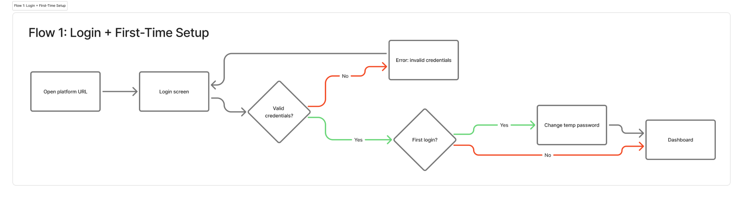

Flow 2: Dashboard
LIGHTWEIGHT — Matches existing product with new metrics
Covers: UC-S06, UC-S07, UC-S08
Steps
1. Supervisor lands on Dashboard after login.
2. Dashboard displays metric cards scoped to own teams: teams + status, agents online/total, agents in active session, active/total/completed sessions, sessions last 7 days, avg session duration, AI Voice Off rate, top language pair, avg confidence score, reply usage rate, reply type breakdown, top 5 replies.
3. Recent activity feed shows latest session events (completed, started, etc.) with session ID, status, date/time.
4. Quick actions section provides shortcuts: View my teams, View sessions, Search sessions, Export reports.
5. If supervisor manages multiple teams, a team filter/selector allows scoping all metrics to a specific team.
6. Date range selector filters all metrics by period.
Navigation from Dashboard
• Click quick action → navigates to corresponding page.
• Click on a session in recent activity → navigates to session details.
• Click on a team card/name → navigates to team details.
Mermaid
graph LR
A[Login] --> B[Dashboard]
B --> C[Metric cards - scoped to own teams]
B --> D[Recent activity feed]
B --> E[Quick actions]
B --> F[Team filter / Date range]
D -->|Click session| G[Session details]
E -->|View teams| H[Teams page]
E -->|View sessions| I[Sessions page]
E -->|Export reports| J[Export modal]

Graph
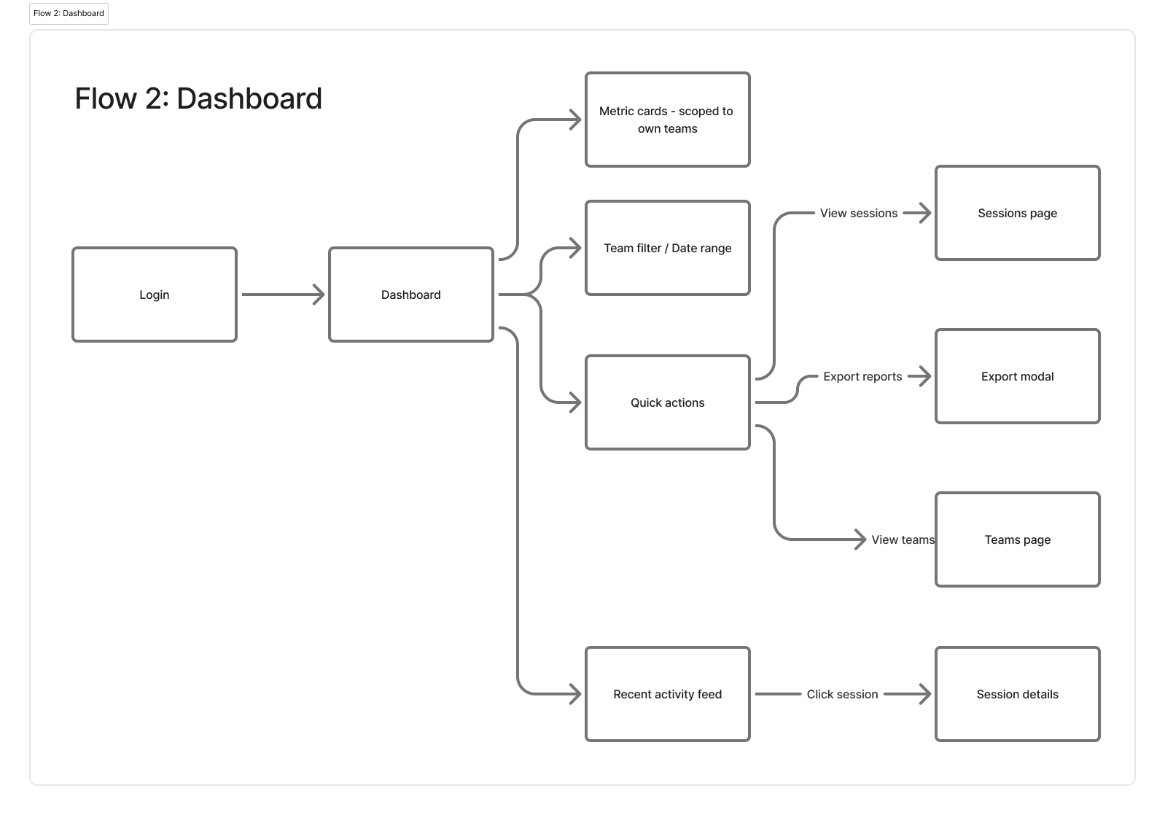

Flow 3: Sessions
CHANGED — Consolidated view replaces team-first navigation
Covers: UC-S09 through UC-S16
What Changed
• Previously: supervisor had to select a team first, then see sessions for that team.
• Now: sessions page shows ALL sessions from ALL assigned teams in a single table. Team is a filter, not a prerequisite.
• Entering from a team page pre-applies the team filter.
Steps: Browse + Filter
1. Supervisor clicks Sessions in side panel (or quick action).
2. System displays consolidated sessions table with all sessions from assigned teams.
3. Table columns: Session ID, Agent, Team, Status, Language pair, Duration, Start time, AI Voice (icon: enabled/disabled).
4. Search bar allows keyword search across sessions.
5. Filters available: date range, team, agent, status, language pair, AI Voice.
6. Pagination at bottom of table.
7. Export button: CSV or JSON for the filtered result set.
If supervisor entered from a team page, the team filter is pre-applied. Can be cleared to see all teams.
Steps: View Session Details
1. Supervisor clicks a session row.
2. System navigates to session details page.
3. Header shows: back button, Session ID, Agent name, Team, Start/end time, Duration, Language pair, Status.
4. Transcript section displays bilingual conversation (original + translated).
5. Transcript can be viewed side-by-side (columns) or combined.
6. Each message shows: speaker (agent/customer), timestamp, original text, translated text, confidence % with color indicator (green >80%, yellow 60-80%, red <60%).
7. Search bar within transcript for keyword search.
8. Scroll to latest button jumps to most recent message.
9. Export transcript: JSON, CSV, or text.
10. Share button copies session link (accessible to SA/Admin/Sup with org login).
Error States
⚠️ No sessions found → empty state with message.
⚠️ Transcript not available → message indicating transcript is unavailable for this session.
⚠️ HIPAA active on team → transcript not stored, message indicating HIPAA restrictions.
Mermaid
graph LR
A[Side panel: Sessions] --> B[Consolidated sessions table]
A2[Team page: View sessions] -->|Pre-filtered by team| B
B --> C[Search / Filter]
C --> B
B --> D[Export filtered results]
B -->|Click session| E[Session details]
E --> F[View transcript]
F --> G[Search within transcript]
F --> H[Export transcript]
F --> I[Share session link]
E --> J{HIPAA active?}
J -->|Yes| K[Transcript not available]
J -->|No| F

Graph
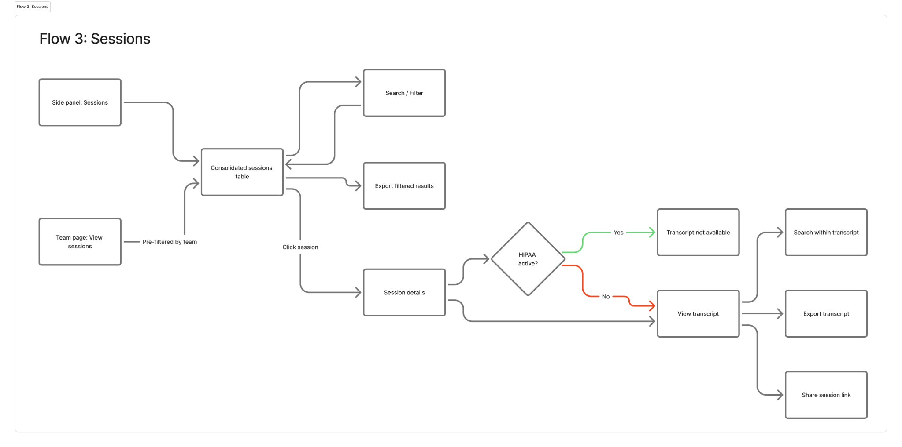

Flow 4: Teams
LIGHTWEIGHT — Mostly matches existing product
Covers: UC-S17 through UC-S24
Steps: View Teams
1. Supervisor clicks Teams in side panel.
2. System displays assigned teams as cards or list (toggle view).
3. Each team shows: name, description, supervisor, agent count, languages, status (active/inactive).
4. Search bar to filter teams by name.
Steps: View/Edit Team Details
1. Supervisor clicks a team card.
2. System shows team detail page with cards: team members count, active sessions, total sessions.
3. Tab navigation: Team Details | Members.
4. Team Details tab sections (top to bottom): Team Information (name, description, supervisor), Language Configuration, Security & Compliance, SDK Translation Mode.
5. Supervisor edits name/description → Save Changes / Cancel.
Supervisor cannot change who the supervisor is. That is admin-only.
Steps: Configure Team Languages (UC-S20)
1. In Team Details tab, Language Configuration section shows enabled languages as chips.
2. Add Language: click to search/select from admin-enabled pool.
3. Remove Language: click X on a language chip.
Only languages activated in the global catalog by Admin are available in the pool.
Steps: Manage Members (UC-S22, UC-S23, UC-S24)
1. Members tab shows current members list with name and email.
2. Remove member: click remove button next to agent.
3. Add member: search available agents in lower section.
4. Only unassigned agents appear (agent can only be in one team).
5. Select agent → added to team.
Error States
⚠️ No available agents to add → message: all agents are assigned to teams.
⚠️ Agent already in another team → not shown in available list.
Mermaid
graph LR
A[Side panel: Teams] --> B[Teams list/cards]
B -->|Click team| C[Team detail page]
C --> D[Team Details tab]
C --> E[Members tab]
D --> F[Edit name/description]
D --> G[Configure languages]
D --> H[Configure SDK mode]
E --> I[View members]
E --> J[Add member]
E --> K[Remove member]
J --> L{Agent available?}
L -->|Yes| M[Agent added]
L -->|No| N[No agents available]
Graph
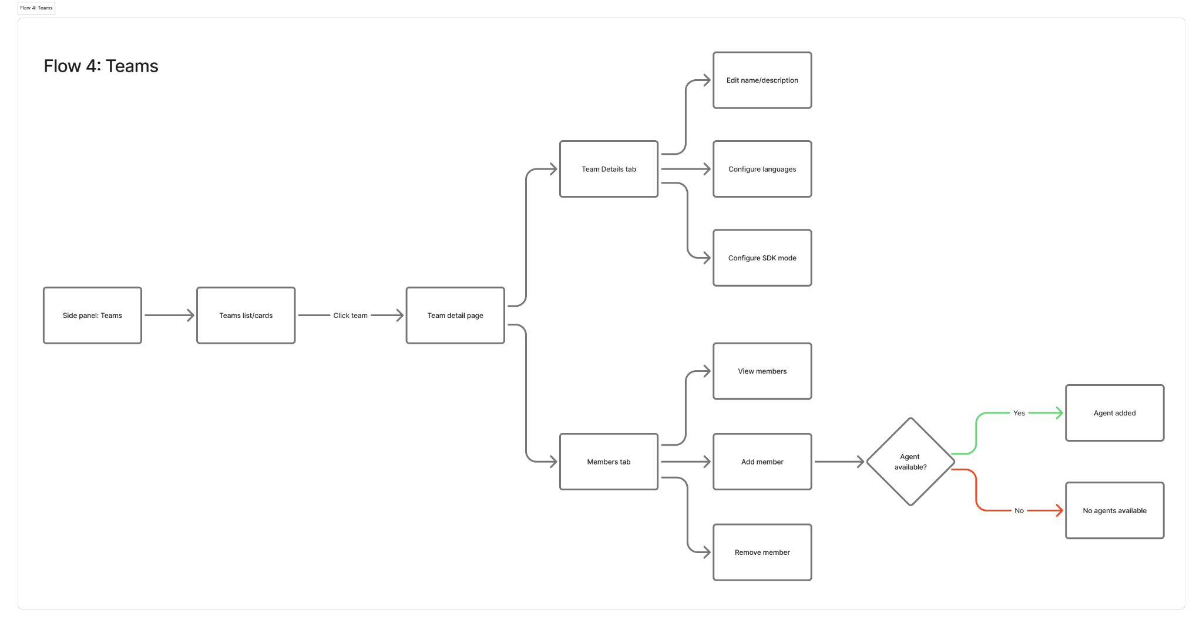

Flow 5: SDK Translation Mode
NEW — Does not exist in current product
Covers: UC-S21
Context
Team-level setting that defines which SDK method the desktop app uses for translation. Two options:
• STT + TTS (default): Sequential pipeline. Speech → text → translation → text → speech.
• S2S (Speech-to-Speech): SDK processes full pipeline in one step. Potentially faster, no benchmark yet.
Steps
1. Supervisor navigates to Team Details tab of a team.
2. SDK Translation Mode section displays current mode (default: STT + TTS).
3. Supervisor selects alternative mode from dropdown or toggle.
4. System shows confirmation: "Changing to [mode]. Active agents will need to restart the app for this change to take effect."
5. Supervisor confirms.
6. System saves the new mode. Active sessions continue on old mode.
7. Agent sees updated mode indicator in top status bar after app restart.
Error States
⚠️ Change fails to save → error message, mode reverts to previous.
No impact on transcript or other features. If issues arise, it is an S2S integration problem. Subject to changes per Dayanna review [E].
Mermaid
graph TD
A[Team Details tab] --> B[SDK Translation Mode section]
B --> C[Current mode displayed]
C --> D[Supervisor selects new mode]
D --> E[Confirmation dialog]
E -->|Confirm| F[Mode saved]
E -->|Cancel| C
F --> G[Active sessions unaffected]
F --> H[Agent restarts app]
H --> I[New mode active + indicator in status bar]
Graph
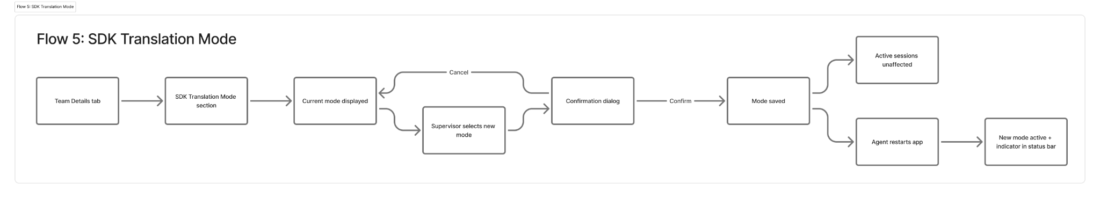

Flow 6: Replies (Full CRUD)
CHANGED — Supervisor now has full CRUD on replies and categories
Covers: UC-S25 through UC-S36
What Changed
• Previously: admin created categories and replies; supervisor only viewed/assigned.
• Now: supervisor has full CRUD on replies and categories for own teams. Can create, edit, delete, toggle, bulk upload, and export. SA/Admin can still edit/delete anything.
Steps: View Replies (UC-S25)
1. Supervisor clicks Replies/Responses in side panel.
2. System displays categories as expandable sections.
3. Each category shows: name, description, language, reply count.
4. Expanding a category reveals its replies.
5. Search bar: search by category, language, tag, or reply keyword.
6. Language selector: view replies in a different language.
Steps: Create Category (UC-S26)
1. Supervisor clicks Create Category button.
2. Modal opens: Category Name, Description, Language.
3. Supervisor fills fields and saves.
4. New category appears in the list.
Steps: Edit/Delete Category (UC-S27)
1. Supervisor clicks edit on a category they created.
2. Edit modal: change name, description, language.
3. Save or cancel.
4. Delete: supervisor clicks delete on own category.
5. Confirmation dialog: "Delete category [name]? This will remove all replies within it."
6. Confirm → category and replies deleted.
Supervisor can only edit/delete categories they created. SA/Admin can edit/delete any.
Steps: Create Reply (UC-S28)
1. Inside a category, supervisor clicks Add Response/Reply.
2. Modal opens: Title, Language, Message, Tag and Visibility toggle.
3. Supervisor fills fields and saves.
4. Reply appears in the category.
Steps: Edit/Delete Reply (UC-S29, UC-S30)
1. Supervisor clicks edit on a reply they created.
2. Input modal opens with current text.
3. Edit and save, or cancel.
4. Delete: click delete → confirmation → reply removed.
Supervisor can only edit/delete replies they created.
Steps: Bulk Upload (UC-S31)
1. Supervisor clicks Bulk Upload button.
2. System prompts for JSON file upload.
3. Supervisor selects file and confirms.
4. System validates format and imports replies into the selected category.
5. Success message with count of imported replies.
⚠️ Invalid format → error message with details of what failed.
⚠️ Partial failure → report of which replies imported and which failed.
Steps: Assign to Team (UC-S33)
1. In Teams Details tab, supervisor will be able to also there assign replies categories to te teams.
Steps: Toggle On/Off (UC-S34)
1. Supervisor clicks toggle next to a reply.
2. Toggle off: agents stop seeing the reply immediately.
3. Toggle on: agents see it again.
Steps: Export (UC-S32)
1. Supervisor clicks Export.
2. System exports all replies (or filtered set) as file.
Mermaid: Category CRUD
graph LR
A[Replies page] --> B[View categories + replies]
B --> C[Search / Filter / Change language]
B --> D[Create category]
D --> E[Modal: name, desc, language]
E --> F[Category created]
B --> G[Edit own category]
G --> H[Edit modal]
H --> I[Saved]
B --> J[Delete own category]
J --> K[Confirmation dialog]
K -->|Confirm| L[Category + replies deleted]
K -->|Cancel| B
Mermaid: Reply CRUD
graph LR
A[Inside category] --> B[Add reply]
B --> C[Modal: Title, Language, Message, Tag and Visibility toggle]
C --> D[Reply saved]
A --> E[Edit own reply]
E --> F[Edit modal]
F --> G[Saved]
A --> H[Delete own reply]
H --> I[Confirmation]
I --> J[Deleted]
A --> K[Bulk upload JSON]
K --> L{Valid format?}
L -->|Yes| M[Replies imported]
L -->|No| N[Error report]
A --> O[Toggle reply on/off]

Graph Category CRUD
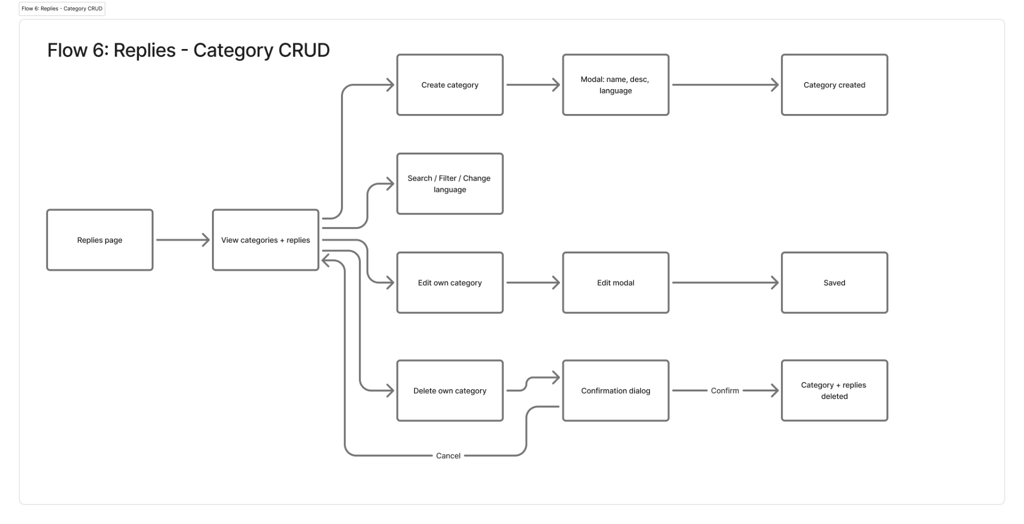
Graph Reply CRUD
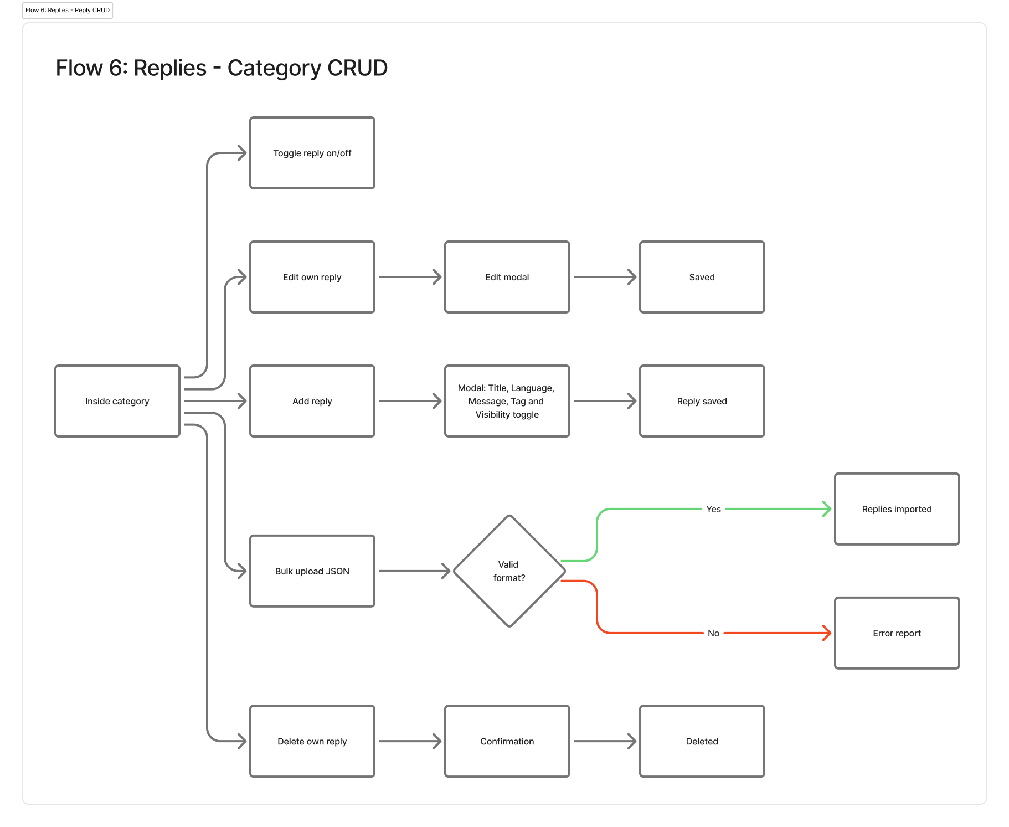

Flow 7: Auto-Greeting
NEW — Does not exist in current product
Covers: UC-S36
Context
Supervisor configures an automatic greeting message for a team. When enabled, agents can choose whether to use it at the start of each session. The supervisor enables, the agent decides.
Steps
1. Supervisor navigates to Replies page or Team Details (location TBD).
2. Auto-greeting section shows current status (enabled/disabled), message text and language.
3. Supervisor writes or edits the greeting message.
4. Supervisor toggles auto-greeting on for the team.
5. System saves. Agents on this team now see the auto-greeting option in their app.
6. Agent, at session start, sees option to send auto-greeting or skip.
7. If agent enables it, greeting is sent automatically at start of each new session.
8. Agent can toggle it off at any time.
Error States
⚠️ Empty greeting message + toggle on → validation error: message required.
Mermaid
graph LR
A[Supervisor: Auto-greeting category] --> B[Write/edit message]
B --> C[Toggle on for team]
C --> D{Message empty?}
D -->|Yes| E[Validation error]
D -->|No| F[Saved and active]
F --> G[Agent sees auto-greeting option]
G --> H{Agent enables?}
H -->|Yes| I[Greeting sent at session start]
H -->|No| J[No greeting]
Graph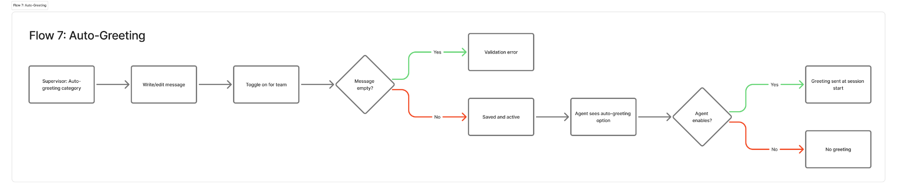

Flow 8: HIPAA Toggle
CHANGED — Confirmation modal needs definition
Covers: UC-S37
Context
Team-level toggle that activates HIPAA-compliant handling. When on, sessions are not stored, transcripts are not saved. Disabling requires explicit confirmation due to compliance risk.
Steps: Enable HIPAA
1. Supervisor navigates to Team Details.
2. HIPAA Compliance section shows toggle (currently off).
3. Supervisor toggles on.
4. System shows confirmation modal:
Title: Enable HIPAA Compliance
Body: "When enabled, this team operates with HIPAA-compliant handling rules. Sessions will not be stored and transcripts will not be saved."
Buttons: [Cancel] [Enable HIPAA]
5. Supervisor confirms → HIPAA active. New sessions follow HIPAA rules.
Steps: Disable HIPAA
1. Supervisor toggles HIPAA off.
2. System shows warning modal:
Title: Disable HIPAA Compliance?
Body: "Turning off HIPAA compliance means sensitive health information may no longer be protected according to HIPAA standards. This could result in compliance violations. Are you sure you want to continue?"
Buttons: [Cancel] [Disable HIPAA]
3. Supervisor confirms → HIPAA disabled. New sessions will be stored normally.
Important Rules
• Change applies to new sessions only. Active sessions continue under previous setting. Agent will be shown a HIPAA activated modal to let them know the new status.
• When HIPAA is on: session history shows metadata but no transcript.
• When HIPAA is on: export transcript is not available.
Error States
⚠️ Toggle fails to save → error message, state reverts.
Mermaid
graph LR
A[Team Details: HIPAA section] --> B{Current state?}
B -->|Off| C[Supervisor toggles on]
C --> D[Enable confirmation modal]
D -->|Confirm| E[HIPAA active]
D -->|Cancel| A
B -->|On| F[Supervisor toggles off]
F --> G[Warning modal: compliance risk]
G -->|Confirm| H[HIPAA disabled]
G -->|Cancel| A
E --> I[New sessions: no storage]
H --> J[New sessions: stored normally]

Graph
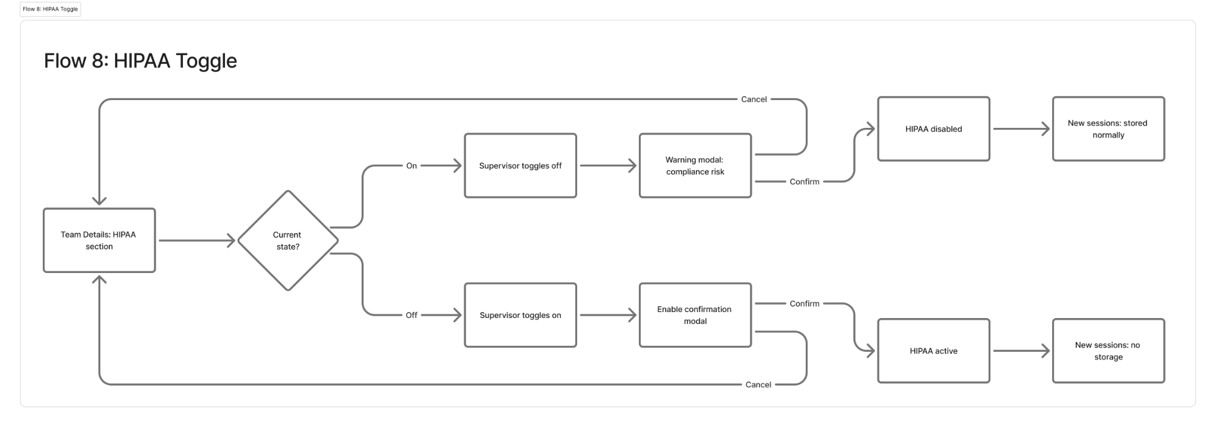

Flow 9: Profile & Password
LIGHTWEIGHT — Matches existing product behavior
Covers: UC-S03, UC-S04
Steps: View Profile (UC-S04)
1. Supervisor clicks profile icon/name at bottom of side panel.
2. Menu opens: name, email, role tag, Profile Settings link, Logout.
3. Click Profile Settings → navigates to profile page.
4. Profile page shows: first name, last name, email (all read-only).
Steps: Change Password (UC-S03)
1. In Profile Settings, password section shows current/new/confirm fields.
2. Supervisor enters current password, new password, confirms.
3. Click Change Password.
4. On success: confirmation message.
Error States
⚠️ Current password incorrect → error message.
⚠️ New password does not meet requirements → validation message.
⚠️ Confirm does not match → validation message.
Mermaid
graph LR
A[Profile icon] --> B[Profile menu]
B --> C[Profile Settings page]
C --> D[View info - read only]
C --> E[Change password]
E --> F{Valid?}
F -->|Yes| G[Password changed]
F -->|No| H[Validation error]
B --> I[Logout]
Graph
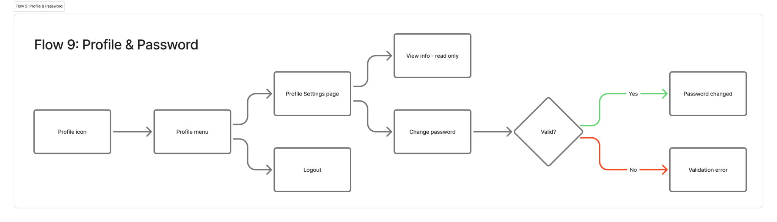

Flow 10: Export & Share
LIGHTWEIGHT — Matches existing product behavior
Covers: UC-S15, UC-S16, UC-S32, UC-S39

Large Export Handling (applies to all exports)
When an export file may be large (multiple teams, long date ranges, many sessions), the system should handle it gracefully:
1. User clicks Export and selects format.
2. System shows a persistent banner/toast at the top of the page: "Preparing your export. Please don’t close this tab." with a spinner or progress indicator.
3. Banner persists until export is ready. User can continue navigating within the same tab.
4. When ready: banner updates to "Export ready" and download starts automatically.
5. If export fails: banner changes to error state: "Export failed. Please try again." with a retry action.
Use a persistent banner, not a modal — modals block the UI. The banner should not auto-dismiss; it stays until download completes or user dismisses it.
Steps: Export Sessions (UC-S15)
1. From sessions table: click Export → choose CSV or JSON → large export handling applies.
2. From session details: click Export → choose JSON, CSV, or text → download (typically small, instant).
Export respects current filters. HIPAA sessions have no transcript in export.
Steps: Share Session Link (UC-S16)
1. From session details: click Share button.
2. System copies session link to clipboard.
3. Recipient must log in with org credentials to view (SA/Admin/Sup only).
Steps: Export Replies (UC-S32)
1. From replies page: click Export → download.
Steps: Export Reports (UC-S39)
1. From dashboard quick actions or sessions page: click Export Reports.
2. System generates report based on current scope/filters. Large export handling applies.
Mermaid
graph TD
A[Click Export] --> B[Select format]
B --> C[Persistent banner: Preparing export...]
C --> D{Export size?}
D -->|Small| E[Instant download]
D -->|Large| F[Banner persists with progress]
F --> G{Success?}
G -->|Yes| H[Banner: Export ready + auto download]
G -->|No| I[Banner: Export failed + retry]
I --> A
Graph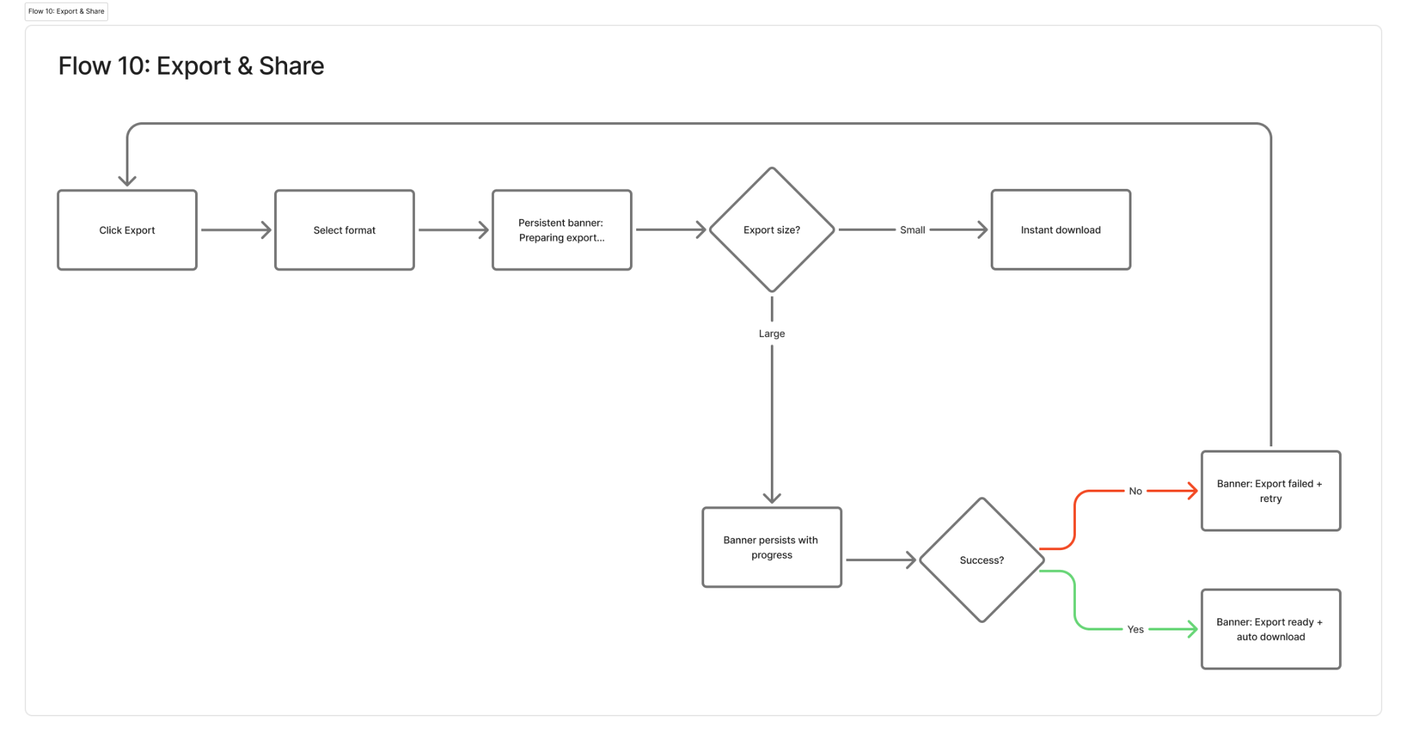

Flow 11: Logout
LIGHTWEIGHT — Matches existing product behavior
Covers: UC-S05
Steps
1. Supervisor clicks profile icon at bottom of side panel.
2. Menu opens with Logout option.
3. Click Logout.
4. System ends session, redirects to login screen.

Flow 12: Replies Audit Log
[E] — Pending validation
Covers: UC-S38
Proposed Steps
1. Supervisor navigates to Replies page or a dedicated Audit tab.
2. Audit log shows changes to replies and categories in own teams.
3. Each entry: timestamp, actor (who made the change), action (created/edited/deleted/toggled), affected item.
4. Filterable by date range and action type.
Scope: supervisor sees only changes in own teams. SA/Admin see global activity log (separate flow, not covered here).

Navigation Structure Summary
Side panel structure for Supervisor:

• PLATFORM
— Dashboard
— Sessions
— Teams
— Replies
• SETTINGS
— Profile Settings
• PROFILE (bottom)
— Name, email, role, Profile Settings, Logout

This matches the existing side panel structure. Supervisor does not see Users or System Settings (those are admin-only).

