Executive Summary
AI-Driven BWB Inverse Design
ASME IDETC/CIE 2026 Student Hackathon — nTop Challenge
Barbara Sylvester – The Tarleton Texans

1. Objective
This project addresses the nTop-sponsored challenge: build an automated inverse design pipeline that takes a Blended Wing Body (BWB) aircraft's case profile, target lift-to-drag ratio, minimum payload and fuel volume, and a flight condition (altitude, airspeed, angle of attack), and directly outputs both the optimal external planform geometry (10 parameters: chord ratios, span fractions, sweep angles, root chord) and internal structural configuration (11 parameters: skin thickness, spar and rib placement/thickness, for both wing and fuselage) for that case, subject to a hard 335 MPa structural stress limit.

2. Methodology

2.1 Forward Surrogates
Four quantities needed forward models trained on the provided dataset: structural mass, payload volume, fuel volume, and maximum hotspot stress. All were trained using gradient-boosted decision trees (HistGradientBoostingRegressor), a strong, fast, GPU-free approach well-suited to tabular engineering data of this size.
Mass, payload volume, and fuel volume all fit cleanly, with R² above 0.98 on held-out data. Stress did not: the raw stress distribution is extremely right-skewed (median ≈228 MPa, but a small number of outlier designs exceed 1,000,000 MPa, driven by mesh-level artifacts in the underlying FE data). A regressor trained directly on raw stress values actually performed worse than predicting the average every time, since a squared-error loss lets those few extreme outliers dominate training at the expense of accuracy near the values that actually matter.
To fix this the stress model was retrained on log(stress) instead. This distribution is well-behaved (standard deviation ≈0.68 in log space versus spanning multiple orders of magnitude in raw units), and the 335 MPa threshold sits in the dense, well-sampled middle of that distribution, exactly where prediction accuracy matters most for the feasibility decision.

2.2 Aerodynamics
Lift-to-drag ratio was computed using the organizers' provided trained neural network surrogate directly, run with each candidate design's planform geometry and the case's flight condition as input. No independent aerodynamic model was built, per the challenge constraints.

2.3 Optimization
The inverse design search, 21 continuous/integer variables, a black-box objective built on tree-ensemble surrogates with no usable gradient, was solved with differential evolution (scipy.optimize.differential_evolution), a population-based, gradient-free global optimizer well suited to this kind of mixed, non-smooth search space. Two structural variables (rib count, fuselage spar count) are integer-constrained, and one (fuselage rib count) must be an odd integer in {3,5,7,9,11}; these are searched as continuous values and snapped to their nearest valid discrete value only at evaluation time, keeping the search space smooth while still respecting the discrete constraints.
The objective function minimizes structural mass, with additive penalties for any shortfall against the case's L/D target and payload/fuel volume minimums (no reward for exceeding a target, only for meeting it), plus the large feasibility penalty described above.

3. Results
The pipeline was run independently against all three official case profiles.
Case | Mass (kg) | L/D ach. | L/D target | Payload ach. (m³) | Payload min (m³) | Fuel ach. (m³) | Fuel min (m³) | Feasible prob
High Speed Dash | 33.1 | 7.61 | 6.0 | 0.772 | 0.75 | 0.435 | 0.45 | 0.93
Max Endurance | 50.2 | 10.05 | 10.0 | 0.925 | 0.80 | 0.456 | 0.45 | 0.95
Max Capacity | 54.8 | 14.80 | 15.0 | 0.480 | 1.00 | 0.335 | 0.65 | 0.92
Table 1: Final results
Two patterns are worth mentioning specifically:
- Mass scales sensibly with case demand. The highest-capacity case (Case 3) produces the heaviest optimized structure, which is a reasonable physical sanity check for a purely data-driven pipeline with no first-principles physics.
- Fuel volume is the target most often left short across cases, suggesting this is where the design space is most tightly constrained relative to the other case requirements.

4. Trade-off Analysis
To demonstrate the coupling between external aerodynamics and internal structure explicitly, rather than reporting a single optimum per case the optimizer was re-run across a sweep of relative weights on the L/D-shortfall penalty, from prioritizing mass almost exclusively to prioritizing L/D achievement. Plotting the resulting (mass, L/D) pairs together approximates a Pareto front for each case.
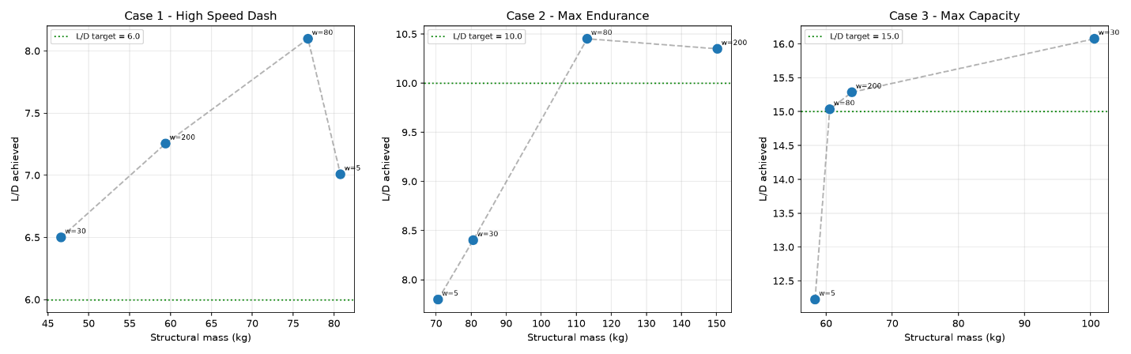
Figure 1: Pareto front for each case
Thus, showing how much structural mass must be traded to gain additional aerodynamic efficiency for a given case. A direct, visualized answer to how the pipeline balances external and internal design variables rather than optimizing them independently.

5. Limitations and Future Work
- The stress feasibility gate is conservative by design; this likely costs some achievable mass reduction in exchange for confidence the design is genuinely safe under the hidden validation. This trade-off was deliberate given the scoring structure, but a wider Pareto sweep between conservatism and mass could quantify exactly what it costs.
- The Pareto sweep used a reduced optimizer budget per point to keep total runtime reasonable; a production run with a larger budget would produce a smoother, less noisy trade-off curve.
- With more time, ensemble surrogates (averaging multiple independently trained models) could further reduce the risk of a single model's blind spot driving a bad feasibility call.

6. Reproducibility
Full code, trained models, and exact run instructions are included in the accompanying repository (README.md). The pipeline is pure Python (numpy, pandas, scikit-learn, scipy), no GPU or paid dependencies required.

