Developing a novel methodology for analysing egress utilising graph networks within IFC

Richard Lai

Master of Engineering Science
Fire Safety Engineering



The University of Queensland
2026

Thesis Title

by Richard Lai

Student Number: 4956847
Course Code: CIVL7513
Supervisor: Dr David Lange & Dr Anwar Orabi
Submission Date: 08/06/2026

School of Civil Engineering
The University of Queensland

Acknowledgements

Lorem ipsum dolor sit amet, consectetur adipiscing elit. Duis urna tortor, vulputate pretium laoreet eget, semper blandit ante. Vivamus placerat, libero non egestas porttitor, leo sapien volutpat nunc, at fermentum erat leo vel ex. Suspendisse potenti. Donec luctus venenatis ligula eu iaculis. Nulla dapibus aliquam aliquet. Donec porttitor sapien urna, sed feugiat ex lacinia vel. Sed nec pellentesque erat, ut pellentesque neque. Quisque tempus molestie volutpat. Duis quam libero, semper eget elit eget, suscipit finibus enim. Nam nec lacus quis sem imperdiet sagittis a nec nulla.

Abstract

Lorem ipsum dolor sit amet, consectetur adipiscing elit. Duis urna tortor, vulputate pretium laoreet eget, semper blandit ante. Vivamus placerat, libero non egestas porttitor, leo sapien volutpat nunc, at fermentum erat leo vel ex. Suspendisse potenti. Donec luctus venenatis ligula eu iaculis. Nulla dapibus aliquam aliquet. Donec porttitor sapien urna, sed feugiat ex lacinia vel. Sed nec pellentesque erat, ut pellentesque neque. Quisque tempus molestie volutpat. Duis quam libero, semper eget elit eget, suscipit finibus enim. Nam nec lacus quis sem imperdiet sagittis a nec nulla.

Acknowledgement of AI use
https://guides.library.uq.edu.au/tools-and-techniques/ai-student-hub
https://guides.library.uq.edu.au/tools-and-techniques/ai-student-hub/acknowledge-and-reference-ai-use

Example:
Tool | Use | Prompts | Section | Date
ChatGPT 4o | Initial idea generation that I adapted | Brainstorm ideas around how sustainable development goals can be applied locally | Framework on p 18 | 6 January 2025
Claude 3.5 | Generating a draft conclusion that I adapted | Provide a summary of Chapters 3, 4, and 5 | Conclusions (p 30, 31) | 10 January 2025
Grammarly EDU | Used to check spelling and grammar and edit my final document | Enhance my text to improve clarity and expression | Entire work | 14 January 2025
Microsoft Copilot | Used to modify the written tone/style of the introduction | Rewrite this paragraph so that the tone is appropriate for a university assignment | Introduction (p 2) | 14 January 2025
Microsoft Copilot | Generating images for analysis | Create an image of a highly effective suburban park | Introduction (p 1) | 28 March 2025

Weekly Logbook
Course code:
Student ID:
Student Name:
Week | Activity, topics discussed, actions | Supervisor initials
1
2
3
4
5
6
7
8
9
10
11
12
13

Table of Contents
1. Heading 1 3
1.1 Sub-Heading 1 3
1.2 Sub-Heading 2 3
2. Heading 2 4
2.1 Example Citations 4
Bibliography 5
Appendix A 6
Appendix B 7

Table of Figures

Figure 1 Example thesis figure. 7

Introduction

Project Background
- Define BIM
- Contextualise Fire Safety Engineering within BIM
- Describe challenges in integration with BIM
- Consequences for not integrating with BIM?
- Discuss attempt to bridge gap with smaller stepping stones

Research Aims and Objectives
- List Aim and Objectives

Literature Review

Example Citations
Citations should be used in the literature review (Washington, 2019). There is no set referencing style, but a consistent style should be used throughout the thesis.
Discuss BIM use in general
Discuss modelling process and interaction with fire eng software
Discuss ifcopenshell
Discuss graph networks and examples
Discuss use of ifcspaces in IFC and graphs
Discuss egress fundamentals. And discuss how it is quantified. Existing methods
Discuss pathfinding algorithms?

Methodology

Overview
- Summary of methodology
The project will consist of developing an IFC building model in Python through the use of the Python library IfcOpenShell, then using this model to extract information required for the method. IfcOpenShell is used to construct the geometry, but more importantly to set up the structure of the information modelling. The model structure is developed specifically such that the information can be extracted consistently. Such information needed to be extracted is IfcSpace boundary relationships, object locations, or if any openings exist within a room. Some properties may be retrieved or defined in a model in different ways, depending on how the user or software has configured it. Hence, a model has been developed in IfcOpenShell for consistency in information extraction for this project.
Once the building model has been created, additional functions are developed to extract different parameters from the model. These parameters are then used for input into the pathfinding algorithm. The pathfinding algorithm will determine the longest paths of travel from any point of the building to the exit, simply by input of the IFC model.
Finally, Pathfinder will be used as a validation method. The IFC model that was constructed will be imported into Pathfinder as a basis for the model geometry. Simulations will be performed on the geometry to assess the travel distances as a benchmark for the algorithm developed. Further details of each method are described in this section.

Model Creation IfcOpenShell
- Detailed description of model creation method
- Defining parameters to be used
The model for the building is constructed more manually using IfcOpenShell, as opposed to more traditional methods such as Autodesk Revit, or Archicad. The reasoning behind this, as mentioned earlier in Section 3.1, is due to potential inconsistencies of IFC models generated between different platforms. That is, different software could store the IFC information about the specific building parameters in different locations, or require an entirely different calling function to access this information. Therefore by using IfcOpenShell and then specifically selecting the way parameters are accessed allows for a consistent model structure. This can then be more easily utilised to achieve the main objectives and aim of this research project.
IfcOpenShell is an open source library that is compatible with Python. The model is created using code in Python and relevant commands defined by IfcOpenShell. Some functions are created in Python to allow for easier creation of the geometry in IFC. These functions are to create a slab, wall, door and space. A space in this instance is referred to as an IfcSpace, which is used to distinguish between different rooms within a storey. Therefore, there will be multiple IfcSpace entities within a storey, where each IfcSpace may be connected to another via an opening (i.e. door). This relationship is defined through another function to define IfcSpace boundaries and relationships. The primary functions in Python used for creating geometry are described in table x.
Function | Description
add_slab | Creates a slab of specified length and width at the selected location.
add_wall | Creates a wall of specified length and height at the selected location.
add_space | Creates an IfcSpace of specified length and width at a selected location. Additionally, it creates a new child element “IfcSpace” for the subject storey.
add_space_boundary | Creates a virtual boundary entity of class “IfcRelSpaceBoundary2ndLevel” relating the specified IfcSpace to the specified opening.
add_opening | Creates an opening of specified width and height by placing a void entity within a selected wall and location. Additionally, relates the opening to the IfcSpace of the connected room/s.
add_room | Performs add_slab, add_wall, and add_space to create a room with geometry and defined IfcSpace of specific length and width at the selected location.

Extracting Parameters from Model
- Detailed description of how extracting model parameters will be done
In order obtain information about the IFC model, additional functions are created to extract this information from the model. This information will be used as input to the pathfinding algorithm described in Section 3.4. At this stage of the project, the information needed is not confirmed, as the algorithm is not yet defined. However it is expected that functions to extract the coordinates of objects, and determining adjacent boundary rooms (adjacent IfcSpace) will be necessary. Further details will be confirmed at a later stage of the project.

Algorithm to find longest paths of travel
- Describe the algorithm used and pseudo code for this task
Once the building IFC model is created, the geometry will be set and so will network of IfcSpace entities. The IfcSpace elements are connected to each other via the door openings. Therefore the entire structure of the building can be represented as a graph network. Using this representation, of the IFC model, this algorithm will determine where the longest travel distances are located from any point of the building.
Further details of this procedure will be developed and completed at a later stage of the project.

Validation using Pathfinder
Upon completion of the steps outlined above, the longest travel distances will be validated through Pathfinder. The IFC model created will be imported into Pathfinder for geometry creation, then used to determine the egress routes in the simulation. Firstly, occupants will be placed in each room. Then the simulation will determine which occupants, and therefore which locations take the longest amount of time to evacuate the building.

Preliminary Results

Model Creation

Relating IfcSpaces to IfcSpaces

Parameter Extraction

Graph Network

Risk and Project Management

Project Timeline

Risk Management
- Risks in scaling up larger IFC model i.e. will it take long? other issues taking a “basic” approach?
- Scalability of algorithm for larger IFC model. What is the estimated size of the algorithm (Big O notation)?

Preliminary Conclusion

Example Citations
Citations should be used in the literature review (Washington, 2019). There is no set referencing style, but a consistent style should be used throughout the thesis.

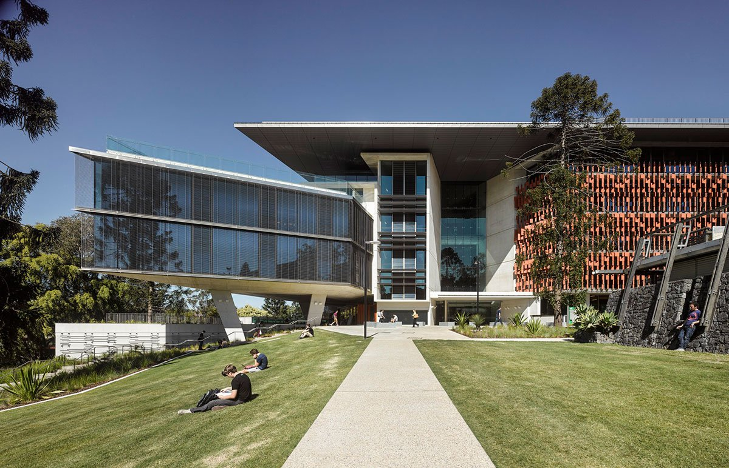
Figure 1 – Example thesis figure.

Bibliography

Washington, S. (2019). An Example Citation. Journal of Fake Sources, 12-25.

Appendix A

Nulla ut tempor orci, et suscipit tellus. Sed efficitur nibh quis dolor luctus congue. Suspendisse sed tempus dolor, vel tincidunt dui. Nulla sed iaculis tellus, sed ultrices augue. Fusce hendrerit sem sem, sit amet efficitur lorem hendrerit vitae. Class aptent taciti sociosqu ad litora torquent per conubia nostra, per inceptos himenaeos. Praesent non felis sed diam ornare consequat at eget mi. Vestibulum ultrices porttitor urna, ac accumsan purus pharetra at.

Appendix B

Nulla ut tempor orci, et suscipit tellus. Sed efficitur nibh quis dolor luctus congue. Suspendisse sed tempus dolor, vel tincidunt dui. Nulla sed iaculis tellus, sed ultrices augue. Fusce hendrerit sem sem, sit amet efficitur lorem hendrerit vitae. Class aptent taciti sociosqu ad litora torquent per conubia nostra, per inceptos himenaeos. Praesent non felis sed diam ornare consequat at eget mi. Vestibulum ultrices porttitor urna, ac accumsan purus pharetra at.

