26-07-2021

André Barbosa

Annual members and casual riders

Differences in bike usage



Contents

Introduction 2

The Data 3

The analysis 4

Key Findings 5

Final Recommendations 7

Illustrations

Graph 1 - Number of riders by rider type by day of the week. 5

Graph 2 - Average ride length by user type by day of the week. 6

Graph 3 - Rideable type by member type. 6

# Introduction

Cyclistic users can be divided into two groups. Casual riders, who purchase single-ride or full-day passes and Cyclistic members who purchase annual memberships. The pricing flexibility is appealing to a broader audience, but the key to Cyclistic’s future growth relies on turning casual riders into annual members.

To this end we need to find how do annual members and casual riders use Cyclistic bikes diﬀerently.

# The Data

The data used for this study, part of the Divvy dataset, consists of the last twelve months’ trip data collected at the bike stations, and organized by month.

The data is stored at <https://divvy-tripdata.s3.amazonaws.com/index.html> and used under license by Motivate International Inc. and the City of Chicago.

# The analysis

The cleaning and processing of the data was based on previous work by Kevin Hartman.

The data was prepared by ensuring that the data types were consistent among the tables relative to the 12 months of data and then combined into a single data frame, excluding the geographical coordinates, station ids and end station names.

Next the data related to the rides’ start and end date and time was converted to datetime format to enable the creation of a new column with the length of the ride and another with the day of the week.

Finally, bad data was removed. Entries with negative ride length, that were impossible to be corrected, and entries related to quality checks performed on the bikes, since they were not useful and could create bias on the analysis.

After the data was clean, a descriptive analysis was conducted to calculate some statistical data and find the number of rides by type of user by weekday, the average ride length by type of user by weekday, and the rideable type by user type.

# Key Findings

From the analysis of our data, we can observe that the number of rides by members is somewhat consistent through the week (slightly slower on Sundays) but casual riders peak during the weekend.

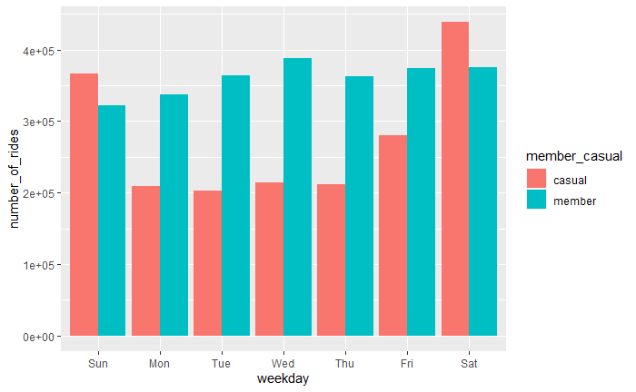

Graph 1 - Number of riders by rider type by day of the week.

The average ride duration is much higher on rides taken by casual riders, independently of the day of the week.

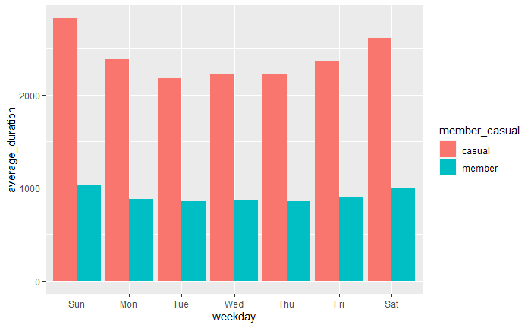

Graph 2 - Average ride length by user type by day of the week.

We can also see that while both types of users prefer the docked bikes, the difference is bigger on casual riders.

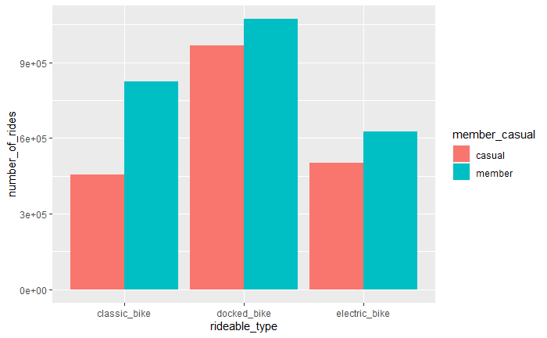

Graph 3 - Rideable type by member type.

# Final Recommendations

Based on our findings, some interesting steps to take on our marketing campaign would be:

* Helping casual riders acknowledge the mobility advantages of weekday usage of our service and the benefits of a membership for a daily usage;
* Helping casual riders acknowledge the mobility advantages of our service for shorter distances and how a membership would ensure the best cost/benefit relationship;
* Helping casual riders acknowledge that a membership would enable the easier use of other rideable types and, at the same time, reinforce our docked availability and network.