|  |
| --- |
| Software Requirements  Specification |
| Library Activity Management |

Barbu Mihai-Alexandru

1. Specific Requirements …………………………………………………………

1.1 External Interface Requirements ………………………………………

1.1.1 User Interfaces ………………………………………………..

1.1.2 Hardware Interfaces ………………………………………….

1.1.3 Software Interfaces ……………………………………………

1.1.4 Communication Interfaces ………………………………………

1.2 System Features and Functional Requirements ………………………..

1.3 Performance Requirements ……………………………………………..

1.4 Design Constraints ……………………………………………………..

1.5 Software System Attributes …………………………………………….

**1. Specific Requirements**

This section contains all of the functional and quality requirements of the system. It gives a detailed description of the system and all its features.

**1.1 External Interface Requirements**

This section provides a detailed description of all inputs into and outputs from the system. It also gives a description of the hardware, software and communication interfaces and provides basic prototypes of the user interface.

**1.1.1 User Interface**

When the user first enters the page, they should see the log-in page, see Figure 1. If they don’t currently own an account, they can easily make one by clicking New Account and are taken to the registration page, see Figure 2, where they complete with their data and then they can access the main page, see Figure 3.

From here, the user can look for the book that they want to borrow\loan by typing its title in the search bar. When the user finds the book that they desire, they are taken to the Book’s page, see Figure 4, where they can see additional information about it as well as the loan option. When they click it, it will send them to the checkout page, see Figure 5, where they will be notified that their book is waiting for them for pickup.

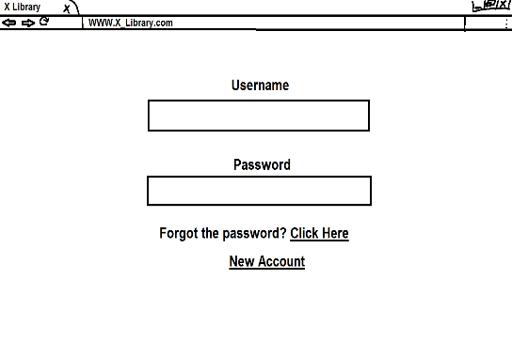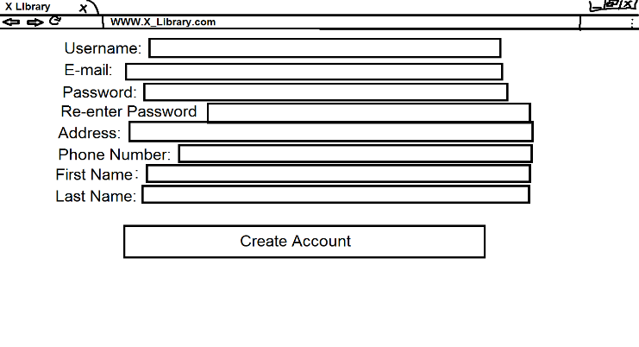

Figure 1 – Login Figure 2 – Registration Page

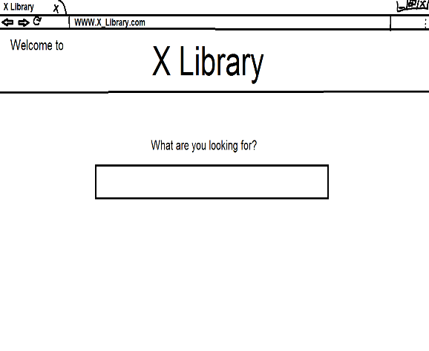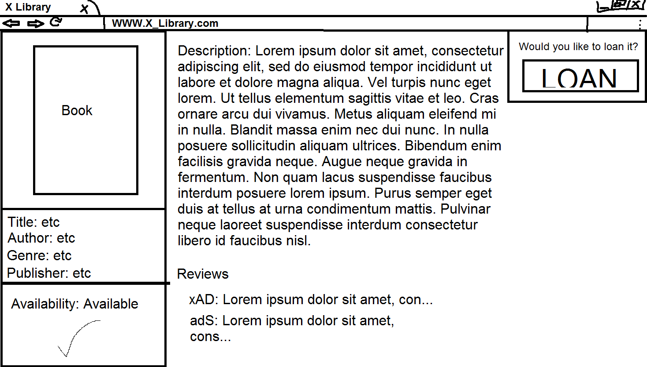

Figure 3 – Main Page Figure 4 - Book Page

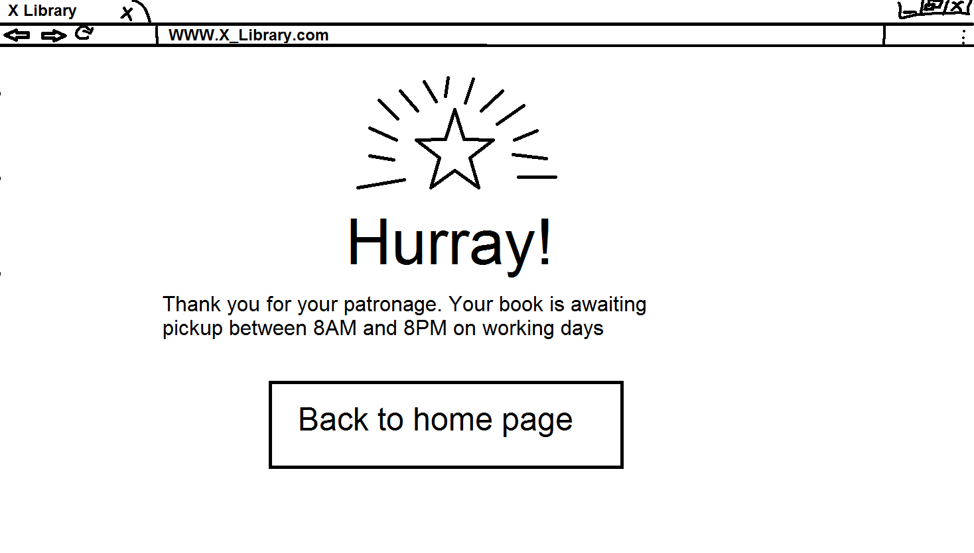

Figure 5 – Checkout

**1.1.2 Hardware Interfaces**

The website itself doesn’t have any designated hardware, hence it does not have any direct hardware interfaces. It will function on the hardware of the administrator’s computer.

**1.1.3 Software Interfaces**

The communication between the software interface, the database and the web portal is handled through the operating system of the administrator.

**1.1.4 Communication Interfaces**

Not applicable, see the previous point.

**1.2 System Features and Functional Requirements**

This section includes the features and requirements that encapsulate and specify the behavior of the system.

**1.2.1 User Login**

DESC: A simple interface for the user to identify themselves

FR: I. User must provide a valid username;

II. User must provide a valid password;

III. If both username and password are valid, user is taken to the main page;

IV. If either password and/or username is invalid, user is notified through an on-screen message that the password or username is invalid and is advised to rewrite them.

**1.2.2 User Registration**

DESC: The method by which an user account is made

FR:I. The “new account” button takes the user to the authentication page

II. Username section is used to introduce the wanted username of user

III. E-mail section is used to introduce the e-mail of user

IV. Password section is used to introduce the password of user

V. Re-enter Password section is used to reintroduce the password of user

VI. Address section is used to introduce the address of user

VII. Phone number section is used to introduce the phone number of user

VIII. First Name section is used to introduce the first name of user

IX. Last Name section is used to introduce the last name of user

X. When all the boxes have been completed, and the user clicks create account, the account will be created and the user will be able to connect to their account.

**1.2.3 Search Bar**

DESC: The method by which a user searches for the desired book

FR: I. User writes the title of the desired book  
 II. If the book doesn’t exist in the library’s inventory, nothing will appear on the screen

III. If the book does exist in the library’s inventory, it will appear in a drop down list