Software Design Document (SDD) Template

Software design is a process by which the software requirements are translated into a representation of software components, interfaces, and data necessary for the implementation phase. The SDD shows how the software system will be structured to satisfy the requirements. It is the primary reference for code development and, therefore, it must contain all the information required by a programmer to write code. The SDD is performed in two stages. The first is a preliminary design in which the overall system architecture and data architecture is defined. In the second stage, i.e. the detailed design stage, more detailed data structures are defined and algorithms are developed for the defined architecture.

This template is an annotated outline for a software design document adapted from the IEEE Recommended Practice for Software Design Descriptions. The IEEE Recommended Practice for Software Design Descriptions have been reduced in order to simplify this assignment while still retaining the main components and providing a general idea of a project definition report. For your own information, please refer to [IEEE Std 1016­1998](http://www.cs.concordia.ca/~ormandj/comp354/2003/Project/ieee-SDD.pdf)1 for the full IEEE Recommended Practice for Software Design Descriptions.

1 <http://www.cs.concordia.ca/~ormandj/comp354/2003/Project/ieee>­SDD.pdf

# Team Barbu, Chitibura, Cioroboiu

# The Management of a Library’s activity

# Software Design Document

Name (s):

Lab Section: Workstation:

Date: (mm/dd/yyyy)

**TABLE OF CONTENTS**

1. INTRODUCTION 2
   1. Purpose 2
   2. Scope 2
   3. Overview 2
   4. Reference Material 2
   5. Definitions and Acronyms 2
2. SYSTEM OVERVIEW 2
3. SYSTEM ARCHITECTURE 4
   1. Architectural Design 4
   2. Decomposition Description 4
   3. Design Rationale 4
4. DATA DESIGN 5
   1. Data Description 5
   2. Data Dictionary 6
5. COMPONENT DESIGN 7
6. HUMAN INTERFACE DESIGN 6
   1. Overview of User Interface 6
   2. Screen Images 8
   3. Screen Objects and Actions 8
7. REQUIREMENTS MATRIX 9
8. APPENDICES 9

### INTRODUCTION

## Purpose

The purpose of this document is to give a detailed description of the requirements for the “Activity management for a library” project. It will illustrate the purpose and complete declaration for the development of the system. It will also explain system constraints and interface.

## Scope

The project’s scope is developing of a software system for a library’s activity management’s process automatization:

- collecting of data related to available books;

- management of clients’ data;

- generating reports;

- providing information through a web portal;

- system interrogation;

- management of the document flow for making reservations

## Overview

Provide an overview of this document and its organization.

## Reference Material

http://aman.ro/

## Definitions and Acronyms

Not applicable.

### SYSTEM OVERVIEW

The system will consist of a login feature to accommodate the library’s readers, along with the availability and list of books the library has to offer. Each user will have an account through which they can borrow books on their name.

Since this is a data-centric product it will need somewhere to store the data. For that, a database will be used.

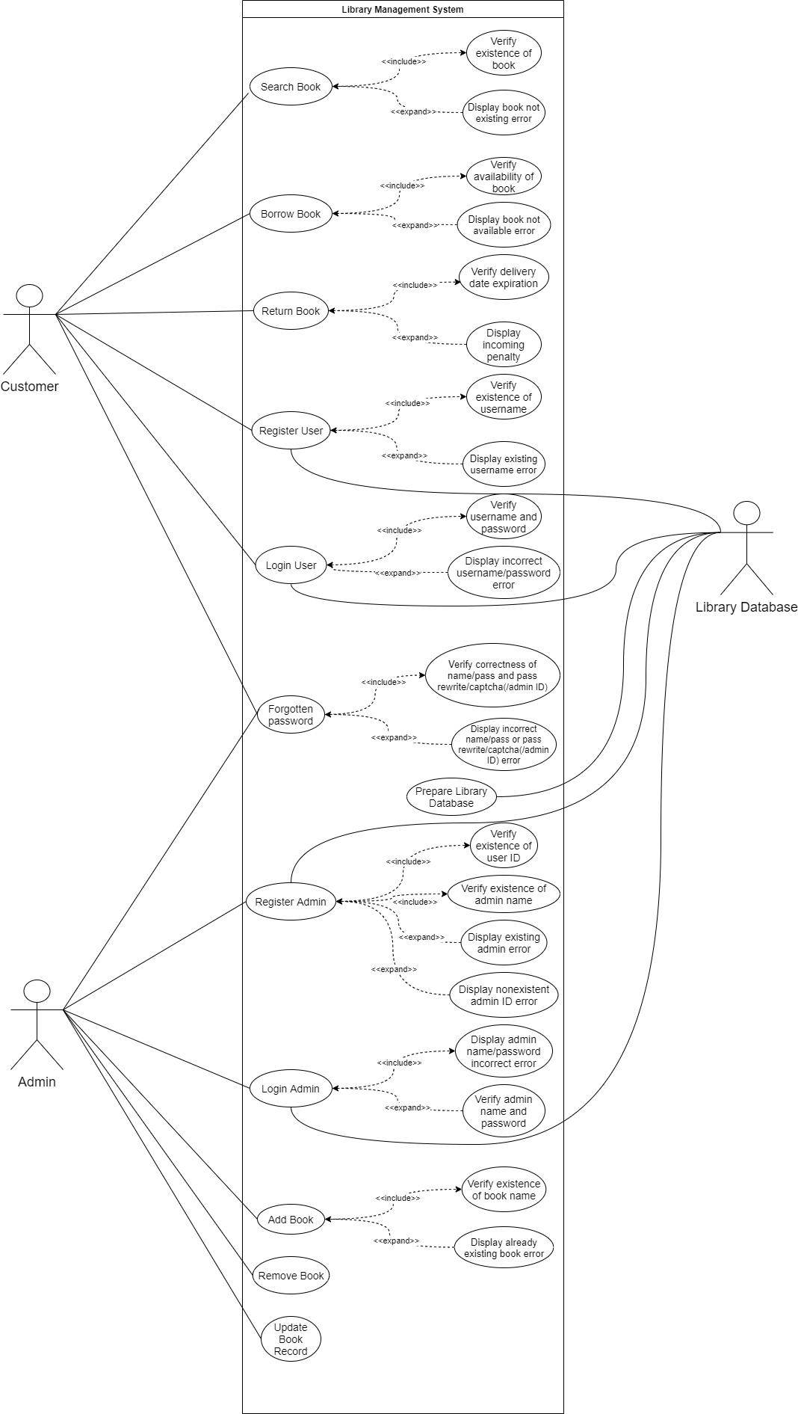

### SYSTEM ARCHITECTURE

## Architectural Design

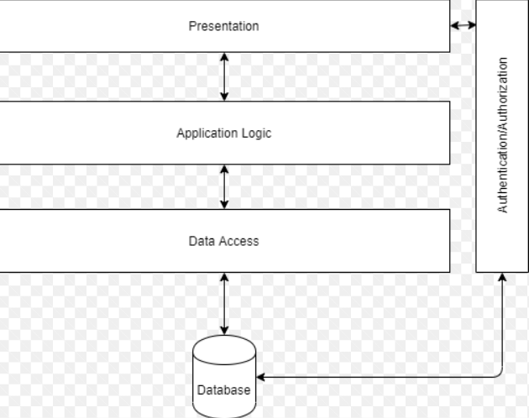

## Decomposition Description

Not applicable.

## Design Rationale

The design will have 3 main parts;

1. The web application used by the customer to register, log in, shearch and borrow books;
2. A desktop application used by the administrator to input books data. Remove/add books and get reports;
3. The Database and API used to comunicate with the 2 applications;

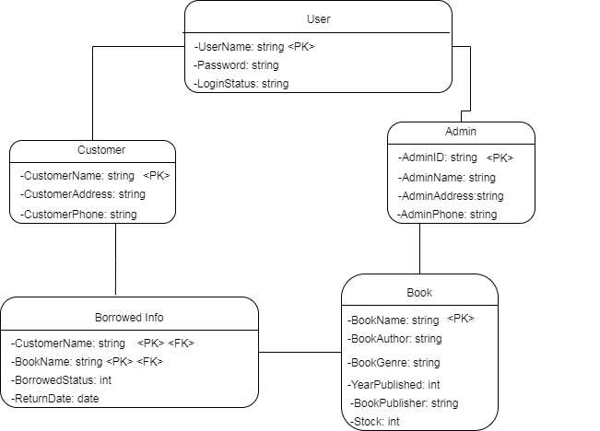

### DATA DESIGN

## Data Description

The data used throughout the system consists mainly of data coming from the database, namely its various object tables such as “Book”, “User”, “Inventory” etc. This data is stored, processed and organized using SQL Server Management.

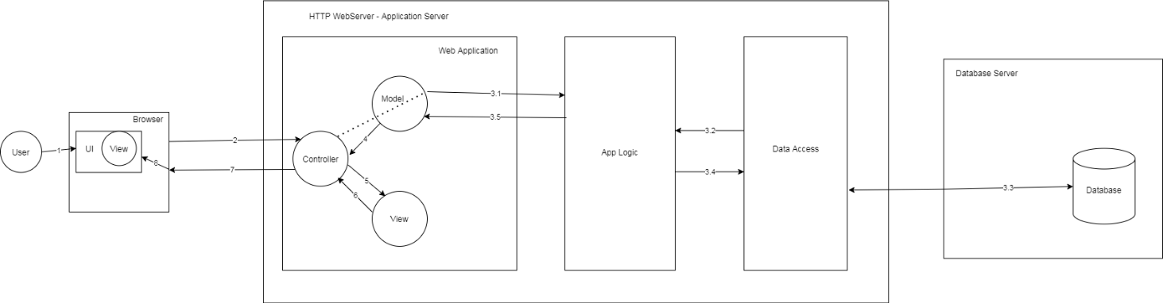

## Data Dictionary

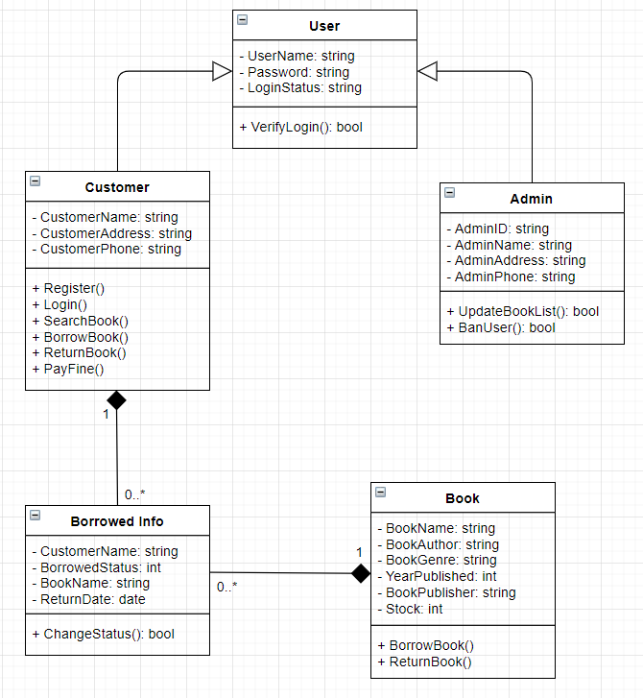

### COMPONENT DESIGN

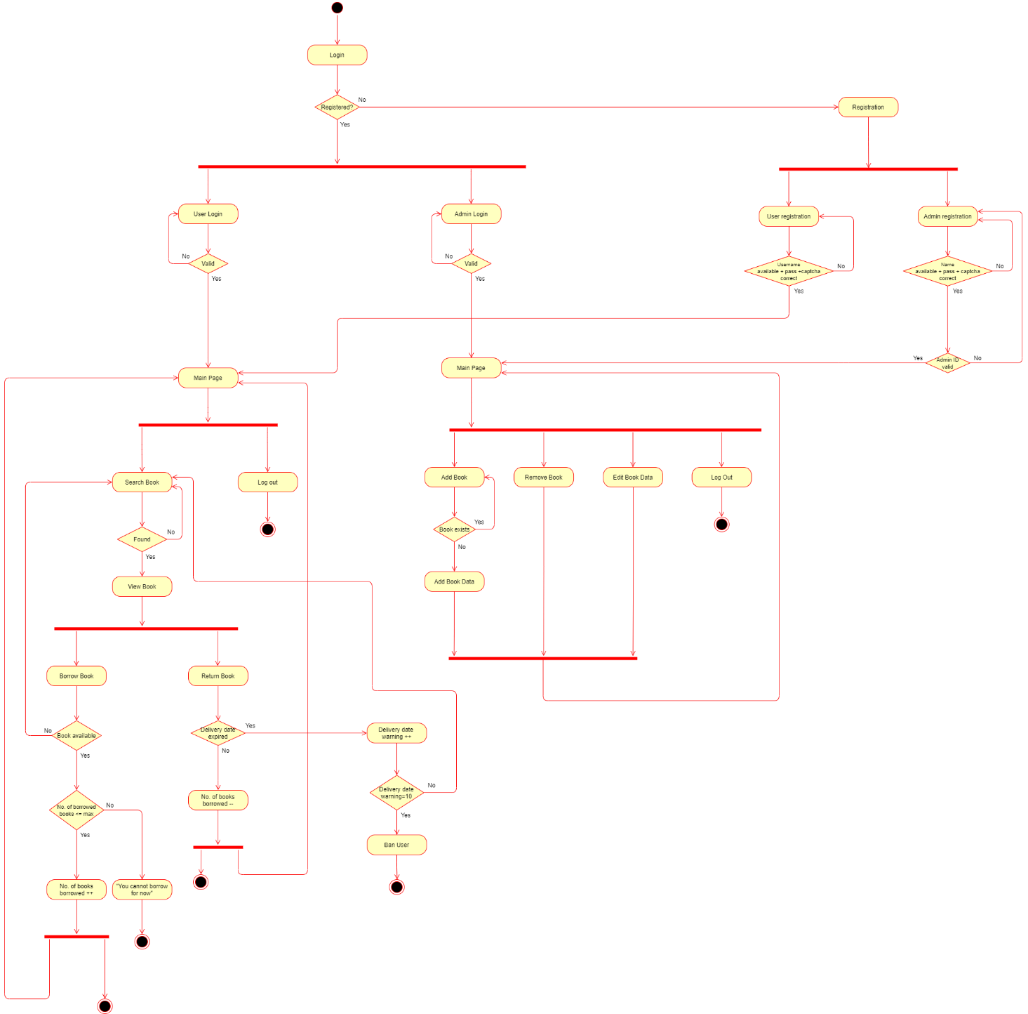

### HUMAN INTERFACE DESIGN

## Overview of User Interface

When the user first enters the page, they should see the log-in page, see Figure 1. If they don’t currently own an account, they can easily make one by clicking New Account and are taken to the registration page, see Figure 2, where they complete with their data and then they can access the main page, see Figure 3.

From here, the user can look for the book that they want to borrow\loan by typing its title in the search bar. When the user finds the book that they desire, they are taken to the Book’s page, see Figure 4, where they can see additional information about it as well as the loan option. When they click it, it will send them to the checkout page, see Figure 5, where they will be notified that their book is waiting for them for pickup.

## Screen Images

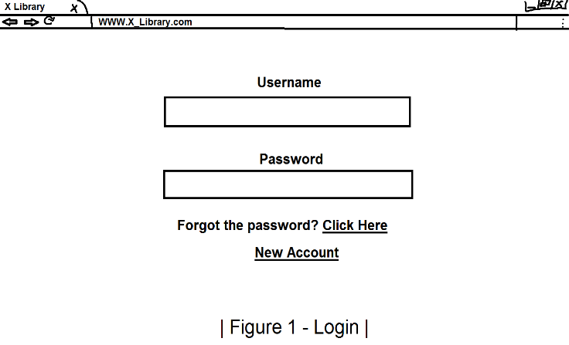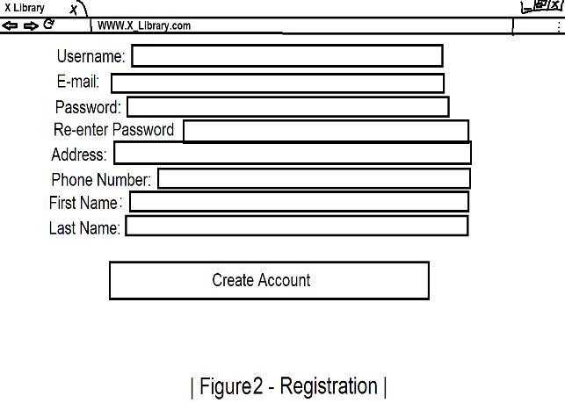

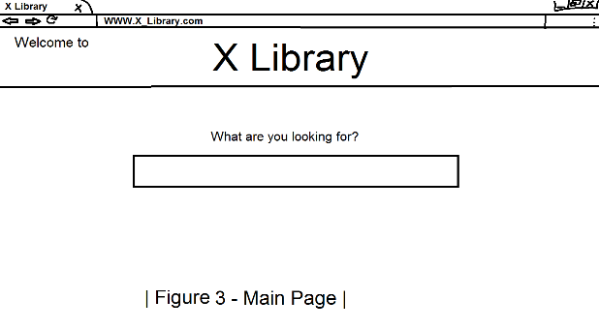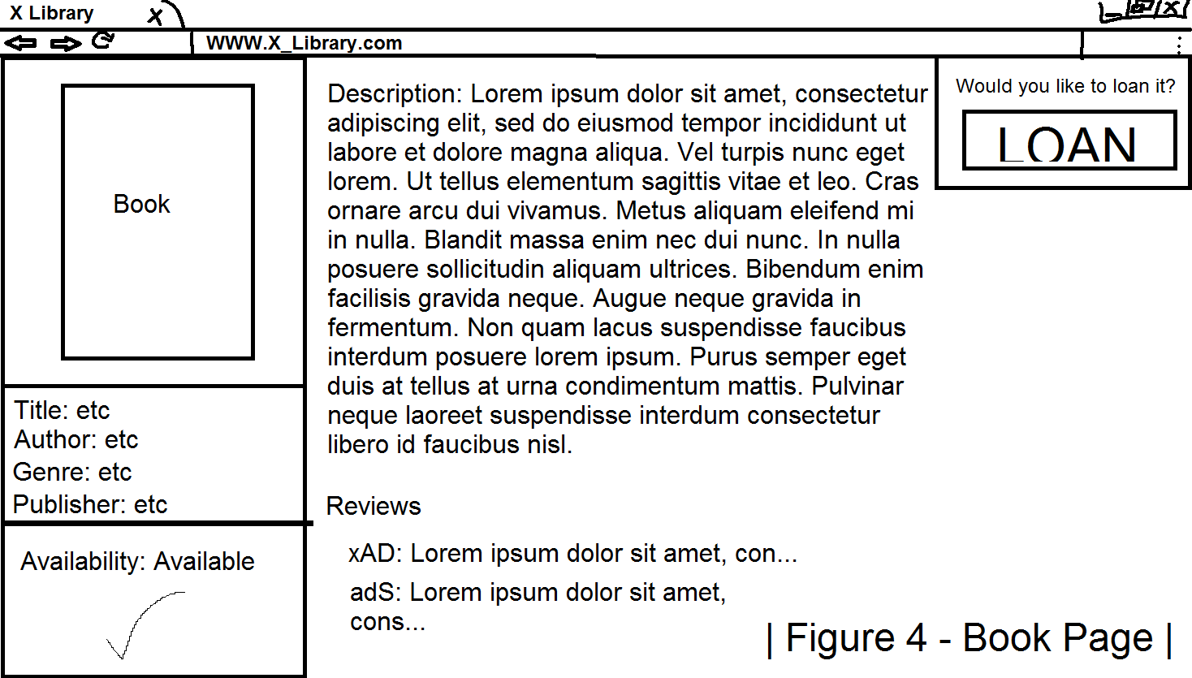

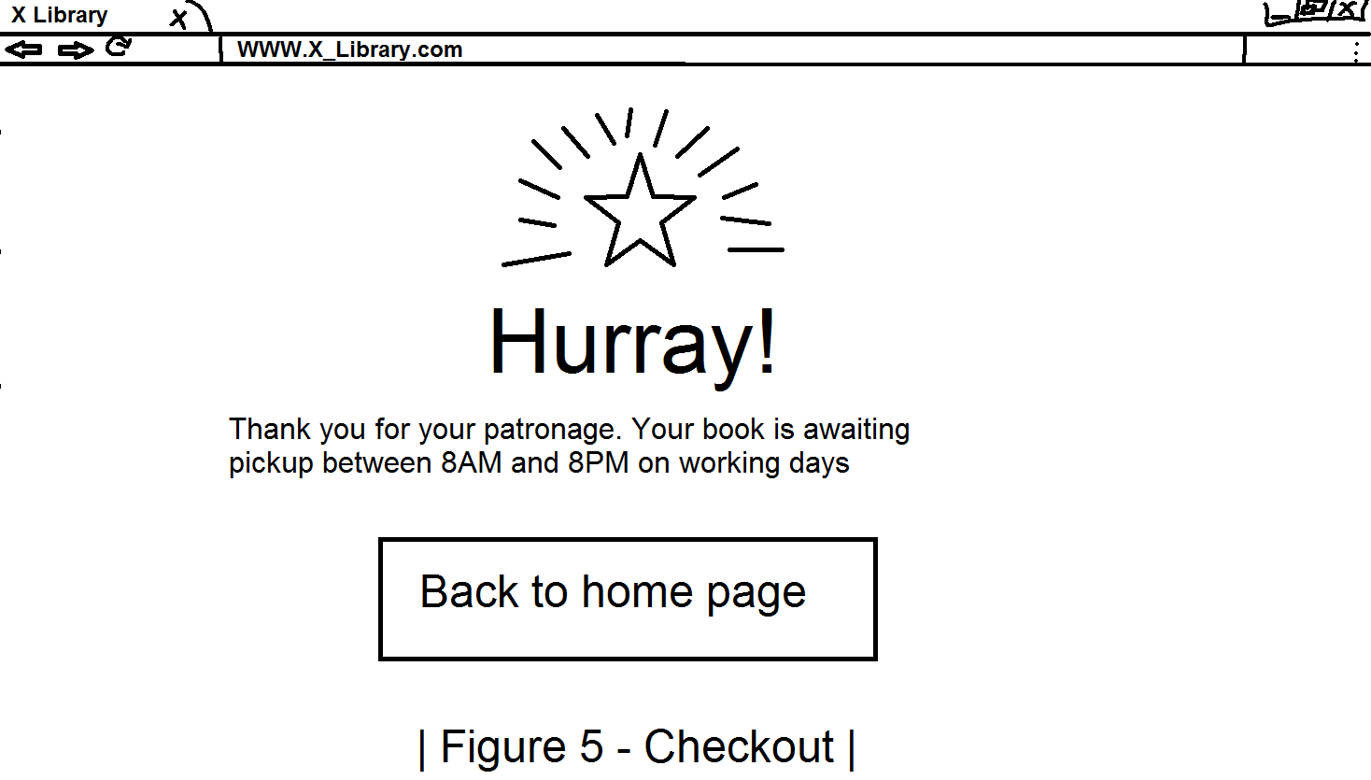

## Screen Objects and Actions

The main screen objects are buttons which direct the user to the specified path.

### REQUIREMENTS MATRIX

### APPENDICES