Software Requirements Specification
for
The Management of a Library’s activity
Version 1.0 approved
Prepared by Barbu Mihai-Alexandru, Chitibura Tiberiu-Gabriel, Cioroboiu Catalin-Petrisor
09.03.2021
Table of Contents
Table of Contents ii
Revision History ii
1. Introduction 1
1.1 Purpose 1
1.2 Document Conventions 1
1.3 Intended Audience and Reading Suggestions 1
1.4 Product Scope 1
1.5 References 1
2. Overall Description 2
2.1 Product Perspective 2
2.2 Product Functions 2
2.3 User Classes and Characteristics 2
2.4 Operating Environment 2
2.5 Design and Implementation Constraints 2
2.6 User Documentation 2
2.7 Assumptions and Dependencies 3
3. External Interface Requirements 3
3.1 User Interfaces 3
3.2 Hardware Interfaces 3
3.3 Software Interfaces 3
3.4 Communications Interfaces 3
4. System Features 4
4.1 System Feature 1 4
4.2 System Feature 2 (and so on) 4
5. Other Nonfunctional Requirements 4
5.1 Performance Requirements 4
5.2 Safety Requirements 5
5.3 Security Requirements 5
5.4 Software Quality Attributes 5
5.5 Business Rules 5
6. Other Requirements 5
Appendix A: Glossary 5
Appendix B: Analysis Models 5
Appendix C: To Be Determined List 6

Revision History
Name | Date | Reason For Changes | Version

Introduction

Purpose
The purpose of this document is to give a detailed description of the requirements for the “Activity management for a library” project. It will illustrate the purpose and complete declaration for the development of the system. It will also explain system constraints and interface.

Document Conventions
This report has default margins (1 inch), 1-line spacing, font Times of size 12.

Intended Audience and Reading Suggestions
This document is intended for the following audiences:
- users;
- administrators;
- developers;

The project will feature some particular terms, such as:
- USER – someone who interacts with the library’s website;
- Admin/Administrator – system administrator who is given specific permission for managing and controlling the system;
- Web Portal – a web application which presents the library along it’s products;
Also, we have technical terms, namely abbreviations from elements used in the project’s making:
- CSS = Cascading Style Sheets
- HTML = Hypertext Markup Language
- HTTP = Hypertext Transport
- DB = Database
- SQL = Structured Query Language
- IDE = Integrated Development Environment
- RAM = Random Access Memory

Product Scope
The project’s scope is developing of a software system for a library’s activity management’s process automatization:
- collecting of data related to available books;
- management of clients’ data;
- generating reports;
- providing information through a web portal;
- system interrogation;
- management of the document flow for making reservations

References
www.aman.ro

Overall Description

Product Perspective
The system will consist of a login feature to accommodate the library’s readers, along with the availability and list of books the library has to offer. Each user will have an account through which they can borrow books on their name.
Since this is a data-centric product it will need somewhere to store the data. For that, a database will be used.

Product Functions
On the library’s website, users will be able to search for preferred books, and depending on their availability, reserve an exemplary based on their log-in account. The result of the search will be viewed in a list view. The books will be sought by their names.

User Classes and Characteristics
There are two types of users that interact with the system: registered users and administrators.
Users will only be able to search for a book, reserve an exemplary, whereas administrators will also be able to add new books or remove books to the available books list and change their properties: availability, number of copies available.

Operating Environment
Since it is basically a website, it will operate in a web browser, mainly on personal computers. It should be operational at least in Microsoft Windows 7 and above. Also, it should coexist peacefully with the web browser (Chrome), and other applications, in order to have a decent RAM usage.

The following languages will be used: HTML5, CSS3

Design and Implementation Constraints
The Internet connection represents a major constraint for the website. Since it fetches data from the database over the Internet, it is crucial that there is an Internet connection for the website to function.

IDE: Visual Studio 2019
Front-end: HTML5, CSS3, JavaScript, Bootstrap 4.6
Back-end: C Sharp, ASP.NET MVC Core 3.1
Database: SQL Server Database Management: SQL Server management 2019

User Documentation
A user manual will be provided, to help people who use the website acknowledge it’s functionalities and the way of using it properly.

Assumptions and Dependencies
One assumption about the product is that it will always be used on personal computers that have enough performance. If the PC does not have enough hardware resources available for the application, for example, RAM memory might be insufficient, there may be scenarios where the application does not work at all.

External Interface Requirements

User Interfaces

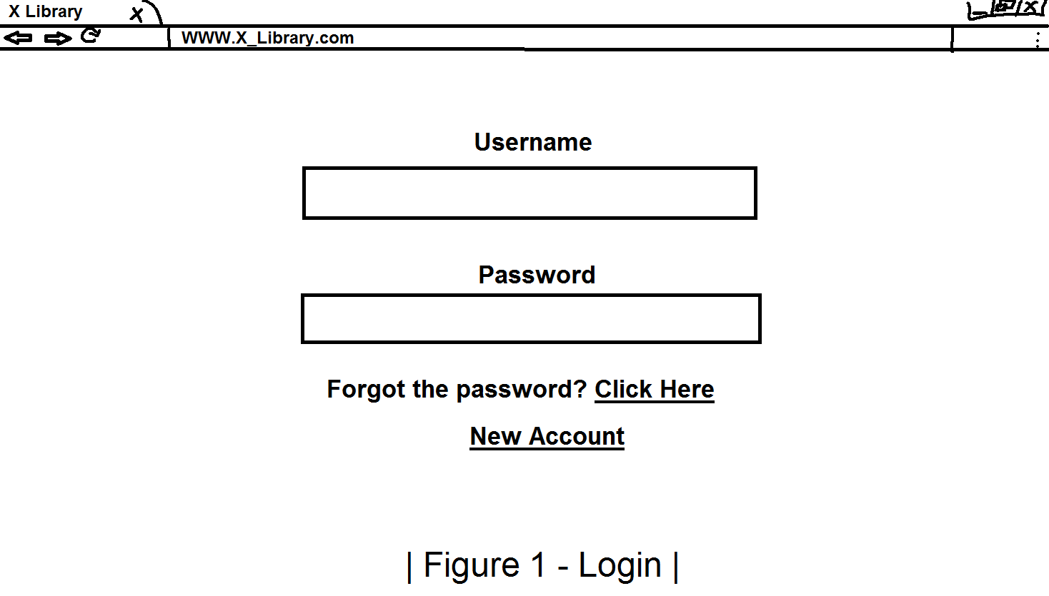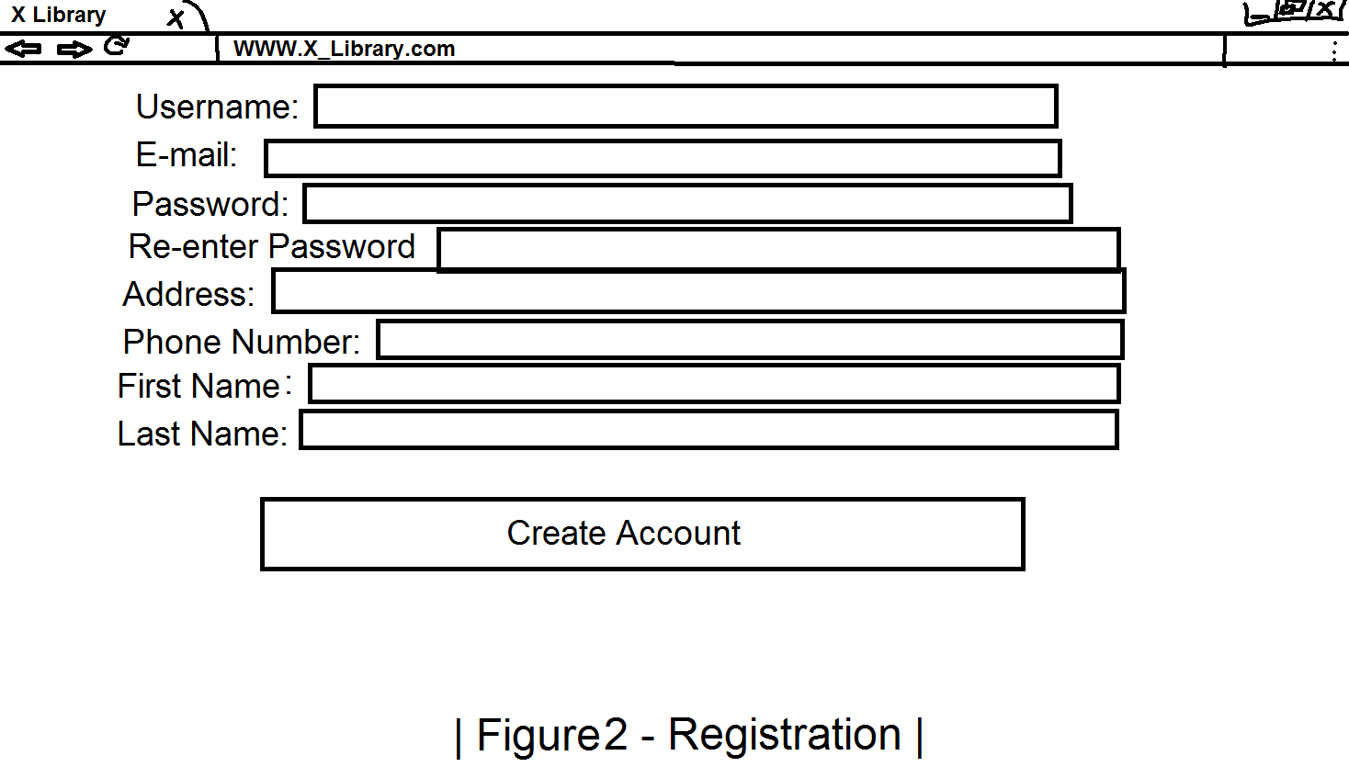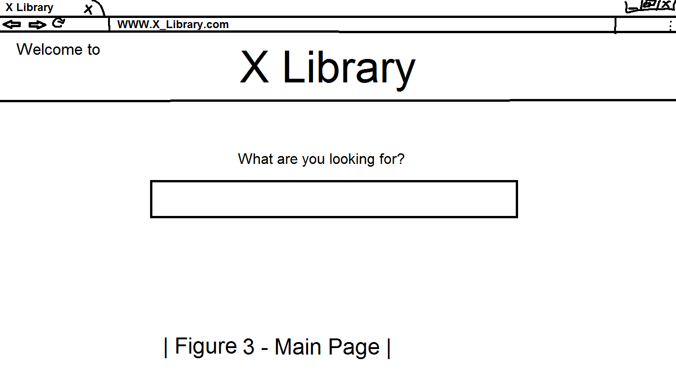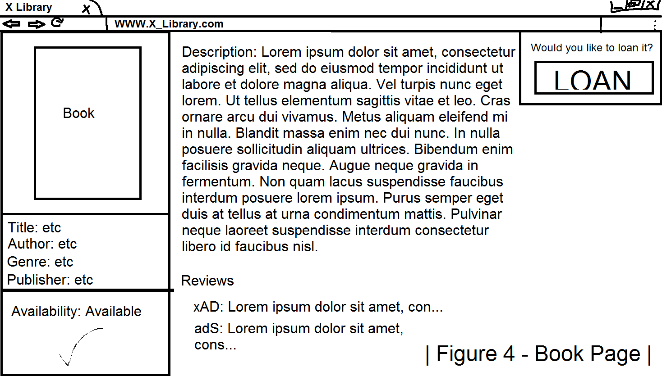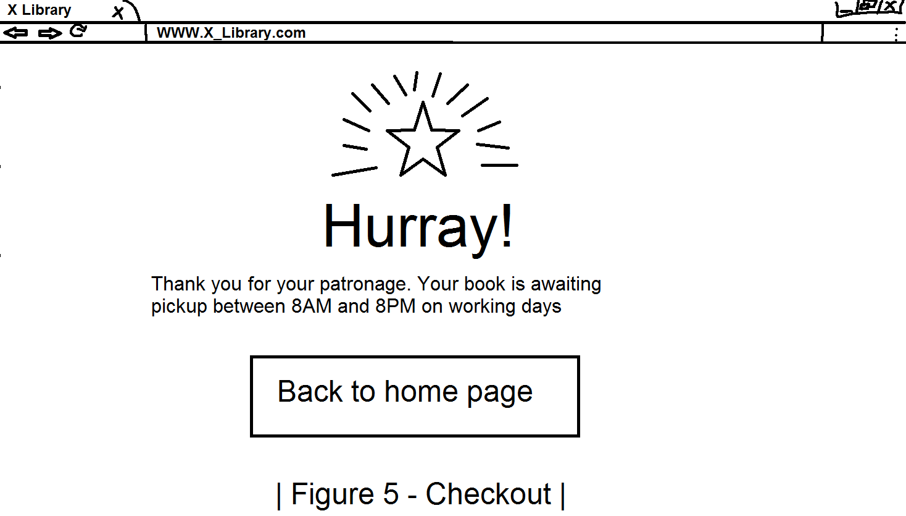
When the user first enters the page, they should see the log-in page, see Figure 1. If they don’t currently own an account, they can easily make one by clicking New Account and are taken to the registration page, see Figure 2, where they complete with their data and then they can access the main page, see Figure 3.

From here, the user can look for the book that they want to borrow\loan by typing its title in the search bar. When the user finds the book that they desire, they are taken to the Book’s page, see Figure 4, where they can see additional information about it as well as the loan option. When they click it, it will send them to the checkout page, see Figure 5, where they will be notified that their book is waiting for them for pickup.

Hardware Interfaces
Not applicable

Software Interfaces
At the core, the webpage will use a database, created using SQL, to manage all the data regarding the library branches, its customers, the books etc. and the relations between each one. The user interface will be created using HTML and CSS.

Communications Interfaces
For the communication between interfaces we will use a server for the database to store the information provided, an application server for administration of clients’ accounts and transactions and a web server to host the webpage.

HTTP communication standard will be used.

System Features

Customer Login
4.1.1 Description and Priority
A simple interface for the customer to identify themselves. High priority.

4.1.2 Stimulus/Response Sequences
Once the user has created their profile, it will be stored in the database to save their data. That way, we can better know our customers.
4.1.3 Functional Requirements
1-20:
REQ: The guest must select between the “Administrator Login” and “User Login” buttons
REQ: The “Administrator Login” prompts to a new page for administrator login.
REQ: The “User Login” prompts to a new page for user login.
REQ: The “Sign in” button on the “User Login” page prompts the user to a new page for an existing account login.
REQ: The “Sign up” button on the “User Login” page prompts the user to a new page for account creation.
REQ: The “E-mail Address” cassette is used to introduce the e-mail of the user.
REQ: An error message should alert the user when an already registered e-mail is already used in order to create a new account when creating an account on the “Sign up” page.
REQ: The “Username” cassette is used to introduce the username of the user.
REQ: An error message should alert the user when an already registered username is already used in order to create a new account when creating an account on the “Sign up” page.
REQ: The “First Name” cassette is used to introduce the first name of the user.
REQ: The “Second Name” cassette is used to introduce the second name of the user.
REQ: The “Password” cassette is used to introduce the password of the account.
REQ: The “Retype Password” cassette is used to reintroduce the password of the account.
REQ: The “Age” cassette is used to introduce the age of the user.
REQ: The “Phone Number” cassette is used to introduce the phone number of the user.
REQ: The “Create account” button grants access to the new account just created by the user.
REQ: If the mandatory fields are not completed (Username, E-mail Address, Password, Retype Password) or are partially completed, pressing “Create Account” will not create the new account, but show error “This field is mandatory” beside the empty mandatory fields.
REQ: An error message should alert the user when a username used for logging in does not exist or is not correct on the “Sign in” page.
REQ: An error message should alert the user when a password used for logging in is not correct on the “Sign in” page.
REQ: Once logged on the website, on the main page there will be a link, “Log out”, which will lead to the page that requires the user to choose between Administrator and User logins.

Navigation/Search Bar
4.2.1 Description and Priority
A simple way for the user to search for the book they want. High Priority
4.2.2 Stimulus/Response Sequences
When the user clicks the category bar, it will drop down a list of all the categories of books where they will be able to choose the desired one. There will also be a search bar to directly look for the required book.
4.2.3 Functional Requirements
21-27:
REQ-21: The “Search” cassette will give users to ability to seek for desired books, based on their name.
REQ: An error message saying “The book could not be found” will be shown if the input from the “Search” cassette matches none of the existing entries.
REQ: The correct correspondence between the user input from the “Search” cassette and the entries’ name will lead to the list of the sought-for books being displayed
REQ: In the list of corresponding entries, users can click on the books’ links to have an insight on the details of books, their availability
REQ: Using the “Reserve book” button on the separate page of each book, the user can reserve the book.
REQ: If there are no available books left, pressing “Reserve book” will show the error message: “There are no exemplaries of this book left. Please wait until further availability of this book.”

Internal Links
4.3.1 Description and Priority
A path to a certain book’s Wikipedia page. High Priority.
4.3.2 Stimulus/Response Sequences
When the user clicks the hyperlink, they will be directed to the Wiki page of the respective book, for further insight.
4.3.3 Functional Requirements

28-50:
REQ: Administrator Login link
REQ: User Login link
REQ: Log out link
REQ: Change Username link, which is a link that leads to a page where the user has to input the new username, and also the password
REQ: “Sign up” link
REQ: “Sign in” link
REQ: “I forgot the password” link, which will lead to a page that requires the user to type and retype a new password
REQ: “View profile” link to see user’s details, number of books borrowed
REQ: “Change password” link in the “View profile” page which functions as “I forgot password”, but also requires the user to type the old password
REQ: “View profile” but for administrator accounts only, to see admin’s details and books borrowed
REQ: “Add, remove, or edit books” button to add or remove books from the library, which leads to a page where the admin can choose one of the two links, , available to administrators only
REQ: “Remove book” button to delete the book from the website, available for administrators only
REQ: “Add book” link to add a new book to the website, which leads to a separate page with the following mandatory fields to complete: name, author, number of available exemplaries, available to administrators only
REQ: “Edit books” link to edit info of existing books, which leads to a page that displays, in a list, all the books in the library, available to administrators only
REQ: Each book entry in the “Edit books” link will be link to the separate page of that book, where the administrator can edit it’s info

Other Nonfunctional Requirements

Performance Requirements
The web application will use a maximum of 2 gigabytes (GB) of RAM memory. It’s loading time will have a variation between 0.05ms and 60s. These performance requirements are deemed only when the required software has it’s versions up-to-date.

Safety Requirements
Not applicable.

Security Requirements
Users’ data will be protected using the logging-in by a Username and Password feature.

Software Quality Attributes
- code indentation: always use 2 spaces for indentation of hierarchical parts of code
- line length < 80: for readability, lines longer than 80 characters will be avoided
- global variables written in uppercase
- variable and function names written as: “bookStore”
- constants like “PI” written in uppercase
- code spacing
- avoiding variable types’ names when naming variables
- only one declaration per line
- statements on separate lines
- only lowercase letters for html coding

Business Rules
Do not make any business with unidentified individuals – if they don’t have an identity card or anything similar to that.

Any damaged sustained by the merchandise will be paid by the one who damaged it (excluding the owner of the merchandise)

Other Requirements
Any merchandise given to the business will belong to the business permanently – so if any merchandise is damaged or lost the business will get the money from the recipient.
Appendix A: Glossary
Not applicable
Appendix B: Analysis Models
Not applicable
Appendix C: To Be Determined List
A user manual will be provided, to help people who use the website acknowledge it’s functionalities and the way of using it properly.

