Emmanuel Cardenas Jacky Salas
Godija Ghaniem
Natalie Tapia
John Goohan
Simple Harmonic’s Motion
Purpose:
To investigate what angles are more likely to fall into simple harmonics.
Procedure:
- Starting at a small angle find the time it takes the pendulum to oscillate 10 times.
- Calculate the period.
- Increase the angle in small increments and repeat the two steps above.
- Once there is enough data graph a period vs angle chart.
- Add more mass to the pendulum system and repeat the above steps.
Results:
T_{i} = 2π$\sqrt{\frac{L}{g}}$ T_{F} = time / 10
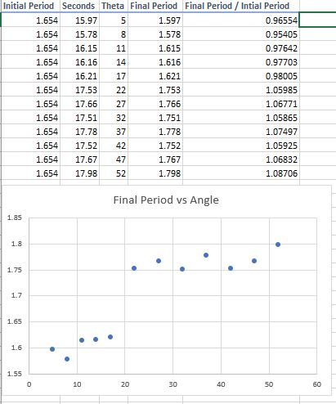
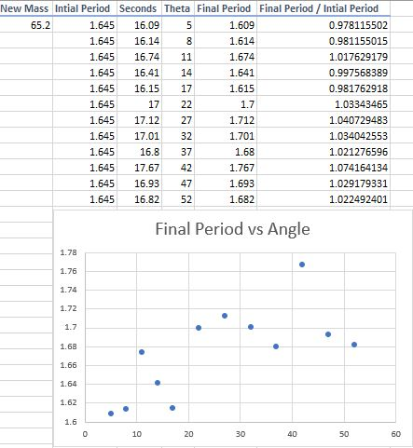
Conclusion:
In our first experiment you can see a big jump in the experimental period when theta reaches 22 degrees and up. At 17 degrees you can see that we were off by 2% in the theoretical value for the period. In the second experiment when we increased the mass, I believe the values we got are somewhat like the first experiment but due to being in a hurry we may have made some errors in the timing and measurements, got us some different result. However even with the different results you can tell from the graphs that there is a resemblance, especially where there was a jump at 22 degrees which would mean that changing the mass had no effect.

