Enhancing the Customer Experience of

British Airways (2016-2023)

*1.**Problem Statement*

British Airways, once emblematic of premium air travel, is grappling with a noticeable decline in customer satisfaction. This report examines passenger feedback over the past several years to identify the root causes of dissatisfaction and offer data-driven solutions to reinstate the airline’s esteemed reputation and market competitiveness.

*2. Objective*

This analysis aims to:

* Assess the overall customer satisfaction based on feedback from 1324 valid reviews between 2016 and 2023.
* Analyze customer feedback specifically regarding cabin staff service, highlighting strengths and identifying areas for improvement.
* Scrutinize key performance indicators such as seat comfort, food quality, and in-flight entertainment provisions.
* Formulate strategic, insightful recommendations to refine service excellence, foster enduring customer loyalty, and elevate both recommendation indices and brand preeminence.

*3. Data Overview*

* Data Source: Customer reviews from online platforms and direct feedback from British Airways passengers.
* Data Volume: 1324 valid customer reviews gathered between 2016 and 2023.
* Key Metrics: header, author, date, place, content, aircraft, traveler type, route, date flown, recommended, trip verified, rating, seat comfort, cabin service, food quality, ground service, ground service, value for money, entertainment.
* Segmentation: Data was segmented by seat type, traveler type, aircraft group
* Analytical Tools: Data was analyzed using Power BI for visualizing trends and identifying key insights.
* Data Quality: 100% of the records were found to be correctly formatted - complete and clean, with no missing data.

*4. Methodology*

4.1 Data Preparation:

* Cleaning: No duplicate records indicating a high level of data integrity. This allowed for accurate analysis without skewed results.
* Transformation: No inconsistencies were found. The data was carefully transformed to ensure consistency and alignment with analytical needs using Power Query in Power BI*.*

4.2  Analytical Methods:

* Descriptive Analysis: Key metrics like seat comfort, cabin service, and entertainment were analyzed using custom DAX measures. These measures calculated counts and averages, allowing for a comprehensive view of service satisfaction. For example, Seat Comfort and Entertainment ratings were handled with the USERELATIONSHIP function to activate inactive relationships in the data model.
* Segmentation Analysis: Feedback was segmented by seat type (Economy, Business, First) and traveler type (solo, family, business) to uncover trends in customer satisfaction across different groups.
* Correlation Analysis: I explored relationships between key variables, like seat comfort and recommendation likelihood, using DAX to calculate averages and correlations.
* Trend Analysis: Yearly trends (2016–2023) in service satisfaction were analyzed to identify periods of decline and service gaps.
* Comparative Analysis: Satisfaction levels were compared across demographics, flight routes, and service categories using DAX measures to assess performance disparities.

1. *Findings*

5.1 Customer Feedback and Overall Rating

British Airways faces a significant challenge in customer satisfaction. The airline's average overall satisfaction rating of **4 out of 10** falls considerably short of expectations for a premium air travel provider, signaling a substantial disconnect between the promised and delivered customer experience. This dissatisfaction is further amplified by the fact that a clear majority of passengers (56.8%) indicated they would not recommend British Airways. This low recommendation rate—a crucial metric in the airline industry—presents a serious threat to the airline's reputation and future growth, as positive word-of-mouth is a powerful driver of customer acquisition and brand loyalty. The combination of a low satisfaction score and a high percentage of detractors underscores the urgent need for British Airways to address these customer concerns.

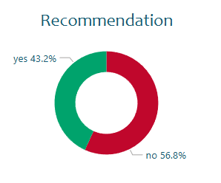

5.2 In-Flight Experience: Key Areas for Improvement

A detailed analysis of individual service categories reveals specific areas of concern within the in-flight experience:

* Entertainment**:** In-flight entertainment emerges as a critical weakness, receiving an average rating of just 1 out of 5. The prevalence of negative (-1) ratings in this category suggests widespread customer disappointment rather than simply a lack of usage. This indicates a need for substantial investment and improvement in the entertainment offerings.
* Food Quality: Food quality is another significant area of concern, with an average rating of only 2 out of 5. This low score, coupled with the poor entertainment rating, points to a broader issue with the in-flight experience failing to meet customer expectations.
* Seat Comfort: While not as severely criticized as entertainment or food, seat comfort received an average rating of 3 out of 5. This score, while seemingly moderate, is still a notable weakness, particularly given the importance of comfortable seating for passenger satisfaction on both short and long-haul flights.
* Cabin Crew Service: The average rating of 3 out of 5 for cabin crew service suggests a moderate level of satisfaction. While not a primary driver of dissatisfaction, improvements in this area could contribute to a more positive overall customer experience.
* Ground Service: Similar to cabin crew service, ground service received an average rating of 3 out of 5 indicating a moderate level of satisfaction with room for improvement.
* Value for Ticket Price: The average rating of 3 out of 5 for value for ticket price suggests that customers do not perceive the current offerings as justifying the cost. This perception is likely influenced by the shortcomings in other service categories, especially entertainment, food quality, and seat comfort.

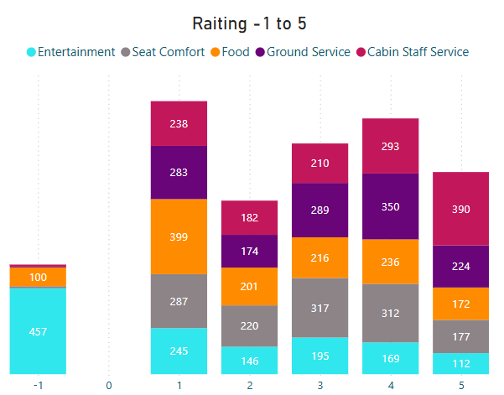

5.3 Customer Segmentation and Trend Analysis

* Seat Type: Economy Class passengers, who represent the largest segment of British Airways' customer base (55% of reviews), frequently cited seat comfort as a major concern. Addressing this issue in Economy Class would have the broadest positive impact on overall customer satisfaction. While Business and First Class passengers reported higher satisfaction with food quality and seat comfort, the smaller sample size in these segments suggests that improvements, while valuable, would not have as widespread an effect.

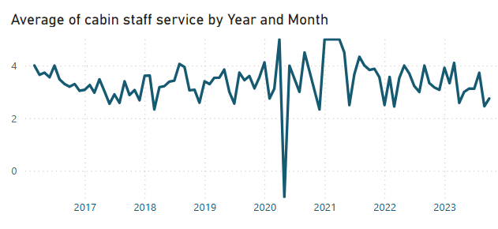

* Flight Routes: The Johannesburg to London and London to Cape Town routes were among the most frequently reviewed. Further analysis of customer feedback specific to these high-volume routes could reveal targeted opportunities for service enhancements.
* Geographical Trends: A clear regional disparity exists in customer ratings. European and North American travelers consistently reported higher satisfaction levels than passengers from Africa and Asia. This highlights the need for regionally tailored service strategies that address specific cultural expectations and potential service delivery inconsistencies.
* Yearly Trends: Customer satisfaction levels remained relatively stable from 2019 to 2021. However, a significant decline occurred between 2022 and 2023, particularly in food quality and seat comfort. This decline likely reflects operational challenges and service disruptions experienced in the post-pandemic recovery period.

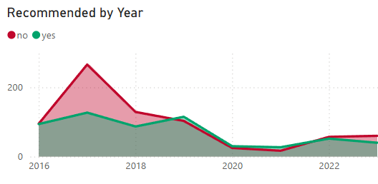

*6. Recommendations*

6.1 Enhance Seat Comfort for Economy Class

Between 2025 and 2026, British Airways must revolutionize its seating. Short-haul routes demand slimline, ergonomic seats, while long-haul flights require memory foam cushioning, adjustable headrests, and deeper reclines for lasting comfort. Premium cabins should feature lie-flat seats, privacy dividers, and luxury materials for unparalleled exclusivity.

Technology like seatback entertainment and charging ports must become standard across all cabins. Lightweight, sustainable materials will reduce fuel consumption, balancing passenger comfort with environmental goals. This transformation ensures a world-class seating experience, blending efficiency, innovation, and luxury.

6.2 Improve Food Quality Across All Classes

By 2025, British Airways should make in-flight dining a top priority. Collaborating with celebrated chefs to create an array of refined, diverse menus, offering inclusive dietary options, and utilizing locally sourced, sustainable ingredients will significantly enhance the culinary experience. The integration of intuitive meal ordering systems, alongside real-time passenger feedback, will enable further personalization. This strategy will redefine the airline dining experience, establishing a new benchmark for quality and sophistication in air travel cuisine.

6.3 Boost Recommendation Ratio

By 2027, British Airways must prioritize boosting its recommendation ratio through customer-centric initiatives. Establishing an elite loyalty program, offering bespoke rewards for frequent travelers, and incentivizing customer referrals will nurture deeper engagement and advocacy. Integrating real-time feedback mechanisms, such as in-flight surveys or mobile applications, will empower the airline to swiftly address passenger concerns and elevate service excellence. This agile responsiveness, coupled with tailored rewards for positive reviews and recommendations, will cultivate a robust customer advocacy network. By investing in these strategies, British Airways will forge enduring relationships with passengers and redefine the paradigm of customer loyalty within the aviation industry.

6.4 Empowering Cabin Crew with Cross-Cultural Expertise

British Airways has built a solid foundation with its skilled workforce, providing a strong base for exceptional service delivery. To elevate this further, the airline should focus on advanced training initiatives that refine key competencies such as customer service, conflict resolution, and emotional intelligence. Additionally, enhancing cross-cultural sensitivity will better equip cabin crew to meet the diverse expectations of passengers. Integrating AI-driven personalization tools and recognizing outstanding staff contributions will ensure more tailored and memorable experiences.

*7. Conclusion*

This evaluation of British Airways' customer experience provides explicit, evidence-based strategies to resolve key areas for improvement and revitalize the airline’s position as a market leader. By focusing on enhancements in seat comfort, food quality, and cross-cultural competence among its cabin crew, the airline can significantly augment passenger satisfaction and loyalty.

The proposals outlined in this report offer a realistic yet visionary strategic roadmap to not only resolve existing challenges but also set a new touchstone for service excellence. Strategic commitments to innovation, tailored customer experiences, and advanced staff training will strengthen British Airways to deliver exceptional value across diverse markets.

With clear goals set for 2025 to 2029, this framework aims to guide British Airways in achieving groundbreaking progress during this period, laying the foundation for enduring growth and renewed passenger trust. By embracing transformation and adaptability, British Airways is primed to craft a travel experience that strikes a chord globally, securing its heritage as a leader in modern aviation.