Phase 1 Report
Authors : Navid Naserazad – Bardia Akbari
Date : 20 September 2025

1. Introduction
- Describe what point clouds are
In 3D modeling, a point cloud is a discrete set of data points in a 3D coordinate system—commonly known as the XYZ axes. Each point represents a single spatial measurement on the object's surface. Taken together, a point cloud represents the entire external surface of an object. If the RGB value of each point is recorded, color information can also be added to the point cloud. A point cloud is created using a 3D scanner, lidar, or photogrammetry software. It can be converted into the familiar formats of mesh models, CAD models, or NURBS surface models through a process known as surface reconstruction.
Cite : https://www.gigabyte.com/Glossary/point-cloud
- Why point cloud classification + segmentation is important
خود point cloud ها به خودی خود داده های خام هستند و سیستم های هوشمند عملکرد مناسبی روی داده های خام ندارند. بنابراین پردازش point cloud ها تبدیل کردن آنها به داده های معنا دار باعث بهبود عملکرد سیستم های هوشمند می شود. در واقع classification و segmentation این داده ها باعث می شود سیستم های هوشمند بتوانند درک مناسب تری از محیط در مقایسه با استفاده از داده خام داشته باشند. در واقع point cloud classification/segmentation در تناظر با image classification/segmentation است با این تفاوت که point cloud ها 3 بعدی و تصاویر 2 بعدی می باشند.
- Applications (autonomous driving, robotics, AR/VR, etc.)
3D data arises in many application areas such as autonomous driving, augmented reality, and robotics.
Cite : Point Transformer introduction section
- State your objective:
“Our goal is to implement and improve Point Transformer or maybe some other SOTA papers for classification and segmentation.”

2. Problem Definition
Define:
ModelNet40 ) As it’s huge dataset we use ModelNet10 ( 10 category instead of 40 ) ) (https://modelnet.cs.princeton.edu/# ), ShapeNet part (https://www.kaggle.com/datasets/majdouline20/shapenetpart-dataset),
Stanford Large-Scale 3D Indoor Spaces (S3DIS) (https://sdss.redivis.com/datasets/9q3m-9w5pa1a2h), ScanNetv2 ( http://www.scan-net.org/changelog#scannet-v2-2018-06-11), ScanObjectNN (https://hkust-vgd.github.io/scanobjectnn/)
- Tasks (classification, part segmentation, scene segmentation)
Classification : طبقه بندی (کلاس بندی) شیء داده شده.
Part segmentation : قطعه بندی یا جزء بندی هر شیء ( برای مثل صندلی -> پایه، پشتی / انسان -> دست، پا ، سر)
Scene segmentation : جداسازی یا جزء بندی هر یک صحنه به اجزای مختلف ( برای مثال: عکس یک خیابان -> آدم ها، چراغ راهنمایی رانندگی، ساختمان )
- Challenges (irregularity, permutation invariance, local/global context, sparsity)
Irregularity : unlike pixels of an image, point clouds are some unordered sets which are not located regularly. Therefore some proposed approaches make them regular (voxel-based approaches) and some others don’t
permutation invariance : due to being unordered sets, any valid model needs to return the same answer for a given input regardless of its permutation
cardinality invariance : point clouds differ in cardinality, therefore the proposed model needs to handle this issue
Invariance under transformations : As a geometric object, the learned representation of the point set should be invariant to certain transformations. For example, rotating and translating points all together should not modify the global point cloud category nor the segmentation of the points. -> cite : PointNet paper

3. Literature Review (your 6 papers)

For this part I will use the summary Microsoft word file I have prepared from studying those papers.

4. Dataset Collection & EDA
✔ Dataset Source
ModelNet40 ) As it’s huge dataset we use ModelNet10 ( 10 category instead of 40 ) ) (https://modelnet.cs.princeton.edu/# ), ShapeNet part (https://www.kaggle.com/datasets/majdouline20/shapenetpart-dataset),
Stanford Large-Scale 3D Indoor Spaces (S3DIS) (https://sdss.redivis.com/datasets/9q3m-9w5pa1a2h), ScanNetv2 ( http://www.scan-net.org/changelog#scannet-v2-2018-06-11), ScanObjectNN (https://hkust-vgd.github.io/scanobjectnn/)

✔ EDA Findings (very important)
We only could do Exploratory Data Analysis on first two datasets because others are either need access or huge computational power to analyze them.

1- ModelNet10

ModelNet10: ModelNet10 is a curated subset of the larger ModelNet40 dataset, created by researchers at Princeton University. It serves as one of the earliest and most standard benchmarks for 3D Object Classification. The dataset consists of synthetic CAD (Computer-Aided Design) models rather than real-world scans, meaning the geometry is clean and free of sensor noise, though the meshes themselves vary in quality.
Data Content & Specifications
- Classes: It contains 10 object categories chosen for their manual alignment and clean orientation. These are: Bathtub, Bed, Chair, Desk, Dresser, Monitor, Night Stand, Sofa, Table, Toilet.
- Format: The data is provided as OFF (.off) files (Object File Format), which store geometry as a list of vertices and faces (polygons).
- Scale:
  - Standard: Typically contains 4,899 models (3,991 training, 908 testing).
Key Characteristics:
- Mesh Qualit: EDA shows us, the complexity of the models varies wildly. A "sofa" might have ~10k vertices, while a simple "chair" might have fewer than 100. Crucially, check revealed that most meshes are "NOT watertight" (they have holes or unclosed surfaces), which is a critical detail for algorithms that require closed volumes (like voxelization).
- Class Imbalance: analysis highlighted a significant imbalance. "Chair" is the dominant class (889 samples), while "Bathtub" is the minority (106 samples). This requires careful handling during training (e.g., weighted loss) to prevent the model from simply guessing "Chair" every time.
- Preprocessing Needs: identified that raw .off files are rarely used directly. They usually require resampling (to a fixed number of points, e.g., 1024 or 2048), normalization (centering and scaling to unit sphere), and augmentation.
Applications & Usages
- Algorithm Benchmarking: It is the "MNIST" of 3D learning—used to test if a new neural network architecture (like PointNet or DGCNN) works at all.
- 3D Classification: The primary task is assigning a single label (e.g., "Desk") to an input shape.
- Feature Learning: Learning to map 3D shapes to vector embeddings where similar shapes (e.g., two different beds) are close together in vector space.
The python code that we done for EDA (https://colab.research.google.com/drive/1lV7an2GMZ0Y7377z4_-vtVE6NkVTefPY?usp=sharing).
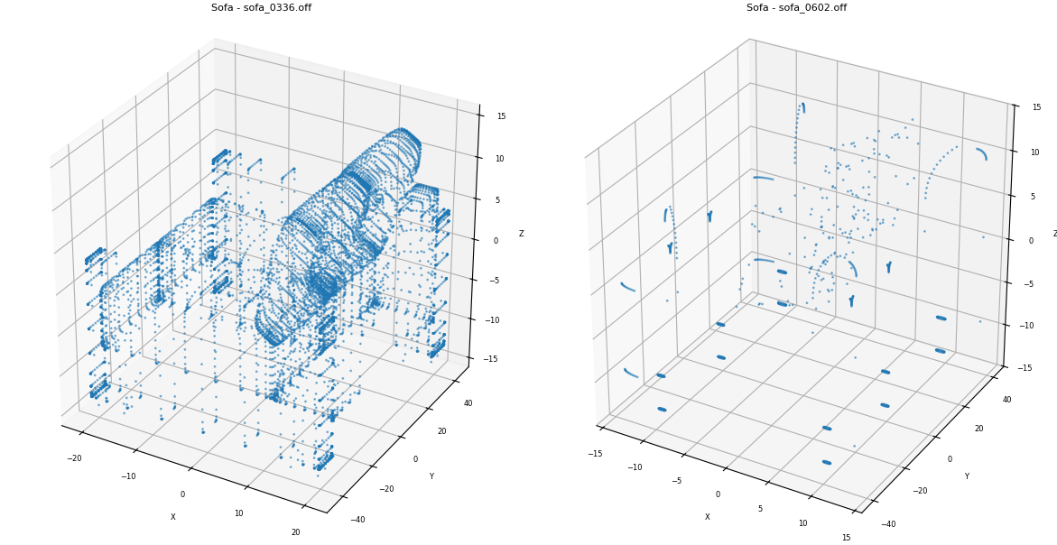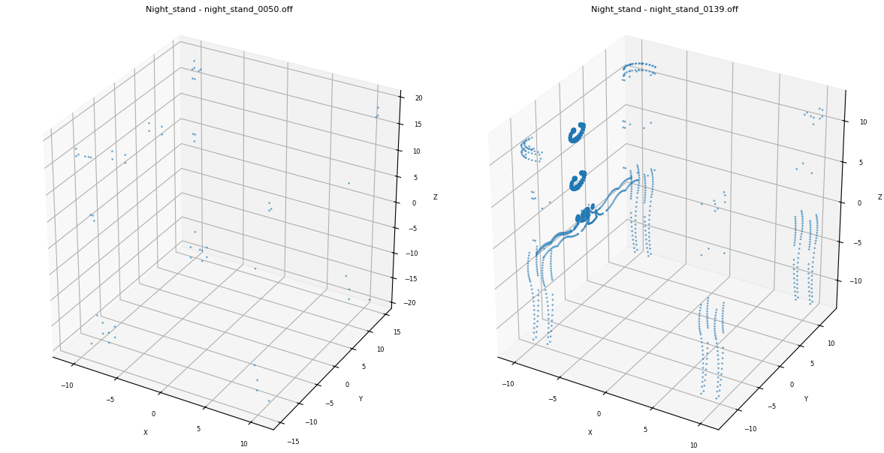
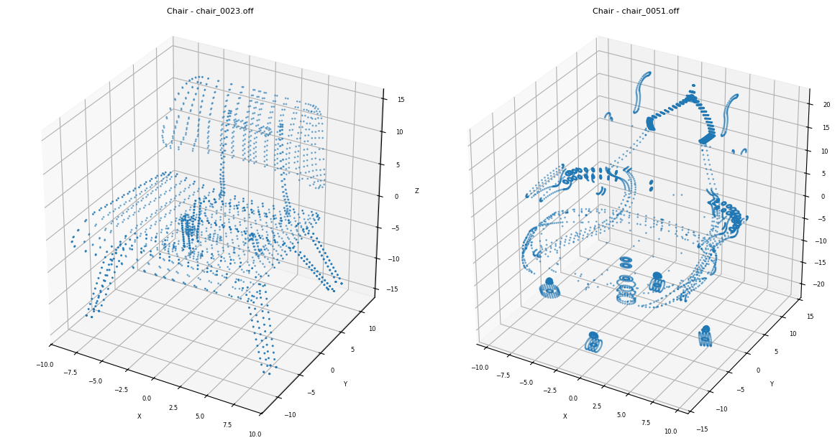
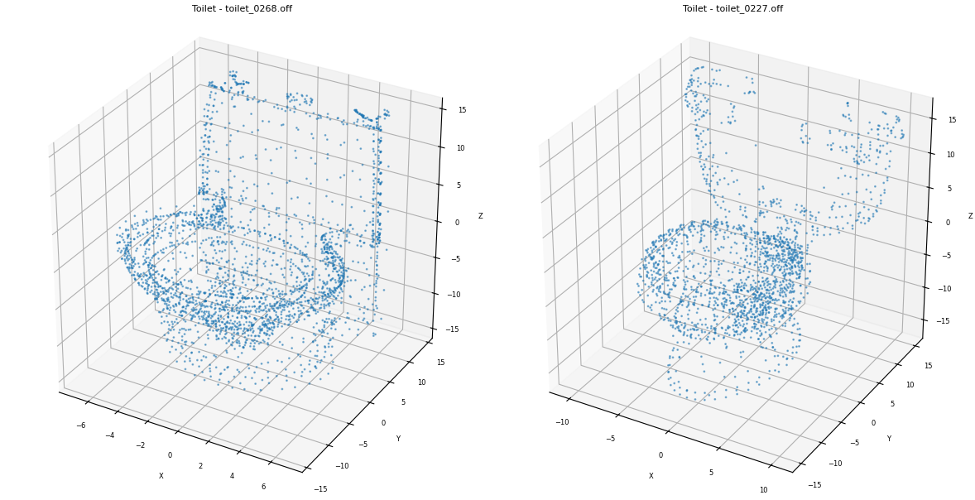
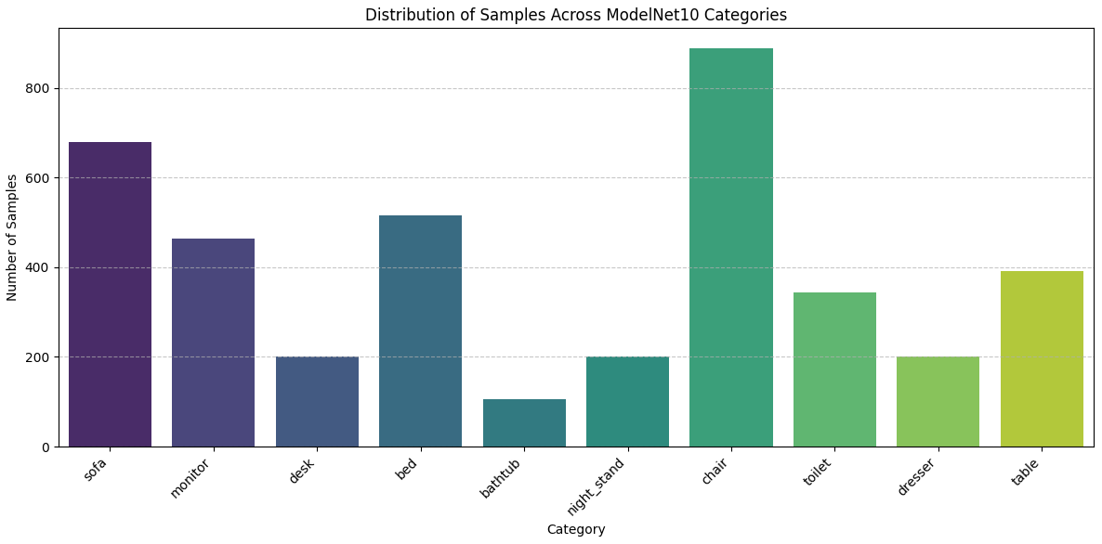

2- ShapeNet Part

ShapeNet is a massive repository of 3D CAD models. The "ShapeNet Part" dataset is a specific subset annotated for 3D Part Segmentation. Unlike ModelNet, where the goal is to say "this is a chair," the goal in ShapeNet Part is to label every point on the chair as "leg," "seat," "back," or "arm."
Data Content & Specifications
- Classes: It covers 16 object categories, including Airplane, Bag, Cap, Car, Chair, Earphone, Guitar, Knife, Lamp, Laptop, Motorbike, Mug, Pistol, Rocket, Skateboard, Table.
- Format: While the source ShapeNet is meshes (OBJ/MTL), the "Part" dataset is often distributed as sampled Point Clouds with per-point labels.
Key Characteristics:
- Geometric Complexity: The objects are generally more complex and varied than ModelNet. For example, "Motorbike" and "Earphone" have intricate thin structures that are hard to capture with low-resolution point clouds.
Applications & Usages
- Fine-Grained 3D Understanding: The primary usage is teaching machines to understand components of objects (e.g., a robot needing to know where the "handle" of a "mug" is to pick it up).
- Point Cloud Segmentation: It is the standard benchmark for part segmentation (metric: mean IoU over parts).
- Shape Editing: If an AI understands parts, it can allow users to "swap the legs of this chair with that table."
The python code that we done for EDA (https://colab.research.google.com/drive/18g87CIgkUaEWiStcV96zS932VLb2IRIM?usp=sharing).
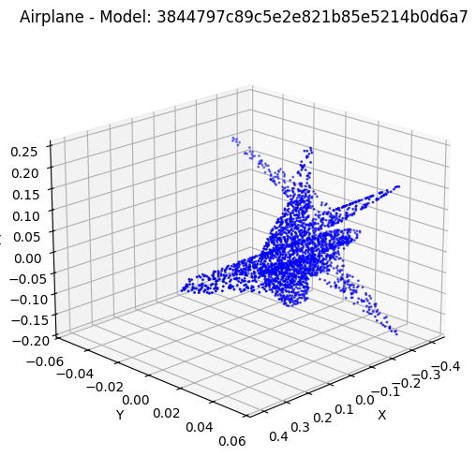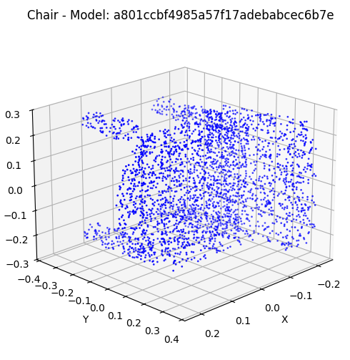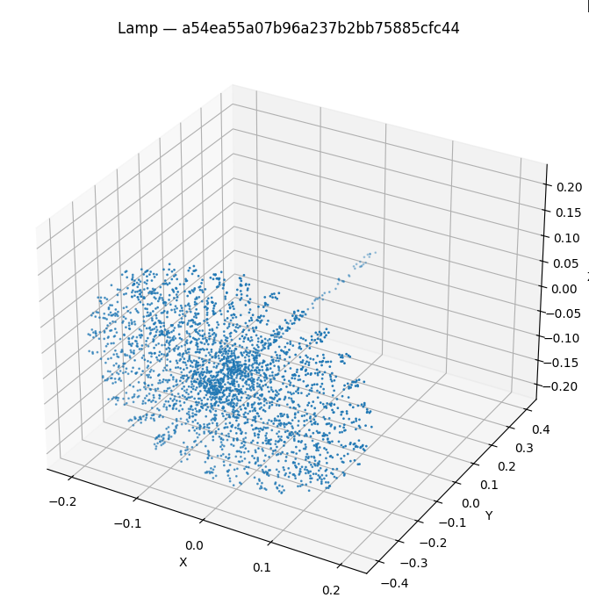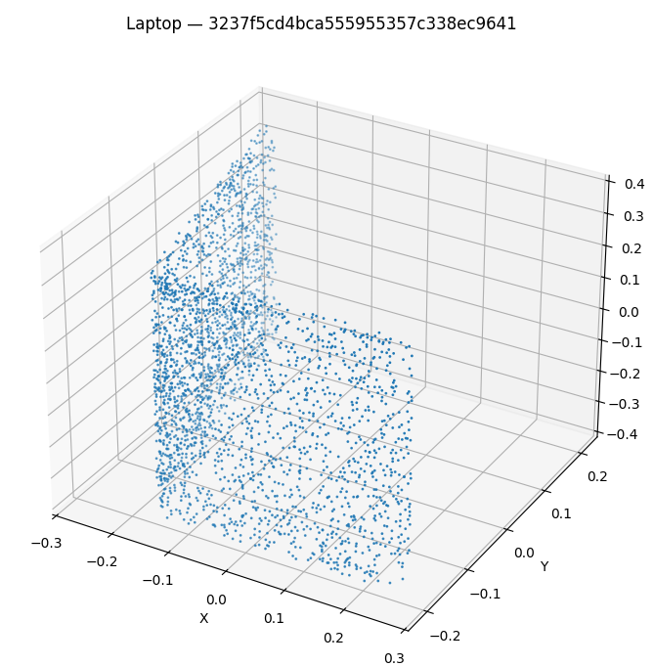
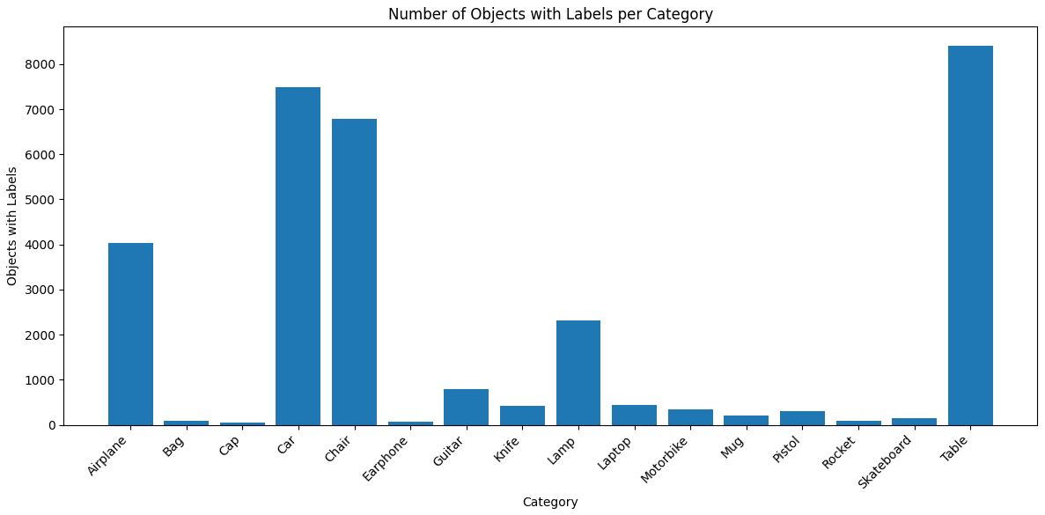

3- Stanford Large-Scale 3D Indoor Spaces (S3DIS)
The S3DIS dataset addresses the need for semantic understanding in large-scale indoor environments. Unlike datasets that rely on isolated objects, S3DIS captures continuous execution of real-world spaces, specifically covering six large areas across three different buildings at Stanford University. The data spans over 6,000 square meters and includes roughly 270 individual rooms, ranging from offices and conference rooms to hallways and auditoriums.
The primary value of S3DIS lies in its dense semantic annotations. Every point in the 3D cloud is labeled with one of 13 categories, distinguishing between structural elements (walls, floors, ceilings, beams, columns, windows, doors) and movable furniture (tables, chairs, sofas, bookcases, boards). This makes it a standard benchmark for semantic scene segmentation, where algorithms must classify every point in a room, and for parsing room topology. It essentially forces models to deal with the "messy" reality of inhabited spaces rather than sanitized synthetic environments.

4- ScanNetv2
While S3DIS focuses on a few large institutional buildings, ScanNetv2 allows for a broader analysis of domestic environments. It is currently one of the most widely used benchmarks for indoor scene understanding due to its scale and diversity, containing over 1,500 scanned scenes. These scans were captured using commodity hardware (RGB-D sensors on mobile devices), which introduces realistic sensor noise and occlusion patterns that algorithms must learn to handle.
The dataset provides rich annotations, including 3D object instance segmentation for 18-20 classes common in home environments, such as beds, toilets, sinks, and curtains. Because ScanNetv2 includes the original RGB-D video frames alongside the reconstructed meshes, it is uniquely useful for tasks beyond simple segmentation, such as 3D surface reconstruction and scene completion. It serves as a rigorous testbed for state-of-the-art methods in identifying and separating object instances within cluttered rooms.

5- ScanObjectNN
ScanObjectNN serves as a bridge between the scene-level datasets above and traditional object classification. Historically, object classification was tested on perfect CAD models, which often failed to translate to real-world applications. ScanObjectNN addresses this by providing about 15,000 objects extracted directly from real-world scans (like those in ScanNet).
These objects retain the artifacts of scanning—background clutter, holes from occlusion, and non-uniform point density. The dataset is organized into 15 categories (e.g., bag, bin, desk, pillow) and offers several variants to test model robustness, such as "OBJ_BG" (objects with background noise) and perturbed versions with rotation. It is primarily used to evaluate the robustness of classification networks and their ability to generalize from synthetic training data to real-world sensor data.

5. Proposed Approach (Phase 2 & 3 Plan)
Write the plan clearly:

Model to reproduce: Point Transformer

The code of Point Transformer is publicly available so we won’t gain great experience by just implementing the model. Instead, we will try to improve this or maybe some other models by implementing our ideas and modifying the existing SOTA models.

Your 7 creative modifications
1- use CLS token instead of global average pooling in Point Transformer
2- make other models aware of the background
3- increase receptive field of Point transformer by using farthest point sampling like Stratified Transformer
4- try PointNet segmentation style on Point Transformer ( concatenating global average pooling vector to all the point clouds ) and compare it with Point Transformer segmentation.
5- try Contextual Relative Position Encoding on Point Transformer
6- Stratified Transformer classification ( w or w/o background awareness )
7- use T-net ( from PointNet ) in Point Transformer

6. Phase 1 Achievements
Summarize:
- Completed literature survey
- Collected dataset
- Performed EDA
- Identified challenges
- Defined baseline & plan for implementation
- Listed creative ideas
This section is essential.

7. Discussion
Reflect scientifically:
- What you learned from reading papers
I have summarized my finding in a microsoft word file. I will use them with the help of AI to write this section.
- Insights from dataset
BARDIA
- Challenges going forward
Lack of powerful computation resources (we just have access to Kaggle and google colab GPU)
How to use Contextual Relative Position Encoding for a non voxel-based models ( our fifth idea )
- Expected improvements from your modifications
By mixing the novelties introduced by these papers ( or maybe some other papers which we may study in the next phase ) , we expect to improve the performance of the model

8. Conclusion & Next Steps
Write:
Next steps for Phase 2:
- Reading some of the codes of reviewed papers
- Try 2 or 3 ideas

