Movie Recommendation System - Final Project Report

Bardia Akbari - 401222013

1. Introduction
This report presents the development of a sophisticated Movie Recommendation System as part of the final project for the Machine Learning course. The goal of this project was to build a recommender system that effectively combines multiple approaches including popularity-based, content-based, collaborative filtering, and hybrid methods. To achieve this, multiple datasets were merged, preprocessed, analyzed, and modeled.
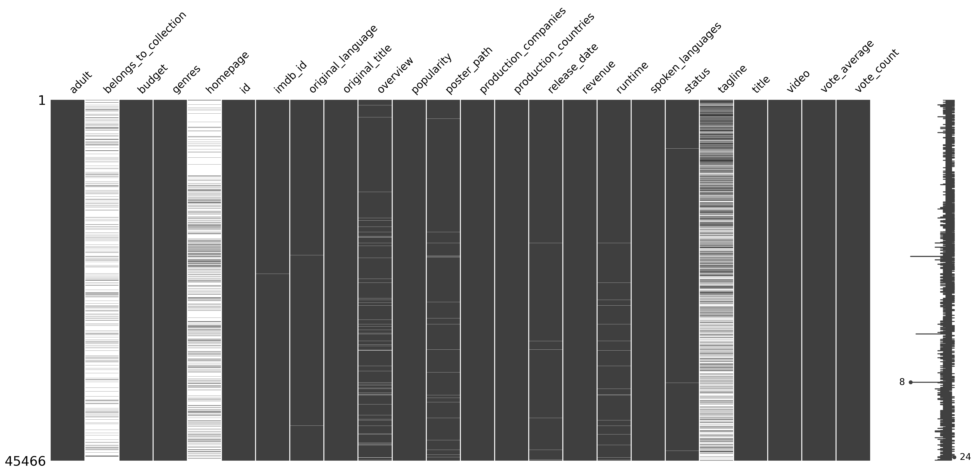
1 – missing values
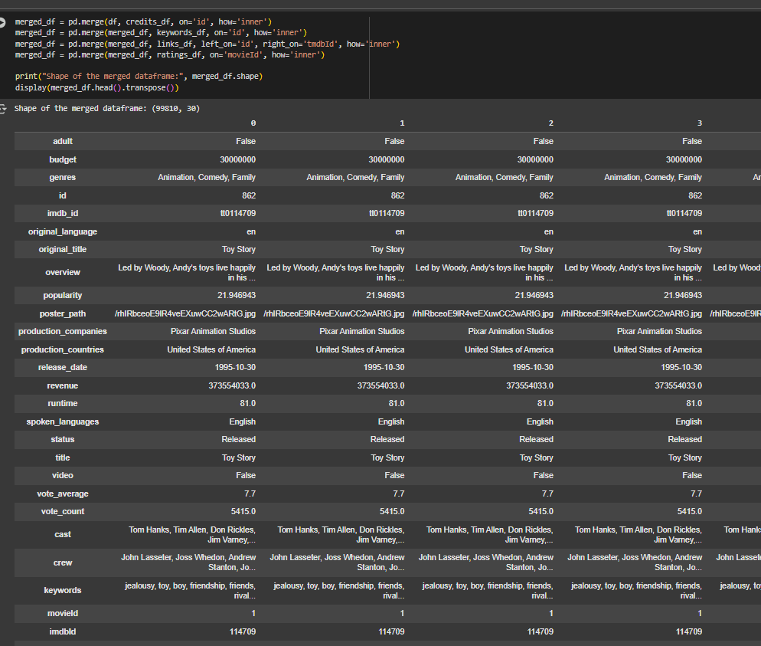
2- merging

2. Data Preprocessing
The datasets used in this project include:
- Metadata
- Credits
- Keywords
- Links
- Ratings
The preprocessing steps involved the following:
- Handling missing values and imputing them appropriately
- Parsing and decoding JSON fields into structured rows
- Detecting and removing duplicate records
- Cleaning and normalizing text fields
After preprocessing each dataset individually, they were merged into a single comprehensive dataframe.

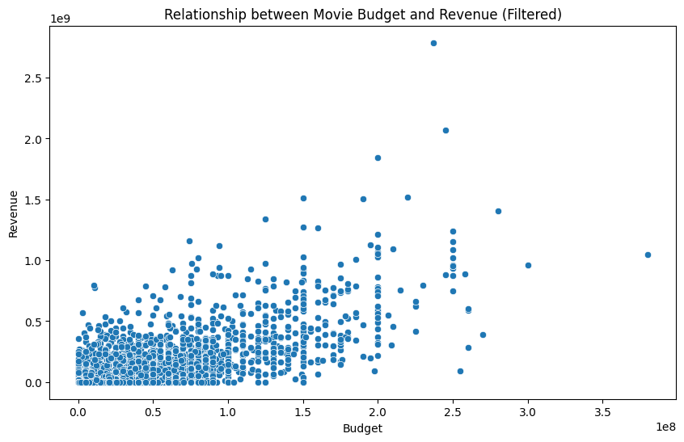
3 – budget revenue correlation
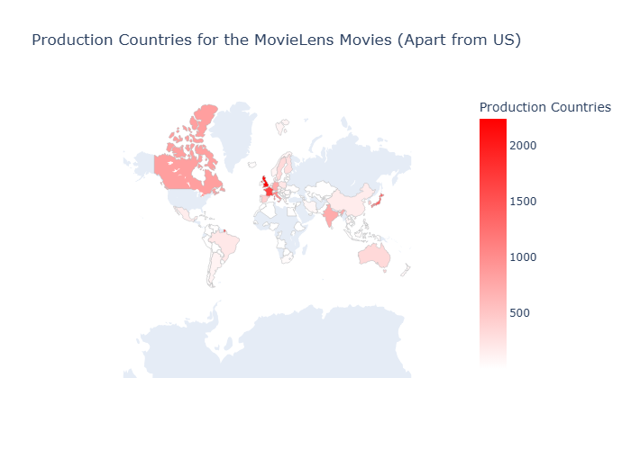
4 – movie production - US
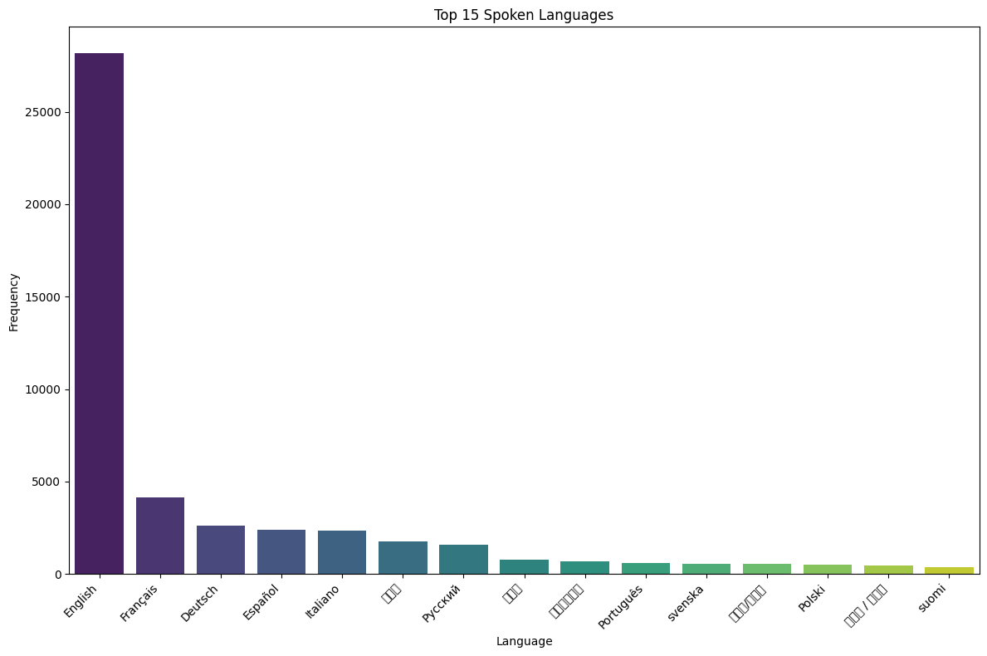
5- language distribution

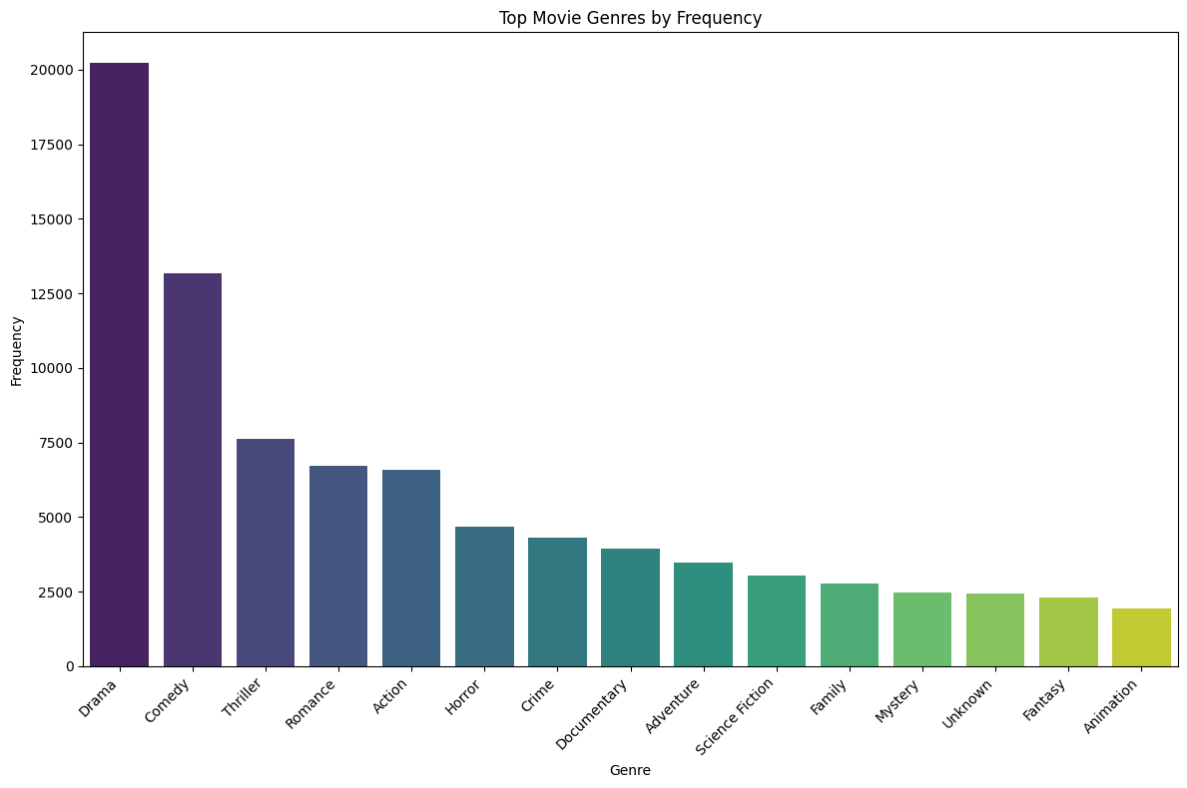
6 – genres frequency
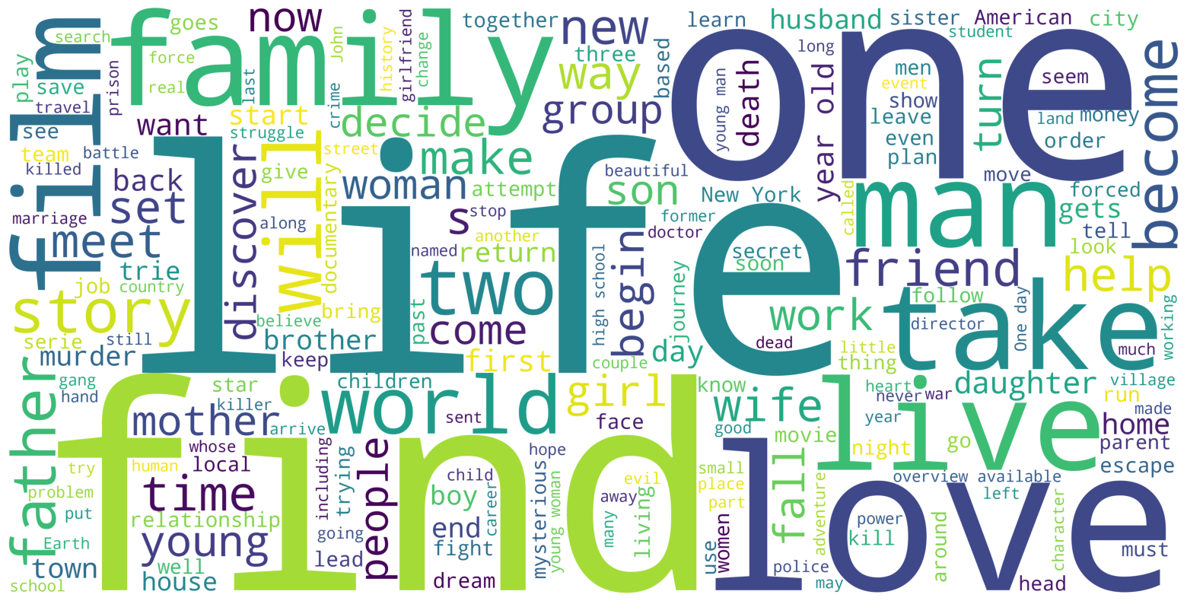7 - keywords
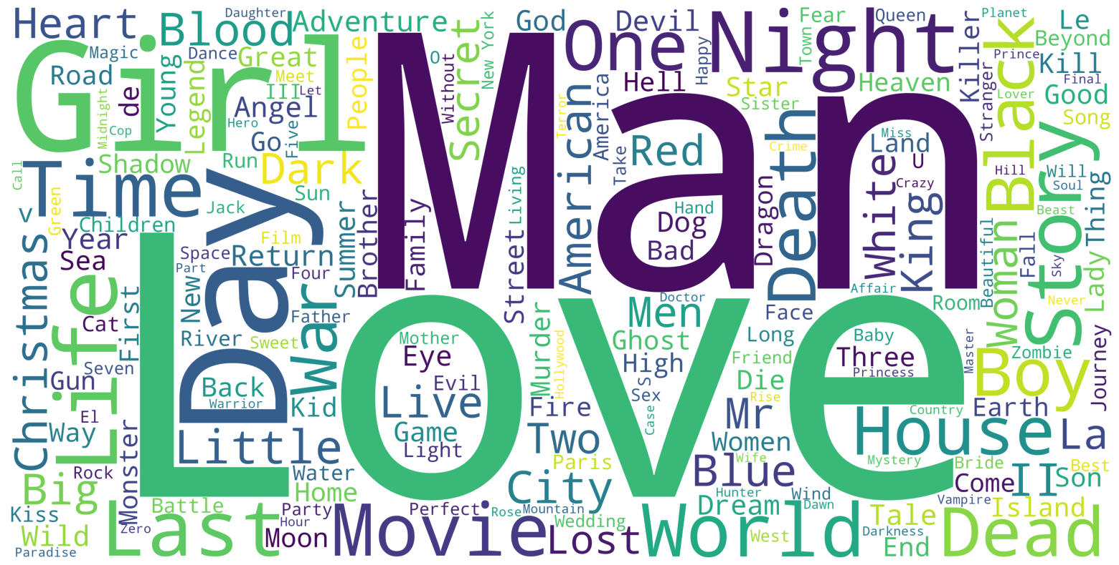8 – keywords
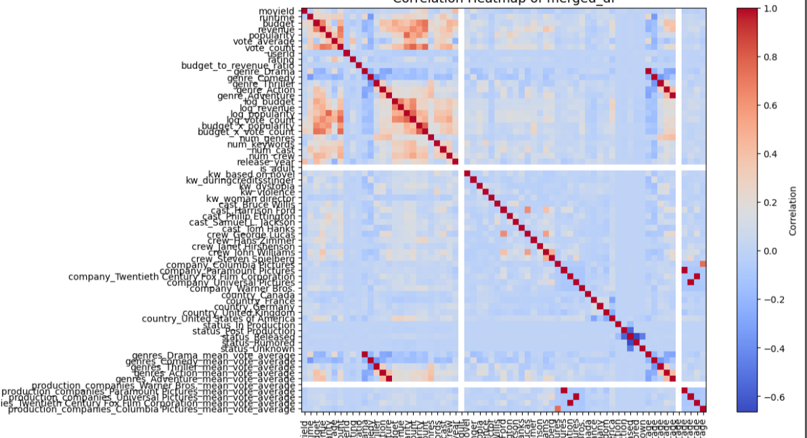
9- CORLATION HEATMAP

3. Exploratory Data Analysis (EDA)
A detailed EDA was conducted to understand the structure and distribution of the data. Key insights include:
- A strong positive correlation exists between movie budget and revenue.
- Distribution of movies by decade:
* 2010s: highest
* 2000s: second
* 1990s: third
- Popularity distribution decreases gradually with a long-tail effect.
- Rating distribution approximates a normal distribution.
- Runtime distribution: Most movies range between 90–200 minutes, with the majority between 1–2 hours.
- Top genres (in order): Drama, Comedy, Thriller, Romance, Action, Horror, Crime, Documentary.
- Top languages (in order): English, French, Dutch, Spanish, Italian.
- Top production companies: Warner Bros., Metro-Goldwyn-Mayer, Paramount Pictures, Universal Pictures, 20th Century Fox Film Corporation.
- Top production countries: United States, United Kingdom, France, Germany, Italy, Canada.
- Word cloud analysis of the 'Overview' field highlighted frequent words such as 'life', 'family', 'feel', 'love', and 'find'.

4. Feature Engineering
Several feature engineering techniques were applied to enrich the dataset:
- TF-IDF vectorization for textual features.
- One-hot encoding for categorical variables.
- Creation of new features such as top cast members, directors, production companies, and countries.
- Dimensionality reduction using Singular Value Decomposition (SVD) with 120 components.
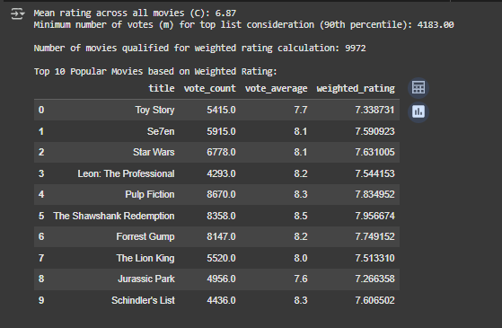
9- Baseline
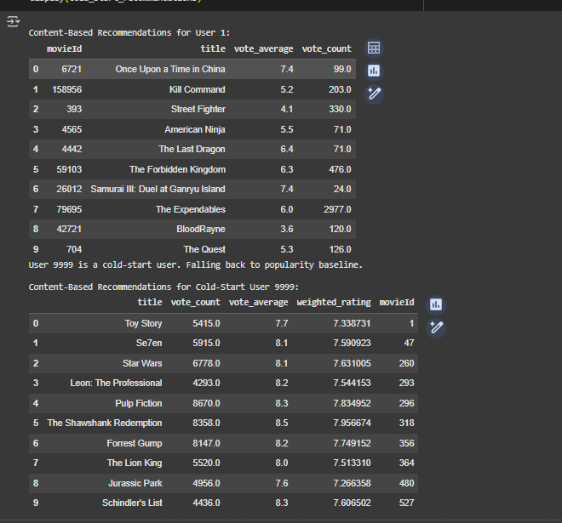
10 – CB ( content – based)
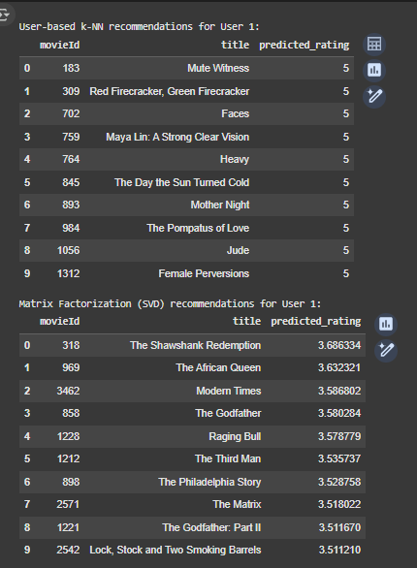
11 – CF (Collaborative Filtring)

5. Modeling
Multiple recommendation models were implemented and evaluated:
1. **Popularity Baseline**:
- Recommends the most popular movies overall.
- Example recommendations: Toy Story, Jumanji, Heat, GoldenEye, Casino.
2. **Content-Based Filtering**:
- Suggests movies based on the similarity of content features to user preferences.
3. **Collaborative Filtering**:
- Matrix factorization methods were used.
- Achieved RMSE: 0.90.
- User-based KNN achieved RMSE: 0.96.
4. **Hybrid Model**:
- Combines content-based and collaborative filtering approaches.
- Collaborative filtering coefficient converged towards 1, while content-based coefficient converged towards 0.
- Achieved RMSE: 0.89–0.70.
- Alternative hybrid configuration achieved RMSE: 1.06.

6. Conclusion
This project successfully developed a robust movie recommendation system through a structured pipeline of data preprocessing, exploratory analysis, feature engineering, and model implementation. Among the tested approaches, the hybrid model provided the most promising results, demonstrating the power of combining content-based and collaborative filtering techniques. The achieved RMSE scores highlight the model's strong predictive performance. Future work may include integrating deep learning approaches to further improve recommendation quality.

