CSE 5311-001 Lab Assignment 1

Due March 3, 2021

Goals:

1. Understanding of coupon collecting.
2. Understanding of enumeration.
3. Understanding of random simulation to verify a probability result.

Requirements:

1. The following paper does a variety of interesting probabilistic analyses:

P. Flajolet et.al., “Birthday paradox, coupon collectors, caching algorithms and self-organizing search”, Discrete Applied Mathematics 39 (1992), 207-229. ( http://algo.inria.fr/flajolet/Publications/FlGaTh92.pdf )

It includes the following formula, which provides the expected number of coupons needed under a general discrete probability distribution P for m coupons:

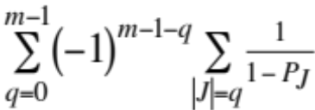 (14b) where 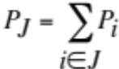

For m=3 and 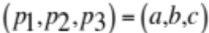, the paper simplifies (14b) to:

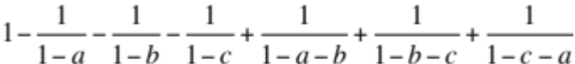.

Your task is write a C program to 1) evaluate (14b) for the special case that k of the probabilities are the value p and the other m - k probabilities are the value q and 2) implement a simple random simulation of generating coupons for this situation. Your program must compile and execute on omega.uta.edu.

(Formula (1) in https://web.cs.wpi.edu/~hofri/CCP.pdf says essentially the same thing as the formula above.)

2. Submit your C code on Canvas before 3:45 p.m. on March 3. Be sure to include comments regarding how to compile and execute your code.

Getting Started:

1. m will not exceed 50. m is at least 2.

2. The input is very simple:

a. The first input line is m and k. k must be larger than 0 and smaller than m.
b. The second line will have the value of the probability p for each of the first k coupons. p must be larger than 0 and such that k • p is smaller than 1. Each of the other m - k coupons will have a probability of q = (1 - k • p)/(m - k)
c. The third input line will be the number of times to execute a random simulation.
d. The fourth input line is a seed for the random number generator (e.g. srandom()). (The only significance of the seed is in the reproducibility of the experiments.)

3. Your powerset approach should use Θ(m²) time instead of the Θ(2^{m}) time needed by the original version of expression (14b). Elementary combinatorics ( https://en.wikipedia.org/wiki/Pascal%27s_triangle ) will be useful. You should output how many times innermost loop(s) execute for the theoretical part. The time for computing binomial coefficients should not be included.

